PRIMER OR PRIMER-FREE GLUING – PROBLEMS OF ADHESIVES IN AUTOMOTIVE INDUSTRY

Luboš PROKŮPEK¹, Miroslav VEČEŘA, Jana MACHOTOVÁ
Institute of Chemistry and Technology of Macromolecular Substances, University of Pardubice, CZ-532 10 Pardubice

The presented work aims at the comparison of physical and mechanical properties of commercially available black polyurethane adhesives designed for glass bonding in automotive industry and at the assessment of adhesive systems with primer. These adhesives require application and drying out of the appropriate polymer or a primer-free adhesive layer before bonding. UV stability is additionally measured in view of changing colours and mechanical properties.
¹ To whom correspondence should be addressed (lubos.prokupek@upce.cz)

Introduction
Adhesive bonding with pasty single-component (1K) polyurethane adhesives is a common standard today in automotive industry. The appropriate surface is degreased with a solvent and a thin primer layer is applied before bonding. Primers are isocyanate-based liquid, high-volatile and easy-to-dry agents, commonly filled with carbon particles for glazing. Primer is used for additional surface cleaning: it connects to the remaining contaminants, such as oil and silicon thus creating a substrate for a good adhesive anchoring. Primer is laid on a painted bodywork metal and on the bonded glass. After the primer dries out, the remaining adhesive is applied, usually in thicker layer of at least 3 mm.
Manufacturers obviously try – due to financial reasons and time constraints – to develop an adhesive that does not require application of primer while retaining the same strength properties as adhesive systems with primer. This trend is seen in car manufacturers but much more in the market sector focusing on adhesives and sealants designed for car components and car-repair shops which would benefit from substantial simplification and price reduction of the whole car glass changing due to a primer-free operation.
Bonded joints in automotive industry appear in many types according to their functional strain and construction aspect. We can say that bonding has additional and sealing function (bonding and sealing of bodyworks for the purpose of tightening, vibrations tamping, anticorrosion measures, application of reinforcement, etc.) or replaces welding technology in construction strength welds in specific cases.
Bodywork metal sheets have recently been joined by the resistance welding (spot, seam and projection welding) technology. These technologies have certain drawbacks, e.g. problematic joining of different thickness and quality metal sheets or thermal influence on the welded area. Further problems are caused by zinc coating, which functions as an anticorrosive protection. Zinc adheres to electrodes and the protective coating at the joints is largely reduced. This problem can be easily avoided by using bonding technology [1-4].
The ratio between welding and bonding in automotive industry has been gradually changing in favour of bonding. Modern adhesives enabled manufacturers reduce spot welding by almost 50 %. Recently about 9 % of annual adhesives production in the world are used in automotive industry. A car recently contains as much as 18 kg of adhesives. In the event of an accident, adhesives behave as a “bumper” – certain adhesives can contribute to a maximum passenger protection. Front glass is constructed to resist to a strong strain while appropriate adhesives contribute to bodywork stiffness.
We have many types of adhesives in a wide range of price and varied material properties. The most frequently used in automotive industry are epoxide, polyurethane (PUR) acrylate and cyanoacrylate adhesives. These adhesives are filled by different additives to improve their material properties, such as shear limit, strength limit or resistance against different types of loading, as well as the resistance against solvents and other negative impacts [5-8].
Beside different PUR adhesives, automotive industry uses silane-modified polyurethanes (SMP) car-glass adhesives. Polymers modified this way combine an excellent PUR cohesion and silicone adhesion. Their modification is based on the end NCO- groups of PUR prepolymer and aminosilane or isocyanate-silane agent with silicon networkable alkoxy groups. SMPs usually react with air humidity (while releasing the appropriate alcohol) thus hardening the used adhesive. The silane-modification is shown in Figure 1.
Modified silicone (MS) polymers are utilized nowadays as well. These adhesives lack the isocyanate component. They are based on trimethoxysilane modified polyether polyols [9]. The hardening principle is the same for SMPs and MS polymers (with different adhesive skeleton and equal reactive groups) as described in Figure 2. SMPs have a six-functional molecule while MS polymers have only four-functional one. SMPs have excellent adhesion to non-porous substrates and moreover, while hardened, R-OH alcohol releases instead of CO₂ as is the case of NCO- group reaction with water at classical 1K PUR adhesives. Strength of silane-modified adhesives is so far lower than that of purely PUR adhesives.
The main objective of this work was to compare adhesive systems requiring primer and adhesives without the need of primer for car glasses hardened by air humidity. Their gluing efficiency was evaluated using mechanical properties (tensile strength and bonded joints shear strength on adherends metal/metal, glass/glass and metal/glass) and optical properties by monitoring colour changes by CIELAB method [11].

Experiment
Materials
Samples of adhesives requiring primer and samples of adhesives without primer for car glasses hardened by air humidity were supplied by company Matrix a.s. Třebešov. Altogether four 1K adhesives without primer (PF) and three adhesive systems requiring primer (P) with the use of the appropriate primers (BETAPRIME 5500 and 5404) were tested and compared, namely: Teroson Terostat 9000 PL HMLC (Henkel) – silane-modified polyether polymer (PF); Teroson Terostat 9097 PL HMLC (Henkel) - PUR system on the MDI (PF); SIMP Seal 60 HV (N.P.T.S.r.l.) – silane finished polymer (PF); SikaTack GO! (Sika) - PUR system on the MDI (PF); BETASEAL 1517 (DOW) - PUR system (P); BETASEAL 1527 EP (DOW) - PUR system (P); 3M 590 (3M) – PUR system (P). Figure 3 shows samples of various used primers.

Description of bonding procedure
Bonded areas were degreased with a solvent-wetted textile. Glass was degreased by acetone, carbon steel with chloroform. In the case of adhesive systems with primer, application of the primer layer was made, leaving 10 mins for solvent evaporation. Then bonding was performed at the ambient temperature using the adhesive device, joints overlay was set on 18x25 mm. To reach a constant thickness of a joint, i.e. 5 mm for the combination glass/glass, metal/glass, metal/metal and 0.15 mm at a thinner joint metal/metal, distance profiles of 0.6 mm Al metal U-form sheets and steel wires, respectively, were inserted in the bonded joint. After applying the adhesive on one bonded area and inserting the distance profile/wire, the second adherend was applied and loaded with a 1kg weight.
The joint was then bonded and hardened for minimum 28 days, then the adhesive streaks were removed. Due to technology reasons, 110 x 25 mm metal sheets were applied at the adhesive ends of metal/glass and glass/glass systems, while the overlap with primer adherends was 70 x 25 mm. Distance plates complying with the joint thickness were applied at the ends of bonded joints to align the joint when clamped in a shredder.
The main objective was to compare the adhesives while using a primer. Its influence was monitored on mechanical properties – comparison of tensile strength according to ASTM 1708, bonded joints shear strength on adherends metal/metal, glass/glass and metal/glass in compliance with CSN EN 1465 standard and optical properties – monitoring colour changes after 500 hours-long exposure in QUV panel using CIELAB method. Glass transition temperatures (T_{g}) were determined by means of the thermomechanical analysis (TMA) using the TMA CX04R (R.M.I., Czech Republic). Figure 4 shows a bonded joint metal/glass and its typical testing dimensions.

Results and discussion
Results of tensile resistance are given in Table 1. Tensile strength was higher at P adhesives; all of them reached 5.5 MPa. In the case of PF adhesives, only SikaTack GO! was closer to the limit. Adhesive 3M 590 showed the highest tensile strength, the lowest SIMP Seal 60. Elongation of all the tested adhesives was relatively high, which is not surprising in regard to the requirement for elasticity of the adhesive designed to function as a flexible car glass sealant. Nevertheless, if compared directly, P adhesives show better results: elongation of Betasel 1517 and 1527 EP reached a maximum of 200 %, 3M 590 almost 300 %. Elongation of PF adhesives ranged from 100 % (SIMP Seal 60 and Teroson 9000) up to 160 % (Teroson 9097).
Results of shear strength are summarized in Table 2 and Figure 5. Joints with a 5 mm seam have thickness typical for the given application; 0.15 mm is a standard value according to CSN EN 1465. As far as shear strength is concerned, it was at each measurement higher at the thickness of 0.15 mm than at 5 mm. Shear strength decrease at 5 mm was sharp; it went down to 24-34 % of the original value (See Graph 5). The lowest shear strength in both categories was reached at the PF adhesives; Teroson 9000 at 0.15 mm and SikaTack GO! at 5 mm. The greatest shear strength was reached at both thickness types with Betaseal 1527 EP. Both Betasel adhesives showed more than twice the shear strength value compared to other adhesives.
Table 3 shows the shear modulus and elasticity; graphic description of elasticity is shown in Figure 6. The shear modulus in a thin seam showed a large dispersion (140–520 MPa) in numerous adhesives. Nevertheless, as the shear strength decreased, its values dramatically decreased with a thicker joint; typically to 20-30 MPa. The elongation, on the contrary and as expected, increased with the increased thickness, mostly at Betasel 1527 EP, the least at SikaTack GO! The shear resistance of the tested adhesives at metal/glass joint demonstrated that adhesive strength was unfortunately higher than the strength of the glass adherends; therefore in all tests the glass broke at the tension of max. 0.6 MPa (390N).
Besides measuring the shear resistance of the adhesives, the way of a joint breaking was assessed visually together with its shape after the test. The 0.15 mm joint mostly exhibited the adhesion failure, only Betaseal 1517 and 1527 EP showed the cohesion failure. The 5 mm joint showed a pure adhesion failure at Sika Tack GO!, 3M 590, Teroson 9000 and 9097. Betaseal 1517 and Betaseal 1527 EP exhibited adhesion and cohesion failure; the only pure cohesion failure was demonstrated at SIMP Seal 60.
Further, we focused on the measurement of colour changes of thin layers of adhesives by means of colour space L*a*b* (CIELAB). The results are shown in Tables 4 and 5 (yellowing index). It was demonstrated that overall colour change ΔE did not concern P or PF adhesives but both the categories; or the change depended on a particular adhesive composition. Adhesives Betaseal 1527 EP (P) and Sika Tack GO! (PF) fall within the category of unacceptable, Betaseal 1517 and 3M 590 (P) showed average results. Change in colour recognizable only with an experienced eye was seen at SIMP Seal 60 and Teroson 9000 (PF). Teroson 9097 (PF) had almost invisible change in colour.
The most significant change in measuring the yellowing index was seen at adhesive Sika Tack GO! (PF) followed by Betaseal 1527 EP (P), which corresponds to the results of colour changes. SIMP Seal 60 demonstrated the least change in the yellowing index. Its results in colour change were also very good. The remaining adhesives moved within the yellowing interval 2.5 to 8.
Temperatures T_{g} of the black adhesives were very low, which demonstrates a rubberlike character of the used adhesives. They were very similar to each other across the spectre of adhesives (within -76.4 to -62.2 ºC).

Conclusion
The above indicated results demonstrate that between adhesives requiring primer and adhesives without the need of primer exist substantial differences that vary according to the test type. As mechanical properties of adhesives with primer are concerned, the tests unambiguously proved better values of those showing better tensile and shear resistance. Moreover, they did not dramatically loose tensile strength after QUV exposition as the adhesives without primer that mostly fell apart already at the ageing. In terms of the thin layer colour, adhesive systems with primer comply with the standard, but most adhesives without primer showed better values even when tested visually. Nevertheless, it is important to point out that the adhesives requiring primer were not UV-protected by a primer which is normally used in this type of application. Taking in consideration the mechanical resistance, the adhesives without primer failed in comparison with the adhesive systems with primer. The absence of primer was evident, despite the adhesives should be prepared for primer-free application.

References
[1] Brydson, J.: Plastics materials, 7th ed. Boston: Butterworth-Heinemann,
778–809, 1999.
[2] Dodge J.: Synthetic methods in step-growth polymers, Hoboken, N. J.: Wiley-Interscience, 197–263, 2003.
[3] Segura, D. M. et al.: Handbook of Adhesives and Sealants: Chemistry of polyurethane adhesives and sealants, 1st ed. Loughborough: Elsevier, 101–162, 2005.
[4] Fink, K. J.: Reactive polymers fundamentals and applications: a concise guide to industrial polymers, Norwich, NY: William Andrew Pub., 69–138, 2005.
[5] Symietz, D., Lutz, A.: Strukturkleben im Fahrzeugbau, Dow Automotive, D-80992, Germany, 2006.
[6] Petrásek, V.: UV stability of polyurethane adhesives, Diploma Thesis, University of Pardubice, 2015.
[7] Bláha, A.: Adhesive bonding in the car industry, Bachelor Thesis, Brno University of Technology, 2015.
[8] Přívratský, P.: Durability test of structural adhesives, Diploma Thesis, University of Pardubice, 2014.
[9] Burchardt, R. B., Merz W. P.: Handbook of adhesives and sealants. 1st ed. Boston, Mass.: Elsevier, 355–460, 2006.
[10] Cao, CL. et al.: Study of Properties of One-Component Moisture-Curable Polyurethane and Silane Modified Polyurethane Adhesives: Journal Of Adhesion Science And Technology, 26, 10–11, 1395–1405, 2012.
[11] Boubakri, A. et al.: Study of UV-aging of thermoplastic polyurethane material, Materials Science and Engineering A., 527, 7–8, 1649–1654, 2010.

Figure 1: Formation of an amino-silane modified PUR.
Figure 2: STP and MS polymers networking [10].
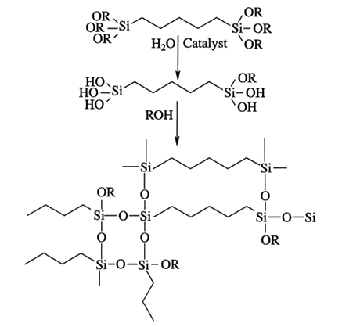

Figure 3: Sample primers for glass and metal.
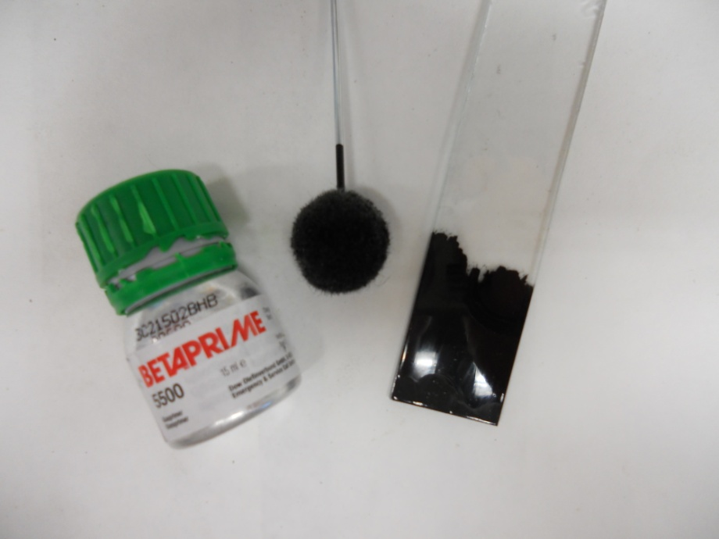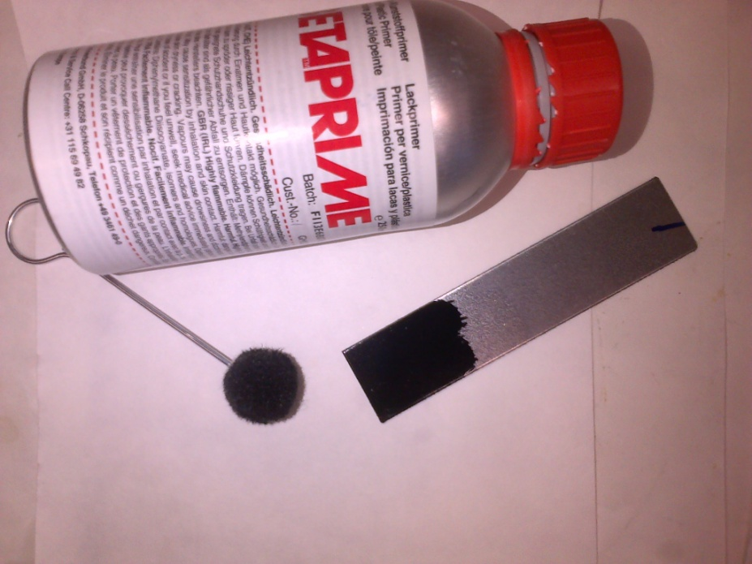

Figure 4: Dimensions and picture of bonded joint metal/glass.
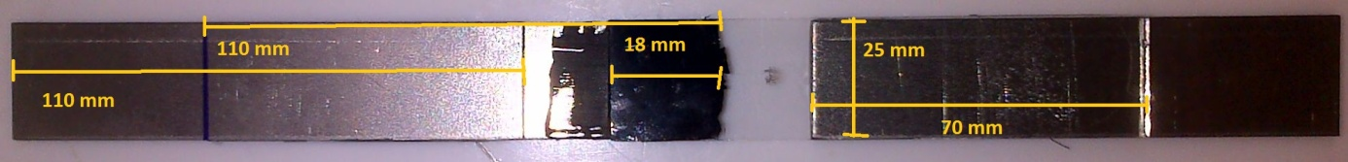

Table 1: Results of the tensile testing of black adhesives.
Sample | Tensile modulus (MPa) |  |  | Tensile strength (MPa) |  |  | Tensile force (N) |  |  | Elongation  (%)
Teroson 9000 | 3.96 | ± | 0.32 | 2.84 | ± | 0.34 | 26.82 | ± | 2.93 | 106.0 | ± | 20.0
Teroson 9097 | 2.33 | ± | 0.10 | 3.10 | ± | 0.20 | 32.53 | ± | 1.92 | 161.8 | ± | 10.6
SIMP Seal 60 | 3.52 | ± | 0.22 | 1.84 | ± | 0.24 | 18.67 | ± | 1.88 | 104.7 | ± | 16.6
SikaTack GO! | 5.50 | ± | 0.30 | 5.20 | ± | 0.25 | 55.72 | ± | 2.05 | 138.6 | ± | 6.7
Betaseal 1517 | 4.30 | ± | 0.17 | 5.82 | ± | 0.25 | 67.96 | ± | 6.07 | 211.8 | ± | 15.2
Betaseal 1527 EP | 3.22 | ± | 0.10 | 5.54 | ± | 0.18 | 56.06 | ± | 4.54 | 199.7 | ± | 4.8
3M 590 | 2.58 | ± | 0.10 | 5.84 | ± | 0.30 | 52.13 | ± | 5.26 | 297.8 | ± | 25.4

Table 2: Shear strength of black adhesives, adherends metal/metal at joint thickness of 0.15 and 5 mm.
 | Shear strength (MPa) |  |  |  |  |  | Shear force (N)
Joint thickness | 0.15 mm |  |  | 5 mm |  |  | 0.15 mm |  |  | 5 mm
Teroson 9000 | 1.26 | ± | 0.17 | 0.30 | ± | 0.04 | 719.2 | ± | 58.5 | 180.5 | ± | 31.7
Teroson 9097 | 1.34 | ± | 0.13 | 0.28 | ± | 0.04 | 732.5 | ± | 71.0 | 174.2 | ± | 22.6
SIMP Seal 60 | 2.38 | ± | 0.09 | 0.79 | ± | 0.05 | 1477.5 | ± | 59.9 | 496.0 | ± | 33.1
SikaTack GO! | 1.50 | ± | 0.08 | 0.19 | ± | 0.01 | 870.8 | ± | 48.5 | 120.5 | ± | 6.7
Betaseal 1517 | 5.50 | ± | 0.41 | 1.70 | ± | 0.18 | 3258.1 | ± | 246.5 | 1091.0 | ± | 114.5
Betaseal 1527 EP | 6.71 | ± | 0.32 | 2.09 | ± | 0.06 | 3946.9 | ± | 178.0 | 1362.5 | ± | 43.6
3M 590 | 2.01 | ± | 0.22 | 0.61 | ± | 0.07 | 1154.5 | ± | 135.6 | 389.2 | ± | 43.7

Figure 5: Comparison of shear strength at joint thickness of 0.15 mm (white columns) and 5 mm (grey columns).

Table 3: Shear modulus and elongation of black adhesives, adherends metal/metal at joint thickness of 0.15 and 5 mm.
 | Shear modulus (MPa) |  |  |  |  |  | Elongation (%)
Joint thickness | 0.15 mm |  |  | 5 mm |  |  | 0.15 mm |  |  | 5 mm
Teroson 9000 | 286.5 | ± | 31.8 | 21.22 | ± | 1.19 | 0.62 | ± | 0.12 | 3.49 | ± | 0.22
Teroson 9097 | 141.9 | ± | 21.1 | 12.96 | ± | 1.99 | 1.41 | ± | 0.12 | 4.79 | ± | 0.81
SIMP Seal 60 | 178.9 | ± | 26.2 | 25.88 | ± | 1.41 | 2.78 | ± | 0.37 | 6.94 | ± | 0.88
SikaTack GO! | 401.4 | ± | 33.9 | 30.44 | ± | 1.11 | 0.56 | ± | 0.09 | 1.21 | ± | 0.27
Betaseal 1517 | 485.5 | ± | 59.9 | 30.28 | ± | 1.77 | 2.05 | ± | 0.18 | 7.56 | ± | 0.93
Betaseal 1527 EP | 521.7 | ± | 51.9 | 24.02 | ± | 1.74 | 2.07 | ± | 0.20 | 11.60 | ± | 0.78
3M 590 | 356.8 | ± | 30.5 | 21.98 | ± | 1.49 | 0.82 | ± | 0.15 | 5.15 | ± | 1.14

Figure 6: Comparison of elongation at shear test for joint thickness of 0.15 mm (white columns) and 5 mm (grey columns).

Table 4: Colour change according to CIELAB after 500 hours-long exposure in QUV panel.
Sample | ΔL |  |  | Δa |  |  | Δb |  |  | ΔEª
Teroson 9000 | 0.75 | ± | 0.13 | 0.07 | ± | 0.01 | 1.14 | ± | 0.08 | 1.36
Teroson 9097 | -0.19 | ± | 0.49 | -0.16 | ± | 0.02 | 0.62 | ± | 0.02 | 0.67
SIMP Seal 60 | 1.25 | ± | 0.74 | -0.11 | ± | 0.01 | 0.09 | ± | 0.07 | 1.26
SikaTack GO! | 4.09 | ± | 0.08 | 0.82 | ± | 0.03 | 4.37 | ± | 0.04 | 6.05
Betaseal 1517 | 2.70 | ± | 0.34 | 0.03 | ± | 0.01 | 1.72 | ± | 0.01 | 3.2
Betaseal 1527 EP | 5.75 | ± | 0.33 | 0.14 | ± | 0.03 | 4.09 | ± | 0.11 | 7.05
3M 590 | -2.22 | ± | 0.38 | 0.09 | ± | 0.03 | 1.77 | ± | 0.11 | 2.84
ª ΔE (overall colour change)
0–1 non-recognizable, 1–2 recognized with an experienced eye, 2–3.5 average, 3.5–5 high, > 5 unacceptable

Table 5: Index of black adhesives yellowing.
Sample | Yellowing index (0 h) | Yellowing index (500 h) | Δ of yellowing index
Teroson 9000 | 2.2 | 6.98 | 4.78
Teroson 9097 | 3.36 | 5.92 | 2.56
SIMP Seal 60 | -4.49 | -4.03 | 0.46
SikaTack GO! | -13.52 | 6.44 | 19.96
Betaseal 1517 | -0.36 | 6.58 | 6.94
Betaseal 1527 EP | -8.09 | 8.97 | 17.06
3M 590 | 0.53 | 8.37 | 7.84

