Intrinsic properties of high-aspect ratio single- and double-wall anodic TiO₂ nanotube layers annealed at different temperatures
Martin Motola ª, Ludek Hromadko ^{a,b}, Jan Prikryl ª, Hanna Sopha ^{a,b,1}, Milos Krbal ª, Jan. M. Macak ^{a,b,*,1}
ª Center of Materials and Nanotechnologies, Faculty of Chemical Technology, University of Pardubice, Nam. Cs. Legii 565, 530 02 Pardubice, Czech Republic
^{b} Central European Institute of Technology, Brno University of Technology, Purkynova 123, 612 00 Brno, Czech Republic
* Corresponding author: e-mail address: jan.macak@upce.cz
¹ ISE member
Abstract
In this work, we present the influence of thermal annealing on morphological, structural, electrical, optical, and photoelectrochemical properties of double- (DW) and single-wall (SW) TiO₂ nanotube (TNT) layers. High-aspect ratio TNT layers with a thickness of ~5 µm and ~20 µm with an average inner diameter of ~250 nm and ~130 nm, respectively, were prepared via electrochemical anodization of Ti foil in two different fluoride containing ethylene glycol-based electrolytes. The inner wall of the native DW TNT layers was quantitatively removed via a mild pre-annealing followed by a selective etching treatment in piranha solution, yielding SW TNT layers. The obtained SW TNT layers annealed at 300 – 500 °C possess enhanced conductivity by 1 – 2 orders compared to their DW counterparts. The photoelectrochemical properties of SW TNT layers are enhanced compared to their DW counterparts in the annealing temperature range 300 – 800 °C. In principle, the SW TNT layers could be potentially favored to the DW TNT layers in electrical and photoelectrochemical applications due to their more superior intrinsic properties.
Keywords: TiO₂ nanotubes; Annealing; Single-wall; Conductivity; Photoelectrochemistry
1. Introduction
Synthesis of self-aligned TiO₂ nanotube (TNT) layers via electrochemical anodization was first reported in 1984 [1]. However, such TNT layers have received significant attention only after pioneering works [2,3] reported more than two decades later. Their unique one-dimensional (1D) morphology and exceptional physical and chemical properties [4,5] are responsible for the attractiveness of these nanomaterials. Nowadays, the TNT layers are used in a plethora of applications such as photocatalysis [5], gas sensing [6], solar cells [7–9], water splitting [10], and biomedicine [11]. One of the many advantages of TNT layers is that they can be grown directly on Ti substrates by anodization in suitable aqueous- or organic-based electrolytes containing fluoride ions [12–14]. Such nanotubes represent a favorable morphology especially for photoelectrochemical applications as they offer 1) a high surface area and enhanced incident light absorption due to their 1D ordered structure [15]; 2) a direct path for the photogenerated charge carriers towards the underlying Ti substrate [16,17]; and 3) easily tunable dimensions, in particular diameter and thickness [18]. In the last decade, ethylene glycol-based electrolytes containing NH₄F and H₂O were the most widely used electrolytes to produce high-aspect ratio TNT layers [4,19]. However, in such electrolytes a double layer oxide structure is formed composed of an inner and an outer wall [20]. The origin of this double-wall (DW) structure can be explained considering the plastic flow model for the nanotube formation [21,22]. The inner wall consists of TiO₂ that is contaminated with C and F species [23–25]. These species originate from the voltage induced decomposition of the electrolyte during anodization. The outer wall (the nanotube wall) consists of almost pure TiO₂. Furthermore, some F accumulation can be localized between the nanotubes and on the interface between the nanotubes and the underlying substrate [26–28]. Previous studies report that the removal of the inner wall increases the efficiency of dye-sensitized solar cells (DSSCs) [25,27] and enhances the photoelectrochemical [28,29] and photocatalytic [22,29] properties of such single-wall (SW) TNT layers.
The amorphous as-anodized TNT layers are not favored in semiconducting applications due to their intrinsically low conductivity and significant amount of recombination centers which hinder the efficient charge transport [30,31]. Thus by controlling the crystalline state of TNT layers, their efficiency for photoelectrochemical applications can be significantly improved. In general, TiO₂ is an n-type semiconductor with a band gap of ~3.2 eV for the anatase and ~3.0 eV for the rutile phase [32,33]. Numerous studies report on the influence of the annealing conditions (e.g., temperature, time and atmosphere) on the crystallinity of the TNT layers and subsequent impact of these conditions on their photoelectrochemical [15,34,35], photocatalytic [36] and electrocatalytic [37] properties, electrical resistance [15,38], phase transition [15,34–42], morphology [15,34–40,42], the increased efficiency of electrodes in microbial fuel cells [42] and in DSSCs [39]. Nevertheless, most of these publications [35–37,39–42] show the performance of DW TNT layers synthesized in ethylene glycol-based electrolytes. Recent reports [20,22,25–29] show enhanced properties of SW TNT layers in photoelectrochemical applications compared to their DW counterparts. However, the study on the influence of different annealing temperatures and its impact on the intrinsic properties of such SW TNT layers is of high interest and yet missing.
In this work, we show the impact of the annealing temperature on two types of high-aspect ratio DW and SW TNT layers. We present the influence of the annealing temperatures on the intrinsic properties of TNT layers such as structure, morphology, optical band gap, electrical resistance, and photoelectrochemical performance.

2. Experimental
2.1 Synthesis and annealing of TNT layers
According to our previous works [43,44], two different kinds of high-aspect ratio DW TNT layers with an inner diameter of ~250 nm and ~130 nm and thickness of ~5 μm and ~20 μm, respectively, were prepared via electrochemical anodization. Prior to the anodization, the Ti foils were degreased by sonication in isopropanol, acetone, and isopropanol, respectively, and dried with a nitrogen jet. To obtain ~5 μm thick self-aligned DW TNTs (1 cm² area) with an inner diameter of ~250 nm (aspect ratio ~20), anodization of Ti foils using a high-voltage potentiostat (PGU-200V, Elektroniklabor GmbH) was conducted at 100 V for 4 h at room temperature in ethylene glycol-based electrolyte containing 10 % water and 0.15 M NH₄F. The ~20 μm thick self-aligned DW TNTs (1 cm² area) with an inner diameter of ~130 nm (aspect ratio ~154) were prepared via anodization of the Ti foils using a high-voltage potentiostat (PGU-200V, Elektroniklabor GmbH) conducted at 60 V for 4 h at room temperature in ethylene glycol-based electrolyte containing 1.5 % water and 0.17 M NH₄F. A two-electrode configuration using Ti foil (GoodFellow, 0.140 mm thick, >99.6 % purity) as a working electrode and Pt foil as a counter electrode was used in all anodizations. A previously reported chemical etching treatment [22,28,29] was used to remove the inner wall of the DW TNT layers to obtain SW TNT layers of both 5 μm and 20 μm thicknesses. First, the prepared DW TNT layers were pre-annealed at 135 °C and 150 °C for 5 μm and 20 μm tubes, respectively, for 1 h in air using a heating rate of 15 °C/min. Second, the pre-annealed TNT layers were immersed in piranha solution (H₂SO₄:H₂O₂ = 3:1) for 10 min (5 μm thick TNT layers) and 8 min (20 μm thick TNT layers) at 70 °C. After etching, the TNT layers were immersed in H₂O and ethanol for 1 min, respectively, and dried with a nitrogen jet.
The DW and SW TNT layers were annealed in a muffle oven at 300 °C, 400 °C, 500 °C, 600 °C, 700 °C, and 800 °C. TNT layers were placed inside the oven at room temperature and heated to the desired temperature with the heating rate of 2.1 °C/min. After reaching the target annealing temperature, the TNT layers were soaked for 1 hour. After the annealing, the TNT layers were cooled down inside the oven to the room temperature.
2.2 Characterization of TNT layers
A field-emission scanning electron microscope (FE-SEM, JEOL JSM 7500F) was used for morphological characterization. The morphological parameters of TNT layers were evaluated by statistical analyses of SEM images using proprietary Nanomeasure software.
The crystalline structure was characterized by X-ray diffractometer (XRD, PANalytical Empyrean Cu Kα radiation, λ = 1.5418 Å) with a scintillation detector Pixcel^{3D} in the 2θ range 5-65°, the step size was 0.026°.
The electrical resistance was analyzed by a two-point probe using Au-coated W tips on the nanotube layer and the back contact to Ti foil (SUSS Micro Tec PM5) both interfaced to a digital multimeter (Keithley 2602). The electrical resistance values were obtained by cycling the potential from -3 to +3 V with a step rate of 0.1 V/s and measuring the currents at 4 different spots for each sample. The differences in the measurements of electrical resistance did not exceed ±5 %.
The diffuse reflectance UV-VIS spectra were recorded in the wavelength range from 200 nm to 1100 nm using a UV-VIS spectrophotometer (UV3600Plus Series Shimadzu) with ISR-603 integrating sphere.
The photocurrent measurements of TNT layers were carried out in an aqueous 0.1 M Na₂SO₄ solution at 0.4 V_{vs. Ag/AgCl} in the spectral range from 300 nm to 450 nm. A photoelectric spectrophotometer (Instytut Fotonowy) with a 150 W Xe lamp and a monochromator with a bandwidth of 10 nm connected with the modular electrochemical system AUTOLAB (PGSTAT 204, Metrohm Autolab B.V., Nova 1.10 software) was used for the photocurrent measurements.

3. Results and discussion
Fig. 1A and B shows top-view and cross-sectional (as insets) SEM images of the as-prepared 5 μm and 20 μm thick TNT layers with the inner diameter of ~250 nm and ~130 nm, yielding nanotubes with an aspect ratio of ~20 and ~154, respectively. Fig. 1C and D reveals the presence of the inner wall (porous areas within the nanotube interiors) at the bottom parts of the 5 μm and 20 μm thick DW TNT layers, respectively. The quantitative chemical etching treatment in piranha solution led to the inner wall removal. Both 5 μm (Fig. 1E) and 20 μm (Fig. 1F) thick SW TNT layers did not show any visible porous areas within the nanotubes. It is necessary to say that no significant differences in the morphology of the nanotube tops for amorphous and annealed DW compared to the SW TNT layers were observed. The selective etching treatment removes solely the inner wall of the nanotubes (TiO₂ contaminated with C and F species) which is situated in the bottom parts of the nanotubes [19,22,28], leaving the outer wall of the nanotubes (pure TiO₂) undamaged.
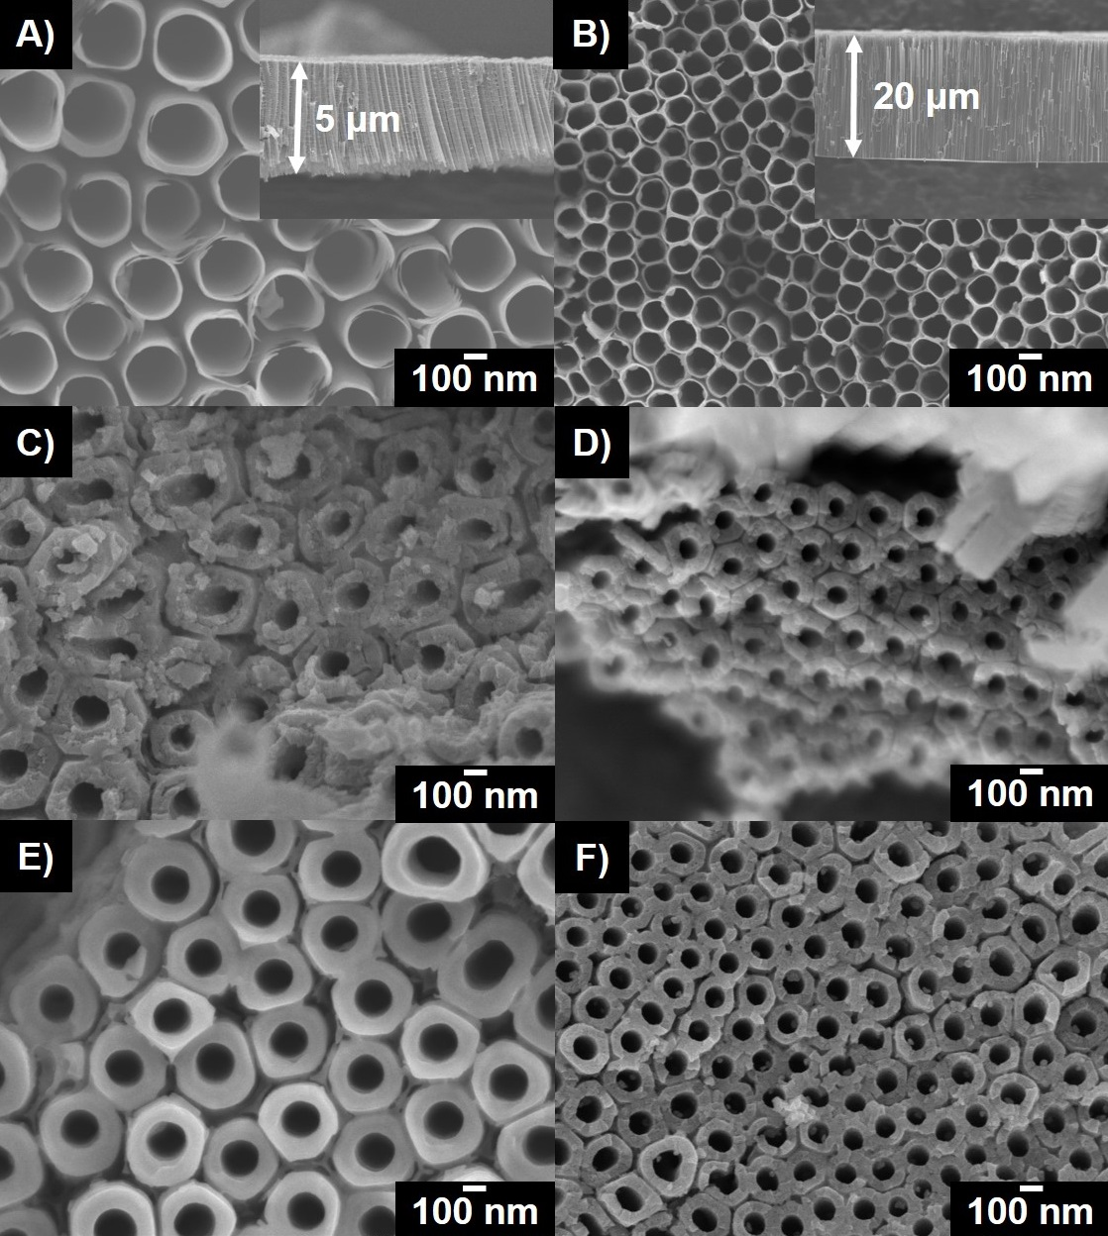
Fig. 1. SEM images of (A, B) as-prepared TiO₂ nanotube tops, (C, D) double-wall structure of the nanotubes depicted at the nanotube bottoms and (E, F) single-wall structure of the nanotubes depicted at the nanotube bottoms of 5 μm and 20 μm thick TiO₂ nanotube layers, respectively. The insets show the cross-section of the nanotube layers.
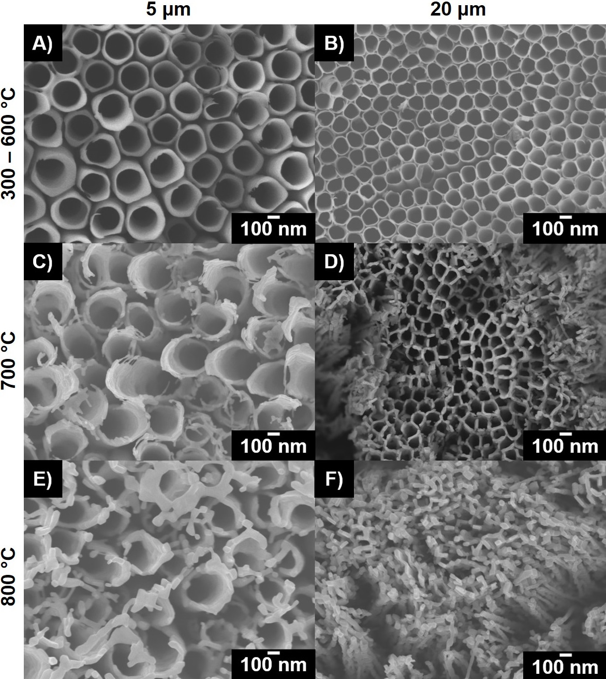
Fig. 2. SEM top-view images of 5 μm and 20 μm thick single-wall TiO₂ nanotube layers annealed at (A, B) 300 – 600 °C, (C, D) 700 °C and (E, F) 800 °C, respectively.
Fig. 2 shows the representative top-view SEM images of 5 μm and 20 μm thick SW TNT layers annealed at 300 °C, 400 °C, 500 °C, 600 °C, 700 °C, and 800 °C. Fig. 2A and B show the representative morphology of the 5 μm and 20 μm thick TNT layers, respectively, annealed in the temperature range 300 – 600 °C. No significant morphological changes of the nanotubes were observed in this annealing temperature range and the morphology is similar to that of the amorphous TNT layers (Fig. 1A and B, respectively). After annealing at 700 °C (Fig. 2C and D), the originally well-defined nanotubular structure is disturbed and visible surface flaws are observed due to the thermal annealing. In particular, the morphology of the 20 μm (Fig. 2D) thick TNT layers where the nanotube openings starts to collapse. The full collapse of the nanotube tops of the 20 μm (Fig. 2F) thick TNT layers is revealed after annealing at 800 °C and the nanotubes coalesced to form a rather nanorod type of structure. In case of the 5 μm thick TNT layers, although the nanotube openings are significantly disturbed, the nanotubular structure is still observed after annealing at 800 °C (Fig. 2E). The higher temperature stability of the 5 μm thick TNT layers compared to their 20 μm thick counterparts can be assigned to an increased robustness of such nanotubes. In particular, the nanotube walls are 2 – 12 times thicker (approx. 10 – 60 nm) in 5 μm thick TNT layers, compared to those in the 20 μm TNT layers (5 – 10 nm).
As previously reported [15,45], an additional TiO₂ thermal oxide layer is present between the nanotube layer and Ti substrate after annealing. The formed thermal oxide layer consists mainly of a rutile phase [45] and its thickness increases with increased annealing temperature [15]. Fig. 3A-D show illustrative cross-sectional SEM images with the visible thermal oxide layer in 5 μm and 20 μm thick SW TNT layers annealed at 600 °C. The presence of the thermal oxide layer was observed in all TNT layers. Their thicknesses are listed in Table 1, for different annealing temperatures and also illustratively depicted in Fig. 3E and F. The thickness of the thermal oxide layer increased exponentially. No thermal oxide layer was observed in the non-annealed (amorphous) TNT layers. In the annealing temperature range 300 – 500 °C, the thickness of the formed thermal oxide layer increased in accordance to the increased annealing temperature to the total thickness in the range from ~20 nm to ~120 nm, respectively. A major increase in the total thickness of the thermal oxide layer in all TNT layers was observed after annealing at temperatures ≥600 °C. The observed thickness of the thermal oxide layer substantially increased up to 0.45 – 0.7 μm, 2.5 – 3 μm and 6.3 – 7 μm for both types of TNT layers annealed at 600°C, 700 °C and 800 °C, respectively. To point out, no significant differences in the thicknesses of the thermal oxide layers were observed for the SW compared to the DW TNT layers. This is clear from Fig. 3E and F where the data points of the SW and the DW TNT layers overlap each other in both 5 μm and 20 μm thick layers.
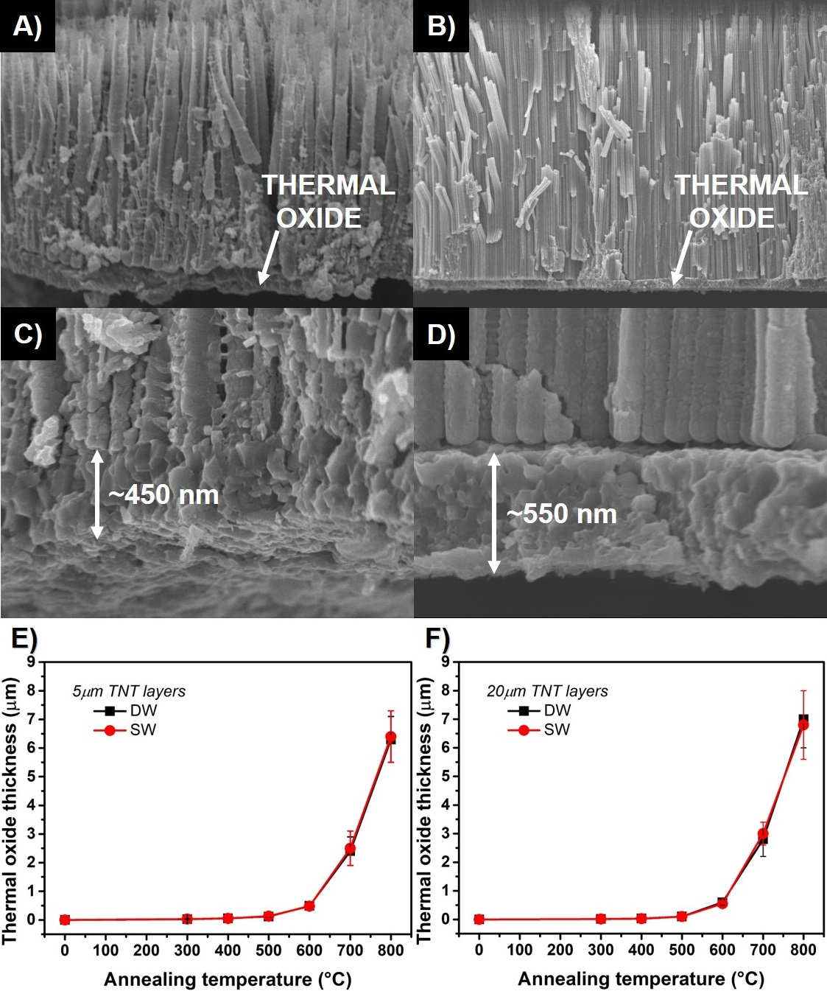
Fig. 3. (A, B) low and (C, D) high magnification cross-sectional SEM images of 5 μm and 20 μm thick single-wall TiO₂ nanotube layers annealed at 600 °C with a visible thermal oxide layer underneath the nanotubes. Thickness of the thermal oxide layer vs annealing temperature for (E) 5 μm and (F) 20 μm thick TiO₂ nanotube layers, respectively. Data points are connected with lines for better eye-guidance.
Fig. 4A-D shows XRD patterns of amorphous and annealed DW and SW TNT layers annealed in the temperature range 300 – 800 °C for 1 h in air. Three different crystalline structures were identified in all types of TNT layers, namely, tetragonal anatase TiO₂ with space group P42/mnm (ICCD 01-086-1157) [46,47], tetragonal rutile TiO₂ with space group I41/amd (ICCD 00-021-1276) [46,47] and metallic Ti with the hexagonal structure with space group P63/mmc (ICCD 00-044-1294) [48–50]. In general, the as-prepared TNT layers are of amorphous nature with the visible diffractions of the underlying Ti substrate [48–50]. The intensity of these Ti diffractions is more pronounced in 5 μm thick TNT layers (Fig. 4A and B) due to the lower mass of TiO₂ to be penetrated by X-rays. Indeed, the diffraction signal of Ti is readily detected by XRD due to the 4-times smaller thicknesses of such TNT layers compared to their 20 μm thick counterparts. The intensity of the Ti diffractions decreased with increased annealing temperatures as the thermal oxide layer developed at the Ti substrate/nanotubes interface (Fig. 3) [15,45,51]. For 5 μm thick DW (Fig. 4A) and SW (Fig. 4B) TNT layers, the crystallization of the nanotubes occurs at 300 °C with the most intense (101) anatase diffraction at 2θ = ~25.3 °. In the annealing temperature range of 300 – 500 °C, solely the anatase phase was detected in all 5 μm thick DW and SW TNT layers. Annealing at 600 °C resulted in the beginning of the rutile formation with the most intense (110) diffraction at 2θ = ~27.4 °. With further increase of the annealing temperature (up to 800 °C), the intensity of the (110) rutile diffraction significantly increased, while the intensity of the (101) anatase decreased. Indeed, the anatase-to-rutile transformation increased exponentially as the annealing temperature increased [52]. These results correlate with the obtained results from SEM (Fig. 3). This is due to the lower surface free energy of the rutile phase compared to the anatase phase [52]. Overall, the kinetically stabilized anatase phase is at lower temperatures (300 – 500 °C) while at higher temperatures (600 – 800 °C) the thermodynamically stable rutile phase is preferred in 5 μm DW and SW TNT layers. In case of 20 μm thick DW (Fig. 4C) and SW (Fig. 4D) TNT layers, solely the anatase phase was detected in the annealing temperature range of 300 – 700 °C. The rutile phase was detected only after annealing at 800 °C. This suggests the stabilization of the anatase phase in the annealing temperature range 300 – 700 °C whereas at 800 °C the anatase-to-rutile transformation starts to occur in 20 μm thick DW and SW TNT layers. The reason for this dissimilarity in the anatase-to-rutile transformation for 5 μm and 20 μm thick TNT layers can be described as follows. In general, based on previous reports [53,54], it is considered that the irreversible anatase-to-rutile transformation in TiO₂ begins at the annealing temperature of ~600 °C in air, although some papers report that this transformation begins at different annealing temperatures (in the range 400 - 1200 °C) [46,47,55]. Obviously, there is a controversy regarding the anatase-to-rutile transformation in TiO₂. Besides the obvious annealing temperature and time conditions for the anatase-to-rutile transformation, additional factors such as aspect ratio, surface to volume ratio and morphology of TiO₂ influence the kinetics of its transformation [46,47,52–55]. The 5 μm thick TNT layers possess thicker nanotube walls (10 – 60 nm) compared to their 20 μm counterparts (5 – 10 nm). Thus, the physical constraints imposed by the thickness of the nanotube walls influence the anatase-to-rutile transformation. Therefore, as the anatase-to-rutile transformation is rather a reconstructive than an instantaneous process, where the sufficient amount of thermal energy is necessary to facilitate the rearrangement of atoms and the formed rutile crystallites are bigger in size compared to the anatase crystallites [46,47,52–55], the thickness of the nanotube wall is a crucial parameter for this transformation in TNT layers. The thermal energy for the anatase-to-rutile transformation in thicker walls of 5 μm thick TNT layers is lower (transformation starts at 600 °C) compared to their 20 μm thick counterparts (transformation starts at 800 °C). The anatase:rutile ratios for all TNT layers are summarized in Table 1.
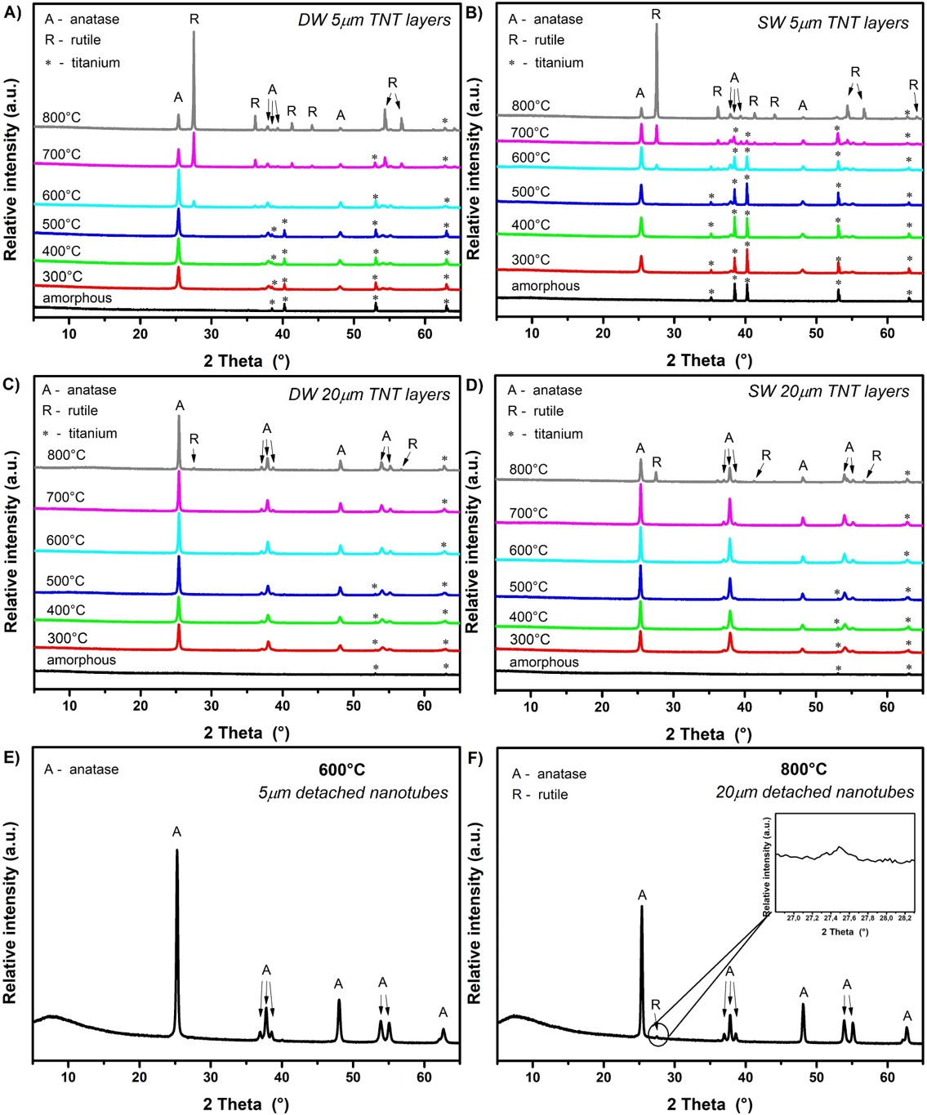
Fig. 4. XRD patterns of 5 μm thick A) double-wall and B) single-wall and of 20 μm thick C) double-wall and D) single-wall TiO₂ nanotube layers annealed at different temperatures; E) 5 μm thick DW nanotubes detached from the substrate annealed at 600 °C and F) 20 μm thick DW nanotubes detached from the substrate annealed at 800 °C. A - anatase; R - rutile; * - titanium.
For a deeper understanding on the anatase-to-rutile transformation of TNT layers, XRD analyses of TNT layers annealed without the Ti substrates were carried out. In this way the growth of the thermal oxide layer underneath the nanotubes was prevented. The DW TNT layers were used for this purpose. According to our recent report [56], the nanotubes were peeled-off from the substrate via mechanical bending. The obtained detached TiO₂ nanotubes (in the form of nanotube bundles) were subsequently annealed at 600 °C and 800 °C for 5 μm and 20 μm thick layers, respectively. The different annealing temperatures for such analyses were chosen based on the previous XRD results (Fig. 4) for 5 μm and 20 μm thick TNT layers. In 5 μm and 20 μm thick TNT layers, the rutile diffraction first appeared when annealing at 600 °C and 800 °C, respectively. Therefore, the 5 μm and 20 μm detached nanotubes were annealed at 600 °C and 800 °C, respectively, to evaluate their anatase-to-rutile transformation. Solely the anatase phase was detected in 5 μm thick detached TNT layers (Fig. 4E). In the case of 20 μm thick detached TNT layers, additional low intensity diffraction of the rutile phase was detected at 2θ = ~27.5 ° (Fig. 4F). Based on these side analyses, one can assume that the rutile content detected by XRD in all TNT layers (Fig. 4) primarily stems from the underlying thermal oxide layer. Nevertheless, it can be also expected that the nanotubes (when attached to the Ti substrate) annealed at temperatures ≥600 °C undergo some anatase-to-rutile transformation. The rutile containing thermal oxide layer induces the anatase-to-rutile transformation of the TNT layers. This is expected due to the template crystallization. On the other hand, the TNT layers used in semiconducting applications are used as a whole system (including the nanotubes, the thermal oxide layer and the underlying substrate) and not solely as separated nanotubes. Based on the presented results, it is therefore advisable to use TNT layers annealed at temperatures in the range of 300 – 500 °C to avoid any interface effects of the thermal oxide layer in between TNT layers and Ti substrates.
Table 1 Comparison of the thermal oxide layer thickness, anatase:rutile ratio, electrical resistance (R), optical band gap, and band gap of 5 μm and 20 μm thick double- (DW) and single-wall (SW) TiO₂ nanotube layers annealed at different temperatures.
5 μm thick TNT layers
Annealing temp. (°C) | Thermal oxide layer thickness (nm) |  | Ratio anatase:rutile  (%) |  | R (Ω) |  | Optical band gap (eV) |  | Band gap (eV)
 | DW | SW | DW | SW | DW | SW | DW | SW | DW | SW
- | 0 | 0 | - | - | 8.3x10⁹ | 1.5x10⁸ | - | - | - | -
300 °C | 25±5 | 30±5 | 100 : 0 | 100 : 0 | 2.5x10⁶ | 2.3x10⁴ | 3.14 | 3.12 | 3.14 | 3.11
400 °C | 55±5 | 50±5 | 100 : 0 | 100 : 0 | 1.4x10⁵ | 2.8x10⁵ | 3.12 | 3.11 | 3.11 | 3.13
500 °C | 120±20 | 130±10 | 99 : 1 | 99 : 1 | 2.7x10⁶ | 3.3x10⁵ | 3.10 | 3.10 | 3.10 | 3.09
600 °C | 490±20 | 480±20 | 84 : 16 | 81 : 19 | 7.1x10⁷ | 3.1x10⁷ | 2.96 | 2.93 | 2.99 | 2.95
700 °C | 2400±100 | 2500±120 | 37 : 63 | 60 : 40 | 9.4x10⁸ | 1.4x10⁹ | 2.93 | 2.92 | 2.90 | 2.91
800 °C | 6300±150 | 6400±200 | 20 : 80 | 15 : 85 | 6.3x10⁸ | 3.2x10⁹ | 2.92 | 2.78 | 2.85 | 2.86
20 μm thick TNT layers
Annealing temp. (°C) | Thermal oxide layer thickness (nm) |  | Ratio anatase:rutile  (%) |  | R (Ω) |  | Optical band gap (eV) |  | Band gap (eV)
 | DW | SW | DW | SW | DW | SW | DW | SW | DW | SW
- | 0 | 0 | 100 : 0 | 100 : 0 | 2.4x10¹⁰ | 2.1x10⁹ | - | - | - | -
300 °C | 15±5 | 15±5 | 100 : 0 | 100 : 0 | 8.7x10⁷ | 5.1x10⁶ | 3.01 | 3.07 | 3.06 | 3.07
400 °C | 30±5 | 25±5 | 100 : 0 | 100 : 0 | 3.1x10⁷ | 7.2x10⁵ | 3.04 | 3.10 | 3.13 | 3.13
500 °C | 100±5 | 100±5 | 100 : 0 | 100 : 0 | 2.7x10⁶ | 8.8x10⁴ | 3.04 | 3.09 | 3.07 | 3.13
600 °C | 600±100 | 550±100 | 100 : 0 | 100 : 0 | 1.0x10⁸ | 1.1x10⁸ | 3.01 | 3.04 | 2.95 | 3.00
700 °C | 2800±600 | 3000±400 | 100 : 0 | 99 : 1 | 1.0x10⁹ | 7.2x10⁸ | 3.02 | 3.03 | 2.90 | 2.99
800 °C | 7000±1000 | 6800±1000 | 98 : 2 | 77 : 23 | 2.7x10⁹ | 6.8x10⁸ | 2.95 | 2.92 | 2.88 | 2.85

Fig. 5 shows the dependence of the electrical resistance on the annealing temperature of the 5 μm and 20 μm thick DW and SW TNT layers studied by a conventional two-point probe measurement. For 5 μm thick DW and SW TNT layers (Fig. 5A), the lowest resistance was obtained for the layers annealed at 400 °C (order 10⁵ Ω) and 300 °C (order 10⁴ Ω), respectively. The 20 μm thick DW and SW TNT layers (Fig. 5B) possess the lowest electrical resistance for the layers annealed at 500 °C (order 10⁷ Ω for DW and order 10⁵ Ω for SW). In general, the electrical resistance of SW TNT layers is decreased by 1 - 2 orders compared to their DW counterparts when annealed up to 300 °C and 300 – 500 °C for 5 μm and 20 μm thick layers, respectively. This significant difference is attributed to the removal of the inner wall of the SW TNT layers. Indeed, the detrimental C and F species in the inner wall hinder the conductivity of TNT layers. In particular the F species which are primarily situated on the outer walls of the nanotubes (between the nanotubes) and at the nanotubes/substrate interface (between the nanotubes and the underlying substrate) [22–24] are responsible for decreased conductivity of DW compared to SW TNT layers. For TNT layers annealed at 600 °C, a significant increase in the electrical resistance was recorded. The reason for this is two-fold: i) a pronounced growth of a thermal oxide layer underneath the nanotube layers (Fig. 3 and Table 1). This is due to a heat transfer reasons [15,45] which occur during the annealing of TNT layers (i.e., crystallization of TiO₂), and ii) the anatase-to-rutile transformation starts (the rutile phase possess lower electron mobility compared to the anatase phase) [38,57,58].
It is noteworthy that during the measurement of the electrical resistance, in particular during the repetitive forward and reverse bias cycling, the typical Schottky-type curve for the n-type semiconductor was recorded (data not shown here), with no hystereses visible between different cycles. No abrupt changes in the current density that would be typical for the resistive switching of TiO₂ shown in the literature [59] were observed.
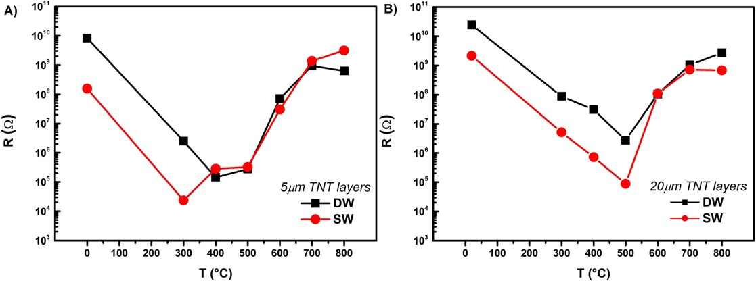
Fig. 5. Electrical resistance as a function of the annealing temperature for A) 5 μm thick double-wall and single-wall and B) 20 μm thick double-wall and single-wall TiO₂ nanotube layers. Data points are connected with lines for better eye-guidance.
Further, diffuse reflectance UV-VIS spectra and the corresponding Kubelka-Munk curves were recorded to determine the reflectance and the indirect optical band gap energy (Table 1) of TNT layers annealed at different temperatures (Fig. 6). As shown in Table 1, it was observed that up to an annealing temperature of 600 °C the reflectance edge appeared at ~400 nm, which can be attributed to the anatase phase with the optical band gap energy ~3 eV [35]. An additional reflectance edge at ~420 nm (optical band gap ~2.95 eV) appeared in TNT layers annealed at 700 °C and 800 °C which is attributed to the rutile phase [35]. The obtained values of the indirect optical band gap energy are in good agreement with previous reports on TiO₂ materials composed of solely anatase or mixed anatase/rutile phase [60–63]. Overall, the incident light absorption and the optical band gap energy is similar in DW and SW TNT layers of each particular thickness.
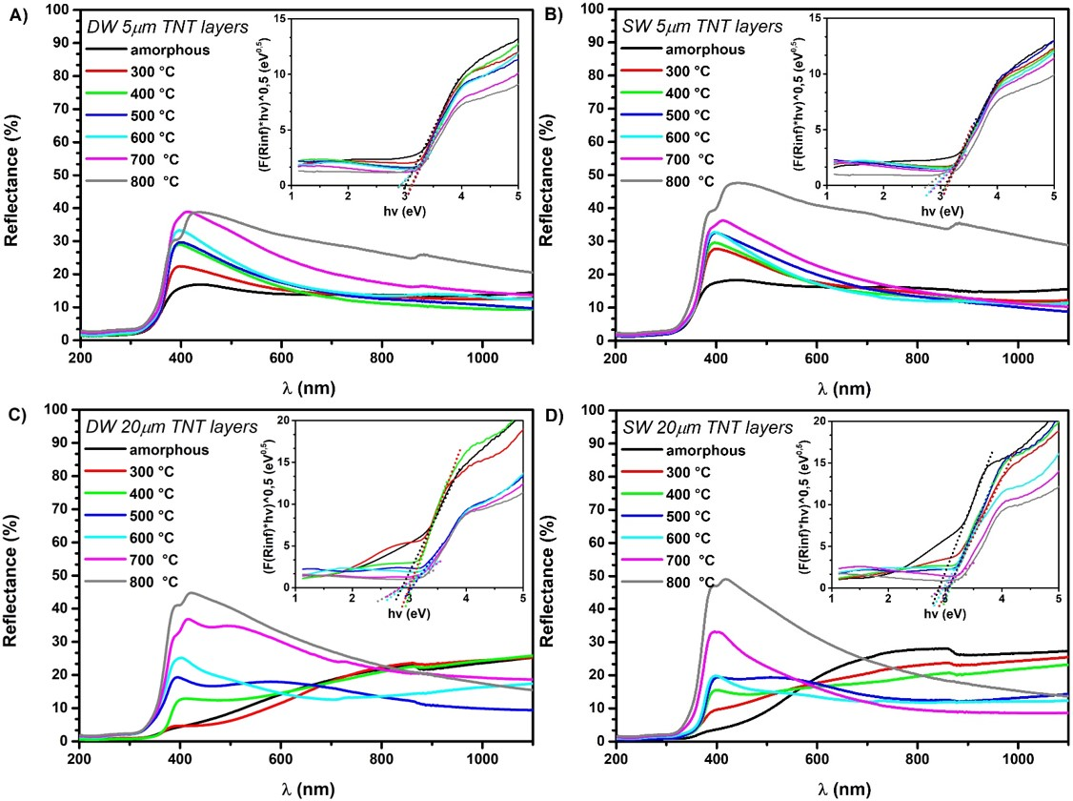
Fig. 6. UV-VIS diffuse reflectance spectra and the corresponding Kubelka-Munk curves (the insets) for 5μm thick A) double-wall and B) single-wall and for 20 μm thick C) double-wall and D) single-wall TiO₂ nanotube layers.
Fig. 7 shows incident photon-to-electron conversion efficiencies (IPCE) of amorphous and annealed (300 – 800 °C) DW and SW TNT layers. For both 5 μm and 20 μm thick TNT layers, a pronounced increase in the IPCE values can be observed for the SW compared to the DW layers. Such increase in the IPCEs of SW TNT layers can be ascribed to the removal of the inner wall [28]. It is apparent that the TNT layers annealed in the temperature range of 300 – 500 °C provide higher IPCE values compared to layers annealed at 600 – 800 °C. This difference can be explained with regard to the impact of the anatase and the rutile phases on the photoelectrochemical properties of TiO₂. Although the band gap energy of the anatase TiO₂ (~3.2 eV) is higher compared to that of the rutile (~3.0 eV), the anatase phase possesses a higher electron mobility than the rutile phase [15,64]. Therefore, in the UV light region, the anatase phase with lower recombination rate of charge carriers resulted in higher IPCE values. The lower IPCE values obtained from the TNT layers annealed in the temperature range 600 – 800 °C stem from the increased rutile content (Fig. 4) and thicker thermal oxide layers between the TNT layers and the underlying Ti substrate (Fig. 3 and Table 1). This is in line with previous reports [15,45] showing that the thickness of the thermal oxide layer underneath the nanotubes increased with increased annealing temperature, thus significantly affected the photoelectrochemical properties of such TNT layers.

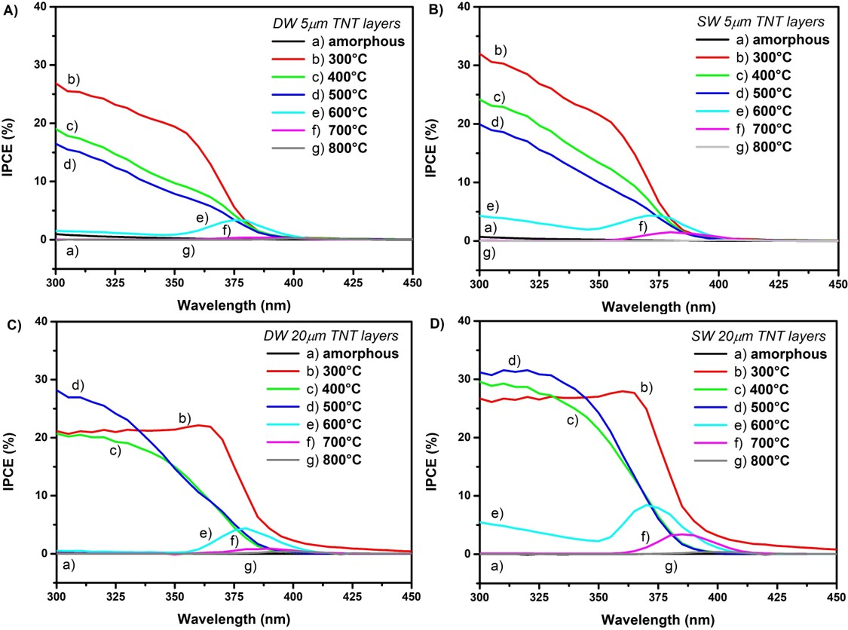
Fig. 7. Incident photon-to-electron conversion efficiencies (IPCE) vs wavelength for 5μm thick A) double-wall and B) single-wall and for 20 μm thick C) double-wall and D) single-wall TiO₂ nanotube layers.
Fig. 8 shows the (IPCE. hν)^{1/2} vs hν plots which were employed to explore the influence of the different annealing temperatures on the indirect band gap energy of TNT layers and are summarized in Table 1. Here, similar to the evaluated optical band gap results obtained from the diffuse reflectance UV-VIS spectroscopy (Fig. 6), the band gap shifts to the lower energies with increased annealing temperature. When annealed in the temperature range 300 – 500 °C and 300 – 700 °C for 5 μm and 20 μm thick TNT layers, respectively, the obtained band gap values ranged from 3.00 eV to 3.15 eV. Annealing in the temperature range 600 – 800 °C and at 800 °C for 5 μm and 20 μm thick TNT layers, respectively, resulted in the band gap shift to the lower energies from 2.85 eV to 3.0 eV for all TNT layers. Indeed, the increased rutile-to-anatase ratio (Fig. 4 and Table 1) and the increased thickness of the underlying thermal oxide layer (Fig. 3 and Table 1) in TNT layers is responsible for such shift. Interestingly, the photoresponse (Fig. 7) of 5 μm and 20 μm thick TNT layers is comparable. Moreover, the incident light absorption (Fig. 6) of 20 μm thick TNT layers is more efficient compared to that of 5 μm thick layers. This is in contrast with the previous study [65] where the authors report the photoresponse and the incident light absorption as a dependence of the nanotube layer thickness (i.e., the thinner nanotube layers possess increased UV photoresponse compared to the thicker ones). In general, the absorption coefficient of a semiconductor depends on the materials band gap and on the properties of the incident light (e.g., wavelength, frequency) [66]. Besides that, the actual mass of TiO₂ (as an incident light collector) in a material is another crucial parameter. Although the thickness of 5 μm thick TNT layers is 4 times smaller compared to that of 20 μm thick layers, which favors the migration of the photogenerated charge carriers to the electron collecting tube bottom in such layers [65], the actual mass of TiO₂ is also ~4.8 times smaller. The calculated mass of TiO₂ in 5 μm and 20 μm thick TNT layers is ~0.41 mg and ~1.96 mg per macroscopic cm² of the sample, respectively. The calculated values were further confirmed by a simple experimental effort. As recently reported [56], the nanotubes were peeled-off by mechanical bending from the substrate to obtain bundles of nanotubes which were subsequently weighed. Therefore, due to the increased mass of TiO₂ in the 20 μm compared to the 5 μm thick TNT layers, the thicker layers possess comparable photoresponse and even enhanced light absorption compared to the thinner layers. All in all, it is clear that the best photoelectrochemical performance is achieved using SW TNT layers annealed in the temperature range 300 – 500 °C with the more efficient light absorption due to the inner wall removal compared to their DW counterparts.
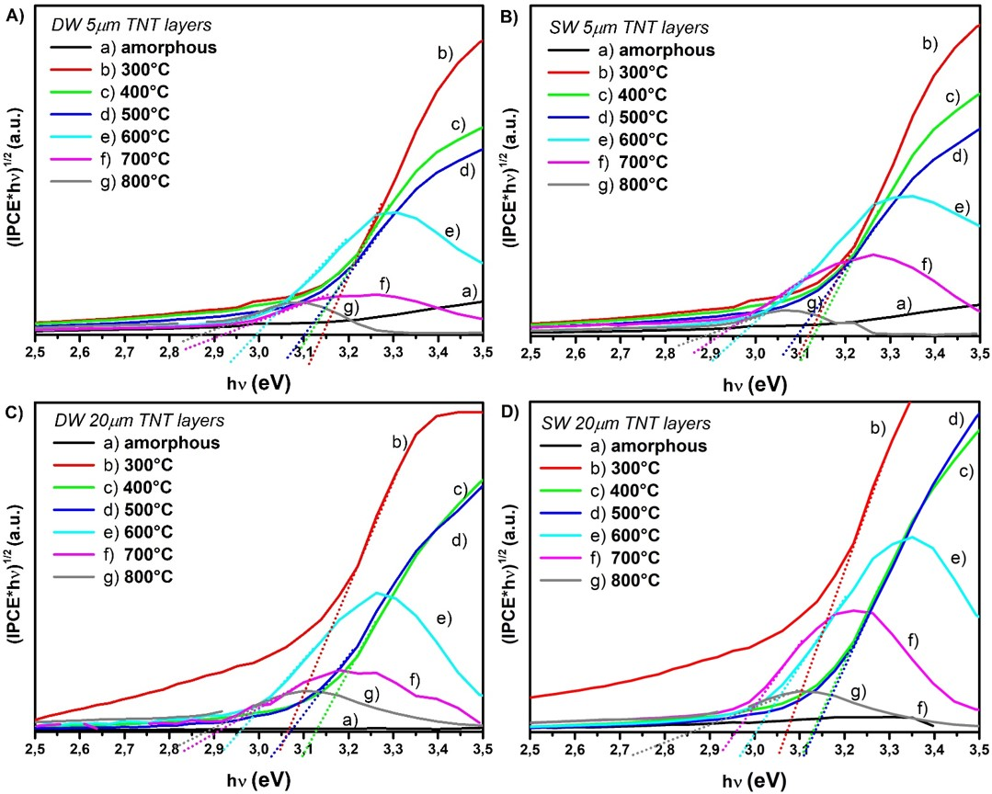
Fig. 8. (IPCE. hν)^{1/2} vs hν for 5μm thick A) double-wall and B) single-wall and for 20 μm thick C) double-wall and D) single-wall TiO₂ nanotube layers.

4. Conclusions
In the present work, we compared the intrinsic properties of high-aspect ratio anodic DW and SW TNT layers annealed at different temperatures in air. During the annealing, solely the anatase phase was detected by XRD in the temperature range 300 – 500 °C and 300 – 700 °C in 5 μm and 20 μm thick TNT layers, respectively. The mixture of anatase/rutile was detected in the temperature range 600 – 800 °C and at 800 °C for 5 μm and 20 μm thick TNT layers, respectively. The conductivity of SW TNT layers was increased by 1 – 2 orders compared to the DW TNT layers when annealed up to 300 °C and up to 500 °C for 5 μm and 20 μm thick layers, respectively. This is due to the removal of the inner wall and due to the relatively thin thermal oxide layer formed during annealing underneath the nanotubes compared to the TNT layers annealed at temperatures >500 °C where the thickness of the thermal oxide layer is substantial. Photoelectrochemical properties of the SW TNT layers of both thicknesses annealed in the temperature range 300 – 800 °C possess enhanced IPCE values and improved charge carrier transport compared to that of the DW TNT layers due to the lack of the inner wall.
Acknowledgements
The authors acknowledge the financial support from the European Research Council (ERC No. 638857) and the Ministry of Education, Youth and Sports of the Czech Republic (projects LM2015082, LM2018103, LQ1601, CZ.02.1.01/0.0/0.0/17_048/0007421).
References
[1] M. Assefpour-Dezfuly, C. Vlachos, E.H. Andrews, Oxide morphology and adhesive bonding on titanium surfaces, J. Mater. Sci. 19 (1984) 3626–3639. doi:10.1007/BF02396935.
[2] S.P. Albu, A. Ghicov, J.M. Macak, P. Schmuki, 250 µm long anodic TiO2 nanotubes with hexagonal self-ordering, Phys. Status Solidi – Rapid Res. Lett. 1 (2007) R65–R67. doi:10.1002/pssr.200600069.
[3] J.M. Macak, H. Tsuchiya, A. Ghicov, K. Yasuda, R. Hahn, S. Bauer, P. Schmuki, TiO2 nanotubes: Self-organized electrochemical formation, properties and applications, Curr. Opin. Solid State Mater. Sci. 11 (2007) 3–18. doi:10.1016/j.cossms.2007.08.004.
[4] K. Lee, A. Mazare, P. Schmuki, One-dimensional titanium dioxide nanomaterials: Nanotubes, Chem. Rev. 114 (2014) 9385–9454. doi:10.1021/cr500061m.
[5] J.M. Macak, M. Zlamal, J. Krysa, P. Schmuki, Self-Organized TiO2 Nanotube Layers as Highly Efficient Photocatalysts, Small. 3 (2007) 300–304. doi:10.1002/smll.200600426.
[6] P.M. Perillo, D.F. Rodríguez, The gas sensing properties at room temperature of TiO 2 nanotubes by anodization, Sensors Actuators, B Chem. 171–172 (2012) 639–643. doi:10.1016/j.snb.2012.05.047.
[7] P. Roy, D. Kim, K. Lee, E. Spiecker, P. Schmuki, TiO2 nanotubes and their application in dye-sensitized solar cells, Nanoscale. 2 (2010) 45–59. doi:10.1039/b9nr00131j.
[8] X. Gao, J. Li, J. Baker, Y. Hou, D. Guan, J. Chen, C. Yuan, Enhanced photovoltaic performance of perovskite CH 3 NH 3 PbI 3 solar cells with freestanding TiO 2 nanotube array films, Chem. Commun. 50 (2014) 6368–6371. doi:10.1039/c4cc01864h.
[9] D. Pugliese, A. Lamberti, F. Bella, A. Sacco, S. Bianco, E. Tresso, TiO2 nanotubes as flexible photoanode for back-illuminated dye-sensitized solar cells with hemi-squaraine organic dye and iodine-free transparent electrolyte, Org. Electron. 15 (2014) 3715–3722. doi:10.1016/j.orgel.2014.10.018.
[10] G.K. Mor, K. Shankar, M. Paulose, O.K. Varghese, C.A. Grimes, Enhanced photocleavage of water using titania nanotube arrays, Nano Lett. 5 (2005) 191–195. doi:10.1021/nl048301k.
[11] S. Bauer, J. Park, J. Faltenbacher, S. Berger, K. Von Der Mark, P. Schmuki, Size selective behavior of mesenchymal stem cells on ZrO2 and TiO2 nanotube arrays, Integr. Biol. 1 (2009) 525–532. doi:10.1039/b908196h.
[12] J.M. Macak, H. Tsuchiya, L. Taveira, S. Aldabergerova, P. Schmuki, Smooth Anodic TiO2 Nanotubes, Angew. Chemie Int. Ed. 44 (2005) 7463–7465. doi:10.1002/anie.200502781.
[13] J.M. MacAk, K. Sirotna, P. Schmuki, Self-organized porous titanium oxide prepared in Na2SO 4/NaF electrolytes, Electrochim. Acta. 50 (2005) 3679–3684. doi:10.1016/j.electacta.2005.01.014.
[14] K. Zhu, N.R. Neale, A. Miedaner, A.J. Frank, Enhanced charge-collection efficiencies and light scattering in dye-sensitized solar cells using oriented TiO2 nanotubes arrays, Nano Lett. 7 (2007) 69–74. doi:10.1021/nl062000o.
[15] S. Das, R. Zazpe, J. Prikryl, P. Knotek, M. Krbal, H. Sopha, V. Podzemna, J.M. Macak, Influence of annealing temperatures on the properties of low aspect-ratio TiO2 nanotube layers, Electrochim. Acta. 213 (2016) 452–459. doi:10.1016/j.electacta.2016.07.135.
[16] H. Tsuchiya, J.M. Macak, A. Ghicov, A.S. Räder, L. Taveira, P. Schmuki, Characterization of electronic properties of TiO2 nanotube films, Corros. Sci. 49 (2007) 203–210. doi:10.1016/j.corsci.2006.05.009.
[17] R. Beranek, H. Tsuchiya, T. Sugishima, J.M. Macak, L. Taveira, S. Fujimoto, H. Kisch, P. Schmuki, Enhancement and limits of the photoelectrochemical response from anodic TiO2 nanotubes, Appl. Phys. Lett. 87 (2005) 1–3. doi:10.1063/1.2140085.
[18] H. Sopha, L. Hromadko, K. Nechvilova, J.M. Macak, Effect of electrolyte age and potential changes on the morphology of TiO2 nanotubes, J. Electroanal. Chem. 759 (2015) 122–128. doi:10.1016/j.jelechem.2015.11.002.
[19] S.P. Albu, A. Ghicov, S. Aldabergenova, P. Drechsel, D. LeClere, G.E. Thompson, J.M. Macak, P. Schmuki, Formation of Double-Walled TiO 2 Nanotubes and Robust Anatase Membranes, Adv. Mater. 20 (2008) 4135–4139. doi:10.1002/adma.200801189.
[20] N. Liu, H. Mirabolghasemi, K. Lee, S.P. Albu, A. Tighineanu, M. Altomare, P. Schmuki, Anodic TiO2 nanotubes: Double walled vs. single walled, Faraday Discuss. 164 (2013) 107–116. doi:10.1039/c3fd00020f.
[21] S. Berger, S.P. Albu, F. Schmidt-Stein, H. Hildebrand, P. Schmuki, J.S. Hammond, D.F. Paul, S. Reichlmaier, The origin for tubular growth of TiO2 nanotubes: A fluoride rich layer between tube-walls, Surf. Sci. 605 (2011). doi:10.1016/j.susc.2011.06.019.
[22] M. Motola, M. Čaplovičová, M. Krbal, H. Sopha, G.K. Thirunavukkarasu, M. Gregor, G. Plesch, J.M. Macak, Ti3+ doped anodic single-wall TiO2 nanotubes as highly efficient photocatalyst, Electrochim. Acta. (2019). doi:10.1016/j.electacta.2019.135374.
[23] A. Dronov, I. Gavrilin, E. Kirilenko, D. Dronova, S. Gavrilov, Investigation of anodic TiO 2 nanotube composition with high spatial resolution AES and ToF SIMS, Appl. Surf. Sci. 434 (2018) 148–154. doi:10.1016/j.apsusc.2017.10.132.
[24] S. Mohajernia, A. Mazare, I. Hwang, S. Gaiaschi, P. Chapon, H. Hildebrand, P. Schmuki, Depth elemental characterization of 1D self-aligned TiO 2 nanotubes using calibrated radio frequency glow discharge optical emission spectroscopy (GDOES), Appl. Surf. Sci. 442 (2018) 412–416. doi:10.1016/j.apsusc.2018.02.185.
[25] H. Mirabolghasemi, N. Liu, K. Lee, P. Schmuki, Formation of “single walled” TiO2 nanotubes with significantly enhanced electronic properties for higher efficiency dye-sensitized solar cells, Chem. Commun. 49 (2013) 2067–2069. doi:10.1039/c3cc38793c.
[26] S. So, F. Riboni, I. Hwang, D. Paul, J. Hammond, O. Tomanec, R. Zboril, D.R. Sadoway, P. Schmuki, The double-walled nature of TiO 2 nanotubes and formation of tube-in-tube structures – a characterization of different tube morphologies, Electrochim. Acta. 231 (2017) 721–731. doi:10.1016/j.electacta.2017.02.094.
[27] S. So, I. Hwang, P. Schmuki, Hierarchical DSSC structures based on “single walled” TiO2 nanotube arrays reach a back-side illumination solar light conversion efficiency of 8%, Energy Environ. Sci. 8 (2015) 849–854. doi:10.1039/c4ee03729d.
[28] M. Motola, H. Sopha, M. Krbal, L. Hromádko, Z.O. Zmrhalová, G. Plesch, J.M. Macak, Comparison of photoelectrochemical performance of anodic single- and double-walled TiO2 nanotube layers, Electrochem. Commun. 97 (2018) 1–5. doi:10.1016/j.elecom.2018.09.015.
[29] D. Beketova, M. Motola, H. Sopha, J. Michalicka, V. Cicmancova, F. Dvorak, L. Hromadko, B. Frumarova, M. Stoica, J.M. Macak, One-Step Decoration of TiO 2 Nanotubes with Fe 3 O 4 Nanoparticles: Synthesis and Photocatalytic and Magnetic Properties, ACS Appl. Nano Mater. 3 (2020) 1553–1563. doi:10.1021/acsanm.9b02337.
[30] M. Krbal, J. Kucharik, H. Sopha, H. Nemec, J.M. Macak, Charge transport in anodic TiO ₂ nanotubes studied by terahertz spectroscopy, Phys. Status Solidi - Rapid Res. Lett. 10 (2016) 691–695. doi:10.1002/pssr.201600179.
[31] P. Roy, S. Berger, P. Schmuki, TiO2 Nanotubes: Synthesis and Applications, Angew. Chemie Int. Ed. 50 (2011) 2904–2939. doi:10.1002/anie.201001374.
[32] D.A. Tryk, A. Fujishima, K. Honda, Recent topics in photoelectrochemistry: Achievements and future prospects, Electrochim. Acta. 45 (2000) 2363–2376. doi:10.1016/S0013-4686(00)00337-6.
[33] O. Carp, C.L. Huisman, A. Reller, Photoinduced reactivity of titanium dioxide, Prog. Solid State Chem. 32 (2004) 33–177. doi:10.1016/j.progsolidstchem.2004.08.001.
[34] B. Munirathinam, H. Pydimukkala, N. Ramaswamy, L. Neelakantan, Influence of crystallite size and surface morphology on electrochemical properties of annealed TiO 2 nanotubes, Appl. Surf. Sci. 355 (2015) 1245–1253. doi:10.1016/j.apsusc.2015.08.017.
[35] Y. Rambabu, M. Jaiswal, S.C. Roy, Effect of annealing temperature on the phase transition, structural stability and photo-electrochemical performance of TiO2 multi-leg nanotubes, Catal. Today. 278 (2016) 255–261. doi:10.1016/j.cattod.2016.01.016.
[36] Y. Li, H. Yu, C. Zhang, W. Song, G. Li, Z. Shao, B. Yi, Effect of water and annealing temperature of anodized TiO2 nanotubes on hydrogen production in photoelectrochemical cell, Electrochim. Acta. 107 (2013) 313–319. doi:10.1016/j.electacta.2013.05.090.
[37] C. Kim, S. Lee, S. Kim, J. Yoon, Effect of Annealing Temperature on the Capacitive and Oxidant-generating Properties of an Electrochemically Reduced TiO2 Nanotube Array, Electrochim. Acta. 222 (2016) 1578–1584. doi:10.1016/j.electacta.2016.11.143.
[38] A. Tighineanu, T. Ruff, S. Albu, R. Hahn, P. Schmuki, Conductivity of TiO2 nanotubes: Influence of annealing time and temperature, Chem. Phys. Lett. 494 (2010) 260–263. doi:10.1016/j.cplett.2010.06.022.
[39] N. Vaenas, M. Bidikoudi, T. Stergiopoulos, V. Likodimos, A.G. Kontos, P. Falaras, Annealing effects on self-assembled TiO2 nanotubes and their behavior as photoelectrodes in dye-sensitized solar cells, Chem. Eng. J. 224 (2013) 121–127. doi:10.1016/j.cej.2013.02.017.
[40] J.M. Aquino, J.P. Silva, R.C. Rocha-Filho, S.R. Biaggio, N. Bocchi, Comparison between microwave and muffle annealing of self-organized TiO2 nanotubes into crystalline anatase, Mater. Lett. 167 (2016) 209–212. doi:10.1016/j.matlet.2015.12.069.
[41] J.Y. Lin, Y.T. Chou, J.L. Shen, M.D. Yang, C.H. Wu, G.C. Chi, W.C. Chou, C.H. Ko, Effects of rapid thermal annealing on the structural properties of TiO 2 nanotubes, Appl. Surf. Sci. 258 (2011) 530–534. doi:10.1016/j.apsusc.2011.08.073.
[42] S.A.A. Yahia, L. Hamadou, M.J. Salar-García, A. Kadri, V.M. Ortiz-Martínez, F.J. Hernández-Fernández, A.P. de los Rios, N. Benbrahim, TiO 2 nanotubes as alternative cathode in microbial fuel cells: Effect of annealing treatment on its performance, Appl. Surf. Sci. 387 (2016) 1037–1045. doi:10.1016/j.apsusc.2016.07.018.
[43] R. Zazpe, M. Knaut, H. Sopha, L. Hromadko, M. Albert, J. Prikryl, V. Gärtnerová, J.W. Bartha, J.M. Macak, Atomic Layer Deposition for Coating of High Aspect Ratio TiO2 Nanotube Layers, Langmuir. 32 (2016) 10551–10558. doi:10.1021/acs.langmuir.6b03119.
[44] S. Das, H. Sopha, M. Krbal, R. Zazpe, V. Podzemna, J. Prikryl, J.M. Macak, Electrochemical Infilling of CuInSe ₂ within TiO ₂ Nanotube Layers and Subsequent Photoelectrochemical Studies, ChemElectroChem. 4 (2017) 495–499. doi:10.1002/celc.201600763.
[45] S.P. Albu, H. Tsuchiya, S. Fujimoto, P. Schmuki, TiO2 Nanotubes - Annealing Effects on Detailed Morphology and Structure, Eur. J. Inorg. Chem. 2010 (2010) 4351–4356. doi:10.1002/ejic.201000608.
[46] P.I. Gouma, M.J. Mills, Anatase-to-Rutile Transformation in Titania Powders, J. Am. Ceram. Soc. 84 (2001) 619–622. doi:10.1111/j.1151-2916.2001.tb00709.x.
[47] H. Zhang, J.F. Banfield, Phase transformation of nanocrystalline anatase-to-rutile via combined interface and surface nucleation, J. Mater. Res. 15 (2000) 437–448. doi:10.1557/JMR.2000.0067.
[48] M. Motola, L. Satrapinskyy, T. Roch, J. Šubrt, J. Kupčík, M. Klementová, M. Jakubičková, F. Peterka, G. Plesch, Anatase TiO2nanotube arrays and titania films on titanium mesh for photocatalytic NOXremoval and water cleaning, Catal. Today. 287 (2017) 59–64. doi:10.1016/j.cattod.2016.10.011.
[49] M. Motola, L. Satrapinskyy, M. Čaplovicová, T. Roch, M. Gregor, B. Grančič, J. Greguš, Ľ. Čaplovič, G. Plesch, Enhanced photocatalytic activity of hydrogenated and vanadium doped TiO 2 nanotube arrays grown by anodization of sputtered Ti layers, Appl. Surf. Sci. 434 (2018) 1257–1265. doi:10.1016/j.apsusc.2017.11.253.
[50] M. Motola, E. Dworniczek, L. Satrapinskyy, G. Chodaczek, J. Grzesiak, M. Gregor, T. Plecenik, J. Nowicka, G. Plesch, UV light-induced photocatalytic, antimicrobial, and antibiofilm performance of anodic TiO 2 nanotube layers prepared on titanium mesh and Ti sputtered on silicon, Chem. Pap. 73 (2019) 1163–1172. doi:10.1007/s11696-018-0667-4.
[51] O.K. Varghese, D. Gong, M. Paulose, C.A. Grimes, E.C. Dickey, Crystallization and high-temperature structural stability of titanium oxide nanotube arrays, J. Mater. Res. 18 (2003) 156–165. doi:10.1557/JMR.2003.0022.
[52] D.A.H. Hanaor, C.C. Sorrell, Review of the anatase to rutile phase transformation, J. Mater. Sci. 46 (2011) 855–874. doi:10.1007/s10853-010-5113-0.
[53] M. Hirano, C. Nakahara, K. Ota, O. Tanaike, M. Inagaki, Photoactivity and phase stability of ZrO2-doped anatase-type TiO2 directly formed as nanometer-sized particles by hydrolysis under hydrothermal conditions, J. Solid State Chem. 170 (2003) 39–47. doi:10.1016/S0022-4596(02)00013-0.
[54] T.B. Ghosh, S. Dhabal, A.K. Datta, On crystallite size dependence of phase stability of nanocrystalline TiO2, J. Appl. Phys. 94 (2003) 4577–4582. doi:10.1063/1.1604966.
[55] R.D. Shannon, J.A. Pask, Kinetics of the Anatase-Rutile Transformation, J. Am. Ceram. Soc. 48 (1965) 391–398. doi:10.1111/j.1151-2916.1965.tb14774.x.
[56] H. Michalkova, Z. Skubalova, H. Sopha, V. Strmiska, B. Tesarova, S. Dostalova, P. Svec, L. Hromadko, M. Motola, J.M. Macak, V. Adam, Z. Heger, Complex cytotoxicity mechanism of bundles formed from self-organised 1-D anodic TiO2 nanotubes layers, J. Hazard. Mater. 388 (2020) 122054. doi:10.1016/j.jhazmat.2020.122054.
[57] R. Sanjinés, H. Tang, H. Berger, F. Gozzo, G. Margaritondo, F. Lévy, Electronic structure of anatase TiO2 oxide, J. Appl. Phys. 75 (1994) 2945–2951. doi:10.1063/1.356190.
[58] L. Forro, O. Chauvet, D. Emin, L. Zuppiroli, H. Berger, F. Lévy, High mobility n-type charge carriers in large single crystals of anatase (TiO2), J. Appl. Phys. 75 (1994) 633–635. doi:10.1063/1.355801.
[59] V. Aglieri, A. Zaffora, G. Lullo, M. Santamaria, F. Di Franco, U. Lo Cicero, M. Mosca, R. Macaluso, Resistive switching in microscale anodic titanium dioxide-based memristors, Superlattices Microstruct. 113 (2018) 135–142. doi:10.1016/j.spmi.2017.10.031.
[60] W.R. Siah, H.O. Lintang, M. Shamsuddin, L. Yuliati, High photocatalytic activity of mixed anatase-rutile phases on commercial TiO2 nanoparticles, in: IOP Conf. Ser. Mater. Sci. Eng., Institute of Physics Publishing, 2016. doi:10.1088/1757-899X/107/1/012005.
[61] H.Y. Liu, Y.L. Hsu, H.Y. Su, R.C. Huang, F.Y. Hou, G.C. Tu, W.H. Liu, A comparative study of amorphous, anatase, rutile, and mixed phase TiO2 films by mist chemical vapor deposition and ultraviolet photodetectors applications, IEEE Sens. J. 18 (2018) 4022–4029. doi:10.1109/JSEN.2018.2819700.
[62] W. Fu, G. Li, Y. Wang, S. Zeng, Z. Yan, J. Wang, S. Xin, L. Zhang, S. Wu, Z. Zhang, Facile formation of mesoporous structured mixed-phase (anatase/rutile) TiO2 with enhanced visible light photocatalytic activity, Chem. Commun. 54 (2017) 58–61. doi:10.1039/c7cc05750d.
[63] Z. Luo, A.S. Poyraz, C.H. Kuo, R. Miao, Y. Meng, S.Y. Chen, T. Jiang, C. Wenos, S.L. Suib, Crystalline mixed phase (anatase/rutile) mesoporous titanium dioxides for visible light photocatalytic activity, Chem. Mater. 27 (2015) 6–17. doi:10.1021/cm5035112.
[64] D. Mardare, G.I. Rusu, The influence of heat treatment on the optical properties of titanium oxide thin films, Mater. Lett. 56 (2002) 210–214. doi:10.1016/S0167-577X(02)00441-X.
[65] J.M. Macak, A. Ghicov, R. Hahn, H. Tsuchiya, P. Schmuki, Photoelectrochemical properties of N-doped self-organized titania nanotube layers with different thickness, J. Mater. Res. 21 (2006) 2824–2828. doi:10.1557/jmr.2006.0344.
[66] E.J. Johnson, Chapter 6 Absorption near the Fundamental Edge, Semicond. Semimetals. 3 (1967) 153–258. doi:10.1016/S0080-8784(08)60318-X.

