Dilemmas of using the quality of life’s concept for region’s socioeconomic development
Jan Mandys, Martin Šanda, Tetiana Korovchenko
Abstract: Socio-economic development of the region is not derived only from the performance of the local economy and riches of inhabitants. In an effort to achieve equilibrium of the social society, regional management is facing numerous obstacles. The main obstacle is finding the method of measuring the degree of satisfying the needs of inhabitants, citizens. One of the way for retrospective evaluation of effectivity and effectiveness measures, which are promoting the development of region, is using of concept of quality of life. In the following text are briefly described the basic dilemmas in definition of quality of life. Then weaknesses of individual procedures are discussed in the examples of specific measurements. The result is a reasoning - how to measure quality of life so as to deliver the expected results for the needs of regional management? The primary issue in our considerations is the minimum number of publicly available data on the subjective quality of life. We consider objective indicators simplistic and often misleading (in relation to an abstract concept to most definitions of quality of life). Because the subject of interest of this concept is the man, we have to look for the intersection of these two approaches. Another important question is to use data obtained by regional management in decision making and very definition of the expectations of the regional management of these data.
Key words: Quality of Life, Public Policy, Region, Socio-economic Development
JEL Classification: C69 · H79 · H83 · I31 · O21 · R59

Introduction
Public policy is responsible for the local socio-economic development. Public policy is accountable to its citizens to the general target. With this objective public policy is ensuring decent conditions for life, consequently optimum for the development of all aspects of life. Public policy cannot give attention only to individuals but they must be viewed from a broader perspective - for realizing of general target.
Quality of life (inhabitants' satisfaction with the place where they live) is one of the indicators of a successful region. As is evident, quality of life is a variable which is empirically difficult to be grasped. The following text attempts to show the quality of life as a key attribute of socio-economic development of the region. And this text highlights the complexity of definitions and specific examples of the complexity of its applicability to a useful practice. These dilemmas are illustrated with specific measurements of quality of life on real data.
If we occupy ourselves with defining the term ‘quality of life’, we have to consider influence of historical, cultural and social changes, which take place in given society. Quality of life should be looked upon as a multidimensional variable, which contains information about the psychosocial status of an individual influenced by, for example, age, gender, education, social status, economic situation or an individual’s values. Quality of life needs to be viewed as the subjective appreciation of one’s own living situation. Quality of life can be viewed as the availability of options from which an individual can choose during the course of his/her life (Phillips; 2006, Royuela, V., & Moreno, R., & Vayá, E.; 2010).
Defining the term quality of life brings many dilemmas. Currently, there is no consensus what does the quality of life define. Multidimensional aspect demonstrates a lot of indicator systems, for example, set by the European Statistical System Committee. See figure 1.

Figure 1 Quality of Life indicators for the Europe Union
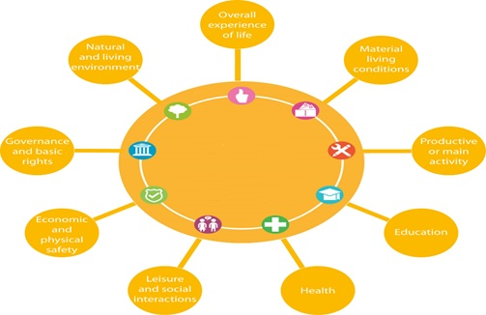
Source: Eurostat; 2016
Quality of life thus represents universal category determining welfare of citizens of a certain region. This category relies on:
- Objective factors: Objective factors of quality of life are considered the following:
- Gross domestic product: (Český statistický úřad; 2016, Kubátová; 2010).
- Living standards of a single individual or a household: income levels and consumption, wealth and poverty (Kubátová; 2010). Direct quantification of amount of consumed goods and services, or financial incomes and property, leisure, means spent on public services from the budget. Also amount of harmful substances discharged into water or air, average life expectancy, infant mortality, level of insecurity/insecurity index (Červenka; 2010).
- The human development index: contains these three components: wealth, health and level of education. Within these items minimal and maximal fixed values have been established (Kotýnková, Kubelková; 2011)
- Other examples: Economic welfare index, Index of Social Health – ISH (Ayvazyan; 2016).
- Subjective aspect: Subjective aspect of quality of life derives from individual well-being. Regarding the issue of wellbeing, authors state (Dvořáková, Dušková, Svobodová, a kol.; 2006) that well-being represents long-term emotion state of satisfaction of an individual with his/her life. This emotional state is relatively constant over time. Life satisfaction, morality or happiness can be considered as components of well-being.
Other examples (Ayvazyan; 2016): Quality of life index from World Health Organisation, Consumer Confidence Indexes – CCI, Eurobarometer.

Methods
Quality of life evaluation is very complicated issue. Therefore it is appropriate to "take the help of" software or programming tools such as expert systems, multi criteria decision making systems and models, rule-based systems and using special methodologies and methods of system engineering for solving these problems. Particularly advantageous are extensions of these methods using fuzzy set theory (Škrabánek, P.; 2014). The Technique for Order of Preference by Similarity to Ideal Solution (TOPSIS) method is one of Multi Attribute Decision Making algorithms, which is widely adopted. TOPSIS ranks the available networks, which are based on their scores, with the highest being the best solution (Senouci, M. A., & Hoceini, S., & Mellouk, A.; 2016). TOPSIS method is presented by Chen and Hwang and it is a multiple criteria method to recognize solutions from a limited set of variants or alternatives. The fundamental rule is that the preferred alternative should have the shortest distance from the ideal solution and longest distance from the negative-ideal solution (CHen SJ., & Hwang CL.; 1992). TOPSIS method was used in this way in 10 selected indicators, for all of NUTS3 regions of Czech Republic for each year in the range 2000 – 2015. In order to help the agency STEM/MARK, a survey , whose goal was find important indicators (by inhabitants in Czech Republic), was created. Altogether, 506 respondents (from differently regions, education, age and etc.) were participated in the STEM/MARK's survey in august 2016. Indicators used in the survey are summarized in Table 1. In our study, ten most important indicators were selected from them. Specifically, indicators that more than 30% from all respondents have identified as important were used.

Table 1 Selected indicators
Signification | Indicator | Ranking (%) | Important indicator
K1 | Life expectancy at birth | 50.4 | yes
K5 | Doctors per 1,000 inhabitants | 49.6 | yes
K9 | Gross domestic product per capita | 47.6 | yes
K18 | Dust emissions | 41.7 | yes
K10 | Long-term unemployed | 37.9 | yes
K4 | Crimes per 1,000 population | 37.5 | yes
K24 | A household with Internet access | 36.2 | yes
K12 | Median gross monthly wages | 35.0 | yes
K19 | Share of developed areas | 31.0 | yes
K8 | Share of population living in houses connected to public sewage | 30.4 | yes
K21 | Cars per 1,000 population | 28.1 | no
K15 | Number of unsuccessful applicants for the elderly | 26.7 | no
K23 | Proportion of university-educated population | 26.7 | no
K11 | Number of applicants for one position at the labor offices | 25.5 | no
K20 | Waste of companies per capita | 24.9 | no
K6 | Occupational diseases per 100,000 inhabitants | 22.5 | no
K7 | Average duration of incapacity | 21.1 | no
K14 | Value of social aid benefits paid per capita | 20.9 | no
K2 | Total population increase per 1000 population | 20.0 | no
K13 | Number of businesses | 19.8 | no
K17 | Number of small protected areas | 18.6 | no
K3 | Traffic accidents per 1,000 population | 13.8 | no
K22 | Voter turnout in elections to the regional assemblies | 13.4 | no
K16 | Share of the surplus budget to the expenditure in region | 12.6 | no

Source: STEM/MARK

Data matrix for the individual indicators for all years and all indicators were compiled from the Czech Statistical Office. In the next section, the results for the NUTS3 regions, in individual years and the progress status of regions within the Czech Republic by method TOPSIS, are presented. Weight for indicators was determined 0,1 - for each equally.
For arguments of useful using subjective quality life concept, we will briefly outline results of the two surveys (Mandys, Jirava, Křupka, Kašparová, Duplinský; 2012, Mojžíšová; 2016) which analysed public perception in relation to social issues in the city of Pardubice in the years 2012 and 2015. Under the terms of this analysis, there was a first, and subsequently a second, survey on views of citizens on quality of life in this region. In both cases, the responses were carried out by means of a questionnaire with the help of trained questioners. In both cases, the same methodology of data collection was used (based on age category and residence in one of the 8 Pardubice districts).
The first survey was focused on the situation in social services within the city of Pardubice (Mandys, Jirava, Křupka, Kašparová, Duplinský; 2012). Enquiries directed to the public were merely a partial component. Altogether 384 respondents took part in the analysis in the given region. Respondents answered nineteen questions. The second survey was focuses on mapping satisfaction with social services in the city of Pardubice (Mojžíšová; 2016). Data collection and analysis was carried out in the year 2015. Under the terms of pre-research, the questionnaire from the 2012 analysis was tested in the second place. Subsequently, slight modifications have been made which resulted in a 22-item questionnaire. Questions related to the quality of life have not been modified. 387 respondents took part in the survey in 2012 and 337 in 2015. Both surveys equally asked following questions:
- How does the respondent assess his quality of life?
- How secure does the respondent feel in everyday life?
- Does the respondent have access to information which is necessary for his/her life?

Research results
In this part we shortly introduce both of our analysis of objective and subjective approaches to problem definition quality of life.

Quality of life evaluation results in NUTS3 regions in Czech Republic
Quality of life evaluation results in NUTS3 regions in Czech Republic are shown in Table 2, and visualized in Fig. 2. In this figure, values of coefficient c_{i} in years 2000 – 2015 are shown, where coefficient c_{i} is a result of TOPSIS method, and c_{i} ∈<0;1>.
Table 2 Data matrix
Region / c_{i} values | C₂₀₀₁ | C₂₀₀₃ | C₂₀₀₅ | C₂₀₀₇ | C₂₀₀₉ | C₂₀₁₁ | C₂₀₁₃ | C₂₀₁₅
HKR | 0.52336 | 0.52308 | 0.52308 | 0.52293 | 0.52209 | 0.52711 | 0.53133 | 0.53058
JHČ | 0.52140 | 0.51916 | 0.52304 | 0.52322 | 0.51916 | 0.52290 | 0.52387 | 0.52062
JHM | 0.51652 | 0.51972 | 0.51943 | 0.51818 | 0.51910 | 0.51976 | 0.51963 | 0.52128
KVA | 0.53115 | 0.52770 | 0.52675 | 0.53004 | 0.52746 | 0.52454 | 0.52379 | 0.52575
LIB | 0.53287 | 0.53707 | 0.53575 | 0.53223 | 0.53802 | 0.53527 | 0.53552 | 0.53611
MSZ | 0.54544 | 0.54534 | 0.54662 | 0.54594 | 0.54669 | 0.54435 | 0.54417 | 0.54356
OLO | 0.51510 | 0.51794 | 0.51908 | 0.51740 | 0.51945 | 0.52054 | 0.52223 | 0.53117
PAK | 0.52482 | 0.52503 | 0.52452 | 0.52093 | 0.52678 | 0.52586 | 0.53052 | 0.52930
PLZ | 0.51978 | 0.52248 | 0.52191 | 0.52163 | 0.52003 | 0.51940 | 0.52067 | 0.51754
PRA | 0.52245 | 0.52250 | 0.52253 | 0.52253 | 0.52255 | 0.52245 | 0.52235 | 0.52233
STČ | 0.54263 | 0.54296 | 0.54297 | 0.54187 | 0.54376 | 0.54156 | 0.54063 | 0.53708
UST | 0.54591 | 0.54571 | 0.54658 | 0.54476 | 0.54175 | 0.54260 | 0.54324 | 0.53944
VYS | 0.52470 | 0.52614 | 0.53074 | 0.52372 | 0.53188 | 0.53057 | 0.52574 | 0.52511
ZLN | 0.52402 | 0.52525 | 0.52532 | 0.52334 | 0.52381 | 0.52330 | 0.52342 | 0.52366
Source: Own processing

Figure 2 Results of coefficient c_{i}

Source: Own processing
In Table 2, following marking of the NUTS3 regions is used: : HKR - Hradec Králové Region, JHČ - South Bohemian Region, JHM - South Moravian Region, KVA - Karlovy Vary Region, LIB - Liberec Region, MSZ - Moravian-Silesian Region, OLO – Olomouc Region, PAK – Pardubice Region, PLZ - Plzeň Region, PRA - Prague, STČ - Central Bohemian Region, UST – Ústí n.L. Region, VYS - Vysočina Region and ZLN – Zlín Region.
As this figure shows, the differences among the regions are not significant. Thus, we can say, that quality of life is in all regions alike good. For certain regions, we can see constant development; however "interesting" trend or fluctuations can be recognized in other ones. It is worth emphasizing that the graph seems to be confused. It is caused by many similar curves that overlap each other. Contrary to our expectations, regions MSZ and UST did well. Indeed, these regions are rather taken as a "regions with problems" in terms of crimes, environment, employment, etc.. This fact can be taken as an advantage of the used method TOPSIS. Even when using relative values, the quantity had not a great significance. As further evidence can be taken "unpleasant" surprise which was born in Prague. The indicator has stable value for this region; however, the region has moved up to around 10-th place in the ranking.

Quality of life in City of Pardubice
Here we make comparisons of results from both analyses. In both cases, very similar samples, without principal difference in terms of number of respondents, their education structure and economic activity, were considered. Considering this fact, it can be stated that it is a real view of reality. In various opinion polls and charts, Pardubice ranks highly over a long period of time. Indeed, the city has a favourable geographical location including good transport facilities. Moreover, there are a lot of working opportunities in this region. These facts are also reflected in results of our surveys.

Figure 3 Quality of life assessment
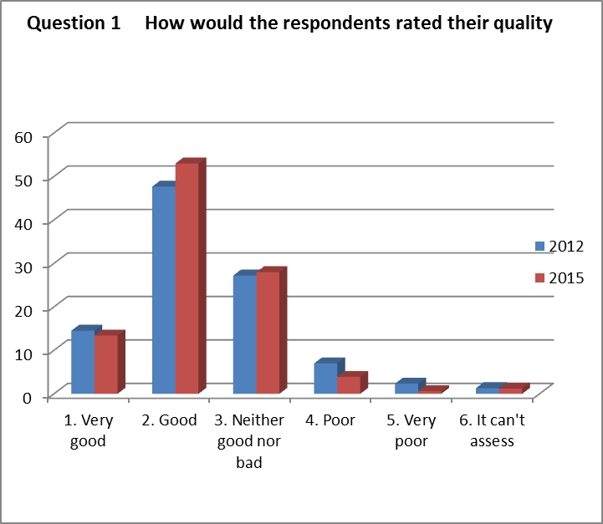
Source: Mandys, Jirava, Křupka, Kašparová (2012), Mojžíšová (2016)

The answers of the first question show that only a small part of the respondents do not valuate the life in Pardubice in a positive way. The most of the respondents think that the city is a good place to live. A neutral answer within similar classification is usually caused by the fact that the respondent profits from the possibility of escape and avoids giving a definite answer. This is the usual problem that the most of researchs solve.

Figure 4 How secure do the respondents feel in everyday life
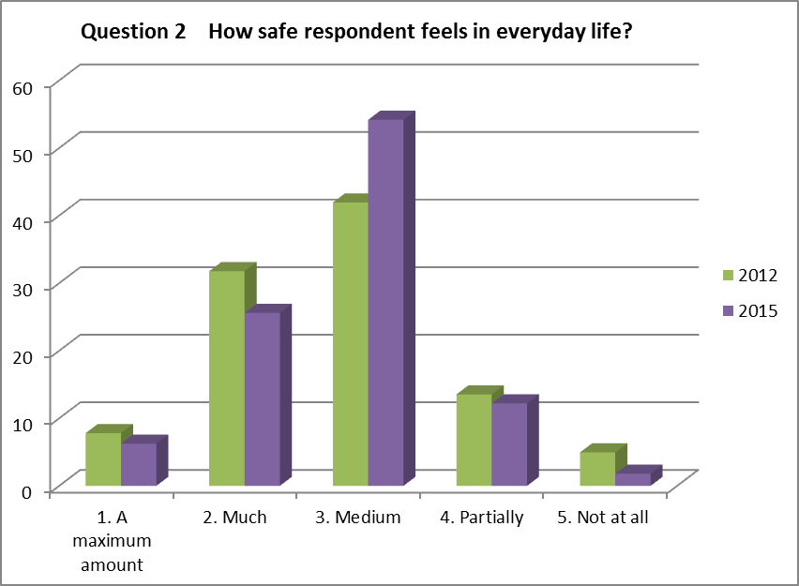
Source: Mandys, Jirava, Křupka, Kašparová (2012), Mojžíšová (2016)
Security is among the key attributes of the quality of life. We see again that there are generally no major changes in the results. Slight increase in neutral assessment can be seen in the year 2015. Yet most of the respondents perceive security in the city in a neutral or rather positive way. It can also be influenced by the fact that people are more trying to solve their problems with the help of Pardubice city police (Statutární město Pardubice; 2016).

Figure 4 Enough information for everyday life
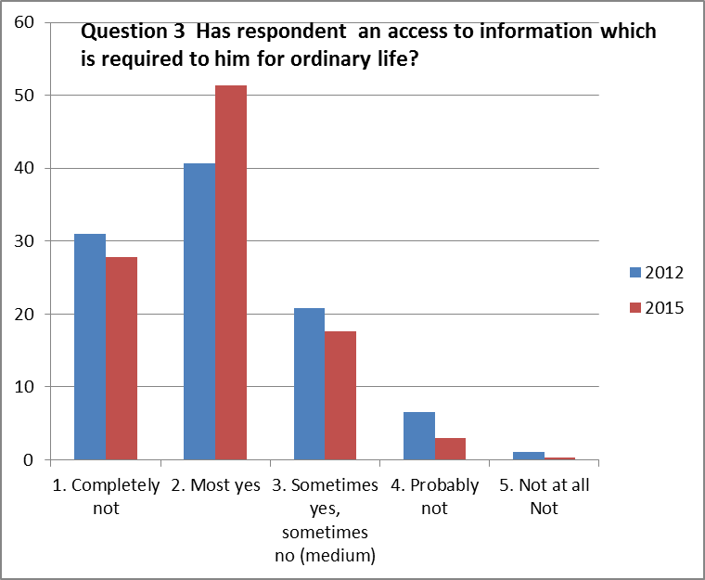
Source: Mandys, Jirava, Křupka, Kašparová (2012), Mojžíšová (2016)

Awareness within the city of Pardubice can also be considered as good. We consider adequate information to be a principal attribute of the quality of life a specially with respect to current information overload in society. In this point, we recommend particularly concrete definition of typology of information, which the public administration considers to be essential for life in a municipality (region).
It is merely a schematic procedure while analysing quality of life. Quality of life is quite challenging. This is mainly due to the fact that there is a significant number of indicators which may be important in assessing the quality of life. Actually, this was primarily a test about how the respondents will react to these questions, what results they will bring, and whether these results will be useful for local administration management. Our results do not bring complex view on given problems on a selected region. We consider as a partial success the fact that questions on quality of life have been successfully integrated into sub segments of analytical work for the needs of the city of Pardubice.

Conclusions
As was shown in this paper, evaluation of the quality of life is fairly problematic issue. Its practical implementation is usually challenging; however, tools like rule-based systems, expert systems, multi criteria decision making systems, method of system engineering may simplify this process. Despite this drawback, the concept of the quality of life has one big advantage. This concept monitors the quality of life from many facets. Thus, this concept allows a complex assessment of the quality of life.
As follows from the findings and our experiences, the concept of the quality of life is a useful tool for management of the socio-economic development of regions. However, the concept has to be used in an appropriate way. At first, a regional management has to manifest a real (not only declarative) interest about needs of the community (region). It is also necessary to define local indicators which will be used for regular surveys. Regular evolution of the survey’s results is a foregone conclusion. These activities have to be carried out systematically. Using of this concept, without following all these assumptions, is meaningless.
We realize that definition of the indicators, aimed on measurement of citizen’s satisfaction with regions, is really not a simple task. Nevertheless, information about public opinions is fundamental for political representations. Indeed, members of political representations are elected representatives who build their programs on this information. Unfortunately, Czech political representation is based rather on clientelism than on understanding real needs. In order to overcome this drawback, we suggest combining of measures aimed on both objective and subjective quality of life. Such an approach allows preventing theoretical debates about selections of criteria or about choices of approaches. However, it is necessary to sensibly select monitored indicators. The indicators have to be selected with respect to local regional specifics.
Acknowledgement
The paper was supported by the University of Pardubice, Faculty of Economics and Administration, Project SGS_2016_023 „Economic and social development in private and public sector“.

References
Ayvazyan, s., A., (2016) Quality of Life and Living Standards Analysis. An Econometric Approach. Berlin: de Gruyter, 2016. ISBN: 978-3-11-031625-4.
Červenka, J. How to measure the standard of living?? (2016) [on-line]. Socioweb [cit. 2016-10-24]. Available from: http://www.socioweb.cz/index.php?disp=teorie&shw=114&lst=103
CHen SJ., & Hwang CL. (1992). Fuzzy Multiple Attribute Decision-Making: Methods and Applications. Springer-Verlag, New York. ISBN: 978-3-540-54998-7
Czech statistical office, (2016) Gross domestic product (GDP). [on-line] [cit. 2016-10-24]. Available from: https://www.czso.cz/csu/czso/hruby_domaci_produkt_-hdp-
Dvořáková, Z., & Dušková, L., & Svobodová, L. et all., (2006). The world of work and quality of life. Effect of changes in the world of work of quality of life. Prague: Occupational safety research institutE, 2006. ISBN 80-86973-08-5.
Eurostat. (2016) Quality of Life indicators for the Europe Union. [on-line] [cit. 2016-10-24]. Available from: http://ec.europa.eu/eurostat/web/gdp-and-beyond/quality-of-life/data
Kotýnková, M., & Kubelková, K., (2011). Indicators of human development, focusing of the poverty in the Czech Republic. Reproduction of human capital - mutual linkages and connections III. Praha: Oeconomica, 2011. ISBN 978-80-245-1697-4.
Kubátová, H., (2010). Sociology of lifestyle. Praha: Grada Publishing a.s., 2010. ISBN 978-80-247-2456-0.
Mandys, J., & Jirava P., & Kašparová, M., & Křupka, J., & Duplinský, J., (2012). The situation in social services in the city of Pardubice. Final research report. Pardubice: Univerzity of Pardubice.
Mojžíšová, m., (2016). Satisfaction analyses of social policy in Pardubice. [Dissertation]. Pardubice: Univerzity of Pardubice.
Phillips, D. (2006). Quality of Life: Concept, Policy and Practice. London: Routledge, 2006. ISBN 978-0-415-32355-0.
Royuela, V., & Moreno, R., & Vayá, E. (2010) Influence of Quality of Life on Urban Growth: A Case Study of Barcelona. Regional Studies. 44. (5), 551–567.
Senouci, M. A., & Hoceini, S., & Mellouk, A. (2016). Utility function-based TOPSIS for network interface selection in Heterogeneous Wireless Networks. 2016 IEEE International Conference on Communications (ICC). IEEE, 2016, 1-6. DOI: 10.1109/ICC.2016.7511563. ISBN 978-1-4799-6664-6.
Stem/Mark. Quality of life: importance of indicators. 2016. Netbus 11. - 15. 8. 2016. Czech Republic.
Škrabánek, P. (2014) Teorie fuzzy množin a její aplikace [online] [cit. 2016-10-24] Pardubice: Univerzita Pardubice, 2014. ISBN 978-80-7395-875-6. Available from: https://e-shop.upce.cz/fcgi/versot.fpl?fname=eo_priloha&id=164598

