Human capital as an important growth factor of regions in the czech republic
Denisa Chlebounová a
a University of Pardubice
chlebounovadenisa@seznam.cz
Keywords:
human capital – economic growth – gross domestic product – higher education – region
JEL classification: O15, R11
Abstract:
Human capital is generally regarded as one of the key factors of regional growth. This paper examines the interdependence between human capital and the regional growth in the Czech Republic by correlation analysis. Human capital is expressed as a result of education, particularly as the percentage of people with higher education. The amount of the regional gross domestic product (GDP) per capita is a scale for economic performance of regions. The calculated correlation coefficient characterizes the intensity of the relationship between the two variables, which in this case appeared considerably significant.

Introduction
The concept of human capital has become a subject of interest in the second half of the 18th century. Smith (1776) started point to the fact that among the factors of production include the skills and knowledge of individuals in economic theories. More specific definition of the term "human capital" is often attributed to the authors of the Chicago School of Economics - Nobel Laureate Becker (1963) and Mincer (1958).
Nowadays it is generally accepted Becker definition: "Human capital is the skills and adequate incentives these skills apply." It also states that individuals decide on participation in the development of human capital as an investment based on a comparison of revenues and expenses. In its conception yields are e.g. higher wages, better jobs, but also non-monetary income such as improved health, culture and education, moving up the social ladder. Cost is the time value (lost opportunity costs) and the value of expenditure on the acquisition of these investments. Formation of human capital takes place mainly through education. Due to the difficult assessment innate ability, family and social environments that have human capital also had a profound impact, based on the assumption that human capital is the result of education.
Human capital is by Lucas (1988) and Romer (1990) - representatives of the new growth theory - the driving force behind long-term economic growth. They argue that human capital, innovation and knowledge contribute significantly to economic growth. With this view, however, disagree Bils and Klenow (2000) and Pritchett (2001), according to which, the role of human capital in economic growth is too exaggerated. The study of Pritchett concludes that education creates no human capital. It cannot increase cognitive skills or productivity, but it can lead to wage increases because an educated man is more valuable for employers. Another conclusion of this study is that human capital is used in many countries, activities that reduce economic growth, e.g. bloated bureaucracy.
- Methods, literature overview
In this section I will try to answer the key question that I asked. Is there a dependency (or how strong dependency is) between the highest level of education reached (I consider the percentage share of the population with higher education) in each Czech region, and the amount of gross domestic product per capita in these regions for 2014? Or whether the regional GDP is higher in regions with a higher proportion of people with higher education?
On this question, I will try to answer through the establishment of correlation analysis. The necessary data for calculating the correlation analysis are given in Table 1:
TAB. 1: Comparison of regional GDP with percentage share of the population with higher education in 2014
Source: own calculations based on Czech Statistical Office (2015)
The purpose of correlation analysis is to obtain a correlation coefficient. It is used to capture the intensity of the relationship between the two variables. Word correlation in the general sense is a measure of the degree of association of two variables. If the coefficient is positive it means that one quantity grows, other quantity is also growing (extreme value is 1). For calculating the correlation analysis it is needed somehow quantify (estimated) level of human capital. We need an indicator that best describes human capital, but also is applicable in practical terms, therefore, is well predictable. In doing so, the basic definition of human capital is evident that the measurement will not be easy. Human capital is the qualitative characteristics of unit (human), while we want it to capture quantitative indicator. It therefore offers the possibility of an assessing the level of human capital through surveys highest level of education, which I also used. The problem may be that the same levels of education sometimes differ considerably from each other.
In looking at the individual level of human capital plays a role also its degree of wear. Gained knowledge by Mazouch and Fischer (2011) eventually become obsolete and it is necessary to renew, update and develop them (like skills). Yet the highest level of education reached is one of the most frequently used and relatively simple, although imperfect measurable characteristics of human capital. Educational statistics provides annual data on the number of graduates. The disadvantage of this approach is that it only considers formal education and neglects other forms, especially lifelong learning and adult education. But the data of this type of education are less accessible. For this reason, the calculation used this approach.
- Result
The value of the correlation coefficient in this analysis: r = 0.9567. Of this amount of correlation coefficient can be deduced significant relationship between examined variables. Higher education, according to this model, has a significant impact on the economic performance of the region.
FIG. 1: Higher education and regional GDP
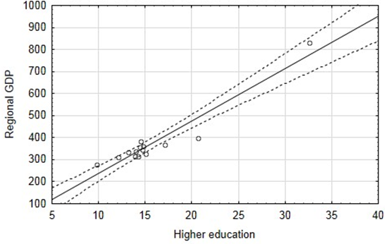
Source: authors’ calculations in program STATISTICA 10
If we in the same manner calculated correlation coefficients for other educational groups, we would find that people with secondary education with graduation have a correlation coefficient slightly lower than undergraduates (r = 0.8529). There is less dependence compared to undergraduates, but it is still significant. The correlation coefficient of people with secondary education without graduation and primary education or no education came out negative (if the value is negative, one quantity increases and the other quantity decreases). With the growth of the share of these persons, economic performance of the region is declining. The correlation coefficient of people with secondary education without graduation came out: r = -0.9482 (while for persons with primary education or no education: r = -0.7561).
This analysis has shown that current support secondary education without graduation from politicians due to the decline of interest in this study is erroneously justified. Namely, apprentices influence on economic growth is negative. Another proof confirming this fact is high unemployment rate of graduates of secondary vocational schools. In April 2016, according to statistics (2016) unemployment reached 9.1 % (for graduates of secondary vocational education with a graduation exam 7.5 %). Also, students' interest in these fields falls according to recent surveys. Ondráčková (2016) says that some secondary vocational schools recorded up about 60 % fewer applications in comparison with last year. The reason is the greater availability of graduation courses and in particular also a growing demand for highly skilled workers. According to a study by Scio (2015) another problem is that half the number of apprentices eventually does not work and does not want to work in the fields in which qualifications were obtained (unsatisfactory financial conditions, substandard work).
FIG. 2: Compliance education and employment of graduates of secondary vocational schools
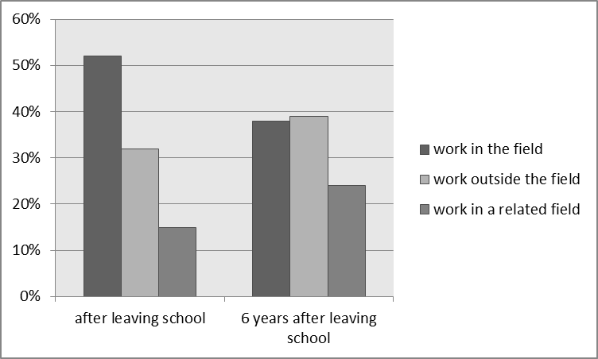
Source: Scio (2015)
All the above problems suggest that attempts to increase the number of apprentices are contra productive and do not contribute to economic growth.
- Discussion
The relationship between education levels and economic performance is also engaged Kostelecký, Patočková and Vobecká (2007). Their research also dealt with regions of the Czech Republic. Using the same method - correlation analysis - they reached a similar conclusion: there is a positive correlation between level of education in the region and its economic performance, but this correlation is weaker (r = 0.51) compared to the result of my research (r = 0.9567). The reason for this difference is the use of other input data. Kostelecký, Patočková and Vobecká examined the relationship between economic performance and the share of people with at least secondary education aged 25-34. They characterized the economic performance through “Aggregate index of economic performance”. The simplification when we do not take into account the different determination of economic performance, we could say when we compare their research with my research that independently people with higher education have a greater influence on size of the regional GDP (higher correlation coefficient) than if we include also persons with secondary education.
Scio (2015) says that the main reason for the growing demand of companies for craftsmen is obtaining cheap labour. A higher number of craftsmen enable companies to reduce wages and increase employee loyalty due to the excess of supply over demand in the labour market. This increasing demand creates the impression that there is the insufficient number of apprentices in the labour market. Therefore, politicians support apprenticeship, try to increase the number of apprentices to resolve this situation. However, the above mentioned unemployment rate speaks of unused labour. It would be preferable to strive to improve the quality of graduates of apprenticeships. Thus the chance of their success in the labour market increases more than if there was their simple numerical growth.
However, assessing the Impact of education on economic growth in the region is difficult. There are more economic factors and also non-economic factors. Barro (1996) among these factors ranks: life expectancy, fertility, trade, government spending, the level of rights and inflation. Problematic can be also a fact that the relationship between economic growth and education is very long-term and remain hidden to normal view. Growth of education to economic growth often manifests itself after some delay. Despite the above uncertainties, the positive impact of human capital on economic growth measured by level of education is indisputable. Kubík (2010) confirms the positive contribution of human capital to economic growth. Specifically, an additional year of education contributes to economic growth in the range of 2-6 %. These results are consistent with previous studies, e.g. Cohen and Soto (2007).

Conclusion
The main objective of this paper was to answer the question whether regional GDP is higher in regions of the Czech Republic, where is a higher proportion of people with higher education. The correlation analysis confirmed this relationship. The correlation coefficient is close to 1 in this research, which indicates almost certain dependence between the studied variables. This result is consistent with previous literature, which deals with the relationship between education levels and economic performance. E.g. by Kostelecká, Patočková and Vobecká (2007), education has a significant impact on economic growth.
It also proved that people with higher education have the biggest impact on economic growth of all education groups. People with secondary education with graduation have a slightly lower coefficient of correlation than undergraduates, the correlation coefficient of people with secondary education without graduation and primary education or no education came out negative. This means that with a growing proportion of these people, economic growth declines.
The analysis also confirmed unfounded political efforts to increase the number of apprentices. Namely, apprentices influence on economic growth is negative. One piece of evidence supporting this fact is high unemployment rate of graduates of secondary vocational schools. In this case, it is not reasonable to increase the numbers of apprentices, as required by companies, but rather to improve the quality of graduates of secondary vocational schools and to increase the interest of apprentices to work in the field they studied.
This research considers only formal education. In doing so, it can be assumed that the education of persons in many cases does not end completing formal education, but it will continue in various forms of lifelong learning, which are not included because of the difficulty of data availability. Level of education, however, is obviously very rough characteristic of human qualities and his potential contribution to society. Moreover, important is not only the quantity but also the quality of educational attainment and the ability of graduates in practice. For further research in this area it would be beneficial to expand its scope of these problems.
References:
Barro, R. J. (1996). Determinants of Economic Growth: A Cross-Country Empirical Study. The National Bureau of Economic Research, 1(1). doi:10.3386/w5698
Becker, G. S. (1963). Human Capital: A Theoretical and Empirical Analysis, with Special Reference to Education. Chicago: University of Chicago Press.
Bils, M., & Klenow, P. J. (2000). Does schooling cause growth?. The American Economic Review, (90)5, 1160-1183.
Czech Statistical Office. (2015). Komentář k regionálnímu HDP za rok 2014. Retrieved from http://apl.czso.cz/nufile/Reg_koment_12_2015.pdf.
Cohen, D., & Soto, M. (2007). Growth and human capital: good data, good results. Journal of Economic Growth, 12(1), 51–76. doi:10.1007/s10887-007-9011-5
Kostelecký, T., & Patočková, V., & Vobecká, J. (2007). Kraje v České republice – existují souvislosti mezi ekonomickým rozvojem, sociálním kapitálem a výkonem krajských vlád?. Czech Sociological Review, 33(5), 911-943.
Kubík, R. (2010). Kvantita a kvalita lidského kapitálu: Může počet let vzdělávání zvýšit úroveň studentů? Littera Scripta, 6(1), 61–69.
Lucas, R. (1988). On the mechanics of economic development. Journal of Monetary Economics, 22(1), 3-42. doi:10.1016/0304-3932(88)90168-7
Mazouch, P., & Fischer, J. (2011). Lidský kapitál – měření, souvislosti, prognózy. Praha: C. H. Beck.
Mincer, J. (1958). Investment in Human Capital and Personal Income Distribution. Journal of Political Economy, 66(4), 281-302.
National Institute for Education. (2016). Nezaměstnanost absolventů. Retrieved from http://www.infoabsolvent.cz/Temata/ClanekAbsolventi/5-1-04
Ondráčková, K. (2016). Všichni chtějí studovat. O učňovské obory není zájem. Retrieved from http://finexpert.e15.cz/vsichni-chteji-studovat-o-ucnovske-obory-neni-zajem
Pritchett, L. (2001). Where has all the education gone?. The World Bank Economic Review, 15(3), 367-391. doi:10.1093/wber/15.3.367
Romer, P. (1990). Endogenous technological change. Journal of Political Economy, Part 2, 98(5), 71-102. doi:10.3386/w3210
Scio. (2015). Více učňů prosperitě naší země nepomůže. Retrieved from http://www.ceskaskola.cz/2015/03/scio-vice-ucnu-prosperite-nasi-zeme.html
Smith, A. (1776). An Inquiry into the Nature And Causes of the Wealth of Nations.
Ing. Denisa Chlebounová
University of Pardubice
Studentská 95
532 10, Pardubice 2
Czech Republic

