Comparison of lab-made boron-doped diamond electrodes in electroanalysis of linuron and mesalazine

Michaela Štěpánková ª, Renáta Šelešovská ª, Lenka Janíková ª, Marián Marton ^{b}, and Pavol Michniak^{b}
ª University of Pardubice, Faculty of Chemical Technology, Institute of Environmental and Chemical Engineering, Studentská 573, 532 10 Pardubice, Czech Republic,
E-mail: st26846@student.upce.cz
^{b} Slovak University of Technology in Bratislava, Faculty of Electrical Engineering and Information Technology, Institute of Electronics and Photonics, Ilkovičova 3, 812 19 Bratislava, Slovak Republic.

Abstract
In this study, electrochemical properties of lab-made sensors based on boron-doped diamond (BDD) prepared by hot filaments chemical vapor deposition under different conditions and its application options for determination of substituted urea herbicide linuron and drug mesalazine have been studied. The B/C ratio in the gas phase was varied in the range from 1 000 to 20 000 ppm and the content of CH₄ in H₂ mixture was 1 %. Parameters of DPV and SWV were optimized on commercial BDDE. These methods were applied for analysis of both analytes using all tested BDDEs, and the calculated statistical parameters were compared.

Key words: Sensors, Boron-doped diamond electrode, Linuron, Mesalazine, Voltammetry.

Introduction
Boron-doped diamond (BDD) is an electrode material, which has great popularity in a various electrochemical applications since its introduction in 1992¹. It is substantiated by its excellent physical, mechanical, and electrochemical properties, such as very low and stable capacitive background current over a wide potential range, electrochemical stability in acidic as well as in alkaline media, extreme hardness, resistance to electrode fouling, and microstructural stability at extreme cathodic and anodic potentials². Diamond is generally recognized as an insulating material and for its electrochemical utilization, it needs to be doped with different atoms of elements. The majority of studies with doped-diamond electrodes use boron-doped diamond. Substances such as diborane or trimethyl borane can be used³. The boron content in BDD is one of the factors influencing substantially the film conductivity and morphology. The concentration of boron also significantly influences the electrochemical properties of the BDD films. Obviously, increased boron content leads to higher capacitance, slightly narrower solvent windows, and can increase the likelihood of undesirable incorporation of sp² impurities. Depending on doping level, BDD films present either semiconducting or metallic electronic properties². Besides electrochemical properties, the boron content can has influence in application area too. Thus, in this study, two analytes (herbicide linuron and mesalazine drug) with different chemical structure were chosen for the study of lab-made BDDEs.

Mesalazine, also known as 5-aminosalicylic acid or mesalamine (5-ASA, 5-Amino-2-hydroxybenzoic acid, CAS: 89-57-6, Fig. 1A), is well-established compound used in the management of inflammatory bowel disease (IBD). 5-ASA is an active moiety of sulfasalazine drug, which is metabolized to sulfapyridine and mesalazine. 5-ASA, as an antioxidant, traps free radicals, which are potentially damaging by products of metabolism^{4,5}. Linuron (LIN, 3-(3,4-dichlorophenyl)-1-methoxy-1-methylurea, CAS: 330-55-2, Fig. 1B) is substituted phenylurea herbicide used widely to selectively control newly established broadleaf weeds and grasses in fruit and field crops, and cereals⁶. LIN is a slightly toxic compound in EPA toxicity class III. It is used as a pre- and post-emergence herbicide and it acts as an inhibitor of photosynthesis⁷.

The electrochemical properties of lab-made BDDEs with the various content of boron were studied in present paper. Its application possibilities for determination of LIN and 5-ASA were investigated.

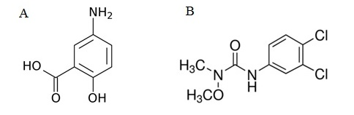
Fig. 1. Structural formula of mesalazine (A), and linuron (B).

Experimental
All chemicals used for preparation of the standard solutions, supporting electrolytes, and other stock solutions were of p.a. purity. Britton-Robinson (BRB) buffer of pH value from 2.0 to 12.0 was prepared from an acidic component (consisting of 0.04 mol L⁻¹ H₃PO₄, 0.04 mol L⁻¹ H₃BO₃, and 0.04 mol L⁻¹ CH₃COOH – all Lachema, Brno, Czech Republic), and from an alkaline component of 0.2 mol L⁻¹ NaOH (Lachema, Brno, Czech Republic). The electrolytes based on 1, 0.5, and 0.1 mol L⁻¹ HNO₃ were diluted from 65 % HNO₃ (Penta, Praha, Czech Republic). All solutions were prepared in distilled water. 1×10⁻³ mol L⁻¹ stock solution of linuron was made by dissolution of the LIN powder (purity 99.7 %, Sigma Aldrich, Praha, Czech Republic) in 70 % acetonitrile, and 0.01 mol L⁻¹ stock solution of mesalazine was made by dissolution of the 5-ASA powder (Sigma Aldrich, Praha, Czech Republic) in 0.1 mol L⁻¹ HCl (Penta, Praha, Czech Republic). Both stock solutions were stored in the glass flasks in a refrigerator.

Voltammetric measurements of LIN were performed by computer controlled Eco-Tribo Polarograph (Polaro-Sensors, Praha, Czech Republic) equipped by POLAR.PRO software (version 5.1) for Windows. On the other hand, for voltammetric study of 5-ASA was used AUTOLAB PGSTAT 12 (Metrohm Autolab, The Netherlands) potentiostat/galvanostat controlled by NOVA 1.11 software. All measurements were provided in a 3-electrodes set up, where commercially available BDDE (7.07 mm²) (Windsor Scientific Ltd, United Kingdom) or lab-made BDDEs (0.43 mm²) (Slovak University of Technology in Bratislava, Slovak Republic) served as the working electrode, saturated silver/silver chloride as a reference and platinum wire as an auxiliary electrode (both Monokrystaly, Turnov, Czech Republic). Accumet pH-meter AB150 (Fisher Scientific spol. s.r.o., Pardubice, Czech Republic) was used for the pH measurement. All experiments were performed at laboratory temperature (23±2 °C). Each BDDE was firstly anodically (+3 V for 60 s), and subsequently cathodically (−3 V for 300 s) pretreated in 0.5 mol L⁻¹ H₂SO₄ (Penta, Praha, Czech Republic) at the beginning of each working day.

For fabrication of LM-BDD sensors, the n-type Si(100) wafer with 1.4 µm thick SiO₂ layer (CVD, Oxford PlasmaLab 80) was used as a substrate. Firstly, the Si substrates were cleaned with isopropanol and deionized water and then they were seeded in the ultrasonic bath using a nanodiamond powder <10 nm (CAS: 7782-40-3, Sigma Aldrich). The BDD films were deposited 2 hours using double bias enhanced hot filaments reactor (HF CVD). A boron-doped monocrystalline diamond was achieved by adding trimethylboron (TMB) to the 1 % CH₄ in H₂ gas mixture. The B/C ratio in the gas phase was from 1 000 to 20 000 ppm. The deposition was performed in the pressure 3 000 Pa at a temperature 650 ± 20°C. The active area (0.43 mm²) of working electrode was created in 400 nm SiO₂ (CVD, Oxford PlasmaLab 80) by using standard optical lithography and wet etching in BOE solution (6:1 volume ratio of 40 % NH₄F in water to 49 % HF in water). The electrode chip (10×3 mm²) was electrically connected by Ag polymer paste (CB115, DuPont) to the printed circuit board´s support and completely passivated by non-conducting paste (548X, DuPont)⁸.

The voltammetric behavior of LIN was studied by cyclic voltammetry (CV) between potentials from −500 mV to +2 200 mV with scan rate (v) of 100 mV s⁻¹. DC voltammetry (DCV), with followed parameters: initial potential (E_{in}) of −500 mV, final potential (E_{fin}) of +1 900 mV and v of 25-500 mV s⁻¹, was utilized for studying the effect of a v on the voltammetric response of LIN. Differential pulse voltammetry (DPV) with following optimized parameters was applied for LIN determination: E_{in} = +400 mV, E_{fin} = +1 600 mV, v = 50 mV s⁻¹, pulse height = 70 mV and pulse width = 20 ms. Voltammetric behavior of 5-ASA was studied by CV between potentials 0 mV and +2 200 mV in dependence of v (v = 10-400 mV s⁻¹) and pH (v = 100 mV s⁻¹). Square wave voltammetry (SWV) with optimized parameters (E_{in} = 0 mV, E_{fin} = +2 200 mV, step potential = 7 mV, amplitude = 70 mV, frequency = 25 Hz) was used for 5-ASA determination. The limits of detection (LOD) were calculated as a three times, and limits of quantification (LOQ) as a ten times the standard deviation for the blank solution and divided by the slope of the calibration curve. The parameters of calibration curves (e.g., slope, intercept) were calculated using software OriginPro 9 (OriginLab Corporation, USA) and Excel (Microsoft Office, USA).

Results and discussion
In our previous work, the surface of boron-doped diamond films was characterized by scanning electron microscopy and Raman spectroscopy. Cyclic voltammetry and electrochemical impedance spectroscopy (EIS) of the redox system [Fe(CN)₆]^{3-/4-} were used for electrochemical characterization of prepared electrodes. From CV it was found that the peak separation decreases with the increasing of boron doping level, which corresponds to the increasing of reversibility, and the heights of both responses, anodic as well cathodic increase with higher boron concentration in BDD film⁸.

The voltammetric behavior of LIN and 5-ASA as well as the optimization of methods for their determination has been studied on commercial BDDE. CV and DCV were used for initial experiments to investigate the electrochemical behavior of LIN a 5-ASA. It was found that LIN provides one oxidation signal at about +1 300 mV, and no reduction signal was observed, which is obvious from the Fig. 2 B. On the other hand 5-ASA provides one oxidation signal at about +900 mV, and the electrode reaction was also irreversible (Fig. 3 B). BRB of pH 2.0 (LIN), and BRB of pH 7.0 (5-ASA) were chosen as a suitable supporting electrolytes, because the current signals were well developed and evaluable in these mediums. The linear dependences of peak height on the square root of scan rate were obtained for both analytes, which corresponds to the diffusion-controlled electrode processes.

The measuring parameters of DPV were optimized for LIN determination, and parameters of SWV were proposed for 5-ASA determination. The examples of the recorded concentration dependences of LIN and 5-ASA are shown in Fig. 2A, and 3A, respectively. The applicability of both methods was verified by successful analysis of practical samples of herbicide and pharmaceutical preparations. Methods developed with commercially available BDDE were subsequently applied for analysis of model solutions containing LIN and 5-ASA using all tested lab-made BDDEs and various statistical parameters including the relative standard deviations of repeated measurements (RSD_{M}(11)), relative standard deviations of repeated determinations for various concentration levels (RSD_{D}(5)), linear dynamic ranges (LDR), limits of detection (LOD), and limits of quantification (LOQ) were calculated and compared with respect to the different boron content in used diamond films. The example of obtained statistical parameters for 5-ASA on lab-made BDDEs is shown in Table I.

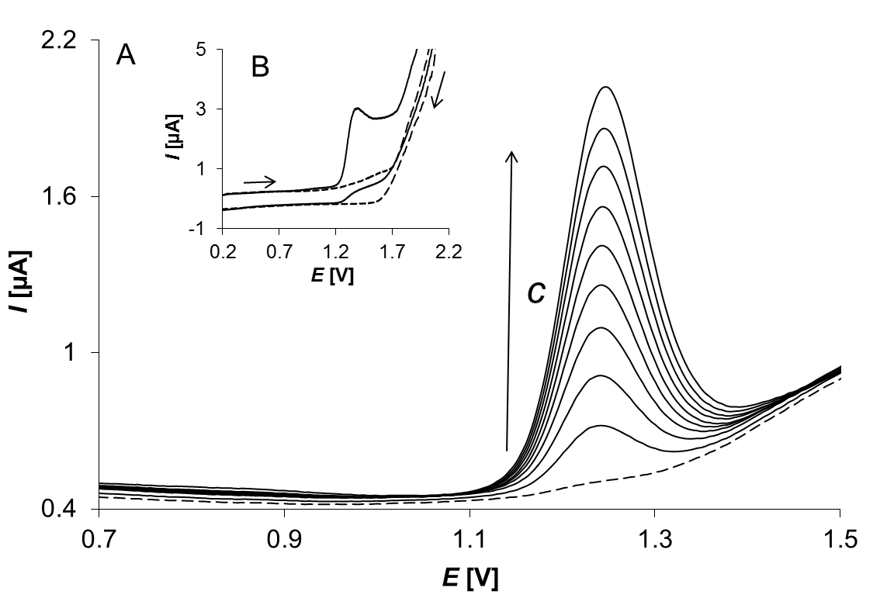
Fig. 2. A – Concentration dependence of LIN (DPV, BRB (pH 2.0), c_{LIN} = 5.0×10⁻⁶-4.5×10⁻⁵ mol L⁻¹); B – Cyclic voltammogram of LIN (CV, BRB (pH 2.0), c_{LIN} = 1.0×10⁻⁴ mol L⁻¹) obtained on commercial BDDE.

8
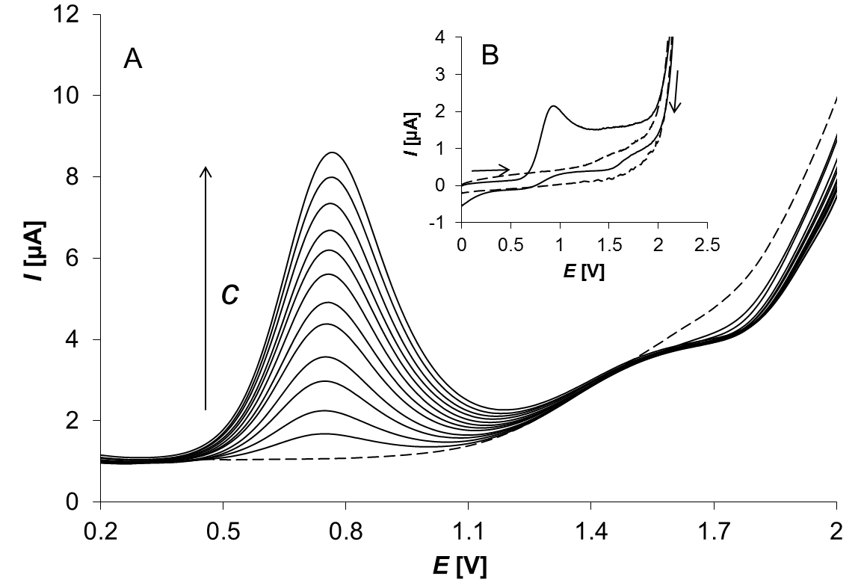
Fig. 3. A – Concentration dependence of 5-ASA (SWV, BRB (pH 7.0) c_{5-ASA} = 2.5×10⁻⁵-3.0×10⁻⁴ mol L⁻¹); B – Cyclic voltammogram of 5-ASA (CV, BRB (pH 7.0), c_{5-ASA} = 1.0×10⁻⁴ mol L⁻¹) (B) obtained on commercial BDDE.
Table I.
Statistical parameters of 5-ASA voltammetric determination obtained on lab-made BDDEs.

Conclusion
CV and EIS were performed for electrochemical characterization of lab-made BDDEs in the presence of Fe(CN₆)³⁻/Fe(CN₆)⁴⁻as a redox probe, and scanning electron microscopy and Raman spectroscopy were used for surface characterization of BDD films. The voltammetric behavior of substituted urea herbicide linuron and anti-inflammatory drug mesalazine on commercial BDDE and on lab-made sensors based on boron-doped diamond was investigated. Optimized parameters of DPV were used for determination of LIN and optimized parameters of SWV for determination of 5-ASA on BDDE as well as on tested lab-made BDDEs. Various statistical parameters were calculated and the properties of BDDEs with different boron content were compared for determination of both substances used.

Acknowledgement
This work was supported by the University of Pardubice (projects No. SGSFChT_2017_002 and SD373001/82/30350(2016)) and by the grant project of The Czech Science Foundation (project No. 17-03868S). Production and surface characterization of lab made electrodes was supported by Slovak National Grant Agency VEGA grants 1/0785/16 and 1/0558/17.

References
- Swain G. M., Ramesham R.: Anal. Chem. 65, 345 (1993).
- Zavázalová J., Barek J., Pecková K.: Sensing in Electroanalysis 8, 21 (2013).
- Kraft A.: Electrochem. Sci. 2, 355 (2007).
- Joshi R., Kumar S., Unnikrishnan M., Mukherjee T.: Free Radical Res. 39, 1163 (2005).
- Iacucci M., Silva S., Ghosd S.: Can. J. Gastroenterol. 24, 127 (2010).
- Caux, P. Y., Kent R. A., Fan G. T., Grande C.: Environ. Toxicol. Water Qual. 13, 1 (1998).
- http://extoxnet.orst.edu/pips/linuron.htm, Downloaded March 24st, 2017.
- Šelešovská R., Štěpánková M., Janíková L., Nováková K., Vojs M., Marton M., Behúl M.: Monatsh. Chem. 147, 1353 (2016).

