Promising new insensitive cocrystal
Ahmed K. HUSSEIN¹, Svatopluk ZEMAN¹ , Ahmed ELBEIH²
¹ Institute of Energetic Materials, Faculty of Chemical Technology, University of Pardubice, Czech Rep.
² Explosive department, Military Technical College, Cairo, Egypt

Abstract
A novel energetic co-crystal based on 1,4-dinitro-1,4-diazabutane (EDNA) and 1,5-diaminotetrazole (DAT) in a 1:2 molar ratio was synthesized. The formation of the cocrystal was monitored by Scanning electron microscope (SEM), powder X-ray diffraction (PXRD) and Raman spectroscopy. Sensitivity to impact was measured and 50% probability of initiation was 9.73 J for the cocrystal and 15.4 J for the EDNA. In addition, the detonation characteristics were predicted by EXPLO5 Code. The detonation velocity (D) and the detonation pressure (P) of the cocrystal are 8254.5 m s⁻¹ and 26.7 GPa respectively. The obtained cocrystal possesses a promising future for expanding the reuse of EDNA in antitank ammunition after overcome the acidity problem with the explosive in addition, the higher nitrogen content and acceptable sensitivity to external stimuli.
Key word: EDNA, DAT, Cocrystal, sensitivity, thermal study.

Introduction
Energetic materials; explosives, propellants and pyrotechnics, are used for a variety of military purposes and civilian applications[1]. However, there are unacceptable explosive characteristics when using single crystal explosive materials, among them: low performance, high sensitivity to external stimuli, the insufficient physical properties of some explosives. Consequently, programs have been established worldwide to develop novel energetic materials with higher potential energy and enhanced insensitivity by synthesizing new energetic materials, preparing nanoscale particles of explosives [2] or adding insensitive compounds such as; phlegmatized explosives “waxed explosives” [3]or coatings by polymers “PBX” [4, 5]. However, all the previously mentioned method can’t optimize between the main characteristics; high performance, thermodynamic stability and low sensitivity [6-11]. Recently, new approach has been introduced “Co-crystal technique” which succeeds to combine conformers of “different explosive materials” with each other. This technique is one of the main types of superamolecules which based on the intermolecular interaction as hydrogen bond, bi-stacking, van der Waals forces and halogen bonds [7]. This intermolecular interaction (Co-crystal) can connect two different materials together in one crystal form, which can improve the solubility, performance and sensitivity[12]. These technique had been announced in pharmaceutical systems, it had been succeed with different drugs to improve the bioavailability and the solubility[13, 14]. It was also passed down to energetic materials science and different publication were studied theoretically and were performed experimentally by combining two different energetic materials, as an example; CL-20 Co-crystals [15-21], TNT Co-crystal [17, 22, 23] and HMX Co-crystal [15, 23-27] or with inert material such as; CL20/ caprolactam [24] and other more
1,5-Diaminotetrazole (DAT) (shown in Fig: 1.a) is one of the family of Tetrazoles which are the core of aza in the heterocyclic compounds. The high positive enthalpies of formation and high nitrogen content of tetrazoles have made their complexes interesting for energetic materials investigation and research topics. They are involved in new researches focused on reducing impact on environment and synthesized green energetic materials [28]. They are heterocyclic compounds rich in electron pairs, and can coordinate with transition-metal ions. These compounds are thermally stable and yield a large volume of gas on thermal decomposition, so as to be used as prospective gas-generating, blowing agents for polymeric systems and other combustible and thermally decomposition systems. DAT compound has the highest content of nitrogen among all organic substances,84.0% [29] and it has a positive heat of formation, 310.37 kJ.mol⁻¹, its density is 1.75 g.cm⁻³,and the detonation velocity is 7570 m.s⁻¹[30]. It has a unique structure and remarkable properties. It is used in key intermediate in many organic synthesis, the medicinal and biological applications and others.
1,4-Dinitro-1,4-diazabutane (N,N'-dinitroethylenediamine or EDNA) also known as Haleite [31] (shown in fig. 1.b) was first described as high explosive which was used during the WW II in antitank ammunitions. It was used also in different application as secondary explosive, booster explosive and in the preparation of cast explosives such as Ednatol (55% EDNA + 45% TNT). It has very interesting properties, possessing a high brisance, comparatively low impact sensitivity and high heat sensitivity. In contradiction with the above mentioned properties, there is a problem using EDNA as it has a high chemical acidic reactivity that drawback its chemical instability. EDNA is highly acidic (pK a1=5.31 and pK a2 = 6.64) [32]. It is corrosive and can react with metals and metal salts [31]. In this study, we describe the use of co-crystallizations for change the acidic affinity of EDNA by stabilization using the DAT and consequently increase the durability of EDNA in different applications by adding the high nitrogen content heterocyclic DAT.
(a) | (b)
Fig. 1: Chemical structures of a) DAT and b) EDNA

Experimental work
  - Materials and preparation of the cocrystal
EDNA was prepared according to reference [33], DAT was obtained by a reaction of thiosemicarbazide, sodium azide, and lead oxide in dimethylformamide according to ref. [34]. Acetonitrile were purchased from Penta Reagent Factory, Czech Republic. The cocrystal was carried out by dissolving EDNA and DAT in molar ratio of 1:2 in Acetonitrile at 45 ^{ᴏ}C for 2 hours with constant stirring. After complete dissolving of the coformers. Ethanol eas used as antislovent and used for precipitation at the same temperature. After that, the mixture of precipitate will be stirred for another hour during cooling and after the temperature decrease d to normal temperature, filterating the new fine slightly yellow cocrystal and dried.
  - powder X-ray diffraction (PXRD)
The powder X-ray diﬀraction (PXRD) patterns were recorded to identify EDNA, DAT and the prepared cocrystal sample by sixth generation MiniFlex X-ray diffractometer (XRD), (Cu Kβ, λ= 0.15406 nm, 40 kV, 15 mA, Miniflex, Rigaku, Japan). Images were integrated from 2 to 50 with a 0.05 step size using PDXL full-function powder diffraction analysis software suite.
  - SEM and Raman spectroscopy
The crystal morphology of the prepared cocrystal and the coformer were studied by scanning electron microscope (SEM) JSM-5500LV, JEOL, Japan. While, Raman spectra were measured with Nicolet Is50Raman, Thermo scientific, using an Ar laser (λ = 514.5 nm) and a semiconductor laser (λ= 785 nm). The maximum output power is 1.7 mW of the light spot of the Raman spectrometer and the spectral resolution is 1 cm⁻¹.
  - Elemental Analysis
Fisons – EA-1108 CHNS-O elemental analyzer was used for the determination of C, H, and N in the prepared cocrystal. The results of the elemental analysis were recalculated to match the nitrogen content to the individual explosive and reported in Table 1 as a hypothetical formula. By this way, the calculated formula was used as if it is individual explosive and it was used in the detonation parameters calculations.
  - Heat of Combustion
An automatic high pressure Bomb calorimeter, model BCA 500, OZM research s.r.o, Czech republic, was used to measure the heat of combustion of the cocrystal. The cocrystal was placed in a closed bomb filled with an excess of oxygen [35] and ignited. The output data was used for calculation of the enthalpy of formation Table 1 of the cocrystal that was used for determining the detonation characteristics.
  - Calculation of the detonation properties
The theoretical detonation characteristics (detonation velocity, D, heat of detonation, Q, and detonation pressure, P) of the Cocrystal, as well as those of the individual explosives, were calculated by the EXPLO5 code version 5.04 [36]. The following Becker-Kistiakowsky-Wilson equation of state (BKW EOS) was used with BKWN set of parameters α = 0.5, β = 0.176, κ = 14.71, Θ = 6620 [36]. The detonation heat is the heat released in a constant volume explosion and is determined by subtracting the heats of formation of the explosive (reactants) from the sum of the heats of formation of the detonation products. The theoretical calculation and the error between the experimental results are listed on Table 1
  - Sensitivity to impact
The standard impact tester with exchangeable drop weight of BAM impact sensitivity instrument [37] was used ; the amount of substance tested was 50 mm³ , and drop hammers of 2 and 5 Kg weight were used. The probability analysis was used to determine the probability levels of the initiation. Only the 50% probability of initiation (H₅₀) is used in this article and is reported in Table 1.

Results and discussion
  - Powder XRD:
According to the small size of the cocrystal simple and the limited features of the available single crystal XRD, the cocrystal was measured by powder XRD. Comparing the XRD results of the cocrystal with the pure component, it has been confirmed that the formed cocrystal is different from its components. By comparing XRD spectra with the mixture, it can be found that mixture is combing the XRD peaks of pure EDNA and DAT and different than EDNA/DAT Cocrystal which gave another confirmation of the formation of the cocrystal. The XRD patterns are shown in Fig 2. From Fig. 2, we can find that the main diffraction angles of the EDNA/DAT cocrystal localized at 34.78º, 29.74 º, 27.66 º, 23.38 º, 19.74 º, and 17.22 º. are evidently different from the raw materials EDNA and DAT and their mixture. In the 2Ɵ range of 10–40, some of the peaks for EDNA and DAT have disappeared, such as the peaks at 35.02 º, 25.02 º for DAT and 16.44 º, 26.3 º, 30.08 º, 33.38 º, 35.06 º, 37.78 º, 42.6 º of EDNA and new peaks localized at 34.78 º, 27.66 º and 24.74 ºare observed in the diﬀraction pattern of the cocrystal when compared with the PXRD pattern of the Mixture.These differences enable easy distinction between the cocrystal and pure raw DAT or EDNA, as shown in Fig. 2. The unique XRD patterns of the cocrystal indicate that it is a new substance instead of the separate crystallization of the raw materials.
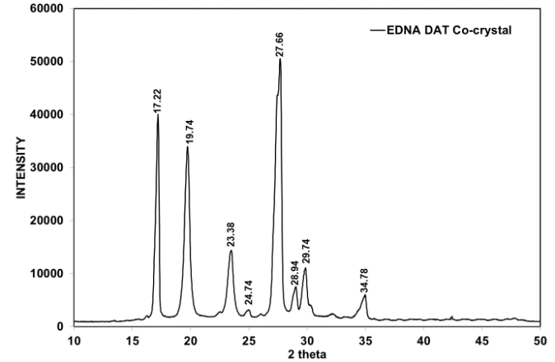 | 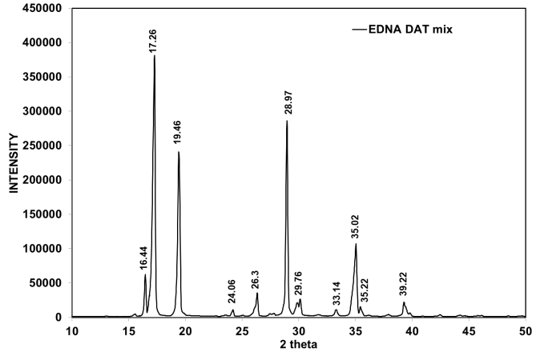
- EDNA/DAT Co-crystal | - EDNA/DAT Mixture
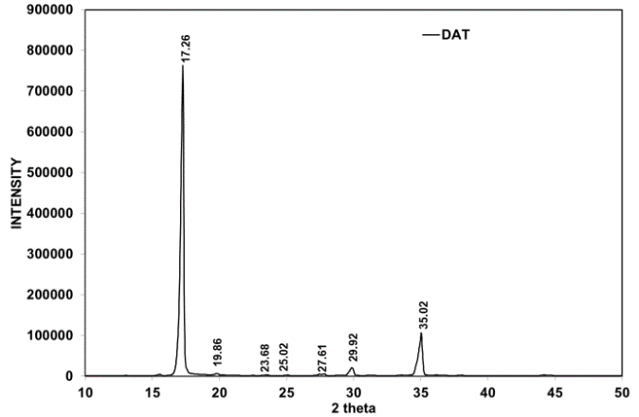 | 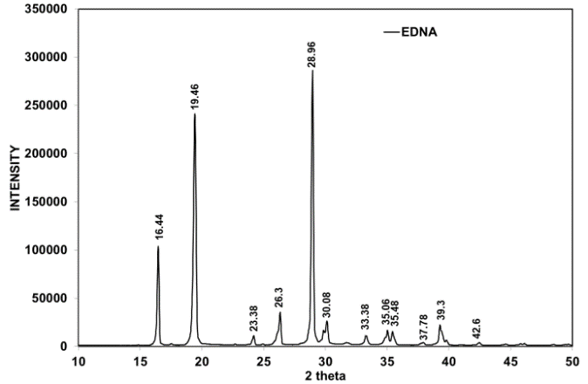
- DAT | - EDNA
Fig. 2: A comparison of powder XRD Spectra for a. EDNA/DAT Cocrystal, EDNA/DAT Mixture, c. DAT and d. EDNA.
  - SEM
The SEM images of coformer EDNA, DAT, and their cocrystal are shown in Figure 3. As is shown in Fig. 3 (a), the morphology of raw EDNA particles presents the shape of polyhedron with uneven distribution, and the average particle size is about 100 µm. Raw DAT sample particles in Fig. 3(b) are plates and have a rough surface. The average particle size is about 300 µm. As shown in Fig. 3(c), the cocrystal micro-particles obtained are amorphous within range from 50 µm to 100 µm in size.
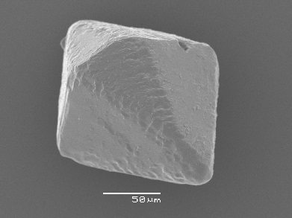 | 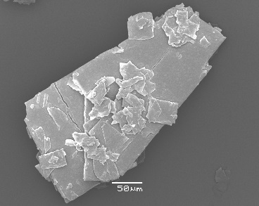 | 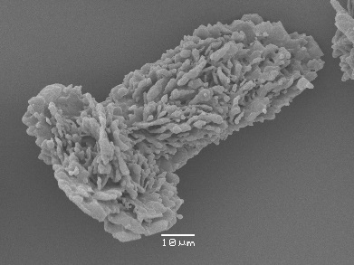
(a) | (b) | (c)
Fig. 3: SEM image of a. EDNA crystal, b. DAT crystal and c. EDNA/DAT Cocrystal

  - Raman spectroscopy
Raman spectroscopy is another useful means for the characterization of the cocrystal that shows that the vibrational modes of the cocrystal are diﬀerent from those of the starting materials.
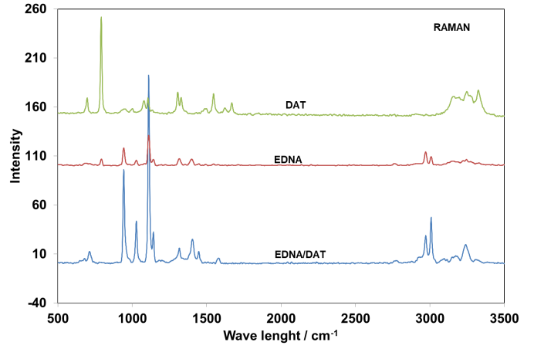
(a)
Fig. 4 Raman Spectrum of EDNA/DAT cocrystal
A full understanding of the effects of the cocrystal formation on the vibrational modes of motion is obtained by the complete assignment of the spectra of the starting materials and of the cocrystal. The Raman spectra of raw EDNA, DAT, and the cocrystal are shown in Fig. 4. While a comparison of the spectra are as following; For Cocrystal; the bands are;3326, 3247, 3008, 2970, 1668, 1549, 1400, 1315, 1145,1112, 1027, 944, 792, and 698. In case of the DAT, the bands are; 3325, 3249, 3160, 1669, 1546, 1329, 1306, 1106, 1079, 792, and 697 cm⁻¹. While for EDNA, the bands are 3240, 3008, 2972, 1447, 1405, 1317, 1142, 1111, 1028, 943, and 713 cm⁻¹. The results show certain shift in the band of the cocrystal compared with the cocforme which lead for another confirmation about the formation of the cocrystal.
  - Performance results
By the aid of both the elemental analysis and the automatic high pressure Bomb calorimeter, the summary formula and calculation of heat of the combustion were exist. This data was used as input for the EXPLO5 which was used to calculate the explosives characteristic the data calculated from the program was listed in Table 1. The density of the coformer EDNA and the cocrystal were measured experimentally using pyrometer using hexane as liquid for measurement

Table 1: Explosive characteristics and physical properties of EDNA, DAT and their EDNA/DAT cocrystal :
Explosive |  |  | Formula |  | Molecular weight  (g.mol⁻¹) | Heat of combustion  kJ.mol⁻¹ | Heat of formation  kJ.mol⁻¹ | Density  g.cm⁻³ | Det. Velocity calculated  m.s⁻¹ | Det. Pressure calculated GPa | Impact sensitivity  (J) | N %
no |  | Code designation
1 | DAT |  |  | C₁H₄N₆ | 100.1 | 1276.6^{[38]} | 310.37^{[38]} | 1.57^{[38]} | 7570.0^{[30]} | 20.7 | 15.4 | 84.0
2 | EDNA |  |  | C₂H₆N₄O₄ | 150.1 | 1540.1^{[39]} | -104.6^{[39]} | 1.75 | 8422.5 | 30.9 | 8.3^{[40]} | 37.3
3 | EDNA/DAT  cocrystal |  |  | C_{3.88}H_{13.63}N_{15.3}O_{3.9} | 337.1 | 2747.6 | 196.9 | 1.73 | 8254.5 | 26.7 | 9.7 | 54.8
From the obtained data, the positive heat of formation and high nitrogen percentage of the conformer DAT provide a positive influence on the performance characteristics of the produced cocrystal EDNA/DAT. The detonation velocity of the EDNA/DAT cocrystal is 8254.5 m.s⁻¹ at density 1.73 g cm⁻³ and the detonation pressure is 26.7 GPa which are slightly lower than of EDNA but it is much higher than DAT. It is important to focus that the cocrystal has better characteristics than the coformer DAT and the percentage of nitrogen content was improved significantly to be 54.8 % of nitrogen rather than 37.3% of nitrogen for the EDNA.
The impact sensitivity of the cocrystal was tested by BAM fall hammer method. Each test includes 5 impact energy levels and each level repeated 10 times, from which the probability will be calculated. The impact curves were obtained for the EDNA/DAT cocrystal, and the DAT compound which are shown in Fig. 5.
(a) | (b)
Fig. 5: The impact sensitivity curves of DAT and EDNA/DAT cocrystal
According to the impact data that was calculation at 50% probability of initiation, the sensitivity of the cocrystal to impact, 9.7 J, which is much lower than the pure EDNA this might be due to lower sensitivity of DAT to impact, 15.4 J, which reflected in the sensitivity behavior of the Cocrystal. The impact sensitivity of the cocrystal is 9.7 J which is clearly similar to the impact sensitivity of the well-known explosive 2,2’,4,4’,6,6’-hexanitrostilbene (HNS) [40].

Conclusion
The Powder XRD and the RAMAN spectroscopy confirm the existence of the new EDNA/DAT co-cystal. The formed co-crystal has a promising detonation characteristics, the detonation velocities (D) and the detonation pressure (P) are 8254.5 m s⁻¹ and 26.7 GPa respectively. The cocrystal has good impact sensitivity of 9.73 J in the level of HNS and so is lower compared with the conformer EDNA. This cocrystal possesses a promising future for expanding the reuse of EDNA in antitank ammunition after overcome the acidity problem with the explosive in addition, the higher nitrogen content and acceptable sensitivity to external stimuli.

Reference:
[1] J.P. Agrawal, R. Hodgson, Organic chemistry of explosives, John Wiley & Sons, 2007.
[2] D. Doblas, M. Rosenthal, M. Burghammer, D. Chernyshov, D. Spitzer, D.A. Ivanov, Smart Energetic Nanosized Co-Crystals: Exploring Fast Structure Formation and Decomposition, Crystal Growth & Design, 16 (2015) 432-439.
[3] A. Elbeih, S. Zeman, Characteristics of melt cast compositions based on cis-1, 3, 4, 6-tetranitrooctahydroimidazo-[4, 5 d] imidazole (BCHMX)/TNT, Central European Journal of Energetic Materials, 11 (2014).
[4] A. Elbeih, J. Pachman, W.A. Trzciński, S. Zeman, Z. Akštein, J. Šelešovský, Study of Plastic Explosives based on Attractive Cyclic Nitramines Part I. Detonation Characteristics of Explosives with PIB Binder, Propellants, Explosives, Pyrotechnics, 36 (2011) 433-438.
[5] A. Elbeih, S. Zeman, M. Jungová, P. Vávra, Attractive Nitramines and Related PBXs, Propellants, Explosives, Pyrotechnics, 38 (2013) 379-385.
[6] E. Gagnière, D. Mangin, F. Puel, A. Rivoire, O. Monnier, E. Garcia, J.-P. Klein, Formation of co-crystals: kinetic and thermodynamic aspects, Journal of Crystal Growth, 311 (2009) 2689-2695.
[7] F. Lara-Ochoa, G. Espinosa-PÉRez, Cocrystals Definitions, Supramolecular Chemistry, 19 (2007) 553-557.
[8] J.P. Shen, X.H. Duan, Q.P. Luo, Y. Zhou, Q. Bao, Y.J. Ma, C.H. Pei, Preparation and characterization of a novel cocrystal explosive, Crystal Growth & Design, 11 (2011) 1759-1765.
[9] D.D. Bavishi, C.H. Borkhataria, Spring and parachute: How cocrystals enhance solubility, Progress in Crystal Growth and Characterization of Materials.
[10] A.D. Bond, What is a co-crystal?, CrystEngComm, 9 (2007) 833-834.
[11] H.-H. Licht, Performance and sensitivity of explosives, Propellants Explosives Pyrotechnics, 25 (2000) 126-132.
[12] D.D. Bavishi, C.H. Borkhataria, Spring and parachute: How cocrystals enhance solubility, Progress in Crystal Growth and Characterization of Materials, 62 (2016) 1-8.
[13] P. Vishweshwar, J.A. McMahon, J.A. Bis, M.J. Zaworotko, Pharmaceutical co‐crystals, Journal of pharmaceutical sciences, 95 (2006) 499-516.
[14] M. Nishimaru, S. Kudo, H. Takiyama, Cocrystal production method reducing deposition risk of undesired single component crystals in anti-solvent cocrystallization, Journal of Industrial and Engineering Chemistry, 36 (2016) 40-43.
[15] O. Bolton, L.R. Simke, P.F. Pagoria, A.J. Matzger, High power explosive with good sensitivity: A 2: 1 cocrystal of CL-20: HMX, Crystal Growth & Design, 12 (2012) 4311-4314.
[16] H.-f. Gao, S.-h. Zhang, F. Liu, R.-j. Gou, X. Ding, Theoretical insight into the co-crystal explosive of 2, 4, 6, 8, 10, 12-hexanitrohexaazaisowurtzitane (CL-20)/1, 1-diamino-2, 2-dinitroethylene (FOX-7), Computational Materials Science, 107 (2015) 33-41.
[17] H. Li, Y. Shu, S. Gao, L. Chen, Q. Ma, X. Ju, Easy methods to study the smart energetic TNT/CL-20 co-crystal, Journal of molecular modeling, 19 (2013) 4909-4917.
[18] K. Liu, G. Zhang, J. Luan, Z. Chen, P. Su, Y. Shu, Crystal structure, spectrum character and explosive property of a new cocrystal CL-20/DNT, Journal of Molecular Structure, 1110 (2016) 91-96.
[19] D.I. Millar, H.E. Maynard-Casely, D.R. Allan, A.S. Cumming, A.R. Lennie, A.J. Mackay, I.D. Oswald, C.C. Tang, C.R. Pulham, Crystal engineering of energetic materials: Co-crystals of CL-20, CrystEngComm, 14 (2012) 3742-3749.
[20] H. Xu, X. Duan, H. Li, C. Pei, A novel high-energetic and good-sensitive cocrystal composed of CL-20 and TATB by a rapid solvent/non-solvent method, RSC Advances, 5 (2015) 95764-95770.
[21] Z. Yang, H. Li, X. Zhou, C. Zhang, H. Huang, J. Li, F. Nie, Characterization and properties of a novel energetic–energetic cocrystal explosive composed of HNIW and BTF, Crystal Growth & Design, 12 (2012) 5155-5158.
[22] C. Guo, H. Zhang, X. Wang, X. Liu, J. Sun, Study on a novel energetic cocrystal of TNT/TNB, Journal of Materials Science, 48 (2013) 1351-1357.
[23] H. Li, C. An, W. Guo, X. Geng, J. Wang, W. Xu, Preparation and Performance of Nano HMX/TNT Cocrystals, Propellants, Explosives, Pyrotechnics, 40 (2015) 652-658.
[24] C. Guo, H. Zhang, X. Wang, J. Xu, Y. Liu, X. Liu, H. Huang, J. Sun, Crystal structure and explosive performance of a new CL-20/caprolactam cocrystal, Journal of Molecular Structure, 1048 (2013) 267-273.
[25] K.B. Landenberger, A.J. Matzger, Cocrystals of 1, 3, 5, 7-Tetranitro-1, 3, 5, 7-tetrazacyclooctane (HMX), Crystal Growth & Design, 12 (2012) 3603-3609.
[26] Y.-x. Li, S.-s. Chen, Theoretical insights into the structures and mechanical properties of HMX/NQ cocrystal explosives and their complexes, and the influence of molecular ratios on their bonding energies, Journal of molecular modeling, 21 (2015) 1-12.
[27] H. Lin, S.G. Zhu, L. Zhang, X.H. Peng, P.Y. Chen, H.Z. Li, Intermolecular interactions, thermodynamic properties, crystal structure, and detonation performance of HMX/NTO cocrystal explosive, International Journal of Quantum Chemistry, 113 (2013) 1591-1599.
[28] Y.H. Joo, B. Twamley, J.n.M. Shreeve, Carbonyl and Oxalyl Bridged Bis (1, 5‐Diaminotetrazole)‐Based Energetic Salts, Chemistry–A European Journal, 15 (2009) 9097-9104.
[29] Y. Cui, J. Zhang, T. Zhang, L. Yang, J. Zhang, X. Hu, Synthesis, structural investigation, thermal decomposition mechanism and sensitivity properties of an energetic compound [Cd (DAT) 6](ClO 4) 2 (DAT= 1, 5-diaminotetrazole), Journal of hazardous materials, 160 (2008) 45-50.
[30] T. Konkova, Y. Matyushin, V. Sinditskiy, M. Dutov, A. Fogelzang, Thermochemistry of complex salts of transitive metals with 1, 5-diaminotetrazole as ligand, in: INTERNATIONAL ANNUAL CONFERENCE-FRAUNHOFER INSTITUT FUR CHEMISCHE TECHNOLOGIE, Berghausen; Fraunhofer-Institut fur Chemische Technologie; 1999, 2000, pp. P88-P88.
[31] W. Tomlinson, O. Sheffield, Engineering design handbook, explosive series of properties explosives of military interest, Report AMCP, (1971) 706-177.
[32] V. Ivshin, T. Ivshina, L. Smirnova, M. Ponomareva, ACIDITY OF PRIMARY N-NITROAMINES, ZHURNAL ORGANICHESKOI KHIMII, 20 (1984) 7-13.
[33] C.W. Sauer, Process for the preparation of nitramines, in, Google Patents, 1958.
[34] P. Gaponik, V. Karavai, Synthesis and properties of 1, 5-diaminotetrazole, Chemistry of Heterocyclic Compounds, 20 (1984) 1388-1391.
[35] S. Fuels, determination of heat of combustion by calorimetric method in the pressure vessel and caculation of calorific value, , Czech Institute of standards, Czech Tech. Standard CSN ISO 1928 (June 1999).
[36] M. Sućeska, Calculation of detonation parameters by EXPLO5 computer program, in: Materials Science Forum, Trans Tech Publ, 2004, pp. 325-330.
[37] S. Muhamed, Test methods for Explosives, Springer,, Heideleberg,, 1995.
[38] M. Tremblay, Spectres infrarouges de composes riches en azote, Canadian Journal of Chemistry, 43 (1965) 1154-1157.
[39] P. Tavernier, J. Boisson, B. Crampel, Propergols hautement énergétiques, in, AGARD, 1970.
[40] S.N. Bulusu, Chemistry and physics of energetic materials, Springer Science & Business Media, 2012.

