CHLORINATED AROMATICS – OCCURRENCE, USAGE AND METHODS OF DEGRADATION

J. Pérko, T. Weidlich

Institute of Environmental and Chemical Engineering, Faculty of Chemical Technology, University of Pardubice, Studentská 95, 532 10 Pardubice, Czech Republic,
E-mail: jan.perko@upce.cz

Abstract
This paper is summarizing the occurrence, usage and available techniques for dehalogenation of chlorinated aromatics, mainly chlorinated phenols and chlorinated phenoxy- or benzyl- phenols and their homologues, or polychlorinated biphenyls and dibenzodioxins (PCB´s and PCDD´s). These chemicals are among the most common organic pollutants in the wastewaters from production of pesticide, solvents, paints, pharmaceuticals, wood preserving chemicals, and from pulp and paper industry. Chlorine and other chlorine based oxidants are used for the bleaching of wood pulp accompanied with the formation of toxic organochlorine water pollutants which are polluting the river effluents, its inhabitants and accumulate in the tissues of river biota. These chemicals could be removed (and/or degraded) in many different ways, e.g. there are advanced oxidation processes (AOP´s) involving the generation of reactive hydroxyl radicals (•OH) or hydrodehalogenation processes to effect the destruction of recalcitrant pollutants in water effluents.
Occurrence
Chlorinated aromatics such as chlorinated phenols, chlorinated phenoxy/benzylphenols or polychlorinated biphenyls, polychlorinated dibenzodioxins, polychlorinated dibenzofurans, polychlorinated diphenyl ethers (see Figure 1 for structures of these compounds) are among pollutants which are the subject of many papers and scientific studies from all around the world. All of above mentioned chemicals belong to category of so called persistent organic pollutants which means they have the ability to persist in the environment and their natural breakdown is either very slow or is not even possible and they could bioaccumulate and cause serious defects in living organisms and in the environment. Because of the urgent warnings from the scientific sphere about the dangers these chemicals are posing there has been a consensus of opinion regarding their production, usage, disposal and gradually total restriction of selected compounds which were found the most dangerous. This is what has become the Stockholm Convention on Persistent Organic Pollutants enlisting many of the above mentioned and co-signatories agreeing to limit and outlaw the chemicals on the list¹⁻³.

1 Polychlorinated phenols 2 Polychlorinated biphenyls (PCB´s)

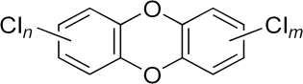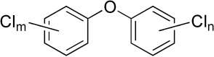

3 Polychlorinated dibenzodioxins (PCDD´s) 4 Polychlorinated biphenyl ethers (PCDE´s )

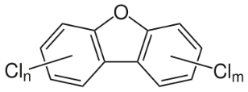
5 Polychlorinated dibenzofurans (PCDF´s)

Figure 1. Structures of selected chlorinated aromatics.

However the origin of chlorinated, or let´s say halogenated aromatics is quite complex. Although many of the previous mentioned chemicals are manmade there is a large majority of organohalogen compounds which are occurring naturally in the environment. For example there are thyroid hormones containing iodine (thyroxine 6), product of various molds which contain chlorine (griseofulvin 7)⁴.

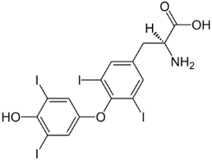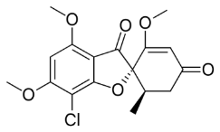
6 Thyroxine 7 Griseofulvin

Figure 2. Examples of naturally occurring halogenated aromatics.

With the technological development and progression in the field of analytical methods it turns out that naturally occurring organohalogens is maybe much more than expected and we can find these in fungi, bacteria, water plants and animals. In the literature⁵⁻⁷ we could find a large number of chlorinated compounds detected by chemical analysis in these organisms, e.g. Streptomyces sp. bacteria are producing enormous number of metabolites containing halogens such as chloropeptin I (8), an unusual chlorinated hexapeptide produced by the soil actinomycete Streptomyces sp. WK-3419.1 is able to inhibit HIV virus replication⁸.
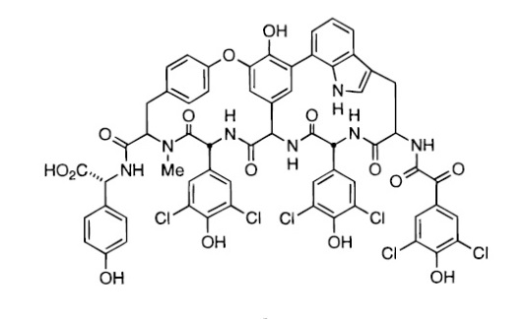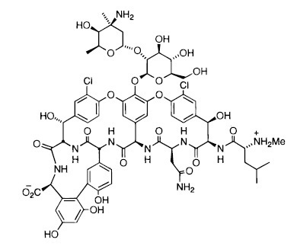
8 Chloropeptin I 9 Vancomycin
Many organohalogens (and non-halogenated organics as well) can serve as a chemical protection of plants and animals (antibacterial, antifungal, etc.). The antibiotic vancomycin (9) produced by Amycolatopsis orientalis has been used against several bacterial infections since 1950´s⁵. Growth hormone
4-chloroindole-3-acetic acid (10) and its methyl ester are biosynthesized by peas, lentil, vetch, and fava bean⁷.
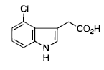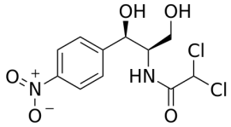
10 4-chloroindole-3-acetic acid 11 Chloramphenicol
Usage
Antibiotic chloramphenicol (11) discovered in 1950´s was one of the first discovered and successfully used antibiotics. It was the first massively manufactured antibiotic and it was used both in developed and developing countries for its wide range of effect. Nowadays in the western world there are used antibiotics of a new generation and its using was abandoned but the bacteria resistance is far more common (due to frequent prescription) when using the new antibiotics. An effort of coming back to in the past used antibiotics (where is no bacteria resistance) is made. In developing countries to this day it is still one of the most used antibiotics for its low price and good availability. It is effective against gram-positive, gram-negative bacteria and anaerobic organisms but the biggest disadvantage is its toxicity for bone marrow and subsequent aplastic anemia which could cause death. From this reason this pharmaceutical is only prescribed in life-threatening infections where is no other alternative and where the pros overcome the risks of chloramphenicol⁹⁻¹¹.
Chlorinated phenols and their derivatives are persistent organic pollutants which are used in the manufacturing of dyes, pharmaceuticals and many other industrial (mainly more complex chlorinated) products. These compounds are highly toxic for living organisms thanks to their carcinogenic, mutagenic and cytotoxic properties. Agrochemical manufacturing takes around 80-90% of overall consumption of chlorinated phenols, e.g. herbicide dicamba (3,6-dichloro-2-methoxybenzoic acid, 12), 2,4-dichlorophenoxyacetic acid or a pharmaceutical clofibrate (Atromid-S, Ethyl 2-(4-chlorophenoxy)-2-methylpropanoate, 13) which was used in the past for treating high blood pressure. Among biocides (herbicides, pesticide, insecticide etc.) based on chlorinated phenols are also chlorophene and pentachlorophenol which is as well used for manufacturing of wood and cellulose preservatives.¹²

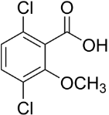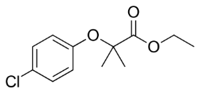
12 Dicamba 13 Clofibrate

The usage of polychlorinated biphenyls was very wide – from plasticizers, heat transfer fluids plasticizers, lubricant inks, fire retardants, paint additives to sealing liquids, immersion oils, adhesives, anti-dusting agents, waxes, carbonless copy papers and mostly as dielectric fluids for capacitors and transformers. PCB´s got into the environment by using them but significant amount got there from disposals, accidents and leakage from the industrial facilities¹³⁻¹⁵. On the other hand polychlorinated dibenzodioxins (PCDD´s), polychlorinated dibenzofurans (PCDF´s) and polychlorinated dibenzoethers (PCDE´s) are mostly unwanted by-products in thermal systems containing chlorine such as incomplete combustion, municipal waste incineration, metal industries, bushfires and controlled burnings. These compounds are also present as impurities in chlorinated phenols and chlorinated phenoxyacetic acids preparations¹⁶.
Degradation methods
There have been several ways of remediation and affords to degrade these sort of pollutants which are already in the environment. We could name so called advanced oxidation processes (AOP´s) based on the Fenton reaction which includes generation of hydroxyl radicals (•OH) which are one of the most powerful oxidants and because of their non-selectivity it is possible to degrade wide range of different chemicals¹⁷. Particular techniques are e.g. TiO₂/UV photocatalysis^{18,19}, electrochemistry²⁰, sonoelectrochemistry^{21,22}, ozonation²³, using of chlorine dioxide²⁴, potassium permanganate²⁵ and Fenton based processes which are used in recent years in many different ways.
We could distinguish Fenton reactions as follows: classical Fenton reaction uses H₂O₂ and Fe²⁺ to generate •OH radicals by their combination¹⁷, Fenton-like process (H₂O₂ and Fe³⁺)²⁶, photo-Fenton (H₂O₂/ Fe²⁺ (Fe³⁺) / UV¹⁹ and also electro-Fenton reaction. By electro-Fenton the hydrogen peroxide could be generated from the saturated oxygen solution on the electrodes of many kinds and materials, e.g. titanium²⁷, graphite²⁸, aluminum, stainless steel, copper²⁹, platinum, boron-doped diamond³⁰ or by the direct injection of the gas to a gas diffusion electrode.
There are also reductive ways of pollutant degradation such as electrochemical reduction, e.g. one study is describing electrocatalytic process where hydrogen formed on a cathode (by the reduction of water) results in the hydrodechlorination of chlorinated pollutant³¹. Direct using of hydrogen is also possible and was studied by several groups of scientists, the reaction could be influenced either by pressure of hydrogen gas or by using different kinds of catalysts^{32,33}. Using zero valent metals as reducing agents has been a significant amount of interest last few years. Particularly zero valent iron has been used the reductive dechlorination of chlorinated pollutants and most investigators agree that the reduction takes place directly on the iron surface^{34,35}. Using of metal alloys (Al-Ni³⁶⁻³⁸, Devarda´s alloy³⁹, etc.) proofed to be working very well as the agent for reductive dehalogenation of halogenated aromatics.
Yet there are another processes suitable for the degradation which were studied, e.g. biological processes since it is known that there have been identified reductive dehalogenases in several bacteria types⁴⁰. And also important to mention is of course the incineration process which could be used as the basic method to degrade organic pollutants. But as it is a process where many side reactions are taking place and many different by-products are generated (as above mentioned PCDD´s, PCDF´s and PCDE´s are created by incineration) which could be even more toxic than the original compounds, this method seems to be not very suitable in the modern degradation chemistry.
This paper is a short summary of various methods which could be used for degradation of chlorinated aromatic pollutants persisting in the environment and which are posing a threat for the food chain and generally for the living organisms. Suitable way of remediation is therefore required to minimize the amounts and effects of these chemicals in soils, waters and air.
References
- Rodan B. D., Pennington D. W., Eckley N., Boethling R. S.: Environ. Sci. Technol. 33, 3482 (1999).
- Gosh A., Gupta S. S., Bartos M. J., Hangun Y., Vuocolo L. D., Steinhoff B. A., Noser C. A., Horner D., Mayer S., Inderhees K., Horwitz C. P., Spatz J., Ryabov A. D., Mondal S., Collins T. J.: Pure Appl. Chem. 73, 113 (2001).
3. Laine D. F., Cheng I. F.: Microchem. J. 85, 183 (2007).
4. Macháček V., Panchartek J., Večeřa M.: Organická chemie, 1. část, Univerzita Pardubice, Pardubice, 2001, ISBN: 80-7194-363-0
5. Gribble G. W.: Acc. Chem. Res., 31, 141 (1998).
6. Gribble G. W.: Prog. Chem. Org. Nat. Prod. 68, 1 (1996).
7. Gribble G. W.: Chemosphere 52, 289 (2003).
8. Gouda H., Matsuzaki K., Tanaka H., Hirono S.: J. Am. Chem. Soc. 118, 13087 (1996).
9. Hernandez, M., Girardet M., Ramisse F., Vidal D., Cavallo J.-D.: J. Antimicrob. Chemother. 52, 1029 (2003).
10. O´Connor R. P.: Tetracyclines, Chloramphenicol, Macrolides and Lincosamides (online). (cit. 12.3.2017).
Cited from:
http://www.federaljack.com/ebooks/My%20collection%20of%20medical%20books,%20208%20Books%20(part%201%20of%203)/Modern%20Pharmacology%20With%20Clinical%20Applications/Ch47.pdf
11. Falagas M. E.; Grammatikos A. P.; Michalopoulos A.; Expert Rev. Anti Infect. Ther. 6, 593 (2008).
12. Muller F., Caillard L.: Chlorophenols. In Ullmann’s Encyclopedia of Industrial Chemistry. John Wiley & Sons, Inc; 2011. Published online - DOI: 10.1002/14356007.a07_001.pub2.
13. Safe S.: Crit. Rev. Toxicol. 24, 87 (1994)
14. Baker J. I., Hites R. A.: Environ. Sci. Technol. 34, 2879 (2000).
15. De Voogt, P. and Brinkman, U. A. T., Production, properties and usage of polychlorinated biphenyls, in Halogenated Biphenyls, Terphenyls, Naphthalenes, Dibenzodioxins and Related Products, Kimbrough, R. D. and Jensen, A. A., Eds., Elsevier-North Holland, Amsterdam, 1989, 3.
16. Altarawneh M., Dlugogorski B. Z., Kennedy E. M., Mackie J. C.: Prog. Energy Combust. Sci. 35, 245 (2009).
- Fenton H. J. H.: J. Chem. Soc. Trans. 65, 899 (1894).
- Latch D. E., Packer J. L., Stender B. L., Van Overbeke J.,Arnold D. A., McNeill K.: Environ. Toxicol. Chem. 24, 517 (2005).
- Klamerth N., Miranda N., Malato S., Aguera A., Fernández-Alba A. L., Maldonado M. I., Coronado J. M.: Catal. Today 144, 124 (2009).
- Butkovskyi A., Jeremiasse A. W., Hernandez Leal L., van der Zande T., Rijnaarts H., Zeeman G.: Environ. Sci. Technol. 48, 1893 (2014).
- Ren Y.-Z., Franke M., Anschuetz F., Ondruschka B., Ignaszak A., Braeutigam P.: Ultrason. Sonochem. 21, 2020 (2014).
- de Vidales M. J. M., Sáez C., Cañizares P., Rodrigo M. A.: J. Chem. Technol. Biotechnol. 88, 823 (2013).
- Zhang H., Yamada H., Tsuno H.: Environ. Sci. Technol. 42, 3375 (2008).
- van den Heuvel M. R., Leusch F. D. L., Taylor S. , Shannon N., McKague A. B.: Environ. Sci. Technol. 40, 2594 (2006).
- Jiang J., Pang S.-Y., Ma J., Liu H.: Environ. Sci. Technol. 46, 1774 (2012).
- Munoz M., de Pedro Z. M., Casas J. A., Rodriguez J. J.: Chem. Eng. J. 198-199, 275 (2012).
- Yang K. S., Mui G., Moulijn J. A.: Electrochim. Acta 52, 6304 (2007).
- Sudoh M., Kodera T., Sakai K., Zhang J. Q., Koide K: J. Chem. Eng. Jpn. 19, 513 (1986).
- Vyhnánková E., Kozáková Z., Krčma F., Hrdlička A.: Open Chem. 13, 218 (2015).
- Sirés, I.; Garrido, J. A.; Rodríguez, R. M.; Brillas, E.; Oturan, N.; Oturan, M. A.: Appl. Catal., B 72, 382 (2007).
- Dabo P., Cyr A., Laplante F., Jean F., Menard H., Lessard J.: Environ. Sci. Technol. 34, 1265 (2000).
- Heinrichs B., Schoebrechts J.-P., Pirard J.-P.: J. Catal. 200, 309 (2001).
- Roy H.M., Wai C.M., Yuan T., Kim J.-K., Marshall W.D.: Appl. Catal., A 271, 137 (2004).
- Klausen J., Ranke J., Schwarzenbach R.P.: Chemosphere 44, 511 (2001).
- Cantrell K.J., Kaplan D.I., Wietsma T.W.: J. Hazard. Mater. 42, 201 (1995).,
- Weidlich T., Krejčová A., Prokeš L.: Monatsh. Chem. 141, 1015 (2010).
- Weidlich T., Prokeš L.: Cent. Eur. J. Chem. 9, 590 (2011).
- Weidlich T., Opršál J., Krejčová A., Jašúrek B.: Monatsh. Chem. 146, 613 (2015).
- Weidlich T., Krejčová A., Prokeš L.: Monatsh. Chem. 144, 155 (2013).
- Janssen D.B., Oppentocht J.E., Poelarands G.J.: Curr. Opin. Biotechnol. 12, 254 (2001).

