SiO₂ fibers by centrifugal spinning with excellent textural properties and water adsorption performance
Luděk Hromádko,ª Eva Koudelková,^{b} Roman Bulánek,^{b} Jan M. Macak^{a*}
a Center of Materials and Nanotechnologies, Faculty of Chemical Technology, University of Pardubice, Nam. Cs. Legii 565, Pardubice 530 02, Czech Republic
b Department of Physical Chemistry, Faculty of Chemical Technology, University of Pardubice, Studentska 573, Pardubice 530 02, Czech Republic
* Corresponding Author: e-mail: jan.macak@upce.cz
Phone: +420-466 037 401

Keywords: centrifugal spinning, fibers, SiO₂, mesoporous, adsorption
Abstract
We present a facile and innovative route for large-scale synthesis of SiO₂ fibers with excellent textural properties and H₂O adsorption performance. At first, 3D network of SiO₂ precursor fibers was produced from tailored spun solutions (without any toxic elements and surfactants) by centrifugal spinning, which is very modern fiber-synthesis technique with numerous advantages over electrospinning. Upon a thermal annealing of the precursor fibers, mesoporous amorphous SiO₂ fibers with an ultrahigh surface area of up to 824 m²/g and the pore size distribution in the range of 2-10 nm were produced. Owing to the high number of OH groups available on the surface, the produced SiO₂ fibers showed significantly better performance in H₂O adsorption compared to the reference silicagel.
Introduction
Fibrous structures have been extensively used for decades in various filtration applications, catalysis, health care, textile, etc. Within past 15 years, however, fibers with diameter on the nm and sub-μm scale have attracted significant scientific and technological attention due to their very high porosity and permeability, often combined with a high specific surface area.^{1–3} There are essentially four classes of fibers (including nanofibers) based on their composition: i) polymeric,^{4,5} metal oxide,^{6,7} metal,⁸ and hybrid ones ^{9,10} etc. In particular, nano- and microfibers of amorphous SiO₂ have already shown a potential for to capture air moisture,^{11,12} as catalyst carriers,¹³ or part of solid-state electrolytes of batteries.¹⁴ The specific chemical, electronic and ion properties of SiO₂ in combination with high specific surface and 3D structure of fibers make fibrous materials highly promising for many other applications. In general, numerous techniques for production of nano- and microfibers exist, including electrostatic spinning,^{15,16} centrifugal spinning,^{17,18} including pressurised spinning,^{19,20} template growth,²¹ self-assembly,²² phase separation,²³ melt-blown.²⁴ Nevertheless, the most widely employed technique for these types of fibers has been the electrostatic spinning, known also as „electrospinning“ which is based on application of electrostatic field between the spinnerette (continuously fed with spun solution) and collecting electrode and consequent withdrawal of tiny fibers from the spun solution towards the collecting electrode.
For an efficient electrospinning process, the first key step is the preparation of stable spun solution. There are many different compositions of spun solutions published in the literature for specific types of fibers. In particular for SiO₂ fiber synthesis, spinning solutions usually contain precursor of SiO₂, carrying polymer, solvent and frequently also additional stabilizers. In most of published papers, the tetraethyl orthosilicate (TEOS) was used as SiO₂ precursor.^{12,25–36} Numerous carrying polymers were used, including polyvinyl pyrrolidone (PVP),^{25,30,31,33} polyvinyl alcohol (PVA),^{12,28,35} polyethylene oxide (PEO) ³³ or Pluronic F127.^{12,26,32} When combining sol-gel method with electrospinning there is no need of carrying polymer.^{26,27,29,36}
Since TEOS is well soluble in H₂O, the H₂O-based solutions were used for sol-gel solution that undergo pre-gelation (aging) of TEOS, which is followed by the main spinning process.^{26,27,29,36} The alcohol-based spun solutions usually contain ethanol, methanol with other solvents like dimethyl formamide³⁶ or dimethyl sulfoxide.³³ The polymeric reaction of TEOS is driven and stabilized by hydrochloric acid HCl,^{26,33,37} acetic acid ^{25,34,36} or H₃PO₄.³⁰ The specific surface area of fibers can be further increased by addition of surfactant in to the spun solution, for example Pluronic F127.^{26,29,35} Finally, the spun solutions undergo the electrostatic spinning using conditions that strongly depend on the design of the spinning tool. Most typically, the voltage and the distance between electrodes are in the range of dozens of kV and 5-20 cm, respectively.
Literature on electrospun SiO₂ fibers reports the mean fiber diameter in the range of 100 – 500 nm. Until now, there has been no other technique capable of production of fibers with such small diameters. However, the available literature provides only limited data on the detailed textural properties. Out of the 8 papers available on electrospun SiO₂ fibers,^{12,26,27,30,32,38–40} 5 of them contain textural properties. Data from these papers are summarized in Table S1 of Supplementary information. Specific surface areas span from 120 to 506 m²/g and porosity of the fibers cover broad range of micro- and mesoporosity depending on condition of spinning and composition of the solution. However, electrospinning has also some disadvantages. From handling point of view, the most serious problem is the electrostatic charge of electrospun fibers that causes difficulties for all kinds of mechanical handling. In addition, some spinning solutions also contain HCl which causes a corrosion of the production facility. Based on recent literature,^{17,18} it seems that centrifugal spinning, where no electrostatic charge is involved, not only overcomes the disadvantages of the electrospinning, but is also industrially upscalable, which is comparably difficult with electrospinning tools. In addition, the centrifugal spinning processes possess significantly higher yield (amount of fibers produced per unit of time) than conventional electrospinning processes. The gyratory centrifugal spinning^{19,20} further improves the positive yield figure.
To the best of author´s knowledge, so far only two synthetic papers were reported on the preparation of SiO₂ fibers by centrifugal spinning. In the first report, Jung et al.²³ utilized TMOS aqueous solution with a surfactant. Their mesoporous fibers reached specific surface area of 605 m²/g. This result is also listed in Table S1 along with electrospun SiO₂ fibers. In a recent paper by Ren et al.,⁴¹ various nano- and microfiber SiO₂ assemblies were reported with fiber diameters well below 500 nm, which was previously exclusive only to electrospun fibers. These two papers, however, did not report any fiber application and used aqueous chlorine containing (corrosive and environmentally not favorable) spun solution. Thus, it is important to develop an advanced synthesis of SiO₂ fibers by centrifugal spinning and to exploit these fibers for applications.
In this work we aim to contribute to this development. We present several new features: new spun solution without any chlorine agents, optimized centrifugal spinning technique (industrially already exploited) yielding mesoporous SiO₂ fibers with excellent textural properties and excellent results of the H₂O adsorption.

Results and discussions
Morphological and structural analysis of fibers
Figure 1 shows SEM and TEM images of the as-spun and calcined SiO₂ fibers. As one can see, the fiber structure of the as-spun fibers was preserved after calcination. However, the integrity of the as-spun fibers was not preserved after calcination due to the volume contraction and gravimetric loss based on the burn-out of the carbonaceous compounds from the as-spun fibers (for thermal gravimetric results, see Figure S1 in the Supplementary information). In other words, the fibers get shorter in length and smaller in diameter through the calcination process. The fibers are completely amorphous in nature, as evident from TEM images and selected-area diffraction pattern in Figure 1f and further corroborated by XRD measurements (see Figure S2). This is in line with literature that reports crystallization of amorphous SiO₂ to quartz SiO₂ at as high temperature as 1200°C.³³

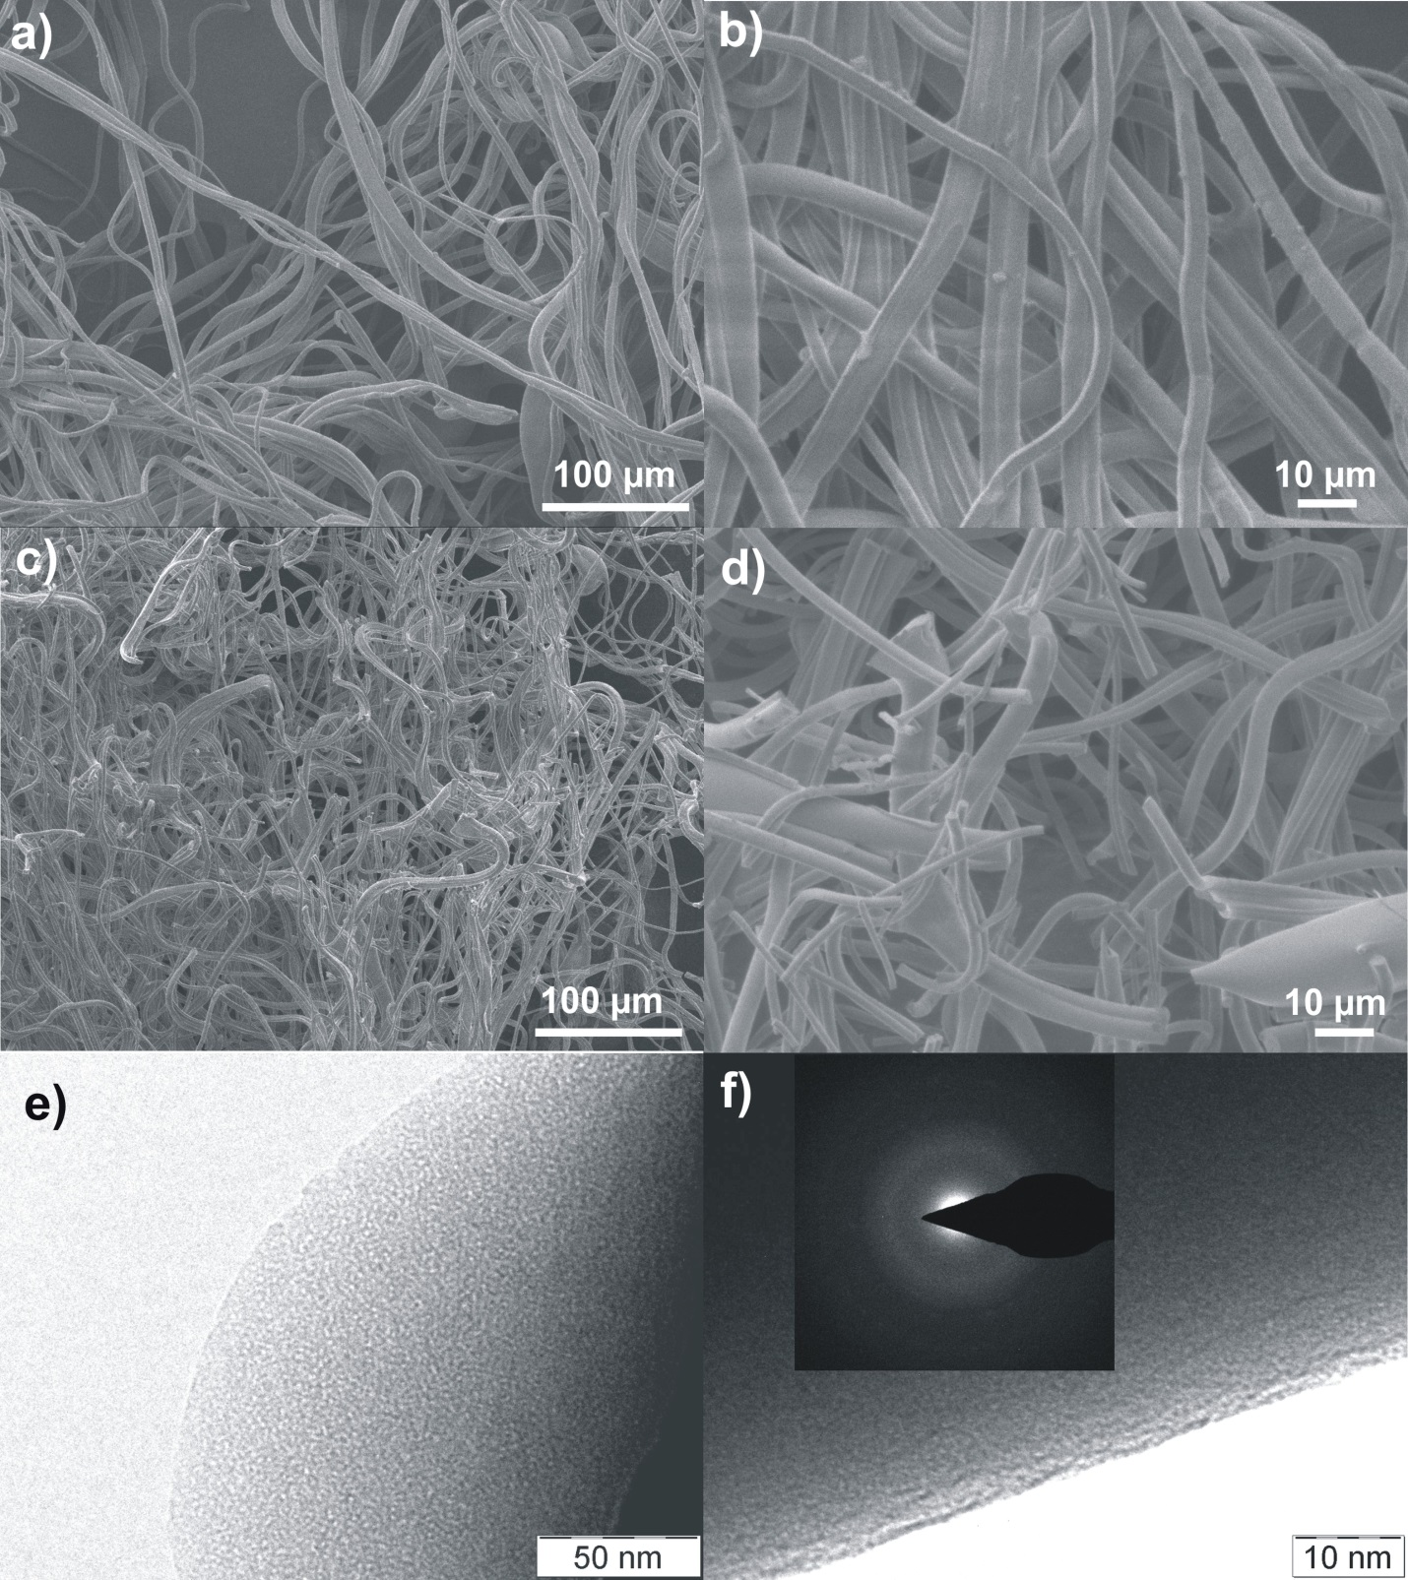
Figure 1. SEM images of a-b) as-spun fibers; c-d) calcined SiO₂ fibers; e,f) TEM images of calcined SiO₂ fibers. All fibers prepared from solution TEOS:PVP 1:1. The inset in f) shows selected-area diffraction pattern revealing an amorphous material.
The diameters of as-spun and calcined SiO₂ fibers are shown in Figure 2 for different TEOS:PVP ratios. All fibers were calcined at 500°C, 6 hours (as in Figure 1). Apparently, there is no clear trend of the increasing TEOS content on fiber diameters. In general, the diameter of the as-spun fibers is influenced by numerous factors, such as the type and the shape of spinnerette,¹ composition and viscosity of the solution.^{42–45} However, according to the authors experience with the SiO₂ fiber production process, the temperature and the relative humidity of the atmosphere in the spinning chamber influences the properties and quality of prepared fibers. However, for the fiber synthesis presented here, the humidity and temperature of the spinning chamber was controlled and stable (30 % RH and 35 °C). Therefore, the most important parameter influencing the fiber diameter within this work remains the absolute amount of TEOS in the precursor fibers. The largest diameter was observed in the case of TEOS:PVP 1.5:1 solution (which has 14.25 g of TEOS and 9.5 g of PVP in 100 g of the whole solution). Apparently, this diameter variation is due to the viscoelastic properties of the solution (influenced by the TEOS absolute amount) that for the given and constant size of nozzles within the spinnerette and the constant rotation speed influence the solution flow through the nozzles and the resulting diameter of withdrawn fibers. Interestingly, the measured dynamic viscosities of all 4 solutions lie in a relatively narrow range between 290 and 315 mPa.s, provided that solutions based on TEOS:PVP 2:1 are most viscous from all solutions. According to Figure 2, for the given setup even the small viscosity difference influences strongly the diameter of as-spun as well as calcined SiO₂ fibers. It should be emphasized at this point, that the fiber diameter is solely a consequence of solution composition and the used setup (Figure 5). It cannot be influenced otherwise by any other process condition. It should also be noted that some as-spun fibers might have smaller diameters than calcined fibers (as apparent from the overlap of scatter bars in Figure 2). It is a natural feature of fiber production that fibers have scatter in fiber diameter. What is most important is that the mean of the fiber diameter is significantly lower for calcined fibers.
Figure 2. Diameter of as-spun and calcined SiO₂ fibers for different TEOS:PVP ratios.
Another important aspect of the inorganic fiber production, especially in terms of the costs, is the calcination yield. The calcination yield for fibers was calculated as a ratio between the mass of calcined SiO₂ fibers and the mass of as-spun fibers x 100%. It resulted into 8, 14, 17, and 25 wt.% for fibers made out of solutions with increasing TEOS content. This is in line with expectation that the higher the TEOS content in the solution, the higher the gravimetric yield in terms of residual mass compared to the mass of as-spun fibers.

Textural properties
Within preliminary experiments, the as-spun fibers were calcined at several different temperatures (450, 475, 500, 550, 600 and 650°C). As a successful calcination was considered such treatment that led to snow-white 3D fiber network (without any apparent carbonaceous residues) after 6 hours of soaking at the given temperature. The lowest temperatures (450 and 475 °C) resulted in gray fibers (which remained gray even for extensive calcination time of 24 hours). Temperatures from 500°C (and higher) with soaking time of 6 hours always led to the desired white product - SiO₂ fibers
Table 1 provides an overview of textural properties of SiO₂ fibers produced from all 4 solutions upon calcination of as-spun fibers at 500°C for 6 hours. For reference, textural properties of selected benchmark silicagel were analyzed too. The textural properties of all materials were derived from N₂ adsorption isotherms measured at temperature of liquid nitrogen (isotherms are shown in Figure S3 and S4). The BET analysis showed that the highest total specific surface area and the external surface area (S_{BET} = 824 m²/g and S_{ext} = 65 m²/g) of the fibers was obtained in the case of TEOS:PVP 1:1 solution. This solution results also in the smallest diameter of the fibers (as shown in Figure 2) in good agreement with the trends in external surface area. These fibers have also the largest volume of pores (V_{p} = 0.547 cm³/g), which is an essential parameter for an efficient adsorption performance. Fibers from the other solutions have specific surface area no more than 506 m²/g, and comparably smaller pore volume (at most 0.326 cm³/g), as further shown in Table 1.
Interestingly, the TEOS:PVP ratio strongly influences the porosity character of the fibers. While fibers from the TEOS:PVP 0.5:1 and 1:1 solution exhibit very low volume of micropores, the fibers produced from the solutions with TEOS:PVP ratio larger than 1 have a distinct microporous character as can be documented by pore size distribution histograms for all fibers displayed in Figure S5. According to the literature, the typical specific surface areas of SiO₂ fibers produced by electrospinning are in the range of 200 to 500 m²/g.^{27,30–32} Paper by Jung et al. reported SiO₂ fibers by centrifugal spinning with a specific surface area up to 605 m²/g achieved due to addition of surface active compounds in the spinning solution.²³ It is evident that SiO₂ fibers produced from the solution with TEOS:PVP ratio 1:1 reported here exhibit superior S_{BET} and V_{p} compared with materials reported in literature. Based on the textural characteristics of these fibers, the benchmark type of silicagel (Merck Grade 10180) was selected for comparison of adsorption properties. Silicagel textural properties are summarized in the Table 1, adsorption isotherm and pore size distribution histogram are displayed in Figure S4 and S6, respectively.

Fourier transformed Infrared Spectroscopy (FTIR) analyses
FTIR spectra of the fiber sample (TEOS:PVP 1:1) and reference silicagel are presented in the Figure 3. Vibration of silanol groups of fresh and degassed samples are very similar (Figure 3 a and c). The both fresh samples (spectra x) exhibit intense bands at 1632 cm⁻¹ assigned to the bending vibration of physically adsorbed H₂O molecules and the broad spectral feature in the range of 3700 and 2600 cm⁻¹ caused by H-bonding of H₂O molecules on silanols. The subsequent evacuation at 200°C led to H₂O desorption, evidenced by a disappearance of the band at 1632 cm⁻¹ (triplet of the band at 1980, 1870 and 1643 cm⁻¹ visible in the spectra y and z depicted in Figure 4b and 4d are ascribed to the overtones of skeletal vibrations). Spectral region of O-H vibrations is dominated by band at 3746 cm⁻¹, which is assigned to the terminal isolated or geminal silanols, whereas the low-frequency tail belongs to the H-bonded vicinal silanols.
Based on the relative comparison of spectra of both samples, it is evident that SiO₂ fibers contain higher population of H-bonded Si-OH groups. It can be caused by higher overall surface density of silanols or formation of silanol clusters or silanol nests. Calcination of the samples at 490°C led to disappearance of the tail caused by dehydroxylation of H-bonded vicinal silanols which exhibit low stability, as is generally accepted.
In general, combination of high specific surface area, the hydrophilicity (density of surface silanol groups) and the pore volume has a strong influence on the shape of H₂O vapour adsorption isotherm and adsorption capacity.^{46–48} Based on the differences in textural properties of SiO₂ fibers and reference silicagel, especially in the pore volume, the differences in the adsorption of H₂O could be expected.
Figure 3. FTIR spectra of prepared TEOS:PVP 1:1 SiO₂ fibers (a-b) and reference silicagel (c-d); x – fresh sample, y – sample degassed under vacuum at 200°C for 10 h, z – sample degassed under vacuum at 490°C for 3 h.
All in all, considering the performance vs. production cost figure (based on the favorable textural properties and the synthetic yield), SiO₂ fibers from solution TEOS:PVP 1:1 were selected as optimal for further testing by H₂O adsorption isotherms and FTIR.
H₂O adsorption performance
Figure 4a displays volumetric adsorption isotherms of the H₂O vapour on SiO₂ fibers (TEOS:PVP 1:1) and reference silicagel at 25°C. Both isotherms belong to type IV concerning IUPAC classification with similar character of hysteresis loop proving hydrophilicity of the surface and the fact that capillary condensation in mesopores is dominant phenomenon at higher relative pressure of H₂O vapour.
From Figure 4b it is evident that the adsorption performance at pressures below p/p₀ = 0.4 is almost the same for both materials. In the middle region (between relative pressures 0.4 and 0.75) SiO₂ fibers overcome silicagel due to narrower pore size distribution ranging from 2 to 8 nm (Figure S5b) compared to silicagel having pore size between 2 and 20 nm (Figure S6). Above relative pressure 0.75, silicagel can adsorb more H₂O due to the presence of larger mesopores and slightly higher total pore volume (see Table 1).

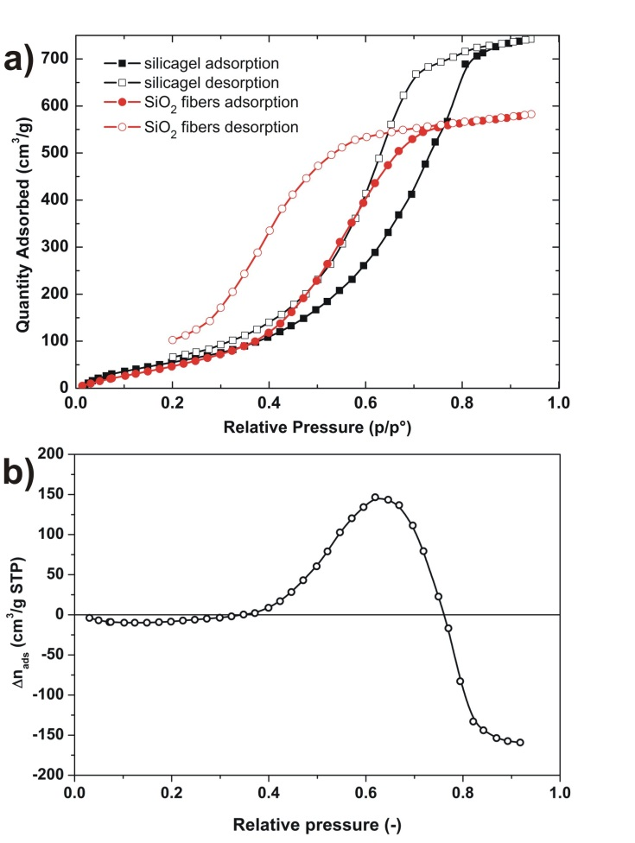
Figure 4. a) Volumetric adsorption isotherms of H₂O vapours on SiO₂ fibers TEOS:PVP 1:1 and benchmark silicagel showing adsorption and desorption branches. Full points – adsorption branch of isotherms, empty points – desorption branch of isotherms; b) difference isotherm obtained by subtracting of the adsorption branches of both isotherms depicted in (a) (SiO2 fibers (TEOS:PVP 1:1) – reference silicagel).

Table 1. Summary of textural properties of the samples. The specific surface (S_{BET}), external surface area (S_{ext}), total volume of the pores (V_{p}), volume of the micropores (V_{micro}), and porosity character.
sample | S_{BET} | S_{ext} | V_{p} | V_{micro} | D_{p}
sample | (m²/g) | (m²/g) | (cm³/g) | (cm³/g) | (nm)
TEOS:PVP 0.5:1 | 506±1 | 32 | 0.326 | 0.020 | 2-7
TEOS:PVP 1:1 | 824±3 | 65 | 0.547 | 0.011 | 2-10
TEOS:PVP 1.5:1 | 364±1 | 18 | 0.191 | 0.069 | 1.5; 2-5
TEOS:PVP 2:1 | 424±1 | 13 | 0.175 | 0.141 | 1.2; 1.55
reference silicagel | 557±1 | 14 | 0.640 | 0.000 | 4-17

The reason for the strong prevalence of SiO₂ fibers in the range of medium humidities stems from the combination of their large surface area and steeper increase in the cumulative pore volume at smaller mesopores. The large area of hydrophilic surface (see FTIR spectra of silanol vibration in Figure 3) implies a large number of silanol groups on the fiber surface, through which H₂O molecules are adsorbed. In addition, the pore volume contributes to an additional H₂O uptake by capillary condensation taking place in the mesopores.
All in all, the results clearly show that SiO₂ fibers have the potential to be used advantageously for broad range of applications, including desiccant wheel dehumidification systems⁴⁹ and solar-powered adsorption refrigeration.⁵⁰ Due to above mentioned reasons, this technique allows production of SiO₂ fibers on an industrial scale.

Conclusions
In this paper, novel type of 3D network of SiO₂ precursor fibers with high surface area (≈ 824 m²/g) and large pore volume was synthesized for the first time by centrifugal spinning from tailored spun solutions without toxic elements and surfactants. The optimized conditions for production of these fibers were found to be: utilization of solution with TEOS:PVP ratio 1:1 for centrifugal spinning, drying of as-produced fibers in air at controlled humidity (30% RH) and subsequent calcination in air at 500°C for 6 h. Based on the textural characteristics of SiO₂ fibers, the benchmark type of silicagel was selected for comparison of the H₂O adsorption performance. From this comparison it is evident that SiO₂ fibers overcome silicagel in the humidity region between relative pressures 0.4 and 0.75 due to combination of their large surface area and steeper increases in the cumulative pore volume in smaller mesopores. SiO₂ fibers are highly promising for production on an industrial scale.

Experimental details
Preparation of the spun solution
The spinning solution was prepared from two individual solutions. The first solution was prepared by mixing of 2 g of lactic acid (LA), 4.75 up to 19 g tetraethyl orthosilicate (TEOS) and 7 g absolute ethanol. The second solution was prepared by dissolving of 9.5 g polyvinylpyrrolidone (PVP, M_{w} = 1,300,000 g/mol) in mixture of 43.5 – 57.75 g absolute ethanol and 19 g n-butanol. The solution was stirred until all PVP was dissolved. Finally, both solutions were mixed together. In total, four different solutions with different TEOS:PVP ratios (0.5:1, 1:1, 1.5:1 and 2:1) were prepared. Viscosities of the as-prepared solutions were measured by a laboratory viscosimeter Maneko VP 1000.
Centrifugal spinning process
The recently developed centrifugal spinning technique was used for the synthesis of fibers with diameters on the micro- and sub-microscale.^{17,18} A centrifugal spinning tool - Caltrop Spike Spinner CS18N - developed and operated by company Pardam Ltd. (Czech Republic) was used for the synthesis of precursor 3D fiber network. The drawing of the tool is shown in Figure 5.

Figure 5. Schematic drawing of the centrifugal spinning setup.
To briefly outline the principle of the centrifugal spinning: the solution is fed through many nozzles within the constantly rotating spinnerette (of diameter of approx. 20 cm) at a constant flow rate. Centrifugal forces (due to rotation) spread out many fibers from the nozzles. Fibers are being dried from the solvents by an air flow (temperature and humidity controlled) while flying to the collectors, which are in distance of approx. 50 cm from the geometrical middle of the spinnerette. They are removed from collector in regular periods (after sufficient amount of material has been collected, typically on the scale of 10-20 min) and submitted to calcination or analyses. This setup has several important advantages compared to the electrospinning. The prepared fibers are in „bulky“ form, which allows their easier handling. There is no non-woven textile or aluminum foil needed for the process as a substrate, which has positive impact on costs. The fibers are collected directly on the spacers. Finally, the as-prepared fibers do not possess an electrostatic charge, which also improves handling with fibers.
Based on preliminary experiments with solutions of different TEOS and PVP contents, the rotations of the spinnerette were set to 7,000 RPM.
Calcination of the as-spun fibers
The prepared precursor fibers were calcined in a laboratory muffle oven. At first, all fiber batches were heated up to 300°C (heating rate 0.8°C/min) in ceramic crucibles and were maintained at this temperature for 1 hour. Then the temperature was increased to 500°C (heating rate 10°C/min), and maintained there for 6 hours. Afterwards, fibers were naturally cooled down to the room temperature.
For the purpose of adsorption properties comparison, a benchmark silicagel (high purity grade Merck Grade 10180, Sigma-Aldrich) with similar textural properties was examined as well.
Morphological and structural analyses.
The morphological characterization of as-spun as well as calcined SiO₂ fibers was carried out using a field-emission scanning electron microscope (JSM7500F, JEOL) and a transmission electron microscope (JEM 2010F, JEOL). Diffraction analyses of the fibers were carried out using X-ray diffractometer (XRD, D8 Advance, Bruker AXE) using Cu Ka radiation with secondary graphite monochromator and Na(Tl)I scintilation detector.
BET analysis
The textural properties (specific surface area, pore size distribution) of the SiO₂ fibers and reference silicagel were determined from the N₂ adsorption isotherms. The isotherms were acquired using an ASAP 2020 instrument (Micromeritics, USA) and evaluated by MicroActive Software (Micromeritics, USA). Before the adsorption measurement, the fibers were carefully degassed to allow a quantitative removal of the pre-adsorbed H₂O. Starting at ambient temperature, the fibers were degassed at 110 °C (temperature ramp of 0.5 °C/min) until the residual pressure of 1 Pa was attained. After further heating at 110 °C for 1 hour the temperature was increased (temperature ramp of 1 °C/min) until the temperature of 200 °C was achieved. The SiO₂ fibers were degassed at this temperature under turbomolecular pump vacuum for 8 hours. This was done to avoid potential structural damage of the fibers due to surface tension effects and hydrothermal alternation. The specific surface area was calculated according to BET method.⁵¹ The mesopore and external surface area were determined by means of t-plot using Harkins–Jura equation for calculation of adsorbed layer thickness, pore volume and pore size distribution were determined by NL DFT approach by using the “N₂ @ 77K” model for cylindrical pores and oxide surface.
H₂O adsorption measurement
The adsorption isotherms of H₂O adsorbate on selected fibers and reference silicagel were also analyzed by ASAP 2020 instrument (Micromeritics, USA). The sample was activated the same way as described above for N₂ adsorption measurement. H₂O adsorption isotherms were measured in the whole range of %RH at 25°C using the tempered box equipped with Peltier-elements and Pt thermoprobe allowing temperature measurement and controlling in the range of -5 to 80 °C with precision of 0.1°C.
Fourier transformed Infrared Spectroscopy (FTIR)
For the FTIR experiments, the samples were pressed into self-supporting wafers with density of ~ 10 mg/cm² and placed into IR cell for transmission measurement connected with vacuum line (AABspec #2000A Multi-Mode System). The samples were in situ activated (outgassed) in a dynamic vacuum (residual pressure < 10⁻⁴ mbar) for 10 h at 200°C or 3 h at 490°C (with rate of temperature increase of 1°C/min up to 127°C, then 30 min at this temperature and subsequently increase of temperature with rate 5°C/min up to targeted temperature). Infrared spectra (32 scans) were collected at 25°C (temperature was checked by thermocouple embedded into sample holder) with a resolution of 2 cm⁻¹ on a Nicolet 6700 FTIR spectrometer equipped with an MCT/A cryodetector. IR spectra of empty IR cell were taken as a background for each measured spectrum. For comparison and quantitative evaluation of individual measured samples, all spectra were normalized to unitary wafer surface density of 10.0 mg/cm² using integral intensity of skeletal overtones (2080–1740 cm⁻¹) as a benchmark.

Acknowledgements
Financial support from Technology Agency of the Czech Republic (project TA04011557) and Ministry of Youth, Education and Sports of the Czech Republic (project LM2015082) is gratefully acknowledged. We thank to Prof. Petra Sulcova, Ph.D. for TGA analyses. We thank to company Pardam Ltd. for cooperation.

Authors information
Luděk Hromádko: ludek.hromadko@upce.cz
Eva Koudelková: eva.koudelkova@upce.cz
Roman Bulánek: roman.bulanek@upce.cz
Jan M. Macák: jan.macak@upce.cz

Supporting information
TG-DTA analysis; XRD pattern of calcined fibers; adsorption isotherm of N₂ (at temperature -196°C); pore size distribution; data collected from literature on textural properties of SiO₂ fibers.

References
(1) Teo, W. E.; Ramakrishna, S. A Review on Electrospinning Design and Nanofibre Assemblies. Nanotechnology 2006, 17, R89.
(2) Luo, C. J.; Stoyanov, S. D.; Stride, E.; Pelan, E.; Edirisinghe, M. Electrospinning versus Fibre Production Methods: From Specifics to Technological Convergence. Chem. Soc. Rev. 2012, 41, 4708–4735.
(3) Dalton, P. D.; Vaquette, C.; Farrugia, B. L.; Dargaville, T. R.; Brown, T. D.; Hutmacher, D. W. Electrospinning and Additive Manufacturing: Converging Technologies. Biomater. Sci. 2013, 1, 1–27.
(4) Demir, M. .; Yilgor, I.; Yilgor, E.; Erman, B. Electrospinning of Polyurethane Fibers. Polymer (Guildf). 2002, 43, 3303–3309.
(5) Homaeigohar, S.; Koll, J.; Lilleodden, E. T.; Elbahri, M. The Solvent Induced Interfiber Adhesion and Its Influence on the Mechanical and Filtration Properties of Polyethersulfone Electrospun Nanofibrous Microfiltration Membranes. Sep. Purif. Technol. 2012, 98, 456–463.
(6) Su, C.; Shao, C.; Liu, Y. Electrospun Nanofibers of TiO2/CdS Heteroarchitectures with Enhanced Photocatalytic Activity by Visible Light. J. Colloid Interface Sci. 2011, 359, 220–227.
(7) Yang, X.; Shao, C.; Liu, Y.; Mu, R.; Guan, H. Nanofibers of CeO2 via an Electrospinning Technique. Thin Solid Films 2005, 478, 228–231.
(8) Xiang, H.; Long, Y.; Yu, X.; Zhang, X.; Zhao, N.; Xu, J. A Novel and Facile Method to Prepare Porous Hollow CuO and Cu Nanofibers Based on Electrospinning. CrystEngComm 2011, 13, 4856–4860.
(9) Kim, Y. J.; Ahn, C. H.; Lee, M. B.; Choi, M. S. Characteristics of Electrospun PVDF/SiO2 Composite Nanofiber Membranes as Polymer Electrolyte. Mater. Chem. Phys. 2011, 127, 137–142.
(10) Wang, C.; Tong, Y.; Sun, Z.; Xin, Y.; Yan, E.; Huang, Z. Preparation of One-Dimensional TiO2 Nanoparticles within Polymer Fiber Matrices by Electrospinning. Mater. Lett. 2007, 61, 5125–5128.
(11) Misha, S.; Mat, S.; Ruslan, M. H.; Sopian, K. Review of Solid/liquid Desiccant in the Drying Applications and Its Regeneration Methods. Renew. Sustain. Energy Rev. 2012, 16, 4686–4707.
(12) Saha, J.; De, G. Highly Ordered Cubic Mesoporous Electrospun SiO2 Nanofibers. Chem. Commun. 2013, 49, 6322–6324.
(13) Wang, H.; Wu, Q.; Cao, D.; Lu, X.; Wang, J.; Leung, M. K. H.; Cheng, S.; Lu, L.; Niu, C. Synthesis of SnSb-Embedded Carbon-Silica Fibers via Electrospinning: Effect of TEOS on Structural Evolutions and Electrochemical Properties. Mater. Today Energy 2016, 1, 24–32.
(14) Wu, X.; Shi, Z.; Wang, C.; Jin, J. Nanostructured SiO2/C Composites Prepared via Electrospinning and Their Electrochemical Properties for Lithium Ion Batteries. J. Electroanal. Chem. 2015, 746, 62–67.
(15) Doshi, J.; Reneker, D. H. Electrospinning Process and Applications of Electrospun Fibers. J. Electrostat. 1995, 35, 151–160.
(16) Reneker, D. H.; Yarin, A. L. Electrospinning Jets and Polymer Nanofibers. Polymer. 2008, pp 2387–2425.
(17) Sarkar, K.; Gomez, C.; Zambrano, S.; Ramirez, M.; De Hoyos, E.; Vasquez, H.; Lozano, K. Electrospinning to Forcespinning. Mater. Today 2010, 13, 12–14.
(18) Edmondson, D.; Cooper, A.; Jana, S.; Wood, D.; Zhang, M. Centrifugal Electrospinning of Highly Aligned Polymer Nanofibers over a Large Area. J. Mater. Chem. 2012, 22, 18646–18652.
(19) Mahalingam, S.; Pierin, G.; Colombo, P.; Edirisinghe, M. Facile One-Pot Formation of Ceramic Fibres from Preceramic Polymers by Pressurised Gyration. Ceram. Int. 2015, 41, 6067–6073.
(20) Raimi-Abraham, B. T.; Mahalingam, S.; Edirisinghe, M.; Craig, D. Q. M. Generation of poly(N-Vinylpyrrolidone) Nanofibres Using Pressurised Gyration. Mater. Sci. Eng. C 2014, 39, 168–176.
(21) Ma, P. X.; Zhang, R. Synthetic Nano-Scale Fibrous Extracellular Matrix. J. Biomed. Mater. Res. 1999, 46, 60–72.
(22) Hong, Y.; Legge, R. L.; Zhang, S.; Chen, P. Effect of Amino Acid Sequence and pH on Nanofiber Formation of Self-Assembling Peptides EAK16-II and EAK16-IV. Biomacromolecules 2003, 4, 1433–1442.
(23) Taek Jung, K.; Chu, Y.-H.; Haam, S.; Gun Shul, Y. Synthesis of Mesoporous Silica Fiber Using Spinning Method. J. Non. Cryst. Solids 2002, 298, 193–201.
(24) Ellison, C. J.; Phatak, A.; Giles, D. W.; Macosko, C. W.; Bates, F. S. Melt Blown Nanofibers: Fiber Diameter Distributions and Onset of Fiber Breakup. Polymer (Guildf). 2007, 48, 3306–3316.
(25) Batool, S. S.; Imran, Z.; Israr-Qadir, M.; Jamil-Rana, S.; Usman, M.; Jamil, H.; Rafiq, M. A.; Hasan, M. M.; Nur, O.; Willander, M. Silica Nanofibers Based Impedance Type Humidity Detector Prepared on Glass Substrate. Vacuum 2013, 87, 1–6.
(26) He, H.; Wang, J.; Li, X.; Zhang, X.; Weng, W.; Han, G. Silica Nanofibers with Controlled Mesoporous Structure via Electrospinning: From Random to Orientated. Mater. Lett. 2013, 94, 100–103.
(27) Ma, Z.; Ji, H.; Teng, Y.; Dong, G.; Zhou, J.; Tan, D.; Qiu, J. Engineering and Optimization of Nano- and Mesoporous Silica Fibers Using Sol–gel and Electrospinning Techniques for Sorption of Heavy Metal Ions. J. Colloid Interface Sci. 2011, 358, 547–553.
(28) Shao, C.; Kim, H. Y.; Gong, J.; Ding, B.; Lee, D. R.; Park, S. J. Fiber Mats of Poly(vinyl Alcohol)/silica Composite via Electrospinning. Mater. Lett. 2003, 57, 1579–1584.
(29) Yamaguchi, T.; Sakai, S.; Kawakami, K. Application of Silicate Electrospun Nanofibers for Cell Culture. J. Sol-Gel Sci. Technol. 2008, 48, 350–355.
(30) Wen, S.; Liu, L.; Zhang, L.; Chen, Q.; Zhang, L.; Fong, H. Hierarchical Electrospun SiO2 Nanofibers Containing SiO2 Nanoparticles with Controllable Surface-Roughness And/or Porosity. Mater. Lett. 2010, 64, 1517–1520.
(31) Wu, C.; Yuan, W.; Al-Deyab, S. S.; Zhang, K. Q. Tuning Porous Silica Nanofibers by Colloid Electrospinning for Dye Adsorption. Appl. Surf. Sci. 2014, 313, 389–395.
(32) Wu, Y.; Li, F.; Wu, Y.; Jia, W.; Hannam, P.; Qiao, J.; Li, G. Formation of Silica Nanofibers with Hierarchical Structure via Electrospinning. Colloid Polym. Sci. 2011, 289, 1253–1260.
(33) Liu, Y.; Sagi, S.; Chandrasekar, R.; Zhang, L.; Hedin, N. E.; Fong, H. Preparation and Characterization of Electrospun SiO2 Nanofibers. J. Nanosci. Nanotechnol. 2008, 8, 1528–1536.
(34) Li, J.; Zhang, Y.; Zhong, X.; Yang, K.; Meng, J.; Cao, X. Single-Crystalline Nanowires of SiC Synthesized by Carbothermal Reduction of Electrospun PVP/TEOS Composite Fibres. Nanotechnology 2007, 18, 245606–245609.
(35) Irani, M.; Keshtkar, A. R.; Moosavian, M. A. Removal of Cadmium from Aqueous Solution Using Mesoporous PVA/TEOS/APTES Composite Nanofiber Prepared by Sol-Gel/electrospinning. Chem. Eng. J. 2012, 200–202, 192–201.
(36) Choi, S.-S.; Lee, S. G.; Im, S. S.; Kim, S. H.; Joo, Y. L. Silica Nanofibers from Electrospinning/sol-Gel Process. J. Mater. Sci. Lett. 2003, 22, 891–893.
(37) Feng, X.; Yang, G.; Xu, Q.; Hou, W.; Zhu, J. J. Self-Assembly of polyaniline/Au Composites: From Nanotubes to Nanofibers. Macromol. Rapid Commun. 2006, 27, 31–36.
(38) Iimura, K.; Oi, T.; Suzuki, M.; Hirota, M. Preparation of Silica Fibers and Non-Woven Cloth by Electrospinning. Adv. Powder Technol. 2010, 21, 64–68.
(39) Katoch, A.; Kim, S. S. Synthesis of Hollow Silica Fibers with Porous Walls by Coaxial Electrospinning Method. J. Am. Ceram. Soc. 2012, 95, 553–556.
(40) Du, Q.; Wu, J.; Yang, H. Pt@Nb-TiO2 Catalyst Membranes Fabricated by Electrospinning and Atomic Layer Deposition. ACS Catal. 2014, 4, 144–151.
(41) Ren, L.; Ozisik, R.; Kotha, S. P. Rapid and Efficient Fabrication of Multilevel Structured Silica Micro-/nanofibers by Centrifugal Jet Spinning. J. Colloid Interface Sci. 2014, 425, 136–142.
(42) Buchko, C. J.; Kozloff, K. M.; Martin, D. C. Surface Characterization of Porous, Biocompatible Protein Polymer Thin Films. Biomaterials 2001, 22, 1289–1300.
(43) Yang, Y.; Jia, Z.; Li, Q.; Guan, Z. Experimental Investigation of the Governing Parameters in the Electrospinning of Polyethylene Oxide Solution. IEEE Trans. Dielectr. Electr. Insul. 2006, 13, 580–585.
(44) Mit-uppatham, C.; Nithitanakul, M.; Supaphol, P. Ultratine Electrospun Polyamide-6 Fibers: Effect of Solution Conditions on Morphology and Average Fiber Diameter RID C-4353-2008. Macromol. Chem. Phys. 2004, 205, 2327–2338.
(45) Theron, S. A.; Zussman, E.; Yarin, a L. Experimental Investigation of the Governing Parameters in the Electrospinning\tof Polymer Solutions. Polymer (Guildf). 2004, 45, 2017–2030.
(46) Zhuravlev, L. T. The Surface Chemistry of Amorphous Silica. Zhuravlev Model. Colloids Surfaces a-Physicochemical Eng. Asp. 2000, 173, 1–38.
(47) Nastaj, J.; Aleksandrzak, T. Adsorption Isotherms of Water, Propan-2-Ol, and Methylbenzene Vapors on Grade 03 Silica Gel, Sorbonorit 4 Activated Carbon, and HiSiv 3000 Zeolite. J. Chem. Eng. Data 2013, 58, 2629–2641.
(48) Oh, H.-T.; Lim, S.-J.; Kim, J. H.; Lee, C.-H. Adsorption Equilibria of Water Vapor on an Alumina/Zeolite 13X Composite and Silica Gel. J. Chem. Eng. Data 2017, 62, 804–811.
(49) Beccali, M.; Butera, F.; Guanella, R.; Adhikari, R. S. Simplified Models for the Performance Evaluation of Desiccant Wheel Dehumidification. Int. J. Energy Res. 2003, 27, 17–29.
(50) Khattab, N. M. A Novel Solar-Powered Adsorption Refrigeration Module. Appl. Therm. Eng. 2004, 24, 2747–2760.
(51) Brunauer, S.; Emmett, P. H.; Teller, E. Adsorption of Gases in Multimolecular Layers. J. Am. Chem. Soc. 1938, 60, 309–319.

Table of Contents graphic
