ONE-COMPONENT COATING BINDERS BASED ON SELF-CROSSLINKING LATEX: EFFECT OF COVALENTLY LINKED FLAME RETARDANTS AND ALTERNATIVE CROSSLINKING AGENTS ON COATING PROPERTIES
RÜCKEROVÁ A., MACHOTOVÁ J., VEČEŘA M.
UNIVERSITY OF PARDUBICE, Institute of Chemistry and Technology of Macromolecular Materials, The University of Pardubice, CZ–532 10 Pardubice, Czech Republic

Keywords: Core-shell; Phosphazene; Cone-calorimeter, Emulsion polymerization

Introduction
In this century, the abundance of harmful substances in the air has reached new limits; therefore, there is a tendency to develop and practically use the water-based coatings in the industry to eliminate volatile organic compounds (VOCs). Water-based coatings do not contain VOC and they could be useful as interior and exterior coatings for wood and metal substrates as well. Latex coatings can offer comparable mechanical, optical and adhesion properties, together with chemical and water resistance as many solvent-borne coatings¹⁻⁴. In special applications, e.g. burning resistance, the film flammability can be influenced by integrating hallogene-carbohydride based additives or phosphazene derivatives in the paint systems⁵.
For special aplications the basic member of the phosphazene family hexachloro-cyclo-triphosphazene (HCCTP) and its derivatives are often used as flame retardants for preparing some polymeric materials,as well as paint materials⁶⁻⁸.
The presented workdeals with the use of hexaamino-cyclo-triphosphazene (HACTP) and
hexaallylamino-cyclo-triphosphazene (HAACTP) derivatives in emulsion copolymers where this derivatives reduce flammability of the derived paint coatings. The also cause inter-molecular cross-linking resulting in the improvement of mechanical properties of paints.
Self-crosslinking latexes for one-component coatings were prepared by semi-continuous emulsion polymerization. Latex materials were prepared in glass reactors in the inert nitrogen atmosphere at the reaction temperature of 85ºC. Structured core-shell latex particles included a novel flame retardant as the intra-particle crosslinking agent. The flame retardant hexaallylamino-cyclo-triphosphazene (HAACTP) was covalently linked to other main monomers in the shell structure of latex particles. Functionalized latex particles also included in their shell structure diacetone acrylamide to cause a subsequent crosslinking reaction at room temperature. The commercially used adipic acid dihydrazide (ADH) or the alternative crosslinking agent represented by poly(amidoamine) (PAMAM) dendrimer and hexaamino-cyclo-triphosphazene (HACTP), respectively, were added in the form of 10 wt.% water solution to the final latex. PAMAM dendrimer and HACTP were chosen as more eco-friendly crosslinkers. HAACTP decreased flammability of resulting coatings in sense of maximum average rate of heat emission, which was determined by cone-calorimeter combustion.

Emulsion polymerization

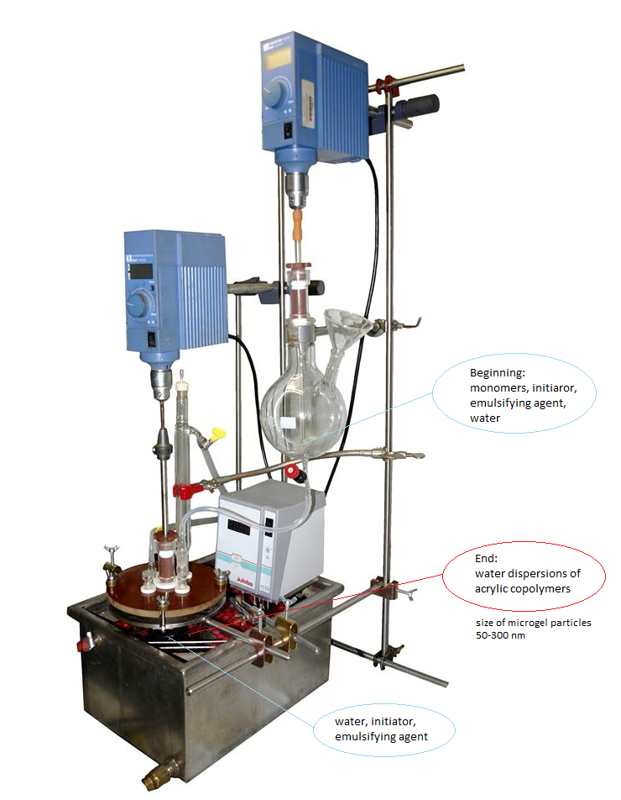
Figure 1 Layout of apparatus for latex preparation

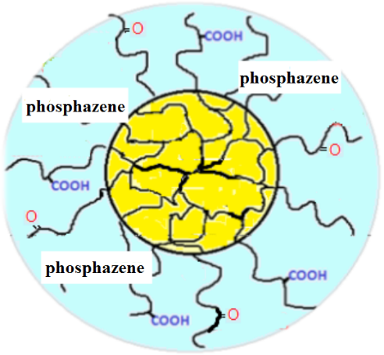
Figure 2 Latex particles core-shell structure

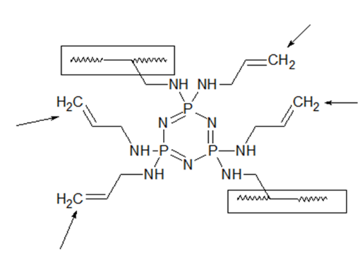
Figure 3 Hexaallylamino-cyclo-triphosphazene structure

Interparticle crosslinking

Figure 4 Cross-linking principle using three different agents

Table 1 Characteristics of latex without cross-linking agents and with cross-linking agents

Crosslinking agent | MFFT (ºC) | Gel content (wt.%) | Chemical resistence MEK (s) | Mc (g.mol⁻¹)
- | 6.3 | 65.9 | 21 | 53648
OG PAMAM | 3.5 | 82.6 | 156 | 27974
ADH | 6.2 | 79.4 | 25 | 14856
HACTP | 6.1 | 75.4 | 124 | 30726

MFFT – Minimum film forming temperature
Gel content - Dry latex swelling in toluene
MEK – Methylethylketone
Mc - calculated molecular weight between the nodes. Derived network density

Results
Figure 5 Differences in paint-film water absorption without cross-linking agents (A) and with cross-linking agents: B: HACTP, C: ADH, D: 0G PAMAM

Figure 6 Influence of different phosphazene concentrations on MARHE value
Figure 7 Influence of used cross-linking agent on MARHE value

Table 2 Results obtained by burning in conical calorimeter

Crosslinking agent | HRR (kw/m².g⁻¹) | EHC (MJ.kg⁻¹.g) | TOC (g.g⁻¹) | TSR  (m⁻².m⁻².g⁻¹) | MARHE  (kw/m².g¹) | Time to ignition (s)
 | 28.09 | 1.96 | 1.69 | 70.05 | 28.38 | 92
OG PAMAM | 28.20 | 1.61 | 1.77 | 65.19 | 27.55 | 119
ADH | 27.45 | 1.80 | 1.71 | 69.45 | 28.64 | 99
HACTP | 28.72 | 1.99 | 1.66 | 72.57 | 28.76 | 90

HRR – Released heat
EHC – Caloric capacity
TOC – Oxygen burning consumption
MARHE – Maximum average value of released heat

Comment

Presence of hexaamino-cyclo-triphosphazene (HACTP) and hexaallylamino-cyclo-triphosphazene in one-component compositions had positively affected the paint mechanical properties while reducing the film flammability. Regarding the transparency and low MFT of the material, the films can be used as primers and surface interior paints/lacquers. The results show that combination of hexaallylamine-cyclotrifosphazene and of the cross-linking agent PAMAM has substantial influence on flammability reduction.

Conclusion
It was found that all prepared latexes were stable for 12 months and provided coatings exhibiting transparent character, good mechanical properties and high gloss. Combination of appropriate properties of hexaallylamino-cyclo-triphosphazene and PAMAM dendrimer as an inter-particle crosslinking agent covalently linked in the polymeric systems created one-component water based coatings with improved mechanical properties, chemical resistance and water resistance. Thus, these prepared coatings are usable as interior coatings for wood, glass and metal substrates.

Literature
1 Bal A., Güçlü G., İyim T.B., Özgümüş S.: Effects of nanoparticles on film properties of waterborne acrylic emulsions. Polymer-Plastics Technology and Engineering 50 (2011) 990–995.
2 Liu J., Ma J., Bao Y., Zhu Z.: Synthesis and application of polyacrylate/ nano-SiO2 composite leather finishing agent with polymerizable surfactant. Polymer-Plastics Technology and Engineering 51 (2012) 1460–1467.
3 Xu H., Yang D., Guo Q., Wang Y., Wu W., Qiu F.: Waterborne polyurethane-acrylate containing different polyether polyols: Preparation and properties Polymer-Plastics Technology and Engineering 51 (2012) 50–57.
4 Steward P.A., Hearn J., Wilkinson M.C.: An overview of polymer latex film formation and properties. Advances in Colloid and Interface Science 86 (2000) 195–267.
5 Rückerová A. et al.: Sci. Pap. Univ. Pardubice, Ser. A 24 (2018) 159–165.
6 Kubota S., Ito O.: Aminophosphazenes cured epoxy resins – carbon fiber composites, in Mizumachi H. (Ed): Adhesion Science and Technology, Proceedings of the International Adhesion Symposium. Gordon and Breach Science Publishers, Yokohama 1994, p. 578.
7 Fox T.G., Flory P.J.: Second-order transition temperatures and related properties of polystyrene. I. Influence of molecular weight. Journal of Applied Physics 21 (1950) 581–591.
8 Bakhshi H., Zohuriaan-Mehr M.J., Bouhendi H., Kabiri K.: Effect of functional monomer GMA on the physical-mechanical properties of coatings from poly(BA-MMA) latexes. Journal of Materials Science 46 (2011) 2771–2777.

Acknowledgement
The Technological Agency of the Czech Republic (TE02000011) is gratefully acknowledged for supporting this work.

