This is the accepted version of the following article:

Ruckerova, A., Machotova, J., Svoboda, R., Pukova, C, Bohacik, P., & Valka, R. (2018). Ambient temperature self-crosslinking latices using low generation PAMAM dendrimers as inter-particle crosslinking agents. Progress in Organic Coatings, 119, pp. 91-98. doi: 10.1016/j.porgcoat.2018.02.027

This postprint version is available from URI https://hdl.handle.net/10195/72634

Publisher’s version is available from
https://www.sciencedirect.com/science/article/pii/S030094401730886X?via%3Dihub


This postprint version is licenced under a Creative Commons Attribution-NonCommercial-NoDerivatives 4.0.International.

Ambient temperature self-crosslinking latices using low generation PAMAM dendrimers as inter-particle crosslinking agents

Adela Ruckerova ¹, Jana Machotova ¹, Roman Svoboda ², Katerina Pukova ³, Peter Bohacik ¹, Roman Valka ¹

¹ Institute of Chemistry and Technology of Macromolecular Materials, Faculty of Chemical Technology, University of Pardubice, Studentská 573, 532 10 Pardubice, Czech Republic
² Department of Physical Chemistry, Faculty of Chemical Technology, University of Pardubice, Studentská 573, 532 10 Pardubice, Czech Republic
³ Institute of Environmental and Chemical Engineering, Faculty of Chemical Technology, University of Pardubice, Studentská 573, 532 10 Pardubice, Czech Republic

Correspondence to: Jana Machotová; e-mail address: jana.machotova@upce.cz,
tel.: +420 46 603 7194, fax: +420 46 603 7068.

Abstract
This study focuses on one-component ambient temperature self-crosslinking latex coating compositions containing poly(amidoamine) (PAMAM) dendrimers in the role of eco-friendly crosslinking agents. Low generation amine-terminated PAMAM dendrimers of in the form of aqueous solution were added into acrylic latices containing diacetone acrylamide (DAAM) repeat units in their polymer structure. The latex storage stability and coating performance were evaluated and compared with the coating compositions containing the conventional adipic acid dihydrazide (ADH) crosslinking agent. It was found that the latices containing PAMAM dendrimers, exhibited a long-term storage stability and provided crosslinked coating films of high gloss, transparency and mechanical performance comparable to ADH-based self-crosslinking latices. Moreover, PAMAM-crosslinked coatings exhibited excellent water-whitening resistance.

Keywords: PAMAM dendrimer; self-crosslinking; latex; diacetone acrylamide; adipic acid dihydrazide; water-whitening

Introduction
During the last decades, coating suppliers have been forced to move to waterborne technology due to increasing environmental regulations and legislative pressures. Therefore, waterborne colloidal polymers, i.e. “latices” prepared via emulsion polymerization are of particular interest and have been widely applied as binders for paints, inks and special coating materials for other applications. However, the performances of common latex coatings such as quick drying, adhesion strength, water resistance, and mechanical properties are usually inferior to solvent-based coatings.
One approach to improve the balance in the properties of latex coatings against solvent-based coatings is to introduce intra-particle crosslinking and/or inter-particle self-crosslinking chemistry in emulsion polymers [1−4]. Currently, self-crosslinking via the reaction of a carbonyl pendant group on the polymer backbone with some diamine, especially where that diamine is the adipic acid dihydrazide (ADH), has attracted a tremendous amount of research activity [5−10]. This chemistry, termed the keto-hydrazide reaction, is favored by the loss of water and the simultaneous decrease in pH arising from the evaporation of ammonia or amines during the film forming process. The ADH-based self-crosslinking latices can get cured rapidly at ambient temperature and do not need any additional crosslinker to be added before use, therefore they have been shown to be suitable for a wide range of applications, starting from paints for the building industry [11], through wood paints and varnishes to paints for metal protection and decorative systems [12,13].
Nevertheless, according to WKG Germany safety rating, ADH represents a highly water polluting substance. Hence, efforts trying to replace ADH by an environmental friendly and effective crosslinking agent are particularly important. One promising way may be achieved by using poly(amidoamine) (PAMAM) dendrimers which are a specific family of dendritic polymers, based on an ethylenediamine core and an amidoamine repeat branching structure [14,15]. These substances are synthesized from cheap raw materials and their size and surface functionality (amine, carboxyl, methylester) can be varied by the number of controlled repetitive additions of monomer units giving rise to different generations [16−18]. Due to unique properties including well-defined molecular structure, spherical shape and water solubility, PAMAM dendrimers have found numerous applications in chemical, biological and physical processes [19−21]. Particularly, low-generation PAMAM dendrimers (third generation or lower) have desired biological properties, such as nontoxicity and nonimmunogenicity for in vivo applications [22,23]. Thus, water soluble amino-functionalized PAMAM dendrimers of lower generations have attracted our attention as the potential pro-ecological crosslinkers for self-crosslinking latex coating compositions containing diacetone acrylamide (DAAM).
The present work deals with low generation amine terminated PAMAM dendrimers as the promising and environmentally friendly inter-particle crosslinking agents for ambient temperature one-component self-crosslinking waterborne coatings. The self-crosslinking of standard latices comprising DAAM repeat units within the polymer was provided by first and second generation PAMAM dendrimers, respectively. The latex stability and coating performance with emphasis on water sensitivity were evaluated and compared with the conventional ADH crosslinking agent.

Materials and methods
Materials
Amine-terminated poly(amidoamine) dendrimers (PAMAM) of generation 0.0 (G0) and generation 1.0 (G1) in as 20 wt.% methanol solutions were purchased from Sigma-Aldrich (Czech Republic). Their chemical formulas are illustrated in Fig. 1. After methanol evaporation, the PAMAM dendrimers were easily dissolved in distilled water to produce 10 wt.% aqueous solution. Adipic acid dihydrazide (ADH) crosslinker was purchased from TCI Europe (Switzerland). Model latices were synthesized of methyl methacrylate (MMA), butyl acrylate (BA), methacrylic acid (MAA), allyl methacrylate (AMA) and diacetone acrylamide (DAAM). All monomers were purchased from Sigma-Aldrich (Czech Republic). Disponil FES 993 (BASF, Czech Republic) was used as the emulsifying agent and ammonium persulfate (Lach-Ner Company, Czech Republic) was used as the initiator of the polymerization.

Preparation and characterization of self-crosslinking latices
Two standard latices were synthesized by the technique of semi-continuous non-seeded emulsion polymerization using variable content of acrylic monomers. To enable the subsequent inter-particle crosslinking with a suitable amine- or hydrazide-based crosslinking agent, DAAM was incorporated in polymer particles to introduce ketone carbonyl functional groups. The latex sample labeled C₀S comprised latex particles without intra-particle crosslinking. With a view to achieve enhanced properties of final coatings, the intra-particle crosslinking was introduced by copolymerizing AMA in the case of the latex sample labeled C_{A}S. To ensure the sufficient film-formation, the ratio of acrylic monomers forming latex particles was chosen to achieve the calculated T_{g} of the resulting polymer of approximately 15 °C (using the Fox equation [24]). The detailed composition of monomer feeds forming the latex sample C₀S was as follows: 43 g MMA, 53 g BA and 4 g MAA dosed in the first step and 38.5 g MMA, 52.5 g BA, 4 g MAA and 5 g DAAM dosed in the second step. In the case of the latex sample C_{A}S, the composition of monomer feeds in the first step consisted of 42 g MMA, 53 g BA, 4 g MAA and 1 g AMA, and the composition of monomer feeds in the second step was identical to C₀S sample.

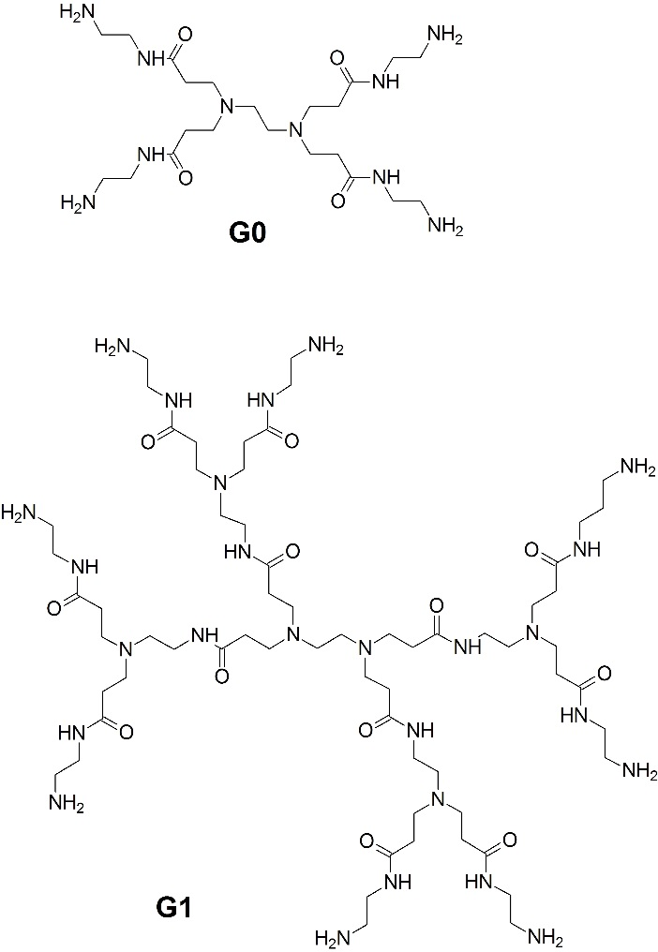
Fig. 1. Structure of PAMAM dendrimers of generation 0.0 (G0) and generation 1.0 (G1).

The latices were produced in a 700 ml glass reactor under nitrogen atmosphere at 85 °C. The reactor charge was put into the reactor and heated to the polymerization temperature. Then the monomer emulsion was fed into the stirred reactor at the feeding rate about 2 ml/min in two steps. After that, during 2 hours of hold period the polymerization was completed. The recipe of emulsion polymerization is shown in Table 1. The pH value of latices was adjusted to 8.5 by adding ammonia solution. The solids content of the latices was about 45 wt.%.
In order to produce G0 PAMAM-based one-component self-crosslinking latices, 10 wt.% water solution of G0 PAMAM dendrimer at the molar ratio G0 PAMAM : DAAM = 1 : 4 was added to the latex. Similarly, G1 PAMAM-based one-component self-crosslinking latices were obtained by adding 10 wt.% water solution of G1 PAMAM dendrimer at the molar ratio G1 PAMAM : DAAM = 1 : 8 to the latex. (The molecular weight of G0 PAMAM and G1 PAMAM is 517 and 1430 g/mol, respectively). Finally, the comparative ADH-based one-component self-crosslinking latices were produced by adding 10 wt.% water solution of ADH to the model latex at the molar ratio ADH : DAAM = 1 : 2. The self-crosslinking reaction of DAAM containing polymer with G1 PAMAM dendrimer and ADH, respectively, is depicted schematically in Figure 2.
The minimum film-forming temperatures (MFFT) of all the prepared self-crosslinking latices and standard latices without any crosslinker were measured according to ISO 2115, using the MFFT-60 instrument (Rhopoint Instruments, UK). pH measurements were carried out at 23 ± 1 °C using a pH meter FiveEasy FE20 (Mettler-Toledo, Switzerland).

Table 1 Recipe of emulsion polymerization
Reactor charge:
Water (g) | 65
Disponil FES 993 IS (g) | 0.5
Ammonium persulfate (g) | 0.4
Monomer emulsion (1st step):
Water | 60
Disponil FES 993 IS (g) | 7.4
Ammonium persulfate (g) | 0.4
Monomers (g) | 100
Monomer emulsion (2nd step):
Water (g) | 60
Disponil FES 993 IS (g) | 7.4
Ammonium persulfate (g) | 0.4
Monomers (g) | 100

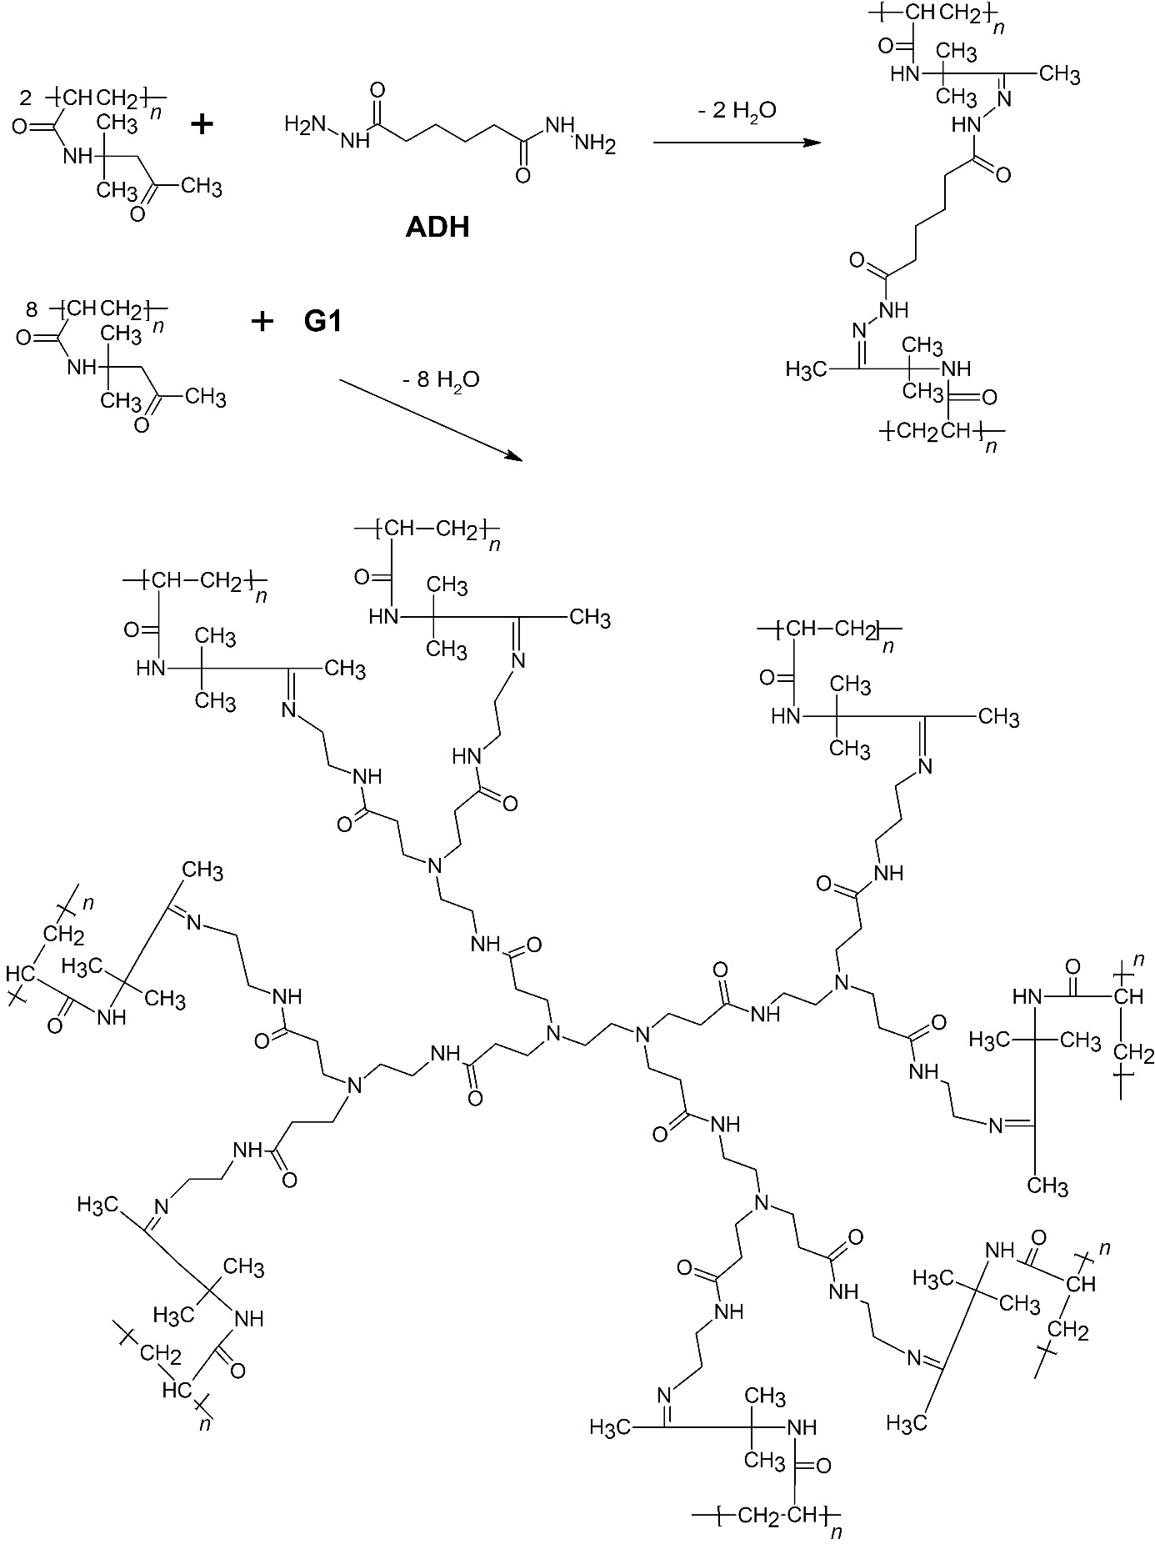
Fig. 2. Crosslinking reaction of ketone carbonyl groups of DAAM repeat units using ADH and G1 PAMAM dendrimer, respectively.

Monitoring of self-crosslinking reaction
The verification of the occurrence of G0 PAMAM- and G1 PAMAM-based self-crosslinking reaction was performed on dried coating films from the point of view of exploring their glass transition temperature (T_{g}), gel content and crosslinking density differences. The self-crosslinking based on PAMAM dendrimers was compared with ADH-based self-crosslinking. The specimens for the measurements were prepared by pouring and drying the latices on silicone substrates. The specimens were first air-dried at room temperature (23 ± 1 °C) and 50 % relative humidity for a month and then vacuum-dried at 30 °C for 2 weeks. The thickness of dry films was approximately 1 mm. The glass transition temperature (T_{g}) of dried latex polymers was measured by means of differential scanning calorimetry using a Pyris 1 DSC instrument (Perkin-Elmer, USA). The measurements were performed under N₂ atmosphere at the heating rate of 10 °C/min from -80 °C to 120 °C and the second heating curve was used for T_{g} determination. The gel content of dried latex polymers was determined by the extraction in a Soxhlet extractor with THF for 24 hours according to CSN EN ISO 6427. The crosslinking density was evaluated from swelling experiments performed on dry gel polymer samples (around 0.2 g) which were immersed in toluene at 25 °C for one week. A swelling time of one week was chosen as the basis of the test results on several samples which showed no significant changes after one week of immersion in toluene. At the end of the immersion period the sample was removed, rapidly blotted with tissue and transferred to the weighing bottle to obtain the swollen weight of the sample. Equations (1-4) employing the theory of Flory and Rehner [25] were used to calculate the average molecular weight between crosslinks (M_{c}) and the crosslinking density (expressed as moles of crosslinks per cm³ of polymer network), as given in the following:
$M_{c}= \frac{V_{1}ρ_{p}[ϕ^{1/3}- ϕ/2]}{-[\ln\left(1-ϕ\right)+ ϕ+ {χϕ}^{2}]}$ (1)
$ϕ= \frac{W_{p}ρ_{s}}{W_{p}ρ_{s}+W_{s}ρ_{p}}$ (2)
$χ=0.34+ \frac{V_{1}}{RT}{(δ_{1}- δ_{2})}^{2}$ (3)
Crosslinking density = ρ_{p} / M_{c} (4)
where V₁ is the molar volume of toluene (106.3 cm³/mol); ρ_{p} is the density of polymer that was calculated to be 1.11 g/cm³ for the BA/MMA/MAA (53/43/4 by weight) copolymer from 1.06, 1.18 and 1.015 g/cm³ for poly(BA), poly(MMA) and poly(MAA), respectively; φ is the volume fraction of the gel polymer in the swollen gel; W_{p} and W_{s} are the weight fractions of the gel polymer and solvent (toluene) in the swollen gel, respectively; ρ_{s} is the density of solvent (0.8669 g/cm³); χ is the polymer and solvent interaction parameter; δ₁ is the solubility parameter of polymer that was calculated to be 9.18 (cal/cm³)^{1/2} for the BA/MMA/MAA (53/43/4 by weight) copolymer from 9.0, 9.3 and 9.8 (cal/cm³)^{1/2} for poly(BA), poly(MMA) and poly(MAA), respectively [26,27]; and δ₂ is the solubility parameter of toluene, 8.9 (cal/cm³)^{1/2}.
Further, the course of the self-crosslinking reaction by G0 PAMAM, G1 PAMAM and AHD crosslinking agent, respectively, was monitored using DSC. The DSC measurements were performed by using a heat-flow differential scanning calorimeter Q2000 (TA Instruments, USA) equipped with an autosampler, RCS90 cooling accessory, and T-zero technology. The instrument was calibrated using In, Zn, and H₂O; dry N₂ was used as purge gas at a flow rate of 50 cm³·min⁻¹. The measurements of wet latex samples (water dispersions themselves without any modification) were performed in open aluminum crucibles in order to let the volatile sample components freely evaporate. The sample masses ranged from 10 to 15 mg. After equilibrating the samples at 10 °C, simple heating scans were applied at the heating rate 1 °C·min⁻¹. Reproducibility of the measurements was checked.

Storage stability testing
The storage stability of the one-component self-crosslinking latices comprising different crosslinking agents was symbolized by storing the latices at 50 °C for 50 days and was evaluated according to changes of the apparent viscosity, the average particle size and zeta potential of latex particles. The apparent viscosity of latices was measured at 25 °C using a Bookfield LVDV- E Viscometer (Brookfield Engineering Laboratories, USA) at 100 rpm according to CSN ISO 2555. The average particle sizes and zeta potentials of latex particles dispersed in water phase were detected by dynamic light scattering (DLS) performed by using a Coulter N4 Plus instrument (Coulter, Corp., UK). The concentration of solid polymer in the water phase was about 0.05 wt.% and the measurements were performed at 25 °C.

Preparation and characterization of coatings
The self-crosslinking latices were applied on glass and metallic panels using a blade applicator. The thickness of wet coating films was 120 µm. No coalescing agents were used. The coatings were air-dried at room temperature (23 ± 1 °C) and 50 % relative humidity for 30 days, although in practice, a procedure of 5 days-long drying at room temperature has been shown to provide coatings that exhibit properties close to the results presented below.” The coating films were evaluated for their gloss, transparency, hardness, adhesion, impact resistance, water-whitening and water absorption. The gloss of coating films was determined by a micro TRI-gloss µ instrument (BYK-Gardner, Germany) using a gloss-measuring geometry 60°. The transparency of coatings was evaluated by the light transmission using a ColorQuest XE Spectrometer (Hunterlab, USA). The hardness of coatings was measured by a pendulum hardness tester “Persoz” (BYK-Gardner, Germany) according to CSN EN ISO 1522. The adhesion of coating films to glass substrate was determined according to CSN ISO 2409 using a cross-cut tester (Elcometer Instruments, UK). The impact resistance was evaluated using an Elcometer 1615 Variable Impact Tester (Elcometer Instruments, UK) following CSN EN ISO 6272.
The water-whitening of coating films cast on glass panels was evaluated objectively by reporting the Delta WI CIE (change in whiteness index) using a ColorQuest XE Spectrometer (Hunterlab, USA) according to ASTM E313. The coating film was immersed in distilled water at 23 ± 1 °C for 1 and 10 days, respectively, followed by the immediate measurement of whiteness index of the exposed coating. The extent of water-whitening ΔWI CIE, is given by ΔWI CIE = WI_{t} CIE – WI₀ CIE where WI₀ CIE is the sample whiteness index before distilled water exposure and WI_{t} CIE is the sample whiteness index after performing the whitening test. All water-whitening tests were carried out at room temperature (23 ± 1 °C).
For the water absorption evaluation, specimens were prepared by pouring the self-crosslinking latices into a silicone mould. Films were air-dried at room temperature (23 °C) for a month. The water absorption expressed in terms of water uptake by latex films was measured by immersing specimens of the approximate dimensions 20 × 20 × 0.75 mm³ in distilled water at 23 °C. The water absorption, A is given by A = 100(w_{t} – w₀)/w₀, where w₀ is the initial weight before immersion and w_{t} is the weight after immersion in distilled water during the specified time. The soaked film was removed from water and the surface of the film was carefully dried by touching the polymer with filter paper.

Results and discussion
MFFT of latices
The results of MFFT measurements are listed in Table 2. In comparison with latices C₀S and C_{A}S without any inter-particle crosslinker, the corresponding G0 PAMAM- and G1 PAMAM-based self-crosslinking latices were found to exhibit significantly decreased MFFT values. On the contrary, ADH-containing self-crosslinking latices were shown to possess higher MFFT than the corresponding neat standard latices. The considerable drop in MFFT values in the case of latices containing G0 PAMAM or G1 PAMAM dendrimers is desirable (suggesting good application properties) and may be associated with enhanced hydroplasticization of polymer due to the presence of highly alkaline amidoamine dendrimers. PAMAM crosslinkers probably caused permanent neutralization of carboxylic groups during the film-formation (in comparison with neat and ADH-crosslinked latex compositions that turn acid after ammonia evaporation resulting in protonated carboxylic groups). Thus, softening of polymer chains comprising ionized carboxylic groups during the whole process of film-formation was probably achieved resulting in MFFT decrease (this effect being more pronounced in the case of the more alkaline G1 PAMAM dendrimers). The differences between pH values of latex compositions after ammonia evaporation are shown in Table 2.

Table 2 Effect of the inter-particle crosslinker type on pH value after ammonia evaporation and MFFT of latex compositions, T_{g}, gel content, M_{c} and crosslinking density of dried latex coating samples
Sample | Crosslinking agent | pH after ammonia evaporation | MFFT (°C) | T_{g} (°C) | Gel content (%) | M_{c} (g/mol) | Crosslinking density (moles/cm³)
C₀S | - | 1.90 | 5.6 | 14.1 | 6.2 | -ª | -ª
C₀S | G0 | 7.66 | 2.0 | 12.4 | 72.2 | 18820 | 5.9 × 10⁻⁵
C₀S | G1 | 7.91 | 1.7 | 12.1 | 79.3 | 14930 | 7.4 × 10⁻⁵
C₀S | ADH | 3.42 | 6.0 | 15.3 | 77.8 | 17340 | 6.4 × 10⁻⁵
C_{A}S | - | 2.04 | 6.2 | 16.1 | 87.9 | 2505 | 44.3 × 10⁻⁵
C_{A}S | G0 | 7.68 | 5.7 | 15.1 | 92.6 | 2210 | 50.2 × 10⁻⁵
C_{A}S | G1 | 7.95 | 5.2 | 13.4 | 94.7 | 1810 | 61.3 × 10⁻⁵
C_{A}S | ADH | 3.47 | 10.0 | 19.5 | 95.2 | 2026 | 54.7 × 10⁻⁵
ª Value was not measured, because gel polymer remained anchored in the extraction thimble.

Verification of self-crosslinking reaction
The crosslinked nature of air-dried coating films cast from latices containing different inter-particle crosslinking agents was verified from the point of view of T_{g} and gel content enhancement. The number average molecular weight between crosslinks (M_{c}) and the crosslinking density of coating film samples were determined too. Further, the course of the self-crosslinking reaction between ketone carbonyl groups of the emulsion polymer and G0 PAMAM, G1 PAMAM and AHD, respectively, was monitored using DSC. For the comparison, coating films based on the standard latices without any crosslinker were tested as well.
Table 2 shows results of T_{g}, gel content and crosslinking density measurements with respect to the inter-particle crosslinker type in a given coating composition. Similarly to MFFT results, G0 PAMAM- and G1 PAMAM-crosslinked coatings were found to exhibit decreased glass transition temperatures, whereas coatings crosslinked with the conventional ADH possessed higher glass transition temperatures in comparison with coating materials cast from the corresponding standard latices without any crosslinker. In spite of the fact that the occurrence of self-crosslinking reaction should be manifested by T_{g} elevation, we believe that the referred T_{g} reduction in the case of coatings containing both types of PAMAM dendrimers can be ascribed to permanent ionization of carboxylic groups by amine groups of dendritic molecules. Thus, the lowest T_{g} was measured for the G1 PAMAM-crosslinked copolymers that are supposed to provide the highest degree of carboxylic acid dissociation. This hypothesis correlates well with a calculated T_{g} reduction of approx. 1.7 °C assuming dissociation of methacrylic acid groups. (The T_{g} calculation was performed according to Fox equation using dry T_{g} values of homopolymers from the reference [28].)
Nevertheless, the evidence of the self-crosslinking using PAMAM dendrimers was well demonstrated by measurements of gel content and crosslinking density. Both types of dendrimers were shown to provide crosslinked polymer materials of increased gel content and crosslinking density. Compared to each other, G1 PAMAM dendrimer produced more densely crosslinked polymer networks. It can be stated as well that both types of dendrimers worked as the effective inter-particle crosslinking agents comparable to the conventional ADH crosslinker.
Enthalpy effects accompanying film-formation of the neat latex sample C₀S and the film-formation of the corresponding one-component self-crosslinking latices containing PAMAM dendrimers or ADH were examined by means of DSC and the results are depicted in Fig. 3; each curve corresponds to the heating scan of a particular tested sample. The sample containing no crosslinker (curve A) exhibits a simple endothermal effect corresponding to the evaporation of the volatile components; note the asymmetry of the peak, which indicates a moderately increasing evaporation rate at higher temperatures. Also, on closer examination it is clear that small amount of volatiles is bound in a stronger manner in the latex matrix and requires higher temperatures to be released – perfectly flat baseline signal is not reached until ca. 100 °C. The second tested sample was the latex with the conventional ADH crosslinker (see the curve B). In addition to the volatiles evaporation effect, a small endothermic sharp peak occurs at ~ 70 °C. We believe this to be the effect of the self-crosslinking reaction, which proceeds until almost all the volatiles have be evaporated. This conclusion is supported also by a significant increase of the overall enthalpy associated with the combined endothermal effects (1140 J·g⁻¹ for the sample with no crosslinker versus 1270 J·g⁻¹ for the sample with the conventional ADH crosslinker), which indicates the presence of a subsidiary endothermic mechanism. The DSC data for the mixture of the latex with the new crosslinker G0 PAMAM and G1 PAMAM are displayed in Fig. 3 as lines C and D, respectively. In this case the crosslinking reaction seems to proceed at higher levels of volatile residues, which means that the self-crosslinking using PAMAM dendrimers proceeds simultaneously as the volatiles are being evaporated. The overall enthalpy determined for the overlapping processes was 1250 J·g⁻¹ for G0 PAMAM and 1350 J·g⁻¹ for G1 PAMAM, which indicates a comparable (in the case of G0 PAMAM) or even stronger self-crosslinking reaction (in the case of G1 PAMAM) compared to the conventional ADH crosslinker.
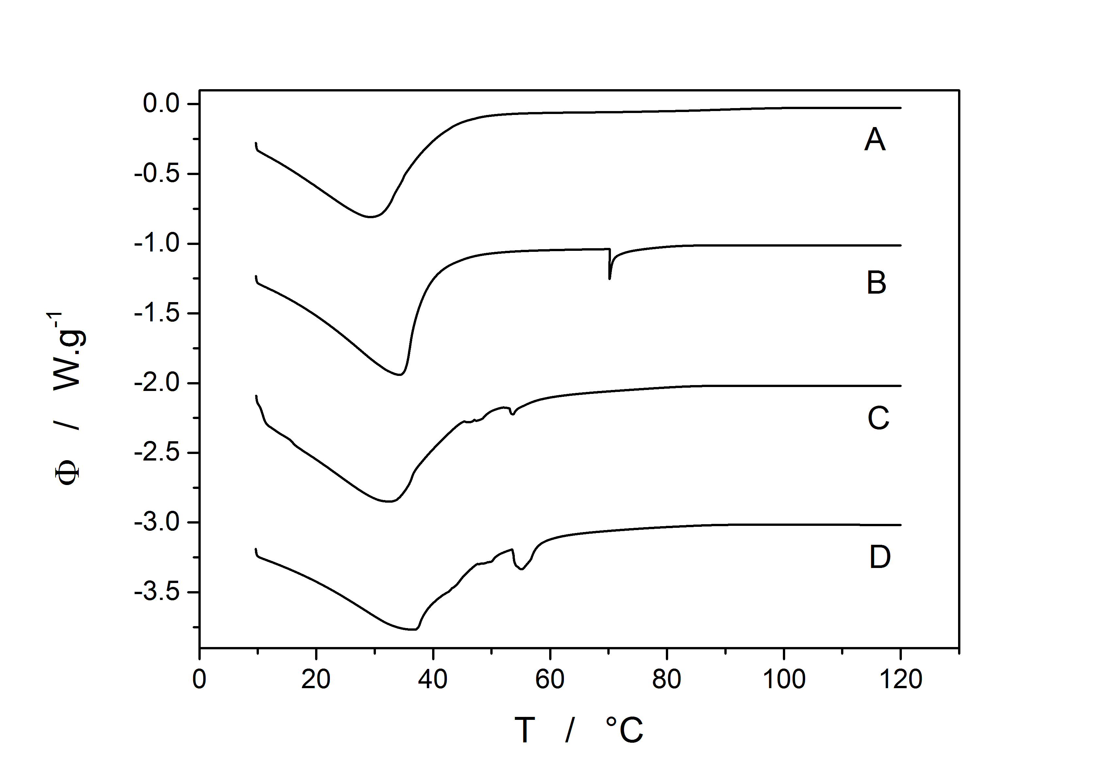
Fig. 3. DSC heating scans of wet latices C₀S: sample containing no crosslinker (curve A), sample containing ADH (curve B), sample containing G0 PAMAM dendrimer (curve C), sample containing G1 PAMAM dendrimer (curve D).

Storage stability evaluation
The results of DSC measurements describing the course of the PAMAM-based self-crosslinking reaction revealed a risk of lower stability in the case of the PAMAM containing self-crosslinking one-component latices. Hence, we focused our research on storage stability testing as well. The stability of latices was evaluated according to changes of the average particle size, zeta potential and latex viscosity before and after storing at 50 °C for 50 days. The results of the measurements are summarized in Table 3. In spite of the facts found by DSC (see curves C and D in Fig. 3 showing that the self-crosslinking reaction proceeded at higher water content during the film-forming process) no significant changes of all the tested properties were observed after the storing, which proves a good stability of the novel one-component self-crosslinking compositions based on PAMAM inter-particle crosslinkers.

Table 3 Characteristics of standard and self-crosslinking latices differing in the inter-particle crosslinker type before and after storing at 50 °C for 50 days
 | Initial state |  |  | After storage
Sample | Particle size (nm) | Zeta potential (mV) | Viscosity (mPa.s)* | Particle size (nm) | Zeta potential (mV) | Viscosity (mPa.s)*
C₀S | 112 | -35.8 | 24.1 | 113 | -38.3 | 26.8
C₀S_{G0} | 111 | -34.2 | 14.4 | 113 | -41.0 | 17.6
C₀S_{G1} | 113 | -36.3 | 11.9 | 115 | -42.6 | 13.5
C₀S_{ADH} | 112 | -33.6 | 14.2 | 115 | -40.2 | 17.5
C_{A}S | 120 | -37.8 | 18.7 | 123 | -45.0 | 21.3
C_{A}S_{G0} | 120 | -31.9 | 11.5 | 122 | -36.7 | 13.2
C_{A}S_{G1} | 119 | -35.4 | 9.3 | 122 | -41.8 | 12.4
C_{A}S_{ADH} | 121 | -34.8 | 14.1 | 124 | -39.7 | 17.0

Coating properties
The effect of inter-particle self-crosslinking using G0 PAMAM, G1 PAMAM and ADH as crosslinking agents on properties of the resulting coatings is shown in Table 4. The thickness of dried coating films was about 50 µm and all prepared coatings were transparent without any surface defects. It was shown that all tested coating films exhibited high gloss without any significant difference depending on the inter-particle crosslinker type. High gloss of a given latex film suggests a good coalescence without any phase separation during the film-formation or premature particle aggregation in the dispersion.
Further, mechanical properties of the PAMAM- and ADH-crosslinked coatings were evaluated. The G0 and G1 PAMAM-crosslinked coatings based on both types of standard latices (C₀S and C_{A}S) were found to possess increased initial and final hardness values in contrast to the non-crosslinked and the ADH-crosslinked coatings. Moreover, the G0 and G1 PAMAM-based coatings showed a better adhesion to glass substrate and a higher impact resistance than the ADH-based coating films. Hence, it is evident that the self-crosslinking latices using PAMAM dendrimers as the intra-particle crosslinkers provide high-quality coatings of similar or even better properties compared to the conventional ADH-based systems.

Table 4 Comparison of final properties of coating films based on standard and self-crosslinking latices differing in the inter-particle crosslinker type
Sample | Gloss 60° (%) | Initial hardnessª (%) | Final hardness^{b} (%) | Adhesion^{c} (degree of flaking) | Impact resistance^{d} (cm)
C₀S | 79.4 ± 1.4 | 16.7 ± 0.6 | 21.7 ± 0.7 | 0 | above 100
C₀S_{G0} | 78.8 ± 0.3 | 23.7 ± 0.3 | 26.2 ± 0.3 | 0 | above 100
C₀S_{G1} | 79.5 ± 1.6 | 23.9 ± 1.2 | 26.6 ± 1.1 | 0 | above 100
C₀S_{ADH} | 81.3 ± 0.5 | 21.7 ± 0.2 | 22.0 ± 0.5 | 1 | 98
C_{A}S | 78.3 ± 2.6 | 19.1 ± 0.6 | 21.1 ± 0.8 | 0 | above 100
C_{A}S_{G0} | 80.5 ± 0.2 | 26.2 ± 1.1 | 28.2 ± 1.3 | 0 | above 100
C_{A}S_{G1} | 83.2 ± 1.8 | 29.4 ± 1.0 | 32.7 ± 1.6 | 0 | above 100
C_{A}S_{ADH} | 80.9 ± 2.1 | 22.5 ± 0.8 | 23.4 ± 0.8 | 1 | 92
ª Hardness after drying for 24 hours.
^{b} Hardness after drying for 30 days.
^{c} Adhesion scale: 0 − 4, where 0 corresponds to the best property.

Water sensitivity
A common drawback of latex coatings is their water sensitivity, usually connected with water-whitening, loss of adhesion and poor durability. Therefore, the efforts to enhance water resistivity of latex coatings by means of polymer structure changes are still being encouraged and the novel PAMAM-based self-crosslinking coating compositions were tested from the point of view of their water sensitivity (expressed in terms of water absorption and water-whitening) as well.
The results of water absorption measurements are illustrated in Figs. 4 and 5. We can observe similar water absorption trends with respect to the inter-particle crosslinker type for both series of latex coatings (based on model latices C₀S and C_{A}S, differing in the absence/presence of AMA-induced crosslinking). The coatings without any inter-particle crosslinker exhibited the lowest water absorption after a short-term contact with water and concurrently, they showed the most pronounced water uptake after a long-term water exposure. When comparing all three types of inter-particle crosslinkers, the conventional AHD provided coatings with the highest water sensitivity according to values of water absorption at later stages of the swelling test. On the contrary, the ADH-crosslinked coatings exhibited a lower water sensitivity at early stages of immersion in water. The PAMAM dendrimers provided films with a considerably low long-term water absorption, but these films suffered from a higher short-term water absorption (the latter was manifested clearly only in the case of the C₀S-based series). It can be summarized that the short-term water absorption seemed to depend mainly on the polarity of macromolecular structure; the more polar the utilized crosslinker (ADH<G0 PAMAM<G1 PAMAM), the higher the early water absorption.
Concerning the long-term water absorption, the reason for the reduced water uptake in the case of crosslinked latex films is associated most likely with the enhanced stiffness of crosslinked polymer, which restricts the influx of water and does not allow water domains to grow. Nevertheless, suggesting a comparable crosslinking density (see Table 2), the explanation of decreased water absorption of PAMAM-crosslinked films in contrast to ADH-crosslinked ones is still challenging. The literature survey revealed that latex coatings composed of amide-based acrylic monomers and polyamine additives exhibited increased water resistance [29]. Therefore, we suppose that a higher level of amine and/or amide functionalities in the resulting polymer structure provided an improved water resistance of coatings.
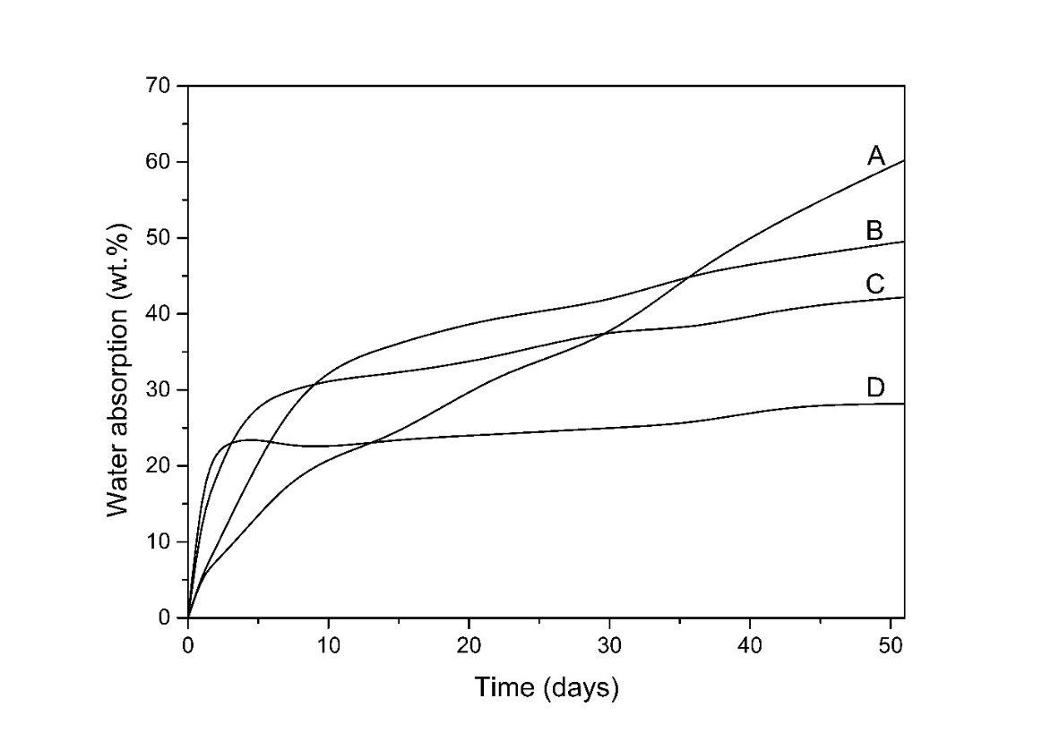
Fig. 4. Water absorption into coatings cast from the latex C₀S: sample containing no crosslinker (curve A), sample crosslinked using ADH (curve B), sample crosslinked using G0 PAMAM dendrimer (curve C), sample crosslinked using G1 PAMAM dendrimer (curve D).
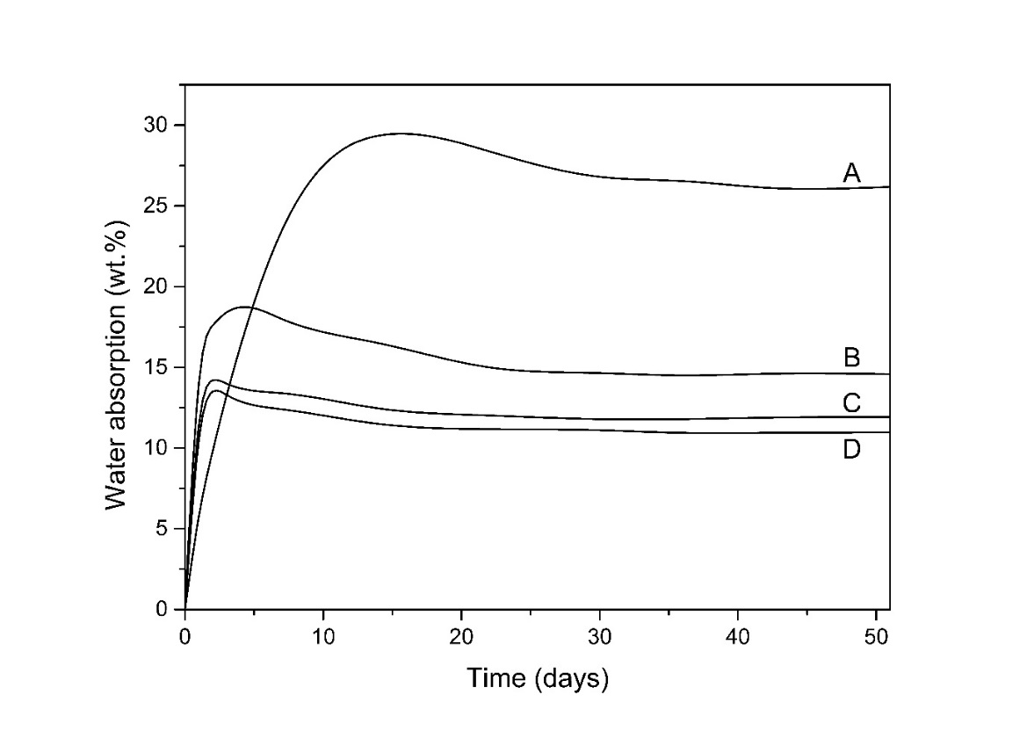
Fig. 5. Water absorption into coatings cast from the latex C_{A}S: sample containing no crosslinker (curve A), sample crosslinked using ADH (curve B), sample crosslinked using G0 PAMAM dendrimer (curve C), sample crosslinked using G1 PAMAM dendrimer (curve D).

Further, water-whitening of dried coating films was evaluated according to changes in whiteness index (ΔWI CIE) (see Table 5). It is known that the water-whitening resistance of latex compositions can be improved by removing hydrophilic components or introducing special monomers into the polymer latex. For the production of water whitening-resistant latex formulations, the VeoVa acrylics have been copolymerized [30] and using polyamine additives has been reported [29]. All these emulsion polymers always contained a considerable amount of amide-based acrylic constituents as well. Hence, we can assume that the presence of a higher level of amine and/or amide functionalities in the polymer can improve the water-whitening performance of coatings significantly.
Nevertheless, water whitening is also closely related to crosslinking density of the coating film. The size and number of the water scattering domains are responsible for the water whitening effect and both can be restricted by the stiffness of the polymer [31]. Thus, films suffering from high water swelling are prone to enhanced water whitening. This fact was confirmed by our experiments. Similarly to water absorption results, the non-crosslinked latices provided coatings of the highest water whitening tendency, whereas after imparting the self-crosslinking chemistry into latices, the water whitening resistance was increased. It was also confirmed that the PAMAM-crosslinked coatings exhibited increased water whitening resistance in contrast to the ADH-crosslinked ones. Comparing both types of PAMAM dendrimers, better water whitening resistance was achieved in the case of G1 PAMAM as the inter-particle crosslinker, obviously due to a higher level of amidoamine groups in the resulting coating polymer.
When considering the effect of AMA-induced internal crosslinking, the C_{A}S-based series of coatings exhibited a considerably increased water whitening resistance in relation to C₀S-based series. This phenomenon can be attributed to the significantly decreased water swelling due to intra-particle crosslinking causing increased density of the polymer network. Thus, the resistance of the polymer to deformation (caused by hydrostatic pressure of the water cells) was increased, as discussed previously. Moreover, no obvious water-whitening could be observed for the PAMAM-crosslinked coatings of C_{A}S-based latices (comprising internally crosslinked particles) even after 10-days-long immersion in distilled water. It can be concluded that highly water whitening-resistant self-crosslinking latex compositions were obtained provided that intra-particle and inter-particle self-crosslinking using PAMAM dendrimers were combined.

Table 5 Water-whitening expressed in terms of the whiteness index change for dry coating films cast on glass panels before and after their immersion in distilled water for 1 and 10 days.
Sample | WI₀ CIE | After immersion for 1 day |  | After immersion for 10 days
Sample | WI₀ CIE | WI_{t} CIE | ΔWI CIE | WI_{t} CIE | ΔWI CIE
C₀S | 16.5 | 67.9 | 51.4 | 83.8 | 67.3
C₀S_{G0} | 16.5 | 53.1 | 36.6 | 74.9 | 58.4
C₀S_{G1} | 16.3 | 29.1 | 12.8 | 55.1 | 38.8
C₀S_{ADH} | 16.4 | 70.4 | 50.0 | 82.1 | 65.7
C_{A}S | 16.1 | 60.7 | 44.6 | 67.1 | 51.0
C_{A}S_{G0} | 16.3 | 17.5 | 0.8 | 17.8 | 1.5
C_{A}S_{G1} | 15.7 | 16.0 | 0.3 | 15.9 | 0.2
C_{A}S_{ADH} | 16.0 | 19.5 | 2.5 | 34.3 | 18.3

Conclusion
The goal of the work presented in this paper was to investigate one-component ambient temperature self-crosslinking latex coating compositions containing amine-terminated PAMAM dendrimers of first and second generation, respectively, as the inter-particle crosslinkers. Surprisingly, the latices containing PAMAM dendrimers did not suffer from a short-term storage stability. Moreover, these coating compositions were shown to possess decreased MFFT values and provided crosslinked coating films of high gloss, transparency and mechanical performance comparable to the conventional ADH-based self-crosslinking lattices. In contrast to coatings crosslinked using ADH, the PAMAM-crosslinked coatings were shown to provide improved water-whitening resistance. It was found as well that an excellent water-whitening performance could be achieved by introducing the combination of AMA-based intra-particle crosslinking and PAMAM-based inter-particle self-crosslinking into latex coating compositions. Compared to each other, PAMAM dendrimer of second generation provided coatings with better properties. With respect to given facts, the PAMAM-based one-component self-crosslinking latices could be perfect binders for exterior clear coat applications on granite or other stone finishes where the standard for non-whitening is extremely high. These latices could also improve the performance of exterior coatings, which have always been plagued with failure caused by moisture and water.

References
[1] Y. Nakayama, Development of novel aqueous coatings which meet the requirements of ecology-conscious society: novel cross-linking system based on the carbonyl-hydrazide reaction and its applications. Prog. Org. Coat. 51 (2004) 280−299.
[2] T.Y. Guo, J.Ch. Liu, M.D. Song, B.H. Zhang, Effects of carboxyl group on the ambient self-crosslinkable polyacrylate lattices. J. Appl. Polym. Sci. 104 (2007) 3948−3953.
[3] P. Holub, One-component systems yield good properties. Eur. Coat. J. 10 (2004) 21−28.
[4] X. Lai, Y. Shen, L. Wang, Preparation and properties of self-crosslinkable polyurethane/silane hybrid emulsion. J. Polym. Res. 18 (2011) 2425−2433.
[5] J.D. Zhang, M.J. Yang, Y.R. Zhu, H. Yang, Synthesis and characterization of crosslinkable latex with interpenetrating network structure based on polystyrene and polyacrylate, Polym. Int. 55 (2006) 951−960.
[6] Ch. Koukiotis, I.D. Sideridou, Mechanicalpropertiesof ﬁlms of latexes based on copolymers BA/MMA/DAAM and BA/MMA/VEOVA-10/DAAM and the corresponding self-crosslinked copolymers using the adipic acid dihydrazide as crosslinking agent, Prog. Org. Coat. 69 (2010) 504−509.
[7] Ch. G. Koukiotis, M.M. Karabela, I.D. Sideridou, Mechanical properties of ﬁlms of latexes based on copolymers BA/MMA/DAAM and BA/MMA/VEOVA-10/DAAM and the corresponding self-crosslinked copolymers using the adipic acid dihydrazide as crosslinking agent, Prog. Org. Coat. 75 (2012) 106−115.
[8] M. Li, X. Lin, X. Li, H. Wang, Preparation and property study of core−shell ambient-temperature crosslinkable polyacrylate binder, Appl. Mech. Mat. 469 (2014) 3−6.
[9] X. Zhang, Y. Liu, H. Huang, Y. Li, H. Chen, The diacetone acrylamide crosslinking reaction and its control of core−shell polyacrylate latices at ambient temperature, J. Appl. Polym. Sci. 123 (2012) 1822−1832.
[10] H. Li, Ch. Kan, Y. Du, D. Liu, Effects of the amount of diacetone acrylamide on the properties of styrene-acrylic copolymer latexes and their films, Polym. Prep. 43 (2002) 413−414.
[11] R.M. Wang, J.F. Wang, X. W. Wang, Y.F. He, Y.F. Zhu, M.L. Jiang, Preparation of acrylate-based copolymer emulsion and its humidity controlling mechanism in interior wall coatings, Prog. Org. Coat. 71 (2011) 369−375.
[12] S.F Zhang, Y.F. He, R.M. Wang, Z.M. Wu, P.F. Song, Preparation of emulsifier-free acrylate cross-linkable copolymer emulsion and application in coatings for controlling indoor, Iran Polym. J. 22 (2013) 447−456.
[13] S.F. Zhang, F.R. Liu, Y.F. He, R.M. Wang, P.F. Song, Waterborne polyurethane-polyacrylic ester hybrid emulsion for humidity-controlling coatings, Arab. J. Sci. Eng. 39 (2014) 23−30.
[14] D.A. Tomalia, H. Baker, J. Dewald, M. Hall, G. Kallos, S. Martin, J. Roeck, J. Ryder, P. Smith, A new class of polymers: Starburst-dendritic macromolecules. Polymer J. 17(1985) 117−132.
[15] D.A. Tomalia, Birth of a new macromolecular architecture: dendrimers as quantized building blocks for nanoscale synthetic polymer chemistry, Prog. Polym. Sci. 30 (2005) 294–324.
[16] A.W. Bosman, H.M. Janssen, E.W. Meijer, About Dendrimers: Structure, physical properties, and applications. Chem. Rev. 99 (1999) 1665–1688.
[17] H. Yang, J.J. Morris, S.T. Lopina, Polyethylene glycol–polyamidoamine dendritic micelle as solubility enhancer and the effect of the length of polyethylene glycol arms on the solubility of pyrene in water, J. Colloid Interface Sci. 273 (2004) 148–154.
[18] K. Torigoe, A. Suzuki, K. Esumi, Au(III)–PAMAM interaction and formation of Au–PAMAM nanocomposites in ethyl acetate, J. Colloid Interface Sci. 241 (2001) 346–356.
[19] M. Liu, K. Konol, J.M. Fre´chet, Water-soluble dendritic unimolecular micelles: Their potential as drug delivery agents, J. Control. Rel. 65 (2000) 121–131.
[20] T. Endo, T. Yoshimura, K. Esumi, Synthesis and catalytic activity of gold–silver binary nanoparticles stabilized by PAMAM dendrimer, J. Colloid Interface Sci. 286 (2005) 602–609.
[21] O.M. Milhem, C. Myles, N.B. McKeown, D. Attwood, A. D’Emanuele, Polyamidoamine Starburst® dendrimers as solubility enhancers, Int. J. Pharm. 197 (2000) 239–241.
[22] J.C. Roberts, M.K. Bhalgat, R.T. Zera, Preliminary biological evaluation of polyamidoamine (PAMAM) Starburst dendrimers, J. Biomed. Mater. Res. 30 (1996) 53–65.
[23] P. Kesharwani, K. Jain, N.K. Jain, Dendrimer as nanocarrier for drug delivery, Prog. Polym. Sci. 39 (2014) 268–307.
[24] T.G. Fox, P.J. Flory, 2nd-Order transition temperatures and related properties of polystyrene. 1. Influence of molecular weight, J. Appl. Phys. 21 (1950) 581−591.
[25] P.J. Flory, J. Rehner, Statistical mechanics of cross-linked polymer networks II. Swelling, J. Chem. Phys. 11 (1943) 521–526.
[26] S. Tobing, A. Klein, Molecular parameters and their relation to the adhesive performance of acrylic pressure-sensitive adhesives, J. Appl. Polym. Sci. 79 (2001) 2230–2244.
[27] H.J. Vandenburg, A.A. Clifford, K.D. Bartle, R.E. Carlson, J. Caroll, I.D. Newton, A simple solvent selection method accelerated solvent extraction of additives from polymers, The Analyst 124 (1999) 1707–1710.
[28] J.G. Tsavalas, D.C. Sundberg, Hydroplasticization of polymers: Model predistions and Application to emulsion polymers, Langmuir 26 (2010) 6960−6966.
[29] J. Xu, T. Zhang, H. Liu, Copolymer dispersion for water whitening resistant coatings, Patent US 8772386 B2 (2014).
[30] H.P. Scholten, M.M. Slinckx, Interpolymer latexes from esters of (meth)​acrylic acid and vinyl esters of branched chain carboxylic acids, Patent EP 486110 A1 (1992).
[31] B. Jiang, J.G. Tsavalas, D.C. Sundberg, Water whitening of polymer films: Mechanistic studies and comparison between water and solvent borne films, Prog. Org. Coat. 105 (2017) 56−66.

