ALD SnO₂ coated anodic 1D TiO₂ nanotube layers for low concentration NO₂ sensing

Siowwoon Ng,¹ Jan Prášek,¹ Raul Zazpe,^{1,2} Zdeněk Pytlíček,¹ Zdeněk Spotz,¹ Jhonatan Rodriguez Pereira,² Jan Michalička,¹ Jan Přikryl,² Miloš Krbal², Hanna Sopha^{1,2}, Jaromír Hubálek¹, Jan M. Macák,^{1,2,*}
¹Central European Institute of Technology, Brno University of Technology, Purkyňova 123, 61200 Brno, Czech Republic.
² Center of Materials and Nanotechnologies, Faculty of Chemical Technology, University of Pardubice, Nám. Cs. Legií 565, 53002 Pardubice, Czech Republic.

KEYWORDS: gas sensing, functional coatings, TiO₂ nanotubes, atomic layer deposition, surface and interface

ABSTRACT: The continuous emission of nitrous oxides contributes to the overall air pollution and deterioration of air quality. In particular, an effective NO₂ sensor capable of low concentration detection for continuous monitoring is demanded for safety, health, and wellbeing. The sensing performance of a metal oxide based sensor is predominantly influenced by the availability of surface area for O₂ adsorption and desorption, efficient charge transport and size or thickness of the sensing layer. In this study, we utilized anodic one-dimensional (1D) TiO₂ nanotube layers of 5 µm thick which offer large surface area and unidirectional electron transport pathway as a platform to accommodate thin SnO₂ coatings as a sensing layer. Conformal and homogeneous SnO₂ coatings across the entire inner and outer TiO₂ nanotubes were achieved by atomic layer deposition with controlled thickness of 4, 8 and 16 nm. The SnO₂ coated TiO₂ nanotube layers attained a higher sensing response than a reference Figaro SnO₂ sensor. Specifically, the 8 nm SnO₂ coated TiO₂ nanotube layer has recorded up to ten-fold enhancement in response as compared to the blank nanotubes for the detection of 1 ppm NO₂ at the operating temperature of 300 ºC with 0.5 V applied bias. This is attributed to the SnO₂/TiO₂ heterojunction effect and controlled SnO₂ thickness within the range of the Debye length. We demonstrated in this work, a tailored large surface area platform based on 1D nanotubes with thin active coatings as an efficient approach for sensing applications and beyond.

1. Introduction
Gas sensors are extensively used in medical, automotive, automation, agriculture, biogas, and mining industries for health, safety, and environmental areas which include detection of hazardous emission, prevention of explosion and air quality monitoring.^{1–3} The global air pollution index is continuously rising due to the increased population and massive industrialization. NO₂ is colorless, odorless, yet its emission is one of the main pollutant causing greenhouse effect. A comprehensive report that monitored the NO_{x} content continuously in different environments in the Czech Republic, as a representation of the Central European region, has shown an overall decreasing trend in the concentration of NO_{x.}⁴ However, to comply to the latest permissible emission of NO_{x} under the European Union directives, it is necessary to reduce the present NO_{x} emission. According to different standards including World Health Organization (WHO),⁵ European Legalization,⁶ Japan,⁷ and China⁸ Air Quality Standards, for healthy air quality, the presence of NO₂ in the air should maintain at sub-part per million (ppm) range. Therefore, the demand to develop a sensitive NO₂ sensor with low concentration detection unceasingly persists to assure the safety, health, and wellbeing.
Since 1960´s SnO₂ has been a widely studied metal oxide for various gas sensors.^{9,10} Its popularity remains today owing to its high sensitivity and rapid response towards various gases, high stability, and low manufacturing costs. In fact, SnO₂ as an active sensing layer has been developed to technological maturity and broadly served as commercial sensors by the world’s leading gas sensor manufacturer such as Figaro¹¹ and Nissha FIS.¹² Positively, there is always space to elevate the performance of these n-type polycrystalline semiconductor gas sensors, especially from the sensitivity aspect. The gas sensing mechanism is mainly based on the surface interactions between the active layer and the adsorbed analytes. Upon adsorption of an analyte, an electron-depleted space charge layer is created with a certain layer thickness, (depletion region width), L and potential height (barrier), h. Essentially two predominant factors are: i) the amount of adsorbed O₂, that determines the degree of increase (or decrease) of charge carrier concentrations, transformed to the change of conductivity; and ii) the grain size, d and Debye length, L_{D} are related in such a manner that if d >> L_{D}, the depletion of charge carrier occurs only at the surface; and if d ≤ L_{D}, the grain is depleted completely to maximize the sensitivity.^{13–15} With the fundamental understanding of the crucial factors contributing to the sensitivity of a sensor, efforts can be devoted to engineering an active sensing layer by increasing free accessible surface and simultaneously decreasing the grain size to achieve a highly sensitive gas sensor.
One-dimensional (1D) nanomaterials appear to be a promising approach for their high surface area for reactions and unidirectional charge transfers to facilitate efficient electron transfer.¹⁶ Among the well-aligned 1D nanostructures, such as Al₂O₃ nanochannels, ZnO nanorods, TiO₂ nanorods and nanotubes, anodic TiO₂ nanotube layer is classified as one of the most widely studied semiconducting 1D nanostructure.¹⁷ The advantages of self-organized TiO₂ nanotube layers include the ease of preparation (by simple electrochemical anodization), scalability, tunable dimensions, robust and high chemical stability. Dissimilar to solid fibers, the hollow tubular structure offers both inner and outer surface, thus offering superior sensing performance.¹⁸ In addition, both metal oxides, SnO₂ and TiO₂ possess good compatibility to form an n-n heterojunction, as demonstrated by a series of SnO₂ and TiO₂ combinations for the detection of volatile organic compounds (VOCs),^{19–23} H_{2,}^{24–26} CO and CH₄.²⁷ Certainly, a few attempts utilized the advantages of 1D TiO₂ nanostructures for the decoration by SnO₂ nanoparticles or nanospheres.^{20,22,23,26,27} Conventional chemical bath impregnation and vapor phase deposition encounter challenges in depositing a secondary material within TiO₂ nanotubes which belongs to the family of the 1D high-aspect-ratio nanostructures. To truly realize the hollow structure for sensing purposes, i.e. to create a uniform and continuous layer of SnO₂ along the entire TiO₂ nanotube walls, Atomic Layer Deposition (ALD) is effectively the most modern and successful solution.²⁸ As the film grown by ALD occurs sequentially, precise thickness control down to the sub-nanometer scale is feasible.²⁹ Such a feature is desirable for the preparation of ultrathin films, as the film thickness can be tailored for sensing purposes to approach the Debye length, typically in the scale of nanometers. In this context, ALD has been utilized to combine TiO₂, ZnO or SnO₂ layers to form core-shell or double-layer nanostructures.^{18,30–32}
ALD SnO₂ coatings within 1 µm thick TiO₂ nanotube layers were first carried out by Barr et al. for catalytic ethanol electrooxidation.³³ In the present work, we attempt to extend the limits of ALD to deposit homogeneous and continuous SnO₂ coatings within anodic 1D TiO₂ nanotube layers of 5 µm thick, corresponding to an aspect-ratio ≈22. A set of thin thicknesses SnO₂ coatings matching the Debye length range is utilized to create hollow SnO₂/TiO₂ tubular structures to explore the sensing of low concentrations of NO₂. This work demonstrates that the deliberately constructed thin sensing layers supported by a 1D nanostructure significantly enhances the sensing response towards NO₂ as an oxidizing gas.

2. Experimental
2.1 Preparation of SnO₂ coated TiO₂ nanotube layers
Self-organized TiO₂ nanotube layers of thickness ≈5 µm and inner diameters ≈230 nm were prepared by electrochemical anodization, followed by an annealing process to crystallize the TiO₂ nanotube layers, as described in our previous work.³⁴ Subsequently, Atomic Layer Deposition (ALD, TFS200, Beneq) of SnO_{x} layers was carried out at 110 ºC. The tin precursor and oxygen source were Tetrakis(dimethylamino)tin(IV) (TDMASn, Strem 99%) and deionized water (Millipore 18 MΩ), respectively. The tin precursor was heated up to 45 ºC to obtain a reasonably high vapor pressure. High purity nitrogen (99.9999%) was the carrier and purging gas at a flow rate of 500 standard cubic centimeters per minute (sccm). Under these deposition conditions, one growth ALD cycle was defined by the following sequence: H₂O pulse (1.75 s)-N₂ purge (30 s)-Sn pulse (750 ms)-N₂ purge (15 s). The recipe was sufficient to achieve complete coating within the entire nanotubes, and hence, no residence time was required during the ALD process. The TiO₂ nanotube layers were coated by a different number of SnO_{x}, ALD cycles, N_{ALD} = 47, 94, and 189 corresponding to 4, 8, and 16 nm, respectively. All thickness of SnO_{x} layers deposited on Si wafers by identical ALD process was verified by variable angle spectroscopic ellipsometry (VASE® ellipsometer, J.A. Woolam, Co., Inc.). Finally, to transform the SnO_{x} coating to crystalline SnO₂, the TiO₂ nanotube layers were annealed at 500ºC for 2 hours in a muffle oven in air ambient. A temperature ramping rate of 2 ºC/min was applied from room temperature up to 500 ºC and naturally cooled down to room temperature once the annealing process was over. The effect of annealing process was also a stabilization of the film before the gas sensing measurements.

2.2 Materials characterizations
For all blank and SnO₂ coated TiO₂ nanotube layers, the structural evaluation was based on X-ray diffraction (XRD) measured by diffractometer (SmartLab 3kW from Rigaku). The diffractometer was set up in Bragg-Brentano geometry using Cu Kα radiation (λ = 1.54 Å) equipped by 1D-detector Dtex-Ultra. Cu lamp was operated at the current 30 mA and voltage 40 kV. Phase analysis was performed based on chemical composition using databases PDF2 and ICSD. Compositional analyses were carried out by X-ray photoelectron spectroscopy (XPS, ESCA2SR, Scienta-Omicron) using a monochromatic Al Kα (1486.7 eV) X-ray source. The binding energy scale was referenced to adventitious carbon shifted to 284.8 eV. The spectra were fitted using Shirley-type background and Voight line-shapes. The morphology of nanotube layers, at various parts of the nanotube layers was imaged by scanning electron microscope (SEM, FEI Verios 460L). Additionally, transmission electron microscope (TEM, TITAN Themis 60-300) operated at 300 kV was employed to evaluate the chemical composition of the thinnest SnO₂ (4 nm) coated TiO₂ nanotube layer and its crystallography. This was performed via chemical elemental mapping in scanning TEM mode (STEM) and using a high-angle annular dark field (HAADF) detector for imaging and high performance SUPER-X detector for energy dispersive X-ray (EDX) spectroscopy, and, via selected area electron diffraction (SAED) in TEM mode, respectively. The EDX elemental maps are shown in net intensities, which represent the count intensities according to the background corrected and fitted model performed by Velox 2.11 software. Electrochemical impedance spectroscopy (EIS) and Mott-Schottky measurements were carried out by an electrochemical system (PGSTAT 204, Metrohm Autolab B.V., Nova 1.10 software). The three-electrode electrochemical cell consisted of blank or SnO₂ coated TiO₂ nanotube layers as the working electrode, a Pt wire and a Ag/AgCl as counter and reference electrode, respectively, in a 1 M Na₂SO₄ aqueous electrolyte. The EIS spectra were recorded at open-circuit potential (OCP, the readback OCPs were 0.15 and 0.075 (± 0.002) V for blank and SnO₂ coated TiO₂ nanotube layers, respectively) in the range of frequencies from 1 MHz to 5 mHz. Mott-Schottky plots were recorded at frequency 1000 Hz in the potential range of 1.0 to -0.4 V_{Ag/AgCl} (from positive to negative potentials).

2.3 Preparation of metal electrodes and gas sensing setup for NO₂ gas sensing measurement
After the stabilization process, the SnO₂ coated TiO₂ nanotube layers were ready for use as sensors. For the preparation of electrodes, Al and Au (both source materials were of 99.99% purity) of 600 and 70 nm thick, respectively, were successively deposited through a laser-cut stencil by electron beam evaporator system (BESTEC GmbH, Germany) in a distance of 3 mm creating an active sensing area of 2 mm × 3 mm. The deposition rates for Al and Au were 3 and 2.1 Å/s, respectively. Gas sensing and measurement of electrical properties were carried out by a semiautomatic experimental setup which has been illustrated and partially described in previous work.³⁵ The sensing layer was placed onto a hotplate with precise temperature-control, operating up to 370 °C in a hermetically-closed gas chamber, fabricated from adsorption resistant Ketron® Peek material (Tribon s.r.o., Czech Republic), 126 ml in volume. The desired gas concentration was obtained by mixing the calibrated gas (10 ppm NO₂ in synthetic air, both supplied by Linde Gas a.s., Czech Republic) with pure synthetic air (20 vol % O₂ in 80 vol % N₂) using mass flow controllers. During the gas sensing measurement, the total mass flow (Air + NO₂) through the chamber was 200 sccm and the pressure of the whole system was 1000 mbar, both conditions were maintained by mass flow controllers and backward pressure-controller (both Alicat Scientific, USA), respectively. The relative humidity (RH) of gas mixtures in the system was ≈3%. A commercial sensor with SnO₂ as sensing material (Figaro TGS 822, maximum operating temperature 200 ºC, unknown sensing area) was placed in the system as a reference. The electrical response was recorded by a source meter (Keithley 2400, Keithley Instruments Inc., USA). The entire sensing setup was controlled by LabVIEW software. NO₂ sensing response measurements were carried out at different temperatures, 150 to 350 °C, and different NO₂ concentrations, 1 to 5 ppm with synthetic air, at a voltage bias of +0.5 V. The resistance was calculated from the voltage bias and measured current. The sensor response was calculated as S = R_{gas}/R_{air}, where R_{gas} and R_{air} are the resistance of the sensing layer in the presence of gas and synthetic air, respectively.

3. Results and discussion
The self-organized TiO₂ nanotube layers with thickness of ≈5 µm and inner diameter ≈230 nm were deposited by 47, 94, and 189 ALD cycles of SnO_{x}, which corresponded to 4, 8, and 16 nm, respectively. This translates into the growth rate of 0.85 Å/cycle, which agrees to the reported growth rate of TDMASn and H₂O as the precursors.^{36,37} Similar to any deposition techniques, for ALD, the selection of precursor, deposition temperature and pulse time influence the properties of the grown layers.²⁹
The blank and SnO_{x} deposited TiO₂ nanotube layers share a similar XRD pattern as shown in Figure 1(a). All the diffraction patterns correspond to anatase TiO₂ and hexagonal Ti from the substrate. The broad peak at 15-20º in 16 nm SnO_{x} is typical for amorphous materials, additionally it cannot be explained by any known phase from the database (ICSD). The XRD patterns (data not shown) of all as-deposited 4, 8 and 16 nm SnO_{x} contain comparable broad peak (the similar position and width). Thus, we assign this peak to amorphous SnO_{x}. In good agreement with Barr et al.³³ and Elam et al.,³⁶ generally, when the deposition temperature is low, the as-deposited SnO_{x} film is non-crystalline. After a simple thermal treatment in an air ambient, the SnO_{x} layers were transformed into crystalline SnO₂ rutile phases. A shoulder peak at 27.2º corresponds to rutile TiO₂ is observed, which was formed during the second annealing to crystallize SnO₂ layers. Figure 1 (b,c) enlarge two different regions for better visualization of SnO₂ diffractions peaks, located at 26.6º, 33.9º and 51.8º associated with (110), (101) and (211) planes, respectively. Overall, the SnO₂ diffraction peaks are rather broad, and the crystallite size evaluated by Scherrer’s method for all 4, 8 and 16 nm SnO₂ coatings was 5.6 nm. Scherrer’s method is widely used for the estimation of crystallite size, however it has seen some limitations when the sample is not thin film-like, especially when the crystallites are irregularly shaped, such as ellipsoidal shape.³⁸ Nevertheless, a clear trend is observed, where the broad peaks become more profound as the thickness of SnO₂ coating increases from 4 to 16 nm for all three diffraction planes marked in Figure 1(b,c).
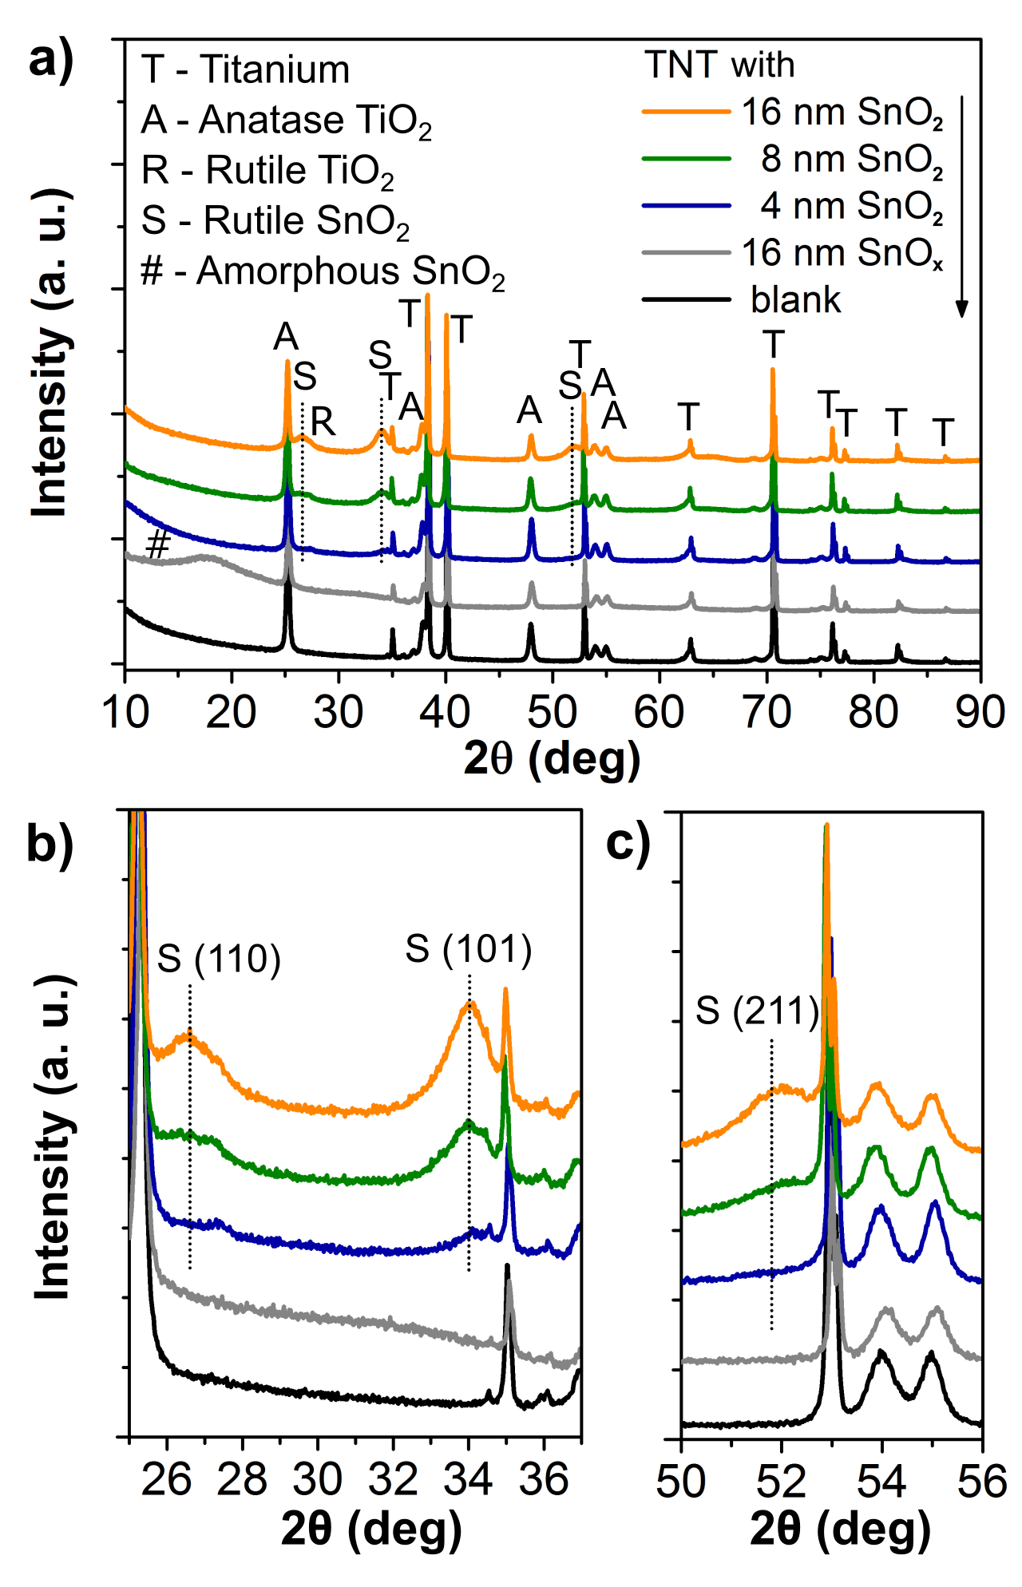
Figure 1. (a) XRD pattern of as-deposited 16 nm (N_{ALD} = 189 cycles) SnO_{x} (before annealing) and 4-16 nm (N_{ALD} = 47-189 cycles) SnO₂ deposited TiO₂ nanotube layers (TNT), (b) and (c) magnify the major planes of SnO₂.

The compositional analyses were performed with TiO₂ nanotube layers with all the different thicknesses of SnO₂ coating. For the as-deposited SnO_{x}, the XPS measurement was deliberately carried out on the thickest coatings i.e. 16 nm, to compare against the annealed SnO₂ in order to analyze purely the coating without the influence of the TiO₂ nanotube layers. The survey spectrum of the as-deposited and all the annealed SnO₂ in Figure 2(a) does not show any discernable difference. Hence, detailed analyses of O 1s, Sn 3d and Sn valance band (VB) are given in Figure 2(b-d). The pronounced peak at ≈530.6 eV for O 1s spectra of the as-deposited SnO_{x} in Figure 2(b) is associated with the O²⁻ which corresponds to the O-Sn bond, and a shoulder peak centered at ≈532-533 eV is attributed to the –OH group from hydrated water. After the annealing process, along with the increase of coating thickness, a shift towards higher binding energy up to ≈531 eV is observed for 16 nm SnO₂. For the Sn 3d spectra of SnO_{x} in Figure 2(c), the intense peaks at 495.1 and 486.7 eV are identified as Sn 3d_{3/2} and Sn 3d_{5/2}, respectively, which are responsible for the Sn⁴⁺ oxidized state for SnO₂. Similar to the O 1s spectrum, both of the Sn 3d_{3/2}, and Sn 3d_{5/2} have experienced the same shifting trend towards higher binding energies to 495.6 and 487.1 eV, respectively. Coincidentally, the shifts for O 1s, Sn 3d_{3/2} and Sn 3d_{5/2} are consistent ≈0.4 eV towards higher energies. These results reveal an increase of O-Sn⁴⁺ within the coatings to achieve better stoichiometric SnO₂.^{39,40} Overall, proper quantification indicates that the ratio of Sn:O was increased from 1.42 to 1.65 after the 2 h annealing (stabilization) process at 500 ºC in air ambient. This suggests that a simple heat treatment improves the stoichiometry of the deposited layer by inducing additional oxygen content into the SnO₂ layer. Besides, the VB spectra in Figure 2(d) portrays the spectra of SnO₂, clearly distinguish between SnO₂ and SnO.^{41,42} Prolonged annealing up to 14 h was unable to further increase the oxygen amount in the coating (XPS results not shown), thus, 2 h annealing was adopted to all SnO₂ coatings within the TiO₂ nanotube layers. The underlying reason is the synchronous deposition and reduction phenomenon for TDMASn as Sn precursor for ALD process. The release of ligands from the TDMA precursor, (CH₃)₂N⁻ may be oxidized and recombined to form tetramethylhydrazine, resulted in partial reduction of the deposited Sn, which then produced an oxygen deficient SnO₂, especially at lower deposition temperatures.⁴³ Instead, the classic SnCl₄ precursor is more prone to producing stoichiometric SnO₂, but it suffers from potential corrosion and agglomeration issues.³⁶ Therefore, more investigation on TDMASn or exploration of other precursors such as SnI₄⁴⁴ for the synthesis of stoichiometric SnO₂ is vital in the near future. It is worth mention that there are no traces of Ti in all coatings except for 4 nm SnO_{2,} a small but noticeable peak at ≈459 eV is indexed to Ti 2p (spectra not shown). This is connected to the thin 4 nm coating and thus, the Ti signal is originated from the TiO₂ tube walls. STEM-EDX and TEM-SAED were performed to investigate the 4 nm coating within the TiO₂ nanotube layer and will be discussed later. In exception for the thinnest 4 nm coating, this series of XPS results affirm no or limited diffusion of the coated SnO₂ layers within the TiO₂ nanotube walls during the ALD process and subsequent thermal treatment at 500 ºC for 2 h. This is attributed to the well-crystallized TiO₂ nanotubes prior to the ALD process, as evidenced in the XRD pattern for blank nanotube layer in Figure 1(a). Thus, the post-deposition annealing achieved two major purposes i) improved crystallinity of rutile SnO₂, and ii) improved stoichiometry of Sn:O. In parallel, the annealing step acts as a stabilization step to the subsequent process at elevated temperatures.
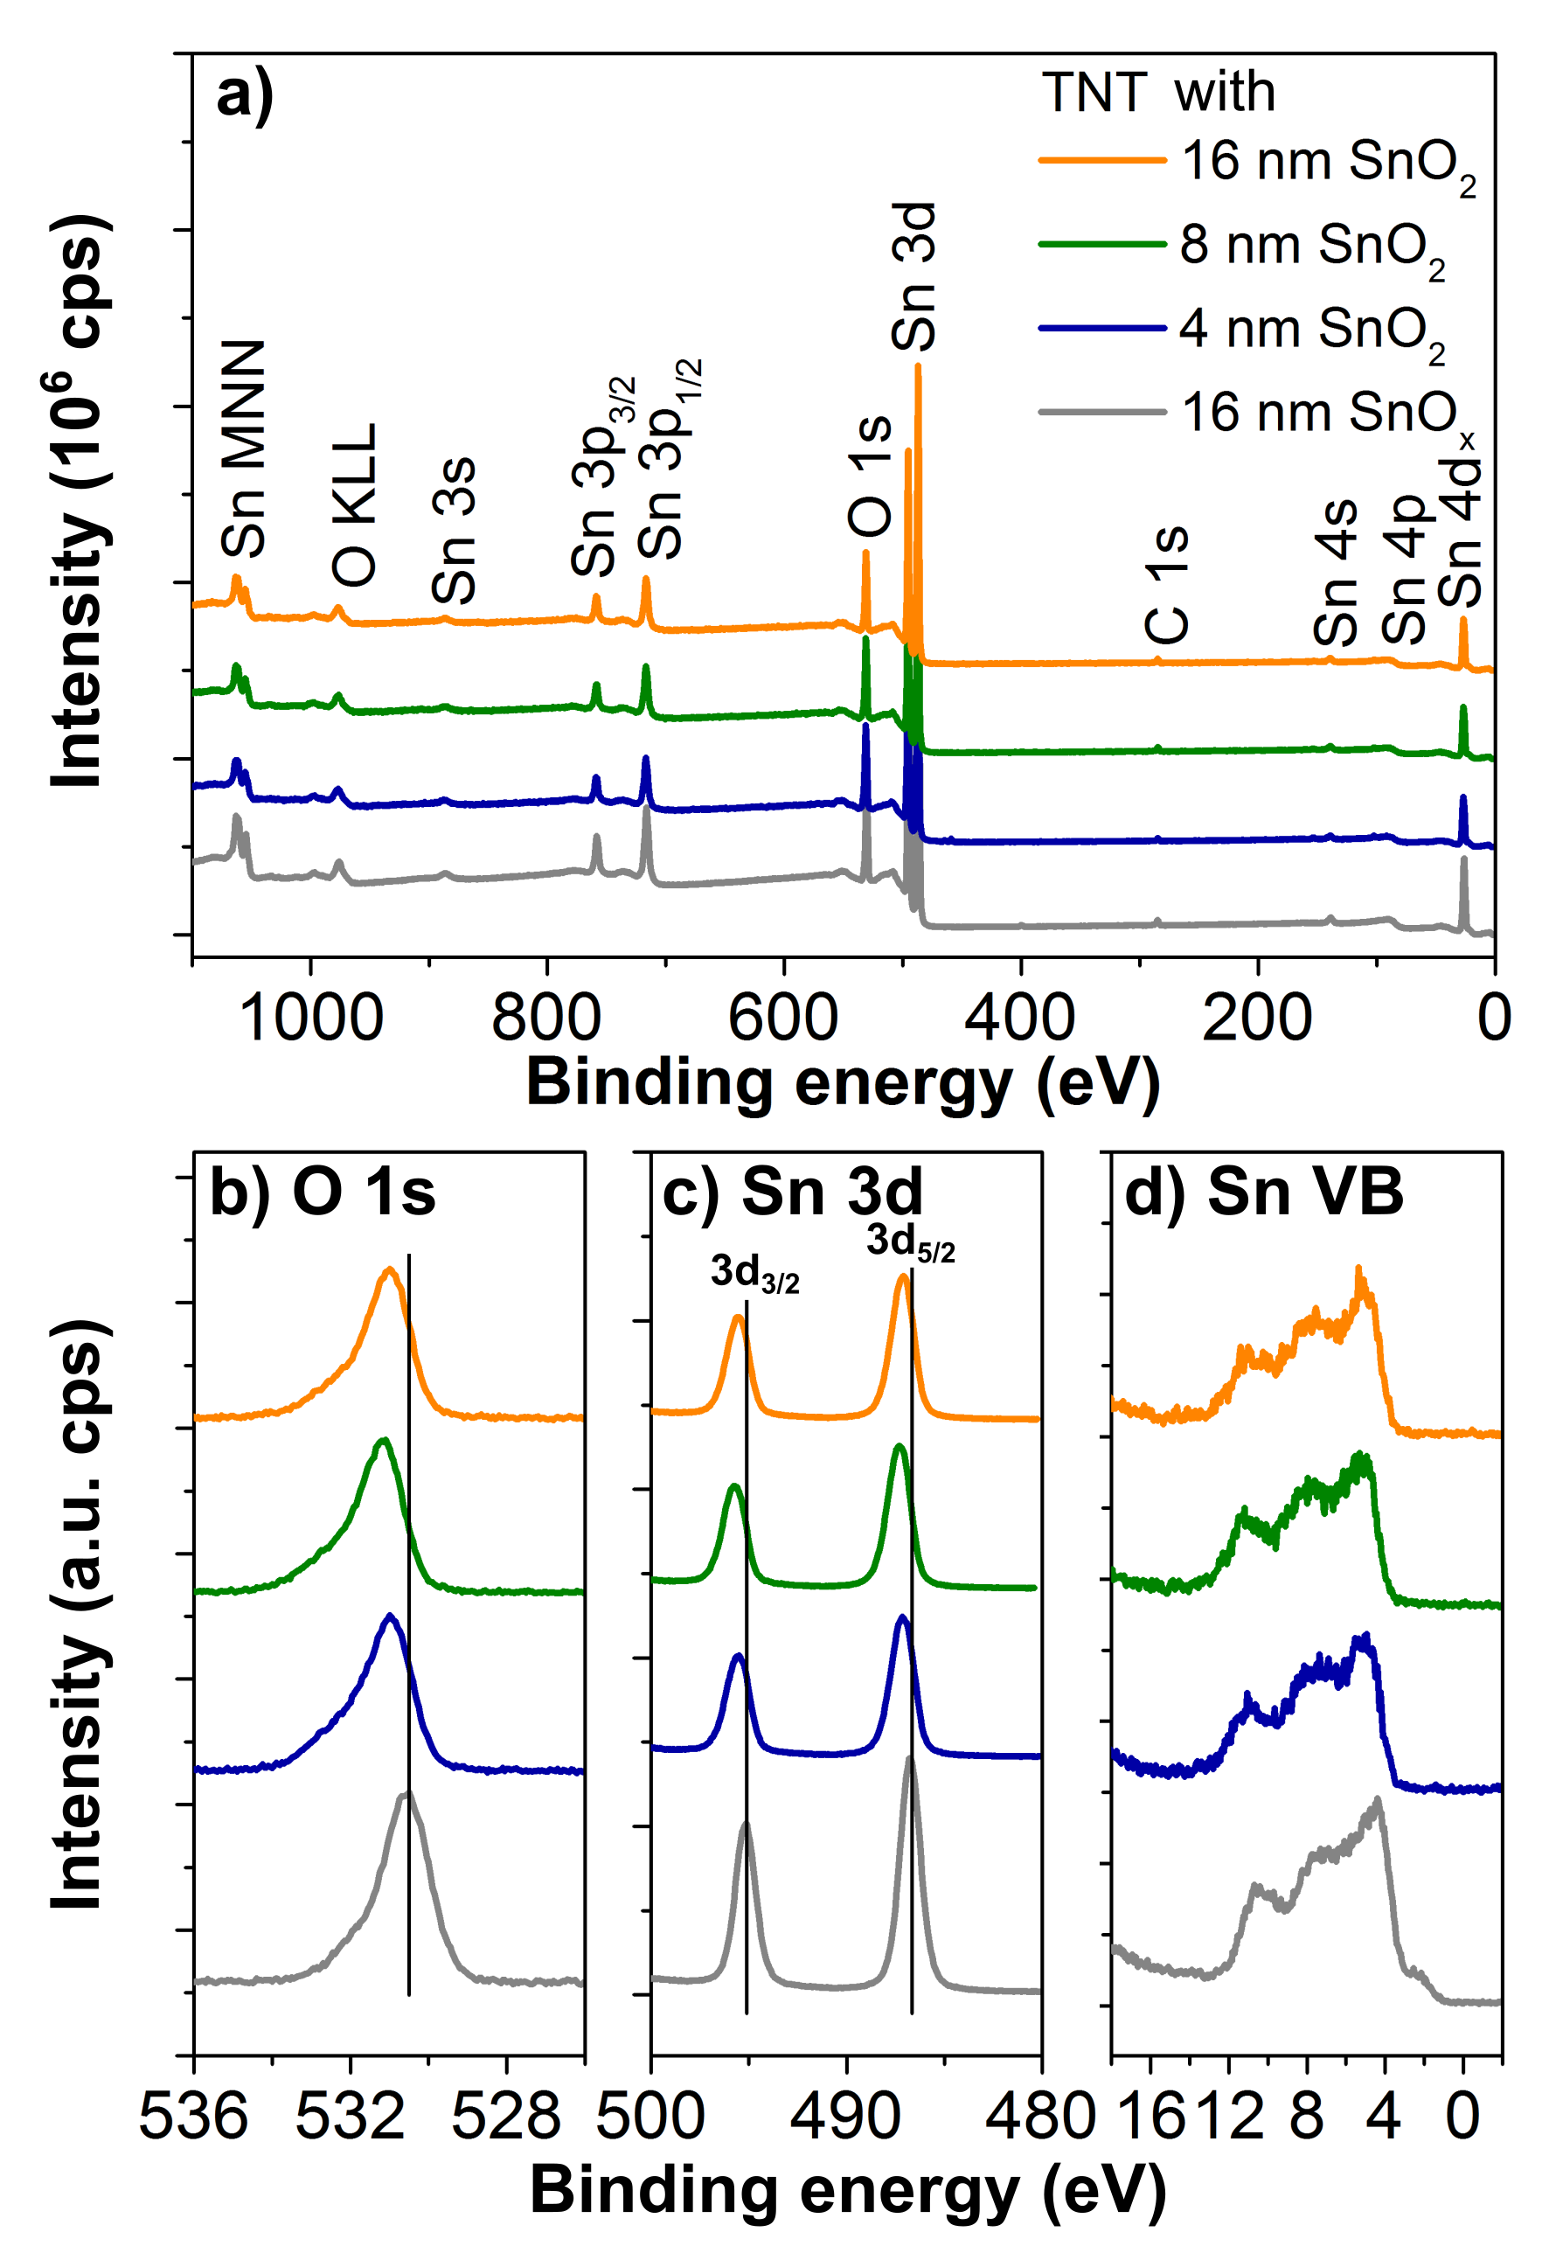
Figure 2. (a) XPS survey, (b) O 1s, (c) Sn 3d, and (d) Sn valence band (VB) spectra of the as-deposited (before annealing) 16 nm (N_{ALD} = 189 cycles) SnO_{x} and 4-16 nm (N_{ALD} = 47-189 cycles) SnO₂ annealed at 500 ºC in air for 2 h.

Figure 3 presents the SEM images of blank and SnO₂ layer (8, 16 nm) coated TiO₂ nanotube layers at different magnifications. As compared to the blank nanotube layer, the thickness of the tube walls gradually increases with the additional SnO₂ coating of 8 and 16 nm. The thicker tube walls result in smaller inner diameter and gap between tube walls. In addition, as shown in Figure 3, the texture of the blank and coated tube walls is distinctly different, where fine grains closely interconnected each other are visible for the 8 and 16 nm SnO₂ coated TiO₂ nanotube layer. The observation of small grains under high magnification of SEM imaging correlates well with the broad diffraction peaks observed in XRD measurement. The increased wall thickness after the coating of secondary material is in line with various reports on ALD coatings of metal oxides within TiO₂ nanotube layers.^{30,33,45} The SnO₂ coatings were homogeneously deposited within the TiO₂ nanotubes from their uppermost part to their bottoms, as evidenced by the SEM images taken at the interface of the bottom part of TiO₂ nanotube layers and Ti substrate, included in Figure S1 (Supporting information). All of these observations are in line with our pioneering efforts in depositing Al₂O₃ within TiO₂ nanotube layers.⁴⁵
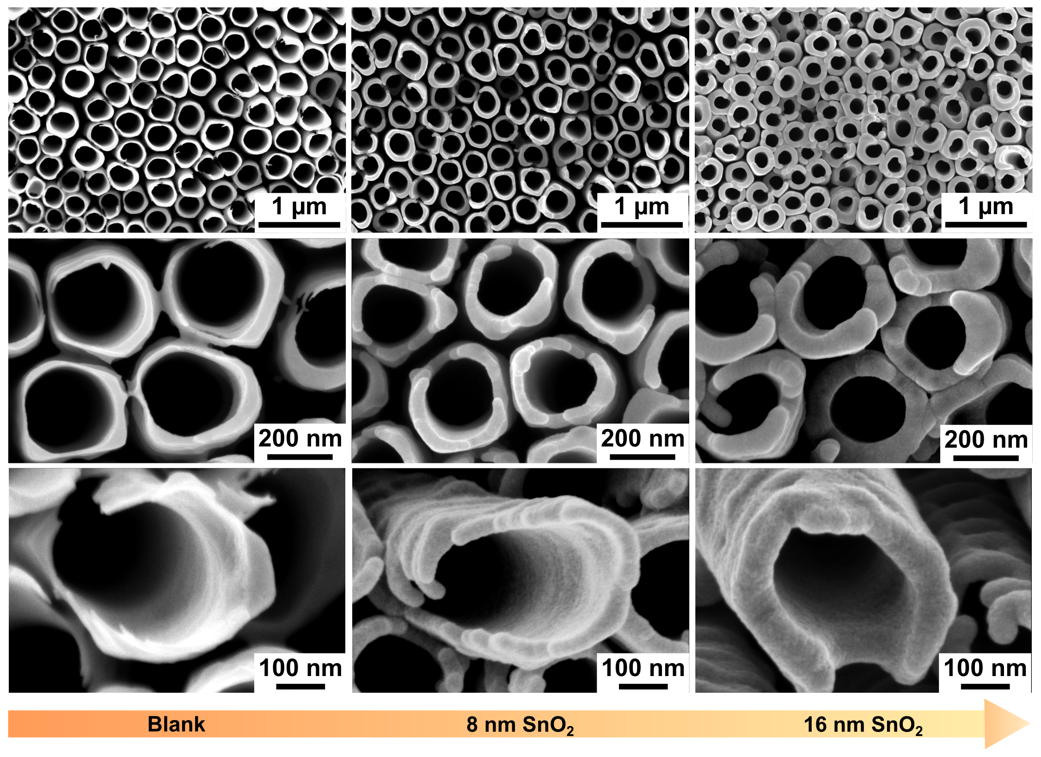Figure 3. SEM images of blank, 8 nm (N_{ALD} = 94), and 16 nm (N_{ALD} = 189) SnO₂ deposited TiO₂ nanotube layers at different magnifications. The highest magnification images in the last row present the different texture of nanotube walls, with and without SnO₂ coatings.

The 4 nm SnO₂ coated TiO₂ nanotube layer was selected to perform STEM-EDX elemental mapping and TEM-SAED to reveal and analyze the thinnest deposited coatings. We intentionally analyzed the 4 nm SnO₂ coating, as the thicker coatings should follow suit once the thinnest crystallized coating is confirmed. Figure 4(a) shows the STEM-HAADF image of a top view of a fragment extracted from the corresponding nanotube layer. Figure 4(b) presents the overlay of the three elements of interest, i.e. Ti-K, O-K and Sn-L present in the nanotube layer. Figure 4(c-e) shows the net intensity distribution of the individual elements. As expected, the tube walls are comprised of Ti and O. Very thin Sn layers can be traced all around the inner and outer tube walls, anew showing homogeneous and complete coverage of the coatings around the tubes. All of these results support that such uniform coatings within high aspect ratio nanostructures can be achieved feasibly by ALD.²⁸ Figure 4(f) presents the corresponding SAED pattern and the diffraction rings reveal both SnO₂ and TiO₂ polycrystalline planes. It is worth mentioned that some of the d-spacing values for both rutile SnO₂ and anatase TiO₂ are too close to be distinguished from each other. However, SnO₂ planes (110), (101) and (211) are well separated and the appearance of these major planes is in good agreement with XRD results shown in Figure 1. The crystallinity of the SnO₂ suggests that the very thin 4 nm coating stands a negligible chance to diffuse to the TiO₂ tube wall.

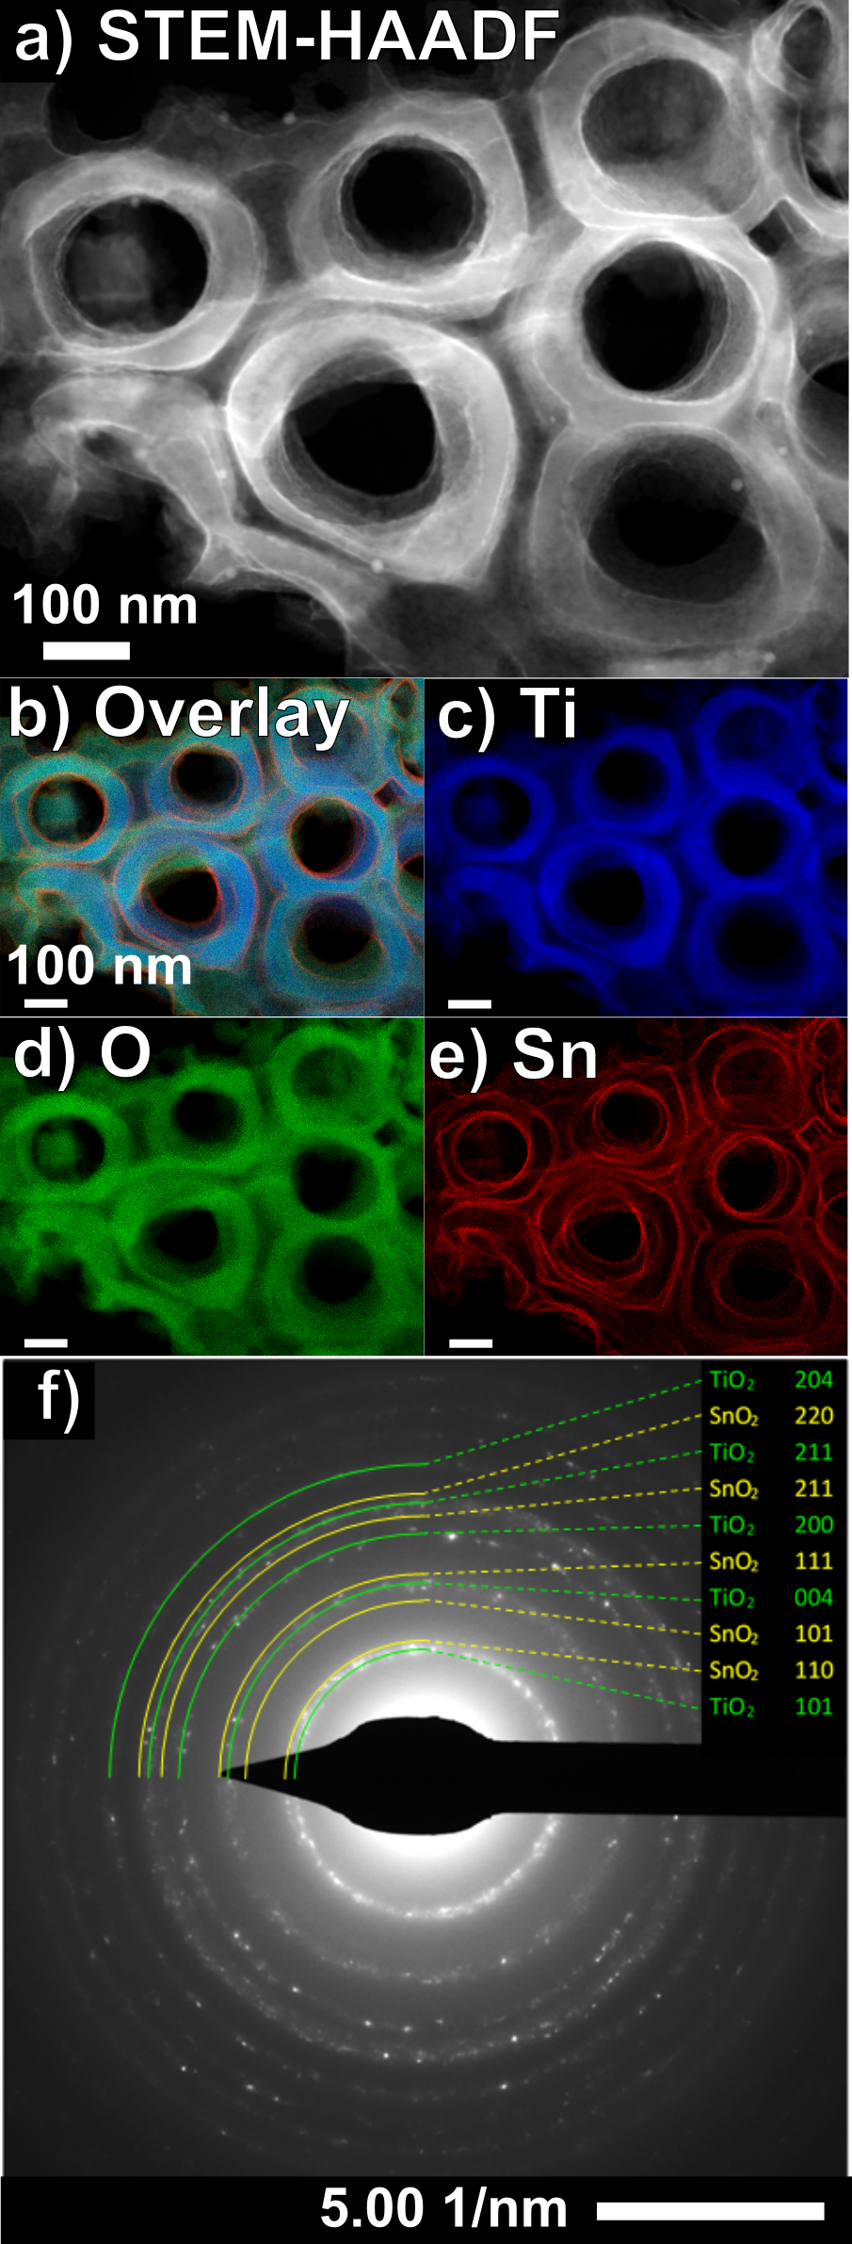
Figure 4. SnO₂ coated 4 nm (N_{ALD} = 47) TiO₂ nanotube layer (a)-(e) STEM-HAADF top view image and STEM-EDX elemental maps. All scale bars in (a)-(e) are 100 nm. f) SAED pattern with the crystallographic planes of SnO₂ and TiO₂ phases indicated on their respective diffraction rings.

The detailed structural, compositional and morphological investigations confirm the presence of ALD coated SnO₂ within anodic TiO₂ nanotube layers and pave the way for the evaluation of sensing response. Herein, NO₂ was selected as an oxidizing gas model. In the initial tests, we carried out different bias from 0.5 to 5 V at 150-350 ºC. At higher bias voltages, the response (R_{g}/R_{a}) is marginally different from low bias voltages. Therefore, the subsequent measurements were fixed at low bias, i.e. 0.5 V, aiming for low power consumption sensor.
Figure 5(a) presents the dynamic response of the 8 nm SnO₂ coated TiO₂ nanotube layer with the exposure of 1 ppm NO₂, continually switching between different operating temperatures. Above all, the change of resistance in the increment (decrement) direction upon the exposure to (removal of) NO₂ as an oxidizing gas, confirms an n-type semiconductor behavior of the n-n heterostructure inherent from both SnO₂ and TiO₂. The overall sensing response gradually decreases, as the operating temperature increases, exhibiting an exponential decay as portrayed in Figure 5(a). At lower temperatures, especially at 150 ºC, the sensing layer has demonstrated a high response, however, the continuously increasing resistance has not approached saturation after 30 min have elapsed. Likewise, the recovery time is rather long after the desorption of NO₂ gas. As the temperature increases to temperatures higher than 200 ºC, even though the response is decreased, the shark-fin-like behavior progressively flattens, shown by the flat region of response curve of 300 ºC. This is due to the equilibration of adsorption of NO₂ and desorption of O₂, i.e. stabilization in response, results in the shortening of response time. Lastly, at 350 ºC, a plateau response curve indicates short response time. Similarly, for the recovery, beyond 200 ºC, the shorter time taken towards stabilization in response is followed by shorter recovery time. It is also worth mentioned that upon NO₂ gas “off” by introducing synthetic air, a mutual competition of desorption of NO₂ and adsorption O₂ causes the resistance to return to the baseline of that particular temperature. This phenomenon suggests that the 8 nm SnO₂ coated TiO₂ nanotube layer possesses good charge trapping and de-trapping capability. Analyzing further the response curves in Figure 5a, when the temperature was switched from 150 and 200 ºC, a sharp decrease in base resistance was recorded. A similar trend was observed at all interfaces between two temperatures. However, due to the pronounced change in resistance (sensing response) as compared to the change in base resistance, the changes of base resistance for the subsequent switches of temperature were not obvious in Figure 5a.
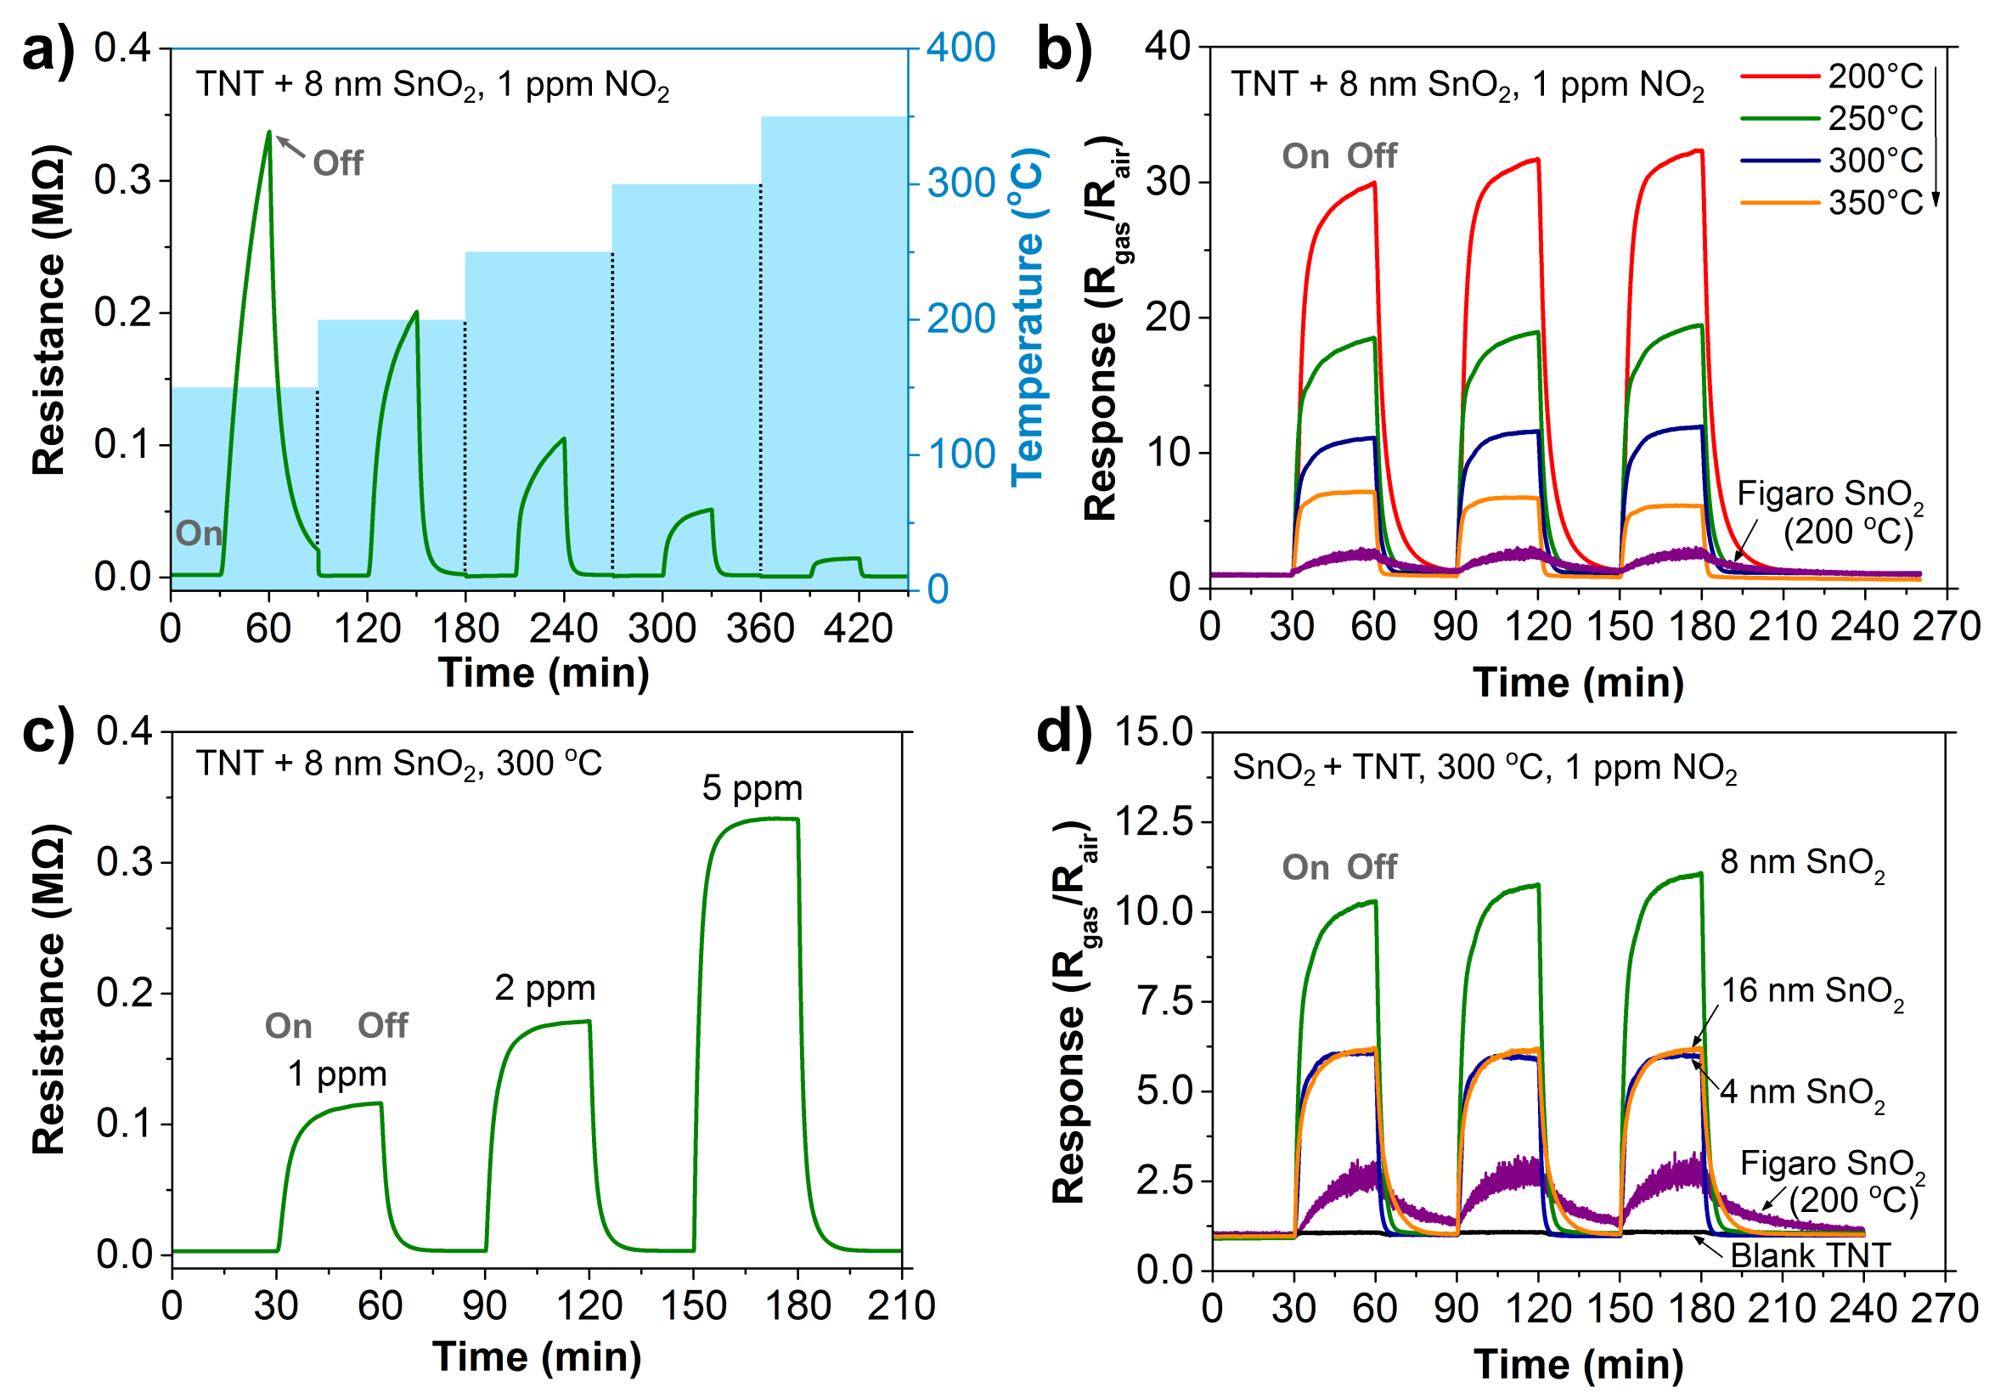
Figure 5. Dynamic response curves of 8 nm (N_{ALD} = 94 cycles) SnO₂ coated TiO₂ nanotube layer in variation of (a) operating temperature 150 – 350 ºC and (c) 1-5 ppm concentration of NO₂. Response and recovery curves in three repetitive cycles of (b) 8 nm SnO₂ coated TiO₂ nanotube layer at different operating temperatures, (d) blank and 4-16 nm (N_{ALD} = 47-189 cycles) SnO₂ coated TiO₂ nanotube layers. Commercial Figaro sensor with an embedded heating platform (operates up to 200 ºC) was measured in the same NO₂ concentration to serve as reference in (b) and (d). NO₂ gas on and off are marked on the first response curve for each figure.

After the consecutive measurements at different operating temperatures, we proceeded to evaluate the repeatability and stability of the 8 nm SnO₂ coated TiO₂ nanotube layer, presented in Figure 5(b). In good agreement with Figure 5(a), when the operating temperature increases, the response decreases, yet the response and recovery time was shorter. The highly consistent responses over three identical cycles of exposure and removal of NO₂ suggest that the sensing layer is stable for continuous sensing purposes. A commercial Figaro SnO₂ sensor with an embedded heating platform was also measured to serve as a reference. Nevertheless, the sensing response of all SnO₂ coated TiO₂ nanotube layer has outperformed the Figaro SnO₂ sensor. Based on this set of measurements, the subsequent measurements were carried out at 300 ºC as the sensing layer operating at this temperature has shown a satisfactory tradeoff between sensing response and recovery time.
The NO₂ sensing response of the 8 nm SnO₂ coated TiO₂ nanotube layer was subsequently assessed for the exposure towards different NO₂ concentrations at 300 ºC, given in Figure 5(c). The sensing layer responded rapidly towards the NO₂ and the responses increase according to the increase in NO₂ concentration applied to the chamber, from 1 to 5 ppm. The continual measurement also indicates that the sensing layer is sensitive towards a small change in NO₂ concentration, which is favored for applications where the sensor is calibrated to trigger different levels of alert according to different NO₂ concentrations. Furthermore, with the exposure to a five-fold NO₂ concentration at 5 ppm, the sensing layer retains the rapid response and recovery time. This demonstrates that the sensing layer is in fact capable adsorbing higher NO₂ concentrations. Nevertheless, we selected 1 ppm as a reasonably low concentration as the main model for study, as we observed that the NO₂ concentration within 0.1 – 500 ppm range was typically employed for SnO₂ based sensors.^{46,47} The primary interest is on a sensing layer that is being able to provide a superior sensing response at 1 ppm or even lower and detailed investigation on the detection of high concentration of NO₂ can be carried out in future work.
For the next measurement, the blank and different thicknesses SnO₂ coated TiO₂ nanotube layers were served as the sensing layer for the detection of 1 ppm NO₂ at 300 ºC, shown in Figure 5(d). Of all sensing layers, the blank TiO₂ nanotube layer has shown the smallest response towards NO₂. We associate the observation to the rather low working temperature at 300 ºC in the present work for TiO₂ to detect NO₂. Several studies have reported that TiO₂ commonly responds to NO₂ only at higher temperatures, 375 ºC or even up to 600 ºC, independent of their morphology and crystalline phases.^{18,48–50} Thus, it is deduced that higher operating temperatures are required to provide sufficiently high activation energy to initiate the sensing response of TiO_{2.}⁵¹
When 4 nm SnO₂ coating was added to the TiO₂ nanotube layer, a significant increment was registered, up to ≈6 times enhancement as compared to the blank TiO₂ nanotube layer. The pronounced result is further enhanced by 8 nm SnO₂ coating, achieving ≈10 times enhancement. Nevertheless, the thicker coating at 16 nm has shown a reverse effect, suggesting that enhanced response is saturated at approximately 8 nm. For comparison and reference purposes, the Figaro SnO₂ sensor was also measured. It has shown a response of 2.5 with a relatively high signal-to-noise ratio but with slower response and recovery compared to the nanotubular layers. All of these results support that the strategy to prepare very thin SnO₂ coatings within 1D TiO₂ nanotube layers effectively improve the sensitivity of NO₂ sensing.
From the response and recovery time aspect, we first refer to Figure 5(b) at a comparable operating temperature of 200 ºC. The 8 nm SnO₂ coated TiO₂ nanotube layer demonstrated shorter response and recovery time, i.e. faster adsorption and desorption, than the Figaro sensor with non-saturation response, which may be tied to the 1D tubular platform for rapid charge transport. Comparing within the same tubular platform, the response time varies with different coating thicknesses in Figure 5d and the thicker coatings required a longer diffusion time. The response time is slightly longer as the SnO₂ coating thickness increases from 0 to 8 nm, and remain similar at 8 and 16 nm, possibly due to a saturation effect. The increase of coating thickness reduces the inner diameter of nanotube, but insignificant, as the diameter of the unmodified nanotubes ≈230 nm was rather large as compared to the thickness of deposited coatings. The tubes remain widely opened as evidenced by the SEM images in Figure 3.
For metal oxides gas sensors, the oxygen molecules are adsorbed on the surface of the sensing layer, forming chemisorbed oxygen species (molecular species O₂⁻ for <150 ºC; atomic species O⁻, and O²⁻ for >150 ºC) by capturing electrons from the conduction band.¹⁵ In this work, we consider only the atomic species as all measurements were conducted at temperatures higher than 150 ºC. The sensing mechanism follows that when the SnO₂ coated TiO₂ nanotube layers are exposed to NO₂, SnO₂ adsorbs NO₂ on its surface by contributing electrons to NO₂ (Equation 1). On the other hand, NO₂ is an oxidizing gas which serves as an electron receiver and transforms to NO (Equation 2a,b).^{52,53}
NO₂ (g) + e⁻ NO₂⁻ (ads) Eq. 1
NO₂ (g) + e⁻ NO (g) + O⁻ (ads) Eq. 2(a)
NO₂ (g) + 2e⁻ NO (g) + O²⁻ (ads) Eq. 2(b)
For a heterostructure, the sensing activities such as electrons transfer are also regulated by the heterojunction at the SnO₂/TiO₂ interface. Figure 6 illustrates the schematic band diagram of TiO₂ and SnO₂ with a possible electron transfer route during the sensing process. Considering the individual energy band diagram of TiO₂ and SnO₂ in Figure 6(a), the work function, Φ_{TiO2} ≈5.1 eV ^{20,54,55} is larger than that of Φ_{SnO2} ≈4.9 eV.^{18,20,56} The difference in work function, following the higher position of the conduction band of TiO₂ than that of SnO₂, leads to the donation of electrons from TiO₂ to SnO₂ until the Fermi level is aligned, as shown in Figure 6(b). In parallel, when SnO₂ is exposed to NO₂, the electrons from conduction band of SnO₂ are released to react with NO₂ as described in Equations 1-2. More electrons are continuously supplied by TiO₂ for subsequent reactions, leading to a significant enhancement in sensing response. All these reactions lead to the increase of energy barrier (height), qΦ at the heterojunction interface, and subsequently the increase of resistance, R, of the heterostructure, as observed by the change of signal in Figure 5. The relationship between R and qΦ is given in Equation 3.
R ≈ exp$\left[\frac{qΦ}{k_{B}T}\right]$ Eq. 3
Where k_{B} is the Boltzmann’s constant and T is the absolute temperature.
A depletion region is created and the depletion width is further expanded at the surface of SnO₂. Similarly, when NO₂ is removed from the system, the captured electrons are transferred back to the SnO₂ and successively to TiO₂. The depletion width is decreased, followed by the decrease of energy barrier and finally the film resistance is restored to the base values.^{52,53} The width of the space charge region, where the electrons are depleted, also known as Debye length, is described in Equation 4.⁵⁷
$L_{D}={\left[\frac{εk_{B}T}{q^{2}N_{C}}\right]}^{1/2}$ Eq. 4
Where the static dielectric constant, ɛ = ɛ_{o}ɛ_{r}, ɛ_{o} is the permittivity of free space, ɛ_{r} is the relative dielectric constant of a material, k_{B} and T are as defined before, q is the electron charge, and N_{C} is the carrier concentration of the material. Based on these parameters, L_{D} is primarily influenced by the operating temperature and the carrier concentration of the sensing layer. Quite surprisingly, the estimated L_{D} in the literature for undoped SnO₂ lies in a substantially large range between 4 to 43 nm.^{58–60}

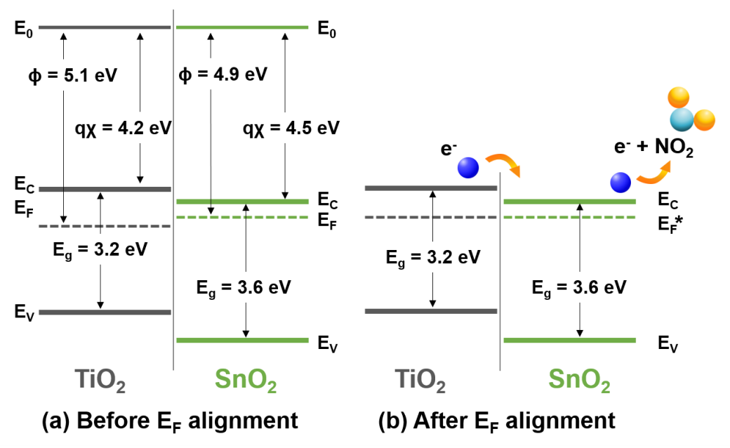
Figure 6. Schematic energy band diagram of SnO₂ coatings and TiO₂ nanotube walls (a) before and (b) after Fermi level alignment. E_{F}* in (b) shows an approximate position where the alignment possibly takes place, as the exact position is unknown. Φ = work function, χ = electron affinity. Values in (a) are adopted with reference to different literature sources.^{18,20,54–56,61}

To understand the charge transfer behavior better and to determine the carrier concentration of the sensing layers, we conducted electrochemical impedance spectroscopy (EIS) and Mott-Schottky measurements. Figure 7(a) depicts the Nyquist plots at high frequency range of the blank and SnO₂ coated TiO₂ nanotube layers. The similar semicircle diameter of all blank and SnO₂ coated layers suggests that the charge transfer resistance, R_{CT}, is similar for all layers. It can be interpreted as the overall conductivity of the TiO₂ nanotube layer was not improved by the thin SnO₂ coatings. In the Mott-Schottky plots in Figure 7(b), the extrapolation of the linear region to the intercept at the potential axis gives the flat band potential, E_{FB}. This gives 0.04 V for TiO₂ nanotube layer, and 0.16 – 0.37 V for SnO₂ with different thicknesses. In contrast to the observation in EIS measurement, with the increase of SnO₂ coating thickness, the flat band potential exhibits an overall positive shift. The positive shifts can be ascribed to two plausible reasons, i) the shift of Fermi level towards the conduction band⁶² and ii) a surface passivation effect.^{63–66} Based on this observation, we can deduce that the Fermi levels alignment occurred at a position higher than 5.1 eV (Φ_{TiO2}) with respect to the vacuum level E_{o} in Figure 6(b). In addition, the continuous SnO₂ coating acts as a surface passivation layer for the more defective TiO₂ nanotube walls. Such effect has been demonstrated by pin-hole free ALD SnO₂ coatings on carbon and graphene-based electrodes,^{63,64} as well as different ALD coatings on 1D TiO₂ nanostructures for suppressing the effects from oxygen vacancies or Ti interstitials.^{65,66} Nevertheless, the gradual shift from 4 to 8 nm but saturation with 16 nm SnO₂ coatings indicate that 8 nm SnO₂ is sufficient for heterojunction and passivation effects.
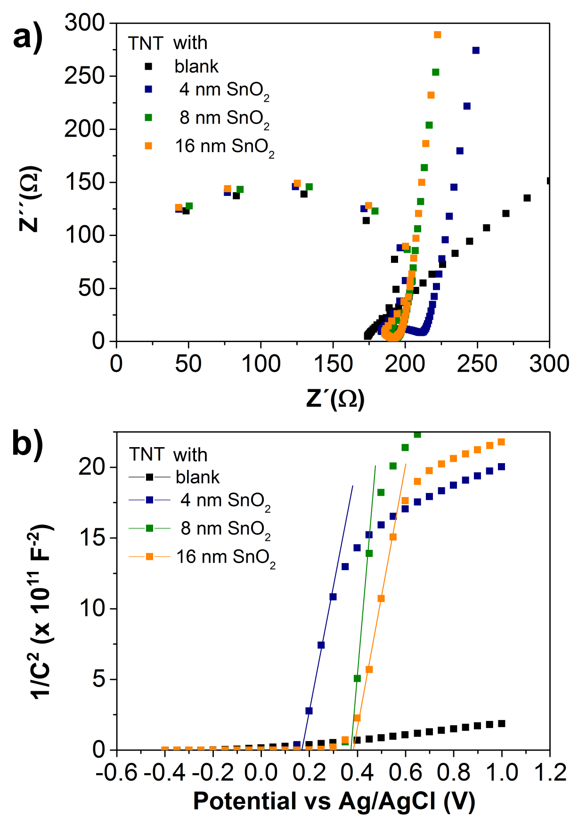
Figure 7. (a) EIS Nyquist plots at high frequency range, recorded at OCPs and (b) Mott-Schottky plots for blank and 4-16 nm (N_{ALD} = 47-189 cycles) SnO₂ coated TiO₂ nanotube layer, recorded at 1000 Hz in the potential range of 1.0 to -0.4 V_{Ag/AgCl} (from positive to negative potentials) in 1 M Na₂SO₄ aqueous solution.

The positive slope in Figure 7(b) confirms the n-type semiconductor behavior of SnO₂ and TiO₂ with electrons as the majority carrier. By fitting the linear region of the plots and taking the relative dielectric constant ɛ_{r} as ≈41⁶⁷ and ≈25,⁶⁸ for anatase TiO₂ and rutile SnO₂ (both were evidenced by XRD measurement in Figure 1), respectively, the carrier concentration, N_{C} was determined. The N_{C} for blank TiO₂ nanotube layer was ≈6 x 10¹⁹ cm⁻³, in accord with other anodically grown TiO₂ nanotube layers with anatase crystallinity.^{66,69} Meanwhile the N_{C} for SnO₂ coatings, as an average of three SnO₂ thicknesses was ≈2 x 10¹⁸ cm⁻³. The obtained value is in good agreement with a crystalline SnO₂ layer, prepared by ALD followed by post-annealing, similar to the procedures adopted in this work.⁷⁰
By applying N_{C} = 2 x 10¹⁸ cm⁻³ in Equation 4, and taking the optimal operating temperature as 300 ºC from Figure 5, the L_{D} for SnO₂ was ≈5.9 nm. For a sensing layer with thickness within the range of L_{D}, the sensing response is significantly enhanced.⁵⁸ Altogether, the present results show that the 8 nm SnO₂ coating has the highest sensitivity among all the coatings, combining the advantages from the heterojunction with TiO₂ for an ample amount of electrons and efficient charge transfer. On the other hand, the 4 nm coating is fully depleted, and a substantial amount has been consumed for the adsorption of the oxygen species in air. Whereas for the 16 nm coating, the reactions are mainly confined within the SnO₂ layer, without involving much of the TiO₂ in charge transfer.³² Similar trend has been observed by other core-shell nanostructures for gas sensing.^{18,32} The low sensing responses of the blank TiO₂ nanotube layer observed in Figure 5(d) suggest that the high response is mainly contributed by the SnO₂ coatings. However, the blank TiO₂ nanotube layer facilitates the whole sensing reaction by i) offering a high surface area by its 1D structure, ii) serving as a heterojunction and providing additional electrons. This reasonably explains the better performance as compared to the commercial thin film SnO₂ sensing layer.
As stable sensing response is an important criterion for a practical sensor, the durability measurement was intentionally conducted on the same 8 nm SnO₂ coated TiO₂ nanotube layer that was employed to measure other sensing responses. A 4 h exposure to NO₂ for four different operating temperatures from 200-350 ºC, cumulatively 16 h of measurement shows that the response was consistent over the entire period, as shown in Figure 8(a). This reveals that the sensing layer is robust for long term measurement.
Separately, the influence of humidity towards the 8 nm SnO₂ coated TiO₂ nanotube layer and Figaro SnO₂ sensor was evaluated. Mimicking the practical environment, a relative humidity (RH) range from 20 to 80 % was selected and the response towards continuous switching of different RH values is presented in Figure 8(b). The response of 8 nm SnO₂ coated TiO₂ nanotube layer is relatively stable with an average response of 5 over the whole range, whereas the response of Figaro SnO₂ sensor is much higher and dependent on the RH values. The consistent response of our sensing layer indicates the possibility of electronic calibration to a similar baseline to omit the signal from water vapor and moisture, to distinguish from the NO₂ sensing response.
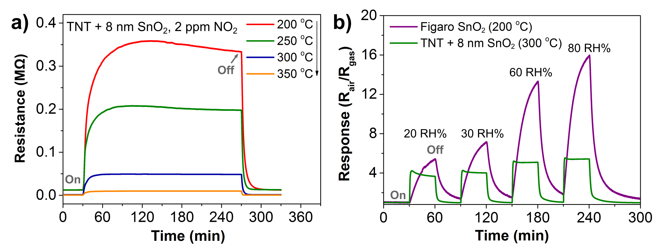Figure 8. (a) Long duration stability test of 8 nm (N_{ALD} = 94 cycles) SnO₂ coated TiO₂ nanotube layer at different operating temperatures 200 – 350 ºC, (b) Dynamic response curves of 8 nm (N_{ALD} = 94 cycles) SnO₂ coated TiO₂ nanotube layer and commercial Figaro SnO₂ sensor in variation of relative humidity (RH %). The “on” and “off” states of the flow of NO₂ gas (in (a)) and water vapor (in (b)) are marked on the corresponding curves.

As a final step to confirm the stability of the layer after all the sensing measurements, analyses on the morphological and structural aspects were carried out on the 16 nm SnO₂ coatings deposited TiO₂ nanotube layer after 2-4 weeks from the final sensing measurements. All materials characterizations for post-sensing measurements were included in Figure S2-4 (Supporting information) for reference. Based on the SEM and XRD measurements, no significant morphological and structural change, respectively, were observed. In addition, the XPS survey and detailed core levels analyses for the same nanotube layer before and after sensing measurements are rather similar. This implies that no detectable change in respective constituents nor diffusion of SnO₂ layer at the interface of SnO₂/TiO₂, credit to the stabilization step done before sensing measurements at temperature 500 ºC, that is higher than the operating temperatures capped at 350 ºC.

4. Conclusion
We presented ALD SnO₂ coatings of different thicknesses (4, 8 and 16 nm) within anodic 1D TiO₂ nanotube layers for efficient sensing of low concentration down to 1 ppm NO₂ driven by a low voltage of 0.5 V. Detailed materials investigations were performed on the prepared heterostructures. The as-deposited SnO_{x} coating was post-annealed to obtain a more stoichiometric crystalline SnO₂ coating. In addition, the inherent surface defects of the TiO₂ nanotube walls were passivated by the homogeneous SnO₂ coatings. Overall, the highest improvement was achieved by 8 nm SnO₂ coatings up to ten times enhancement compared to the blank TiO₂ nanotube layers, and four times compared to commercial SnO₂ sensor. This is related to the suitable thickness which falls within the range Debye length for enhanced sensitivity, and utilizes the advantages of the SnO₂/TiO₂ heterojunction effect, where the suitable energy level alignment promotes efficient charge transfer for enhanced interactions with the targeted gas, NO₂. Most importantly, the sensing layer has demonstrated excellent sensing time stability for practical use. This work combines the 1D nanotubular structure which provides a high surface area platform for the creation of thin coatings by ALD with controllable thickness as the dominant sensing layer.

ASSOCIATED CONTENT
Supporting information
The Supporting Information is available free of charge on the ACS Publications website at DOI:
SEM images of SnO₂ deposited TiO₂ nanotube layers i) at the interface of the bottom part of TiO₂ nanotube layers and Ti substrate, and ii) on the surface, after all sensing measurements. XRD patterns and XPS spectrum before and after sensing measurements.

AUTHOR INFORMATION
Corresponding Author
*Jan M. Macak (jan.macak@upce.cz)
Author Contributions
SN, ZS, JRP, JM, MK materials characterization and analyses. JPra, ZP, SN sensing measurements and analyses. RZ, JPri, HS materials synthesis. SN, JPra and JMM manuscript preparation and editing. JH and JMM conceptualization, supervision and funding acquisition. All authors reviewed and discussed the manuscript.
Funding Sources
We gratefully acknowledge the support from the European Research Council (project No. 638857) and the Ministry of Education, Youth and Sports of the Czech Republic (projects No. LQ1601, LM 2018110, LM2018103).

ACKNOWLEDGMENT
CzechNanoLab project LM2018110 funded by MEYS CR is gratefully acknowledged for the financial support of the XRD, SEM and TEM measurements at CEITEC Nano Research Infrastructure. We thank Dr. F. Dvorak for XPS measurements for the preliminary runs of ALD SnO₂.

REFERENCES
(1) Liu, X.; Cheng, S.; Liu, H.; Hu, S.; Zhang, D.; Ning, H. A Survey on Gas Sensing Technology. Sensors 2012, 12 (12), 9635–9665.
(2) Miller, D. R.; Akbar, S. A.; Morris, P. A. Nanoscale Metal Oxide-Based Heterojunctions for Gas Sensing: A Review. Sensors Actuators, B Chem. 2014, 204, 250–272.
(3) Bai, J.; Zhou, B. Titanium Dioxide Nanomaterials for Sensor Applications. Chem. Rev. 2014, 114 (19), 10131–10176.
(4) Hůnová, I.; Bäumelt, V.; Modlík, M. Long-Term Trends in Nitrogen Oxides at Different Types of Monitoring Stations in the Czech Republic. Sci. Total Environ. 2020, 699, 134378.
(5) Ambient (outdoor) air pollution https://www.who.int/news-room/fact-sheets/detail/ambient-(outdoor)-air-quality-and-health (accessed Mar 5, 2020).
(6) Air Quality Standards https://ec.europa.eu/environment/air/quality/standards.htm (accessed Mar 5, 2020).
(7) Environmental Quality Standards in Japan - Air Quality https://www.env.go.jp/en/air/aq/aq.html (accessed Mar 5, 2020).
(8) China: Air Quality Standards https://www.transportpolicy.net/standard/china-air-quality-standards/ (accessed Mar 5, 2020).
(9) Yamazoe, N.; Fuchigami, J.; Kishikawa, M.; Seiyama, T. Interactions of Tin Oxide Surface with O2, H2O and H2. Surf. Sci. 1979, 86 (C), 335–344.
(10) Oyabu, T. Sensing Characteristics of Tin Oxide Thick Film Gas Sensor. J. Appl. Phys. 1982, 53 (11), 2785.
(11) Gas Sensors - FIGARO Engineering inc. www.figaro.co.jp/en/ (accessed Jan 3, 2020).
(12) Nissha FIS. Inc. High quality gas sensor manufacturer www.fisinc.co.jp/en (accessed Nov 17, 2019).
(13) Yamazoe, N. New Approaches for Improving Semiconductor Gas Sensors. Sensors Actuators B. Chem. 1991, 5, 7–19.
(14) Marichy, C.; Pinna, N. Atomic Layer Deposition to Materials for Gas Sensing Applications. Adv. Mater. Interfaces 2016, 3 (21), 1600335.
(15) Mirzaei, A.; Kim, J.-H.; Kim, H. W.; Kim, S. S. How Shell Thickness Can Affect the Gas Sensing Properties of Nanostructured Materials: Survey of Literature. Sensors Actuators B Chem. 2018, 258, 270–294.
(16) Chen, H.; Yang, S. Nanoscale Horizons Enhancing Charge Separation and Transport in Photoelectrochemical Solar Energy Conversion Systems. Nanoscale Horizons 2016, 1, 96–108.
(17) Weng, B.; Liu, S.; Tang, Z.-R.; Xu, Y.-J. One-Dimensional Nanostructure Based Materials for Versatile Photocatalytic Applications. RSC Adv. 2014, 4 (25), 12685.
(18) Katoch, A.; Kim, J.-H.; Kim, S. S. TiO2/ZnO Inner/Outer Double-Layer Hollow Fibers for Improved Detection of Reducing Gases. ACS Appl. Mater. Interfaces 2014, 6 (23), 21494–21499.
(19) Wen, Z.; Tian-mo, L. Gas-Sensing Properties of SnO2-TiO2-Based Sensor for Volatile Organic Compound Gas and Its Sensing Mechanism. Phys. B Condens. Matter 2010, 405 (5), 1345–1348.
(20) Li, F.; Gao, X.; Wang, R.; Zhang, T.; Lu, G. Study on TiO2-SnO2 Core-Shell Heterostructure Nanofibers with Different Work Function and Its Application in Gas Sensor. Sensors Actuators B Chem. 2017, 248, 812–819.
(21) Zhao, T.; Qiu, P.; Fan, Y.; Yang, J.; Jiang, W.; Wang, L.; Deng, Y.; Luo, W. Hierarchical Branched Mesoporous TiO2–SnO2 Nanocomposites with Well‐Defined n–n Heterojunctions for Highly Efficient Ethanol Sensing. Adv. Sci. 2019, 1902008.
(22) Zeng, W.; Liu, T.; Wang, Z. Enhanced Gas Sensing Properties by SnO2 Nanosphere Functionalized TiO2 Nanobelts. J. Mater. Chem. 2012, 22 (8), 3544–3548.
(23) Zhou, H.; Li, Z.; Niu, X.; Xia, X.; Wei, Q. The Enhanced Gas-Sensing and Photocatalytic Performance of Hollow and Hollow Core-Shell SnO2-Based Nanofibers Induced by the Kirkendall Effect. Ceram. Int. 2016, 42 (1), 1817–1826.
(24) Kusior, A.; Radecka, M.; Zych; Zakrzewska, K.; Reszka, A.; Kowalski, B. J. Sensitization of TiO2/SnO2 Nanocomposites for Gas Detection. Sensors Actuators, B Chem. 2013, 189, 251–259.
(25) Lyson-Sypien, B.; Czapla, A.; Lubecka, M.; Kusior, E.; Zakrzewska, K.; Radecka, M.; Kusior, A.; Balogh, A. G.; Lauterbach, S.; Kleebe, H. J. Gas Sensing Properties of TiO2-SnO2 Nanomaterials. Sensors Actuators, B Chem. 2013, 187, 445–454.
(26) Xun, H.; Zhang, Z.; Yu, A.; Yi, J. Remarkably Enhanced Hydrogen Sensing of Highly-Ordered SnO2-Decorated TiO2 Nanotubes. Sensors Actuators B Chem. 2018, 273, 983–990.
(27) Kim, W.-T.; Kim, I.-H.; Choi, W.-Y. Fabrication of TiO2 Nanotube Arrays and Their Application to a Gas Sensor. J. Nanosci. Nanotechnol. 2015, 15 (10), 8161–8165.
(28) Dvorak, F.; Zazpe, R.; Krbal, M.; Sopha, H.; Prikryl, J.; Ng, S.; Hromadko, L.; Bures, F.; Macak, J. M. One-Dimensional Anodic TiO2 Nanotubes Coated by Atomic Layer Deposition: Towards Advanced Applications. Appl. Mater. Today 2019, 14, 1–20.
(29) Ritala, M.; Niinisto, J. Atomic Layer Deposition. In Chemical Vapour Deposition: Precursors, Processes and Applications; Jones, A. C., Hitchman, M. L., Eds.; Royal Society of Chemistry, 2009; pp 158–206.
(30) Ng, S.; Kuberský, P.; Krbal, M.; Prikryl, J.; Gärtnerová, V.; Moravcová, D.; Sopha, H.; Zazpe, R.; Yam, F. K.; Jäger, A.; Hromádko, L.; Beneš, L.; Hamáček, A; Macak, Jan M. ZnO Coated Anodic 1D TiO2 Nanotube Layers: Efficient Photo-Electrochemical and Gas Sensing Heterojunction. Adv. Eng. Mater. 2018, 20 (2), 1700589.
(31) Park, S.; An, S.; Ko, H.; Lee, S.; Kim, H. W.; Lee, C. Enhanced Ethanol Sensing Properties of TiO2/ZnO Core-Shell Nanorod Sensors. Appl. Phys. A Mater. Sci. Process. 2014, 115 (4), 1223–1229.
(32) Choi, S.-W.; Katoch, A.; Sun, G.-J.; Kim, J.-H.; Kim, S.-H.; Kim, S. S. Dual Functional Sensing Mechanism in SnO2 –ZnO Core–Shell Nanowires. ACS Appl. Mater. Interfaces 2014, 6 (11), 8281–8287.
(33) Barr, M. K. S.; Assaud, L.; Brazeau, N.; Hanbücken, M.; Ntais, S.; Santinacci, L.; Baranova, E. A. Enhancement of Pd Catalytic Activity toward Ethanol Electrooxidation by Atomic Layer Deposition of SnO2 onto TiO2 Nanotubes. J. Phys. Chem. C 2017, 121 (33), 17727–17736.
(34) Das, S.; Sopha, H.; Krbal, M.; Zazpe, R.; Podzemna, V.; Prikryl, J.; Macak, J. M. Electrochemical Infilling of CuInSe2 within TiO2 Nanotube Layers and Subsequent Photoelectrochemical Studies. ChemElectroChem 2017, 4 (3), 495–499.
(35) Pytlicek, Z.; Bendova, M.; Prasek, J.; Mozalev, A. On-Chip Sensor Solution for Hydrogen Gas Detection with the Anodic Niobium-Oxide Nanorod Arrays. Sensors Actuators B Chem. 2019, 284, 723–735.
(36) Elam, J. W.; Baker, D. A.; Hryn, A. J.; Martinson, A. B. F.; Pellin, M. J.; Hupp, J. T. Atomic Layer Deposition of Tin Oxide Films Using Tetrakis(Dimethylamino) Tin. J. Vac. Sci. Technol. A Vacuum, Surfaces, Film. 2008, 26 (2), 244–252.
(37) Liu, C.; Kim, N.; Rubloff, G. W.; Lee, S. B. High Performance Asymmetric V2O5–SnO2 Nanopore Battery by Atomic Layer Deposition. Nanoscale 2017, 9 (32), 11566–11573.
(38) Langford, J. I.; Wilson, A. J. C. Scherrer after Sixty Years: A Survey and Some New Results in the Determination of Crystallite Size. J. Appl. Crystallogr. 1978, 11 (2), 102–113.
(39) Szuber, J.; Czempik, G.; Larciprete, R.; Koziej, D.; Adamowicz, B. XPS Study of the L-CVD Deposited SnO2 Thin Films Exposed to Oxygen and Hydrogen. Thin Solid Films 2001, 391 (2), 198–203.
(40) Jadhav, H.; Suryawanshi, S.; More, M. A.; Sinha, S. Pulsed Laser Deposition of Tin Oxide Thin Films for Field Emission Studies. Appl. Surf. Sci. 2017, 419, 764–769.
(41) Stranick, M. A.; Moskwa, A. SnO2 by XPS. Surf. Sci. Spectra 1993, 2 (1), 50–54.
(42) Nose, K.; Suzuki, A. Y.; Oda, N.; Kamiko, M.; Mitsuda, Y. Oxidation of SnO to SnO2 Thin Films in Boiling Water at Atmospheric Pressure. Appl. Phys. Lett. 2014, 104 (9), 2–6.
(43) García-García, S.; López-Ortega, A.; Zheng, Y.; Nie, Y.; Cho, K.; Chuvilin, A.; Knez, M. Ligand-Induced Reduction Concerted with Coating by Atomic Layer Deposition on the Example of TiO2 -Coated Magnetite Nanoparticles. Chem. Sci. 2019, 10 (7), 2171–2178.
(44) Rosental, A.; Tarre, A.; Gerst, A.; Kasikov, A.; Lu, J.; Ottosson, M.; Uustare, T. Epitaxial Single and Double Nanolayers of SnO2 and TiO2 for Resistive Gas Sensors. IEEE Sens. J. 2013, 13 (5), 1648–1655.
(45) Zazpe, R.; Knaut, M.; Sopha, H.; Hromadko, L.; Albert, M.; Prikryl, J.; Gärtnerová, V.; Bartha, J. W.; Macak, J. M. Atomic Layer Deposition for Coating of High Aspect Ratio TiO₂ Nanotube Layers. Langmuir 2016, 32 (41), 10551–10558.
(46) Maeng, S.; Kim, S.-W.; Lee, D.-H.; Moon, S.-E.; Kim, K.-C.; Maiti, A. SnO2 Nanoslab as NO2 Sensor: Identification of the NO2 Sensing Mechanism on a SnO2 Surface. ACS Appl. Mater. Interfaces 2014, 6 (1), 357–363.
(47) Sharma, A.; Tomar, M.; Gupta, V. SnO2 Thin Film Sensor with Enhanced Response for NO2 Gas at Lower Temperatures. Sensors Actuators B Chem. 2011, 156 (2), 743–752.
(48) Gönüllü, Y.; Haidry, A. A.; Saruhan, B. Nanotubular Cr-Doped TiO2 for Use as High-Temperature NO2 Gas Sensor. Sensors Actuators B Chem. 2015, 217 (2), 78–87.
(49) Maziarz, W.; Kusior, A.; Trenczek-Zajac, A. Nanostructured TiO2 -Based Gas Sensors with Enhanced Sensitivity to Reducing Gases. Beilstein J. Nanotechnol. 2016, 7 (1), 1718–1726.
(50) Saruhan, B.; Yüce, A.; Gönüllü, Y.; Kelm, K. Effect of Al Doping on NO2 Gas Sensing of TiO2 at Elevated Temperatures. Sensors Actuators B Chem. 2013, 187 (2), 586–597.
(51) Wilson, R.; Simion, C.; Blackman, C.; Carmalt, C.; Stanoiu, A.; Di Maggio, F.; Covington, J. The Effect of Film Thickness on the Gas Sensing Properties of Ultra-Thin TiO2 Films Deposited by Atomic Layer Deposition. Sensors 2018, 18 (3), 735.
(52) Jin, C.; Park, S.; Kim, H.; Ko, T.; Lee, C.; Jeong, B. Y. Enhanced NO2 Gas-Sensing Properties of SnO2 Nanorods with a TiO2 Capping. J. Korean Phys. Soc. 2012, 61 (9), 1370–1375.
(53) Jin, C.; Park, S.; Kim, H.; Lee, C. Ultrasensitive Multiple Networked Ga₂O₃-Core/ZnO-Shell Nanorod Gas Sensors. Sensors Actuators B Chem. 2012, 161 (1), 223–228.
(54) Kashiwaya, S.; Morasch, J.; Streibel, V.; Toupance, T.; Jaegermann, W.; Klein, A. The Work Function of TiO2. Surfaces 2018, 1 (1), 73–89.
(55) Marques, F. C.; Jasieniak, J. J. Ionization Potential and Electron Attenuation Length of Titanium Dioxide Deposited by Atomic Layer Deposition Determined by Photoelectron Spectroscopy in Air. Appl. Surf. Sci. 2017, 422, 504–508.
(56) Choi, S.-W.; Katoch, A.; Kim, J.-H.; Kim, S. S. Striking Sensing Improvement of N-Type Oxide Nanowires by Electronic Sensitization Based on Work Function Difference. J. Mater. Chem. C 2015, 3 (7), 1521–1527.
(57) Streetman, B. G.; Banarjee, S. K. Solid State Electronic Devices, 6th ed.; Prentice Hall, 2009.
(58) Ogawa, H.; Nishikawa, M.; Abe, A. Hall Measurement Studies and an Electrical Conduction Model of Tin Oxide Ultrafine Particle Films. J. Appl. Phys. 1982, 53 (6), 4448–4455.
(59) Mills, S.; Lim, M.; Lee, B.; Misra, V. Atomic Layer Deposition of SnO2 for Selective Room Temperature Low Ppb Level O3 Sensing. ECS J. Solid State Sci. Technol. 2015, 4 (10), S3059–S3061.
(60) Barsan, N.; Weimar, U. Conduction Model of Metal Oxide Gas Sensors. J. Electroceramics 2001, 7 (3), 143–167.
(61) Li, H.; Xie, C.; Liao, Y.; Liu, Y.; Zou, Z.; Wu, J. Characterization of Incidental Photon-to-Electron Conversion Efficiency (IPCE) of Porous TiO2/SnO2 Composite Film. J. Alloys Compd. 2013, 569, 88–94.
(62) Haryński, Ł.; Grochowska, K.; Karczewski, J.; Ryl, J.; Siuzdak, K. Scalable Route toward Superior Photoresponse of UV-Laser-Treated TiO2 Nanotubes. ACS Appl. Mater. Interfaces 2020, 12 (2), 3225–3235.
(63) Loussaert, J. A.; Fosdick, S. E.; Crooks, R. M. Electrochemical Properties of Metal-Oxide-Coated Carbon Electrodes Prepared by Atomic Layer Deposition. Langmuir 2014, 30 (45), 13707–13715.
(64) Xie, M.; Sun, X.; George, S. M.; Zhou, C.; Lian, J.; Zhou, Y. Amorphous Ultrathin SnO2 Films by Atomic Layer Deposition on Graphene Network as Highly Stable Anodes for Lithium-Ion Batteries. ACS Appl. Mater. Interfaces 2015, 7 (50), 27735–27742.
(65) Ulusoy, T. G.; Ghobadi, A.; Okyay, A. K. Surface Engineered Angstrom Thick ZnO-Sheathed TiO2 Nanowires as Photoanodes for Performance Enhanced Dye-Sensitized Solar Cells. J. Mater. Chem. A 2014, 2 (40), 16867–16876.
(66) Sopha, H.; Krbal, M.; Ng, S.; Prikryl, J.; Zazpe, R.; Yam, F. K.; Macak, J. M. Highly Efficient Photoelectrochemical and Photocatalytic Anodic TiO₂ Nanotube Layers with Additional TiO₂ Coating. Appl. Mater. Today 2017, 9, 104–110.
(67) Chung, M.-K. Study of Anodic Oxide Films on Titanium and Titanium-Zirconium Alloys and Their Potential for Capacitive Energy Storage, Case Western Reserve University, 2016.
(68) Hallil, H.; Ménini, P.; Aubert, H. Novel Microwave Gas Sensor Using Dielectric Resonator With SnO2 Sensitive Layer. Procedia Chem. 2009, 1 (1), 935–938.
(69) Hazra, A.; Dutta, K.; Bhowmik, B.; Chattopadhyay, P. P.; Bhattacharyya, P. Room Temperature Alcohol Sensing by Oxygen Vacancy Controlled TiO2 Nanotube Array. Appl. Phys. Lett. 2014, 105 (8), 10–15.
(70) Kavan, L.; Steier, L.; Grätzel, M. Ultrathin Buffer Layers of SnO2 by Atomic Layer Deposition: Perfect Blocking Function and Thermal Stability. J. Phys. Chem. C 2017, 121 (1), 342–350.

For Table of Contents

