New Interface for Purification of Proteins: 1D TiO₂ Nanotubes Decorated by Fe₃O₄ nanoparticles
Rudolf Kupcik,¹ Pavel Rehulka,¹ Zuzana Bilkova,¹ Hanna Sopha,² Jan M. Macak^{2*}
¹Department of Biological and Biochemical Sciences, Faculty of Chemical Technology, University of Pardubice, Studentska 573, 532 10 Pardubice, Czech Republic
²Center of Materials and Nanotechnologies, Faculty of Chemical Technology, University of Pardubice, Nam. Cs. Legii 565, 530 02 Pardubice, Czech Republic
KEYWORDS: self-organized TiO₂ nanotubes; magnetic nanoparticles; recombinant His-tagged proteins; isolation; purification.
ABSTRACT: In this work, a high surface area interface, based on anodic 1D TiO₂ nanotubes homogenously decorated by Fe₃O₄ nanoparticles (TiO₂NTs@Fe₃O₄NPs) is reported for the first time for an unprecedented purification of His-tagged recombinant proteins. Excellent purification results were achieved from the model protein mixture, as well as from the whole cell lysate (with His-tagged ubiquitin). Compared to a conventional Immobilized-Metal Affinity Chromatography (IMAC) system, specific isolation of selected His-tagged proteins on behalf of other proteins was significantly enhanced on TiO₂NTs@Fe₃O₄NP´s interface under optimized binding and elution conditions. The combination of specific isolation properties, magnetic features, biocompatibility, and ease of preparation of this material consisting of two basic metal oxides, makes it a suitable candidate for future purification of recombinant proteins in biotechnology. The principally new material bears a large potential to open new pathways for discoveries in nanobiotechnology and nanomedicine.

INTRODUCTION
The production of highly pure biomolecules, such as for example proteins, polypeptides, oligosaccharides or nucleic acids, is a key requirement for their use in medicine and life sciences. In particular, they are widely used for in vivo applications, such as for the production of efficient and selective biopharmaceuticals, including targeted bioactive therapeutics¹, recombinant proteins² or vaccines³. Thus, the development of suitable materials and purification methods for these biologically active compounds, are an important topic in current biomedical research.
There are comprehensive reviews in the field of proteomics or genomics that describe and summarize separation and purification approaches of various biomolecules.⁴⁻⁶ Many recombinant proteins are synthesized with suitable affinity tags to facilitate the purification process. Immobilized-Metal Affinity Chromatography (IMAC) has been the most widely employed technique in the separation of recombinant His-tagged proteins.^{7,8} IMAC is based on interactions between transition metal ions (Co²⁺, Ni²⁺, Fe³⁺, Ga³⁺) and side chains of specific amino acids or phosphate groups of phosphorylated amino acids. Metal ions are commonly immobilized on cross-linked gels or other types of stationary phases. However, IMAC has several drawbacks: e.g. the insufficient purity of separated proteins,⁸ limited surface area of microspheres accessible for binding,⁹ gradual release of the carrier ions during separation,¹⁰ poor mechanical stability,¹¹ and toxicity of the released metal ions.¹² In recent years several nanomaterials for immobilization or purification of His-tagged proteins were also introduced,¹³⁻¹⁷ all utilizing nickel or cobalt (or their oxides), which all are also toxic.
Materials research for purification of biomolecules have therefore also been aimed towards core-shell nanoparticles that combine a high surface area shell made of TiO₂,¹⁸ ZrO₂¹⁹ or functionalized SiO₂^{20,21} for the separation of peptides or proteins and a magnetic core, that adds the magnetic functionality to separate particles from a solution. These nanoparticles, however, have limited separation specificity for recombinant proteins. In addition, they display weak magnetic interactions within a magnetic field disabling their easy quantitative separation from the solution.
However, the ability to separate the solid phase from the liquid phase using a magnetic field is one of the key features that end-users in many biotechnology processes seek for. There are two types of magnetic microparticles, one type has a compact magnetic core covered by a non-magnetic shell and second type has a core composed of multiple magnetic nanoparticles embedded in a non-magnetic matrix.²² The magnetic interaction between superparamagnetic particles can be easily switched on and off. It is easy to manipulate with these particles by strong magnet or by external magnetic field in batch-wise arrangements. Magnetic micro/nanoparticles are widely exploited in many biotechnological or biomedical applications.^{23,24} In particular, iron oxide based particles are of interest, incorporate excellent biocompatibility and safety factors with their unique magnetic properties and are more acceptable than toxic nickel and cobalt based counterparts.²⁵⁻²⁷
All in all, it is desirable to develop highly functional materials that could overcome aforementioned disadvantages, and that would feature a high surface area interface, good enough separation specificity with sufficient capacity for the repetitive purification of His-tagged biomolecules and would be magnetic in the same time. Easy and low-cost decontamination and regeneration of such material is also required.
In an effort to find a suitable material (and interface) to fulfill all these criteria, we came to 1D self-organized anodic TiO₂ nanotube layers (prepared by anodic oxidation of Ti substrates^{28,29}) that have already been shown for numerous applications: to promote the hydroxyapatite growth^{30,31} to accommodate various cell cultures when having optimized tube dimensions,^{32,33} as well as other morphological states of TiO₂.³⁴ TiO₂ nanotube layers have been also utilized as the carrier for drug loading,³⁵⁻³⁷ peptide loading,³⁸ biosensing,^{39,40} catalyst for photo-induced killing of cancer cells⁴¹ and decomposition of various organic molecules.^{42,43} In addition, anodic TiO₂ - based nanotubes were prepared on a number of biomedical alloys widely used for hip implants.^{44,45} Recently, it was also demonstrated that proteins can interact with plane TiO₂ nanotubes and that the amount of adsorbed protein depends on the internal diameter and length of nanotubes as well as on the protein charge.⁴⁶ For the controllable adsorption and enrichment of proteins, a charge-selective TiO₂ nanotube membrane decorated with graphitic carbon patches was created and also self-cleaning features were demonstrated for this type of material.⁴⁷ All in all, interactions of TiO₂ nanotubes based materials with proteins demonstrates their potential for protein purification.
The 1D TiO₂ nanotubes, when decorated with magnetite nanoparticles, seem to be a great candidate as for purification of biomolecules usable in biomedicine, fulfilling all above requirements - i.e. high specificity, high surface area, proper magnetic functionality and regeneration by photocatalytic means. However, to the best of our knowledge, this material (1D TiO₂ nanotubes decorated by Fe₃O₄ nanoparticles) and its interface has never been used for affinity chromatography up to now.
In the present work, we therefore combine these two fascinating materials - anodic 1D TiO₂ nanotubes and magnetite Fe₃O₄ nanoparticles (decorating the nanotubes) - as new material for efficient purification of biomolecules, in particular recombinant proteins carrying a His-tag affinity anchor. The purification performance of this material is compared to conventional IMAC material and protocol with significantly higher selectivity of presented magnetic carrier.
EXPERIMENTAL PROCEDURES
Preparation of the 1D TiO₂ nanotubes decorated by Fe₃O₄ nanoparticles (further noted as TiO₂NTs@Fe₃O₄NPs)
Two types of 1D self-organized TiO₂ nanotube arrays were selected based on preliminary experiments (with a range of tube arrays with different diameters and lengths) and turned out favorable for the performance needed in this work (quantitative loading of magnetic particles, accessibility of proteins). These arrays have been prepared by anodization of Ti foils. Smaller diameter nanotubes (average inner diameter ≈ 125 nm) were produced in pre-aged ethylene glycol electrolyte containing 0.88 mM NH₄F, 2 wt% water containing at 60 V applied for 12 hours, as reported previously.⁴⁸ Larger diameter nanotubes (average inner diameter ≈ 230 nm) were produced in pre-aged ethylene glycol electrolyte containing 0.15 mM NH₄F, 10 wt% water at 100 V applied for 4 hours, as reported previously.⁴⁹ After anodization, nanotubes were sonicated in isopropanol for 5 minutes to remove residues of electrolyte species and tube debris from the tube interiors and exteriors. All chemicals (unless stated otherwise) were purchased from Sigma-Aldrich. For deposition of magnetic nanoparticles, an aqueous suspension of magnetite Fe₃O₄ nanoparticles (Ferrofluid) with an average size of 8 nm (PL-A-Fe3O4-10m, Plasmachem, Germany) were used. This materials is especially suitable for its low-costs, bio-compatibility and great superparamagnetic performance. The Ferrofluid was dropped on the nanotube layers attached to Ti substrate with a strong Nd magnet placed underneath the substrate, to force spreading of magnetite nanoparticles over the nanotube interiors homogenously. Following this protocol, the whole volume of the dropped solution was quantitatively sucked inside the nanotubes, and partially also outside at the nanotube mouths and decorated their walls homogenously. The layers were afterwards dried at 60°C for 4 hours. Ti substrates with grown nanotubes were bent in order to lift-off the loaded nanotubes that were collected, weighed, and supplied for further experiments. No other treatment of the TiO₂NTs@Fe₃O₄NPs material was performed. Morphological characterizations were performed using FE-SEM JSM 7500F (JEOL Ltd.) and HR-TEM Titan (FEI Ltd.) with a high angle annular dark field (HAADF) detector, operated at 200 kV and equipped with EDX. Zeta-potential of an aqueous suspension of the TiO₂NTs@Fe₃O₄NPs was analysed using Zetasizer Nano ZS (Malvern Instruments Ltd., Malvern, UK). Magnetic properties of the samples were analysed by Vibrating Sample Magnetometer (Lake Shore, 3 T).
Isolation of His-tagged peptides/proteins
Preparation of tryptic digests:
Model protein recombinant N-terminal histidine tagged human Ubiquitin expressed in E. coli (His Ubiq, U5507, Sigma-Aldrich,) was dissolved in NH₄HCO₃ solution and the protein was digested with trypsin. Bovine serum albumin (BSA) was dissolved in NH₄HCO₃, disulfide bonds were reduced with 15 mM dithiothreitol at 56°C for 30 min and alkylated with 30 mM iodoacetamide for 20 min at room temperature in the dark. The reaction was quenched by addition of 15 mM dithiothreitol, and the protein was digested with trypsin at 37°C overnight using an enzyme/substrate ratio of 1:50 (w/w).
Isolation of His-tagged peptide:
For each experiment, 10 pmol of the digested His Ubiq was mixed with 10 pmol of digested BSA, both dissolved in binding solution which was added to 1 mg of smaller diameter TiO₂NTs@Fe₃O₄NPs and His-tag containing peptide was isolated. Five different types of binding solutions were tested – 50 mM glycine-HCl buffer pH 3.2; 50 mM glycine-HCl buffer pH 4.5 and 5.5; 50 mM Bis-Tris-HCl buffer pH 6.5; Tris-HCl pH 7.5. After binding, the magnetic carrier was washed with the same buffer containing 10 mM imidazole. The first elution step was performed with 50 mM Tris-HCl buffer pH 7.5, containing 300 mM imidazole. In the second step, 200 mM Na₂HPO₄ and 100 mM imidazole in 10 mM Tris-HCl buffer was used. 1% ammonia solution was used for the regeneration of the magnetic carrier.
Isolation of His-tagged protein from cell lysate:
The whole Jurkat cells lysate was spiked with His Ubiq for both further experiments. The human T-cell acute lymphoblastic leukemia cell line Jurkat was purchased from European Collection of Cell Cultures (UK). These cells were cultured in Roswell Park Memorial Institute 1640 medium (Life Technologies, USA) and lysed in modified RIPA buffer (25 mM Tris-HCl pH 7.6, 150 mM NaCl, 1% Triton X-100, 0.1% SDS). The buffer was changed using Amicon Ultra Centrifugal Filters (Merck Millipore, USA). The total amount 250 µg of proteins (240 µg of proteins from cell lysate and 10 µg of His Ubiq) in 300 µl of 50 mM Bis-Tris-HCl buffer at pH 6.5 was used as the sample of complex protein mixture. The His Ubiq isolation of protein from the whole cell lysate started by protein binding with 6 mg of larger diameter magnetic carrier in 50 mM Bis-Tris-HCl buffer at pH 6.5 for 30 min. Weakly and non-specifically bound proteins were washed 5x with the same buffer containing 20 mM imidazole to isolate His-tagged protein with a high purity. The first elution step was performed in Bis-Tris-HCl buffer pH 6.5 with subsequent addition of imidazole to a final concentration 300 mM. In the second and third elution step, 200 mM Na₂HPO₄ and 100 mM imidazole dissolved in 10 mM Bis-Tris-HCl buffer were used, respectively. 1% Ammonia solution was used for the regeneration of TiO₂NTs@Fe₃O₄NPs.
For IMAC based His Ubiq isolation from a complex protein mixture, the total protein amount was 250 µg (240 µg of proteins from cell lysate and 10 µg of His Ubiq). The proteins were dissolved in 300 µl of 150 mM NaCl/50 mM Tris-HCl buffer (pH 7.5) and incubated with 25 µl of settled His-Pur™ Ni-NTA resin (Thermo Scientific, USA) in Tris-HCl buffer at pH 7.4 + 150 mM NaCl for 30 min. Weakly and non-specifically bound proteins were 5x washed out with the same buffer to isolate His-tagged protein with a high purity. The first and second elution step was performed in Tris-HCl buffer pH 7.4 + 150 mM NaCl with subsequent addition of imidazole to a final concentration 300 mM. Among each step, the resin was centrifuged for 30 s at 1,000×g.
Binding capacity of TiO₂NTs@Fe₃O₄NPs:
The analysis was done with 6 mg of larger diameter TiO₂NTs@Fe₃O₄NPs Loading step of each aliquot was carried out for 30 min. 12 aliquots of initial sample consisted of 10 µg His Ubiq in 300 µl 50 mM Bis-Tris-HCl buffer (pH 6.5) were prepared. The supernatant was collected and analysed. The amount of bound protein was determined as the total loaded protein amount diminished by the protein amount in the supernatant. His Ubiq in concentrations of 0.25 to 15 ug/300µl was added to Tris-Tricine-SDS-PAGE to analyze protein amount in consecutive binding fractions. Absolute quantitation method procedure in Image Lab Software (Bio-Rad, USA) was performed within analysis of electrophoretic data.

Peptides desalting and MS analysis
All analyzed fractions of peptides were desalted using approximately 1 cm long chromatographic reversed-phase POROS Oligo R3 microcolumns, as described previously⁵⁰ with a few modifications. Peptides were directly eluted onto MALDI targets with 5 g.l⁻¹ CHCA solution (60% ACN/0.1% TFA/2 mM diammonium hydrogen citrate). A MALDI Orbitrap MS (Thermo Scientific, USA) was used in the positive mode and set to the resolution of 100,000 (FWHM@m/z 400).
Tris-Tricine-SDS-PAGE
Each separation fraction was mixed with Tricine Sample Buffer (Bio-Rad, USA), boiled at 100 °C for 3 min and then loaded onto a 0.75 mm Tris-Tricine polyacrylamide gel (16.5% T, 3% C separating gel) according to Schägger.⁵¹ Electrophoresis was performed using a Mini-Protean system (Bio-Rad, USA) at 30 and 100 V in Tris-Tricine-SDS running buffer. Proteins in the gels were visualized by a silver staining method,⁵² or by Colloidal Blue Staining Kit (Novex, Life Technologies, USA) according to the manufacturer's instructions. Electropherograms were acquired using a ChemiDoc™ XRS+ System (Bio-Rad, USA) and processed in the Image Lab software (Bio-Rad, USA). The same software quantification method was used to calculate the quantity of His-tagged proteins, evaluating the density and areas of bands.

RESULTS
Figure 1a shows schematically the whole sequence of steps of His-tagged protein purification using the 1D TiO₂ nanotubes homogenously decorated by Fe₃O₄ nanoparticles (TiO₂NTs@Fe₃O₄NPs) in batch-wise arrangement. The procedure begun with the preparation of TiO₂NTs@Fe₃O₄NPs, which were then loaded with peptide/protein mixture in binding buffer containing, among others, His-tagged proteins (Figure 1b). After the incubation time the TiO₂NTs@Fe₃O₄NPs were separated by Nd magnet (Figure 1c) from the resulting flow-through fraction that was in turn saved for further analyses. The TiO₂NTs@Fe₃O₄NPs were afterwards washed from the unbound species, and captured His-tagged biomolecules were eluted with an elution buffer. TiO₂NTs@Fe₃O₄NPs could be regenerated by soaking in ammonia solution and used repeatedly for a next purification cycle.
Figure 1. a) Sequence of the purification of His-tagged proteins using the TiO₂NTs@Fe₃O₄NPs and the optimized purification process, b) photograph of the vial containing solution of TiO₂NTs@Fe₃O₄NPs loaded with proteins, c) photograph of the same solution as in b) with applied magnetic forces (used for the separation of the TiO₂NTs@Fe₃O₄NPs from the solution). Magnetic forces attract the TiO₂NTs@Fe₃O₄NPs within a portion of second.

Self-organized TiO₂ nanotubes decorated by Fe₃O₄ nanoparticles (TiO₂NTs@Fe₃O₄NPs)
Figure 2a shows SEM cross-sectional image of the small diameter nanotube layer, Figure 2b shows the upper part of the same nanotube layer. The as-prepared layers are further noted as plane nanotube layers and are employed as a reference material for further testing on peptide level in this work. Next, the as-prepared layers were homogenously decorated with magnetite nanoparticles (TiO₂NTs@Fe₃O₄NPs) using an aqueous suspension of magnetite Fe₃O₄ nanoparticles, which had an average size of 8 nm (PL-A-Fe3O4-10m, Ferrofluid, PlasmaChem, Germany). The as-prepared TiO₂NTs@Fe₃O₄NPs were also characterized by a high resolution scanning TEM and EDX mapping, as shown in Figure S1. The strong superparamagnetic features of the Fe₃O₄NPs (Figure S2a) were utilized for the homogeneous coating of the nanotube walls, by using a strong magnet placed underneath Ti substrates. In order to achieve the complete coverage of TiO₂ nanotubes by Fe₃O₄ nanoparticles, it was necessary to find a good quantitative balance between both nanoparticles and nanotubes. After numerous experiments, the coverage of the available nanotube surface by nanoparticles was optimized, in contrast to previous literature that reported only randomly dispersed magnetite nanoparticles on the tube surfaces.⁴³ For that purpose, 10 µl of the Ferrofluid was dropped on 1 cm² of the anodized area. Figure 2c shows that indeed the tube interiors are homogenously decorated by magnetite nanoparticles. As apparent from Figure 2d, there is no clogging of the tube mouths by magnetite nanoparticles, the nanotube openings are homogenously decorated by these nanoparticles over the whole sample surface. As also apparent from Figure 2d, a small fraction of nanoparticles was also deposited on the nanotube exteriors (i.e. outer nanotube walls) owing to the gaps between the nanotubes at the most upper part of the nanotube layers (due to a conical nanotube shape). However, the amount of magnetic Fe₃O₄ nanoparticles inside TiO₂ nanotubes was significantly larger than outside. Nevertheless, the paramagnetic properties of magnetic nanoparticles were preserved also for the TiO₂NTs@Fe₃O₄NPs carrier (shown in Figure S2b) and were advantageous for the quantitative removal of the magnetic nanotubular carrier from the media, during the protein purification, as shown in Figure 1c.
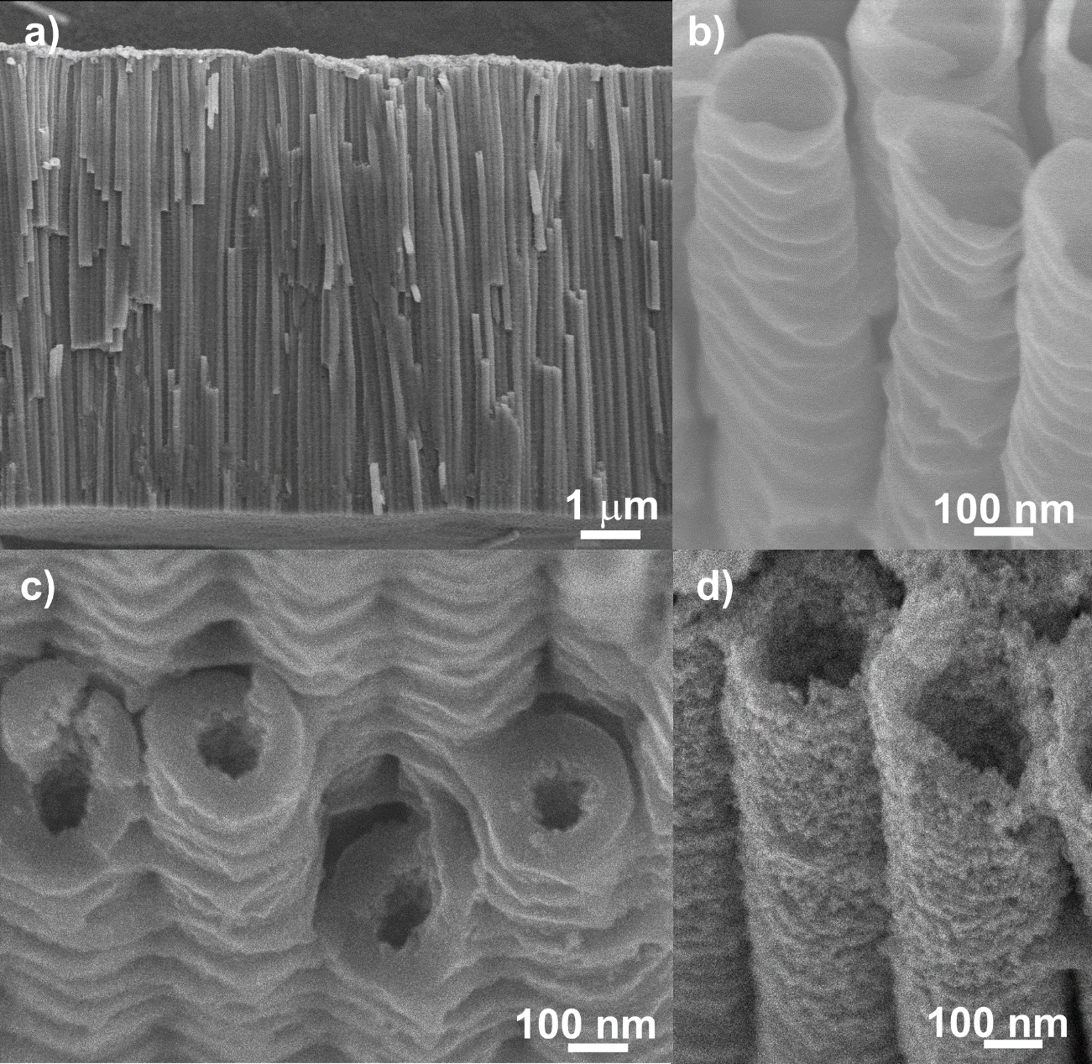
Figure 2. SEM micrographs of smaller diameter plane TiO₂ nanotubes in the cross-sectional view (a) and the top view (b), TiO₂ nanotubes as in (b) with an additional loading of magnetic Fe₃O₄ nanoparticles of an average size 8 nm showing interiors of the tubes (c) and the tube mouths (d) with homogenous nanoparticulate coating without any clogging.
In order to characterize TiO₂NTs@Fe₃O₄NPs in more detail, in particular to address any concerns about their colloidal stability, Zeta-potential of the aqueous suspension of TiO₂NTs@Fe₃O₄NPs and plane TiO₂NT was analysed resulting in values of 4.5±0.5 and 8.9±1 mV, respectively, regardless the tube diameter. From these results, it is clear that there is some difference between the TiO₂NTs@Fe₃O₄NPs and TiO₂NTs in terms of charges. However, these values need to be considered carefully. Compared to colloidally stable suspensions that have nanoparticles well dispersed within the solution for a long time, for the solutions with nanotubes, sedimentation was observed.

Tailoring the binding and elution conditions for purification of His-tagged biomolecules
Interaction of tagged proteins from the protein mixture represents essentially the most important step in the whole purification process. To evaluate the dependence of the binding specificity of His-tagged proteins on pH value of the binding solution, a comparative series of experiments was performed with the plane TiO₂ nanotube carrier (Figure 2a+b), or with TiO₂NTs@Fe₃O₄NPs (Figure 2c+d). Different binding conditions were tested with a peptide mixture containing tryptically digested His-tagged ubiquitin (His Ubiq) and bovine serum albumin (BSA). A comparison between the initial complex peptide solution and the elution fractions after isolation of peptides containing His-tag in their sequence, from both types of carriers (decorated and non-decorated with magnetic nanoparticles) was carried out. The effect of pH of the binding and washing solutions in the range 3.2 - 7.5, on the isolation process, was investigated. The pH ≈ 6.5 was identified to be the most suitable regarding specificity of the isolation procedure, and therefore these conditions were used for the rest of the experiments. For the elution of peptides containing His-tag, shown in Figure 3, tailored elution conditions were used instead of commonly used conditions in protocols for IMAC utilizing Ni²⁺-based materials (see Experimental section for details).
Figure 3a shows MS spectrum of the initial complex peptide solution, which represents the tryptic digests (see Experimental part for details) of His Ubiq and BSA mixed in a molar ratio of 1:1. Evidently, the revealed composition of the mixture is rather complex, as it contains a high amount of contamination. However, for the goal of the present work that is to efficiently purify proteins from complex mixtures of biomolecules, it represents a real-case mixture for the subsequent isolation of peptides containing His-tag.
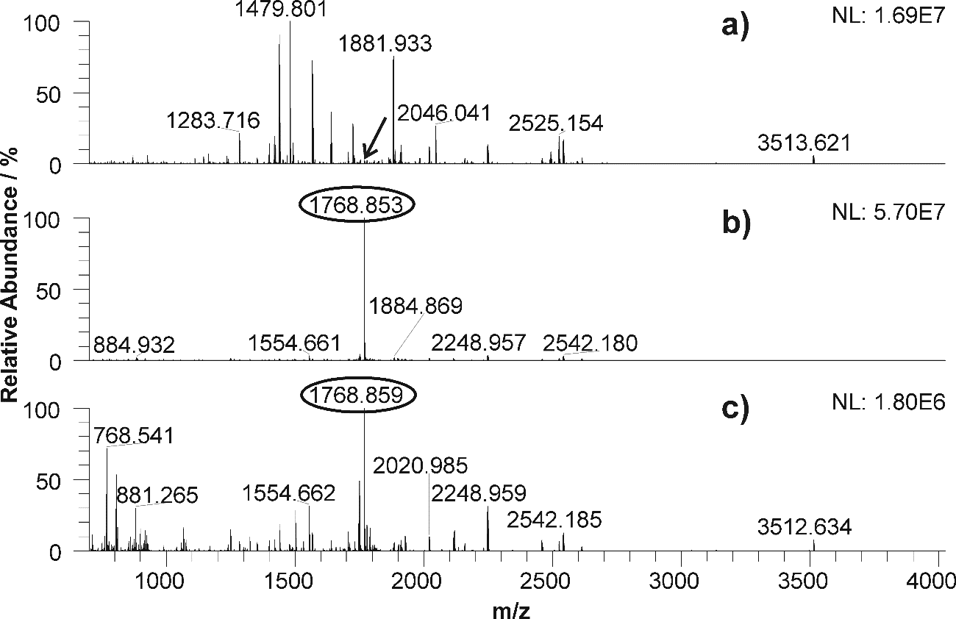
Figure 3. MALDI Orbitrap mass spectra of acquired fractions including His-tagged peptide (a) before isolation and (b) after isolation from digested His Ubiq in mixture with digested BSA by TiO₂NTs@Fe₃O₄NPs; (c) the same elution step for His-tag isolated as in (b) but using plane TiO₂ NTs (i.e. without magnetic particles). Peaks corresponding to His-tagged peptide GSSHHHHHHSSGLVPR are marked by a circle or an arrow. For this experiment, smaller diameter TiO₂ nanotubes were used.
From this mixture, an N-terminal peptide including His-tag (GSSHHHHHHSSGLVPR) originating from digested His Ubiq was isolated using a smaller diameter TiO₂NTs@Fe₃O₄NPs, or plane smaller diameter TiO₂ NTs in Bis-Tris-HCl buffer (pH ≈ 6.5). As evident from Figure 3b, acquired for TiO₂NTs@Fe₃O₄NPs, the peptide containing polyhistidine-tag was effectively isolated from the peptide mixture. All other peptides were almost completely removed, as revealed from the absence of any significant other peak. Figure 3b demonstrates extraordinary isolation specificity of TiO₂NTs@Fe₃O₄NPs under the optimized isolation conditions.
Figure 3c shows the results obtained for the plane TiO₂ NTs. The isolation of the His-tag containing peptide under the same experimental conditions used for TiO₂NTs@Fe₃O₄NPs (Figure 3b) showed substantially decreased purity of the isolated peptide in the eluate. It can be that the amorphous TiO₂ is to a certain extent capable to capture of His-tagged peptide. However, the achieved specificity of plane TiO₂ NTs is significantly lower than for the magnetic counterpart. Reasons for this interesting aspect, however, remain unclear at this stage and will be subject of future work.

Magnetic carrier for purification of recombinant protein
Another very important application of the presented TiO₂NTs@Fe₃O₄NPs is the isolation of intact His-tagged proteins from complex protein mixtures. To demonstrate the unique isolation ability of TiO₂NTs@Fe₃O₄NPs to purify recombinant proteins efficiently, a model mixture of standard proteins containing two His-tagged proteins was used for optimization of the purification protocol. Two His-tagged proteins (His Ubiq (6xHis-tag) and MSP1D1 (7xHis-tag)) were successfully separated from six non-tagged proteins (Ovalbumin, Concanavalin A, Carbonic Anhydrase I, Myoglobin, Cytochrome C, Non-his-tagged Ubiquitin) on the larger diameter magnetic carrier in 50 mM Bis-Tris-HCl pH 6.5 used as the binding buffer and 200 mM Na₂HPO₄ and 100 mM imidazole dissolved in 10 mM Bis-Tris-HCl buffer used as elution solution. Commonly used elution solution with 300 mM imidazole only was not enough sufficient to elute His-tagged proteins. Also, upon elution, the His-tagged proteins bound to the TiO₂NTs@Fe₃O₄NPs were successfully eluted and analyzed. The quality and required parameters of TiO₂NTs@Fe₃O₄NPs have been confirmed.
To prove the applicability of TiO₂NTs@Fe₃O₄NPs for isolation of recombinant His-tagged proteins from the whole Jurkat cells lysate spiked with His Ubiq was used for experiment. The total amount of proteins was 250 µg (240 µg of proteins from cell lysate and 10 µg of His Ubiq). Figure 4 shows Tris-Tricine-SDS-PAGE analysis of each step in the isolation process for (a) larger diameter TiO₂NTs@Fe₃O₄NPs and (b) conventional IMAC system for comparison. In Figure 4a, Lane M corresponds to molecular marker. Lane 1 represents the initial sample - whole cell lysate of Jurkat cells spiked with His Ubiq, which represents a complex mixture of proteins. Lane 2 corresponds to flow-through, where His-tagged proteins remain attached on TiO₂NTs@Fe₃O₄NPs, showing its binding capacity and specificity, whereas other proteins were washed away. Lane 3 shows the fraction from the first elution step with 300 mM imidazole only. As presented in the case of the model protein mixture, these conditions (typical for IMAC systems) were not sufficient for the elution of captured biomolecules from the larger diameter TiO₂NTs@Fe₃O₄NPs. Therefore, an additional elution step, with modified composition, had to be carried out (Lane 4). To get a higher recovery of proteins, an additional elution step was carried out with the same conditions (Lane 5). The single and intensive protein band of His Ubiq proves the ability of the carrier to isolate recombinant proteins from the complex mixture. Overall, the results from Tris-Tricine-SDS-PAGE analysis confirmed strong affinity and binding specificity of His-tagged proteins to TiO₂NTs@Fe₃O₄NPs. Both these features are crucial for protein purification.
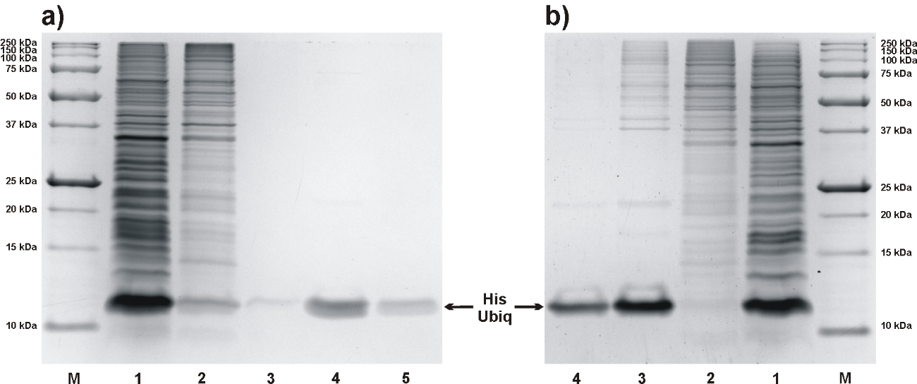
Figure 4. Tris-Tricine-SDS-PAGE analysis of the His-tagged protein purification experiment with Jurkat cells lysate spiked with His-tagged ubiqitin where a) represents purification on the TiO₂NTs@Fe₃O₄NPs, followed by silver staining. Lanes: M – marker of molecular weights (10-250 kDa) 1 – initial cell lysate, 2 – flow-through, 3 – first elution (300 mM imidazole in 50 mM Bis-Tris-HCl buffer pH 6,5), 4 – second elution (100 mM imidazole, 200 mM Na₂HPO₄ in 10 mM Bis-Tris-HCl buffer pH 6,5), 5 – second elution (100 mM imidazole, 200 mM Na₂HPO₄ in 10 mM Bis-Tris-HCl buffer pH 6,5) and b) represents HisPur™ Ni-NTA Resin purification, followed by silver staining. Lanes: M – marker of molecular weights (10-250 kDa) 1 – initial cell lysate, 2 – flow-through, 3 – first elution (300 mM imidazole in 50 mM Bis-Tris-HCl buffer pH 6,5), 4 – second elution (300 mM imidazole in 50 mM Bis-Tris-HCl buffer pH 6,5). For this experiment, smaller diameter TiO₂ nanotubes were used.
In Figure 4b, Lane 1 represents the initial sample - whole cell lysate of Jurkat cells spiked with His Ubiq as a model of real sample, Lane 2 corresponds to the flow-through, where His-tagged proteins remain attached on the carrier. Lane 3 shows the fraction from the first elution step with 300 mM imidazole, where contamination with other proteins was observed. In contrast to the elution conditions used for TiO₂NTs@Fe₃O₄NPs, this imidazole concentration was sufficient for the elution of captured biomolecules from the IMAC resin. To get a higher recovery of protein, an additional elution step was carried out with the same conditions (Lane 4), as for the first elution step. The most intensive protein bands in lanes of the elution fractions correspond to the His Ubiq. Lane M corresponds to the molecular marker.
During elution experiments, significant differences between IMAC and TiO₂NTs@Fe₃O₄NPs were observed. The first elution fraction from IMAC includes main part of eluted amount of His Ubiq but contaminated by other proteins. The second elution fraction includes mainly residues of His Ubiq. The first elution from TiO₂NTs@Fe₃O₄NPs with the same imidazole concentration (300 mM) does contain almost no His Ubiq, in contrast to the first elution step from IMAC. However, the second elution from TiO₂NTs@Fe₃O₄NPs includes the main portion of His Ubiq and no contaminants at all. These findings have been also confirmed by MS analysis (see Experimental part for details). It is obvious that the TiO₂NTs@Fe₃O₄NPs is capable of an enhanced separation specificity compared to IMAC systems and allows to get completely pure His-tagged protein in one step.
To prove the effectivity of TiO₂NTs@Fe₃O₄NPs for the isolation of recombinant His-tagged proteins, the binding capacity was tested in batch-wise arrangement. Figure 5 shows Tris-Tricine-SDS-PAGE analysis of consecutive binding fractions. Aliquots of the initial sample (10 µg of His Ubiq in 300 µl of binding solution) were consecutively loaded to the larger diameter TiO₂NTs@Fe₃O₄NPs for 30 min each. The binding fraction (BF) represents the sample after binding to a larger diameter TiO₂NTs@Fe₃O₄NPs. The binding capacity was determined as 6.9 µg of His Ubiq per 1 mg of larger diameter TiO₂NTs@Fe₃O₄NPs from the total amount of His Ubiq we could bind to this material. Absolute quantitation method in Image Lab Software (Bio-Rad, USA) was performed within analysis of electrophoretic data. Linear calibration curve from 0.25 to 15 µg of His-tagged-Ubiquitin yielded R-Squared value 0.990 for gel 1 (Fig 5b) and 0.988 for gel 2 (Fig 5c), respectively. From calculated values for each BF, binding curve was created (Fig 5a).
DISCUSSION
Two important points need to be discussed with respect to the results shown in Figure 2–5: physical and chemical stability of TiO₂NTs@Fe₃O₄NPs used and their specificity for the isolation of proteins. TiO₂NTs@Fe₃O₄NPs survived vibrations (vortexing), ultrasound of low to moderate output (when put in the ultrasonic bath) and all separation steps (shaking, separation from liquid using magnetic force or centrifugation) without any disintegration or loss of magnetism. In contrast to a recent paper,⁵³ reporting on conversion of amorphous TiO₂ nanotubes into layered crystalline Fe₂TiO₅ upon electrodeposition of Fe₂O₃ by annealing at 550°C, our TiO₂NTs@Fe₃O₄NPs were not exposed to any annealing treatment, except drying the as-decorated NTs in a dryer at 60°C. Due to the amorphous nature of TiO₂ nanotubes, it seems that rather some kind of non-stoichiometric oxide is formed. Even though the bond character and an exact stoichiometry remains unclear at this stage (beside a detailed XRD study that was carried out without any clear result), the binding is strong enough to keep magnetic particles attached to the nanotube walls, as depicted in Figure 6. The stabilization phenomena of Fe₃O₄ nanoparticles, once attached to TiO₂ nanotubes was evident from the stability at different environments (tested prior to use in this work) with different pH in the range of 1-12. No decay, decomposition or loss of magnetic activity of TiO₂NTs@Fe₃O₄NPs was observed under these harsh conditions. The TiO₂NTs@Fe₃O₄NPs were e.g. stable in 5% trifluoroacetic acid and/or in organic solvent - such as acetonitrile. In contrast, Fe₃O₄ nanoparticles themselves did not survive mild binding conditions (pH 6.5). It suggests a vital bond between the magnetic crystalline Fe₃O₄ nanoparticles and amorphous TiO₂ nanotubes that maintained these magnetic nanoparticles stable on the surface. Presumably, it was also the nanotube encapsulating architecture that protected magnetic nanoparticles from removal. By repeating the entire purification sequence (shown in Figure 1), it was revealed that the TiO₂NTs@Fe₃O₄NPs carrier can be used for at least 4 repetitive cycles without any significant loss of performance (see Figure S3).
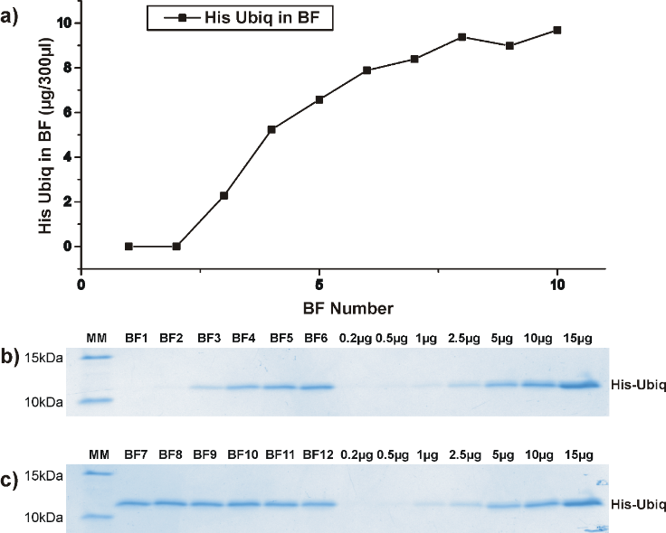
Figure 5. Part a) represent saturation curve from binding fractions 1 – 10 calculated from calibration curve. For this experiment, smaller diameter TiO₂NTs@Fe₃O₄NPs were used. b) and c) represents Tris-Tricine-SDS-PAGE analysis of binding capacity of the His-tagged protein to TiO₂NTs@Fe₃O₄NPs, followed by colloidal Coomassie Brilliant Blue staining. Lanes: BF 1 – 12 correspond to binding fractions after His Ubiq loading to magnetic carrier. Right side of gels was used for quantity calibration 0.2 – 15 µg of His Ubiq. MM marker of molecular weights (10-15 kDa).
To evaluate reasons for the outstanding specificity of TiO₂NTs@Fe₃O₄NPs presented in this work, a series of isolations at different pH were performed. At pH ≤ 6, elution fractions contained large amounts of peptides with acidic amino-acids, the aspartic (D) and glutamic acid (E), respectively. This suggests the presence of the positive surface charge on the magnetic carrier at pH ≤ 6, which results in electrostatic interactions with peptides containing negatively charged amino acids. Moreover, the literature reports that histidine side chains bear a positive charge at pH ≤ 6 that prevents its chelating properties towards positively charged TiO₂NTs@Fe₃O₄NPs.⁵⁴⁻⁵⁶ On the other hand, for pH ≥ 6, the histidine side chain does not carry any charge, and its interaction towards TiO₂NTs@Fe₃O₄NPs is not electrostatically driven. Thus, the interaction seems to be based on chelation of TiO₂NTs@Fe₃O₄NPs by histidine side chains.
Based on the performed sequence of experiments at different pH, the pH value is indeed an important driving factor for the formation of the chelating bond between TiO₂NTs@Fe₃O₄NPs and the histidine side chain within the given binding and elution conditions. As outlined in Figure 6, the chelation likely occurs between nitrogen atoms of the imidazole ring (in the histidine side chain) and the Fe atoms in the magnetite lattice.
We have to discuss at this point also the possible elution mechanism. Within an elution of His-tagged proteins using a phosphate buffer, phosphate species replace the histidine side chains on the TiO₂NTs@Fe₃O₄NPs´s surface. In addition, a higher pH (discussed above) helps to elute His-tagged proteins from TiO₂NTs@Fe₃O₄NPs more quantitatively. This in line with i) high affinity of phosphate groups to TiO₂ or Fe₃O₄ and ii) fact that phosphate salts are used for an elution of phosphopeptide, as known from description of an phosphopeptides enrichment process.⁵⁷ However, during our experiments phosphoproteins were not attached to TiO₂NTs@Fe₃O₄NPs.
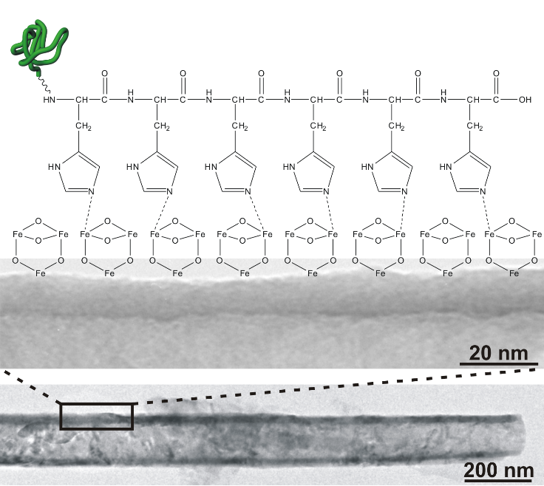
Figure 6. Proposed chemical interaction of His-tagged proteins with the TiO₂NTs@Fe₃O₄NPs through side chains of histidines.
There is obviously a strong interaction between His-tagged peptides/proteins and the surface of TiO₂NTs@Fe₃O₄NPs according to Fig. 4. This interaction is stronger than the interaction of His-tagged proteins and IMAC stationary phase, where eluting buffers containing imidazole elute the His-tagged proteins quite easily. One possible explanation for this behavior may be the apparently higher metal (i.e. Fe) ion density in the crystal lattice of Fe₃O₄, as compared to the number of metal ions (e.g. Ni²⁺) coordinately bound in the common IMAC stationary phase.
As a consequence, the sequence of several histidines may find a higher number of coordination counters for binding with the Fe₃O₄ part of TiO₂NTs@Fe₃O₄NPs, which may also be given by steric or structural hindrances. The practical application of this strong interaction between TiO₂NTs@Fe₃O₄NPs and His-tagged peptides or proteins allows one to use significantly higher concentrations of imidazole during washing steps, as compared to common published protocols for metal based IMAC isolation.⁵⁸
Last, but not least, there is also some protein isolation possible with plane TiO₂ nanotubes, as shown in Figure 3. As described previously in literature, interactions between the imidazole side chain as well as an electrostatic interactions between to protonated amine group and the negatively charged surface of TiO₂ may occur.⁵⁹ The non-specific isolation of peptides shown in Figure 3c may be possible due to the known charge interaction between TiO₂ and negatively charged amino acids in proteins and peptides.⁶⁰ The modification of the TiO₂ nanotubes with Fe₃O₄NPs makes this material more specific to isolation of His-tagged proteins and peptides and simultaneously removes the unwanted interaction of negatively charged amino acids with the isolation material.
CONCLUSIONS
In this work, a novel material based on anodic 1D TiO₂ nanotubes decorated with magnetic Fe₃O₄ nanoparticles (TiO₂NTs@Fe₃O₄NPs) was introduced for the purification of recombinant His-tagged proteins. The combination of TiO₂NTs@Fe₃O₄NPs with tailored isolation protocol offered an enhanced separation specificity compared to the established IMAC based protocols. Besides the challenges to characterize the specific interactions of TiO₂NTs@Fe₃O₄NPs with biomolecules, the presented results are highly valuable for efficient and quantitative separation of various His-tagged proteins. Moreover, the presented material (TiO₂NTs@Fe₃O₄NPs) possesses several unique advantages: it is non-toxic, robust, it can be easily separated from any solution due to its intrinsic magnetism, and being based on TiO₂ it can be simply decontaminated by UV-light induced photo-catalytic treatment at low-costs and re-used again at the same quality for the bioactive molecules isolation for biomedical applications. There is also no necessity of complicated instruments and could be easily up-scaled for preparative use. Furthermore, the specificity of TiO₂NTs@Fe₃O₄NP, surmounted by their unique properties, may open new pathways for the purification of biomolecules, and for a whole range of in vivo applications.
AUTHOR INFORMATION
Corresponding Author
*E-mail: jan.macak@upce.cz
Author Contributions
RK, PR and ZB designed all purification experiments. JMM designed the TiO₂NTs@Fe₃O₄NPs. HS and JMM prepared and characterized TiO₂NTs@Fe₃O₄NPs. RK and PR carried out all analytical steps. RK, ZB and JMM wrote the manuscript. All authors have given approval to the final version of the manuscript.
ACKNOWLEDGMENT
JMM and HS gratefully acknowledge the support of the Ministry of Education, Youth and Sports of the Czech Republic (projects nr. LM2015082 and CZ.02.1.01/0.0/0.0/16_013/0001829). RK, PR and ZB thank to European Union’s NADINE project (nr. 246513). JMM, RK and ZB thank to TACR GAMA TG02010058 with the part 01/021 - TG361021. Authors thank Mrs. Pavla Krulišová, Mrs. Eliška Kročová, Dr. Sayantan Das, Dr. Jiří Palarčík (all University of Pardubice) and Dr. Klara Čepe (RCPTM Olomouc) for technical help with experiments. Mrs. Tereza Bílková is acknowledged for help with graphic arts.

SUPPLEMENTARY INFORMATION
Characterization of TiO₂NTs@Fe₃O₄NPs by scanning TEM imaging including EDX mapping; volume magnetization of Fe₃O₄NPs, TiO₂NTs@Fe₃O₄NPs and TiO₂NTs; analysis of reusability of TiO₂NTs@Fe₃O₄NPs for purification of His-tagged protein.
REFERENCES
(1) Walsh, G. Biopharmaceutical Benchmarks 2010. Nat. Biotechnol. 2010, 28, 917.
(2) Mooney, J. T.; Fredericks, D. P.; Zhang, C.; Christensen, T.; Jespergaard, C.; Schiødt, C. B.; Hearn, M. T. W. Purification of a Recombinant Human Growth Hormone by an Integrated IMAC Procedure. Protein Expression Purif. 2014, 94, 85–94.
(3) Michel, M.-L.; Tiollais, P. Hepatitis B Vaccines: Protective Efficacy and Therapeutic Potential. Pathol. Biol. 2010, 58, 288–295.
(4) Saraswat, M.; Musante, L.; Ravidá, A.; Shortt, B.; Byrne, B.; Holthofer, H. Preparative Purification of Recombinant Proteins: Current Status and Future Trends. BioMed Res. Int. 2013, 2013, 1–18.
(5) Tan, S. C.; Yiap, B. C. DNA, RNA, and Protein Extraction: The Past and The Present. J. Biomed. Biotechnol. 2009, 2009, 1–10.
(6) Tichy, A.; Salovska, B.; Rehulka, P.; Klimentova, J.; Vavrova, J.; Stulik, J.; Hernychova, L. Phosphoproteomics: Searching for a Needle in a Haystack. J. Proteomics 2011, 74, 2786–2797.
(7) Gaberc-Porekar, V.; Menart, V. Potential for Using Histidine Tags in Purification of Proteins at Large Scale. Chem. Eng. Technol. 2005, 28, 1306–1314.
(8) Block, H.; Maertens, B.; Spriestersbach, A.; Brinker, N.; Kubicek, J.; Fabis, R.; Labahn, J.; Schäfer, F. Chapter 27 Immobilized-Metal Affinity Chromatography (IMAC): A Review. In Methods in Enzymology; Burgess R. R, Deutscher M. P., Eds.; Elsevier: Amsterdam, 2009; Vol. 463; p 439.
(9) Sigfridsson, K.; Nordmark, A.; Theilig, S.; Lindahl, A. A Formulation Comparison between Micro- and Nanosuspensions: The Importance of Particle Size for Absorption of a Model Compound, Following Repeated Oral Administration to Rats during Early Development. Drug Dev. Ind. Pharm. 2011, 37, 185–192.
(10) Crowe, J.; Dobeli, H.; Gentz, R.; Hochuli, E.; Stiiber, D.; Henco, K. 6xHis-Ni-NTA Chromatography as a Superior Technique in Recombinant Protein Expression/Purification. In Protocols for Gene Analysis; Harwood, A. J., Ed.; Humana Press: Totowa, 1994; Vol. 31; p 371.
(11) Cheung, R. C. F.; Wong, J. H.; Ng, T. B. Immobilized Metal Ion Affinity Chromatography: A Review on Its Applications. Appl. Microbiol. Biotechnol. 2012, 96, 1411–1420.
(12) Denkhaus, E.; Salnikow, K. Nickel Essentiality, Toxicity, and Carcinogenicity. Crit. Rev. Oncol. Hematol. 2002, 42, 35–56.
(13) Qi, X.; Chen, L.; Zhang, C.; Xu, X.; Zhang, Y.; Bai, Y.; Liu, H. NiCoMnO₄ : A Bifunctional Affinity Probe for His-Tagged Protein Purification and Phosphorylation Sites Recognition. ACS Appl. Mater. Interfaces 2016, 8, 18675–18683.
(14) Benelmekki, M.; Xuriguera, E.; Caparros, C.; Rodríguez-Carmona, E.; Mendoza, R.; Corchero, J. L.; Lanceros-Mendez, S.; Martinez, L. M. Design and characterization of Ni²⁺ and Co²⁺ decorated Porous Magnetic Silica spheres synthesized by hydrothermal-assisted modified-Stöber method for His-tagged proteins separation. J. Colloid Interface Sci. 2012, 365, 156–162.
(15) Lee, J.; Lee, S. Y.; Park, S. H.; Lee, H. S.; Lee, J. H.; Jeong, B.-Y.; Park, S.-E.; Chang, J. H. High Throughput Detection and Selective Enrichment of Histidine-Tagged Enzymes with Ni-Doped Magnetic Mesoporous Silica. J. Mater. Chem. B 2013, 1, 610.
(16) Bloemen, M.; Vanpraet, L.; Ceulemans, M.; Parac-Vogt, T. N.; Clays, K.; Geukens, N.; Gils, A.; Verbiest, T. Selective Protein Purification by PEG–IDA-Functionalized Iron Oxide Nanoparticles. RSC Adv. 2015, 5, 66549–66553.
(17) Aygar, G.; Kaya, M.; Özkan, N.; Kocabıyık, S.; Volkan, M. Preparation of Silica Coated Cobalt Ferrite Magnetic Nanoparticles for the Purification of Histidine-Tagged Proteins. J. Phys. Chem. Solids 2015, 87, 64–71.
(18) Ma, W.-F.; Zhang, Y.; Li, L.-L.; You, L.-J.; Zhang, P.; Zhang, Y.-T.; Li, J.-M.; Yu, M.; Guo, J.; Lu, H.-J.; Wang, C.-C. Tailor-Made Magnetic Fe₃O₄@mTiO₂ Microspheres with a Tunable Mesoporous Anatase Shell for Highly Selective and Effective Enrichment of Phosphopeptides. ACS Nano 2012, 6, 3179–3188.
(19) Li, W.; Deng, Q.; Fang, G.; Chen, Y.; Zhan, J.; Wang, S. Facile Synthesis of Fe₃O₄@TiO₂–ZrO₂ and Its Application in Phosphopeptide Enrichment. J. Mater. Chem. B 2013, 1, 1947–1961.
(20) Kim, J.; Piao, Y.; Lee, N.; Park, Y. I.; Lee, I.-H.; Lee, J.-H.; Paik, S. R.; Hyeon, T. Magnetic Nanocomposite Spheres Decorated with NiO Nanoparticles for a Magnetically Recyclable Protein Separation System. Adv. Mater. 2010, 22, 57–60.
(21) Ni, Q.; Chen, B.; Dong, S.; Tian, L.; Bai, Q. Preparation of Core-Shell Structure Fe₃O₄@SiO₂ Superparamagnetic Microspheres Immoblized with Iminodiacetic Acid as Immobilized Metal Ion Affinity Adsorbents for His-Tag Protein Purification: Superparamagnetic Microspheres for His-Tag Protein Separation. Biomed. Chromatogr. 2016, 30, 566–573.
(22) Horák, D.; Babič, M.; Macková, H.; Beneš, M. J. Preparation and Properties of Magnetic Nano- and Microsized Particles for Biological and Environmental Separations. J. Sep. Sci. 2007, 30, 1751–1772.
(23) Gijs, M. A. M.; Lacharme, F.; Lehmann, U. Microfluidic Applications of Magnetic Particles for Biological Analysis and Catalysis. Chem. Rev. 2010, 110, 1518–1563.
(24) Schladt, T. D.; Schneider, K.; Schild, H.; Tremel, W. Synthesis and Bio-Functionalization of Magnetic Nanoparticles for Medical Diagnosis and Treatment. Dalton Trans. 2011, 40, 6315.
(25) Arami, H.; Khandhar, A.; Liggitt, D.; Krishnan, K. M. In Vivo Delivery, Pharmacokinetics, Biodistribution and Toxicity of Iron Oxide Nanoparticles. Chem. Soc. Rev. 2015, 44, 8576–8607.
(26) Ivask, A.; Titma, T.; Visnapuu, M.; Vija, H.; Kakinen, A.; Sihtmae, M.; Pokhrel, S.; Madler, L.; Heinlaan, M.; Kisand, V.; Shimmo, R.; Kahru, A. Toxicity of 11 Metal Oxide Nanoparticles to Three Mammalian Cell Types in Vitro. Curr. Top. Med. Chem. 2015, 15, 1914–1929.
(27) Chusuei, C. C.; Wu, C.-H.; Mallavarapu, S.; Hou, F. Y. S.; Hsu, C.-M.; Winiarz, J. G.; Aronstam, R. S.; Huang, Y.-W. Cytotoxicity in the Age of Nano: The Role of Fourth Period Transition Metal Oxide Nanoparticle Physicochemical Properties. Chem.-Biol. Interact. 2013, 206, 319–326.
(28) Macák, J. M.; Tsuchiya, H.; Schmuki, P. High-Aspect-Ratio TiO₂ Nanotubes by Anodization of Titanium. Angew. Chem., Int. Ed. 2005, 44, 2100–2102.
(29) Macak, J. M.; Tsuchiya, H.; Taveira, L.; Aldabergerova, S.; Schmuki, P. Smooth Anodic TiO₂ Nanotubes. Angew. Chem., Int. Ed. 2005, 44, 7463–7465.
(30) Tsuchiya, H.; Macak, J. M.; Müller, L.; Kunze, J.; Müller, F.; Greil, P.; Virtanen, S.; Schmuki, P. Hydroxyapatite Growth on Anodic TiO₂ Nanotubes. J. Biomed. Res. 2006, 77A, 534–541.
(31) Kodama, A.; Bauer, S.; Komatsu, A.; Asoh, H.; Ono, S.; Schmuki, P. Bioactivation of Titanium Surfaces Using Coatings of TiO₂ Nanotubes Rapidly Pre-Loaded with Synthetic Hydroxyapatite. Acta Biomater. 2009, 5, 2322–2330.
(32) Park, J.; Bauer, S.; von der Mark, K.; Schmuki, P. Nanosize and Vitality: TiO₂ Nanotube Diameter Directs Cell Fate. Nano Lett. 2007, 7, 1686–1691.
(33) Song, Y. Y.; Schmidt-Stein, F.; Berger, S.; Schmuki, P. TiO₂ Nano Test Tubes as a Self-Cleaning Platform for High-Sensitivity Immunoassays. Small 2010, 6, 1180–1184.
(34) Qiu, J.; Li, J.; Wang, S.; Ma, B.; Zhang, S.; Guo, W.; Zhang, X.; Tang, W.; Sang, Y.; Liu, H. TiO₂ Nanorod Array Constructed Nanotopography for Regulation of Mesenchymal Stem Cells Fate and the Realization of Location-Committed Stem Cell Differentiation. Small 2016, 12, 1770–1778.
(35) Aninwene, G. E.; Yao, C.; Webster, T. J. Enhanced Osteoblast Adhesion to Drug-Coated Anodized Nanotubular Titanium Surfaces. Int. J. Nanomed. 2008, 3, 257–264.
(36) Lai, Y.-K.; Wang, Q.; Huang, J.-Y.; Li, H.-Q.; Chen, Z.; Zhao, A. Z.-J.; Wang, Y.; Zhang, K.-Q.; Sun, H.-T.; Al-Deyab, S. S. TiO₂ Nanotube Platforms for Smart Drug Delivery: A Review. Int. J. Nanomed. 2016, 11, 4819–4834.
(37) Gulati, K.; Ramakrishnan, S.; Aw, M. S.; Atkins, G. J.; Findlay, D. M.; Losic, D. Biocompatible Polymer Coating of Titania Nanotube Arrays for Improved Drug Elution and Osteoblast Adhesion. Acta Biomater. 2012, 8, 449–456.
(38) Min, Q.; Chen, X.; Zhang, X.; Zhu, J.-J. Tailoring of a TiO₂ Nanotube Array-Integrated Portable Microdevice for Efficient on-Chip Enrichment and Isotope Labeling of Serum Phosphopeptides. Lab Chip 2013, 13, 3853.
(39) Mun, K.-S.; Alvarez, S. D.; Choi, W.-Y.; Sailor, M. J. A Stable, Label-Free Optical Interferometric Biosensor Based on TiO₂ Nanotube Arrays. ACS Nano 2010, 4, 2070–2076.
(40) Terracciano, M.; Galstyan, V.; Rea, I.; Casalino, M.; De Stefano, L.; Sbervegleri, G. Chemical Modification of TiO₂ Nanotube Arrays for Label-Free Optical Biosensing Applications. Appl. Surf. Sci. 2017, 419, 235–240.
(41) Kalbacova, M.; Macak, J. M.; Schmidt-Stein, F.; Mierke, C. T.; Schmuki, P. Phys. Status Solidi RRL 2008, 2, 194–196.
(42) Shrestha, N. K.; Macak, J. M.; Schmidt-Stein, F.; Hahn, R.; Mierke, C. T.; Fabry, B.; Schmuki, P. Magnetically Guided Titania Nanotubes for Site-Selective Photocatalysis and Drug Release. Angew. Chem., Int. Ed. 2009, 48, 969–972.
(43) Altomare, M.; Pozzi, M.; Allieta, M.; Bettini, L. G.; Selli, E. H₂ and O₂ Photocatalytic Production on TiO₂ Nanotube Arrays: Effect of the Anodization Time on Structural Features and Photoactivity. Appl. Catal., B 2013, 136–137, 81–88.
(44) Macak, J. M.; Tsuchiya, H.; Taveira, L.; Ghicov, A.; Schmuki, P. Self-Organized Nanotubular Oxide Layers on Ti-6Al-7Nb and Ti-6Al-4V Formed by Anodization in NH₄F Solutions. J. Biomed. Res. 2005, 75A, 928–933.
(45) Tsuchiya, H.; Macak, J. M.; Ghicov, A.; Schmuki, P. Self-Organization of Anodic Nanotubes on Two Size Scales. Small 2006, 2, 888–891.
(46) Kulkarni, M.; Mazare, A.; Park, J.; Gongadze, E.; Killian, M. S.; Kralj, S.; von der Mark, K.; Iglič, A.; Schmuki, P. Protein Interactions with Layers of TiO2 Nanotube and Nanopore Arrays: Morphology and Surface Charge Influence. Acta Biomater. 2016, 45, 357–366.
(47) Xu, J.; Yang, L.; Han, Y.; Wang, Y.; Zhou, X.; Gao, Z.; Song, Y.-Y.; Schmuki, P. Carbon-Decorated TiO ₂ Nanotube Membranes: A Renewable Nanofilter for Charge-Selective Enrichment of Proteins. ACS Appl. Mater. Interfaces 2016, 8, 21997–22004.
(48) Macak, J. M.; Kohoutek, T.; Wang, L.; Beranek, R. Fast and Robust Infiltration of Functional Material inside Titania Nanotube Layers: Case Study of a Chalcogenide Glass Sensitizer. Nanoscale 2013, 5, 9541.
(49) Das, S.; Sopha, H.; Krbal, M.; Zazpe, R.; Podzemna, V.; Prikryl, J.; Macak, J. M. Electrochemical Infilling of CuInSe₂ within TiO₂ Nanotube Layers and Subsequent Photoelectrochemical Studies. ChemElectroChem 2017, 4, 495–499.
(50) Gobom, J.; Nordhoff, E.; Mirgorodskaya, E.; Ekman, R.; Roepstorsff, P. Sample Purification and Preparation Technique Based on Nano-Scale Reversed-Phase Columns for the Sensitive Analysis of Complex Peptide Mixtures by Matrix-Assisted Laser Desorption/Ionization Mass Spectrometry. J. Mass Spectrom. 1999, 34, 105–116.
(51) Schägger, H. Tricine–SDS-PAGE. Nat. Protoc. 2006, 1, 16–22.
(52) Oakley, B. R.; Kirsch, D. R.; Morris, N. R. A Simplified Ultrasensitive Silver Stain for Detecting Proteins in Polyacrylamide Gels. Anal. Biochem. 1980, 105, 361–363.
(53) Liu, Q.; He, J.; Yao, T.; Sun, Z.; Cheng, W.; He, S.; Xie, Y.; Peng, Y.; Cheng, H.; Sun, Y.; Jiang, Y.; Hu, F.; Xie, Z.; Yan, W.; Pan, Z.; Wu, Z.; Wei, S. Aligned Fe₂TiO₅-Containing Nanotube Arrays with Low Onset Potential for Visible-Light Water Oxidation. Nat. Commun. 2014, 5, 5122.
(54) Li, S.; Hong, M. Protonation, Tautomerization, and Rotameric Structure of Histidine: A Comprehensive Study by Magic-Angle-Spinning Solid-State NMR. J. Am. Chem. Soc. 2011, 133, 1534–1544.
(55) Jiang, J.; Oberdörster, G.; Biswas, P. Characterization of Size, Surface Charge, and Agglomeration State of Nanoparticle Dispersions for Toxicological Studies. J. Nanopart. Res. 2009, 11, 77–89.
(56) Tamura, H.; Katayama, N.; Furuichi, R. Modeling of Ion-Exchange Reactions on Metal Oxides with the Frumkin Isotherm. 1. Acid-Base and Charge Characteristics of MnO₂, TiO₂, Fe₃O₄, and Al₂O₃ Surfaces and Adsorption Affinity of Alkali Metal Ions. Environ. Sci. Technol. 1996, 30, 1198–1204.
(57) Aryal, U. K.; Ross, A. R. S. Enrichment and Analysis of Phosphopeptides under Different Experimental Conditions Using Titanium Dioxide Affinity Chromatography and Mass Spectrometry. Rapid Commun. Mass Spectrom. 2010, 24, 219–231.
(58) Bornhorst, J. A.; Falke, J. J. Purification of Proteins Using Polyhistidine Affinity Tags. Methods Enzymol. 2000, 326, 245–254.
(59) Mudunkotuwa, I. A.; Grassian, V. H. Histidine Adsorption on TiO ₂ Nanoparticles: An Integrated Spectroscopic, Thermodynamic, and Molecular-Based Approach toward Understanding Nano–Bio Interactions. Langmuir 2014, 30, 8751–8760.
(60) Larsen, M. R.; Thingholm, T. E.; Jensen, O. N.; Roepstorff, P.; Jørgensen, T. J. Highly Selective Enrichment of Phosphorylated Peptides from Peptide Mixtures Using Titanium Dioxide Microcolumns. Mol. Cell. Proteomics 2005, 4, 873–886.

Table of Content
