Capacity range calculation

Jaromír Široký, Přemysl Šrámek, Katarína Magdechová, Erik Tischer, Pavlína Široká

Summary: The aim of this paper is to use a new capacity parameter called capacity range for evaluation of individual operational concept on the same line before and after planned modernization. The paper uses a new capacity parameter called capacity range. The methodology of capacity range counting is based on one main number, but it takes more aspects. It deals with the operational facility occupancy rate, with the identifying of the bottleneck, with the simulation problems solved in the simulation program SimuT and with the quality aspect of capacity. It creates the link between capacity quality and quantity, between the displayed Ishikawa diagram and the possibility of the wrong operational concept selection. The definition is explained and then the parameter is calculated for a selected section of Týniště nad Orlicí – Choceň. The capacity range is counted for current conditions (single track line, old equipment) and then for comparison for future conditions (double track line, new safety equipment). Capacity range, expressed as dependence of the number of trains on average delay increment, is a useful capacity parameter particularly for coherent railway sections with remote traffic control.
Key words: capacity parameter, trains, range calculation.

Introduction

In a doctoral thesis (1), it was found out that it would be appropriate to extend the existing methodologies of calculating capacity parameters (SŽDC D24, UIC 406), particularly by adding parameters allowing for a more network-based calculation of capacity (through several interstation sections). Even though these parameters would be limited by railway network bottlenecks, which they would likely fail to identify, they would still be useful for the evaluation (comparison) of individual operational concepts. At the same time, they would fit the notion that capacity as such actually doesn't exist (2).
With the current implementation of remote traffic control through several interstation sections, it is possible to move trains through bottlenecks more efficiently than before. That's why a new parameter was defined: CR (capacity range) (3).
For evaluation of individual operational concept was the CR used in this case – it was counted for the same selected section before and after planned modernization.

Objectives
The aim of this paper is to use a new capacity parameter called capacity range for evaluation of individual operational concept on the same line before and after planned modernization.

Methodology
To meet the above mentioned objectives, the following methods are to be employed: capacity range calculation, bottleneck identification (operational facility occupancy rate), simulation. Due to timetable stability must be assured the quality aspect of capacity (4).
Capacity range calculation – capacity range (hereinafter referred to as CR) definition is shown in Fig. 1. CR is defined as an area delimited by 2 lines and 1 curve. Specifically, it is a perpendicular line to the X-axis from the point where N = 1 (N denoting the total number of trains), and the actual X-axis representing the state where ADI = 0. Here, ADI means average delay increment (5). The curve then expresses the dependence of ADI on N in a specific section of infrastructure. Mathematically, the relationship is expressed as follows:

CR = $\left|\int_{1}^{E}{f\left(x\right)dx}\right|$ (1)

CR is calculated as an integral of a dependence function of ADI on N, delimited by N = 1 on one hand (N can be neither negative nor zero), and a point of balance, where ADI = 0 min/train based on the specified number of trains (based on f(x)), on the other hand. With further increasing the number of trains, ADI becomes positive, leading to reduced stability of the timetable and impossibility to limit or eliminate the stochastically driven delay.

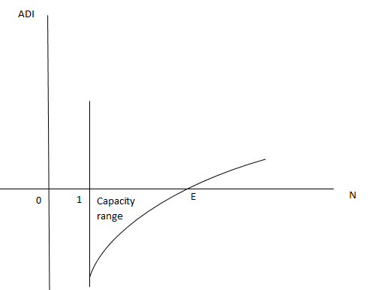
Fig. 1 - Capacity range definition
Source: Authors

The average delay increment is calculated according to the following formula:

$ADI = \frac{Z_{p}exit- Z_{p}entry}{N}$ (2)

As such, it is a quotient of the difference between the total exit delay and the total entry delay of all trains, and their total number.
Where the railway infrastructure manager is willing to sacrifice timetable stability to a certain extent to increase the number of trains in the specific infrastructure section, enlarged capacity range can be considered as well (CRE – capacity range enlarged) (6). This is shown in Fig. 2.
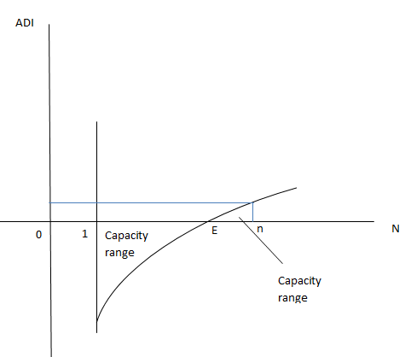
Fig. 2 - Enlarged capacity range definition
Source: Authors

The capacity range area can optionally be enlarged due to the railway infrastructure manager deciding to operate a higher number of trains at the price of certain instability of the timetable (positive ADI). This actually means increasing quantity at the expense of quality of railway transport. Mathematically, the relationship is expressed as follows:

CRE = $\left|\int_{1}^{E}{f\left(x\right)dx}\right|$ + $\int_{E}^{n}{f\left(x\right)dx}$ (3)

This gives rise to a new area above the curve (f(x)) delimited by the X-axis and the point of balance, where ADI = 0 min/train, and a set point (either based on the maximum allowable ADI or the required number of trains N).
The greatest challenge in calculating capacity range is the calculation of the dependence function f(x) of ADI on N, this function being different for different railway infrastructure sections. The calculation is described below in the specific application section.
Identifying a bottleneck – since capacity range is mainly useful for evaluating operational concepts, or lines, it cannot primarily be used to identify a railway network bottleneck. Therefore, operational facility occupancy rate is calculated as an additional parameter, according to the Railway Infrastructure Administration (SŽDC) (ČD) regulation No. D24. This is expressed as the ratio of the total time of occupancy of the operational facility with the regular scope of railway transport to the calculation period reduced by the total time of closures and permanent manipulations (7). A facility is considered sufficiently occupied having a rate of occupancy within a range of $S_{o}$= 0.5 to 0.67 (1). Mathematically expressed:

$S_{o}=\frac{{N∙t}_{obs}}{T-(\sum{t_{výl}+\sum{t_{stál})}}}$ (4)

Where
So - operational facility occupancy rate [-];
T - calculation period [min];
N - regular scope of transport [number of trains / calculation period];
tobs - technological time of occupancy of a specific operational facility by one train [min/train];
$\sum{t_{výl}}$ - total time of closures of operational facility for repairs and maintenance [min];
$\sum{t_{stál}}$ - total time of occupancy of operational facility due to permanent manipulations [min].

Simulation – as a simulation program, SimuT was chosen mainly due to the simple determination of timetable stability based on the average delay increment calculated as a quotient of the difference between the exit delay and the entry delay, and the number of trains. Entry delay is entered by the simulation program for individual trains based on exponential probability distribution. Furthermore, SimuT allows for the calculation of capacity parameters according to the SŽDC (ČD) regulation No. D24 (8). SimuT – it means the programme Simulation of Tracks, whose primary purpose is verification of operational concepts (including timetables) according to the related transport infrastructure. As input data are required the transport infrastructure data, examined range of rail traffic data and the definition of alternative solution [9]. The main output – the average delay increment indicator – evaluates the timetable stability and the train routes quality.
The quality aspect of capacity – in the thesis (1) there was found, the quality aspect of capacity counted via ADI can be influenced by the timetable periodicity. There was suggested the flow chart of periodic timetable implementation on defined rail infrastructure and the quality Ishikawa diagram of failure of the desired timetable quality achievement. This case of using ADI was verified and it was the evidence to use more often the average delay increment indicator. Therefore, the Ishikawa diagram is shown in the following figure (Fig. 3).

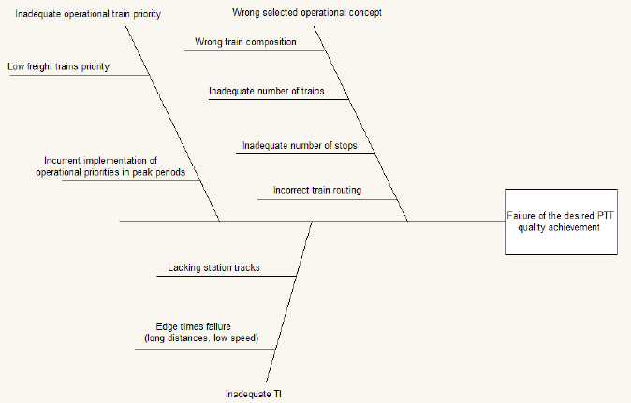
Fig. 3 - The Ishikawa diagram of failure of the desired periodic timetable quality achievement
Source: Authors

The capacity range parameter is related to identify a wrong selected operational concept. Due to the capacity range calculation is possible to evaluate on the one number basis the quality of the operational concept, including the wrong train composition, the inadequate number of trains, the inadequate number of stops and the incorrect train routing (10).

2. Application of capacity range on the section of Týniště nad Orlicí – Choceň before planned modernization

In practical application, it is necessary to enter the required data concerning the infrastructure and scope of operation into the programme. Capacity range calculation was performed on part of the 020 line, specifically on the section between Týniště nad Orlicí (incl.) and Choceň (incl.) with a total number of 5 railway stations. Using the GVD 2016 analysis, the average daily scope of railway transport was identified as 44 trains, 0 of which were long-distance passenger service trains (Ex, R), 32 of which were regional passenger service trains (Sp, Os), and 12 of which were freight service trains.
The dependence function (f(x)) of ADI on N is determined based on the maximum reliability function created by fitting the curve to individual points. These individual points represent particular ADI values for the given number of trains. The more points are identified, the more reliable will the determination of the function f(x) be. It would thus be optimal to create the individual points by always adding one train at a time. On the other hand, this solution would be very time consuming and would make the calculation too complex. Therefore it is necessary to set individual steps in the simulation programme to specify the number of trains by which the individual points would differ (11).
So as not to encumber the steps with a different number of trains of different categories, the trains need to be added in "packages". These packages always need to be adapted to the operation on the particular line. As for the section of Týniště nad Orlicí – Choceň, where the ratio of trains is 0:32:12 (long-distance passenger service : regional passenger service : freight service), the function f(x) can be determined using 6 points with one step representing the addition of 1 long-distance passenger service trains, 0 regional passenger service trains, and 10 freight service trains. This package was chosen according to the planned modernization, which is aimed to increasing of the freight service. The overall results for the individual steps including bottleneck identification (operational facility occupancy rate) are shown in Table 1. These are outputs from the SimuT simulation program.

Table 1 - Individual steps of determining the function f(x), BM
Number of trains | ADI  (min/train) | Bottleneck | S_{o}
44 (0+32+12) | -0.84 | Borohrádek – Týniště nad Orlicí | 0.25
55 (1+32+22) | 0.52 | Borohrádek – Týniště nad Orlicí | 0.33
66 (2+32+32) | 1.44 | Borohrádek – Týniště nad Orlicí | 0.41
77 (3+32+42) | 3.13 | Borohrádek – Týniště nad Orlicí | 0.50
88 (4+32+52) | 4.82 | Borohrádek – Týniště nad Orlicí | 0.58
99 (5+32+62) | 5.85 | Borohrádek – Týniště nad Orlicí | 0.66
Source: Authors

As can be seen from Table 1, ADI increases with the individual steps. In each of the steps, the interstation section Borohrádek. – Týniště nad Orlicí was identified as a bottleneck. This fact reflects the overall consistency of the calculation and shows that the operational facility occupancy rate increases with the individual steps as well.
The dependence function f(x) of ADI on N can also be expressed as follows:

$ADI=f (N)$ (5)

The results of the individual steps corresponding to the above mentioned equation are shown in Fig. 4.

Fig. 4 - Dependence of ADI on N – specific CR
Source: Authors

Individual points were fitted to a trendline with the highest reliability; the dependence of ADI on N is linear. Or:
$ADI= 0.1248∙N-6.435$ (6)

The capacity range formula can also be expressed as follows:

CR = $\left|\int_{1}^{E}{f\left(N\right)dN}\right|$ (7)

Point E can be calculated by inserting ADI = 0 min/train into the above mentioned equation, which gives rise to a standard quadratic equation:

$0= 0.1248∙N-6.435$ (8)

Based on the rules for calculating linear equations, the result is as follows:

E1 = 51,5625 (9)

As it is a total number of trains, the number must be positive and integral. To maintain the timetable stability, E is always rounded down. The resulting point of balance is then E = 51 trains. Given the package, one of the possible optimum solutions of transport structure on the given section would be 1 long-distance passenger service trains, 32 regional passenger service trains, and 18 freight service trains. With this transport structure, the timetable is still stable, i.e. able to reduce random delay. Now we can calculate capacity range:

CR = $\left|\int_{1}^{51}{\left(0.1248∙N-6.435\right)dN}\right|$ (10)
CR = $\left|{\left[0.0624∙N^{2}-6.435∙N\right]}_{1}^{51}\right|$
CR = 159.51
Capacity range of the section Týniště nad Orlicí (incl.) – Choceň (incl.) for further use (comparison of operational concepts, modifications of infrastructure) is 159.5.

3. Application of capacity range on the section of Týniště nad Orlicí – Choceň after planned modernization, part one
It was used the same operation, but now on the section after planned modernization. It will be considered double track line and dividing of the interstation sections.

Table 2 - Individual steps of determining the function f(x), AM, part one
Number of trains | ADI  (min/train) | Bottleneck | S_{o}
44 (0+32+12) | -1.29 | Borohrádek – Týniště nad Orlicí, 1.TK, 2.TK | 0.07
55 (1+32+22) | -1.02 | Borohrádek – Týniště nad Orlicí, 1.TK, 2.TK | 0.09
66 (2+32+32) | -0.81 | Borohrádek – Týniště nad Orlicí, 2.TK | 0.11
77 (3+32+42) | -0.69 | Borohrádek – Týniště nad Orlicí, 2.TK | 0.13
88 (4+32+52) | -0.54 | Borohrádek – Týniště nad Orlicí, 2.TK | 0.15
99 (5+32+62) | -0.53 | Borohrádek – Týniště nad Orlicí, 1.TK, 2.TK | 0.16
Source: Authors

On double track line there is for each pocket stable timetable and there isn’t overloaded infrastructure. The results of the individual steps corresponding to the above mentioned equation are shown in Fig. 5.

Fig. 5 - Dependence of ADI on N – specific CR
Source: Authors

Individual points were fitted to a trendline with the highest reliability; the dependence of ADI on N is polynomial, and in this case quadratic. Or:

$ADI= -0.0002∙N^{2}+0.0464∙N-2.8904$ (11)

Point E can be calculated by inserting ADI = 0 min/train into the above mentioned equation, which gives rise to a standard quadratic equation:

$0= -0.0002∙N^{2}+0.0464∙N-2.8904$

Based on the rules for calculating quadratic equations, the result is as follows: discriminatory D = -0,02097 – according to this, the solution isn’t in the field of real numbers. Therefore we have to determine the local maximum of the function (in this case).
Based on the rules for searching of function extremes, the result is as follows: The local maximum of the quadratic function LM has coordinates [116;-0.20]. More is shown in Fig. 6.
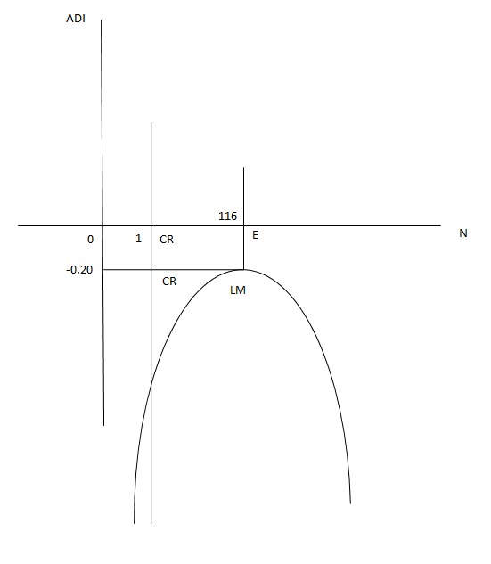

Fig. 6 - Capacity range with local maximum
Source: Authors

In this case, CR is calculated in 2 phases. The first step is calculating according to the Fig. 1. The second step is adding of the created rectangle with the upper limit ADI = 0 min/train. The first step is as follows:

CR1 = $\left|\int_{1}^{116}{\left(-0.0002∙N^{2}+0.0464∙N-2.8904\right)dN}\right|$ (12)
CR₁ = $\left|{\left[-0.00006667∙N^{3}+0.0232∙N^{2}-2.8904∙N\right]}_{1}^{116}\right|$
CR₁ = 124.31

The second step is:
CR2 = $\left|\left[\left(116-1\right)∙\left(-0.20-0\right)\right]\right|$ (13)
CR₂ = 23

Then:
CR = CR1 + CR2 (14)
CR = 147.31

Capacity range of the section Týniště nad Orlicí (incl.) – Choceň (incl.) for further use (comparison of operational concepts, modifications of infrastructure) after planned modernization would be 147.31 for one track – for 2 tracks (double track line) then 294, 62.
The capacity range is higher than in the case before planned modernization. It is interesting, for one track is the capacity range lower than in the case before planned modernization, but the total of both tracks is higher, sure. In the part two, there is shown the classic procedure, where it is possible to gain the point with ADI = 0 min/train.

4. Application of capacity range on the section of Týniště nad Orlicí – Choceň after planned modernization, part two
For better calculation it is recommended to reach the point with ADI = 0 min/train. Therefore, we have to add into the simulation program the defined train packages until the moment, where ADI is null or positive. More it is shown in Table 3.

Table 3 - Individual steps of determining the function f(x), AM, part two
Number of trains | ADI  (min/train) | Bottleneck | S_{o}
44 (0+32+12) | -1.29 | Borohrádek – Týniště nad Orlicí, 1.TK, 2.TK | 0.07
55 (1+32+22) | -1.02 | Borohrádek – Týniště nad Orlicí, 1.TK, 2.TK | 0.09
66 (2+32+32) | -0.81 | Borohrádek – Týniště nad Orlicí, 2.TK | 0.11
77 (3+32+42) | -0.69 | Borohrádek – Týniště nad Orlicí, 2.TK | 0.13
88 (4+32+52) | -0.54 | Borohrádek – Týniště nad Orlicí, 2.TK | 0.15
99 (5+32+62) | -0.53 | Borohrádek – Týniště nad Orlicí, 1.TK, 2.TK | 0.16
110 (6+32+72) | -0.40 | Borohrádek – Týniště nad Orlicí, 1.TK, 2.TK | 0.18
121 (7+32+82) | -0.26 | Borohrádek – Týniště nad Orlicí, 1.TK, 2.TK | 0.20
132 (8+32+92) | -0.19 | Borohrádek – Týniště nad Orlicí, 2.TK | 0.24
143 (9+32+102) | -0.12 | Borohrádek – Týniště nad Orlicí, 1.TK, 2.TK | 0.24
154 (10+32+112) | 0.05 | Borohrádek – Týniště nad Orlicí, 1.TK, 2.TK | 0.26
Source: Authors

On double track line there isn’t overloaded infrastructure. The timetable is unstable (positive ADI) for number of trains 154. The results of the individual steps corresponding to the above mentioned equation are shown in Fig.

Fig. 7 - Dependence of ADI on N – specific CR
Source: Authors

Individual points were fitted to a trendline with the highest reliability; the dependence of ADI on N is logarithmic. Or:
$ADI=0.9872∙\ln{N}-4.9946$ (15)

Point E can be calculated by inserting ADI = 0 min/train into the above mentioned equation:
$0= 0.9872∙\ln{N}-4.9946$

Based on the rules for calculating logarithmic equations, the result is as follows:
E1 = 157.59

As it is a total number of trains, the number must be positive and integral. To maintain the timetable stability, E is always rounded down. The resulting point of balance is then E = 157 trains. Now we can calculate capacity range:

CR = $\left|\int_{1}^{157}{\left(0.9872∙ln⁡N-4.9946\right)dN}\right|$ (16)
CR = $\left|{\left[0.9872∙\left(N∙\ln{N-N}\right)-4.9946∙N\right]}_{1}^{157}\right|$
CR = 149.49

Capacity range of the section Týniště nad Orlicí (incl.) – Choceň (incl.) after planned modernization is for one track 149.49 – for both tracks of the double track line then 298,98.
In this example, there is apparent, the capacity range could be counted by more ways. For the right consequence it is not necessary to have the point, where the ADI indicator is 0. The most important thing is to be aware of the validity of the consequence only for one track – on double- and more-track lines the consequence must be multiplied (12).

5. Conclusion
This paper isn’t about the capacity range, only. It is about the capacity calculation, about the determination of calculation exactness and about the implementation of more consequences to more easy methodology, especially. The methodology of capacity range counting is based on one main number, but it takes more aspects, too. It deals with the operational facility occupancy rate, with the identifying of the bottleneck, with the simulation problems solved in the simulation program SimuT and with the quality aspect of capacity. It creates the link between capacity quality and quantity, between the displayed Ishikawa diagram and the possibility of the wrong operational concept selection.
This paper unequivocally proved, the capacity range calculation based on the mathematical analysis is generally valid. The consequence in part one, which there was counted without reaching zero ADI point, was very similar to the consequence in part two with the zero ADI point reaching. However, the result is valid only for one track – for more-track lines must be multiplied by the number of tracks.
In this paper, there is interesting, for one track after the planned modernization the CR number is lower than for the old single-track line. It means the capacity growth connected with the building up of new track is not 100 %, exactly. It could be caused by one of the reasons mentioned in the Ishikawa diagram (the question of train priority and train number) and it will be the objective of the further research.

6. Acknowledgment
The paper was supported from ERDF/ESF “Cooperation in Applied Research between the University of Pardubice and companies, in the Field of Positioning, Detection and Simulation Technology for Transport Systems (PosiTrans)” (No. CZ.02.1.01/0.0/0.0/17_049/0008394) and ”Student grant competition“ (No. SGS_2019_010).

References
- Sramek, P. The periodic timetable influence on line capacity. Pardubice: doctoral thesis. 2017
- International Union of Railways. UIC CODE 406, 2nd edition. 2013. Paris [online cit.: 2019-04-20]. Available from: https://tamannaei.iut.ac.ir/sites/tamannaei.iut.ac.ir/files//files_course/uic406_2013.pdf
- Sramek, P.; Siroky, J.; Hlavsova, P. Capacity range-definition and calculation, MATEC Web of Conferences, Volume 235, HORT 2018; 2018. Strecno; Slovakia.
- Siroky, J.; Cempirek, V.; Gasparik, J. Transport Technology and Control. Brno: Tribun EU, 238 p. 2014.
- Gasparik, J.; Majercak, J.; Siroky, J.; Abramovic, B.; Mesko, P.; Nachtigall, P.; Zitricky, V. Railway Traffic Operation. Žilina: Žilinská univerzita, 292 p. 2017.
- Gasparik, J.; Siroky, J.; Peceny, L.; Halas, M. Methodology for assessing the quality of rail connections on the network, In: Communications: scientific letters of the University of Zilina, Vol. 2: p. 25-30. 2014.
- Abramovic, B.; Zitricky, V.; Mesko, P. Logi – Scientific Journal on Transport and Logistics 8 (1), 2017. DOI: https://doi.org/10.1515/logi-2017-0001, p. 1-10.
- Siroky, J. Price for the Allocation of Railway Infrastructure Capacity as a Tool for the Improvement of Train Transport Planning. In MATEC Web of Conferences. Vol. 134: 18th International Scientific Conference - LOGI 2017. 2017. Les Ulis: EDP Sciences. 1-7.
- Siroky, J.; Salakova, H. Analysis of the system of pricing of railway capacity allocation in the Czech Republic. In MATEC Web of Conferences. Vol. 235. 2018. Les Ulis: EDP Sciences, 1-12.
- Bulicek, J. Timetable synchronisation: Urban public transport in busy hubs of long-distance transport. In MATEC Web of Conferences. Vol. 239. 2018. Les Ulis: EDP Sciences. 1-14.
- RNE. RailNetEurope 2018. [online cit: 2018-10-26]. Available from: http://www.rne.eu/members_ns
- Bazant, M.; Bulicek, J.; Kryze, P.; Vesely, P. Calculation of the capacity of switch area within railway stations with use of simulation methods. In 29th European Modeling and Simulation Symposium, EMSS 2017. Rende: CAL-TEK SRL. 316-322. 2017.

doc. Ing. Jaromír Široký, Ph.D., Ing. Přemysl Šrámek, Ph.D., Ing. Katarína Magdechová, Ph.D., Ing. Erik Tischer, Ing. Pavlína Široká, University of Pardubice, Faculty of Transport Engineering, Department of Transport Technology and Control, Studentska 95, 532 10, Pardubice, Czech Republic, Tel.: +420 466 036 199, E-mail: jaromir.siroky@upce.cz

