ESTIMATING THE HOURLY VARIABILITY OF BICYCLE TRIP PATERNS AND CHARACTERISTISC FROM AUTOMATIC BICYCLE COUNTERS: CASE STUDY IN PRAGUE, CZECH REPUBLIC

Vojtěch Jirsa, Yusak O. Susilo
¹University of Pardubice, Jan Perner Transport Faculty, Department of Transport Technology and Control, vojtech.jirsa@upce.cz, KTH Royal Institute of Technology, Division of System Analysis and Economy
yusak.susilo@abe.kth.se

Abstract:
Nowadays it is common for many cities around the world to use automatic bicycle counters laid at main road segments to monitor the cyclists’ traffic flow at any given time in the given location. In most cases, this data is then used to identify the peak period of the bicycle traffic. This paper introduces a method to classify the characteristics of bicycle traffic flows and inferring different proportion trip purposes based on the variations of hourly counts. Whilst of many previous studies investigated the key determinants of bicycle travel demand detected by these counters, none of these studies tried to distinguish different portions of different traffic characteristics in each counting section. In most cases the trip purposes of cycling were grouped into either prevailing utilitarian or prevailing recreational. In reality, however, these recorded bicycle traffic contains both trip purposes. The method which is introduced in this paper was developed and tested on the longitudinal datasets obtained from the bicycle counting system in the city of Prague over five years’ period, i.e. 2010 to 2015. The system consists of 26 counting facilities in various city quarters covering wide variety of road segments. In achieving the study objective, first, a theoretical assumption was done to differentiate three different basic traffic characteristics and their respective hourly variations, i.e.: utilitarian, recreational affected by workhours, and recreational not affected by workhours. These hypothetical hourly variations were tested and confirmed based on the observed Prague sample. Obtained results were discussed with respect to geographical location, built environment and knowledge of local situation. The hourly variations of the recorded bicycle flow were influenced by the build environment factors such as specific land use in the proximity of counting section. The results also indicate some specific routes (and its direction) preferences.

Keywords: cycling, traffic characteristics, hourly variations, optimization.

1. Introduction
Many studies have been carried out measuring impacts of various factors on the use of bicycle and some of them more specifically measuring the impact on bicycle traffic flows (e.g. Thomas et. al., 2012; Miranda-Moreno and Nosal, 2011; Cools, 2009). Different characteristics of bicycle traffic such as utilitarian or leisure showed different sensitivity to explanatory variables such as season, built environment, weather, etc. Among others Liu et. al. (2014, 2015) proved in his mode choice oriented studies that the impact of weather is more significant for leisure cycling than utilitarian. This was also confirmed by studies devoted solely to recreational cycling (e.g. Hamilton, 2005; Jeuring and Becken, 2013).
None of the analyses, focused on bicycle traffic flows, included the characteristics of bicycle traffic flow as continuous explanatory variable. This is due to the fact that information about the trip purpose for every single count is not available. Some of the authors of previous studies made the presumptions about the prevailing traffic characteristics in particular sections according to the knowledge of the local situation. Thomas et. al. (2012) distinguished three types of cycling paths: utilitarian, recreational and mixed according to their location in built environment (connecting municipalities, open to the country side, mixed). Brandenburg at al. (2006) divided counts in two categories according to the time of counting: commuting (working-days between 0700 and 0900 CET) and recreational (working-days after 0900 CET and weekends). The later division is questionable since it presumes that no cyclists commute from work in the afternoon. Other studies performed the analysis for each counting section separately (Miranda-Moreno and Nosal, 2011) and obtained different model parameters for each section.
In modelling dependency of cycling flows on various factors the more comprehensive consideration of bicycle traffic characteristics is necessary. Knowledge of bicycle traffic characteristics is important not only for assessment of the significance of various influencing factors (and hence evaluation of trends and prediction). In practice traffic planners may be more interested in utilitarian cycling which has the potential to relieve other transport modes, while health professionals and tourism workers may be as well interested in leisure trips. This paper suggests the possible classification of bicycle traffic characteristics and outlines the method for calculation of different traffic characteristics ratio for particular section. The calculation is based on hourly variations of traffic flows during working-days and the method used is linear optimization.
In following chapters, first the data sample will be introduced. The time-bound variations analyses will be followed by the theoretical assumptions about the different characteristics of bicycle traffic. Then the used method for bicycle characteristics assessment and calculated results will be described and discussed.
2. Data explanatory analyses
2.1. Study area description
The data used in this study was collected at Prague, the capital of the Czech Republic. The area of the city is 496 square kilometres with roughly 1.3 million inhabitants. It has a good public transport system which covers 43 % of all trips, share of pedestrian trips is 23 % and car trips count for 33 % (TSK, 2014). According to the annual report of city authority responsible for the development and maintenance of road infrastructure (TSK) (TSK, 1988-2014), Prague has rather small mode share of cycling – 1 % of all trips. This figure is monitored from 2007 and remains unchanged until 2014. Over the last years, cyclists are continuously counted in several locations. Whilst in some locations there were not substantial changes captured in bike counts, in some other locations, there were found multiple increases in term of bike counts. This increase was not a surprise as the cycling infrastructure in Prague has been steadily improved over the last few years.

2.2. Data collection and sample characterization
The data used in this study were collected with the system of automatic bicycle counters. The technology of counters is based on processing of electric current induced in the wire loop installed under the pavement. Counters can distinguish bicycles from cars, busses, strollers and other road and sidewalk users and can be used at various types of cycling infrastructure both on and off-road.
In 2015 there was 26 counters installed at different locations. First seven counters were placed in 2010. In 2011 there were altogether 20 facilities with installed counters. The data available from most of the counters were collected during the years 2011 and 2015. In each section the missing and inadequate values were recorded in periods of temporary facility closures and minor counter malfunctions. The data set was thoroughly analysed to remove missing and inadequate values (through the analyses of aggregated daily counts). The data were logged in one hour intervals separately in both directions. The map in figure 5 shows the intention to distribute the counters at the locations with high demand of cyclists such as road arterials, locations along rivers and other natural and artificial barriers and places where the barriers can be overcome. Counters are placed on both on-road bicycle infrastructure (usually bike lanes) and non-motorized paths (usually mixed cycling and pedestrian paths). Either locations with expected leisure and utilitarian cycling are included. The data are collected by TSK and available from the website (Camea, 2015).
Figure 1 comprises the overall information about the sample size and its quality. The height of the columns represents the overall time of operation for each counter from January 2010 to December 2015. Seven counters were in operation over 70 months. The total time of missing values and identified malfunctions is marked in blue and green respectively. The time of one-direction counting is marked in orange and valid both-direction counts in grey. The counters are designed to count in both directions. Therefor the unidirectional counting is considered an error and for further analyses all one-direction, missing and malfunction values were excluded from the sample. Yellow curve in the graph shows the total valid counts in each location. The highest record was captured in the location “Modřany” with over 2 million counts.
Three counting facilities were excluded from the sample (the error records accounted for over three quarters of overall entries): Hlubočepská, Košíře, Podolské nábřeží – vozovka. No valid counts are available for facility Košíře at all. Data available for facilities Hlubočepská and Podolské nábřeží - vozovka are few (less than one-year time period) and do not cover all seasons, which would compromise the accuracy of results.

2.3. Hourly Variations of Bicycle Traffic Flows
As can be seen from Figure 2 and 3, there were a clear pattern of hourly variations among observed working-days and non-working-days, respectively. In this study analysis, the dataset was divided into two groups: a) working-days (excluded weekends, bank holidays and national school holidays); b) non-working-days (weekends and bank holidays). Average hourly variations for the whole operating duration were calculated for each counter. Then average shares of daily counts were calculated for the better interpretation and comparison (see Figure 2 for non-working days and Figure 3 for working-days).
Two typical hourly variations may be identified for non-working-days. Both types are characterized by rising intensities in the morning hours. For the first type the growth slows down around 10am to 11am but continues growing until the intensities start to decrease approximately between 5pm and 6pm. The second type is characterized by slight drop during the lunch hours (11am to 1pm) and by ongoing growth until approximately 3pm to 4pm, when the intensities start to decline. For the second type the growth and decline is steeper than for the first type. Nevertheless, the difference between both types is insignificant. The drop during the lunch hours, which is characteristic for the second type, is always less than 2 % of share of daily intensities. These minor differences may be caused by different ratio of utilitarian/recreational trips, but also by another hidden trip characteristic (proximity of significant employer with weekend shifts, etc.).
For working-days the differences between typical hourly variations patterns are more significant. Three basic types may be identified. The first type is characterized by significant morning peak between 7am and 9am, followed by significant drop (e.g. drop over 7 % of share of daily intensities) with the minimal intensity around noon and evening peak between 5pm and 7pm. The morning peak is roughly equivalent to the evening peak. It is presumed that the first type represents sections with prevailing utilitarian cycling (cyclist going to work in the morning and back home in the evening). This first type of variations (utilitarian) was recorded in 16 of 23 counting facilities.
Second type of variation in working-days is characterized by gradual increase in morning and forenoon hours with accelerated growth in the afternoon and peak between 4pm and 6pm. It can be assumed that this type of variation refers to recreational cycling which is affected by working-hours. Distinctly higher intensities in the afternoon hours may be due to cyclist going for a ride after they have returned from work (e.g. afternoon peak is 10 % of share of daily intensities higher than morning hours).

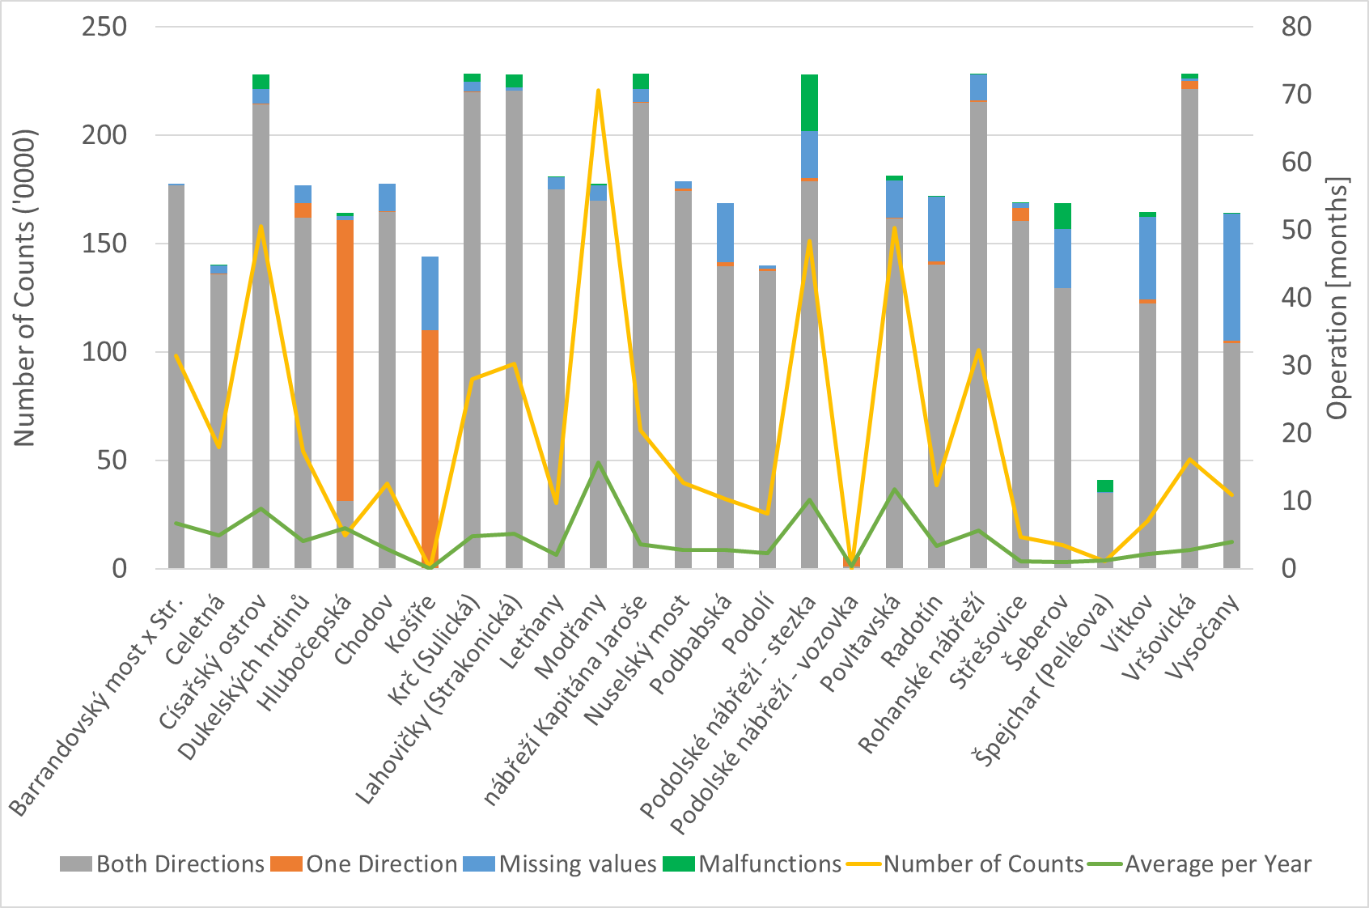
Fig. 1. Sample size and quality.

Last type of variation in workday was recorded by only one facility. This type of variation is remarkably similar to the variations in non-working-days. It can be presumed that this type of variation is characteristic recreational cycling not affected by working-hours. After the morning growth the intensities remain constant until 7pm when they drop.
In most of the sections the recreational (either affected or not affected by work hours) and utilitarian trips are mixed in different rations. In the figure 4 three examples of herein described typical variations are depicted. These variations were selected as they the best characterize three described type of basic variations. While estimating the ration of different traffic characteristic in each profile (see chapter 3) variation in the figure 4 will be taken as a reference.

3. Estimating the Traffic Characteristics
3.1. Assumption for the hourly variations
The estimation is based on the hourly bicycle traffic variations during working-days, since the differences in working-days variations are more distinctive than differences in non-working-days variations. Hypothetically there are three basic categories of hourly bicycle traffic variations:

a) utilitarian (U)
b) recreational affected by work hours (RA)
c) recreational not affected by work hours (RU)

Presumably in most locations all three categories contribute to the overall traffic flow. In the following section the method of calculation of the share of different traffic characteristics on overall flow in individual location is described.

3.2. Calculations
For each location it is assumed, that traffic counts for certain time period () may be calculated as sum of contributions of all cycling traffic characteristics in respective time period. In equation 1 these contributions are represented by , and (utilitarian, recreational affected and not affected by work hours respectively). The same relationship
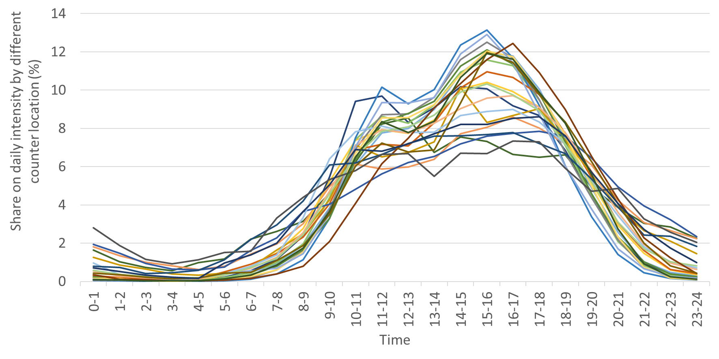
Fig. 2. Average shares of daily counts – Non-working-days

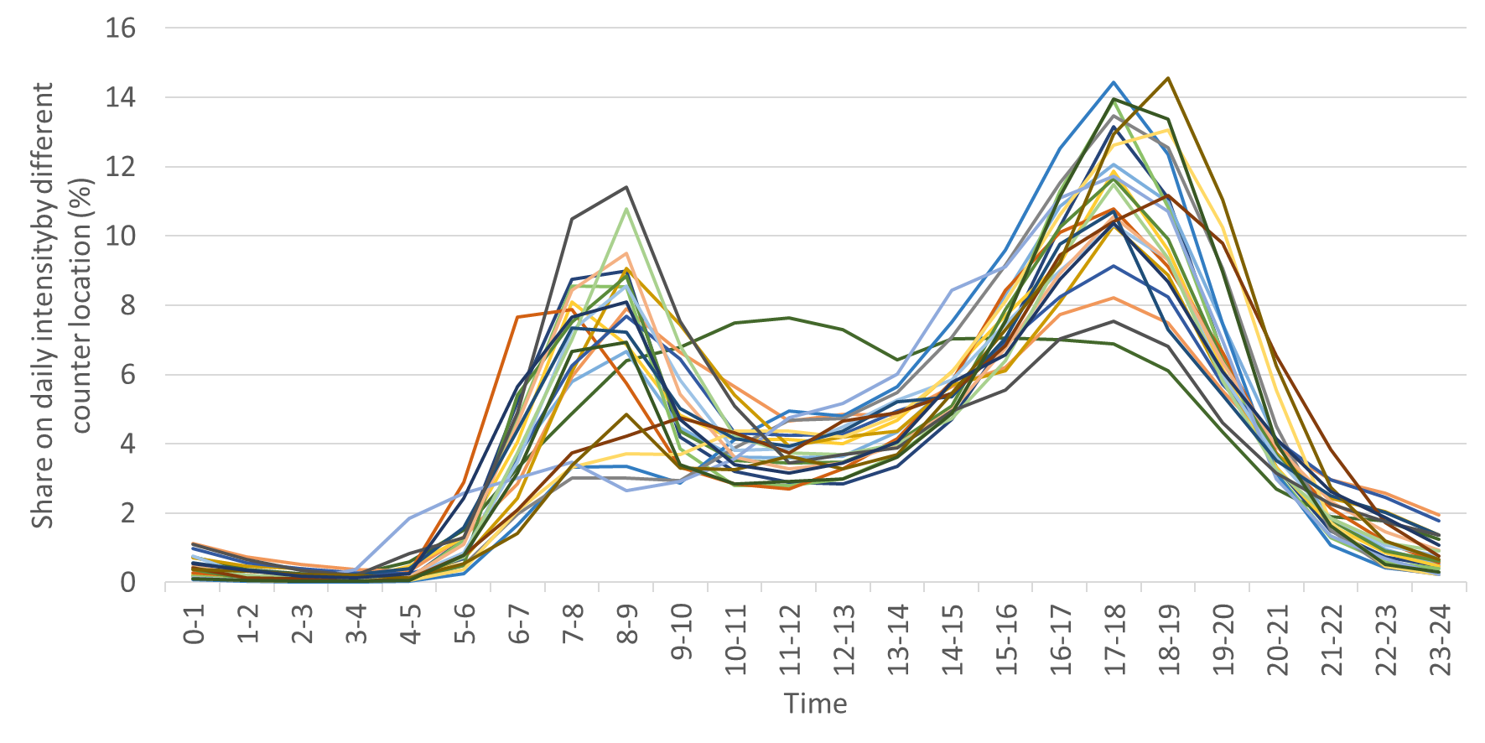
Fig. 3. Average shares of daily counts – working-days
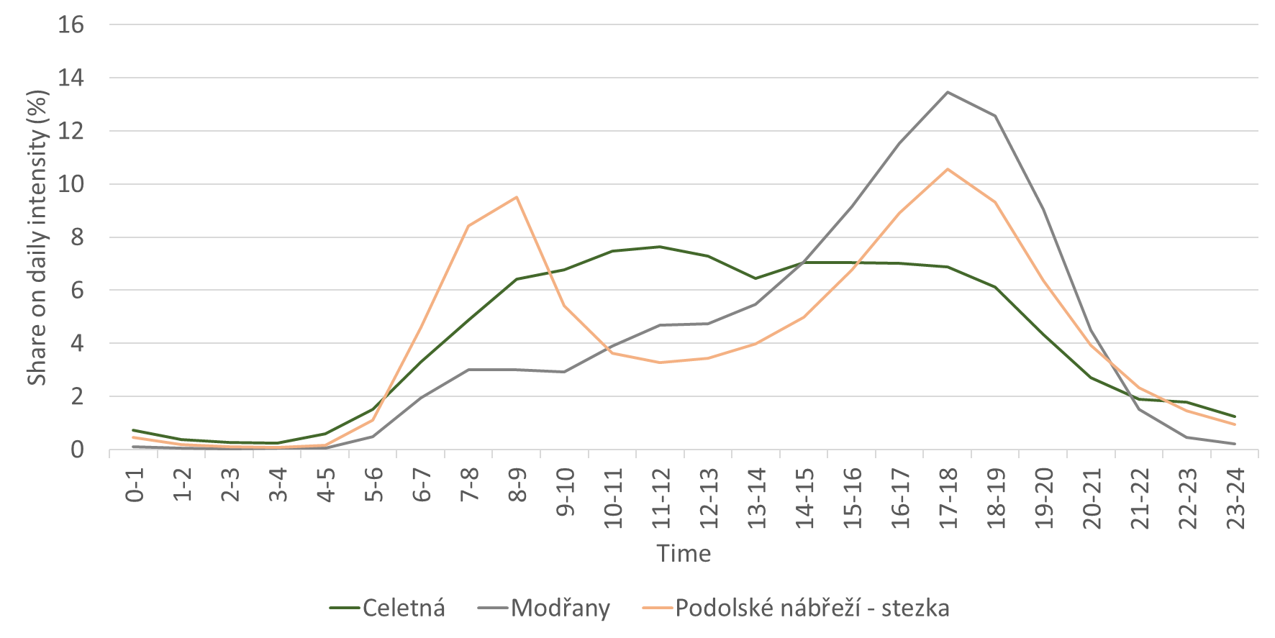
Fig. 4. Average shares of daily counts – working-days, reference sections

can be written for shares on daily counts for certain time period (see equation 2).

(1)

(2)

Similarly, the shares on daily counts can be calculated for hypothetical one-trip purpose locations. These can be referred as reference shares , , (see equation 3). In this case study, reference locations were approximated by selecting locations with the highest level of conformity with anticipated daily variations and according to the knowledge of local situation. To calculate reference shares, variations from figure 4 were taken into account.

=, =o, = (3)
In equation 4, variables , , represent the share of individual trip purposes on overall counts. The contribution of each traffic characteristic to the share on daily counts for certain period is the product of respective reference share and , , . Expression 2 can be adjusted as:
(4)

Next, the values , , are optimized, so that the total difference between the two sides of equation 4 for various time periods is minimized. Optimization is done with the linear programming (gradient method) and the problem is defined as follows:

Minimize:
(5)

Conditions:
(6)

(7)

It is necessary to choose more time periods for optimization, so that the differences in hourly variations between different traffic characteristics are taken into account. Three time periods 5:00-10:00, 10:00-13:00, 13:00-23:00 have been chosen. In the first time period is expected to be considerably higher than reference shares for recreational cycling. For the noon period the highest share on daily counts is expected for recreational cycling not affected by workhours () and is expected to be the most important in the afternoon.

3.3. Results description
Map in figure 5 shows calculated bicycle traffic characteristics for each counting location in Prague. The utilitarian cycling (violet) is rather more important in the central part of the city (places characterized by higher urban density and concentration of trips origin and destinations). Utilitarian cycling also dominates at the river banks which form natural barrier and ensure small trip elevation gradient.
Considerable share of recreational cycling not affected by workhours (green) was estimated for facilities in the proximity of downtown core (Dukelských hrdinů - 48,5 %, nábřeží Kaptána Jaroše – 28,5 % and Rohanské nábřeží – 10,6 %). This may be caused by more frequent occurrence of tourists who decide to enjoy the city by bike while spending their vacation in Prague. There are four more sections with high share (15 % – 29 %) of recreational cycling not affected by workhours which are not directly connected with the touristic areas.
Considerable share of recreational cycling affected by workhours (orange) was estimated for facilities in parks and also for facilities further away from the city centre. At the outskirt of the city the riverbanks seem to be popular locations for recreation of city inhabitants and less important for commuting (Modřany, Lahovičky, Radotín). However, this assumption needs to be supported by further research.

4. Conclusion
In Prague 16 out of 23 counting sections were estimated to be predominantly utilitarian. This may be due to location selection and it gives no information about prevailing characteristics of bicycle trips made in Prague. The estimated
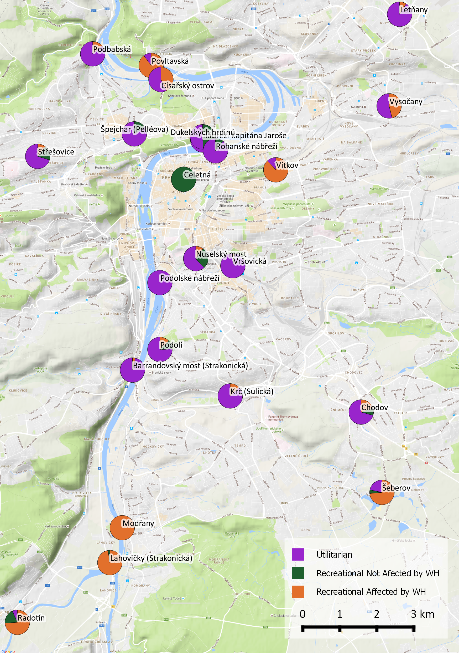
Fig. 5. Calculated bicycle traffic characteristics for each counting location in Prague.
representation of different traffic characteristics corresponds to expectations based on the analysis of the land scape of the city and built environment. Nevertheless, there are several sections with unexpected traffic characteristics (e.g. Nuselský most, Radotín). For better understanding to these exceptions, it is necessary to obtain more information about particular sections (e.g. interview locals and users, analyse trips and destinations of respective trips).
Results can be further used in infrastructure planning in Prague. Presumably different user groups (utilitarian/recreational) demand different type of infrastructure. The method used can be further implemented for yearly averages, so that changes in bicycle traffic characteristics in each section can be evaluated as well as overall changes in attitudes towards cycling. To assess these trends, more complex models need to be utilized reflecting other variables such as weather, season, special occasions (road closures, public transport strikes, etc.) etc.
Used method is based on evaluation of working-days hourly variations averages for the whole operating duration. In reality these variations change over the year as well as the traffic characteristics. It is also to be mentioned, that the used method provides no information on non-working-days traffic characteristics, which may not be in-line with working-days traffic characteristics (e.g. recreational cyclist may be willing to travel further during weekends).
The most uncertain part of the method is to estimate reference shares. Reference shares are calculated from the hourly variations in hypothetical one-trip purpose reference locations (see equation 3 and figure 4). In this case study, reference locations were approximated by selecting locations with the highest level of conformity with anticipated daily variations (described in previous chapter 3.1) and according to the knowledge of local situation. In reality reference variations may differ for each location and especially for different towns/cities/regions. Also the method used for calculation – optimization may provide only local optimums. For these reasons it is difficult to assess the confidence of obtained results.
The method introduced in this paper may be utilized in towns and cities which possess data from bicycle traffic counts (either continuous or manual). It is especially valuable for cities which have no information on travel behaviour and mode share (e.g. developing countries, small cities). It helps to estimate the importance of utilitarian cycling, which may be undervalued in regions with high share of recreational cycling (some people may perceive cycling as purely sporting activity). Obtained results provide important input into the strategic planning as well as infrastructure measure design. The method can be further included into more complex models which asses impact of other variables on bicycle traffic flows.

References
Brandenburg, Ch.; Matzarakis, A.; Arnberger, A. 2007. Weather and cycling - a first approach to the effects of weather conditions on cycling, Meteorological Applications, 1(14): 61-67.
CAMEA, spol. s r.o. 2016. BikeCounter data, Prague. Available from Internet: <https://unicam.camea.cz/Discoverer/ BikeCounter/bc/index/bc/BC_KJ-HRHO>.
Cools, M. 2009. Inter- and intraday variability of Flemish travel behavior, Ph.D. Thesis, University of Hasselt.
Cools, M.; Moons, E.; Creemers, L.; Wets, G. 2010. Changes in travel behavior in response to weather conditions: do type of weather and trip purpose matter?, Transportation Research Record 2157, 22-28.
Cools, M.; Creemers, L. 2013. The dual role of weather forecasts on changes in activity-travel behaviour, Journal of Transport Geography, 28: 167-175.
Hamilton, J.M.; Maddison, D.J.; Tol, R.S.J. 2005. Climate change and international tourism: A simulation study, Global Environmental Change, 15: 253-266.
Jeuring, J.; Becken, S. 2013. Tourists and severe weather – an exploration of the role of ‘Locus of
Responsibility’ in protective behaviour decisions, Tourism Management 37: 193–202.
Liu, Ch.; Susilo, Y.O.; Karlström, A. 2014. Examining the impact of weather variability on non-commuters’ daily activity–travel patterns in different regions of Sweden, Journal of Transport Geography, 182 (39), 36-48.
Liu, Ch.; Susilo, Y.O.; Karlström, A., 2015a. The influence of weather characteristics variability on individual’s travel mode choice in different seasons and regions in Sweden, Transport Policy, 182 (41): 147-158.
Liu, Ch.; Susilo, Y.O.; Karlström, A., 2015b. Investigating the impacts of weather variability on individual’s daily activity-travel patterns: a comparison between commuters and non-commuters in Sweden. Transportation Research Part A 82, 47-64.
Liu, Ch.; Susilo, Y.O.; Termida, N.A. 2015c. Subjective perception towards uncertainty on weather conditions and its impact on out-of-home leisure activity participation decisions. In Proceedings of the 6th International Symposium on Transportation Network Reliability, Nara, Japan.
Miranda-Moreno, L.; Nosal, T. 2011. Weather or not to cycle; whether or not cyclist ridership has grown: a look at weather’s impact on cycling facilities and temporal trends in an urban environment, Journal of the Transportation Research Board, 2300 (500)
Tom, T.; Jaarsma, R.; Tutert B. 2013. Exploring temporal fluctuations of daily cycling demand on Dutch cycle paths: the influence of weather on cycling.
Technická správa komunikací hl. m. Prahy – Úsek dopravního inženýrství (TSK-ÚDI). 1988 - 2016. Annual report on transport, Prague. Available from Internet: <http://www.tsk-praha.cz/wps/portal/root/dopravni-inzenyrstvi/rocenky>.

Vojtěch Jirsa: vojtech.jirsa@upce.cz

