This is an Accepted Manuscript of an article published by Taylor & Francis in The Journal of Maternal-Fetal & Neonatal Medicine on 28 November 2016, available online: http://www.tandfonline.com/doi/full/10.1080/14767058.2016.1260114

Title page
(1) Title: IODINE STATUS IN MOTHERS AND THEIR TERM NEWBORNS AND ADAPTIVE MECHANISMS FOR IODINE TRANSPORT IN HUMAN PLACENTA IN IODINE SUFFICIENT AREA
(2) Short title: Adaptive transport mechanisms for iodine

(3) Kateřina Krylová¹, Radovan Bílek², Jiří Kulička³, Petr Dejmek⁴, Milan Bayer¹ and David Neumann¹
(4) ¹Department of Pediatrics, Charles University in Prague, Faculty of Medicine in Hradec Králové and University Hospital Hradec Kralove, Czech Republic
²Institute of Endocrinology, Prague, Czech Republic
³Department of Informatics in Transport, University of Pardubice, Czech Republic
⁴Department of Pediatrics, Charles University in Prague, 3rd faculty of Medicine and University Hospital Kralovske Vinohrady, Prague, Czech Republic
(5) Correspondence: David Neumann, MD, Ph. D.
Dpt. of Paediatrics, University Hospital Hradec Králové
Sokolská 581, 500 05 Hradec Králové, The Czech Republic
Fax +420 495832030 E-mail david.neumann@fnhk.cz
(6) Keywords: spot urinary iodine concentration, iodine status, iodine transport in human placenta, pregnancy, newborn
(7) Authors declare no conflicts of interest. The funding was rised from low cost project funds of Institutional research of University hospital Hradec Kralove, supported by MH CZ - DRO (UHHK, 00179906)
(8) Word count for the summary/manuscript: 249/2669 Figures 5 Tables 1 References 25

Summary:
Objective Pregnant women are a risk group for iodine deficiency even in iodine-sufficient countries. The study aimed to evaluate an individual mother-newborn iodine status and address possible adaptive placental mechanisms to compensate the real maternal iodine status.
Design Prospective observational study
Patients and methods Pre and post delivery spot urine iodine concentrations (UIC) of 40 healthy mothers and their healthy term newborns at day three were analyzed to set individual relations in different initial iodine conditions.
Results Only 52.5 % of mothers took recommended regular iodine supply. Maternal spot UIC was below 150 mcg/l in 80 %, but UIC was strongly influenced by an iodine intake just before sampling. Maternal UIC after delivery was generally low (median 57.3 mcg/l). Neither maternal nor neonatal UIC reflect declared iodine extra supply in pregnancy. Neonatal spot UIC did not exceed 100 mcg/l in 62.5 % (median 94.6 mcg/l). No clear relation between maternal and newborn UIC was found, but maternal UIC exceeding 50 mcg/l improves offspring iodine status. The placental active iodine transport seems to have gradient from mild to moderate maternal iodine deficit to balance neonatal iodine status, but not in maternal UIC below 50 mcg/l.
Conclusions Spot UIC before delivery reflects an actual iodine intake, maternal IUC at day 3 acute drop of glomerular hyperfiltration and iodine shift toward mammary gland, but neonatal IUC seems to be closest to real iodine status as neonatal TSH does. The UIC of 50 mgc/l in late pregnancy is critical for acceptable offspring UIC.

Introduction
An adequate maternal iodine intake in the gestation 200-250 mcg/day [1] prevents abnormities in the thyroid gland and the neurological development of the fetus and newborn [2,3] and the iodine deficiency-related diseases of mother [4]. Recommended iodine needs of 100 mcg per day increase by at least 50 per cent in the pregnancy. Daily iodine needs rise up in the lactation, as breast milk contains approximately 150 mcg/l of iodine [1]. The supply should balance a growing need of iodine from first to third trimester of the pregnancy and following lactation.
The Czech Republic meets the ICCIDD (International Council for the Control of Iodine Deficiency Disorders) criteria for iodine deficiency free countries, having the longstanding salt iodination program [5]. But still, pregnant and lactating women are considered to be at risk [1], as shows data from Slovakia, Netherlands and Australia [6-8]. An adequate iodine supplementation in pregnancy and lactation was found insufficient and difficult to maintain in France, Belgium, Denmark, Norway and the Ukraine [9-13]. The Japanese study from 2013 [14] shows that even in a country with high iodine supply in the population including pregnant, low UIC may occur in one third of pregnant and lactating women. These data correspond with our own previous observations focused on normative values for the newborn thyroglobulin, obtained in the same population of mothers and their newborns in an urban area of the Czech Republic from 2009-2011. Despite the policy to pregnant women should supply iodine on daily regular base, we found them still with low UIC below 150 and even 50 mcg/l at part.
Although under reservations, neonatal TSH and maternal spot urine samples are meant indicators of iodine status in the pregnant/neonatal population. TSH below 5 mIU/l at least in 97 per cent of newborns and median urinary iodine 150–249 and 100 mcg/l in pregnant women resp. newborns [3] meets WHO criteria for iodine sufficient population.
Thus, the aims of present study were (i) to evaluate a physical iodine status in a region declared to be iodine sufficient and (ii) its relations in pregnant women before the labor and their term healthy newborns, trying to identify (iii) adaptive mechanisms of the human placenta to overcome an iodine abnormity in individual pairs in favor of newborn.
SUBJECTS and Methods
The study was performed in one centre of perinatology, University Hospital Hradec Kralove, between December 2012 and March 2013, in the industrial region of the Czech Republic, Middle Europe. The study protocol was approved by the Local ethical committee. Subjects, pregnant women, filled informed agreements and the study questionnaires at beginning.

Fifty six Caucasians healthy mothers were recruited for the study when admitted before birth (Figure 1). No previous contact between study personnel and them existed. None of them had known thyroid disease themselves or in their family or palpable/visible thyroid. They were advocated by their gynecologists to add multivitamin or iodide tablets to their diet from the beginning of the pregnancy. Subjects were not of low income and ate common middle European diet with no special restrictions. Six pairs mother - baby were later on excluded for insufficient samplings or an incomplete study questionnaire, one for smoking of mother, nine for birth by the Cesarean section. The remaining forty pairs of mother - healthy term newborn were included.

Clinical characteristics of the 40 study pairs, expressed in medians (minimum and maximum) are as follows: Pregnant women/mothers. Maternal age 28.5 (22–41) years, BMI before pregnancy 22.4 (18.3-34.3) kg/m² and at delivery 28.4 (21.3-39.7) kg/m², weight gain during pregnancy 15 (3–25) kg. Spontaneous delivery was at 39, vacuum extraction at 1 case. Neonates, 21 boys and 19 girls, were characterized by gestational age of 40 (37–41) months, birth weight 3360 (2380-4240) g, length 50.5 (45-54) cm and uneventful postnatal adaptation. Iodine-containing disinfectants were not used at any spontaneous delivery and vacuum extraction or hospital stay in these subjects. Neonatal jaundice was mild, thirteen out of 40 (32.5 per cent) needed 12 to 24 hour phototherapy. All newborns stayed in the hospital at least 72 hours according Czech medical standards and were breastfed on Day 3 gaining weight. At these three days, mothers did not use any iodine supplementation.

Maternal UIC levels were analyzed from the last spot urine samples before delivery and on Day 3 in the morning. Newborn spot urine samples were obtained on Day 3. All samples were frozen in plastic tubes to minus 20°C within maximum of 8 hours after collection and examined later on together by spectrophotometric determination by the Sandell-Kolthoff´s reaction. Neonatal TSH levels were established from dry blood spot by fluoroimunoassay kit B032-312 AutoDELFIA® Neonatal hTSH on autoDELFIA 1235 analyser in the Czech newborn screening program. WHO/ICCIDD criteria for UIC levels were taken as normatives (Figure 1). Two pairs mother – newborn was excluded from IUC comparison before statistics, one for missing result and one unreasonably high UIC (741 mcg/l) in the respective newborns. Non-parametric testing for medians was done by Kruskal–Wallis and Mann-Whitney U tests on p=0.05, testing of difference in variance by Kolmogorov-Smirnoff test, chi-square test for difference in a normal population.

RESULTS
Twenty one out of forty pregnant subjects (52.5 %) used any iodine substitution at a declared amount of 50–200 mg per day. Pregnant women displayed a large scale of individual UIC responses, in 32/40 of women (80 %) below 150 mcg/l, in 17.5 % less than 50 mcg/l, with the median 97.5 mcg/l. Declared iodine extras did not significantly influence maternal spot UIC on Day 0 or Day 3 (Table 1). A plot of UIC sampling against an hour in the day (Figure 2) figured the key to understand a variance among information on iodine extras in pregnancies, stable neonatal TSH and a borderline median neonatal UIC. The highest UIC were from the late morning to early afternoon signaling, that the immediate iodine intake strongly influences actual UIC before delivery. Maternal UIC in Day 3 after delivery declined further to a median 57.3 mcg/l. There was no association between UIC and maternal weight, height, BMI, age before pregnancy or delivery, such as weight gain during pregnancy. An excessive iodine status over 500 mcg/l, but also adequate with UIC 150-249 mcg/l were not identified in the pregnant women/mothers. Screening TSH of any newborn between 48 and 72 hours did not exceed 5 mIU/l. There was no relation between TSH and neonatal spot UIC. UIC of newborns were in 62.5 per cent below 100 mcg/l, with median of 94.6 mcg/l. Non newborn of mother with UIC below 50 mcg/l at Day 0 had sufficient UIC over 100 mcg/l, but in 33, 30 resp. 62.5 % in those with 50-99, 100-149 and >250 mcg/l. Offspring’s spot UIC of mothers with and without declared iodine supply did not differ (p=0.168, Figure 3). Higher UIC of pregnant women before delivery advances the offspring iodine status (Figure 4). There was no association between newborn UIC and birth weight or length. Icterus and phototherapy had no effect on the neonatal UIC.

Kruskal-Wallis test did not address a difference between subgroups of neonates of mothers with high iodine supply, mildly, moderately and severely low UIC (p=0.08). But Mann-Whitney tests in subanalysis showed particular differences between neonates of mothers with high iodine supply (p=0.04) and those with UIC 50-99 mcg/l (p=0.03), comparing to newborns of mothers with UIC below 50 mcg/l, but limited by power (r=0.05 for both; Figure 5). Testing did not prove any difference in newborn UIC between subgroups of mothers using 200, 150 and 50 mcg of iodine. The number of measurements needs to triple to prove subgroup of high UIC is cumulated out of the whole set of UIC samples before delivery, despite of depiction (Figure 2).

DISCUSSION
In the present study we address questionned individual UIC as mean to describe iodine status and its variations. The study focused the physical iodine status of mothers and their offspring in the iodine sufficient region with the longstanding iodine fortification program. As others, we found a serious proportion of subjects with low spot urine iodine concentrations, but the inference shifts showing iodine extra supply grossly influences urine iodine at the directly following period. In the second part, we show likely compensatory mechanisms of human placenta in favor to fetus and breast fed baby, but limited by severe iodine deficit in pregnancy.

Physical iodine status in pregnant women and aspects of compliance with recommended supplementation
Regardless of meeting ICCIDD criteria in the general population and the longstanding salt iodization program in the Czech Republic, random spot urine samples of forty pregnant women in the study are in great proportion of low iodine concentration, mostly within 50 and 99 mcg/l. These results conform actual data from other parts of the country [5,15]. Such results with median of 97.5 mcg/l match epidemiologically moderate iodine deficiency. But parameters of neonatal TSH and neonatal UIC contradict such iodine deficit. To understand the real iodine status, the most conflicting seems UIC spot measurement itself [16]. Spot urine samples are meant of enough power only if number of measurements exceeds 300-500 [16,17] or if repeated within the same subject. At present, body of knowledge based on spot UIC, without accurate definitions of timing and previous diet, comprises studies with less than 500 [5,17] and over 1000 subjects [1], showing similar somewhat inconsistent results for a proportion of study subjects. An explanation lacks for pregnant or lactating subjects expected with normal, but physically with low iodine status. Thus, as 24-h urine collection is not suitable for delivery and early motherhood periods for pregnant/mother as well as newborns, careful analysis is recommended to subject the influence of immediate iodine and fluids intake to spot UIC. The fluid intake can be generally addressed by urine iodine/creatinine ratio [18], but both, creatinine and iodine are in the pregnancy changed by glomerular hyperflitration [19]. To overcome this in a small number study, a rough multiplying by the general difference of 41 per cent in the iodine concentration between spot urine samples and 24-h collections [20] may be used. If concede such treatment, our study population of pregnant comes on the border of iodine deficiency and newborns in the reference range. Such, despite gross correction, fits much better with the population parameters as neonatal TSH does.
But still, a more precise expression of unique spot urine iodine output was needed. Thus, the plot of day variation of UIC before delivery against day axis showed the exceptional distribution of high UIC. Majority women with high UIC gave birth between late morning and early afternoon, assuming and reflecting that majority of pregnant women took their medication in the morning, with exceptions. The figure 2 allows also identifying pregnant women, who did not use iodine extras in the period when they expect delivery, but had taken iodine supplementation earlier and those with other iodine sources. Although based on clinical assumption, the interpretation of final results fit well to parameters as neonatal UIC and its median and neonatal TSH within reference values. Thus, the random spot urine sample before delivery is mainly a reflection of recent iodine intake and iodine hyperfiltration of unique woman and even in large scale studies does not reflect unequivocally pre-delivery iodine status.
On the other hand, maternal spot urine third day after delivery draws near to description of a depletion of iodine reserves and iodine concentration for mammary gland. So, the deep slump of UIC from Day 0 to Day 3 post partum in mothers (97.5 and 57.3 mcg/l) is of minor meaning.

Some studies dealing with iodine supply interprete the unexpectedly low UIC, telling that maternal UIC are not influenced by iodine supplementation [14], but individual differences in iodine needs, such as 20 per cent of pregnant women using regularly iodine extras from New York [17]. Others claim that iodine in actual meal can unequivocally mask real average results [19], as we do.

Having the salt iodization in the Czech Republic of 27±7 g per 1 kg (21), this level seems adequate for general population, but lacking for pregnancy and lactation (22). Thus, the insistent claim of WHO/ICCIDD and national authorities in many countries for extra iodine supply is still valid for the population of pregnant and lactating women. Pregnant women also lower iodine intake as they restrict salting, but with minor sense (22). Their real supply with multivitamin or iodide tablets is strongly influenced by personal believes and (mis)interpretation of recommendations, much more in the subgroups with alternative diet. In our study, only a half (52.5 per cent) of mothers declared regular extra iodine intake during the whole course of pregnancy. But still “regular” is difficult to monitor.

Maternal iodine status and iodine status of offspring.
The only condition to clearly maintain neonatal UIC higher than 100 mcg/l seems to raise spot UIC before delivery higher than 50 mcg/l. If this normative value is not too high for first week of life is under debate [3]. Our data also tend to set the median level near to 80 mcg/l. An extra iodine supply given to mothers with low UIC shows the advantage for offspring UIC [4,23], as we found (Figue 5). Population-specific recommendations can be modyfied for high iodine status, mild iodine deficient with mandatory and voluntary iodin fortification programes and severely iodine deficient populations to prevent both, high and low iodine induced pathologies of mothers and their offspring [24].
The general schema for pregnancy – maternal UIC shows decrease after delivery, as the glomerular iodine filtration normalizes and iodine is mobilized for mammary gland. Newborn UIC use to be higher compare to pre and post birth maternal UIC [25]. In mild to moderate iodine deficit in pregnant/mothers adaptive placental and later on mammary mechanisms are able to maintain sufficient iodine status in the offspring. But, as shown by our data, in mothers with UIC below 50 mcg/l is newborn iodine status inadequate. As breast feeding is just little at third day after birth, placental active transport toward fetus and its reserves are main source of iodine in neonatal urine. This data fit to outcomes of similar study from Ireland from 2007 [25]. These expected, and existing, adaptive placental mechanisms set to another view the results of recent population studies showing significantly lower total, verbal and reading intelligence quotients in children at 8 and 9 years of mothers with iodine-to-creatinine urine concentration below 150 mcg/g in a population mild to moderate iodine deficient [1], with deep gradient to those below 50 mcg/g. Placental adaptation was ineffective in the affected individuals, which signifies a deeper iodine deficit with limited child iodine pool.

Methodology remarks and strengths and weaknesses of present study.
Authors excluded from the study pairs of subjects if deliver by Cesarean section. Maternal day 3 and neonatal IUC were abnormally high if compare to Day 0 IUC and the typical schema of UIC levels was disrupted. The use of skin surgical disinfectant has similar effect to sample UIC as amiodarone or cod fishes and brown algae. The urine collection in our study was not systematically done in the morning. Morning setting can artifitially decrease the physical iodine status, as subjects do not eat yet.
Limits of the prospective cohort study are mainly small sample and assumptions to interpret data to population reference. Strengths are real life experience without medical supervision to pregnant women and detailed information on subjects allowing assess mother-newborn UIC ratio. Addressing of the relation to time span when pregnatnt takes iodine substitute and of the placental adaptive mechanisms are major contributions to actual knowledge.

CONCLUSIONS
The iodine supply recommendations for pregnant and lactating women should be carefully modified for populations with naturally high, artificially sufficient and naturally deeply deficient iodine status. In countries, where iodination programs solved generally iodine deficiency, pregnant women has to be encouraged to extra regular iodine supply of at about 150 mg during the whole gestation and lactation to prevent an individual iodine deficit. If severe, iodine deficit seems not to be balanced by placental adaptive mechanisms to favor fetus and newborn as in milder lack.

TABLES and Figures
Figure 1. Flow chart of the study.
* one newborn UIC missing **one result inapropriatelly high (741,4 μg/l)

56 pairs healthy mother – healthy term newborn
6 incomplete maternal or children´s data, incomplete questionnaires (10.7 %)
9 births by cesarean section (16.1 %)
40 pairs healthy mother – healthy term newborn underwent analysis (71.4 %)
Neonatal TSH < 2.5 mIU/l (33; 82.5 %), TSH 2.86- 4.5 mIU/l (7; 17.5 %), UIC_{mother}
iodine sufficient
(150-249 μg/l I_{urine})
mild iodine deficit (100 -149 μg/l I_{urine})
moderate iodine deficit
(50-99 μg/l I_{urine})
severe iodine deficit
(<50 μg/l I_{urine})

high iodine status (250-499 μg/l I_{urine})
0 (0.0 %)
iodine supply
200 μg 0
150 μg 0
50 μg 0
10 (25.0 %)
iodine supply
2
4
0
8 (20.0 %)
iodine supply
2
2
1
7 (17.5 %)
iodine supply
1
1
0
15 (37.5 %)
iodine supply
0
2
3
1 mother – smoker (1.8 %)
-
-
-
mothers
newborns
UIC (μg/l)
<100 0
100> 0

UIC
3 (30.0 %)
7 (70.0 %)
IUC
9 (60.0 %)
4 (26.7 %)*
UIC
6 (85.7 %)
0 (0.0 %)**

UIC
3 (37.5%)
5 (62.5 %)

Table 1. Median urinary iodine concentration (μg/l) in iodine/multivitamin tablets users vs. non users.
* group with adequate UIC was not generated by study.

Before birth Day 0 Post partum Day 3 Newborns
Pregnant Users Non-users Users Non-users Users Non-users
UIC 103,5 88 48,7 66,3 97,05 91,55
UIC < 50 39,3 36,1 28,4 49,55 89,1 49,55
UIC 50-99 85,6 78,05 19,3 47,4 106 91,8
UIC 100-149 109,8 120,5 42,85 98,5 88 84,4
UIC 150-249 - - - - - - *
UIC >250 340,4 268 64 81 134,4 150,3

Figure 2. Day span of births. Pregnancy UIC before delivery differes. Majority of iodine sufficient samples were obtained from late morning to early afternoon. Astrerixs label pregnant women declaring iodine supplementation. Grouping according to UIC.
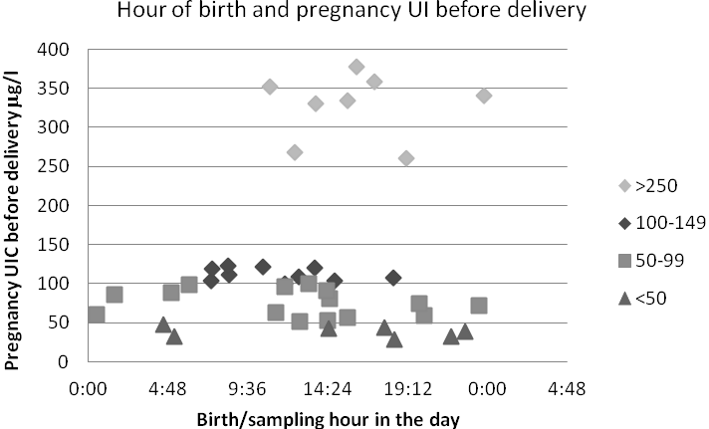
*
*
*
*
*
*
*
*
*
*
*
*
*
*
*
*
*
*
*
*
*

Figure 3. Newborn IUC of mothers with different declared iodine supply (median, 25.-75. percentile)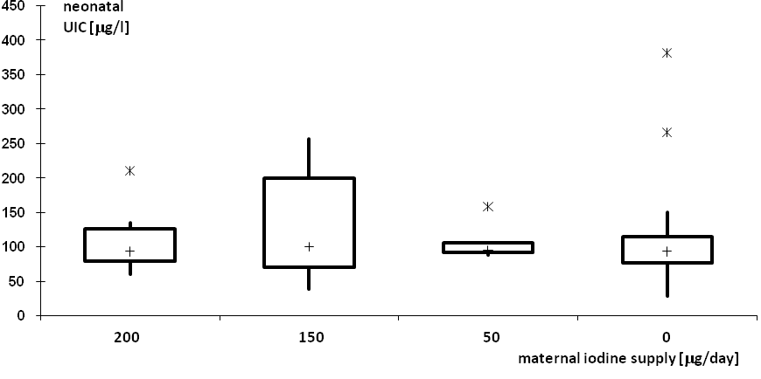

Figure 4. Comparision of newborn urinary iodine concentration according to maternal iodine concentration before delivery (medians and 95% intervals of confidence). *p=0,04 and **p=0,03 for Mann-Whitney U test.

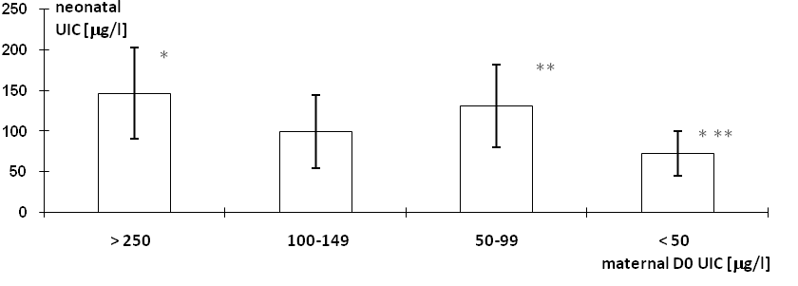

Figure 5. Comparisions of D3 maternal and neonatal IUC with IUC before delivery with exponential trendlines.
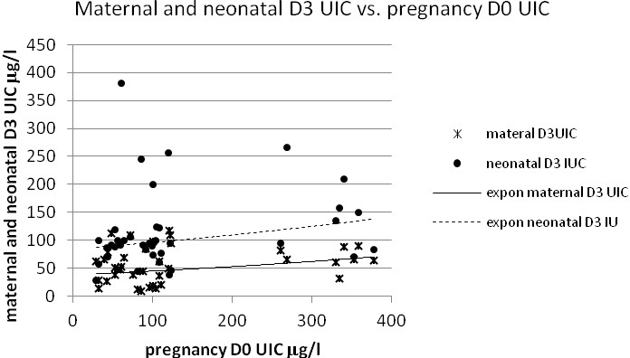

LiteraturE
1. Zimmermann, M.B. (2007) The impact of iodised salt or iodine supplementation on iodine status during pregnancy, lactation and infancy. Pub Health Nutr, 10, 1584-95.
2. Alvarez-Pedrerol, A., Guxens, M., Mendez, M. et al. (2009) Iodine levels and thyroid hormones in healthy pregnant women and birth weight of their offsprings. Eur J Endocrinol,160, 423-429.
3. Zimmermann, M.B. (2009) Iodine deficiency in pregnancy and the effect of maternal iodine supplementation on the offspring: a review. Am J Clin Nutr, 89, 668S-72S.
4. Zimmermann, M.B. (2012) The effects of iodine deficiency in pregnancy and infancy. Paediatric and Perinatal Epidemiology, 26(Suppl.1), 108–117.
5. Jiskra, J., Fait, T., Bílek, R. et al. (2014) Mild iodine deficiency in women after spontaneous abortions living in an iodine-sufficient area of Czech Republic: prevalence and impact on reproductive health. Clin Endocrinol, 80, 452-8.
6. Dluholucký, S., Knapková, M., Cibirová, M., Hrubá, F. (2006). Higher TSH levels from neonatal screening evaluation in Slovakia. Čes Slov Pediatr, 9, 524- 529.
7. Hoogendoorn, E.H., Hermus, A.R., De Vegt, F. et al. (2006) Thyroid function and prevalence of anti-thyroperoxidase antibodies in a population with borderline sufficient iodine intake: influences of age and sex. Clin Chem, 52, 104-111.
8. Travers, C.A., Guttikonda, K., Norton, C.A. et al. (2006) Iodine status in pregnant women and their newborns: are our babies at risk of iodine deficiency? Med J Aust, 184, 617-620.
9. Raverot, V., Bournaud, C., Sassolas, G. et al. (2012) Pregnant French women living in the Lyon area are iodine deficient and have elevated serum thyroglobulin concentrations. Thyroid, 22, 522-8.
10. Vandevijvere, S., Amsalkhir, S., Mourri, A.Bb et al. (2013) Iodine deficiency among Belgian pregnant women not fully corrected by iodine-containing multivitamins: a national cross-sectional survey. Br J Nutr, 109, 2276-84.
11. Andersen, S.L., Sørensen, L.K., Krejbjerg, A. et al. (2013) Iodine deficiency in Danish pregnant women. Dan Med J, 60, A4657.
12. Brantsaeter, A.L., Abel, M.H., Haugen, M. et al. (2013) Risk of suboptimal iodine intake in pregnant Norwegian women. Nutrients, 5, 424-40.
13. Sekitani, Y., Hayashida, N., Takahashi, J. et al. (2013) Urinary iodine concentrations of pregnant women in Ukraine. Clin Chem Lab Med, 51, 811-6.
14. Fuse, Y., Shishiba, Y., Irie, M. (2013) Gestational changes of thyroid function and urinary iodine in thyroid antibody-negative Japanese women. Endocr J, 60, 1095-106.
15. Vítková, H., Aderlová, K., Radiměřská, V. et al. (2015) Urinary iodine concentrations in pregnant women with gestational and pregestational diabetes mellitus. ECE 2015 abstract 984-EP.
16. Vejbjerg, P., Knudsen, N., Perrild, H. et al. (2009) Estimation of Iodine Intake from Various Urinary Iodine Measurements in Population Studies. Thyroid, 19, 1281-1286.
17. Pessah-Pollack, R., Eschler, D.C., Pozharny, Z., Davies, T. (2014) Apparent insufficiency of iodine supplementation in pregnancy. J Womens Health, 23, 51-56.
18. Bath, S.C., Steer, C.D., Holding, J. et al. (2013) Effect of inadequate iodine status in UK pregnant women on cognitive outcomes in their children: results from the Avon Longitudinal Study of Parents and Children (ALSPAC). Lancet, 382, 331–337.
19. Andersen, S.L., Sørensen, L.K., Krejbjerg, A. at al. (2014) Challenges in the Evaluation of Urinary Iodine Status in Pregnancy: The Importance of Iodine Supplement Intake and Time of Sampling. Eur Thyroid J , 3, 179–188.
20. Rasmussen, L.B., Ovesen, L., Christiansen, E. (1999) Day-to-day and within-day variation in urinary iodine excretion. Eur J Clin Nutr, 5, 401-407.
21. Zamrazil, V., Čeřovská, J., Bílek, R. et al. (2007) Evaluation of results of iodine prophylaxis in Czech Republic. Časopis lékařů českých, 146, 262–266.
22. Nazeri, P., Mirmiran, P., Shiva, N. et al. (2015) Iodine nutrition status in lactating mothers residing in countries with mandatory and voluntary iodine fortification programs: an updated systematic review. Thyroid, 25, 611-620.
23. Liesenkotter, K.P., Gopel, W., Bogner. U. et al. (1996) Earliest prevention of endemic goiter by iodine supplementation during pregnancy. Eur J Endocriol, 134, 443-448.
24. Pearce, E.N. (2013) Monitoring and effects of iodine deﬁciency in pregnancy: still an
unsolved problem? Eur J Clin Nutr, 67, 481–484.
25. Smyth, P.P.A., Smith, D.F., Sheehan, S. et al. (2007) Short-term changes in maternal and neonatal urinary iodine secretion. Thyroid, 17, 219-222.

