Resistive switching with chalcogenide thin film

Annotation of Dissertation
Submitted For the Partial Fulfillment of the PhD Degree
To the Faculty of Chemical technology
Department of General and Inorganic Chemistry
UNIVERSITY OF PARDUBICE

Author: Bo Zhang
Supervisor: Prof. Ing. Tomáš Wágner

2017

Contents
Keywords: 4
Abbreviations: 4
1. Introduction 6
2. The principle material in resistive switching 7
2.1 Material selection 7
2.2 Algorithm of measurement 10
2.3 Mechanism of resistive switching 10
2.4 Chalcogenide glasses 11
2.5 Photo and thermal diffusion 11
2.6 Photo-surface deposition 11
2.7 The geometry of memory cell 12
2.7.1 Crossbar structure 12
2.7.2 Via-hole structure 12
2.8 The parameter for memory device 13
2.8.1 Write operation 13
2.8.2 Read operation 13
2.8.3 Resistance ratio 14
2.8.4 Endurance 14
2.8.5 Retention 14
2.9 The observation of conductive filament 14
3. Experimental part 15
3.1 Preparation of thin film 15
3.2 Photo doping and dissolution 16
3.3 Electric pulse measurement 17
3.4 SEM 17
3.5 AFM 18
3.6 Optical microscope 18
4. Main results and their discussion 18
4.1 The resistive switching with spot geometry 18
4.1.1 Introduction 18
4.1.2 Experimental results 18
4.2 Crossbar geometry 19
4.3 Needle contact geometry 22
4.3.1 Introduction 22
4.3.2 The resistive switching curve 23
4.3.3 The observation of sample 23
4.3.4 Electron induced particle creation 26
4.5 Tip (conductive AFM) geometry 31
4.5.1 Introduction 31
4.5.2 The maps of surface morphology and distribution of spread current 31
4.6 Via-hole geometry 35
5. Conclusion of thesis 37
6. Reference 38
7. Publications and conferences 42

Keywords:
Resistive switching, chalcogenide thin layer, conductive filament

Abbreviations:
DRAM: dynamic random access memory
ROM: read only memory
RAM: random access memory
FRAM: ferroelectric random access memory
PRAM: phase change random access memory
MRAM: magnetoresistive random access memory
AFM: atomic force microscope
OIDD: optical induced diffusion and diffusion
SEM: scanning Electron Microscope
RRAM: resistive random access memory
CBRAM: conductive bridge memory
PVD: physical vapor deposition
PECVD: plasma-enhanced chemical vapor deposition
AAO: anodic aluminum oxide
GST: germanium-antimony-tellurium
RF: radio frequency
RS: resistive switching
PLD: pulsed laser deposition
ALD: atomic layer deposition
UV: ultraviolet
AIDCN: 2 - amino - 4, 5 - imidazoledicarbonitrile
TCNQ: 7, 7, 8, 8 - tetracyanoquinodimethane
NPB: N, N’ - Bis ( naphthalen - 1 - yl ) - N, N’ - bis ( phenyl ) benzidine
Rose bengal: 4, 5, 6, 7 - Tetrachloro - 2’ , 4 ’, 5 ’, 7 ’ - tetraiodofluorescein disodium salt
MEH - PPV: poly [ 2 - methoxy - 5 - ( 2 - ethylhexyloxy ) - 1, 4 - phenylenevinylene ]
P3HT: poly ( 3 - hexylthiophene - 2, 5 - diyl )
PARA: poly ( o - anthranilic acid )
Parylene - C: poly - p - xylene
PEDOT: PSS: poly ( 3, 4 - ethylenedioxythiophene ) polystyrene sulfonate
PFN - C: poly [ ( 9, 9 - bis ( 3ethylenedioxythiophene ) polystyrene sulfonatet - 2, 7 - ( 9, 93ethylenedioxythio ]
PFO: polyfluorene
PI: polyimide
PMMA: poly ( methyl methacrylate )
PS: polystyrene
PVA: poly ( vinyl alcohol )
PVK: poly ( 9 - vinylcarbazole )
PVP: poly vinyl pyrrolidone
WPF - oxy - F: poly[( 9, 9 - bis( ( 6 ' - ( N, N, N - trimethylammonium) hexyl) - 2 , 7 - fluorene) - alt - ( 9, 9 - bis( 2 - ( 2 - methoxyethoxy) ethyl) - fluorene) ] dibromide
LSMO: lanthanum strontium manganite
PCMO: Pr_{1-x}Ca_{x}MnO₃
1T1R: one - transistor one - resistor
1D1R: one - diode one - resistive switching memory
1BJT1R: one - bipolar junction transistor one - resistive switching

Introduction
With the development of microelectronic devices, Information technology becomes one of the most important areas. John von Neumann pointed out the basic five parts of computer: Input Unit, Output Unit, Storage Unit, Central Processing Unit and Control Unit, in which the memory device belongs to the storage unit [1]. Two basic states are adopted for data storage, which is “1” and “0” in binary code. Based on the different mechanisms, the memory devices can be divided into two parts: volatile and nonvolatile memories. The volatile memory cannot save data without the power supply. Therefore, it is only used for short term data storage, for instance dynamic random access memory (DRAM) [2]. In contrary, the nonvolatile memory is capable of maintaining the data with or without the power supply, for instance flash disks. Based on the method of reading and writing data, the memory devices can also be attributed into two categories: read only memory (ROM) and random access memory (RAM). ROM is only for reading. Whereas RAM can be used for both reading and writing [3]. Nowadays, many different approaches have been employed for data storage. Researchers focused on several special material fabricated device, such as ferroelectric RAM (FRAM) [4], phase change RAM (PRAM) [5], magnetoresistive RAM (MRAM) [6] and resistive switching RAM (RRAM) [5].
Resistive switching relays on the reversible resistance change of the medium layer, realizing the data memory. The advantages such as fast response speed, low energy consumption, long-time data storage, long term usage of resist and the semiconductor process compatibility makes the RRAM memories a promising next generation of data memories [5]. The scope of resistive switching comprises the microelectronics, materials, physics and chemistry, thus, it is a new interdisciplinary field [7]. However, the detailed mechanism of switching is still unclear [8]. According to the switching behaviour of resistive switching, the RRAM can be described as two types: unipolar and bipolar. The unipolar resistive switching relies on the amplitude of applied bias with the polarity, and bipolar switching relies on the amplitude and the polarity of applied bias [9]. From the materials in PRAM point of view, oxide and chalcogenide thin layers are dominant. The conductive filament can be either metallic filament or oxygen vacancy filament in oxide layer, compared with only metallic filament in chalcogenide thin layer [10]. The main aim of this thesis is discussion of the switching behavior and observation of filaments in chalcogenide layers.
The Ag or Cu doped chalcogenide electrolyte is mostly fast ion conductor. The memory device usually comprises an inert electrode, a diffusive Ag or Cu electrode and a chalcogenide electrolyte layer in-between. The mechanism of filament formation involves the reduction-oxidation reactions of ions leading to the formation or dissolution of metallic filaments [11]. Such memory cell is referred as programmable metallization cell (PMC) [12] or conductive bridging RAM (CBRAM) [13] . PMC cell owns excellent storage performance, for instance, low operative voltage, low operative current, fast response and long-time data storage. In 2005, Terabe et al. [14] reported the atomic switching in Ag/Ag₂S/Pt structure showing potential application in logic gate, which is promising to be applied in computer science.
In this thesis, five different geometries of switching devices are presented: spot geometry, crossbar geometry, needle contact geometry, tip (conductive AFM) geometry and via-hole geometry (See the section “graphic illustration of sample preparation”). Each of these geometries has different advantages and drawbacks and offers alternative view to understand the switching mechanism. More importantly, the scanning electron microscope and atomic force microscope images partially exhibit the outline of conductive filament, providing solid evidence for filament study.

The principle material in resistive switching

2.1 Material selection
The material list of electrolyte in resistive switching has been shown in Table 1 [15]. It can be seen a large number of high K materials exhibiting the resistive switching behaviour, which can be categorized into chalcogenides, oxides (binary, ternary and more complex), nitrides, amorphous-silicon, and some organic materials with flexible substrate.

Table 1: material list for resistive switching [15].
Binary oxides |  |  | Chalcogenides
MgO_{x} | Unipolar | Bipolar | Cu₂S | Bipolar
AlO_{x} | Unipolar | Bipolar | GeS_{x} | Bipolar
SiO_{x} | Unipolar | Bipolar | Ag₂S | Bipolar
TiO_{x} | Unipolar | Bipolar | GeSe_{x} | Bipolar
CrO_{x} | Bipolar |  | Nitrides
MnO_{x} | Unipolar | Bipolar | AlN | Unipolar | Bipolar
FeO_{x} | Bipolar |  | SiN | Unipolar | Bipolar
CoO_{x} | Unipolar | Bipolar | Small molecules
NiO_{x} | Unipolar | Bipolar | AIDCN | Bipolar
CuO_{x} | Unipolar | Bipolar | AlQ₃ | Unipolar | Bipolar
ZnO_{x} | Unipolar | Bipolar | Cu:TCNQ | Bipolar
GaO_{x} | Bipolar |  | NPB | Bipolar
GeO_{x} | Unipolar | Bipolar | Rose bengal |  | Bipolar
ZrO_{x} | Unipolar | Bipolar | Polymers
NbO_{x} | Unipolar | Bipolar | MEH-PPV | Unipolar | Bipolar
MoO_{x} | Unipolar | Bipolar | P3HT | Unipolar | Bipolar
HfO_{x} | Unipolar | Bipolar | PARA | Unipolar | Bipolar
TaO_{x} | Unipolar | Bipolar | Parylene-C | Bipolar
WO_{x} | Unipolar | Bipolar | PEDOT:PSS | Unipolar | Bipolar

CeO_{x} | Unipolar | Bipolar | PFN-C | Unipolar
GdO_{x} | Unipolar | Bipolar | PFO | Unipolar
YbO_{x} | Unipolar | Bipolar | PI | Unipolar | Bipolar
LuO_{x} | Unipolar | Bipolar | PMMA | Bipolar
Ternary or quaternary oxides |  |  | PS | Unipolar | Bipolar
LaAlO₃ | Bipolar |  | PVA | Bipolar
SrTiO₃ | Bipolar |  | PVK | Unipolar | Bipolar
BaTiO₃ | Unipolar | Bipolar | PVP | Bipolar
LC(or S)MO | Bipolar |  | WPF-oxy-F | Bipolar
PCMO | Bipolar |  | Others
BiFeO₃ | Unipolar | Bipolar | Graphene oxide | Bipolar

The common used resistive switching electrolyte material is Ag or Cu doped chalcogenide thin film, with inert and diffusive electrode, referred as PMC (programmable metallization cell) or CBRAM (conductive bridging RAM) [16]. Figure 2 schematically shows the basic principle of the resistive switching [17]. The setup for electrochemical metallization memory cells is very similar to the electrochemical cells with a liquid electrolyte, where the conductive filaments are formed in a solid electrolyte [18]. In electrochemical metallization cells, the solid electrolyte is sandwiched between an inert, e.g. Pt or W, and a diffusive, e.g. Ag or Cu, electrode (Figure 2(a)). At least two stable states are expressed by the formation and dissolution of a metallic filament between the electrodes. Under application of a positive bias to the diffusive electrode, diffusive electrode is oxidized into ions which migrate through the solid electrolyte. These ions are reduced at the inert electrode, where they form an electrodeposited filaments [19]. When the filament reaches the diffusive electrode, the initially highly resistance of cell switches to a low resistance state (ON state after SET process) due to a short circuit between top and bottom electrode (shown in Figure 2(a) II.). Under reverse bias the filament is electrochemically dissolved and the cell is switched back to the high resistance state (OFF state after RESET process) (shown in Figure 2(a) III. and IV.). The memory state can be kept without external electric supply, which is called non-volatile state.
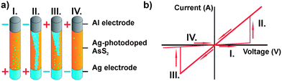
Figure 2: (a) the scheme of resistive switching cell. “+” and “-” symbol shows the plus and negative polarity, (b) I-V curve of resistive switching with 4 different stages [17].

2.2 Algorithm of measurement
Depending on the type of resistive switching, the measuring algorithm can be different. Under appropriate current or voltage application, various materials show a change in resistance, but the switching mechanisms are different. Two main switching schemes can be distinguished as polarity dependent bipolar switching and polarity independent unipolar switching, as shown in Figure 3.
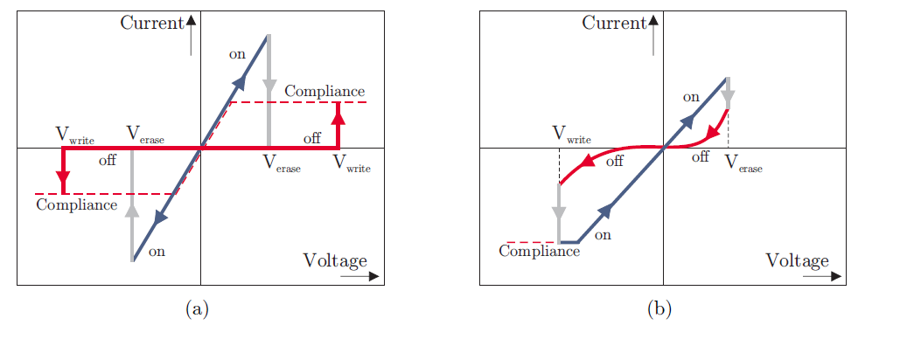
Figure 3: (a) unipolar switching, (b) bipolar switching [19].

2.3 Mechanism of resistive switching
The model of metallic conductive filaments is created for explaining the resistive switching phenomena in fast ion conductor, which is called electrochemical metallization, conductive bridging cell, or programmable metallization. Chalcogenide material doped with Ag or Cu has been explained by this model, as described in above chapter.
Resistive switching in Chalcogenide materials relies on the redox reaction and migration of cations. There is another type of resistive switching device working with migration of anion, which involves with the oxygen vacancy. Such device consists of an inert electrode, for instance Pt or Au and a relatively active electrode, for instance Al, Ti Ta, or Nb. However, neither electrode is not able to induce metal conductive filament, in comparison with Ag or Cu electrode.

2.4 Chalcogenide glasses
Chalcogenide glasses consist of the chalcogenide elements S, Se, and Te alloyed together with other elements such as Ge, As, Sb, Ga, etc.[20]. We can classify the amorphous chalcogenide into the elemental (S, Se, Te ect.), binary (As₂S₃, As₂Se_{3,} ect.), ternary and more complicated (As-S-Se, Ge-Sb-Te, ect.), etc., and the alloys can be divided into stoichiometric (As₂S₃, GeSe₂) and non-stoichiometric compositions (S–Se, As–Se) [21].
Chalcogenide bulk glasses are prepared by quenching of the corresponding melt. The thin film of chalcogenide materials can be done by PVD method (thermal evaporation, flash thermal evaporation) or sputtering.

2.5 Photo and thermal diffusion
Ag⁺ or Cu²⁺ ions can be doped into the chalcogenide material by various method, for instance co-sputtering, photo and thermally diffusion, and pulsed laser deposition.
Photo diffusion or doping was found by Kostyshin et al. [22] and mostly used for Ag doping. The Ag profile of Ag/AsS₂ bilayer is in a step shape with a concentration of 25%, as shown in Figure 4. Accordingly, the structure gradually changes from Ag/AsS₂ to Ag/AgAsS₂/AsS₂ during photo doping and dissolution [23].
Figure 4: schematic illustration of composition profile in (Ag/AgAsS₂/AsS₂) after photo doping of Ag. (a) Ag concentration profile, (b) band diagram, and (c) schematic atomic structure, in which the black circles are an Ag atoms, the big open circles are As atoms, and the small open circles are S [23].

2.6 Photo-surface deposition
Photo-surface deposition is the opposite phenomena against the photo doping effect, which was found by Maruno and Kawaguchi [24]. In short, it is a segregation of Ag particles on the surface of the chalcogenide thin film, due to the exposure of illumination (Figure 5).
Figure 5: SEM images of radiation-induced Ag surface deposition at various radiation doses: (a) 1.58 Mrad, (b) 3.19 Mrad, (c) 7.59 Mrad, and (d) 14.82 Mrad [25].

2.7 The geometry of memory cell

2.7.1 Crossbar structure
The persistent increase of memory integration density expressed by Moore’s law illustrates the demand for ever smaller structures. Therefore, crossbar arrays are widely investigated [26]. The vertical cross point architecture is presented in Figure 6 [27].
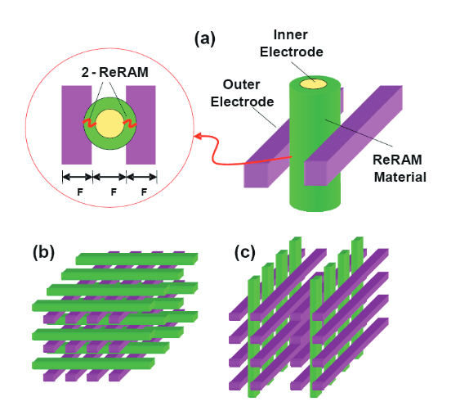

Figure 6: Schematic diagram of (a) an unit vertically-defined ReRAM cell, (b) horizontal cross point architecture, and (c) vertical cross point architecture [27].

2.7.2 Via-hole structure
The via-hole structure contains an insulating thin film with holes defined by photoresist lithography. The resistive functional layer is deposited into the holes, which is free of external disturbance. Thus, a better stability of device can be achieved, compared with crossbar structure (Figure 7).
Figure 7: Cross sectional TEM of the TiN/HfO_{x}/Pt device [28].

2.8 The parameter for memory device

2.8.1 Write operation
The related parameter differs from the material and structure of switching cells, as listed in Table 2.
Table 2: the SET and RESET voltage of switching device.
System | SET and RESET voltage (V) | System | SET and RESET voltage (V)
Cu/Ge_{0.3}Se_{0.7}/SiO₂/Pt | 0.2 | Ag/Ge₂Sb_{2+x}Te₅/Mo | 1.5
Ag/TiO₂/Pt | <0.4 | Al/CuO_{x}/Cu | 1.5
Ag/SrTiO₂/Pt | 0.56 | TiW/InSbTe/ TiAIN | 2.4
Au/ZrO₂/Ag | 1 | Cu/Ta₂O₅/Ru | 3.5
Cu/TaO_{x}/Pt | 1 | Ti/Cu/ZrO₂/Si | 4
W/Cu/WO₃/Cu | 1
Cu/Mn:ZnO/Pt | 0.4

2.8.2 Read operation
Read DC voltages V_{rd} need to be significantly smaller than write voltages V_{wr}, in order to prevent a variation of the ON state resistance during the read operation.

2.8.3 Resistance ratio
The resistance ratio means the ratio of resistance between ON and OFF states (R_{ON} and R_{OFF}). Mostly, the resistive switching memory has from 10 to 10¹¹ resistance ratio.

2.8.4 Endurance
Endurance means the number of repeatable cycles during the writing and the erasing

2.8.5 Retention
Retention means the holding time of resistance [29].

2.9 The observation of conductive filament
Arizona State University developed a result with images of surface filament by using Ag-Ge-Se thin film. Two electrodes (Ag electrode and a W tip electrode) were placed with a distance of 370 µm on the top of sample surface and image was obtained by optical microscope (Figure 8).
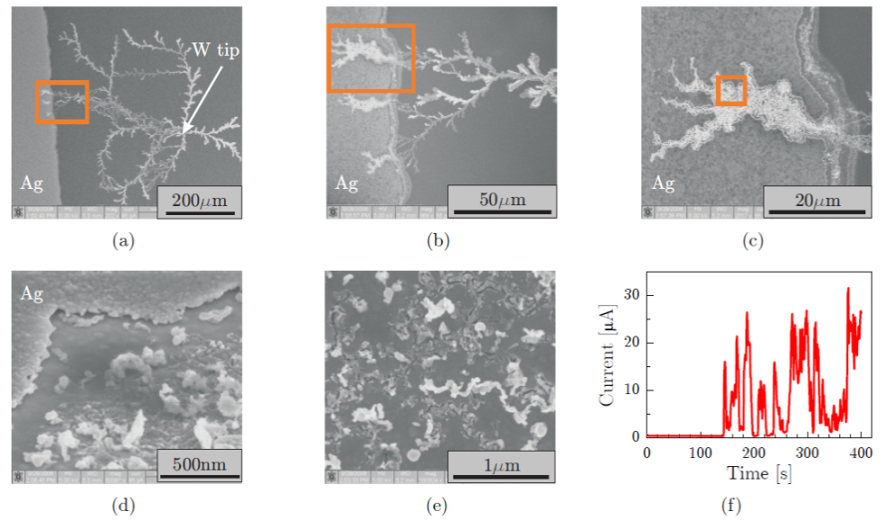
Figure 8: Dendrite growth between a W probe spot and a Ag electrode on the surface of Ag-Ge-S with -4V applied to the W electrode. (a)-(c) show the morphology of dendrite and interface of dendrite and Ag electrode. (d)-(e) show Ag electrode consumption. (f) Current-time curve during dendrite growth [30].
The morphology of conductive filament and the direction of growth in fast ion conductor have been studied in Cu/Cu-GeTe/Pt-Ir system with in-situ TEM imaging. It can be seen the filaments begin to grow form the inert electrode side to the active electrode (Figure 9).
Figure 9: describes the in-situ TEM image from the Cu/Cu-GeTe/Pt-Ir system. [31].

Experimental part

3.1 Preparation of thin film
Table 3 shows the materials selection for different geometries of electrodes and electrolytes. The top electrodes can be divided into two categories: fixed and floated type, in which fixed top electrodes are prepared via thermal evaporation and floated electrodes, relied on the equipment probe. The W and Pt film was prepared by magnetron sputtering and Al₂O₃ film was prepared by PLD.
Table 3: The electrodes and electrolytes of different geometries.
Geometry | Top electrode | Electrolyte | Bottom electrode | Electrode Size
Spot | Al (100 nm) | Ag doped AsS₂  (237 nm) | Ag (300 nm) | Diameter 1 mm
Crossbar | Ag (100 nm) | Ag doped GeSe₂ (120 nm)/Al₂O₃ (2–3 nm) | W (150 nm) | Width 0.1 mm
Needle contact | W coated needle | Ag doped AsS₂  (230 nm) | Ag (100nm) | Needle radius 100 $µm$
Atomic force microscope contact | Tip of atomic force microscope | Ag doped AsS₂  (230 nm) | Ag (100 nm) | Tip radius  20-30 nm
Via-hole geometry | Ag (100 nm) | Ag doped GeSe₂  (120 nm) | Pt (50 nm ) | Diameter 5 $µm$
The parameter of thermal evaporation is presented in table 4.
Table 4: The deposition parameters of thermal evaporation.
Material | Pressure before deposition (Pa) | Evaporation rate (nm/s)
Al | 10⁻⁴ | 1-2
Ag | 10⁻⁴ | 1-2
AsS₂ | 10⁻⁴ | <1
GeSe₂ | 10⁻⁴ | <1
Al₂O₃ | 10⁻⁴ | <1

3.2 Photo doping and dissolution
The Ag ions are commonly introduced into chalcogenide thin film through photo diffusion and dissolution. In the case of Ag/GeSe₂ bilayer, an ultra thin film Ag layer (10 nm) is deposited onto the surface of GeSe₂ thin film. As the ultra thin Ag layer is semi-transparent, the sample can be illuminated from the top side, and Ag ions diffuse into GeSe₂ thin film from up to down side until the Ag layer is completely dissolved. For AsS₂/Ag bilayer, the AsS₂ thin film is deposited onto the surface Ag thin film. The Ag ions are diffused form the bottom to the top side, as shown in Figure 10.
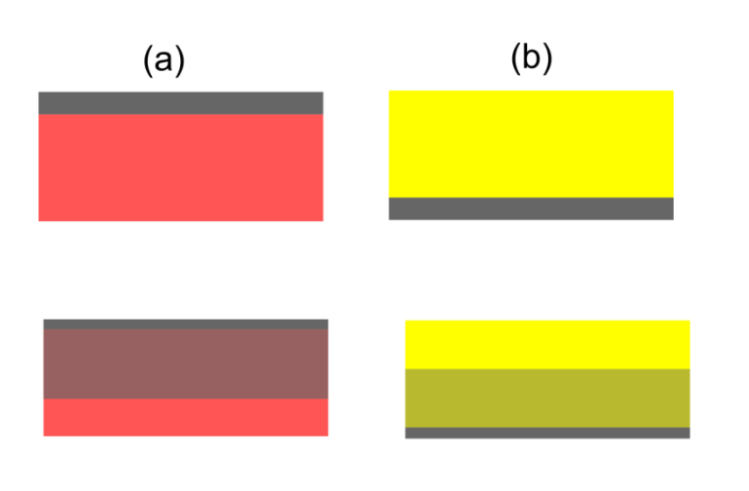
Figure 10: (a) GeSe₂ and (b) AsS₂ thin film before and during photo diffusion and dissolution.

3.3 Electric pulse measurement
The switching behaviour was tested by Keithley 2602 SourceMeter, which offers precision DC, pulse, and low frequency AC source-measure testing [32].
The generated pulse was programed by the software Test Script. The schematic sequence of pulses is shown in Figure 11. Several important parameters can be found, such as: the maximum voltage U_{max}, the minimum voltage U_{min}, the voltage step ΔU, the pulse length t_{pulse}, the delay after each pulse Δt and the delay after each cycle Δt_{After cycle}.
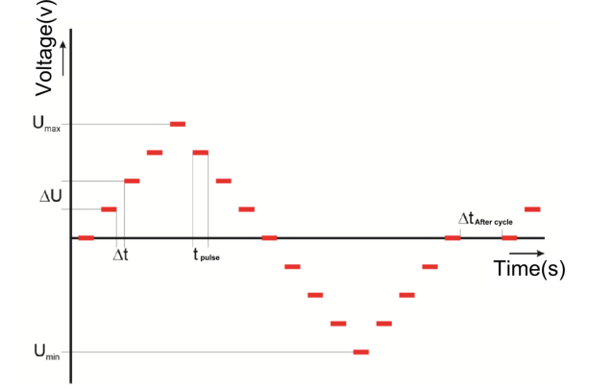
Figure 11: The parameter of pulse measurement.

3.4 SEM
The SEM image was taken by JEOL JSM7500F. JEOL JSM7500F provides topographical magnifications from ×25 to ×1,000,000. The specimen was fixed onto the sample holder, ether by silver paste or conductive tape. During SEM analysis, the non-conducting chalcogenide sample is irradiated with an electron beam, resulting in accumulation of static electric charges. This static charge influences the electron signals and hence deteriorates the image information.

3.5 AFM
The AFM images were taken by conductive atomic force microscope (AFM Solver Pro M, NT-MDT; Russia) with a silicon probe coated with the Cr/Pt layer. Solver PROM works in air or in liquid with minimum scanning step from 0.012 nm to 0.0004 nm. It can be applied to measure the morphology of different verities of material, for example thin films, polymers, semiconductors, biological samples [33].
The probe was defined as the negative electrode and Ag layer as positive electrode in conductive AFM mode. The current flow in this work was considered from the positive electrode to the negative electrode. The tapping mode was selected to investigate the in situ surface morphology of the memory cell, changes and or the spread currents.

3.6 Optical microscope
The colourful low magnitude images were taken by optical microscope olympus BX51 and the magnification lines from 10 x to 100 x.

Main results and their discussion

4.1 The resistive switching with spot geometry

4.1.1 Introduction
The spot geometry was the simplest memory cell, in which the outline of electrode is defined via photoresist lithography or stencil. The advantage of spot geometry is easy and cheap to fabricate and it can be applied to almost all kinds of materials.

4.1.2 Experimental results
It is noticeable the diameter of upper Al electrode was 1 mm, , in accordance with its area 0.785mm². It can be seen from Figure 12 (a) that the R_{on} and R_{OFF} difference is approx. 10. Meanwhile, good repeatability can be found as 5000 cycles. The nature of resistance and repeatability difference reflects the key role of current density. High current density may cause excessive Joule heating, which accelerate the aging of memory cell.
Figure 12 describes the switching cycles in Ag/ photo doped AsS₂/Al (spots) device. In AB stage, the current level is in 10⁻³ ampere during which the conductive filament is not completely formed. Atomic conductance can be found in BC stage showing discrete resistance. The filament is formed completely at point C, which shows the resistance in 10⁻² Ω. In stage CD, the linear dependence shows the metallic conductivity. After point D, the filaments start to be dissolved. During stage DE and EA, it is noticeable that the filament can not be completely dissolved. Generally, the triangle ABC is smaller than the triangle DEA, in which the V_{SET} (0.22V) is lower than the absolute value of V_{RESET} (0.25V). It may be explained as the easier formation of filament than dissolution of filament. And large electrode might induce the leakage of current, in electric deposition of Ag particles. In summary, although the spot geometry is simple, it offers much stable switching repeatability.
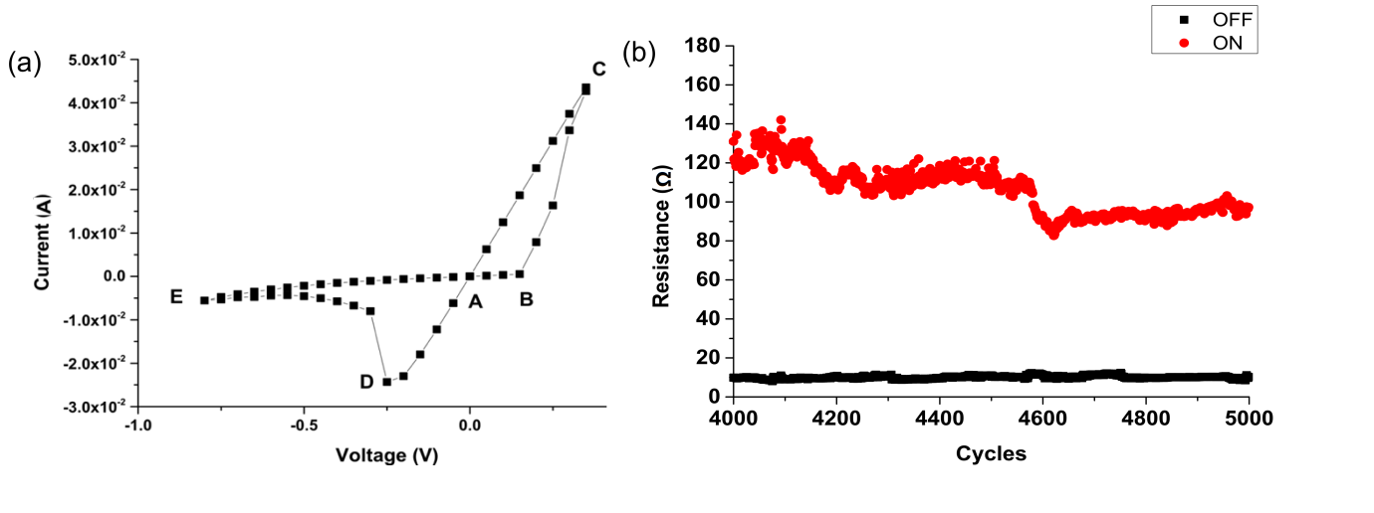
Figure 12 (a) I-V curve of resistive switching, (b) the dependence of R_{ON} and R_{OFF}.

4.2 Crossbar geometry
The crossbar geometry is fabricated with two line-shape electrodes in crossing and the electrolyte with buffer layer is inserted between electrodes. Two sets of samples were fabricated with different positons of Al₂O₃ film, and different I-V curves and impedance were testified, in order to investigate the function of buffer layer.
The cross section view of INERT BUFFER and ACTIVE BUFFER are presented in Figure 13 (a) and 13 (b). The conductive filament is expected to be formed in the chalcogenide GeSe layer rather than Al₂O₃ layer. Figure 13 (c) shows the atomic microscope image of Al₂O₃ layer deposited on the W electrode. The Al₂O₃ film is expected to consist of particles or islands, due to the short duration of laser deposition. It can be found from the AFM image of Al₂O₃ layer, that the surface is formed by particles ranging from 0 to 12 nm in height. It is much larger than the expected value of ultrathin Al₂O₃ layer from ellipsometry (2 nm) (Figure 13 (d)). Therefore, such roughness might be contribution of both Al₂O₃ layer and W layer.
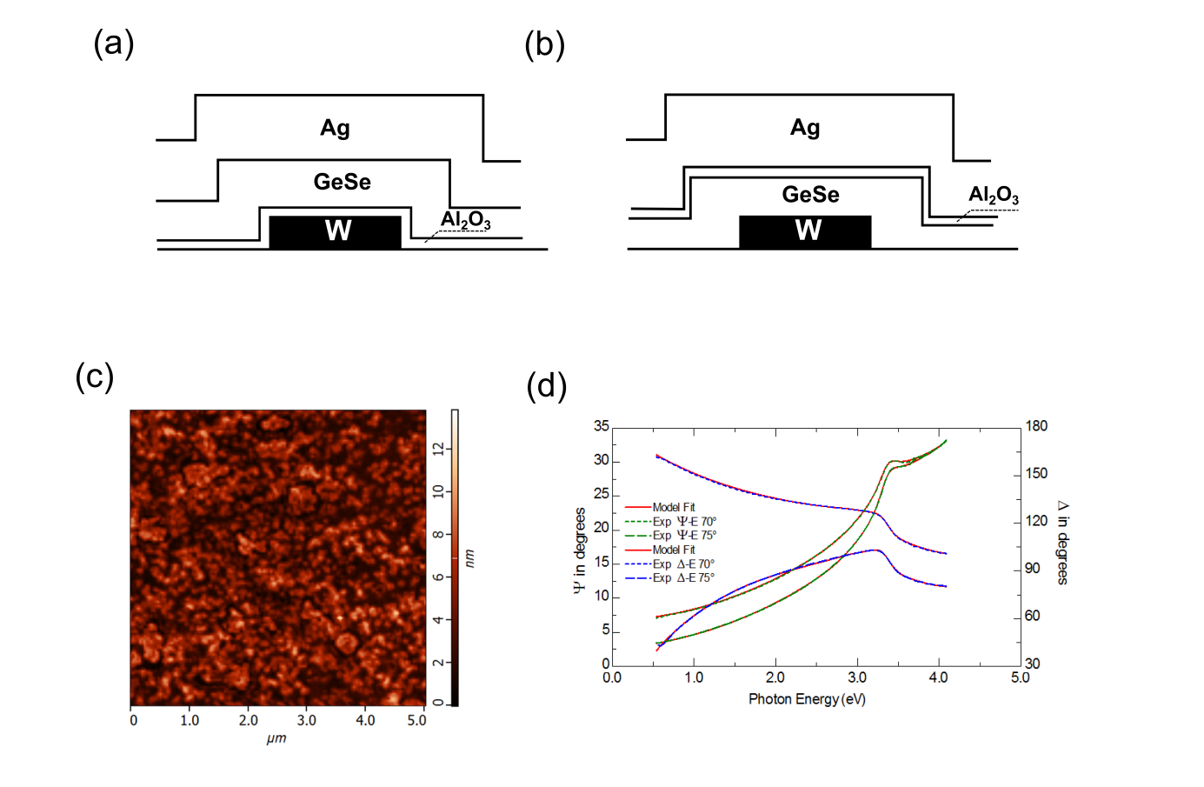
Figure 13: (a) The cross section view of INERT BUFFER device, (b) the cross sectional view of ACTIVE BUFFER device, (c) the atomic force microscope image of ultrathin Al₂O₃ layer (2 nm) deposited onto W layer, (d) ellipsometric data fit for Al₂O₃ layer used for calibration (14 nm, with duration 40 s).
The impedance spectroscopy of the sample was measured with W/Al₂O₃/GeSe/W stacking, which the resulting spectrum is shown in Figure 14. The resistance is 7.4 ×10⁹Ω. Only one semicircle can be identified, which indicates the Al₂O₃ layer does not completely cover the W electrode.
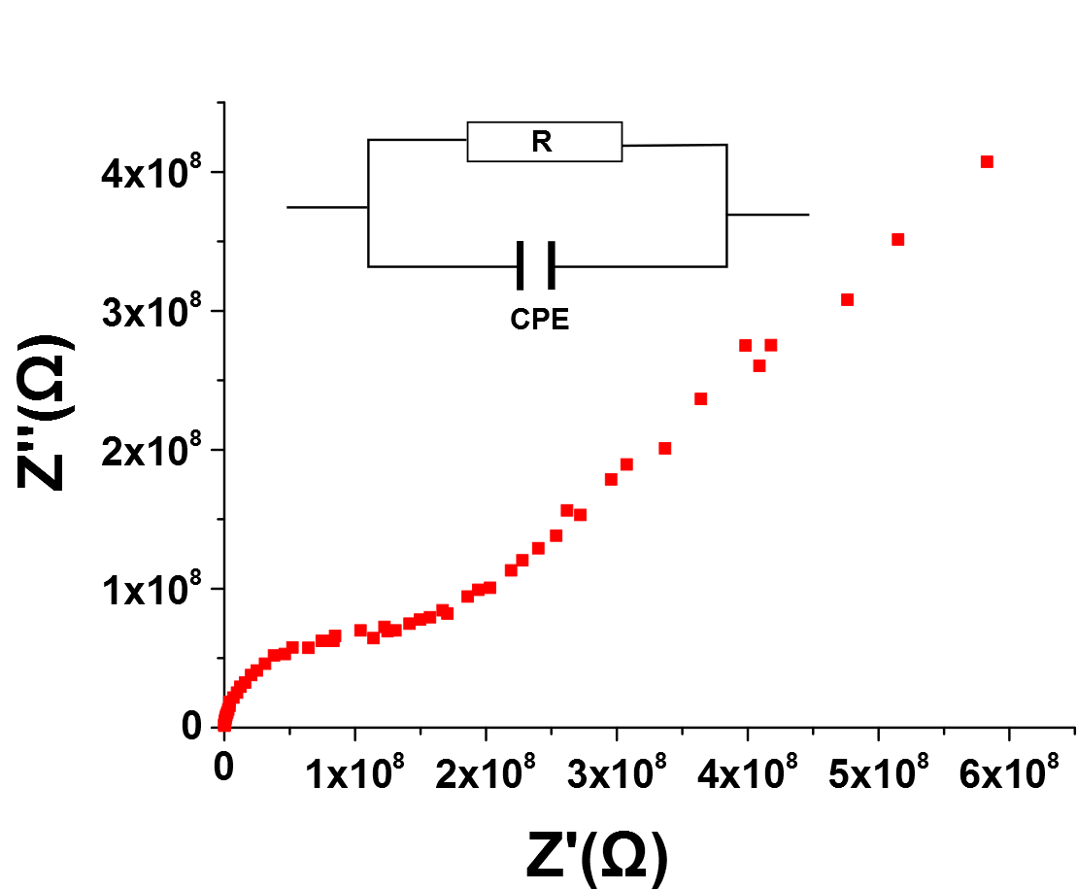
Figure 14: The impedance spectrum measurement of sample and equivalent circuit is presented in figure inset.
Figure 15 shows the I-V curve of resistive switching, in which the bias range and current limit are set differently between two samples. INERT BUFFER sample shows typical resistive switching cycle with SET bias approx. 1.2 V and RESET bias approx. −0.4 V, which is comparably higher than that described in literature [34]. Such difference is possibly caused by the buffer layer in reducing the leakage current and therefore, improving the SET bias. The linear independence of I-V curve proves the existence of metallic conductivity filament in INERT BUFFER sample. On contrary, the I-V curve in ACTIVE BUFFER sample exhibits a diode behavior and fluctuates from 1.0 V to 3.0 V and the corresponding threshold bias for current ramping up is 1.2 V.
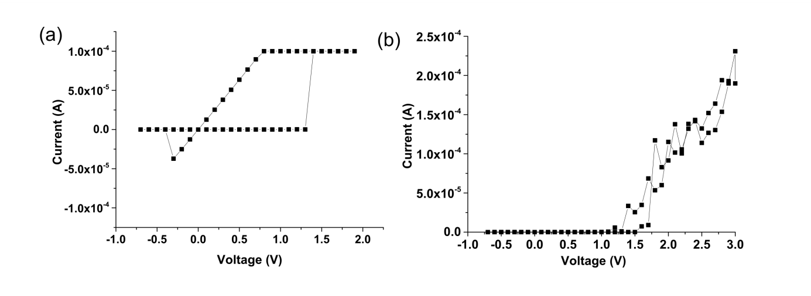
Figure 15: I-V curves: (a) INERT BUFFER (b) ACTIVE BUFFER.
As described above, the positon of buffer layer determines the behavior of device (resistive switching or diode), and the mechanism is explained in Figure 16. The Ag ions tend to nucleate in the uncovered regions, under bias, which finally results in formation of the conductive filaments (Figure 16 (a)). Figure 16 (b) shows the situation of buffer layer lies at interface of Ag electrode and Ag doped GeSe film. Under bias, the Ag ions are less likely to be nucleated either at the Ag or W electrode. Instead, Ag ions might be accumulated at the Ag electrode and causing polarized distribution.
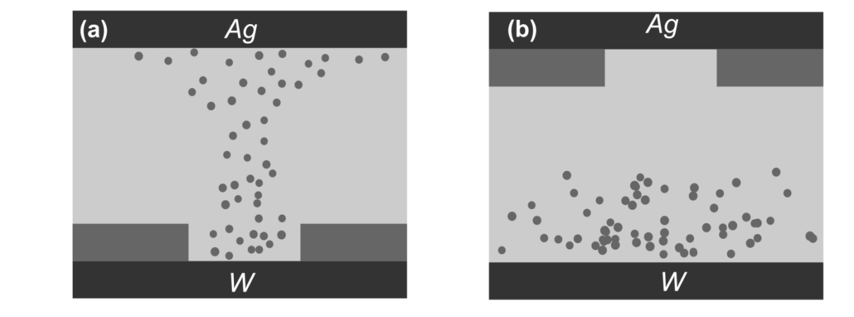
Figure 16: The schematic picture of mechanism in (a) the INERT BUFFER sample and (b) ACTIVE BUFFER sample.
Furthermore, the redox reaction of Ag species does not proceed; instead, the cell is turned into a capacitor. The increase of the device capacitance would lead to large charging current. In summary, the creation of filaments highly depends on the nucleation, which can be facilitated by inducing isolated regions of inert electrode. Moreover, it also proves the growth of filament is started from the inert electrode towards the active electrode, which fits the TEM observation result described in literature [35].

4.3 Needle contact geometry

4.3.1 Introduction
The device fabrication with needle contact geometry is similar as the spot geometry: The 300 nm Ag thin film over coated by 237 nm AsS₂ thin film was carried out onto silica glass substrate without mask. The measurement was done by Keithley 2602, in which the positive W needle probe was contacted with the Ag electrode and negative W probe needle was contacted with the sample surface. Therefore, the negative probe needle behaves as a floating electrode, and the size of needle tip (radius 100 $µm$) determines that of negative electrode.

4.3.2 The resistive switching curve
Figure 17 shows the schematic picture of experiment setup and the pulses. It can be clearly seen that the maximum voltage and minimum voltage was not set with the same value.
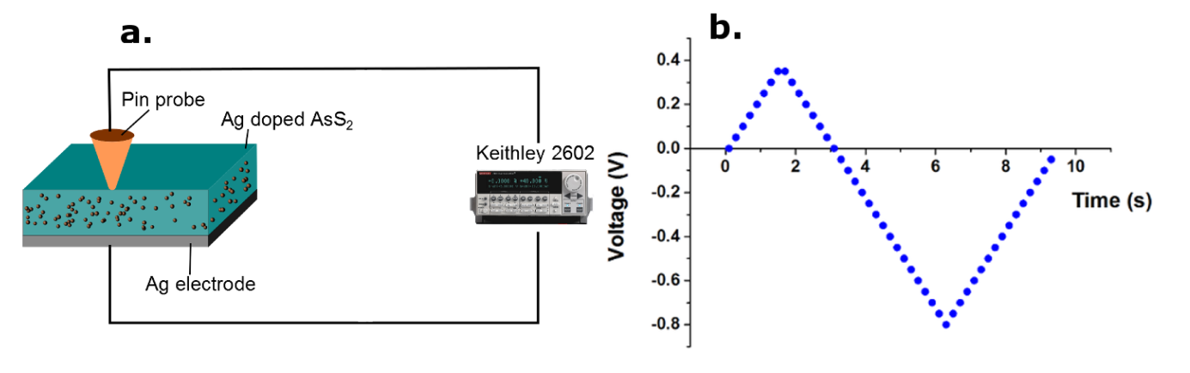
Figure 17: (a) The schematic picture of experiment setup, (b) the pulses of algorithm.
Figure 18 describes I-V curve in one cycle. The SET voltage is 0.35V, which is much smaller the RESET voltage (V_{RESET}), and the filament after RESET process is not completely dissolved.
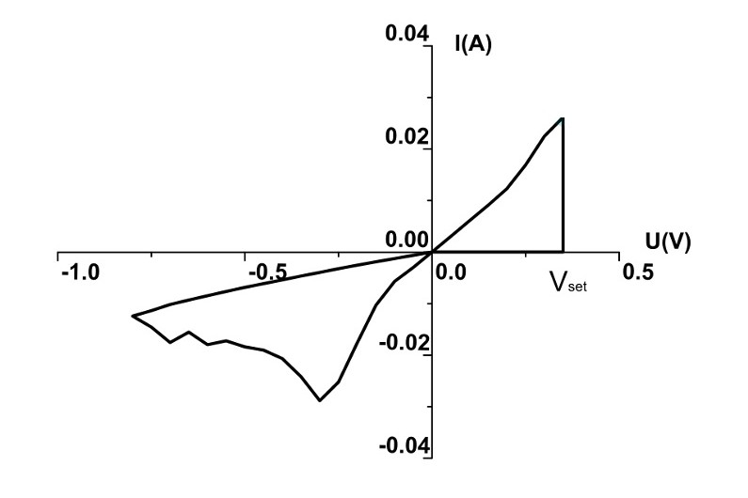
Figure 18: (a) I-V loop curve of AgAsS₂ sample.

4.3.3 The observation of sample
Figure 19 shows the surface morphology of the Ag-doped AsS₂ thin film after SET operation. In Figure 19 (a), Ag particles with different size are apparent that were deposited near to the contact point (labelled as “b”). Figure 19 (b) shows SEM image of this corresponding region highlighted in Figure 19 (a). Figure 19 (c) and Figure 19(d) shows the SEM image of silver particles with different sizes corresponding region marked in Figure 19(a), which might be induced by leakage of current. The cross section view shown in in Figure 19 (e) and Figure 19 (f).
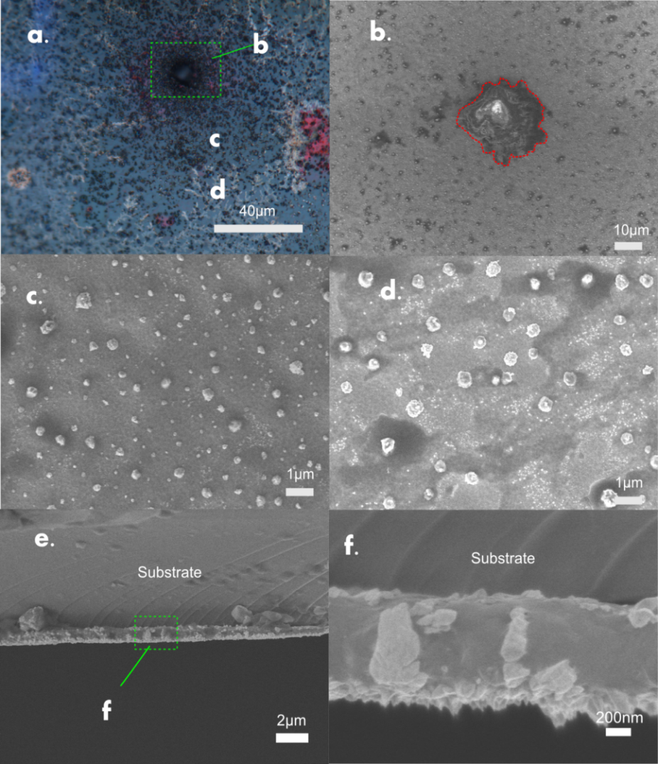
Figure 19: The surface morphology of thin layer memory cell, (a) Optical image of pin probe contact region, (b) SEM image of pin contact point, (c) SEM image of surface particles, (d) SEM image of tree branching, , (e)-(f) cross section images by SEM showing Ag filaments in detail.
From Figure 20, it can be seen that cross section of multilayer thin film, in which photo doped AsS₂ layer, Ag layer and silica substrate are stacked from the top to the bottom. Due to the distribution of electric field, the “etching” of Ag thin film shows different tendency.

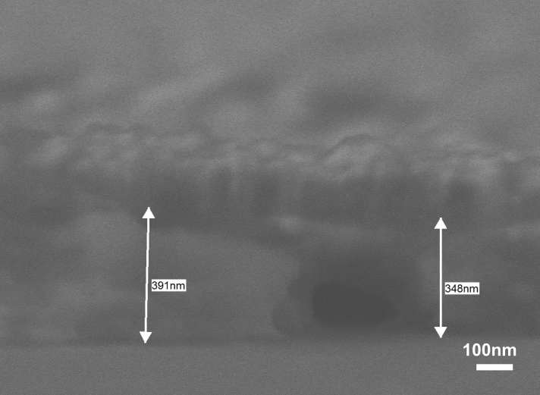
Figure 20: Cross section of multilayer thin film (AgAsS₂/Ag).
As shown in Figure 21, the morphology was porous, and multiple islands can be identified. The loss of Ag can be explained by either by Ag dissolution during photo doping or the oxidation and migration under external voltage. The further development of Ag “etching” might cause the completely loss of electrode, exposing the chalcogenide thin film, resulting in a constant high resistance at last.
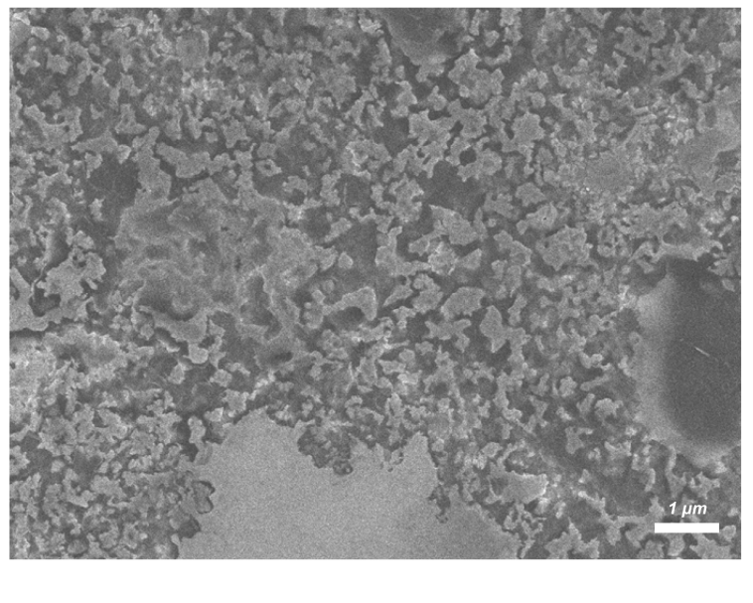
Figure 21: The SEM image of Ag electrode from the back side after switching

4.3.4 Electron induced particle creation
It is worth to mention an electron beam induced particle formation was observed, during SEM imaging. Photo surface deposition has been known for chalcogenide thin film, on which Ag particles are deposited during the light exposure. Photo illumination provides main driving force, in comparison with electrons emitted from SEM gun [24]. . A test was designed with different exposure time and accelerating voltage on photo doped AsS₂ to clarify the phenomena. The SEM image was taken by JEOL 7500. And the relevant parameter was shown in table 5.
Table 5: The parameter of experiment with SEM.
Magnification | Time for image (seconds) | Voltage(kV) | Mode
×20,000 | 0, 30, 60, 90, 120, 180, …, 600 | 15 | Secondary electrons
×100,000 | 0, 30, 60, 90, 120, 180, …, 300 | 15 | Secondary electrons
Figure 22 shows the generation of Ag clusters, under the exposure of electron beam emitted from electron gun of SEM. In Figure 22 (a), there were some Ag cluster cluster nuclei deposited on the surface, which were developed from photo doping and photo surface deposition. From Figure 22 (b) to Figure 22 (f), Most of Ag clusters were grown from nuclei and the growth dimension was along three dimensions. Nevertheless, the morphology of Ag clusters do not share any common geometry and the scale of Ag clusters varied from approx. 1 μm to 100 nm in Figure 22 (f).
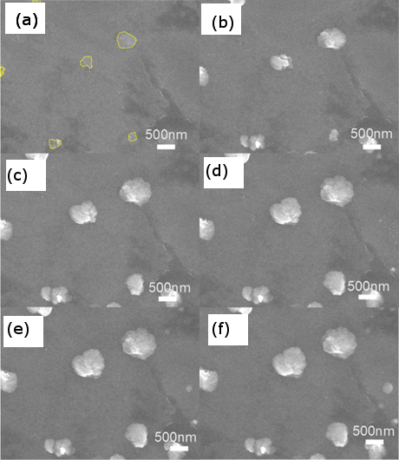
Figure 22: The selected SEM images (×20,000) of Ag clusters; (a) 0 s, (b) 90 s, (c) 180 s, (d) 360 s, (e) 480 s, (f) 600 s; the nuclei are marked with yellow circle.
Figure 23 shows the static data regarding with total number and the maximum diameter of Ag clusters obtained from SEM image, partially shown in Figure 22. It can be seen that the number of Ag clusters was quite stable in the time from 0 to 600 s, which increased only from 6 to 8. During this time, the maximum diameter of Ag clusters increased from approx. 450 to 800 nm in the initial 200 s, then kept stable at 900 nm till 600 s. Therefore, during 200 s, the growth of Ag clusters was the dominated process, and the equilibrium size of Ag clusters was obtained from 200 s to 600 s.
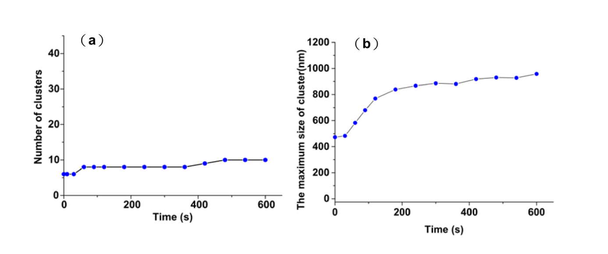
Figure 23: The statistical data obtained from SEM image with ×20,000 magnifications. (a) The number of clusters developed with time per area of approx. 1.2 × 1.2 μm² (b) The maximum diameter of clusters developed with time.
Figure 24 shows the enlarged image of nucleus creation from 0 s till 360 s under 100,000 x magnification. From Figure 24 (a) to Figure 24 (b), the Ag ion started to agglomerate and several nuclei, shown in yellow circle, had formed.
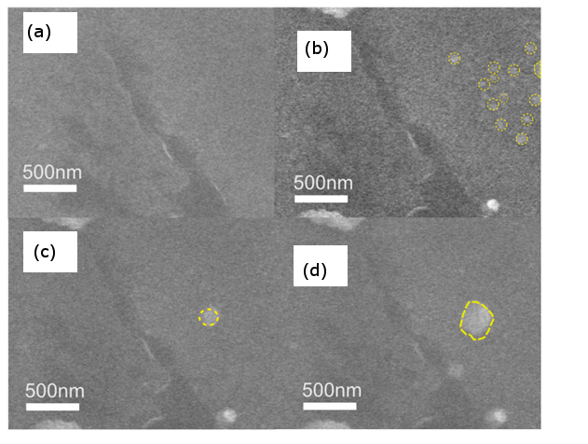
Figure 24: The enlarged SEM image (×20,000) of Ag cluster formation; (a) 0 s, (b) 360 s, (c) 480 s, and (d) 600 s.
Figure 25 shows the image of Ag cluster growth under high magnification (×100,000). The region for observation was selected without nuclei, as shown in Figure 25 (a). All the Ag clusters were induced by the electric beam form SEM. It is noticeable the Ag cluster in red circle, which was appeared at 150 s in Figure 25(b). At 180 s, Ag cluster in yellow circle appeared and the dimension of Ag cluster in red remained unchanged. However, in Figure 25(d), the Ag cluster in yellow circle grew up, while the Ag cluster in red circle was partially dissolved back into thin film.
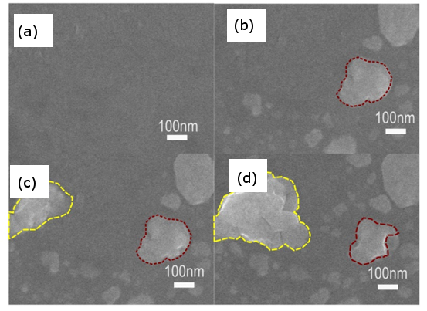
Figure 25: The selected SEM image (×100,000) of Ag clusters and Ag-rich regions; (a) 0 s, (b) 150 s, (c) 180 s, (d) 300 s.
Figure 26 shows the static data obtained from SEM image with ×100,000 magnification. As the higher magnification was used, the exposure time was shortened to be 5 minutes, compared with 10 minutes in Figure 23. The number of clusters in Figure 26 (a) exhibits a saturation value, since 240 s. And the total number is below 10. The maximum size of clusters shows an increasing trend up to 500 nm, as shown in Figure 26 (b).
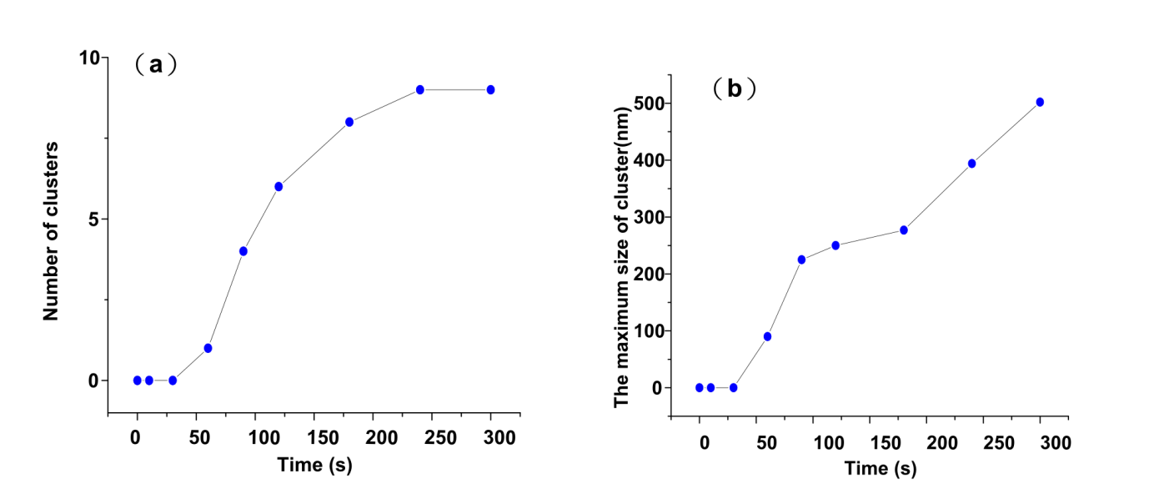
Figure 26: : The statistical data obtained from SEM image with ×100,000 magnification: (a) The number of clusters developed with time (b) The maximum size of clusters developed with time per area of approx. 700× 700 nm².
Figure 27 shows the SEM image of AsS₂/Ag sample illuminated by electron beam at 5kV at 1000x magnification. The grey square presents the illuminated region. It can be clearly found that no Ag particles were deposited on the top of the thin film sample.
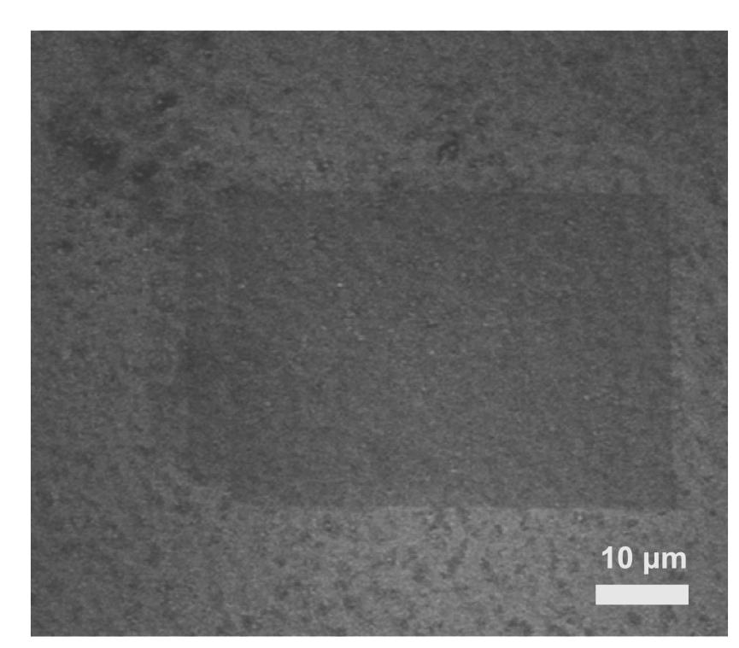
Figure 27: SEM image of AsS₂/Ag sample irradiated by electron beam at 5 kV at ×1,000 magnification.

4.5 Tip (conductive AFM) geometry

4.5.1 Introduction
The resistive switching of the cells was evaluated by a conductive atomic force microscopy (AFM Solver Pro M, NT-MDT; Russia) with a silicon probe coated with the Cr/Pt layer, scanning first from 10 mV to 100 mV and then from -10 mV to -100 mV with bias step 30 mV. The tapping mode was selected to investigate i) the in situ surface morphology of the memory cell, in particular volume changes and ii) the spread currents. The screened area had a size of 3×3 µm².

4.5.2 The maps of surface morphology and distribution of spread current
Figure 28 (a) and (b) shows the surface morphology of the cell. As one can see, the surface consists of Ag particles (with different dimensions) grown on the Ag_{x}AsS₂ layer by the OIDD process. Figure 28 (c) shows a scheme of the C-AFM measurement of the thin cells. The positive electrode consists of the Ag layer and the negative electrode consists of the C-AFM tip utilized for analysis.
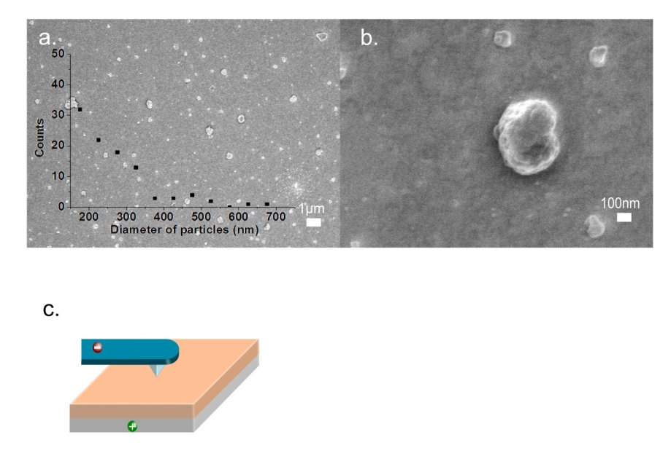
Figure 28: (a) SEM image of Ag particles grown on the Ag_{x}AsS₂ layer by OIDD (The inset shows the Ag particle size distribution on the layer), (b) an enlarged SEM image showing Ag particle in detail, (c) the scheme of experimental setup.
Figure 29 shows the optical image of the tip above the Ag doped AsS₂ thin film before and after applied voltage. Ag precipitation was observed as branching structure, initiated from the AFM tip. That situation should be avoided by applying short pulse of bias and gradually increase the bias.
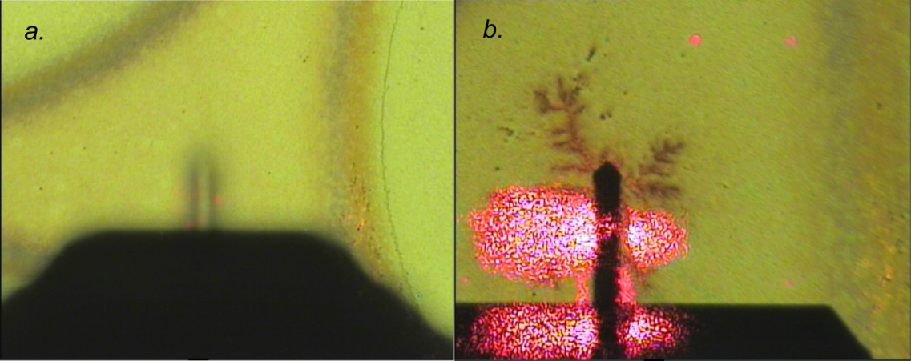
Figure 29: Optical image of conductive AFM and its tip, which shows tree branching after applied with 2.5V for 1 second ((a) Before voltage applied (b) after voltage applied)
Figure 30 shows a sequence of topographical maps and spread current maps recorded on the surface of Ag_{x}AsS₂. In the 2D topological map shown in Figure 30(a), it was recorded before any external bias was applied to the cell. Figure 30(b) corresponds to the case, when a bias of 70 mV was applied to the cell. It can be seen that almost no volume change occurred under this bias. Figure 30(c) corresponds to the case, when a bias of 100 mV was applied to the cell. Compared with results of Figure 30(a) and 30(b), a whole range of new particles with different size appeared on the surface. In addition, the initial 3 spots were also expanded in size. By comparison of maps in Figure 30(c), one can see that the current flows not through the newly grown surface particles, but rather around. Figure 30(d) corresponds to the final step of the switching cycle, when a bias of -100 mV was applied on the cell. As once can see, most of particles disappeared, the current map shows a dramatic decrease of the current.

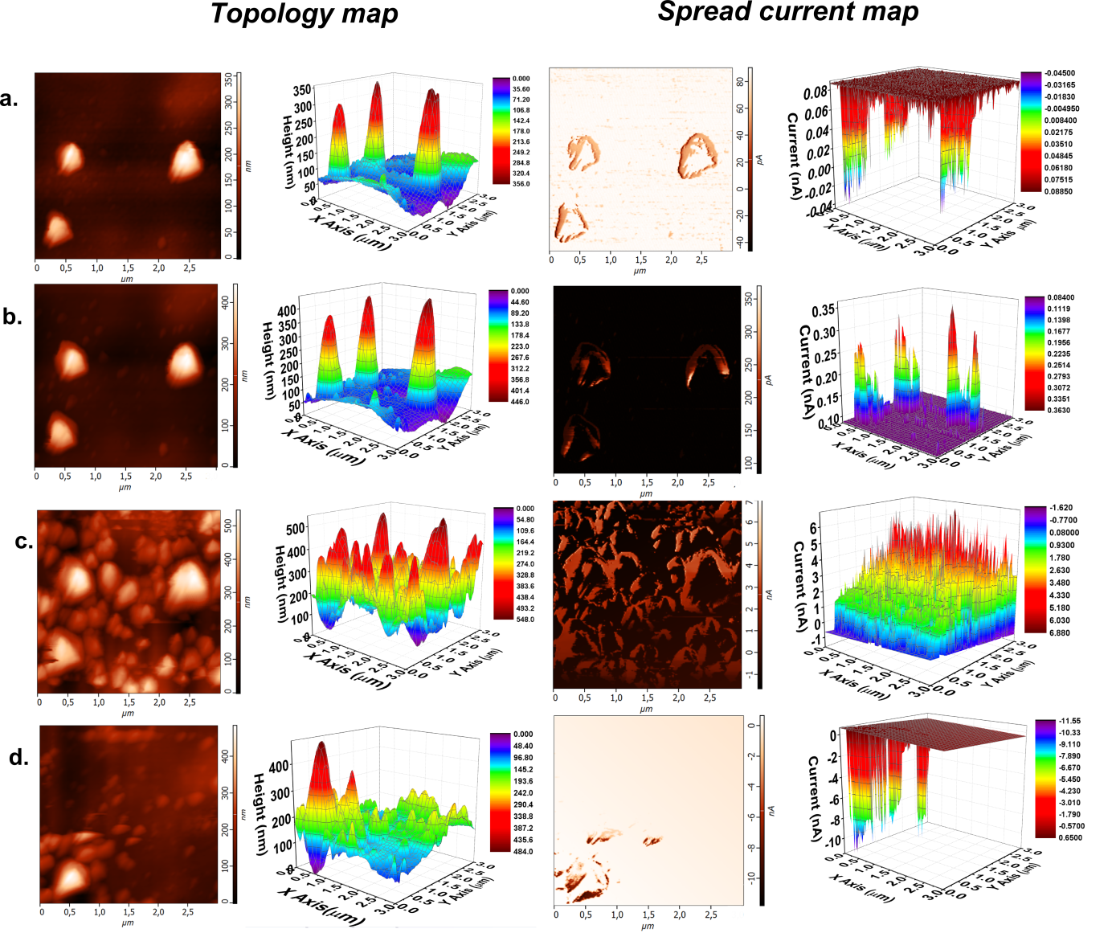
Figure 30: 2D and 3D topological maps (left column) and spread current maps (right column) of the Ag_{x}AsS₂ layer obtained under applied bias of (a) 0 mV, (b) 70 mV, (c) 100 mV, (d) -100 mV.
Figure 31 (a) plots the sum of currents (calculated from the data points in the spread current maps) as a function of the applied bias. Figure 31(b) plots the volume change of Ag_{x}AsS₂ layer, derived from the topological maps obtained by C-AFM measurements, as a function of applied bias.
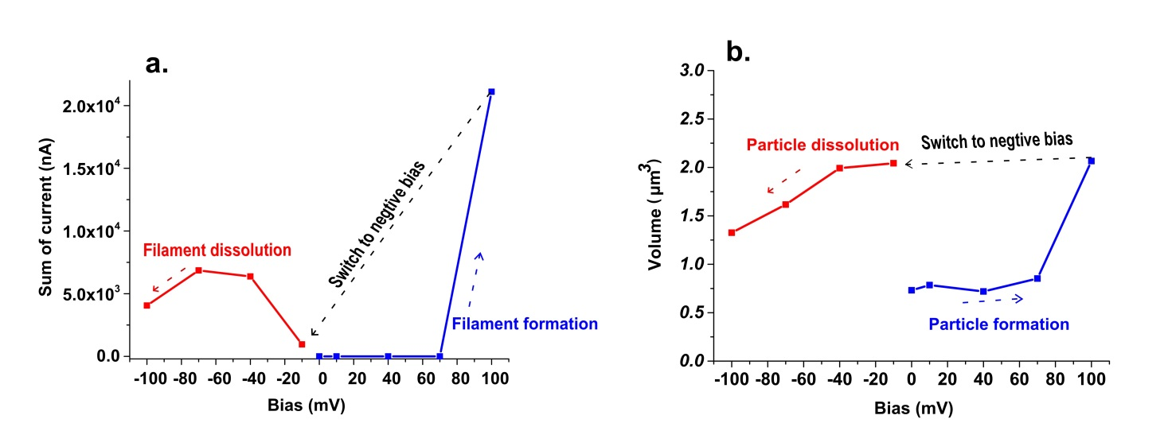
Figure 31: (a) The sum of current flowing through the thin layer, (b) the volume change of thin layer. The blue and red lines represent currents recorded under positive and negative bias, respectively (arrow indicates the direction of bias).
A model explaining the mechanism of the Ag particle and Ag filament formation was proposed in Figure 32, based on the distribution (and interaction) of charge carriers and Ag ions within the Ag_{x}AsS₂ layer. Under illumination, the charge carriers would be generated strongly at the surface. Due to higher mobility of holes in the Ag_{x}AsS₂ layer, the holes diffuse into the interior of thin layer, while the less mobile electrons are aligned at the surface [36]. Electrons and holes form a double layer there, by which the Ag ions are separated away from the uppermost part of surface, as depicted in Figure 32(a). The Ag ions diffuse through the region of accumulated holes and the surface residual electrons lead to the reduction of Ag ions on the surface, as described in Figure 49(b). As explained above, only Ag particles are formed under illumination (OIDD). Figure 32(c) exhibits the possible distribution (in the area without Ag particles) of carrier-rich region (position 1) and Ag ion-rich region (position 2) at the interface after illumination (OIDD). As depicted in Figure 32(d), after biasing the layer, the repulsion between holes and Ag ions takes place. As a result, the reduction of Ag ions (from Ag species forming filaments) occurs within the internal volume of Ag_{x}AsS₂ layer at position 1, in comparison with surface reduction (forming Ag particles) at position 2.
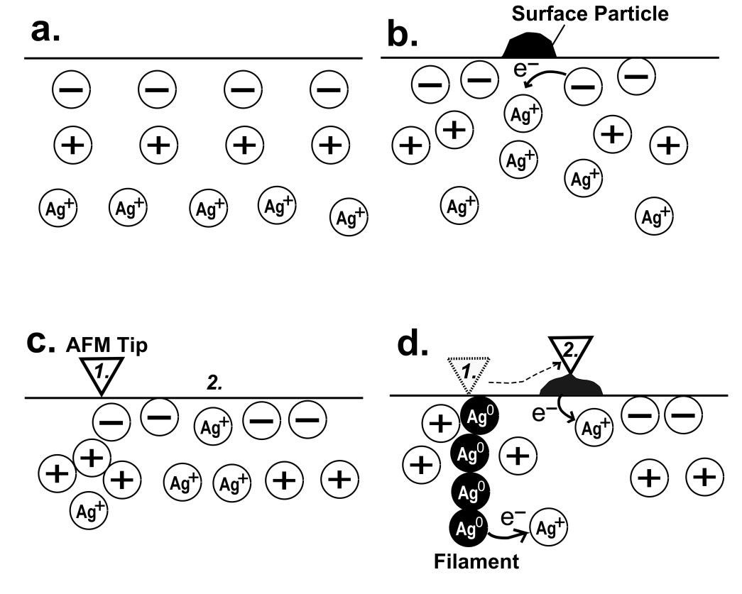
Figure 32: The mechanism of Ag particle and filament formation on and within Ag_{x}AsS₂ layer: [(a) the initial formation of electron-hole double layer and diffusion of Ag ions under illumination, (b) the reduction of Ag ions by surface electrons and followed Ag particles formation under illumination, (c) the initial state of C-AFM scans after illumination. At position 1, there is carrier-rich region layer, blocking the diffusion of Ag ions; at positon 2, the Ag ions reach the surface thin layer, (d) the filament and surface particle formations at position 1 and 2.]

4.6 Via-hole geometry
The fabrication of device starts from the deposition of Ti adhesion layer onto SiO₂ substrate, and a layer of Pt film is followed as the bottom electrode. And SiO₂ layer is deposited by PECVD as a barrier layer, and then etched into graphic picture during photoresist lithography process. The electrolyte and top electrode are deposited normally as the other geometries, as shown in Figure 33.
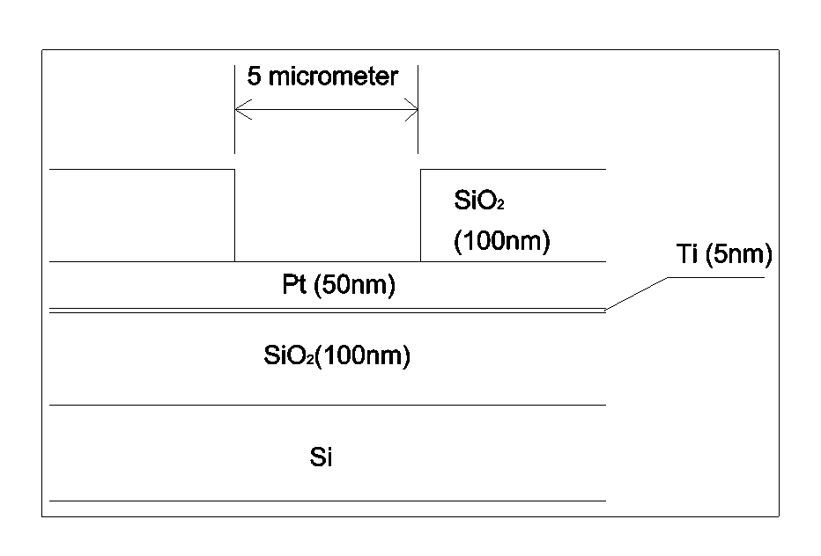
Figure 33: The profile of fabricated device after photoresist lithography
It can be seen from Figure 32 that I-V curves in sample with via-hole geometry. The scanning range is between 0.4 and -0.4 V, and current limit is 1×10⁻⁵A. In contrast with Figure 32, the sample in via-hole geometry owns lower threshold voltage and current limit, which exhibits the miniature of device in photoresist lithography.
Figure 32: I-V curve in sample with via-hole geometry.

Conclusion of thesis
In this thesis, resistive switching devices were fabricated with ionic Ag-doped chalcogenide thin film. Five different geometries were discussed in the context.
The resistive switching is accounted for the material resistance in variation with external voltage. The variation of resistance commonly results in two resistance states, which has been discovered in semiconductor, insulator, and solid state electrolyte. In our study, Ag ions doped chalcogenide was selected as the electrolyte.
Five geometries of memory cells were discussed in the context of thesis, which are spot geometry, crossbar geometry, needle contact geometry, tip (conductive AFM) geometry and via-hole geometry. According to the properties of electrodes, those can be divided by two types: sample with fixed electrode and samples with floated electrode. Fixed electrodes were utilized for device study, while floated electrodes were designed for investigating the switching property of material.
The fixed electrodes were prepared via thermal evaporation or magnetron sputtering and the outline of electrodes were defined by stainless steel stencil mask or photoresist lithography. The dimension of electrode in crossbar geometry is 0.1 mm, in contrast to 5$µm$ in via-hole geometry. Furthermore, the I-V curve of via-hole geometry exhibits lower compliance current and SET voltage than that with the crossbar geometry. Therefore, the via-hole geometry is promising to be commercialized in the future.
Although the study of resistive switching has been carried on over half century, the mechanism is still on debate. Up to now, the conductive filament model has been the most popular. Therefore, the observation of filament is of great importance for learning the physical property of resistive switching.
The filament observation was carried out by SEM and conductive AFM. In order to observe the cross sectional view, the sample was cut mechanically. With the secondary electron mode of SEM, several filaments can be seen, which is embedded in the thin film matrix. In addition, due to the existence of electron beams, the Ag particles were deposited onto the top of thin film. The top view of filaments was obtained by conductive AFM.
In summary, the resistive switching Ag doped chalcogenide electrolyte was discussed in the content with five different geometries. The filament was observed either by SEM or AFM, offering fruitful information for future investigation.

Reference
[1] Von Neumann architecture, Wikipedia. (n.d.). https://en.wikipedia.org/wiki/Von_Neumann_architecture.
[2] Wikipedia, Dynamic random-access memory, (n.d.). https://en.wikipedia.org/wiki/Dynamic_random-access_memory.
[3] Diffen, RAM vs. ROM, (n.d.). http://www.diffen.com/difference/RAM_vs_ROM.
[4] J.F. Scott, Ferroelectric memories, Phys. World. 8 (1995) 46–50. doi:10.1126/science.246.4936.1400.
[5] R.J. Lipton, J.S. Sandberg, Pram: A scalable shared memory, Princent. Univ. (1988) 13.
[6] T.M. Maffitt, J.K. DeBrosse, J. a. Gabric, E.T. Gow, M.C. Lamorey, J.S. Parenteau, et al., Design considerations for MRAM, IBM J. Res. Dev. 50 (2006) 25–39. doi:10.1147/rd.501.0025.
[7] X. Dong, X. Wu, G. Sun, Y. Xie, H. Li, Y. Chen, Circuit and microarchitecture evaluation of 3D stacking magnetic RAM (MRAM) as a universal memory replacement, in: Proc. - Des. Autom. Conf., 2008: pp. 554–559. doi:10.1109/DAC.2008.4555878.
[8] R. Waser, M. Aono, Nanoionics-based resistive switching memories., Nat. Mater. 6 (2007) 833–840. doi:10.1038/nmat2023.
[9] T. Yanagida, K. Nagashima, K. Oka, M. Kanai, A. Klamchuen, B.H. Park, et al., Scaling Effect on Unipolar and Bipolar Resistive Switching of Metal Oxides, Sci. Rep. 3 (2013) 1657. doi:10.1038/srep01657.
[10] F. Pan, C. Chen, Z. Wang, Y. Yang, J. Yang, F. Zeng, Nonvolatile Resistive Switching Memories-Characteristics, Mechanisms and Challenges, Prog. Nat. Sci. Mater. Int. 20 (2010) 1–15. doi:10.1016/S1002-0071(12)60001-X.
[11] D.J. Wouters, R. Waser, M. Wuttig, Phase-Change and Redox-Based Resistive Switching Memories, Proc. IEEE. 103 (2015) 1274–1288. doi:10.1109/JPROC.2015.2433311.
[12] G.H. Oh, Y.L. Park, J.I. Lee, D.H. Im, J.S. Bae, D.H. Kim, et al., Parallel multi-confined (PMC) cell technology for high density MLC PRAM, 2009 Symp. VLSI Technol. 4 (2009) 220–221.
[13] P.Dorion, O.Cueto, M.Reyboz, Simulation of CBRAM devices with the level set method, in: Simul. Semicond. Process. Devices, Glasgow, 2013: pp. 340 – 343. doi:10.1109/SISPAD.2013.6650644.
[14] K. Terabe, T. Hasegawa, T. Nakayama, M. Aono, Quantized conductance atomic switch., Nature. 433 (2005) 47–50. doi:10.1038/nature03190.
[15] F. Pan, S. Gao, C. Chen, C. Song, F. Zeng, Recent progress in resistive random access memories: Materials, switching mechanisms, and performance, Mater. Sci. Eng. R Reports. 83 (2014) 1–59. doi:10.1016/j.mser.2014.06.002.
[16] M.N. Kozicki, A. Tempe, M. Balakrishnan, Programmable metallization cell memory based on Ag-Ge-S and Cu-Ge-S solid electrolytes, in: Non-Volatile Mem. Technol. Symp., 2005: pp. 7–89. doi:10.1109/NVMT.2005.1541405.
[17] J. Kolar, J.M. Macak, K. Terabe, T. Wagner, Down-scaling of resistive switching to nanoscale using porous anodic alumina membranes, J. Mater. Chem. C. 2 (2014) 349. doi:10.1039/c3tc31969e.
[18] X. Guo, C. Schindler, S. Menzel, R. Waser, Understanding the switching-off mechanism in Ag⁺ migration based resistively switching model systems, Appl. Phys. Lett. 91 (2007). doi:10.1063/1.2793686.
[19] C. Schindler, S. Chandran Puthen Thermadam, R. Waser, M. N. Kozicki, Bipolar and Unipolar Resistive Switching in Cu-Doped SiO₂, IEEE T-ED. 54 (2007) 2762–2768. doi:10.1109/TED.2007.904402.
[20] Z.U.Borisova, Glassy semiconductors, Plenum Press, New York,USA, 1981.
[21] S.R. Elliott, Physics of amorphous materials, 1st ed., Longman Group Ltd., London, 1984.
[22] M.T. Kostyshin, E.V. Mikhaylovskaya, P.E. Romanenko, Photographic-Sensitivity Effect in Thin Semiconducting Films on Metal Substrates, Sov. Phys. Solid State. 8 (1966) 451 452.
[23] A.V. Kolobov, S.R. Elliot, Photodoping of amorphous chalcogenides by metals, Adv. Phys. 40 (1991) 625–684.
[24] T. Kawaguchi, K. Tanaka, S.R. Elliott, Photoinduced and electron-beam phenomena in Ag rich amorphous chalcogenide semiconductors, in: Handb. Adv. Electron. Photonic Mater. Devices, 2001: pp. 92–117.
[25] M.S. Ailavajhala, T. Nichol, Y. Gonzalez-Velo, H.J.B. Christian D. Poweleit, Thin Ge–Se films as a sensing material for radiation doses, Phys. Status Solidi. 251 (2013) 1347–1353. doi:DOI 10.1002/pssb.201350188.
[26] J.E. Green, J.W. Choi, A. Boukai, Y. Bunimovich, E. Johnston-Halperin, E. DeIonno, et al., A 160-kilobit molecular electronic memory patterned at 10(11) bits per square centimetre., Nature. 445 (2007) 414–417. doi:10.1038/nature05462.
[27] H.S. Yoon, I.-G. Baek, J. Zhao, H. Sim, M.Y. Park, H. Lee, et al., Vertical cross-point resistance change memory for ultra-high density non-volatile memory applications, 2009 Symp. VLSI Technol. (2009) 26–27.
[28] Z. Zhang, Y. Wu, H.P. Wong, S.S. Wong, Nanometer-Scale HfO_{x} RRAM, IEEE Electron Device Lett. 34 (2013) 1005–1007. doi:10.1109/LED.2013.2265404.
[29] R. Waser, R. Dittmann, C. Staikov, K. Szot, Redox-based resistive switching memories nanoionic mechanisms, prospects, and challenges, Adv. Mater. 21 (2009) 2632–2663. doi:10.1002/adma.200900375.
[30] C. Schindler, Resistive switching in electrochemical metallization memory cells, Technischen Hochschule Aachen, 2009.
[31] C. Sang Jun, P. Gyeong Su, K. Ki Hong, C. Soohaeng, In Situ Observation of Voltage-Induced Multilevel Resistive Switching in Solid Electrolyte Memory, Adv. Mater. 23 (2011) 3272–3277.
[32] Reference Manual, 2600s-901-01 Rev.B. (n.d.). http://www.ece.uprm.edu/~etclab/resources/equipment/keithley2612/2600series_referencemanual.pdf.
[33] Solver PRO M, (n.d.). http://amnol.usv.ro/DOC/AFM.pdf.
[34] C. Schindler, I. Valov, R. Waser, Faradaic currents during electroforming of resistively switching Ag-Ge-Se type electrochemical metallization memory cells., Phys. Chem. Chem. Phys. 11 (2009) 5974–5979. doi:10.1039/b901026b.
[35] Y. Yang, P. Gao, S. Gaba, T. Chang, X. Pan, W. Lu, Observation of conducting filament growth in nanoscale resistive memories, Nat. Commun. 3 (2012) 732. doi:10.1038/ncomms1737.
[36] A. V. Kolobov, On the origin of p-type conductivity in amorphous chalcogenides, J. Non. Cryst. Solids. 198-200 (1996) 728–731. doi:10.1016/0022-3093(96)00119-6.

Publications and conferences
B. Zhang, M. Fraenkl, J.M. Macak, T. Wagner, Ag filament and surface particle formation in Ag doped AsS₂ thin film, Mater. Lett. 163 (2016) 4–7.doi:10.1016/j.matlet.2015.08.131.
B. Zhang, P. Kutalek, P. Knotek, L. Hromadko, J.M. Macak, T. Wagner, Investigation of the resistive switching in Ag_{x}AsS₂ layer by conductive AFM, Appl. Surf. Sci. 382 (2016) 336–340. doi:10.1016/j.apsusc.2016.04.152.
R.M. Mawale, M. Alberti, B. Zhang, F. Max, T. Wagner, J. Havel, Structural elucidation of AgAsS2 glass by the analysis of clusters formed during laser desorption ionisation applying quadrupole ion trap time of flight mass spectrometry, Rapid Commun. Mass Spectrom. 30 (2016) 594–602. doi: 10.1002/rcm.7479.
T. Wagner, B. Zhang, S. Valkova, M. Fraenkl, M. Krbal, M. Frumar, G. Chen, Nanoscale memories in Chalcogenide Glass Films, Society Glass Technology Annual Meeting (Glass Reflections- Glass in the Year of Light), 7 - 9 September 2015, Cambridge, UK. Invited lecture.
T. Wagner, B. Zhang, S. Valkova, M. Fraenkl, M. Krbal, M. Frumar, G. Chen, Chalcogenide glass films for Nanoscale memories, 20th Int. Conf. ISNOG 2016, Niznij Novgorod, Russian, 21-26. Augest 2016
B. Zhang, J. Kolar, J. M. Macak, T. Wagner, “Stages in resistive switching of memory cells based on chalcogenides and nanoporous AAO’’ International Days of Materials Science (IDMS) 2014, Pardubice, 12/2/2014.
B. Zhang, J. Kolar, J. M. Macak, T. Wagner, “Stages in resistive switching of memory cells based on chalcogenides and nanoporous AAO’’ 66th Congress of Chemical Societies (7 - 10 September, Ostrava)

