High performance one-pack ambient crosslinking latex binders containing low generation PAMAM dendrimers and ZnO nanoparticles

Jana Machotova ^{a,*}, Adela Ruckerova ª, Peter Bohacik ª, Katerina Pukova ^{b}, Andrea Kalendova ª, Jiri Palarcik ^{b}

ª Institute of Chemistry and Technology of Macromolecular Materials, Faculty of Chemical Technology, University of Pardubice, Studentská 573, 532 10 Pardubice, Czech Republic
^{b} Institute of Environmental and Chemical Engineering, Faculty of Chemical Technology, University of Pardubice, Studentská 573, 532 10 Pardubice, Czech Republic

Correspondence to: Jana Machotová; e-mail address: jana.machotova@upce.cz,
tel.: +420 46 603 7194, fax: +420 46 603 7068.

Abstract
This study focuses on ambient temperature self-crosslinking acrylic latex coating compositions containing poly(amidoamine) (PAMAM) dendrimers and ZnO nanoparticles in the role inter-particle crosslinking agents and flash rust inhibitors. Low generation amine-terminated PAMAM dendrimers as aqueous solutions were added into latices containing diacetone acrylamide repeat units in their polymer structure. The incorporation of ZnO nanoparticles (without any surface treatment) was performed during the synthesis of a polymer dispersion carried out by the semi-continuous emulsion polymerization technique. The latex storage stability and coating performance with respect to zinc oxide and PAMAM presence were evaluated and compared with a conventional zinc oxide-free coating composition containing adipic acid dihydrazide (ADH) as the crosslinking agent. It was found that the novel latices containing both PAMAM dendrimers and ZnO nanoparticles exhibited a long-term storage stability and provided crosslinked transparent coating films of high gloss, enhanced mechanical properties, solvent resistance and excellent water whitening resistance. Moreover, the latex compositions containing PAMAM dendrimers as the inter-particle crosslinkers were shown to provide flash rust resistance.

Keywords: Self-crosslinking latex, PAMAM dendrimer, Water whitening, Flash rust, Zinc oxide, Nanoparticle

Introduction
With the rise in demand for eco-friendly, cost-effective, high-performance and transparent coatings ideal for protection of various substrates including steel, their development is a major challenge. Latex paints are pollution-free, non-hazardous, safe, and easily applied, which makes them much more preferable to conventional solvent-based paints. On the other hand, their performances such as gloss, hardness, chemical resistance and mechanical properties are usually inferior to solvent-based paints. To overcome these drawbacks, various crosslinking methods of latex coatings have been developed.¹⁻⁴ As the improvement should not detract from easy applicability of latex paints, considerable efforts have been dedicated to development of one-pack self-crosslinking coating compositions curable at ambient temperature. Self-crosslinking systems based on the reaction of a ketone carbonyl group of diacetone acrylamide (DAAM), being the part of the polymer backbone, with a dihydrazide, especially where the dihydrazide is adipic acid dihydrazide (ADH), have been the subject of increased interest.⁵⁻¹⁰ These one-pack coating systems offer the advantage of fast, ambient-temperature crosslinking in functionalized latex, when the dihydrazide is incorporated in the aqueous phase of the latex.
A common drawback of latex coatings is their water sensitivity, usually connected with water whitening, loss of adhesion and poor durability. Normally, when latex particles dry to form a continuous clear film, the liquid water evaporates while ionically-charged or water-soluble components such as surfactants, initiators and buffers remain trapped in interstitial areas of the film. Because they are more hydrophilic than the latex particles, these components tend to attract water and may become a driving force for the migration of water into interstitial areas. This migration results in increased water absorption and water whitening of latex coatings.
The water resistance of latex compositions can be improved by removing hydrophilic components, crosslinking the polymer latex or introducing special monomers into the polymer latex. The hydrophilic components are usually the essential part of standard commercial products, therefore the efforts to enhance water resistivity of latex coatings by means of polymer structure changes are being encouraged. As the special monomers, the VeoVa acrylics have been reported.¹¹ Further, acrylic latex formulations using polyamines as additives have been shown to provide an improved water whitening resistance property.¹² All these emulsion polymers always contained a considerable amount of amide-based acrylic monomers as well.
In view of the above, amine-terminated poly(amidoamine) (PAMAM) dendrimers attracted our attention from the point of view of representing promising crosslinking agents for water resistant one-pack self-crosslinking latex coating compositions based on DAAM-containing emulsion polymers. PAMAM dendrimers are a specific family of dendritic polymers based on an ethylenediamine core and an amidoamine repeat branching structure.^{13,14} They are synthesized from cheap raw materials and their size and surface functionality (amine, carboxyl, methylester) can be varied by the number of controlled repetitive additions of monomer units giving rise to different generations.¹⁵⁻¹⁷ Due to unique properties including water solubility, well-defined molecular structure and spherical shape PAMAM dendrimers have found numerous applications in chemical, biological and physical processes.¹⁸⁻²⁰ As amine-terminated poly(amidoamine) (PAMAM) dendrimers of low generations exhibit desired biological properties, such as nontoxicity and nonimmunogenicity for in vivo applications,^{21,22} they have attracted our attention as substitutes for ADH offering enhanced water resistance of coatings.
Another handicap of latex coatings is flash rust (flash corrosion). Flash rust is a rapid, widespread corrosion that occurs during initial coating application, especially when aqueous coating films reside on the steel surface. For this reason, corrosion inhibitors are typically used to hinder the formation of a passivation layer by insulating coating electrically or making the coating impermeable to fight electrochemical reactions.²³⁻²⁵ Recently, inorganic nanoparticles like silica²⁶ and cerium oxide²⁷ have been successfully applied in formulations of anti-corrosion coatings. Zinc oxide nanoparticles have been reported to impart the flash corrosion resistance as well. Being added into aqueous alkyd dispersion, improved corrosion resistance and mechanical properties of coatings were observed.²⁸ Surface-treated ZnO nanoparticles were incorporated in the course of latex synthesis by means of miniemulsion polymerization and binder coating systems with increased flash rust protection were obtained.²⁹
Herein, we report on the easy preparation of stable self-crosslinking acrylic latices containing surface-unmodified ZnO nanoparticles and low generation amine terminated PAMAM dendrimers. The incorporation of ZnO nanoparticles was performed during the latex synthesis by the conventional emulsion polymerization technique. PAMAM dendrimers as aqueous solutions were added into latices containing diacetone acrylamide repeat units in their polymer structure. Latex storage stability and coating performance with emphasis on water sensitivity, chemical resistance and flash rust resistance were evaluated and compared with a model zinc oxide-free self-crosslinking latex based on a conventional crosslinking agent (ADH).

Experimental
Materials
Amine-terminated poly(amidoamine) dendrimers of generation 0.0 (G0 PAMAM) and 1.0 (G1 PAMAM) as 20 wt.% methanol solutions were purchased from Sigma-Aldrich (Czech Republic). Their structures are demonstrated in Fig. 1. After methanol evaporation, the PAMAM dendrimers were dissolved easily in distilled water to produce 10 wt.% aqueous solutions. Adipic acid dihydrazide (ADH) crosslinker was purchased from TCI Europe (Switzerland). Surface-unmodified ZnO nanoparticles having the average particle size below 100 nm were obtained from Sigma-Aldrich (Czech Republic). Model latices were synthesized of methyl methacrylate (MMA), butyl acrylate (BA), methacrylic acid (MAA) and diacetone acrylamide (DAAM). All monomers were purchased from Sigma-Aldrich (Czech Republic) and were used as received. Disponil FES 993 (BASF, Czech Republic) was used as the emulsifying agent and ammonium persulfate (Lach-Ner Company, Czech Republic) was used as the initiator of the polymerization.

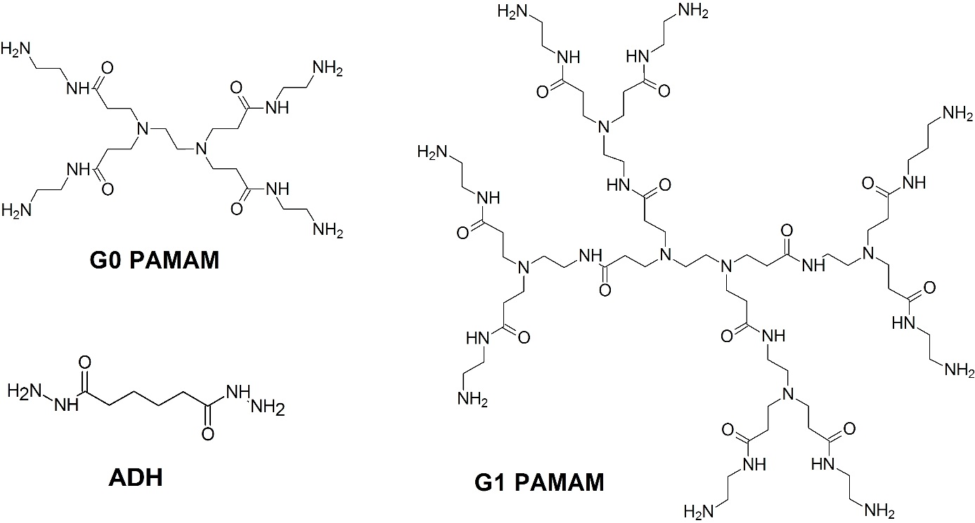
Fig. 1: Chemical formulas of PAMAM dendrimers of generation 0.0 (G0 PAMAM) and generation 1.0 (G1 PAMAM) and the chemical formula of adipic acid dihydrazide (ADH).

Preparation and characterization of self-crosslinking latices
Two model latices differing in ZnO nanoparticles presence were synthesized by the technique of semi-continuous non-seeded emulsion polymerization using variable content of acrylic monomers. To enable the subsequent inter-particle crosslinking with a suitable amine- or hydrazide-based crosslinking agent, DAAM was incorporated in polymer particles to introduce ketone carbonyl functional groups. The latex sample labeled L₀ did not contain ZnO nanoparticles and the latex sample labeled L_{ZnO} comprised 1.5 wt.% of ZnO nanoparticles (theoretical concentration, based on polymer content). To ensure the sufficient film-formation on one hand and non-tackiness of coatings on the other hand, the ratio of acrylic monomers forming latex particles was chosen to achieve the calculated T_{g} of the resulting polymer of approximately 15 °C (using the Fox equation³⁰). The detailed composition of monomer feeds forming both model latices was as follows: 43 g MMA, 53 g BA and 4 g MAA dosed in the first step and 38.5 g MMA, 52.5 g BA, 4 g MAA and 5 g DAAM dosed in the second step.
The latices were produced in a 700 ml glass reactor under nitrogen atmosphere at 85 °C. The reactor charge was put into the reactor and heated to the polymerization temperature. Then the monomer emulsion was fed into the stirred reactor at the feeding rate about 2 ml/min in two steps (a 15 minutes-long period between the two feeding steps was hold). After that, during 2 hours of hold period the polymerization was completed. The recipe of emulsion polymerization is shown in Table 1. The pH value of latices was adjusted to 8.5 by adding ammonia solution. The theoretical solids content of the latices was about 45 wt.%. After the synthesis, filterable solids were dried and weighed and the coagulum content was calculated according to Coagulation (%) = 100 × M_{f} /(real solids content × M_{E} + M_{f}), where M_{f} and M_{E} are weights of dried filterable solids and the filtered emulsion, respectively.
For the preparation of the latex L_{ZnO}, the above mentioned procedure included the preparation of well-dispersed ZnO aqueous suspension. Firstly, ZnO nanopowder was mixed with water and emulsifier that were designated for the preparation of 2nd step monomer emulsion. To destroy agglomerates formed by individual ZnO nanoparticles to a great extent, a proper dispersing using an ULTRA-TURRAX T25 disperser (IKA, Germany) at 14 000 rpm was performed for 20 min followed by ultrasonic treatment for 1 hour. Then the fine nano-ZnO suspension was gently mixed with monomers designed for the preparation of 2nd step monomer emulsion (using a stirrer at low speed for 1 minute). Finally, the resulting 2nd step monomer emulsion containing ZnO nanoparticles was dosed to the reactor immediately.

Table 1: Recipe of emulsion polymerization of model latices L₀ and L_{ZnO}
 | Reactor charge | Monomer emulsion (1st step) | Monomer emulsion (2nd step)
Water (g) | 65 | 60 | 60
Disponil FES 993 (g) | 0.5 | 7.4 | 7.4
Ammonium persulfate (g) | 0.4 | 0.4 | 0.4
Monomers (g) | - | 100 | 100
ZnO nanopowderª (g) | - | - | 1.5
ª The component was used only in the case of L_{ZnO} synthesis.

In order to produce G0 PAMAM-based one-pack self-crosslinking latices, 10 wt.% water solution of G0 PAMAM dendrimer was added to the latex at the molar ratio G0 PAMAM : DAAM = 1 : 4. Similarly, G1 PAMAM-based one-pack self-crosslinking latices were obtained by adding 10 wt.% water solution of G1 PAMAM dendrimer to the latex at the molar ratio G1 PAMAM : DAAM = 1 : 8. (The molecular weights are 517 and 1430 g/mol for G0 PAMAM and G1 PAMAM, respectively). Finally, the comparative ADH-based one-pack self-crosslinking latices were produced by adding 10 wt.% water solution of ADH to the model latex at the molar ratio ADH : DAAM = 1 : 2. For all the self-crosslinking latex formulations, a given inter-particle crosslinker was always added at 15 wt.% excess (considering the amount calculated according to the above mentioned molar ratio) to avoid the undesirable consumption of a crosslinker due to a potential side-reaction with carboxyl groups. (Nevertheless, the conversion of carboxyl groups to amides is difficult at standard conditions of storing and film-formation, because amines and hydrazides are basic compounds and tend to convert carboxyl groups to their highly unreactive carboxylate ions, thus hindering the course of reaction.) The self-crosslinking reactions of DAAM containing polymer with G0 PAMAM, G1 PAMAM dendrimer and ADH are depicted schematically in Fig. 2.
The minimum film-forming temperatures (MFFT) of all the prepared self-crosslinking latices and latices without any inter-particle crosslinker were measured according to ISO 2115, using the MFFT-60 instrument (Rhopoint Instruments, UK). pH measurements were carried out at 23 ± 1 °C using a pH meter FiveEasy FE20 (Mettler-Toledo, Switzerland).

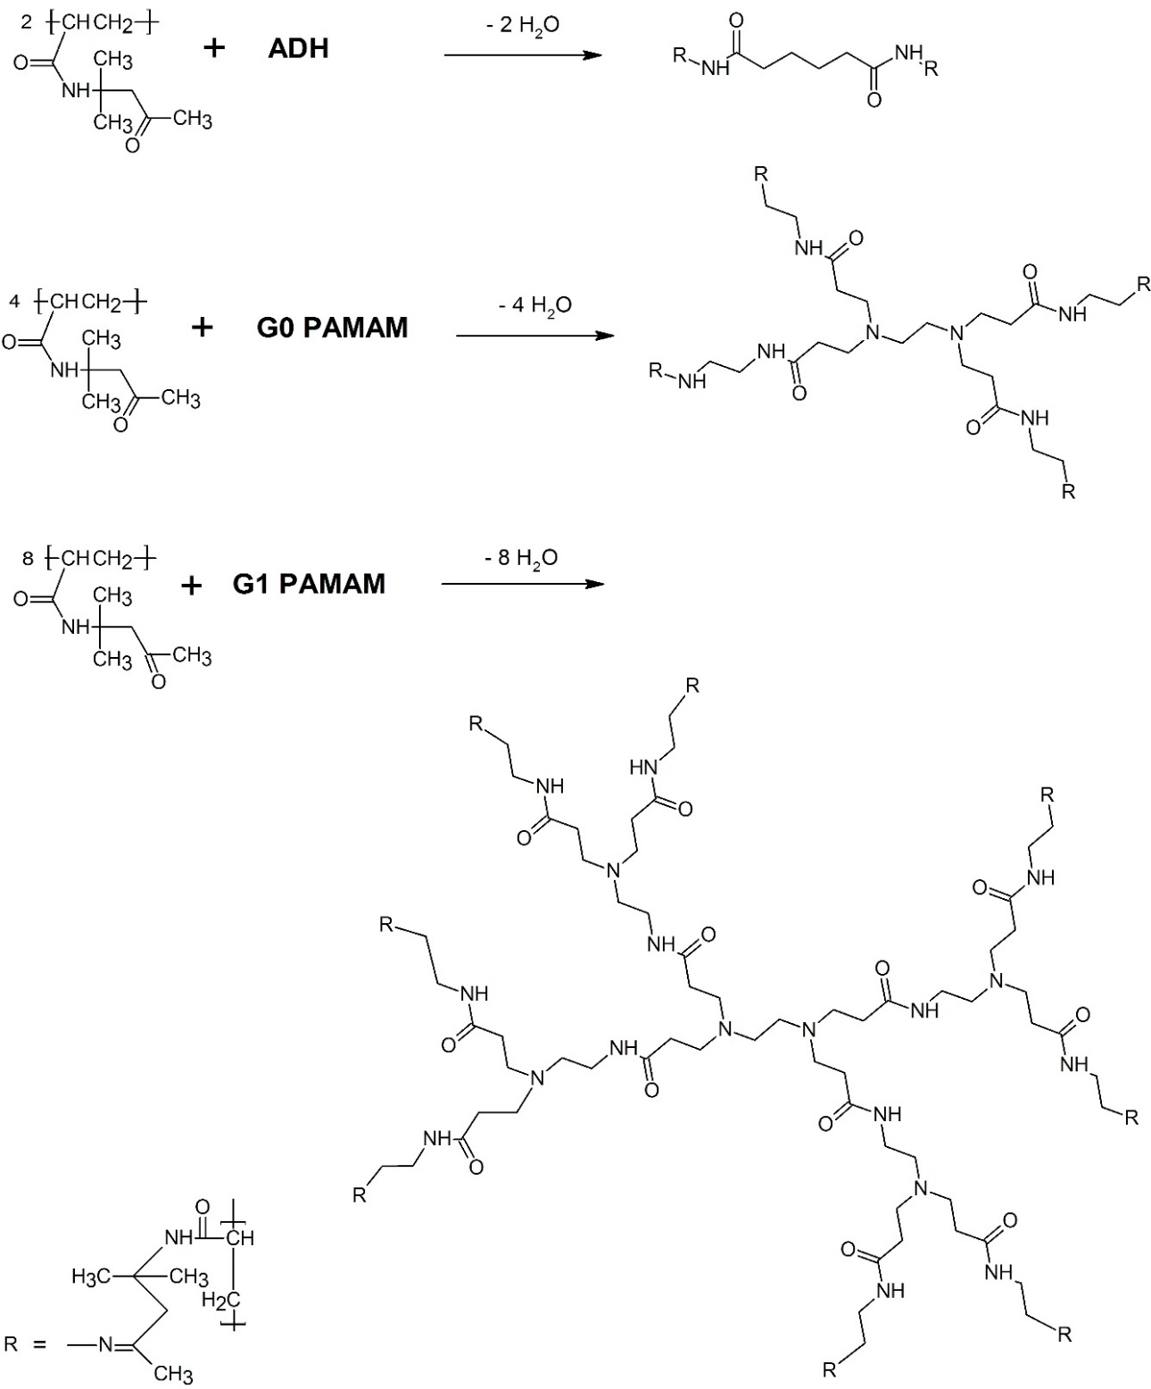
Fig. 2: Crosslinking of ketone carbonyl groups of DAAM repeat units using ADH, G0 PAMAM and G1 PAMAM as inter-particle crosslinking agents.

Evidence of self-crosslinking reaction
The verification of the inter-particle self-crosslinking reaction was performed on dried coating films from the point of view of their gel content changes. The specimens for gel content measurements were prepared by pouring and drying the latices on silicone substrates. The specimens were first air-dried at room temperature (23 ± 1 °C) and at 50 ± 5 % relative humidity for a month and then vacuum-dried at 30 °C for 2 weeks. The thickness of dry films was approximately 1 mm. The gel content of dried latex polymers was determined by the extraction in a Soxhlet extractor with tetrahydrofuran (THF) for 24 hours according to CSN EN ISO 6427.

Storage stability testing
The storage stability of latices was symbolized by storing the latices at 50 °C for 1 month and was evaluated according to changes of apparent viscosity, average particle size and zeta potential of latex samples. The apparent viscosity of latices was measured at 25 °C using a Bookfield LVDV- E Viscometer (Brookfield Engineering Laboratories, USA) at 100 rpm according to CSN ISO 2555. The average particle sizes and zeta potentials of latex particles dispersed in water phase were detected by dynamic light scattering (DLS) performed by using a Coulter N4 Plus instrument (Coulter, Corp., UK). The measurements were performed at 25 °C and solids content in water phase was about 0.05 wt.%.

Preparation and characterization of coatings
The self-crosslinking latices were applied on glass and low carbon steel panels using a blade applicator. The thickness of wet coating films was 120 µm. No coalescing agents were used. Coatings were air-dried at room temperature (23 ± 1 °C) and at 50 ± 5 % relative humidity for a month. The resulting coating films were evaluated for their gloss, hardness, adhesion, impact resistance, chemical resistance, water absorption, water whitening and flash rust resistance. The coatings based on the latex L_{ZnO} were also tested from the point of view of ZnO nanoparticles content and distribution.
The gloss of coating films cast on glass panels coated with a black matte paint (RAL 9005) was determined by a micro TRI-gloss µ instrument (BYK-Gardner, Germany) using a gloss-measuring geometry 60°. The hardness of coatings on glass panels was measured by a pendulum hardness tester “Persoz” (BYK-Gardner, Germany) according to CSN EN ISO 1522. The adhesion of coatings on glass substrates was evaluated by means of the pull-off test according to ISO 4624 using an Elcometer 510 Automatic Adhesion Tester (Elcometer Instruments, UK). The impact resistance of coatings on steel substrates was evaluated using an Elcometer 1615 Variable Impact Tester (Elcometer Instruments, UK) following CSN EN ISO 6272. The chemical resistance was determined by methyl ethyl ketone (MEK) rubbing following ASTM D 4752. All experiments were carried out at room temperature (23 ± 1 °C).
For the water absorption evaluation, specimens were prepared by pouring the self-crosslinking latices into a silicone mould. Films were air-dried at room temperature (23 °C) for a month. The water absorption expressed in terms of water uptake by latex films was measured by immersing film samples in distilled water at 23 ± 1 °C. The water absorption, A is given by A = 100(w_{t} – w₀)/w₀, where w₀ is the initial sample weight before immersion and w_{t} is the sample weight after immersion in distilled water during the specified time (1, 2, 3, 5, 7, 14, 21, 30 and 50 days). The soaked film was removed from water and the surface of the film was carefully dried by touching the polymer with a filter paper. For each sample, three specimens of the approximate dimensions 20 × 20 × 0.75 mm³ were tested and averaged values of the results were collected as a function of time.
The water whitening of coating films cast on glass panels was evaluated objectively by reporting the ΔWI CIE (change in whiteness index) using a ColorQuest XE Spectrometer (Hunterlab, USA) according to ASTM E313. The coating film was immersed in distilled water at 23 ± 1 °C for 1 and 10 days, respectively, followed by the immediate measurement of the whiteness index of the exposed coating. The extent of water whitening ΔWI CIE, is given by ΔWI CIE = WI_{t} CIE – WI₀ CIE where WI₀ CIE is the sample whiteness index before distilled water exposure and WI_{t} CIE is the sample whiteness index after performing the immersion test.
The flash rust resistance was evaluated subjectively on coating films cast on steel substrates (medium carbon steel with 0.5% C) which were obtained from Labimex (Czech Republic). Coatings were air-dried at room temperature (23 ± 1 °C) and at 50 ± 5 % relative humidity for 24 hours before the flash rust evaluation.
The real concentration of ZnO nanoparticles in the coating film based on the latex L_{ZnO} was determined by means of ash content measurements according to CSN EN ISO 3451-1. The distribution of ZnO nanoparticles inside the coating film was evauated by means of scanning electron microscopy (SEM) using a LYRA 3 scanning electron microscop (Tescan, Czech Republic). The gold-sputtered cryo-fractures of coatings were examined. Specimens for the measurements were prepared by pouring and drying the latices on silicone substrates. The specimens were first air-dried at room temperature (23 ± 1 °C) and at 50 ± 5 % relative humidity for a month and then vacuum-dried at 30 °C for 2 weeks.

Results and discussion
MFFT of latices
The results of MFFT measurements for both series of latices (based on model latex L₀ and L_{ZnO}, respectively) are listed in Table 2. In comparison with neat latices (without any inter-particle crosslinker), the corresponding G1 PAMAM- and G2 PAMAM-based self-crosslinking latices were found to exhibit decreased MFFT values in the case of both series of latices, whereas the ADH-containing self-crosslinking latices were shown to provide similar MFFT values to the corresponding neat latices. Decrease in MFFT values in the case of latices containing G0 PAMAM or G1 PAMAM dendrimers is desirable (suggesting good application properties) and may be associated with hydroplasticization of emulsion polymer due to the presence of highly alkaline amidoamine dendrimers causing permanent neutralization of carboxylic acid groups during the latex film drying process (in comparison with neat and ADH-crosslinked latex compositions that turn acid after ammonia evaporation resulting in protonated carboxylic groups). Thus, softening of polymer chains comprising ionized carboxylic groups during the whole process of film-formation was probably achieved resulting in MFFT decrease. The differences between pH values of latex compositions after ammonia evaporation are shown in Table 2.

Table 2: Effect of the inter-particle crosslinker type on MFFT and gel content of latex samples
Sample | Crosslinking agent |  | pH after ammonia evaporation | MFFT (°C) | Gel content (%)
L₀ | - |  | 2.07 | 5.7 | 6.1
L₀ | G0 |  | 7.72 | 1.7 | 70.0
L₀ | G1 |  | 7.97 | 1.8 | 78.6
L₀ | ADH |  | 3.53 | 5.8 | 76.9
L_{ZnO} | - |  | 6.22 | 11.3 | 69.7
L_{ZnO} | G0 |  | 8.42 | 8.6 | 84.7
L_{ZnO} | G1 |  | 8.60 | 8.2 | 88.9
L_{ZnO} | ADH |  | 6.28 | 11.8 | 89.7

It was shown as well that the series of latices containing ZnO nanoparticles exhibited higher MFFT in comparison with the corresponding zinc oxide-free latex compositions. It should be taken into account that ZnO is slightly soluble in water (about 0.00016 g/100 ml water at 20 °C) resulting in slightly soluble zinc hydroxide³¹ formation during latex synthesis and storing. Therefore, dissociated Zn²⁺ ions are present in latex compositions in a low (but not negligible) concentration leading to ionomeric crosslinking (or complexing) of carboxylated emulsion polymers during the film formation process. As the result, the mobility and interdiffusion of polymer chains was probably suppressed and deformability of latex particles was deteriorated at the coalescence stage leading to MFFT elevation.

Verification of self-crosslinking reaction
The evidence of the self-crosslinking using PAMAM dendrimers was demonstrated by gel content enhancement. Table 2 shows results of gel content measurements with respect to the inter-particle crosslinker type in a given coating composition. For the comparison, coating films based on neat latices without any crosslinker were tested as well. In contrast to the neat L₀-based polymer, both types of dendrimers were shown to provide crosslinked polymer materials of increased gel content comparable to ADH. Compared to each other, G1 PAMAM dendrimer produced slightly denser polymer networks. In the case of the neat latex L₀, a low amount of gel was still obtained, which can be explained by intermolecular chain transfer reactions that take place during the latex synthesis due to butyl acrylate units. Thus branched or slightly crosslinked polymer structures can be formed.³²
When comparing both series of latices, the latices containing zinc oxide nanoparticles were shown to provide densely crosslinked materials, which can be assigned to ionomeric crosslinking due to zinc metal ions, as already described in the text above. Although the network of ionic crosslinking is thought not to be as strong as a covalently crosslinked network, the ionomeric crosslinking was shown to withstand THF treatment during Soxhlet extraction. We can conclude that both types of dendrimers worked as the effective inter-particle crosslinking agents comparable to the conventional ADH crosslinker and the presence of zinc oxide nanoparticles increased the network density of resulting materials considerably.

Storage stability evaluation
The occurrence of ionic crosslinking represented a risk of lower stability in the case of the nano-ZnO containing self-crosslinking one-pack latices. Hence, we focused our research on the storage stability testing as well. The stability of latices was evaluated according to changes of the average particle size, zeta potential and latex viscosity before and after storing at 50 °C for 2 months. The results of the measurements are summarized in Table 3. Despite our doubts, no significant changes of all the tested properties were observed after the storing in the case of all latex compositions, which proves a good stability of the novel one-pack self-crosslinking compositions based on PAMAM inter-particle crosslinkers and zinc oxide nanoparticles.

Table 3: Characteristics of latex coating compositions differing in the inter-particle crosslinker type and nano-ZnO presence before and after storing at 50 °C for 2 months
 | Initial state |  |  | After storage
Sample | Particle size (nm) | Zeta potential (mV) | Viscosity (mPa.s) | Particle size (nm) | Zeta potential (mV) | Viscosity (mPa.s)
L₀ - | 90.2 | -39.0 | 72.7 | 93.5 | -45.7 | 80.9
L₀ G0 | 91.7 | -38.1 | 55.2 | 95.6 | -42.9 | 59.5
L₀ G1 | 92.0 | -38.4 | 53.4 | 97.1 | -41.2 | 57.3
L₀ ADH | 90.3 | -41.7 | 61.6 | 91.8 | -43.7 | 63.6
L_{ZnO} - | 113.5 | -38.2 | 84.3 | 115.5 | -41.4 | 88.4
L_{ZnO} G0 | 111.9 | -37.4 | 68.5 | 116.2 | -40.3 | 72.4
L_{ZnO} G1 | 112.3 | -36.1 | 72.7 | 115.9 | -39.8 | 80.5
L_{ZnO} ADH | 112.8 | -40.4 | 79.2 | 114.4 | -42.5 | 82.1

Coating properties
The effects of covalent and ionic self-crosslinking on properties of the resulting coatings are shown in Table 4. The thickness of dried coating films was about 50 µm and all prepared coatings were transparent without any surface defects. It was shown that the tested coating films exhibited high gloss without any significant difference depending on the inter-particle crosslinker type and zinc oxide nanoparticles presence. High gloss of a given latex film reveals the nano-sized ZnO particles and a good coalescence of a latex film without any phase separation during the film-formation or premature particle aggregation in the dispersion.

Table 4: Comparison of final properties of coating films based on standard and self-crosslinking latices differing in the inter-particle crosslinker type and nano-ZnO presence
Sample | Gloss 60° (%) | Initial hardnessª (%) | Final hardness^{b} (%) | Adhesion (MPa) | Impact resistance (cm) | MEK resistance (number of strikes)
L₀ - | 80.4 ± 1.4 | 17.2 ± 0.6 | 21.7 ± 0.7 | 1.43 ± 0.15 | above 100^{c} | 11
L₀ G0 | 80.8 ± 0.5 | 23.6 ± 0.4 | 26.2 ± 0.3 | 3.50 ± 0.18 | above 100 | 19
L₀ G1 | 79.9 ± 1.2 | 23.9 ± 0.5 | 26.6 ± 1.1 | 4.17 ± 0.10 | above 100 | 20
L₀ ADH | 81.1 ± 0.6 | 21.4 ± 0.4 | 22.0 ± 0.5 | 2.57 ± 0.09 | 97 | 14
L_{ZnO} - | 82.7 ± 1.2 | 19.1 ± 0.6 | 22.1 ± 0.8 | 7.17 ± 0.25 | above 100 | 22
L_{ZnO} G0 | 82.2 ± 0.5 | 26.2 ± 0.8 | 29.2 ± 1.3 | 7.58 ± 0.29 | above 100 | above 300^{c}
L_{ZnO} G1 | 83.4 ± 1.1 | 29.4 ± 0.7 | 32.7 ± 0.6 | 8.48 ± 0.22 | above 100 | above 300
L_{ZnO} ADH | 82.6 ± 1.4 | 22.5 ± 0.8 | 23.4 ± 0.8 | 7.41 ± 0.16 | 91 | above 300
ª Hardness after drying for 24 hours.
^{b} Hardness after drying for 30 days.
^{c} Maximum evaluative value (representing the best property).

Further, mechanical properties of the PAMAM- and ADH-crosslinked coatings were evaluated. The G0 and G1 PAMAM-crosslinked coatings based on both types of standard latices (C₀S and C_{A}S) were found to possess increased initial and final hardness values in contrast to the non-crosslinked and the ADH-crosslinked coatings. Moreover, the G0 and G1 PAMAM-crosslinked coatings showed a better adhesion to glass substrate and a higher impact resistance than the ADH-based coating films. The reason of the above mentioned better mechanical performance of PAMAM-corsslinked films in contrast to ADH may be related to increased particle coalescence quality and higher polarity of PAMAM structural segments in polymer coating materials.
When comparing latices regarding to ZnO nanoparticles presence, the results indicated clearly that the coatings containing ZnO nanoparticles (imparting ionic crosslinking) exhibited significantly improved mechanical properties and excellent MEK resistance. Hence, we can conclude that the combination of covalent self-crosslinking using PAMAM dendrimers with ZnO-based ionomeric self-crosslinking provides high-quality coatings of better mechanical properties and high chemical resistance compared to conventional ADH-based systems.

Water sensitivity
The aim of the present work was the development of high-performance latex coating binders suitable for the protection of various substrates including steel. Extensive research has shown that the most suitable binder systems for anti-corrosive coatings should exhibit low water swelling performance.³³ Therefore, we also investigated the water absorption performance of coating films cast from of the novel self-crosslinking coating compositions. The results of water absorption measurements are illustrated in Figs. 3 and 4. It is obvious that similar water absorption trends with respect to the inter-particle crosslinker type can be observed for both series of latex coatings (the series based on model latices L₀ and the series based on L_{ZnO}, differing in the absence/presence of ZnO nanoparticles). The coatings without any inter-particle crosslinker exhibited the most pronounced water uptake at a long-term water exposure. When comparing all three types of inter-particle covalent crosslinkers, the conventional AHD provided coatings with the highest water sensitivity according to values of water absorption at later stages of the swelling test. On the contrary, the PAMAM dendrimers provided films with a considerably low long-term water absorption and the G1 PAMAM-crosslinked coatings were found to be the most water-resistant.
The explanation of suppressed water swelling in the case of crosslinked latex films was well described in literature. Kessel et al.³⁴ studied the competing effects of keto-hydrazide self-crosslinking and interdiffusion in waterborne systems finding that self-crosslinking inhibited particle flattening and retarded interdiffusion and entanglements formation. As the result, a porous film structure was formed and the extraction of ionically-charged components by water was facilitated, which lead to the reduction in osmotic pressure (as the main water absorption driving force). Nevertheless, suggesting the comparable crosslinking density according to gel content results (see Table 2), the reason of decreased water swelling of PAMAM-crosslinked films in contrast to ADH-crosslinked ones may consist in the amidoamine-rich polymer structure of resulting latex films. The literature survey revealed that latex coatings composed of amide-based acrylic monomers and polyamine additives have been shown to provide an improved water resistance.¹² Hence, we presume that the presence of a higher level of amine and/or amide functionalities in the resulting polymer structure provides an improved water resistance performance of coatings.
It was also found that the series of coatings containing ZnO nanoparticles exhibited considerably decreased water swelling in contrast to L₀-based series. This finding is probably associated with the ionomeric crosslinking imparting higher crosslinking density of the polymer. Thus, the enhanced stiffness of highly crosslinked polymer restricted the influx of water and did not allow water domains to grow. The decreased deformability of the latex polymer also probably resulted in incomplete particle coalescence and the hydrophilic compounds (surfactant and salts) could be rapidly extracted of from the coating film after its immersion in water. This statement can explain well the increased initial water absorption of coating films (due to the presence of ionically-charged components in the interstices between coalesced latex particles) followed by drop in water uptake during the timescale of water exposure (as a consequence of reduction in osmotic pressure caused by the extraction of the hydrophilic compounds). This phenomenon also correlates well with MFFT results that revealed suppressed particle coalescence of ZnO-based coating compositions, as described above.
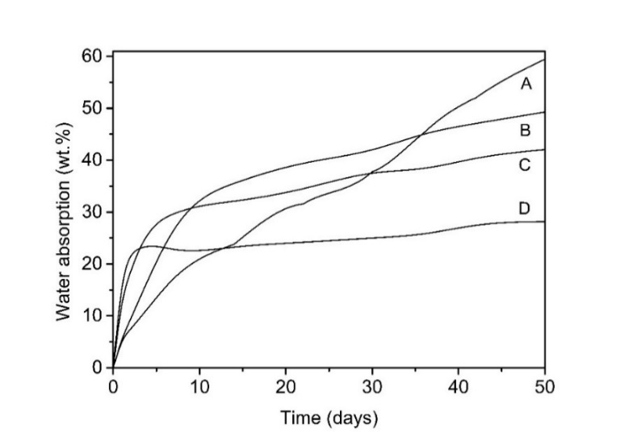
Fig. 3: Water absorption into coatings cast from the latex L₀: sample containing no crosslinker (curve A), sample crosslinked using ADH (curve B), sample crosslinked using G0 PAMAM dendrimer (curve C), sample crosslinked using G1 PAMAM dendrimer (curve D). The standard deviations of performed measurements did not exceed 2 %.
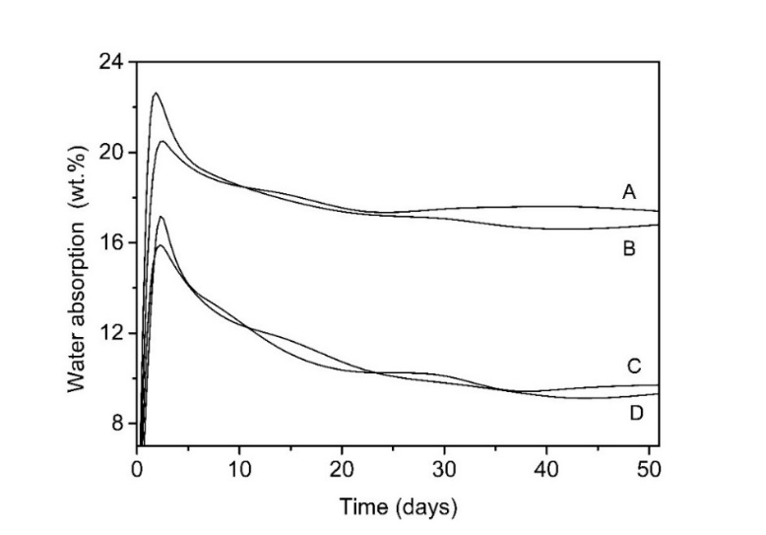
Fig. 4: Water absorption into coatings cast from the latex L_{ZnO}: sample containing no crosslinker (curve A), sample crosslinked using ADH (curve B), sample crosslinked using G0 PAMAM dendrimer (curve C), sample crosslinked using G1 PAMAM dendrimer (curve D). The standard deviations of performed measurements did not exceed 2 %.
Further, water whitening of dried coating films was evaluated according to changes in whiteness index (ΔWI CIE) (see Table 5). The phenomenon of water whitening is believed to be caused by water entrapped inside the coating film. The opacity comes from water scattering centers of appropriate size within the film. The size and number of the water domains are responsible for the water whitening effect and both can be restricted by the stiffness of the polymer.³⁵ Therefore, films suffering from high water swelling are prone to enhanced water whitening as well. It was confirmed that the results of water whitening could be well correlated with the water absorption results. In the case of both series of latexes (differing in ZnO nanoparticles addition), the non-crosslinked latexes provided coatings of the highest water whitening tendency, whereas after imparting the self-crosslinking chemistry into latexes, the water whitening resistance was increased. It was also confirmed (similarly to water absorption results) that the PAMAM-crosslinked coatings exhibited increased water whitening resistance in contrast to the ADH-crosslinked ones. Comparing both types of PAMAM dendrimers, better water whitening resistance was achieved in the case of G1 PAMAM as the inter-particle crosslinker, obviously due to providing a densely crosslinked polymer with a suppressed water uptake.
When considering the effect of ZnO nanoparticles presence, the series of coatings containing ZnO nanoparticles exhibited considerably increased water whitening resistance in relation to ZnO-free series. This phenomenon can be attributed to significantly decreased water swelling due to ionomeric crosslinking causing increased density of the polymer network. Thus, the resistance of the polymer to deformation (caused by hydrostatic pressure of the water cells) was increased and flattening and coalescence of latex particles were deteriorated as well, as discussed previously. Moreover, no obvious water whitening could be observed for the strongly water-resistant PAMAM-crosslinked coatings comprising ZnO nanoparticles after 10-days-long immersion in distilled water. It can be concluded that self-crosslinking latex compositions using ionic crosslinking due to ZnO nanoparticles and covalent crosslinking with PAMAM dendrimers provide highly water whitening resistant coatings.

Table 5: Water whitening expressed in terms of the whiteness index change for dry coating films cast on glass panels before and after their immersion in distilled water for 1 and 10 days.
Sample | WI₀ CIE | After immersion for 1 day |  | After immersion for 10 days
Sample | WI₀ CIE | WI_{t} CIE | ΔWI CIE | WI_{t} CIE | ΔWI CIE
L₀ - | 16.5 | 68.5 | 52.0 | 83.8 | 67.3
L₀ G0 | 16.1 | 55.3 | 39.2 | 74.9 | 58.8
L₀ G1 | 16.3 | 31.1 | 14.8 | 55.1 | 38.8
L₀ ADH | 16.2 | 72.6 | 56.4 | 82.1 | 65.9
L_{ZnO} - | 16.3 | 54.5 | 38.2 | 61.7 | 45.4
L_{ZnO} G0 | 15.8 | 17.1 | 1.3 | 15.8 | 0
L_{ZnO} G1 | 15.9 | 16.9 | 1.0 | 15.9 | 0
L_{ZnO} ADH | 16.0 | 19.0 | 3.0 | 19.7 | 3.7

ZnO nanoparticles distribution in coatings
It should be noted that the neat latex L_{ZnO} contained 0.7 % of coagulum after the synthesis (in contrast to the coagulum-free L₀). Therefore, the real concentration of ZnO nanoparticles in coating films was expected to be lower than the theoretical one (1.5 wt.% based on polymer content). This assumption was confirmed by ash content measurements, which revealed that the real content of ZnO nanoparticles in the L_{ZnO}-based latex coatings was about 1.2 wt.%. The distribution of ZnO nanoparticles inside coating films was investigated as well. Figs. 5 and 6 illustrate the cryo-fracture surfaces of a representative ZnO-based coating sample (L_{ZnO} G1) and a corresponding ZnO-free coating sample (L₀ G1). For better information, secondary electron images (representing the morphological nature of the surface) and backscattered electron images (showing the elementary contrast of the surface) were compared. It can be seen clearly that no micro-sized ZnO agglomerates were present in the coating film. ZnO was shown to be present in the form of distinct nano-sized particles (apparently covered with zinc hydroxide layer due to hydrolysis) that were distributed distinctly and regularly inside the coating film, which corresponds to the transparent nature of coatings.

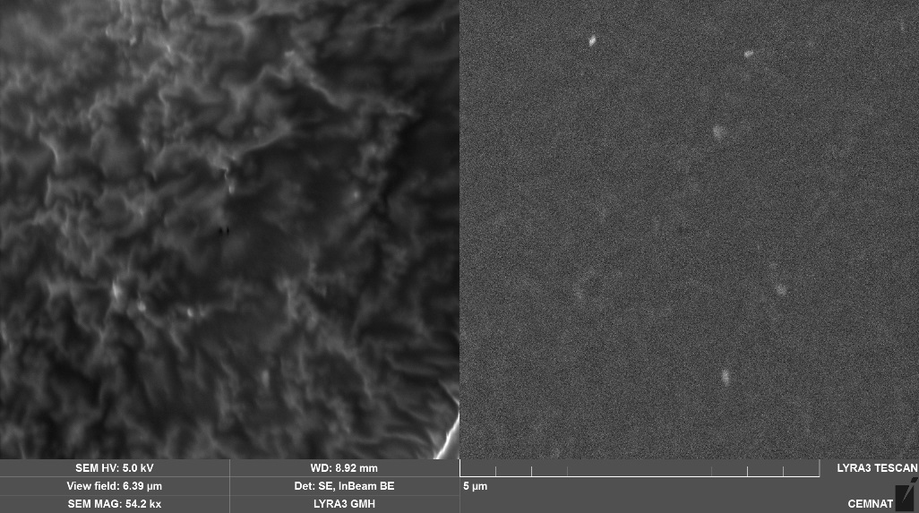
Fig.5: SEM images of L_{ZnO} G1 coating sample performed in the secondary electron mode (left) and the backscattered electron mode (right).
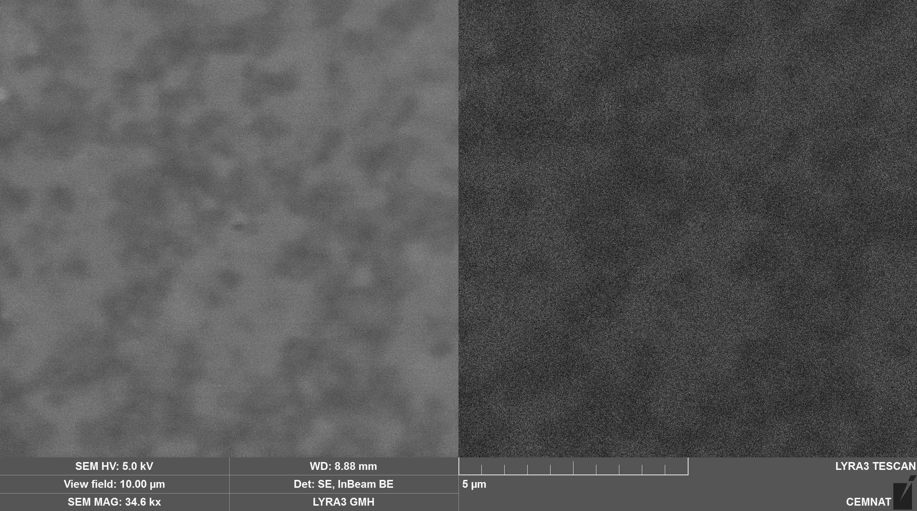
Fig.6: SEM images of L₀ G1 coating film performed in the secondary electron mode (left) and backscattered electron mode (right).

Flash rust resistance
The appearance and course of flash rust is affected by a series of factors (relative humidity and temperature during the film-formation process, the type and the pH value of the coating polymer composition) which can show a synergic action.³⁶ The flash rust appearance on coated steel panels is demonstrated in Fig. 7. It is evident that the coating compositions using both types of PAMAM dendrimers as the inter-particle crosslinkers provided significantly improved flash corrosion resistance, where no flash rust appeared in the case of coatings crosslinked using the G1 PAMAM dendrimer. It is worthy of attention that the series of coating compositions containing ZnO nanoparticles did not show any significant trend to flash rust inhibition. Hence, it can be stated that the effect of cathode reaction suppression (due to Zn²⁺ ions which could create a layer of hybrid hydroxides with cations of the corroding steel) did not play a significant role. We suppose that the flash rust manifestation was affected particularly by the pH value of the given coating composition after ammonia evaporation (as listed in the bottom part of Fig.7); the flash rust resistance was observed in case of latex compositions providing alkalinity in the vicinity of steel substrate during the drying out of a coating film. The phenomenon of flash rust inhibition due to alkaline pH has been reported and discussed in the literature.³⁵

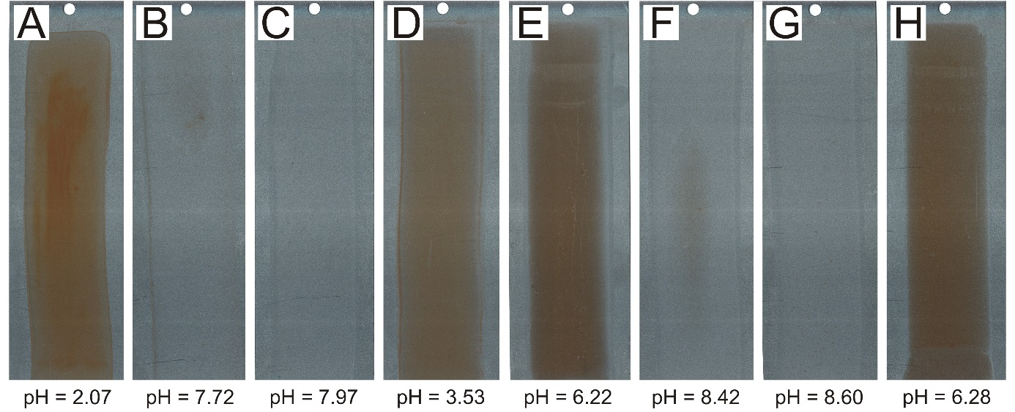
Fig. 7: Photographs of coated metallic panels: coating cast from neat latex L₀ (A), coating made of G0 PAMAM-based self-crosslinking latex L₀ (B), coating made of G1 PAMAM-based self-crosslinking latex L₀ (C), coating cast from ADH-based self-crosslinking latex L₀ (D), coating made of neat latex L_{ZnO} (E), coating made of G0 PAMAM-based self-crosslinking latex L_{ZnO} (F), coating cast from G1 PAMAM-based self-crosslinking latex L_{ZnO} (G), coating cast from ADH-based self-crosslinking latex L_{ZnO} (H). Bottom: pH values of coating compositions after ammonia evaporation.

Conclusion
The goal of the work presented in this paper was to investigate one-package ambient temperature self-crosslinking latex coating compositions containing amine-terminated PAMAM dendrimers of low generation and ZnO nanoparticles as the inter-particle crosslinkers and flash rust inhibitors. The latices containing PAMAM dendrimers and ZnO nanoparticles were shown to possess a long-term storage stability. These coating compositions provided crosslinked coating films of high gloss, transparency and mechanical performance comparable to or even better than the conventional ADH-based self-crosslinking latices. The ZnO nanoparticles incorporation was shown to impart solvent resistance of coatings due to ionomeric crosslinking. It was found as well that an excellent water whitening performance could be achieved by introducing the combination of ZnO-based ionomeric crosslinking and PAMAM-based self-crosslinking into latex coating compositions. Moreover, the coating compositions using PAMAM crosslinkers provided significantly improved flash rust resistance. Compared to each other, PAMAM dendrimer of generation 1.0 provided coatings with better properties. With respect to given facts, it can be concluded that the PAMAM-based one-pack self-crosslinking latices comprising ZnO nanoparticles provide high-performance coatings and have potential use in coating industry as clear coats or binders for exterior and interior material protection including steel.

Acknowledgements
This work was supported by the Ministry of Education, Youth and Sports of the Czech Republic (grants LM2015082 and ED4.100/11.0251).

References
1. Nakayama, Y, “Development of Novel Aqueous Coatings Which Meet the Requirements of Ecology-Conscious Society: Novel Cross-linking System Based on the Carbonyl-Hydrazide Reaction and its Applications.” Prog. Org. Coat., 51 280−299 (2004)
2. Guo, TY, Liu, JCh, Song, MD, Zhang, BH, “Effects of Carboxyl Group on the Ambient Self-Crosslinkable Polyacrylate Lattices.” J. Appl. Polym. Sci., 104 3948−3953 (2007)
3. Holub, P, “One-Component Systems Yield Good Properties.” Eur. Coat. J., 10 21−28 (2004)
4. Lai, X, Shen, Y, Wang, L, “Preparation and Properties of Self-Crosslinkable Polyurethane/Silane Hybrid Emulsion.” J. Polym. Res., 18 2425−2433 (2011)
5. Zhang, JD, Yang, MJ, Zhu, YR, Yang, H, “Synthesis and Characterization of Crosslinkable Latex with Interpenetrating Network Structure Based on Polystyrene and Polyacrylate.” Polym. Int., 55 951−960 (2006)
6. Koukiotis, Ch, Sideridou, ID, “Synthesis and Characterization of Latexes Based on Copolymers BA/MMA/DAAM and BA/MMA/VEOVA-10/DAAM and the Corresponding 1K Crosslinkable Binder Using the Adipic Acid Dihydrazide as Crosslinking Agent.” Prog. Org. Coat., 69 504−509 (2010)
7. Koukiotis, ChG, Karabela, MM, Sideridou, ID, “Mechanical Properties of Films of Latexes Based on Copolymers BA/MMA/DAAM and BA/MMA/VEOVA-10/DAAM and the Corresponding Self-crosslinked Copolymers Using the Adipic Acid Dihydrazide as Crosslinking Agent.” Prog. Org. Coat., 75 106−115 (2012)
8. Li, M, Lin, X, Li, X, Wang, H, “Preparation and Property Study of Core−Shell Ambient-Temperature Crosslinkable Polyacrylate Binder.” Appl. Mech. Mat., 469 3−6 (2014)
9. X. Zhang, Y. Liu, H. Huang, Y. Li, H. Chen, The diacetone acrylamide crosslinking reaction and its control of core−shell polyacrylate latices at ambient temperature, J. Appl. Polym. Sci. 123 (2012) 1822−1832.
10. Li, H, Kan, Ch, Du, Y, Liu, D, “Effects of the Amount of Diacetone Acrylamide on the Properties of Styrene-aAcrylic Copolymer Latexes and their Films.” Polym. Prep., 43 413−414 (2002)
11. Scholten, HP, Slinck, MM, “Interpolymer Latexes from Esters of (Meth)​acrylic Acid and Vinyl Esters of Branched Chain Carboxylic Acids, EP Patent 486,110 A1, 1992
12. Xu, J, Zhang, T, Liu, H, “Copolymer Dispersion for Water Whitening Resistant Coatings.” US Patent 8,772,386 B2 2014
13. Tomalia, DA, Baker, H, Dewald, J, Hall, M, Kallos, G, Martin, S, Roeck, J, Ryder, J, Smith, P, A New Class of Polymers: Starburst-Dendritic Macromolecules.” Polym. J., 17 117−132 (1985)
14. Tomalia, DA, “Birth of a New Macromolecular aArchitecture: Dendrimers as Quantized Building Blocks for Nanoscale Synthetic Polymer Chemistry.” Prog. Polym. Sci., 30 294–324 (2005)
15. Bosman, AW, Janssen, HM, Meijer, EW, “About Dendrimers: Structure, Physical Properties, and Applications.” Chem. Rev., 99 1665–1688 (1999)
16. Yang, H, Morris, JJ, Lopina, ST, “Polyethylene Glycol–Polyamidoamine Dendritic Micelle as Solubility Enhancer and the Effect of the Length of Polyethylene Glycol Arms on the Solubility of Pyrene in Water.” J. Colloid Interface Sci., 273 148–154 (2004)
17. Torigoe, K, Suzuki, A, Esumi, K, “Au(III)–PAMAM Interaction and Formation of Au–PAMAM Nanocomposites in Ethyl Acetate.” J. Colloid Interface Sci., 241 346–356 (2001)
18. Liu, M, Konol, K, Fre´chet, JM, “Water-Soluble Dendritic Unimolecular Micelles: Their Potential as Drug Delivery Agents.” J. Control. Rel., 65 121–131 (2000)
19. Endo, T, Yoshimura, T, Esumi, K, “Synthesis and Catalytic Activity of Gold–Silver Binary Nanoparticles Stabilized by PAMAM Dendrimer.” J. Colloid Interface Sci., 286 602–609 (2005)
20. Milhem, OM, Myles, C, McKeown, NB, Attwood, D, D’Emanuele, A, “Polyamidoamine Starburst® Dendrimers as Solubility Enhancers,.” Int. J. Pharm., 197 239–241 (2000)
21. Roberts, JC, Bhalgat, MK, Zera, RT, “Preliminary Biological Evaluation of Polyamidoamine (PAMAM) Starburst Dendrimers.” J. Biomed. Mater. Res., 30 53–65 (1996)
22. Kesharwani, P, Jain, K, Jain, NK, “Dendrimer as Nanocarrier for Drug Delivery.” Prog. Polym. Sci., 39 268–307 (2014)
23. Reinhard, G, Simon, P, Rammelt, U, “Application of Corrosion Inhibitors in Water-Borne Coatings.” Prog. Org. Coat., 20 383–392 (1992)
24. del Amo, B, Romagnoli, R, Deyá, C, González, JA, “High Performance Water-Based Paints with Non-Toxic Anticorrosive Pigments.” Prog. Org. Coat., 45 389–397 (2002)
25. Reinhard, G, “Formulation of Water-Borne Dispersions for Corrosion-Protective Primers.” Prog. Org. Coat., 18 123–145 (1990)
26. Yeon, SJ, Mijeong, H, “Multi-Functional Hybrid Coatings Containing Silica Nanoparticles and Anti-Corrosive Acrylate Monomer for Scratch and Corrosion Resistance.” Nanotechnology, 22 025601 (2011)
27. Montemor, MF, Ferreira, MGS, “Analytical Characterization of Silane Films Modified with Cerium Activated Nanoparticles and its Relation with the Corrosion Protection of Galvanised Steel Substrates.” Prog. Org. Coat., 63 330–337 (2008)
28. El Saeed, AM, El-Fattah, MA, Azzam, AM, “Synthesis of ZnO Nanoparticles and Studying its Influence on the Antimicrobial, Anticorrosion and Mechanical Behavior of Polyurethane Composite for Surface Coating.” Dyes Pigments, 121 282–289 (2015)
29. Chimenti, S, Vega, JM, Aguirre, M, García-Lecina, E, Díez, JA, Grande, HJ, Paulis, M, Leiza, JR, “Effective Incorporation of ZnO Nanoparticles by Miniemulsion Polymerization in Waterborne Binders for Steel Corrosion Protection.” J. Coat. Technol. Res., 14 829–839 (2017)
30. Fox, TG, Flory, PJ, “2nd-Order Transition Temperatures and Related Properties of Polystyrene. 1. Influence of Molecular Weight.” J. Appl. Phys., 21 581−591 (1950)
31. Reichle, RA, McCurdy, KG, Hepler, LG, “Zinc Hydroxide: Solubility Product and Hydroxy-Complex Stability Constants from 12.5-75 °C.“ Can. J. Chem., 53 3481−3485 (1975)
32. Plessis, Ch, Arzamendi, G, Leiza, JR, Schoonbrood, HA, Asua, JM, “Seeded Semibatch Emulsion Polymerization of Poly(n-Butyl Acrylate). Kinetics and Structural Properties.” Macromolecules, 33 5041–5047 (2000)
33. Gee, S, “Water-Borne Coatings for Steel.” Surface Coat. Int., 7 316–320 (1997)
34. Kessel, N, Illsley, DR, Keddie, JL, “The Diacetone Acrylamide Crosslinking Reaction and Its Influence on the Film Formation of an Acrylic Latex.” J. Coat. Technol. Res., 5 285−297 (2008)
35. Jiang, B, Tsavalas, JG, Sundberg, DC, “Water Whitening of Polymer Films: Mechanistic Studies and Comparison Between Water and Solvent Borne Films.” Prog. Org. Coat., 105 56−66 (2017)
36. Kalendova, A, “Methods for Testing and Evaluating the Flash Corrosion.” Prog. Org. Coat., 44 201−209 (2002)

Table I
Recipe of emulsion polymerization of model latices L₀ and L_{ZnO}
 | Reactor charge | Monomer emulsion (1st step) | Monomer emulsion (2nd step)
Water (g) | 65 | 60 | 60
Disponil FES 993 (g) | 0.5 | 7.4 | 7.4
Ammonium persulfate (g) | 0.4 | 0.4 | 0.4
Monomers (g) | - | 100 | 100
ZnO nanopowderª (g) | - | - | 1.5
ª The component was used only in the case of L_{ZnO} synthesis.

Table II
Effect of the inter-particle crosslinker type on MFFT and gel content of latex samples
Sample | Crosslinking agent |  | pH after ammonia evaporation | MFFT (°C) | Gel content (%)
L₀ | - |  | 2.07 | 5.7 | 6.1
L₀ | G0 |  | 7.72 | 1.7 | 70.0
L₀ | G1 |  | 7.97 | 1.8 | 78.6
L₀ | ADH |  | 3.53 | 5.8 | 76.9
L_{ZnO} | - |  | 6.22 | 11.3 | 69.7
L_{ZnO} | G0 |  | 8.42 | 8.6 | 84.7
L_{ZnO} | G1 |  | 8.60 | 8.2 | 88.9
L_{ZnO} | ADH |  | 6.28 | 11.8 | 89.7

Table III
Characteristics of latex coating compositions differing in the inter-particle crosslinker type and nano-ZnO presence before and after storing at 50 °C for 2 months
 | Initial state |  |  | After storage
Sample | Particle size (nm) | Zeta potential (mV) | Viscosity (mPa.s) | Particle size (nm) | Zeta potential (mV) | Viscosity (mPa.s)
L₀ - | 90.2 | -39.0 | 72.7 | 93.5 | -45.7 | 80.9
L₀ G0 | 91.7 | -38.1 | 55.2 | 95.6 | -42.9 | 59.5
L₀ G1 | 92.0 | -38.4 | 53.4 | 97.1 | -41.2 | 57.3
L₀ ADH | 90.3 | -41.7 | 61.6 | 91.8 | -43.7 | 63.6
L_{ZnO} - | 113.5 | -38.2 | 84.3 | 115.5 | -41.4 | 88.4
L_{ZnO} G0 | 111.9 | -37.4 | 68.5 | 116.2 | -40.3 | 72.4
L_{ZnO} G1 | 112.3 | -36.1 | 72.7 | 115.9 | -39.8 | 80.5
L_{ZnO} ADH | 112.8 | -40.4 | 79.2 | 114.4 | -42.5 | 82.1

Table IV
Comparison of final properties of coating films based on standard and self-crosslinking latices differing in the inter-particle crosslinker type and nano-ZnO presence
Sample | Gloss 60° (%) | Initial hardnessª (%) | Final hardness^{b} (%) | Adhesion (MPa) | Impact resistance (cm) | MEK resistance (number of strikes)
L₀ - | 80.4 ± 1.4 | 17.2 ± 0.6 | 21.7 ± 0.7 | 1.43 ± 0.15 | above 100^{c} | 11
L₀ G0 | 80.8 ± 0.5 | 23.6 ± 0.4 | 26.2 ± 0.3 | 3.50 ± 0.18 | above 100 | 19
L₀ G1 | 79.9 ± 1.2 | 23.9 ± 0.5 | 26.6 ± 1.1 | 4.17 ± 0.10 | above 100 | 20
L₀ ADH | 81.1 ± 0.6 | 21.4 ± 0.4 | 22.0 ± 0.5 | 2.57 ± 0.09 | 97 | 14
L_{ZnO} - | 82.7 ± 1.2 | 19.1 ± 0.6 | 22.1 ± 0.8 | 7.17 ± 0.25 | above 100 | 22
L_{ZnO} G0 | 82.2 ± 0.5 | 26.2 ± 0.8 | 29.2 ± 1.3 | 7.58 ± 0.29 | above 100 | above 300^{c}
L_{ZnO} G1 | 83.4 ± 1.1 | 29.4 ± 0.7 | 32.7 ± 0.6 | 8.48 ± 0.22 | above 100 | above 300
L_{ZnO} ADH | 82.6 ± 1.4 | 22.5 ± 0.8 | 23.4 ± 0.8 | 7.41 ± 0.16 | 91 | above 300
ª Hardness after drying for 24 hours.
^{b} Hardness after drying for 30 days.
^{c} Maximum evaluative value (representing the best property).

Table V
Water whitening expressed in terms of the whiteness index change for dry coating films cast on glass panels before and after their immersion in distilled water for 1 and 10 days.
Sample | WI₀ CIE | After immersion for 1 day |  | After immersion for 10 days
Sample | WI₀ CIE | WI_{t} CIE | ΔWI CIE | WI_{t} CIE | ΔWI CIE
L₀ - | 16.5 | 68.5 | 52.0 | 83.8 | 67.3
L₀ G0 | 16.1 | 55.3 | 39.2 | 74.9 | 58.8
L₀ G1 | 16.3 | 31.1 | 14.8 | 55.1 | 38.8
L₀ ADH | 16.2 | 72.6 | 56.4 | 82.1 | 65.9
L_{ZnO} - | 16.3 | 54.5 | 38.2 | 61.7 | 45.4
L_{ZnO} G0 | 15.8 | 17.1 | 1.3 | 15.8 | 0
L_{ZnO} G1 | 15.9 | 16.9 | 1.0 | 15.9 | 0
L_{ZnO} ADH | 16.0 | 19.0 | 3.0 | 19.7 | 3.7

List of figure captions:

Fig. 1. Chemical formulas of PAMAM dendrimers of generation 0.0 (G0 PAMAM) and generation 1.0 (G1 PAMAM) and the chemical formula of adipic acid dihydrazide (ADH).

Fig. 2. Crosslinking of ketone carbonyl groups of DAAM repeat units using ADH, G0 PAMAM and G1 PAMAM as inter-particle crosslinking agents.

Fig. 3. Water absorption into coatings cast from the latex L₀: sample containing no crosslinker (curve A), sample crosslinked using ADH (curve B), sample crosslinked using G0 PAMAM dendrimer (curve C), sample crosslinked using G1 PAMAM dendrimer (curve D). The standard deviations of performed measurements did not exceed 2 %.

Fig. 4. Water absorption into coatings cast from the latex L_{ZnO}: sample containing no crosslinker (curve A), sample crosslinked using ADH (curve B), sample crosslinked using G0 PAMAM dendrimer (curve C), sample crosslinked using G1 PAMAM dendrimer (curve D). The standard deviations of performed measurements did not exceed 2 %.

Fig.5 SEM images of L_{ZnO} G1 coating sample performed in the secondary electron mode (left) and the backscattered electron mode (right).

Fig.6 SEM images of L₀ G1 coating film performed in the secondary electron mode (left) and backscattered electron mode (right).

Fig. 7 Photographs of coated metallic panels: coating cast from neat latex L₀ (A), coating made of G0 PAMAM-based self-crosslinking latex L₀ (B), coating made of G1 PAMAM-based self-crosslinking latex L₀ (C), coating cast from ADH-based self-crosslinking latex L₀ (D), coating made of neat latex L_{ZnO} (E), coating made of G0 PAMAM-based self-crosslinking latex L_{ZnO} (F), coating cast from G1 PAMAM-based self-crosslinking latex L_{ZnO} (G), coating cast from ADH-based self-crosslinking latex L_{ZnO} (H). Bottom: pH values of coating compositions after ammonia evaporation.

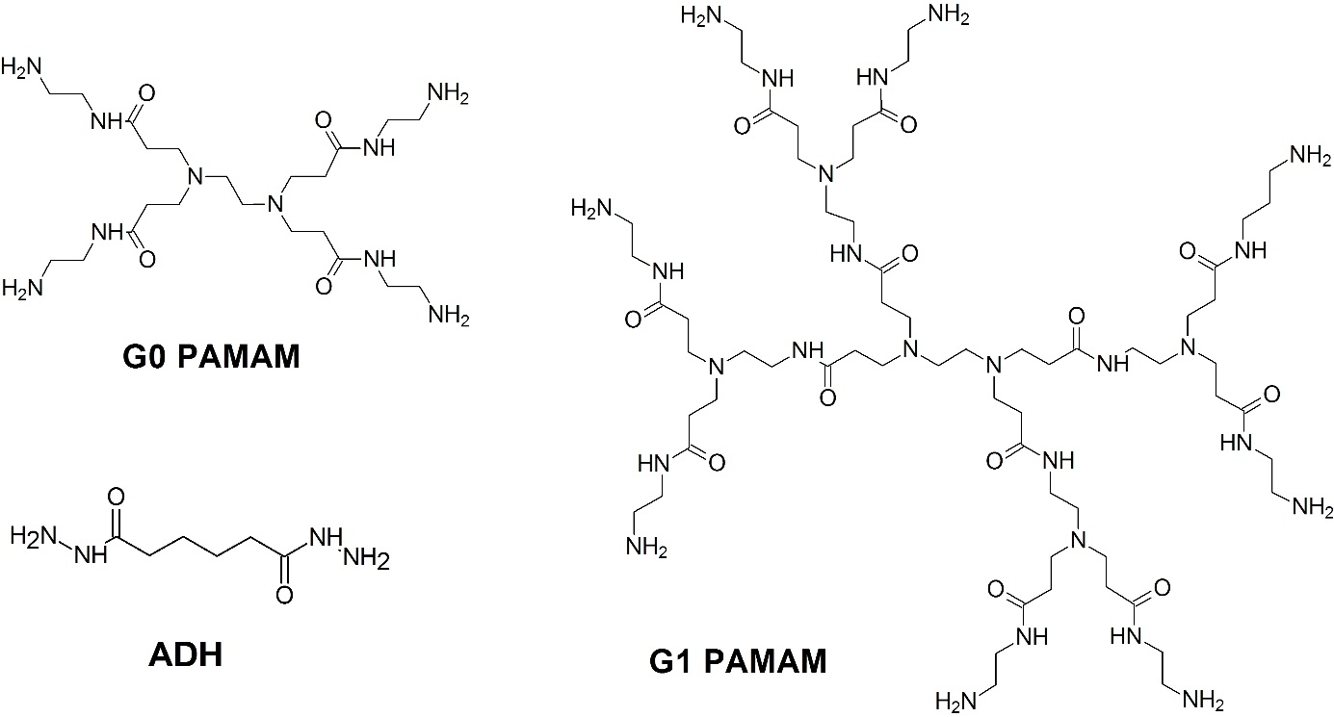
Fig. 1

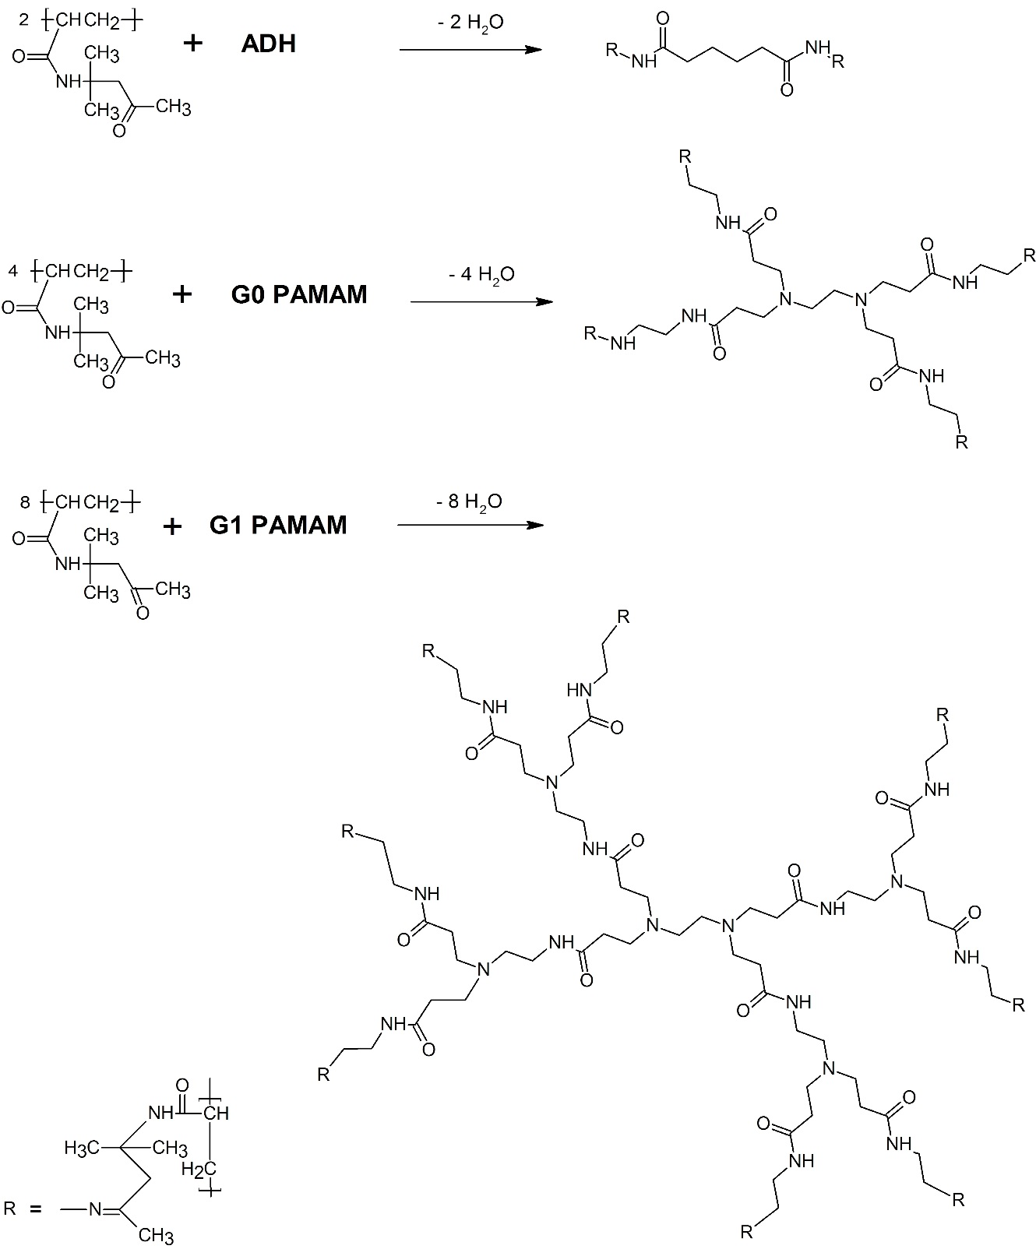

Fig. 2

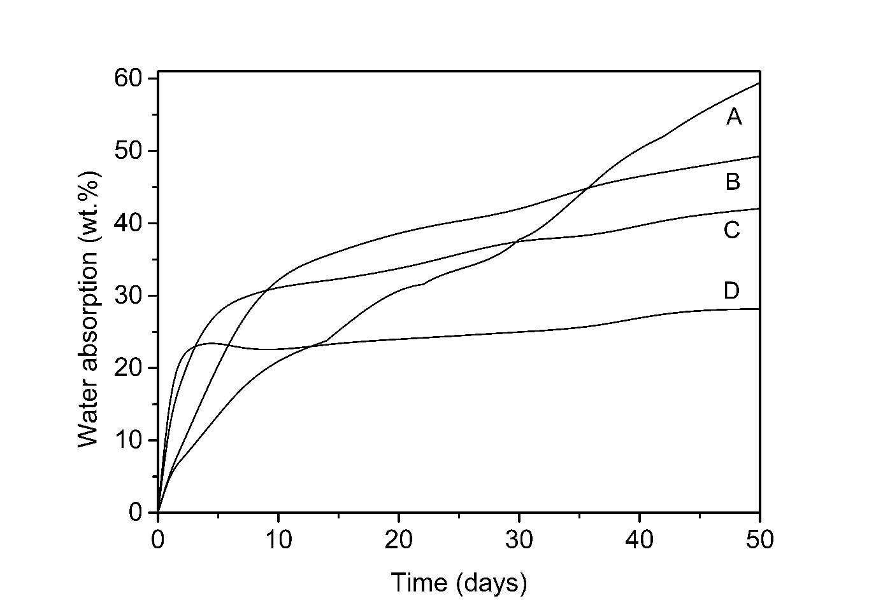
Fig. 3

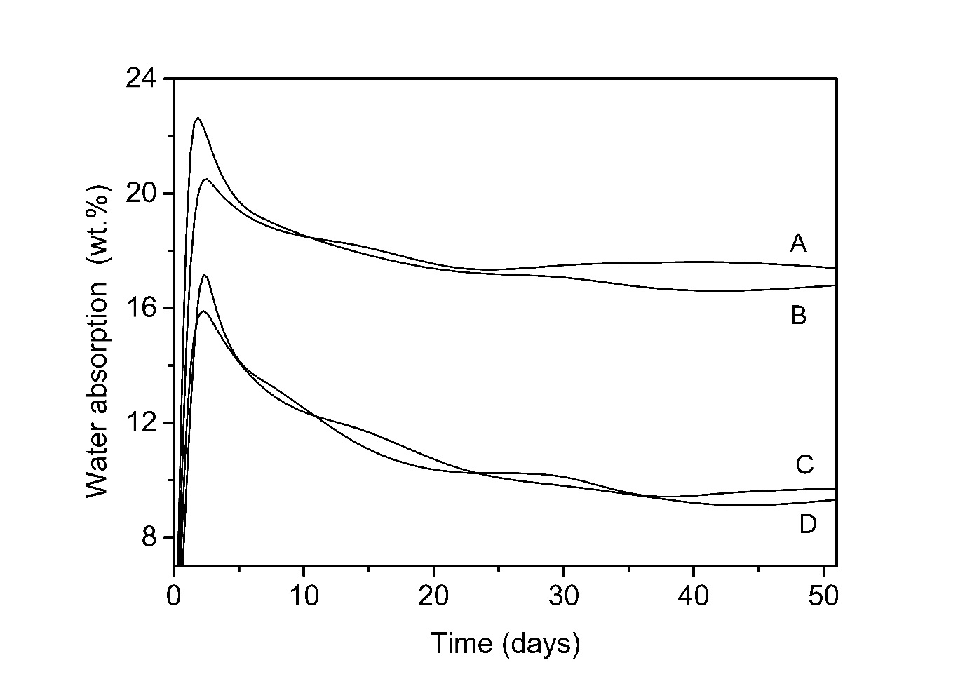
Fig. 4

Fig.5

Fig.6

Fig. 7

