TOOLS FOR DEVELOPING COllaboration IN THE FIELD OF MANUFACTURING PROCESSES

Branska L.¹, Patak, M. ¹, Pecinova, Z.^{1,} Horak, L. ¹

¹University of Pardubice, Faculty of Chemical Technology, Studentska 95, 532 10 Pardubice
Lenka.Branska@upce.cz

Abstract
The development of relationships with suppliers can take place through collaboration in different areas, with collaboration in the manufacturing process being of great importance. The most effective is to deploy such tools for developing collaboration that both partners consider important and are willing to implement to improve supply chain performance. Therefore, primary research has been carried out to help reveal these tools. The research was conducted in two successive stages. In the first stage, quantitative research was carried out among the main suppliers of the nonwoven fabric manufacturer. The aim of this part of the research was to find out which tools for developing collaboration in the production are the most important from the suppliers' perspective. In the second stage of the research, the suitability of individual tools was determined from the point of view of the purchasing enterprise. On the basis of the confrontation of both opinions, the most suitable tools for the development of collaboration in the area of production in the given part of the supply chain were selected. The paper publishes the results of these two surveys. It contributes to the development of scientific knowledge by identifying appropriate tools for developing supplier-customer collaboration in manufacturing processes.

Introduction
Supplier relationship management is a means of increasing the performance of both suppliers and customers. It helps to strengthen the relationship and enables other customers to increase their benefits in the chain. Therefore, it should be promoted by managers and implemented into the way activities in the enterprise are performed [1]. A supplier that binds its customer, thereby protecting its own investments in the relationship already made, is usually more interested in strengthening the relationship [2]. It is especially a customer whose cooperation with the supplier allows it to improve services for its clients that has a prime interest in increasing the benefit of other customers. That is why customers encourage their suppliers to perform well and often help them increase performance through supplier development programmes [3].
Supplier-customer collaboration usually starts at a tactical-operational level, by synchronizing supplies with the customer needs. It allows improving on-time delivery [1]. Continued efforts to increase synchronization of supplies are often the basis for developing collaboration in other areas such as just-in-time use, exchange of strategic information, sharing of the costs of collaborative actions, but also in the development of products [4]. Often involves some degree of collaborative planning [5].
Collaboration in the field of strategic and tactical management of production processes is a natural developmental tendency. If a supplier's business is to be fully supportive of the customer's production system, it forces the supplier to adapt production planning to customer needs. Subsequent synchronization of production and consumption of the products delivered thus becomes a means of efficient managing the material flow in a part of or even the entire supply chain.
Tactical-operational alignment of supply and consumption may be impaired if the customer performs a technological innovation. It is then necessary to adapt the supplier's production system. In order for a synchronized change to take place as quickly as possible and for the innovation to be successful on the whole, businesses in the chain must also work together in the strategic management of their production systems. This increases the popularity of supplier engagement in customer research teams [6]. In research and development, suppliers can contribute by their own knowledge and thus absorb part of the costs that would have to be borne by the customer [7]. These costs can be reduced through frequent communication and better coordination in solving problems associated with the different stages of research and development [7]. However, for the success of research activities, there is a need for an organization of the whole research team [6], an appropriate organizational integration of the team, and a proper use of modern communication technologies [7].
The development of supplier-customer collaboration in the production can therefore be realized through a wide range of different tools. However, which tools are most appropriate and how to apply them has not yet been sufficiently elucidated at the theoretical level as so far few studies have generally been conducted that would propose applying tools for improvement through the implementation of supply chain cooperation [4]. Therefore, it is necessary to address the given area, deepen the knowledge of these tools and specify these tools for the individual areas of the company, also for the production area.
The current research is a follow-up to the research team's research conducted in 2015. The research has shown that, in general, the most beneficial tools are those whose application requires involving both parties. It has also shown tools in production area that can be used to develop supplier-customer relationships [8]. The follow-up research focused on revealing the importance of these tools, both from the point of view of the suppliers of the company and from the point of view of the company. A primary quantitative research was initially carried out among a group of main suppliers of the selected company focusing on the preferences for the various tools for the development of collaboration in production. Subsequently, the same research was carried out, but from the point of view of the customer's company. Comparison of the views of suppliers and customers has enabled us to define appropriate tools for developing collaboration between suppliers and customers in production area.

Goals of research and methodology
In the first stage, a quantitative research was carried out among the major suppliers of a company that is a leading European producer of nonwoven fabrics. The company has approximately 700 suppliers divided into groups according to their importance. The group of major suppliers consists of 38 suppliers. These are suppliers with a turnover of CZK 1 million and/or those providing inputs to the production for customers in the automotive industry.
The aim of this part of the research was to find out which tools for developing collaboration in production area are the most important from the point of view of the suppliers of the company. All the main suppliers of the company were sent a questionnaire electronically, which contained the previous research-defined possible tools for the development of collaboration in the field of production:
- Collaboration in creating quality assurance certificates for supplied products;
- Joint quality control of inputs (saving the customer's activities);
- Collaboration in eliminating technological problems arising from the processing of supplied products;
- Collaboration in technological innovation;
- Collaboration in product innovations of the supplier, e.g. by testing an innovated product;
- Collaboration in area of the lending of production equipment (e.g. in accidents);
- Collaboration in dealing with complaints;
- Collaboration in waste disposal;
- Collaboration in the use of unprocessed products.
Suppliers, as individual respondents, could identify up to 3 of the most important tools for developing collaboration. There was also the possibility of complementing other tools that they consider important for the development of collaboration in this area. The research also included the characteristics of the individual supplying companies, namely: the size of the company according to the number of employees (size), the country from which the supplier comes (region) and the length of practice of the respondent (practice).
The research involved 32 major suppliers (6 remaining main suppliers had not been approached as they are internal suppliers). For the purposes of statistical analysis, the suppliers were divided into two groups, namely small businesses with up to 50 employees and large enterprises with 51+ employees. Depending on the region from which the suppliers come, they were divided into domestic and foreign. The representation of the suppliers in the groups according to the two sorting characteristics was essentially uniform (see the structure of the respondents in Table I).

Table I
Structure of the respondents
 |  | Frequency | Percent
Size | Small businesses | 14 | 54
 | Large enterprises | 12 | 46
Total |  | 26 | 100
Region | Domestic | 11 | 42
 | Foreign | 15 | 58
Total |  | 26 | 100
From the point of view of the length of practice of the respondents, the overwhelming majority (89 percent) of the respondents were employees with experience longer than 5 years, i.e. experienced enough for qualified answers. The answers obtained in the first part of the research were statistically processed using descriptive analysis methods.
The first part of the research was followed by the second part, in which we identified the company's opinion as a customer. Finally, a comparison of the views of both parties was made, which allowed us to evaluate the results of the research and formulate its conclusions.

Discussion and result analysis
The results of the first part of the primary research enabled us to identify the most important tools for developing the relationship between the supplier and the customer, from the point of view of the company's suppliers. Table II includes a frequency-based presentation of the monitored tools of collaboration (% of responses) and the frequency of companies in which the tool of collaboration was identified (% of cases).

Table II
Importance of tools for developing the relationship between the supplier and the customer
Tool | Responses |  | % of Cases
Tool | N | % | % of Cases
Collaboration in eliminating technological problems arising from the processing of supplied products | 18 | 23% | 69%
Collaboration in product innovations of the supplier | 13 | 17% | 50%
Collaboration in technological innovation | 13 | 17% | 50%
Collaboration in creating quality assurance certificates for supplied products | 11 | 14% | 42%
Collaboration in area of the lending of production equipment | 11 | 14% | 42%
Joint quality control of inputs | 4 | 5% | 15%
Collaboration in dealing with complaints | 4 | 5% | 15%
Collaboration in waste disposal | 2 | 3% | 8%
Collaboration in the use of unprocessed products | 1 | 1% | 4%
Total | 77 | 100% | x

It is clear from Table II that suppliers consider collaboration in eliminating technological problems arising from the processing of supplied products to be the most important tool for developing the relationship in the field of manufacturing (reported in almost 70 percent of cases). In a half of the cases, collaboration in innovation, both concerning products and technology, was identified as important. Research results also show that collaboration in waste disposal and in the backflows is of little importance for the development of the relationship. The respondents did not use the option of complementing other tools of cooperation.
A subsequent analysis revealed that respondents' views depend on the size of the company. Small businesses consider collaboration in eliminating technological problems arising from the processing of supplied products to be the most important; large companies consider collaboration in technological and product innovations (e.g. by testing the innovated product) to be more important. The reason for the divergent view may be less innovation activity by small businesses. If these suppliers address innovation activities with less interest, or purchase only the final results of research, they naturally regard collaboration with customers in this area as less important. Comparison of frequencies depending on the size of the company is shown in the graph below (Figure 1).
The differences in views also depend on the region from which the supplier comes (see Figure 2). Domestic suppliers generally agree with foreign suppliers on the importance of collaboration in eliminating technological problems arising from the processing of supplied products (both groups of the respondents consider it to be the most important tool for developing the supplier-customer relationship), but they differ in their views on the importance of collaboration on technological and product innovations. It is more important for domestic suppliers to collaborate in product innovations, and it is more important for foreign suppliers to collaborate in technological innovations. Interestingly, the most pronounced difference in opinion between the two groups of respondents relates to collaboration in the lending of production equipment (e.g. in accidents). Foreign suppliers regard this tool as much more important than domestic suppliers (60 percent vs. 18 percent).

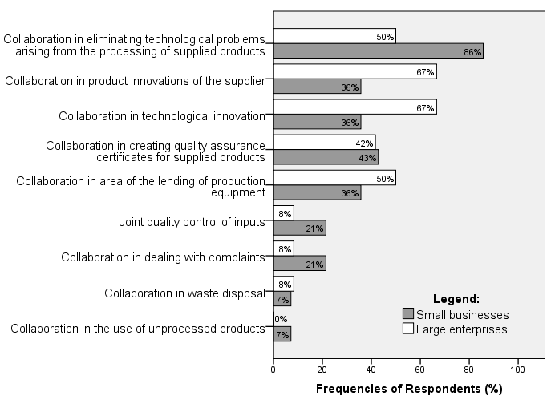
Figure 1. Comparison of the importance of tools depending on the size of the company

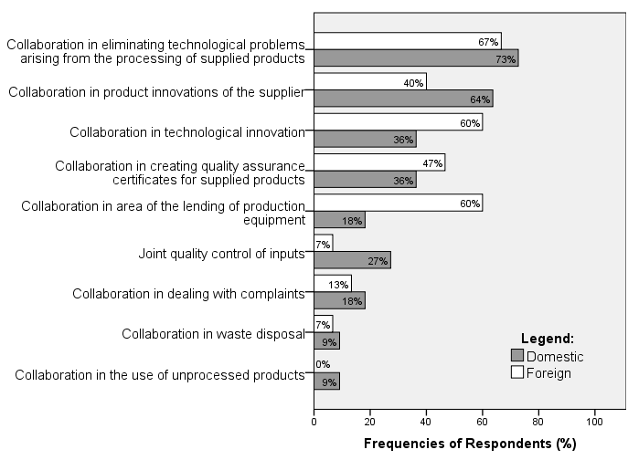
Figure 2. Comparison of the importance of tools depending on the region from which the supplier comes

In the second phase of the research, the viewpoint of the customer's company was inquired on the importance of the individual tools for developing the relationship between the supplier and the customer in the field of production. The enterprise in the position of the customer considers the following to be the most important tools for developing the relationship in the field:
- Collaboration in creating quality assurance certificates for supplied products;
- Collaboration in eliminating technological problems arising from the processing of supplied products;
- Collaboration in product innovations of the supplier, e.g. by testing an innovated product.
In other words, the customer's company is in agreement with its suppliers when considering collaboration in the areas of product innovation and elimination of technological problems arising from the processing of supplied products to be the most important. Unlike its suppliers, however, it also included collaboration in creating quality assurance certificates for supplied products in the group of the three most important tools of collaboration. Still, suppliers consider this tool also important (42 percent of suppliers rank it among the three most important tools).

Conclusion
Cooperation in a chain is generally considered to be very beneficial in terms of improving the performance of both businesses, i.e. those of the supplier and the customer within the supply chain. However, it is important to use tools that both partners consider important. Therefore, the primary research aimed at detecting such tools was carried out. The authors interviewed both the suppliers of the company and the company in the position of their customer. The results show that both suppliers and customers are in agreement when considering collaboration in product innovations and cooperation in eliminating technological problems arising from the processing of supplied products to be two of the three most important tools of cooperation. Suppliers add cooperation in technological innovation to the group of the three most important tools. As the third of this group of tools, the customer mentions cooperation in creating quality assurance certificates, which is, nevertheless, also important to suppliers. It can thus be stated that collaboration in innovations, elimination of technological problems in production process and creation of quality assurance certificates are the most important tools for the development of the supplier-customer relationship in the given supply chain.

References
1. Spina D., Di Serio L. C., Brito L. A. L., Duarte A. L. C. M: AJ MANAG, 15, 54 (2015).
2. Touboulic A., Walker H.: J PURCH SUPPLY MANAG, 21, 178 (2015).
3. Modi S. B., Mabert V. A.: J OPER MANAG, 25, 42 (2007).
4. Mayer J. A., Borchardt M., Pereira G. M.: Ing Investig, 36, 51 (2016).
5. Petersen K., Ragatz G.L., Monczka R.M.: J SUPPLY CHAIN MANAG, 41, 14 (2005).
6. Yan T., Nair A.: DECISION SCI, 47, 589 (2016).
7. Soosay C. A., Hyland P. W., Ferrer M.: SUPPLY CHAIN MANAG, 13, 160 (2008).
8. Branska L., Patak M., Pecinova Z., Horak L.: Supplier Relationship Management as a Tool for Strengthening Partnerships in Supply Chain. STEF92 Technology Ltd., Sofie 2016.

