Analysis of the information security management in Czech Republic

T. Svoboda and J. Horalek¹
¹ University of Pardubice, Faculty of electrical engineering and informatics, Pardubice, Czech Republic
tomas.svoboda5@upce.cz

Abstract— The aim of this article is to introduce an implementation of information security management into organizations in Czech Republic, using the ČSN/ EN ISO/IEC 27001 standard. Information security, on which a high demand is focused nowadays, is introduced firstly. Next, the evolution of information security standards is described in detail. Based on the theoretical background, the research about implementation of information security standards in Czech Republic is conducted, by using a questionnaire survey as a research method. The results of this survey, which reflect responses from more than 30 organizations, are presented in detail.

Index Terms— Certification; Standards; Information; Security; Survey

Introduction

Nowadays, organizations can choose from a large range of internationally recognized and practically verified tools for enhancing information security [1, 3]. Most of large organizations address consulting companies that assist them to select appropriate tools, implement these tools and subsequent audits [2, 3]. This domain has become a big business playground for a number of specialized companies in recent years. New legislations, standards and tools are created in countries of the European Union [4]. But for non-specialized organizations, the situation quickly becomes very confusing [5, 6]. The time when a departments must deal with this issue, as part of the organization, is near [7, 8]. We can expect, that this sector of these services will grow in the future.

Information security

For a proper understanding of the concept of information security, or alternatively the security of information, we must first have a correct understanding of concepts related to information security first.
Information: In everyday life, the information is deemed to be knowledge that can be forwarded, or information which is the content of communication. This also corresponds with the normative interpretation of information according to ISO 5127-2003 (Information and documentation - vocabulary), which defines the information as communication knowledge in the communication process. The aim is to increase knowledge. For purposes of cybersecurity systems, use of the general definition is preferred. From the technical point of view, the information can be understood as a property of an object or system, which expresses its structure and it is fixed in character form on a physical or electronic medium. The information must meet the conditions of confidentiality, integrity and availability to ensure, that it is secured [19]. But it may also include conditions of authenticity, non-repudiation and reliability [10].
Confidentiality: Information is not available or is not disclosed to unauthorized persons, entities or processes [12].
Integrity: Information must be right, accurate and complete.
Availability: Information must be accessible and usable at the request of authorized entities.
Authenticity: to ensure the validation of identity of the entity.
Non-repudiation: Ensure the ability to prove the alleged occurrence or activity of entities that caused them. The authenticity and non-repudiation, can be considered as part of reliability in some cases. So if we are talking about ensuring data reliability, it is means to ensure authenticity and non-repudiation too [13].
Reliability: ensure consistency between intended behavior and results [9].
Data: For interpretation in terms of information security, it is necessary to further refine the concept of information. The information can be interpreted as data (collected or otherwise processed data), which is in an easily readable and understandable form, for the subject to whom it is intended. The data can exist in electronic or paper form and it can be in a verbal or recorded medium.
Information assets: Information and data can be collectively grouped in the concept of an information asset. The asset is defined as anything that has some value for an organization. Information assets are divided into primary and supportive. Information itself is considered as a primary asset. Supporting assets include all resources for storing, processing and securing primary assets.
Information/Cyber security: In general, a security can be defined as the ability of a system or its parts to resist an external or internal act which can affect it [16, 18]. From a viewpoint of information, we can say, that this is a system’s ability to retain the attributes, which are described later in this chapter, namely confidentiality, integrity, availability and reliability [17]. This brings us to the definition of information security, or security of information. We can also meet the term cybersecurity. This term means branches of computing, which mainly deal with the protection of computer systems and networks from theft, corruption or other unforeseen effects of external and internal phenomena. The aim is to preserve the availability, prevent the loss of confidentiality, integrity, and reliability, i.e. keep information systems available and with no adverse changes according to the requirements of their users [10].
Threat: threat is a potential cause of a cyber security incident, which could result in damaged assets. As a threat, we understand each adverse effect on the assets, which can cause damage, abuse or unavailability of assets. The cyber security threats, which act on the primary operating assets, can be monitored mainly through supporting information processes. Protected primary assets (information) are usually a target of threats, because they have a big price.
Vulnerability: Vulnerability is a weakness of an asset or security measure, which can be exploited by one or more threats. The vulnerability arises in areas covered by the supporting assets, which lacks the organizational and technical measures against threats, or where such a measure is not sufficiently effective.
Risk: The risk refers to the possibility that some threats utilize vulnerabilities of the information system and it cause damage to assets.
Security incident: The decree about cybersecurity no. 316/2014 Sb. does not have a direct definition of a security incident. We can define it as “a term designating any non-standard or unpleasant security event, that leads to a distortion of the rules of safety in the organization” [11].

Evolution of a standards for information security
With development of computer systems in the late eighties and early nineties, there was need to respond to new technologies and threats that came with this development. The Commercial Computer Security Centre, United Kingdom Goverment's Department of Trade and Industry, was commissioned to address this issue. The aim was to create evaluation criteria for system security and a set of good security practices for creating and managing such systems.
The evaluation criteria was established as a document labeled ITSEC (Information Technology Security Evaluation Criteria), which was published in 1991. These criteria were subsequently adopted by many other European countries, and later they became ISO / IEC 15408 standard, Information technology - security techniques - evaluation criteria for IT security [14]. This standard is also known as the Common criteria (abbreviation of the full name Common criteria for Information technology security evaluation). A set of security procedures was created as a document labeled BSI-DISC-PD003 (British Standards Institution - Delivering Information Solutions to Customers - Public Document) in 1993. Later, this administration has taken over the British Standards Institution for BSI standards. In 1995 it began publishing the document under the title BS7799. In 1998, developing the standard split into two documents. The first BS7799-1 (Code of Practice for Information Security Management) was a sequel to the original standard BS7799. The second BS7799-2 (Information Security Management Systems - Specification with guidance for use), is also known as ISMS. The first standard BS7799-1 was marked with the International Organization for Standardization as ISO/IEC 17799, Information technology - Security techniques - Code of Practice for Information Security Management, in 2000. Later, in 2007 it was redesignated as the ISO/IEC 27002. The contents were retained. The second standard BS7799-2 was expanded in 2002, inter alia with the well-known "plantation Do-Check-Act" cycle. BS7799-2 was also accepted in 2005 as an international standard with the label ISO/IEC 27001, Information technology - Security techniques - Information security management systems – Requirements [15].

Present state
The aforementioned applicable international standards have been adopted, under the banner of the organization ISO (International Organization for Standardization) and EIC (International Electrotechnical Commission), by a number of countries around the world. Many of them have current applicable laws and regulations on information security, that are originally based on British standards. The Czech Republic is one of these countries.
The international association IQnet was established for the verification of the organization's compliance policies with prescribed international ISO / IEC standards. It is a network of certification authorities, which operate in different countries. Its members are authorized to award certificates of compliance with the conditions of the standards. Nowadays, there is a whole family of ISO/IEC 2700.

Current situation in Czech Republic
Standards in the Czech Republic are under the administration of Office for Standards, metrology and testing. These standards are designated with the acronym ČSN and numerical code. The designation is marking CSN and added to the beginning only. The designation are based on international standards. As we already mentioned, the certification of standards is ensured by the association IQnet. The Czech representative in the association is The Association for Quality System Certification (since 1998). The law about cyber security is in effect from January 1st, 2015 in Czech Republic. It provides a method of protecting information and determines which organizations must do so. For this purpose, it defines the concepts of critical infrastructure and important information systems. Besides the law on cyber security, the National Cyber Security Center (NCKB) has worked in the Czech Republic since 2014. The role of the center is to coordinate cooperation at national and international level to prevent cyber attacks as well as the design and adoption of measures, which deal with incidents and against ongoing attacks.

Practical development of information security

Different organizations have different motivations for implementing information security systems. To ensure the relevance of information on the implementation of standards 27001, this information can not be based only on a theoretical basis.

Methodology of the research
For practical purposes, the questionnaire survey was conducted within organizations, which operate in the Czech Republic. Based on acquired contacts, several persons were contacted, in selected organizations, who works in positions related to the management of ICT. They were determined in order to provide information related to reasons, intensity, impacts and re-evaluation process of implementing the ISO 27001 standard. We addressed only those organizations which, we assume, deal with the question of implementation of ISO 27001 in the past. We examined the information related to reasons, intensity, impacts and the re-evaluation process of implementing the ISO 27001 standard. This was not a selection that represents the entire spectrum of organizations, which operate in the Czech Republic. The questionnaire survey included 12 questions and it was not conceived as anonymous, in order to enhance the credibility of the obtained information. However, some participants expressed a desire to have not been associated with specific answers in text. The questionnaire contains questions aimed at the characteristics of the organization; at implementing or not implementing ISO 27001 certification services and their reasons for doing so, and the next set questions were aimed at the time schedule and budget for implementing ISO 27001 certification. A positive fact is, that a large number of organizations have decided to share their experiences. We selected 33 of them, which are the most important of national and government organizations classified into autonomous territorial units. These organizations operate in the field of healthcare, city administration, government administration and private organizations. To evaluate the questionnaire, quantitative methods, enabling fast and straightforward data collection and relatively easy generalized results, were used. Maximal elimination of dependency on a particular researcher had a significant effect on using quantitative methods of evaluating the research.

Certification of ISO 27001 standard
The first obtained result is the current status of the certification of ISO 27001 by organizations in the Czech Republic. Fig. 1 depicted the obtained results. A surprisingly large number of 21 respondents said, that they currently have the certification of standard 27001. Another three organizations currently have submitted a request for certification of standard 27001. The same number of organizations are now planning to obtain certification of standard 27001. 6 organizations said they do not plan steps to obtain certification of standard 27001.
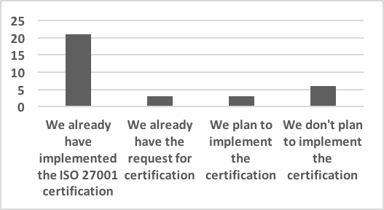
Figure 1: Actual implementation of ISO 27001 in Czech rep. (source: authors)

Contribution of IT specialists
Figure 2 shows next interesting results. They represent interviewed persons, who work in positions related to the management of ICT, and who implement standards and obtain the certification of ISO 27001. 18 persons said they contributed significantly to the establishment of 27001, in their organization. 9 people mentioned only marginal participation. None of the respondents mentioned that they did not participate in the implementation of standards 27001.
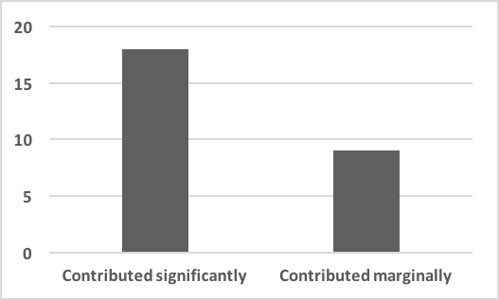
Figure 2: Contribution of IT specialists (source: authors)

Reasons for implementation of ISO 27001
Next obtained results are depicted at Fig. 3. These are the reasons which led the organizations to implement the ISO 27001 standard. Respondents could choose more than one answer in this question. The most common reason is the need to protect information of partners or customers. This was the biggest reason for 24 respondents. The next reasons for implementation are possibility of fulfilling the legislative requirements of the Czech Republic and the need to better protect an information assets – 21 respondents. 3 respondents reported the compliance with the requirements of the cyber law as the reason for the implementation of standard ISO 27001.
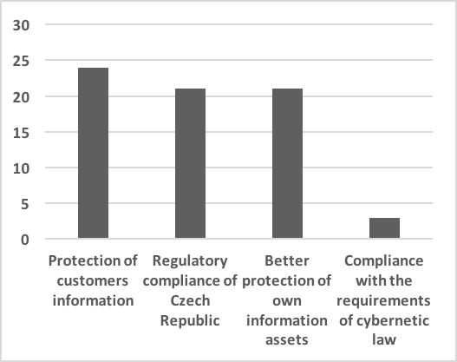
Figure 3: Reason for implementation of ISO 27001
(source: authors)

Fulfilment of requirements
Another question is related to the difficulty and costly process, that was associated with placing all things into line with the requirements of ISO 27001. The results depicted at Fig. 4 are quite interesting. 9 organizations met at least some of the requirements of the standard before its application. 12 of them have already met the most of requirements. So to fulfill the requirements of the standard, a significant effort and cost, was not required.
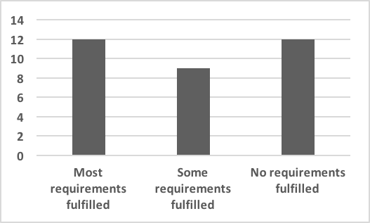
Figure 4: Fulfilment of requirements (source: authors)

Re-implementation of the standard
Another question was aimed to support the implementation of standard ISO 27001, but targeted at organizations that already have implemented the standard. The response is based on the experiences of organizations that already have implemented a standard ISO 27001, and if they would implement this standard again, given their current knowledge. Results are depicted in Fig. 5. 24 respondents said that they would implement the standard in the same range and they would not make any changes. 3 respondents would implement the standard in a different range.
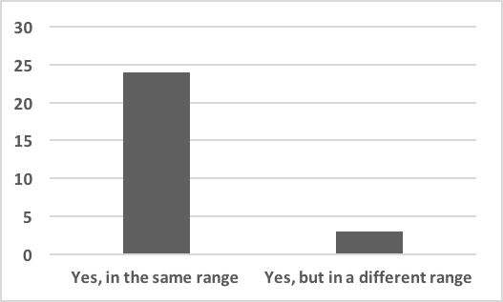
Figure 5: Re-implementation of ISO 27001 standard
(source: authors)

Cybernetics law requirements fulfilment
Figure 6 depicts the penultimate results of obtained data. We asked, whether the organizations plan to meet the demands of cyber law. The majority of respondents (12 respondents) said, that they will deal with the requirements of cyber law, when it will affect them. 6 other respondents believe, that the cyber law will never apply to their organization. They constitute together a majority of 18 votes, which does not deal with cyber law. 6 respondents reported positively, which means they expect the need to meet the requirements of cyber law in the near future. 3 respondents said, that they are meeting the requirements of cyber law right now. The remaining six representatives were unable to answer this question.
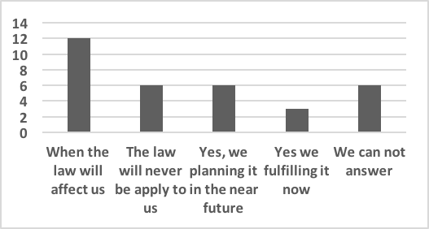
Figure 7: Cybernetics law requirements fulfilment
(source: authors)

Time schedule, requirements and budget
The last results of conducted research are about time schedule, requirements and cost of implementation of the standard ISO 27001. The process of gaining certification of standard ISO 27001 usually lasts from 6 to 12 months. It is a common practice solution, that a consulting companies, which are focused on this, help to organize implementation of the standard. Among the most demanding requirements are: risk analysis, followed by a processing of documentation, and distribution and labeling of assets and management of information security. Based on the results of the research, the respondents didn’t meet with unexpected complications, because they have a well controlled preparation. The budget was exceeded in one case. This fact caused a complication, because the increase had to be approved by the city council and here it was difficult to persuade councilors to understand the importance of information security, in contrast with other investments.

Conclusion

The aim of this article was to introduce information security management in organizations in the Czech Republic. The information security, development of security standards for information security and current state of implementation of ISO 27110 standard, were introduced firstly.
Based on the theoretical background, the questionnaire survey, about the current state of implementation of standards of information security in the Czech Republic, was conducted. The results of this survey, which reflect responses from more than 33 organizations, were presented in detail. Based on the results of the research, we can say, that the implementation of standards for information security in the organizations in the Czech Republic is relatively good. These findings are based on the fact, that the cyber security law has been in effect since January 1st, 2015. It can be assumed that there will be an increasing number of organizations, that will implement the ISO 27001 standard and they will meet the conditions set by the cybersecurity law. It will contribute to greater security of information.

Acknowledgment

This work and contribution is supported by the project of the student grant competition of the University of Pardubice, Faculty of Electrical Engineering and Informatics.

References

- J. Ullrich, J. Cropper, P. Frühwirt, ,E. Weippl, “The role and security of firewalls in cyber-physical cloud computing,” Eurasip Journal on Information Security, 2016 (1), art. no. 18, doi: 10.1186/s13635-016-0042-3
- Y. Bobbert and H. Mulder, “Governance Practices and Critical Success Factors Suitable for Business Information Security,“ Proceedings - 2015 International Conference on Computational Intelligence and Communication Networks, CICN 2015, art. no. 7546267, pp. 1097-1104. doi: 10.1109/CICN.2015.216
- F. Humpert-Vrielink and N. Vrielink, “Modern approach on information security measurement,“ ISSE 2012 Securing Electronic Business Processes: Highlights of the Information Security Solutions Europe 2012 Conference, pp. 48-53, doi: 10.1007/978-3-658-00333-3_5.
- O. Mangin, B. Barafort, P. Heymans and E. Dubois, “Designing a process reference model for information security management systems,” Communications in Computer and Information Science, 2012, pp. 129-140. doi: 10.1007/978-3-642-30439-2_12.
- I. Dionysiou, “An investigation on compliance with ISO 27001 in Cypriot private and public organisations,” International Journal of Services and Standards, 2011, 7 (3-4), pp. 197-234, doi: 10.1504/IJSS.2011.045049.
- B Hlača, S. Aksentijević, E. Tijan. “Influence of ISO 27001:2005 on the port of Rijeka security,” Pomorstvo, 2008, 22 (2), pp. 245-258.
- A. Jaschob, L. Tsintsifa, “IT-grundschutz: Two-tier risk assessment for a higher efficiency in IT security management,“ ISSE, 2006, pp. 95-101, doi: 10.1007/978-3-8348-9195-2_10
- A. Abo-Alian, N.L. Badr, M.F. Tolba, “Security as a service model for cloud storage,“ 2017, Advances in Intelligent Systems and Computing, 533, pp. 225-233.
- M. Moeti, K. Sigama, “Information Security Management Issues in a Cloud-based environment,” 2015, Proceedings - UKSim-AMSS 17th International Conference on Computer Modelling and Simulation, UKSim 2015, art. no. 7576567, pp. 349-354.
- M. Bashir, C. Wee, N. Memon, B. Guo, “Profiling cybersecurity competition participants: Self-efficacy, decision-making and interests predict effectiveness of competitions as a recruitment tool,” 2017, Computers and Security, 65, pp. 153-165.
- K. Grahn, M. Westerlund, G. Pulkkis, “Analytics for network security: A survey and taxonomy,” 2017, Studies in Computational Intelligence, 691, pp. 175-193.
- D. Puthal, S. Nepal, R. Ranjan, J. Chen, “A dynamic prime number based efficient security mechanism for big sensing data streams”, 2017, Journal of Computer and System Sciences, 83 (1), pp. 22-42.
- N. Zawawi, M. Hamdy, R. Ghary, M.F. Tolba, “Realization of a data traceability and recovery service for a trusted authority service coordination within a Cloud environment,” 2016, Soft Computing, 20 (12), pp. 5039-5050.
- H. Chen, D. Bao, Y. Goto, J. Cheng, “A supporting environment for IT system security evaluation based on ISO/IEC 15408 and ISO/IEC 18045,“ 2015 Lecture Notes in Electrical Engineering, 330, pp. 1359-1366.
- P. Kafel and M. Casadesus, “The order and level of management standards implementation: Changes during the time,“ 2016, TQM Journal, 28 (4), pp. 636-647.
- J. Horalek and V. Sobeslav, “IPv6 Firewall Functions Analysis”, 2016, doi: 10.1007/978-3-319-45246-3_21.
- F. Holik, J. Horalek, S. Neradova, S. Zitta and M. Novak, “Methods of deploying security standards in a business environment,” 2015, 25th International Conference Radioelektronika (RADIOELEKTRONIKA). IEEE, doi: 10.1109/RADIOELEK.2015.7128984. ISBN 978-1-4799-8117-5
- R. Cimler, J. Matyska, L. Balik, J. Horalek and V. Sobeslav. “Security Aspects of Cloud Based Mobile Health Care Application,” 2015, doi: 10.1007/978-3-319-15392-6_20.
- T. Svoboda and S. Karamazov, “Analysis of Security Threats of Cloud Computing,” 2017, Journal of Telecommunication, Electronic and Computer Engineering, 9 (1-3), pp. 59-64. e-ISSN: 2289-8131

