Performance characteristics of a new plastic explosive based on cis-1,3,4,6-tetranitrooctahydroimidazo-[4,5-d]imidazole (BCHMX) and 3-nitro-1,2,4-triazol-5-one (NTO)
Ahmed K. HUSSEIN¹, Ahmed ELBEIH², Svatopluk ZEMAN¹
¹ Institute of Energetic Materials, Faculty of Chemical Technology, University of Pardubice, CZ.
² Military Technical College, Kobry Elkobbah, Cairo, Egypt
E-mail: ahmed92egypt@gmail.com
Abstract:
Plastic Explosives have several military and civilian applications. However, high performance with low sensitivity is difficult to obtain using an inert polymeric matrix. In this work, a new plastic explosive composition based on mixture of cis-1,3,4,6-tetranitrooctahydroimidazo-[4,5-d]imidazole (BCHMX) and 3-nitro-1,2,4-triazol-5-one (NTO) bonded by poly-dimethyl siloxane binder (BCHMX/NTO-Sil.),(44/44/12 by wt.), was prepared. For comparison, Two types of plastic explosives based on individual explosives, RDX (1,3,5-trinitro-1,3,5-triazinane or BCHMX, bonded by poly-dimethyl siloxane binder were studied in addition to the commercial available LOVA explosive TNTO (TNT 50% and NTO 50% by wt). Impact and friction sensitivities of these compositions as well as the individual explosives were determined. Experimental detonation velocity were performed for these compositions. Detonation characteristics were calculated using EXPLO5 program and compared with the experimental results. The results showed that BCHMX/NTO-Silicone has low sensitivity in the range of TNTO with higher detonation characteristic.
Key word: bicycle-HMX, NTO; sensitivity; Performance; detonation characteristics.
- Introduction
Searching for the best explosive mixture combining the high performance and low sensitivity considered ambition. Experts had proven that increasing the explosive performance is usually accompanied by an increase in the sensitivity [1-4]. Theories couldn’t prove this phenomenon, mentioned out by Licht [2]. But, exceptions are possible, i.e. explosives which approach the ideal perfect explosive (high explosive strength combined with high security), which is exemplified in Refs.[1, 2, 4]. Previously investigations studies using of the sensitivity and performance data were performed on several plastic bonded explosives (PBXs) [3-6] to explain this problem. These explosives are derived from 1,3,5-trinitro-1,3,5-triazinane (RDX), β-1,3,5,7-tetranitro-1,3,5,7-tetrazocane (β-HMX), ε-2,4,6,8,10,12-hexanitro-2,4,6,8,10,12-hexaazaisowurtzitane (ε-HNIW) and cis-1,3,4,6-tetranitrooctahydroimidazo-[4,5-d]imidazole (BCHMX). In the quality of binders, our staff studied Viton A 200 [3, 6], polydimethylsiloxane (Sil.-binder) [3, 6], softened acrylonitrile-butadiene rubber (NBR) [3, 6], softened polyisobutylene (PIB) [5, 6] and softened polymethylmethacrylate (PMMA) [5, 6] as polymeric matrices to bond different individual explosives. This paper broadens of knowledge of the recent study [6] according to which the optimum binder seems to be the polydimethyl-siloxane matrix. The siloxane matrix has a neutral effect on thermochemistry of detonation of the nitramines studied (according to the volume heat of detonation) as those obtained with fluoroel elastomers and corresponding PBXs have optimum sensitivity parameters. In addition to the previous advantage, the polydimethyl-siloxane has roughly the same influence on increasing the resistance against mechanical impulses. Also, acquisition of PBX with lower vulnerability is possible to achieve by incorporation of 5-oxo-3-nitro-1,2,4-triazole (NTO, or nitrotriazolone) into matrix of these PBXs[7-9]. Thus modified nitramine’s plastic explosives bonded with polydimethylsiloxane binder are a topic of this paper in light of their explosive properties and initiation reactivity.
- Experimental work
  - Characteristics of materials and preparation methods
BCHMX, the chemical structure Figure (1. a), is a white crystalline powder was prepared at the institute of energetic materials (IEM) in two stage method according to the Czech patent [10, 11]. NTO (3-nitro-1,2,4-triazol-5-one), the chemical structure Figure (1.b), is a pale yellow, was product supplied by Eurenco, Paris, France. The average particle size for BCHMX and NTO is 55 and 55µm respectively. Explosive characteristics of the pure explosive are listed in Table.1
(a) | (b)
Figure 1: Chemical structures of a) BCHMX and b) NTO
Table. 1 Thermodynamic and detonation characteristics of the used individual energetic materials
Code designation of explosives | Max. theoretical density, ρ |  | Enthalpy  of formation,  ∆H_{f} |  | Calculated detonation parameters by EXPLO5 at max. theoretical density
Code designation of explosives | (kg m³) | Ref. | (kJ mol⁻¹) | Ref. | detonation velocity  (m s⁻¹) | heat of explosion  (kJ kg⁻¹)
RDX | 1816 | [12] | 66.2 | [6] | 8747 | 6124
BCHMX | 1860 | [13] | 236.5 | [6] | 8922 | 6475
NTO | 1930 | [12] | -129.41 | [14] | 8130 | 3878
TNT | 1654 | [12] | -62.76 | [15] | 7253 | 5226

Polydimethylsiloxane binder was used as a matrix for coating of the prepared explosive mixture. Two kinds of these poly methyl siloxane polymer was used in a ratio of 1:1. Average molecular mass of the first kind was 37.5 kg.mol⁻¹ and its polydispersity index 1.62; the second kind had values of 72.9 kg.mol⁻¹ and 1.57, respectively to obtain the desired average molecular mass and viscosity. Using computerizing mixer plastograph BRABENDER, the plastic explosive was obtained by mixing of the prepared explosive mixtures 88 wt% with the polymeric matrix 12 wt.% at 25 ºC for 90 min. In case of the Plastic explosive mixture the solid ingredient were mixed together before addition of polymeric matrix (BCHMX 44 wt. % and NTO mixer 44 wt.%).
  - Elemental Analysis
Fisons – EA-1108 CHNS-O elemental analyzer was used for the determination of C, H, and N in the prepared cocrystal. The results of the elemental analysis were recalculated to match the nitrogen content to the individual explosive and reported in Table 2 as a hypothetical formula. By this way, the calculated formula was used as if it is individual explosive and it was used in the detonation parameters calculations.
  - Heat of Combustion
An automatic high pressure Bomb calorimeter, model BCA 500, OZM research s.r.o, Czech republic, was used to measure the heat of combustion of the BCHMX/NTO-Sil. The sample was placed in a closed bomb filled with an excess of oxygen [16] and ignited. The output data is reported in Table 2 and was used for calculation the enthalpy of formation of the BCHMX/NTO-Sil which was used for determining the detonation characteristics.
  - Impact sensitivity measurement
The standard impact tester with exchangeable drop weight of BAM impact sensitivity instrument [17] was used ; the amount of substance tested was 50 mm³ , and drop hammers of 2 and 5 kg weight were used. The probity analysis was used to determine the probability levels of the initiation. Only the 50% probability of initiation (H50) is used and is reported in Table 2.
  - Fiction sensitivity measurement
A BAM friction test apparatus was used to determine the sensitivity to friction using the standard test conditions[17]. Sensitivity to friction was determined by spreading about 0.01 g of the studied explosive on the surface of the porcelain plate in the form of a thin layer. Different loads were used to change the normal force between the porcelain pistil and the plate. Sample initiation was observed through sound, smoke appearance, or by the characteristic smell of the decomposition products. Using the Probit analysis [18], only the normal force at which 50% of initiations occurred is reported in Table 2 as the friction sensitivity.
Table 2. Results of the experimental measurements on the samples studied
No. | Code designation |  | Summary formula | Heat of combustion  [J.g⁻¹] | Enthalpy of formation  [kJ.mol⁻¹] | Impact sensitivity  [J] | Friction sensitivity  [N]
 | BCHMX | C₄H₆N₈O₈ |  | 9124 | 236.5 | 3.2 ª | 88ª
 | RDX | C₃H₆N₆O₆ |  | 9522 | 66.2 | 5.6ª | 120ª
 | BCHMX-Sil | C_{5.02}H_{9.18}N₈O_{8.47} Si_{0.54} |  | 11328 | -27.16 | 24.3a | 232ª
 | RDX-Sil | C_{3.78}H_{8.53}N₆O_{6.37} Si_{0.406} |  | 11664 | -129.3 | 31.9 ª | 254 ª
 | BCHMX/NTO-Sil | C_{2.42} H_{2.99} N_{4.84}O_{4.2} Si_{0.81} |  | 9512 | -80.5 | 46.3 | ˃360
 | TNT | C₃H₇N₃O₆ |  | 14963 ^{d} | -67.1^{d} | 39.2e | 342e
 | TNTO (50:50) | C_{4.12}H_{3.34}N_{3.93}O_{4.42} |  | -- | -112.3 | 44.8^{c} | ˃360
 | NTO | C₂H₂N₄O₃ |  | 7305 ^{b} | -129.4 ^{b} | 25.6 ^{c} | ˃360 ^{c}
Note: a [6], b [14], c[19], d [20], e [21]

  - Measurements of the detonation velocity
The detonation velocity of the composition prepared was measured by an EXPLOMET-FO-2000 produced by KONTINITRO AG. The composition tested was prepared in the form of cylinders with 21 mm diameter and 200 mm length. Three optical sensors were placed in each charge, with the first sensor being placed at a distance of 50 mm from the surface containing the detonator. Each of the other two sensors was placed at a distance of 60 mm from the previous one. Charges were set off using detonator no. 8. For good precision for the results three measurements were performed for the composition and the mean value (max. ±68 m s⁻¹) is reported in Table 3.
  - Calculation of the detonation parameters
The theoretical detonation characteristics (detonation velocity, D, heat of detonation, Q, and detonation pressure, P) of the prepared compositions, as well as those of the individual explosives, were calculated by the EXPLO5 code version 5.04 [22]. The following BKWG set of parameters was used: α = 0.5, β = 0.096, κ = 17.56, Θ = 4950 [22].The heat of explosion is the heat released in a constant volume explosion and is determined by subtracting the heats of formation of the explosive (reactants) from the sum of the heats of formation of the detonation. The theoretical calculation and the error between the experimental results are listed on Table 3.
Table 3. Detonation parameters of the samples studied
Studied sample |  | Experimental |  | Explo5 Code
No. | Code of samples | Density  ρ  [g.cm⁻³] | Detonation velocity  D_{exp}  [m.s⁻¹] | Detonation velocity D_{cal.}  [m.s⁻¹] | Error % | Detonation pressure  P  [GPa] | Heat of detonation Q  [kJ.kg⁻¹]
1 | BCHMX | 1.79ª | 8650 | 8840 | +2.19 | 33.95 | 6447
2 | RDX | 1.76 | 8750 | 8718 | -0.4 | 32.12 | 6085
3 | NTO | 1.77ª | 7940 | 7716 | -2.82 | 25.31 | 4031
4 | BCHMX-Sil. | 1.62^{b} | 7994 | 7728 | -3.33 | 24.2 | 6260
5 | RDX-Sil | 1.58 | 7822 | 7640 | -2.32 | 22.8 | 6259
6 | BCHMX/NTO-Sil | 1.61 | 7864 | 7719 | -1.84 | 23.7 | 6242
Note: a[23], b [3]
- Results and discussion
The performance of explosive material has a significant effect on its impact and friction sensitivity which was represent in recently accepted theory [24, 25]. In which, the high performance of explosive is accompanied by an increase of explosive sensitivity. However, modern techniques are used to combine the high values of performance accompanied by the reduction of sensitivity. Therefore, plastic explosive mixture is one of the methods to optimize the performance with the sensitivity reduction. In order to study the sensitivities of the studied samples, Zeman et al [26] presented the difference between initiation by impact (uniaxial compression) and initiation by friction (shear slide with a fixed volume). They announced that the difference might be due to the transfer mode of the initiation impulse into reaction center of the studied nitramine molecule. Here a semi-logarithmic relationship between the friction and the impact sensitivities is presented in Figure 2.
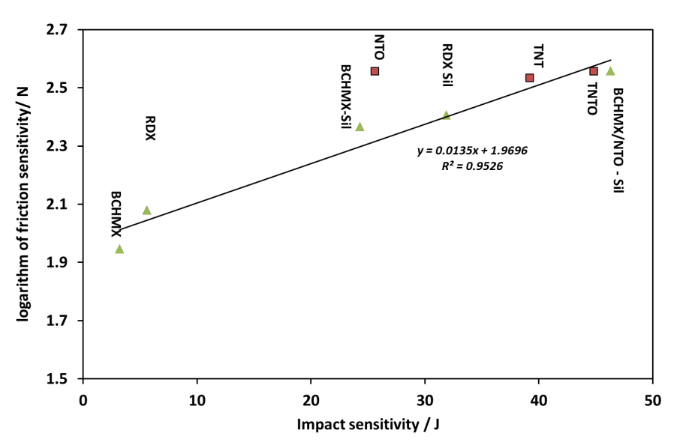
Figure 2: Semi-logarithmic relationship between friction and impact sensitivities.

It was observed that BCHMX/NTO-Sil has impact sensitivity much lower than BCHMX-Sil and all the studied plastic explosives based on silicone matrix in addition to the LOVA mixture based on TNTO. It means that the presence of NTO and silicone matrix has a significant effect on reducing the sensitivity of BCHMX in this mixture.
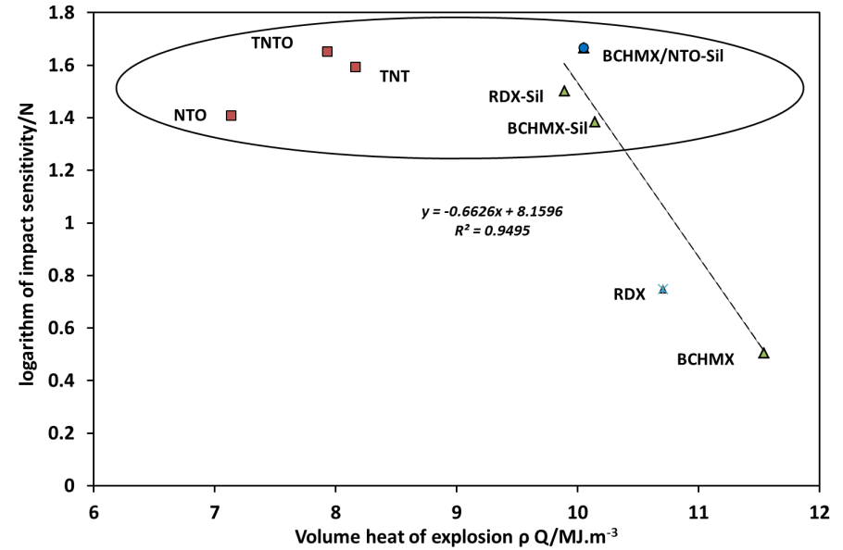
Figure 3: Semi-logarithmic relationship between impact sensitivity and volume heat of explosion

In order to study the performance of the new BCHMX/NTO-Sil, interesting relationship between volume heat of detonation (the product of loading density and the explosion heat ρ.Q/MJ.m⁻³) compared with the logarithm of impact sensitivity is presented in Figure 3. Two groups are presented on this figure, the first group including the nitramines and their plastic explosives bonded by siloxane in addition to the new BCHMX/NTO-Sil. This group has high heat of detonation compared with the second group. The pure RDX and BCHMX explosives have high sensitivity compared with the rest of the studied samples. The second group which represented by oval in Figure 3 includes the pure TNT and NTO with their melt cast composition TNTO, the new BCHMX/NTO-Sil and the siloxane plastic explosives. This group has low sensitivity to impact. Moreover, BCHMX/NTO-Sil has the lowest impact sensitivity of all the studied plastic explosives and in the same level of the LOVA explosive TNTO. The heat of detonation of BCHMX/NTO-Sil is in the same level of the other plastic explosives.
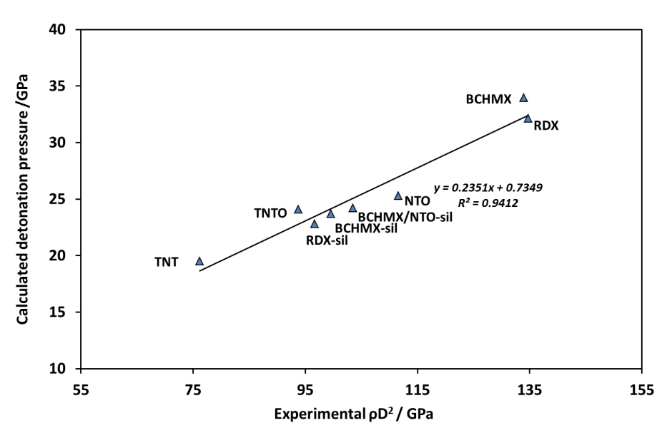
Figure 4: Relationship between calculated detonation pressure and the
square of the experimental detonation velocity multiplied by the loading density.

Regarding to the physics of explosion, the detonation pressure of the explosives could be represented by the products of the square of the detonation velocities and the loading densities. Figure 4 presents a comparison between the calculated detonation pressures (by EXPLO5 code) with the products of the square of the experimental detonation velocities and the loading densities where the compatibility of the calculated results with the experimental measurements was confirmed. Also it is clear that the detonation characteristics of BCHMX/NTO-Sil is higher than that of RDX-Sil and the casted TNTO. The results of sensitivity and performance of studied samples proved that BCHMX/NTO-Sil is interesting plastic explosive has lower impact sensitivity and higher performance than TNTO.
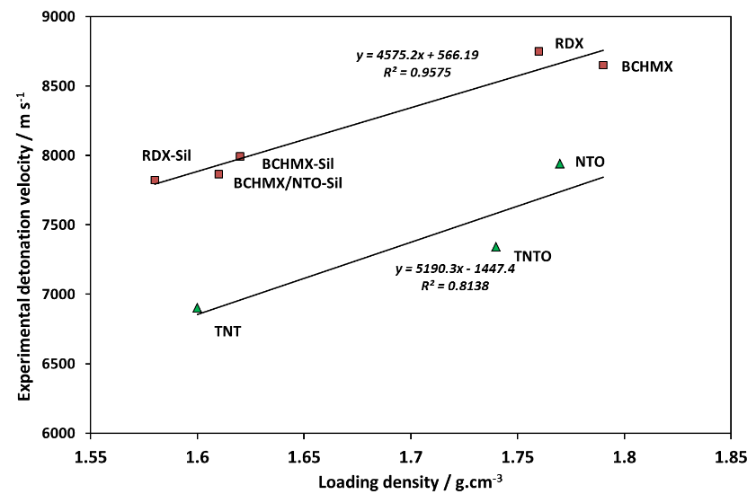
Figure 5: Relationship between the experimental detonation velocity and the
loading density of the studied explosives

Figure 5 represents the well-known dependence of detonation velocity on loading density. It can be observed from the figure that there are two groups. The first group represented by a linear relationship between all the pure nitramines in addition to their plastic explosive mixtures and their densities. A second group includes the relationship based on the pure TNT and NTO in addition to the LOVA explosive TNTO. It is clear that the detonation velocity of new BCHMX/NTO-Sil is higher than that for the LOVA explosive TNTO and the RDX-Sil.
- Conclusion
The newly prepared plastic explosive based on BCHMX/NTO and bonded by polydimethyl siloxane has sensitivities to impact and friction in the same level of LOVA explosive TNTO and lower than all of the pure nitramines studied. A semi-logarithmic relationship exists between the impact and friction sensitivities of the evaluated nitramine explosives. The measured detonation velocity of the BCHMX/NTO-Sil is higher than that for RDX-Sil and TNTO explosive mixture. The calculated heat of detonation and detonation pressure of BCHMX/NTO-Sil are higher than those for studied plastic explosive based on polydimethyl siloxane and TNTO explosive mixture. The BCHMX/NTO-Sil is considered a promising composition optimize between the high performance with low sensitivity.

Acknowledgement
This paper was supported by means of the financial resources of Students Grant Projects No. SGSFCHT_2016002 of the Faculty of Chemical Technology at the University of Pardubice.

Reference
[1] S. Zeman, Study of the initiation reactivity of energetic materials In: R. W. Armstrong, J. M. Short, R. A. Kavetsky, D. K. Anand (Eds.), Energetics science and technology in Central Europe., CECD Series. College Park: University of Maryland (2012) 132-167.
[2] H.-H. Licht, Performance and sensitivity of explosives, Propellants Explosives Pyrotechnics, 25 (2000) 126-132.
[3] A. Elbeih, M. Jungová, S. Zeman, P. Vávra, Z. Akštein, Explosive Strength and Impact Sensitivity of Several PBXs Based on Attractive Cyclic Nitramines, Propellants, Explosives, Pyrotechnics, 37 (2012) 329-334.
[4] S. Zeman, M. Jungová, Sensitivity and performance of energetic materials, Propellants, Explosives, Pyrotechnics, 41 (2016) 426-451.
[5] A. Elbeih, J. Pachman, S. Zeman, P. Vávra, W.A. Trzciński, z. Akštein, Detonation characteristics of plastic explosives based on attractive nitramines with polyisobutylene and poly (methyl methacrylate) binders, Journal of Energetic Materials, 30 (2012) 358-371.
[6] A. Elbeih, S. Zeman, M. Jungova, P. Vávra, Z. Akstein, Effect of different polymeric matrices on some properties of plastic bonded explosives, Propellants, Explosives, Pyrotechnics, 37 (2012) 676-684.
[7] Q.-L. Yan, S. Zeman, A. Elbeih, Recent advances in thermal analysis and stability evaluation of insensitive plastic bonded explosives (PBXs), Thermochimica acta, 537 (2012) 1-12.
[8] J.-S. Lee, K.-S. Jaw, Thermal decomposition properties and compatibility of CL-20, NTO with silicone rubber, Journal of thermal analysis and calorimetry, 85 (2006) 463-467.
[9] A. Becuwe, A. Delclos, Low‐Sensitivity Explosive Compounds for Low Vulnerability Warheads, Propellants, Explosives, Pyrotechnics, 18 (1993) 1-10.
[10] D. Klasovitý, S. Zeman, Method of preparing cis-1, 3, 4, 6-tetranitrooctahydroimidazo-[4, 5-d] imidazole (bicyclo-HMX, BCHMX), Czech Pat, 302068 (2010).
[11] S.V.S. A.A. Lobanova, G.V. Sakovich, A.S. Zharkov, O.A. Efimov, N.I. Popov, Process for Preparation of 2,4,6,8-Tetranitro-2,4,6,8-tetraazabicyclo[3.3.0]octane by Nitration of the Corresponding Tetrasulfonate Salts with Nitric Acid and Nitric Anhydride, Russ. Pat. RU 2445311 C1, C07D471/00, JCS Federal Res. & Prod. Center ALTAI, Biysk (2012).
[12] H. Bathelt, F. Volk, M. Weindel, Der ICT-Thermodynamik-Code, Fraunhofer Institut fur Chemische Technologic (ICT) Pfinztal, Germany, (2004).
[13] D. Klasovitý, S. Zeman, A. Růžička, M. Jungová, M. Roháč, cis-1, 3, 4, 6-Tetranitrooctahydroimidazo-[4, 5-d] imidazole (BCHMX), its properties and initiation reactivity, Journal of hazardous materials, 164 (2009) 954-961.
[14] A. Finch, P. Gardner, A. Head, H. Majdi, The Enthalpies of Formation of 1, 2, 4-triazol-5-one and 3-Nitro-1, 2, 4-triazol-5-one, The Journal of Chemical Thermodynamics, 23 (1991) 1169-1173.
[15] D.R. Stull, E.F. Westrum, G.C. Sinke, The chemical thermodynamics of organic compounds, J. Wiley, 1969.
[16] S. Fuels, determination of heat of combustion by calorimetric method in the pressure vessel and caculation of calorific value, , Czech Institute of standards, Czech Tech. Standard CSN ISO 1928 (June 1999).
[17] S. Muhamed, Test methods for Explosives, Springer,, Heideleberg,, 1995.
[18] J. Šelešovský, J. Pachmáň, Probit analysis-a promising tool for evaluation of explosive's sensitivity, Central European Journal of Energetic Materials, 7 (2010) 269-278.
[19] M.W. Smith, M.D. Cliff, NTO-based explosive formulations: a technology review, in, DTIC Document, 1999.
[20] G. Geiseler, JD Cox und G. Pilcher: Thermochemistry of Organic and Organometallic Compounds. Academic Press, London and New York 1970. 643 Seiten. Preis: 170s, Berichte der Bunsengesellschaft für physikalische Chemie, 74 (1970) 727-727.
[21] C. Storm, J. Stine, J. Kramer, Sensitivity relationships in energetic materials, in: Chemistry and physics of energetic materials, Springer, 1990, pp. 605-639.
[22] M. Sućeska, Calculation of detonation parameters by EXPLO5 computer program, in: Materials Science Forum, Trans Tech Publ, 2004, pp. 325-330.
[23] R. Meyer, J. Köhler, A. Homburg, Explosives, John Wiley & Sons, 2016.
[24] S. Zeman, M. Jungová, Sensitivity and Performance of Energetic Materials, Propellants, Explosives, Pyrotechnics, (2016).
[25] A. Elbeih, S. Zeman, M. Jungova, Z. Akstein, Effect of different polymeric matrices on the sensitivity and performance of interesting cyclic nitramines, Central European Journal of Energetic Materials, 9 (2012) 131-138.
[26] S. Zeman, A. Elbeih, Z. Akštein, Preliminary study on several plastic bonded explosives based on cyclic nitramines, chiense Journal of Energetic Materials, 19 (2011) 8-12.

