EVALUATION OF SELECTED DEVELOPMENTAL SAMPLES OF CHELATING AGENTS ON MODEL WASHING
Petra Bayerová, Veronika Hrubešová, Ladislav Burgert, Michal Černý, Radim Hrdina
Faculty of Chemical Technology, University of Pardubice, Czech Republic
petra.bayerova@upce.cz

Abstract: This work presents the results of model washing with addition of selected developmental samples of chelating agents. The washing was realized in hard water of 22 °dH (given in German degrees of hardness). After 20× repeated washing the content of ash and Ca²⁺ ion were determined. The image of fabric after the model washing was evaluated by means of images from a scanning electron microscope.
Key words: chelating agents, washing of textile materials, model washing

1 INTRODUCTION

Water has an irreplaceable role in textile industry. Any textile production is dependent on water and sufficiency of good quality water. Hard water is not useful for various domestic purposes (washing, bathing, drinking) and for many industries such as textile industry and dyeing industry. Dissolved salts like Ca, Mg, Fe and Mn affect many textile processes. Hard water causes the usual problem of deposition of insoluble salts which interfere with the proper dyeing and printing of the fabrics, textile finishing or pre-treatment of textile materials.
Washing is one of the most important activities in the treatment and maintenance of textiles. Detergent is a part of the washing bath. It is a complex mixture containing various systems – surfactants, builders and auxiliary agents. Chelating agents are the most frequent agents used as components of detergents. Chelating agents (sequestering agents, chelating surfactants) are generally compounds creating chelates, which are specific kinds of complex compounds surrounding a cation (such as Ca²⁺, Mg²⁺, Fe³⁺, Cu²⁺, Mn²⁺). These substances are used for water softening. [1]
Basic indicator of detergent quality is so-called washing efficiency. It can be divided into primary and secondary washing efficiency. Primary efficiency indicates the difference between the amount of soil before and after washing. Secondary efficiency describes how the amount of sediment builds up on washed fabric. Sinking takes place slowly and at least 10 scouring runs are used to determine incrustations. [2]
New types of sequestering agents and chelating surfactants were synthetized at the Institute of Chemistry and Technology of Macromolecular Materials of University of Pardubice, Department of Synthetic Polymers, Fibers and Textile Chemistry These substances were tested in repeated model washing in hard water. Secondary efficacy was determined.

2 EXPERIMENTAL
2.1 Samples of chelating agents
Three types of sequestering agents (sample 1, 2, 3) and two types of chelating surfactants (sample 4, 5) were tested in this study – see Tab. 1.

Table 1 Structures of chelating agents

Sample | Chemical structure
No. 1 | N-(1,2-dicarboxyethyl) glutamic acid tetrasodium salt
No. 2 | N-carboxymethyl- N-(1,2-dicarboxyethyl) aspartic acid pentasodium salt
No. 3 | N,N' - bis(1,2-dicarboxyethyl) aspartic acid hexasodium salt
No. 4 | N – dodecyl-N-(1,2-dicarboxyethyl) aspartic acid tetrapotassium salt
No. 5 | N – dodecyl-N-(1,2-dicarboxyethyl) aspartic acid tetrasodium salt

2.2 Model washing process
Prepared agents were determined under conditions for model washing. The washed material was a batch of 20 grams of cotton textile at a bath ratio of 1:20.The model detergent chosen consisted of water glass (soln. of sodium metasilicate), carboxy-methylcellulose, sodium carbonate, and sodium sulfate and analyzed chelating agent [3]. Washing bath contents 7 g/l of model detergent.
The washing was repeated 20x in hard water of 22 °dH (given in German degrees of hardness) for 30 min at 90 °C (Fig.1). The hard water was prepared by dissolving CaCl₂.6 H₂O in distilled water (1°dH = 39,06 mg CaCl₂ . 6 H₂O).

20 °C
A
B
C
20 min
90 °C, 30 min

Figure 1 Process of model washing

2.3 The evaluation of content of ash and Ca²⁺ ions

The image of fabric after the model washing was evaluated by means of images from a scanning electron microscope (JEOL JSM – 5500LV).
After 20× repeated washing in hard water of 22 °dH for 30 min at 90 °C, the content of ash and Ca²⁺ ion were determined. After 20× repeated washing, the textile was incinerated in a platinum crucible and the amount of calcium was evaluated in ash. The content of calcium was determined by optical emission spectrometry with inductively coupled plasma (Integra XL2-GBC Australia).

3 RESULTS AND DISCUSSION
The prepared samples were tested at model washing conditions. The washing with model detergent without sequestering ingredients increased the content of inorganic deposits in cotton textile. The content of ash and calcium in textile was relatively high: 3.18 % ash and 15.20 g/kg Ca²⁺. The addition of prepared samples with chelating effect improved the result as documented by the data in Table 2.
A reduction of the content of ash and calcium mainly by typical sequestering agents (sample no. 1, sample no. 3) was observed. The lowest content of Ca²⁺ was shown in sample no. 3 N,N'-bis(1,2-dicarboxyethyl) aspartic acid hexasodium salt - see Fig. 6. A surprising result is the high content of ash and calcium in textile with using sample no. 2. Sequestration efficiency can be affected by overalll chemical structure of molecule.
With the addition of chelating surfactants (sample no. 4, 5) the content of ash and calcium is lower than without prepared samples, too. The measured values are higher than for sequestering agents, whereas chelating surfactants have a lower value of sequestering capacity.

Table 2 Content of ash and calcium ion in the cotton textile after twenty times repeated washing in hard water of 22°dH
Sample | Ash content (mass %) | Content of Ca²⁺ (g / 1kg)
no. 1 + model detergent | 0,45 | 1,97
no. 2 + model detergent | 1,99 | 11,40
no. 3 + model detergent | 0,11 | 0,50
no. 4 + model detergent | 2,68 | 11,10
no. 5 + model detergent | 2,18 | 10,90
Washing without sequestering agents in hard water | 3,18 | 15,20
Washing without sequestering agents in distilled water | 0,10 | 0,36
Original cotton textile | 0,10 | 0,23

The image of fabric after the model washing was evaluated by means of images from a scanning electron microscope (Fig. 2 – 8).

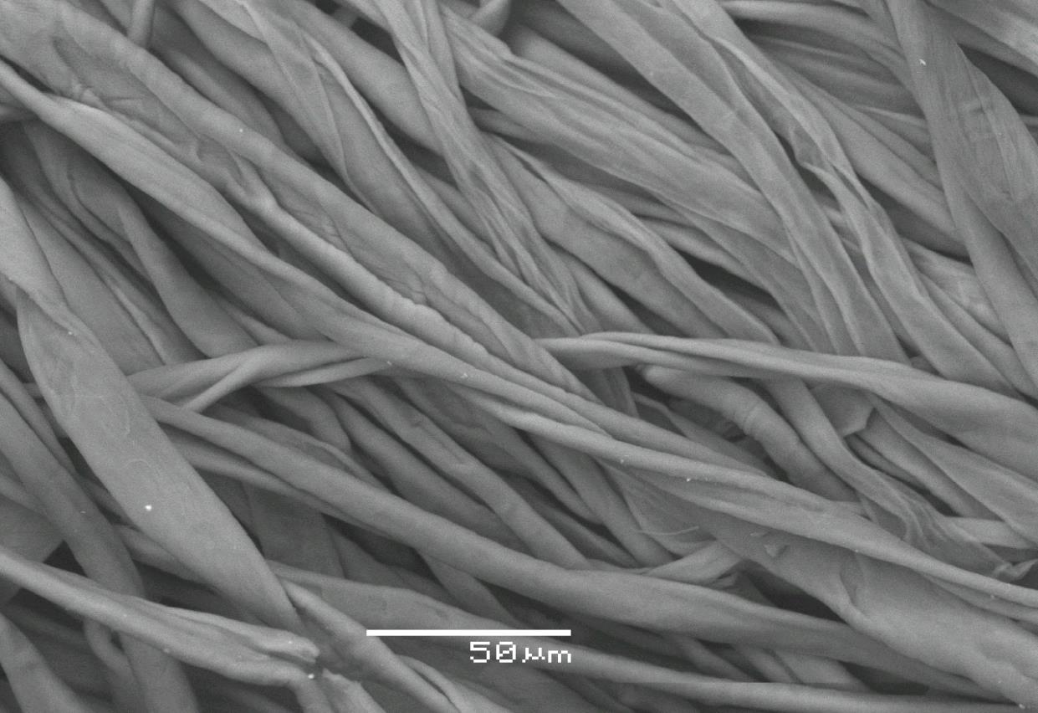

Figure 2 EMS of fiber surface of the original cotton textile

Figure 3 EMS of fiber surface of cotton textile washed without chelating agent with model detergent
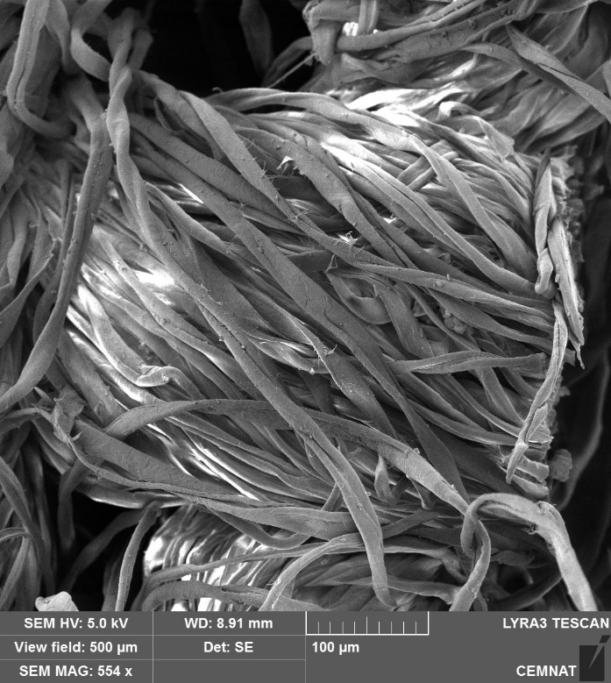

Figure 4 EMS of fiber surface of cotton textile washed with chelating agent no.1

Figure 5 EMS of fiber surface of cotton textile washed with chelating agent no.2

Figure 6 EMS of fiber surface of cotton textile washed with chelating agent no.3

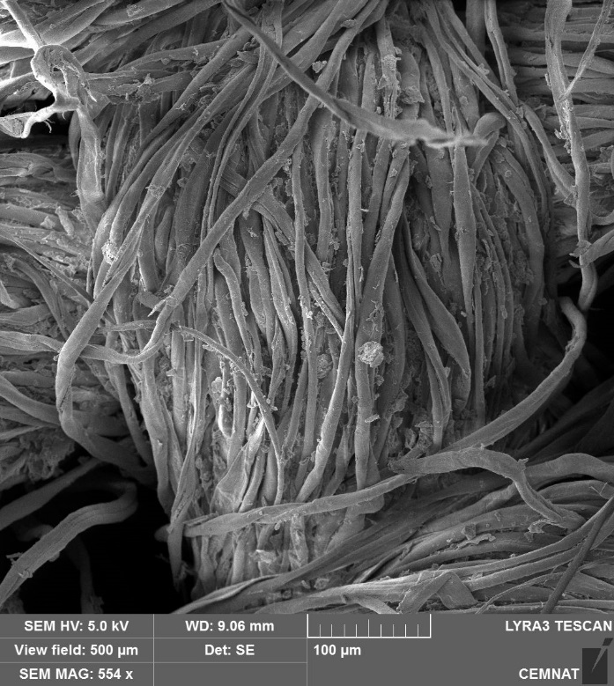

Figure 7 EMS of fiber surface of cotton textile washed with chelating agent no.4

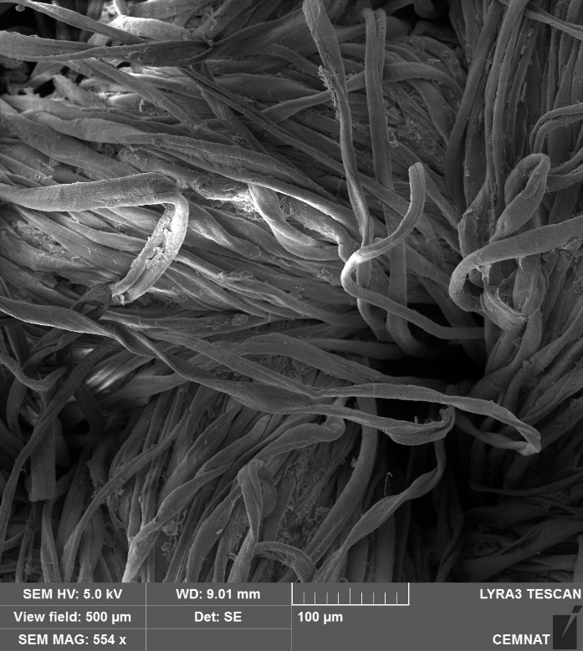

Figure 8 EMS of fiber surface of cotton textile washed with chelating agent no.5

4 CONCLUSIONS
In this work the results of repeated model washing with an addition of selected developmental samples of sequestering agents and chelating surfactants were evaluated. The addition of the prepared chelating samples influences the bath positively. The content of calcium ion is reduced and its negative effect is more limited. The results of the determination of ash values and calcium ion are more favourable in prepared sequestering substances N-(1,2-dicarboxyethyl) glutamic acid tetrasodium salt and N,N'-bis(1,2-dicarboxyethyl) aspartic acid hexasodium salt. Pictures of fiber surface of cotton textile from a scanning electron microscope complement the idea of the sediment for washing material.
It can be concluded that the prepared chelating agents are applicable in many detergent formulas and as textile auxiliary agents for some finishing operations. Sample no. 3 could be recommended as a replacement for existing sequestering agents.

5 REFERENCES
- Choudhury A. K. Roy. Textile Preparation and Dyeing. Enfield NH, USA: Science Publichers, 2006, pp 40-60. ISBN 1-57808-402-4.
- Šmidrkal J. A J. Svobodová: Prací účinnost, XLVIII. Seminář o tenzidech a detergentech. Sborník přednášek, str. 39-43, ISBN 978-80-7395-942-5.
- Hüls Chemische Werke A.-G. Waschmittelformulierungen mit biologisch abbaubaren Polymeren. Inventors: Beck R., Krause F., Schönkäs U. Int. Cl.: C 11 D 3/37. Ger. Offen. DE 43 19 807, 1994 -11 - 17.

