Voltammetric behavior of explosive potassium salt of 2,4-dinitrobenzofuroxan on electrodes with mercury surface

Renáta Šelešovská ª, Romana Sokolová ^{b}, Robert Matyáš ^{c}, and Lenka Janíková ª
ª Institute of Environmental and Chemical Engineering, University of Pardubice, Studentská 573, 532 10 Pardubice, Czech Republic, E-mail: renata.selesovska@upce.c
^{b} J. Heyrovský Institute of Physical Chemistry of ASCR, v.v.i., Dolejškova 3, 182 23 Prague 8, Czech Republic, E-mail: sokolova@jh-inst.cas.cz
^{b} Institute of Energetic Materials, University of Pardubice, Doubravice 41, 532 10 Pardubice, Czech Republic, E-mail: robert.matyáš@upce.c

Abstract
Voltammetric behavior of potassium salt of 2,4-dinitrobenzofuroxan (KDNBF) has been firstly studied using hanging mercury drop electrode (HMDE) and silver solid amalgam electrode (AgSAE). Cyclic voltammetry was applied for the measurements of dependences on pH and scan rate required for the elucidation of the ongoing electrode reactions and differential pulse voltammetry served for the development of sensitive method for KDNBF determination.

Key words: Potassium salt of 2,4-dinitrobenofuroxan, Voltammetry, Hanging mercury drop electrode, Silver solid amalgam electrode.

Úvod
The KDNBF is a primary explosive used in initiating devices. Its structure forms σ Meisenheimer complex ^{1,2} with structure corresponding to formula shown in Fig. 1. According to several authors deal with explosives, KDNBF is used in both military and commercial applications in the USA since the early 1950s ³⁻⁶. The use of KDNBF as the primary explosive in various applications is environmentally quite attractive due to the absence of any toxic heavy metal ⁷. It is frequently patented for use in gas generators for automobile safety devices (airbags, seat belt tensioners) ^{8,9}. KDNBF has been also proposed as a nontoxic replacement of lead styphnate for percussion caps ¹⁰⁻¹⁷ and lead azide replacement for priming charge in detonators ¹⁸. KDNBF is attractive in some marginal applications like in solid propellant for pyrotechnical micromechanical systems ¹⁹ or bullet hit composition (used for staging projectile impacts in theatre, television and film recording) ²⁰.

Fig. 1. Chemical structure of KDNBF.

Although the most mentioned information originates from the patent literature, the authors have personal knowledge about a real use and manufacture of KDNBF. KDNBF is manufactured directly from 4,6-dinitrobenzofuroxan or via its sodium salt in aqueous environment ⁷. Owing to solubility of KDNBF in water (0.245 g/100 ml at 30°C) ²¹) its determination in waste water is very important. The analytical determination of KDNBF in the final pyrotechnic mixture is important as well. At the moment, mostly sophisticated, expensive, time consuming and labor intensive spectrometric and separation methods are used for these purposes thank to their fascinating possibilities ²²⁻²⁵. Unfortunately, their high investment and running costs complicate their widespread use. However, for many electrochemically active explosive compounds, these money and time consuming methods can be successfully substituted by modern electroanalytical methods. Main advantages of these methods are low investment and running costs, simplicity, portability, easy miniaturization and - contrary to general believe - relative selectivity connected with the fact that only very small fraction of existing organic compounds is electrochemically active. In literature, many papers related to the voltammetric or in general to the electrochemical determination of explosives ²⁶⁻³⁰. Nevertheless, only Sivabalan et al. ³¹ described briefly voltammetric behavior of KDNBF on glassy carbon electrode (GCE), but without any detailed studies.

Experimental
All chemicals used for the preparing of the standard solutions, electrolytes and other stock solutions were of p.a. purity. Britton–Robinson buffer solution (BRBS) of a pH value from 2 to 12 was prepared from an alkaline component of 0.2 M NaOH (Lachema, Brno, Czech Republic) and an acidic component consisting of 0.04 M H₃PO₄, 0.04 M H₃BO₃ and 0.04 M CH₃COOH (Lachema, Brno, Czech Republic). The electrolyte based on nitric acid was diluted from the concentrated acid (65 % HNO₃, Penta, Praha, Czech Republic) by the distilled water. For the amalgam electrode activation solution of 2 M KCl (Penta, Praha, Czech Republic) was used. All stock solutions were stored in the dark in a refrigerator.

Caution: KDNBF is a primary explosive sensitive to impact, friction, electric discharge and flame even when wet. The synthesis and handling of it are dangerous operations that require adhering to standard safety precautions for handling primary explosives! The modified Drost method ³² was used. Potassium hydrocarbonate (39 mg, 0.389 mmol) was dissolved in water and warmed to about 50°C. Then the solid 4,6-dinitrobenzofuroxan (80 mg, 0.354 mmol) was slowly added into the solution at temperature 50°C. The carbon dioxide gradually evolved and the orange-red product commenced to participate almost immediately. The stirring was continued for 45 min at 50°C. Then the product was filtered off, washed with water for several time and allowed to dry at room temperature. The yield of orange-red product was 80.0 mg (80.1%). IR (ATR, cm⁻¹): 3427, 3084, 1614, 1587, 1545, 1474, 1450, 1398, 1379, 1326, 1310, 1265, 1235, 1205, 1173, 1123, 1075, 1022, 994, 951, 903, 830, 813, 779, 756, 736, 705, 689. DTA (5°C.min⁻¹): product does not melt; explosion temperature 208°C (210°C ²). The infrared spectrum od KDNBF was collected using a Nicolet iS50 FT-IR spectrometer (Thermo Scientific, USA) with an ATR single reflection diamond crystal. OMNIC software (Thermo Electron Corporation) was used for both data acquisition and evaluation. The thermal analysis of KDNBF was performed using a differential thermal analyzer DTA 551-Ex produced by OZM Research (Czech Republic) and thermogram was examined in OZM Meavy software. The sample (5 mg) was tested in open glass micro-test tubes in air. The heating rate was 5°C min⁻¹.

Voltammetric measurements were carried out using computer controlled Eco-Tribo Polarograph (Eco-Trend Plus s.r.o., Praha) equipped by POLAR-PRO software, version 5.1. Three-electrode setting was used with HMDE and AgSAE (Eco-Trend Plus, Praha) as working electrodes, Ag|AgCl|saturated KCl served as a reference and platinum wire as an auxiliary electrode (both Monokrystaly s.r.o., Turnov). The measurements were performed at laboratory temperature (23±2 °C). Oxygen was removed from the measured solutions by bubbling with nitrogen (purity class 4.0; Linde, Prague, Czech Republic) for 5 minutes. The values of pH were measured using pH-meter Hanna 221 (Hanna Instruments, Inc., USA). Molecular orbital calculations were performed using the density functional theory (DFT) calculations employing B3LYP functional and 6-31G* basis set in the environment of Spartan ’14, v.1.1.0. (Wavefunction, Inc.).

Results and discussion
Voltammetric behavior of KDNBF was studied on hanging mercury drop electrode (HMDE) applying CV. It was found that the analyte provides several cathodic responses strongly depended on the value of pH of the supporting electrolyte. No corresponding anodic signal was observed. It is obvious from Fig. 2 that the number, position, and the ratio between the reduction signals differ with the changes of pH of BRBS. Since the molecule of KDNBF contains a nitro group, measured peaks correspond to the reduction of this group [33]. The specific mechanism of KDNBF reduction on mercury electrode was studied in the course of the other experiments. The suggestion of electroactive nitro group was supported by theoretical calculations of LUMO distribution. A strong dependence of peak potential and the height of reduction peaks on pH suggest the participation of protonation reactions in overall reduction mechanism.

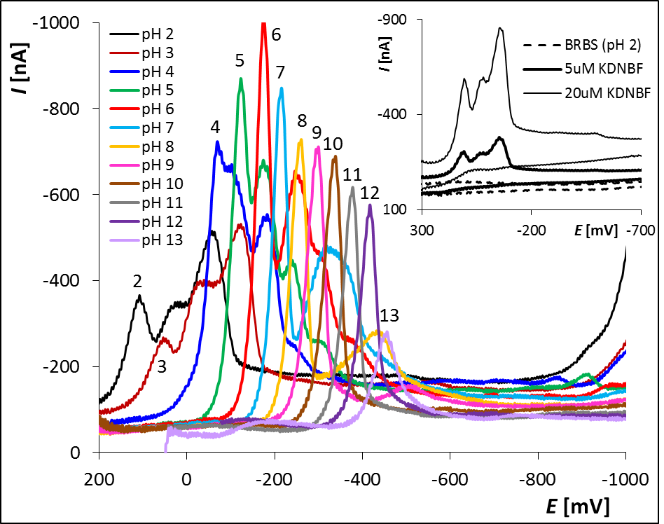
Fig. 2. Cathodic part of cyclic voltammograms of KDNBF obtained in dependence on BRBS pH (2-13) using HMDE; inset: cyclic voltammograms of KDNBF in BRBS (pH 2).

Parameters of DPV were proposed for the determination of KDNBF in model solutions. The measurements were carried out in BRBS of pH 10 because the simple and well developed current signal was obtained. Various concentration dependences were measured under the optimal experimental conditions and the examples of them are shown in Fig. 3A and 3B. Presented linear dependence (Fig. 3C) in the concentration range from 1.96×10⁻⁷-2.188×10⁻⁶ mol L⁻¹ can be described by the following equation (1) with the appropriate correlation coefficient:
I_{p} [nA] = (−57.24±0.50) c [µmol L⁻¹] − (1.21±0.70). (1)

The influence of accumulation was also tested and the adsorptive stripping DPV was applied for the increasing of sensitivity of KDNBF determination. Various statistical parameters, namely the limits of detection (LOD) and quantification (LOQ), relative standard deviations (RSD) of repeated measurements and determinations in model solutions, for proposed voltammetric method of KDNBF determination using HMDE were calculated. Finally, the possibility of the replacing of HMDE by the silver solid amalgam electrode (AgSAE) bare or modified with mercury meniscus for KDNBF analysis was tested too.

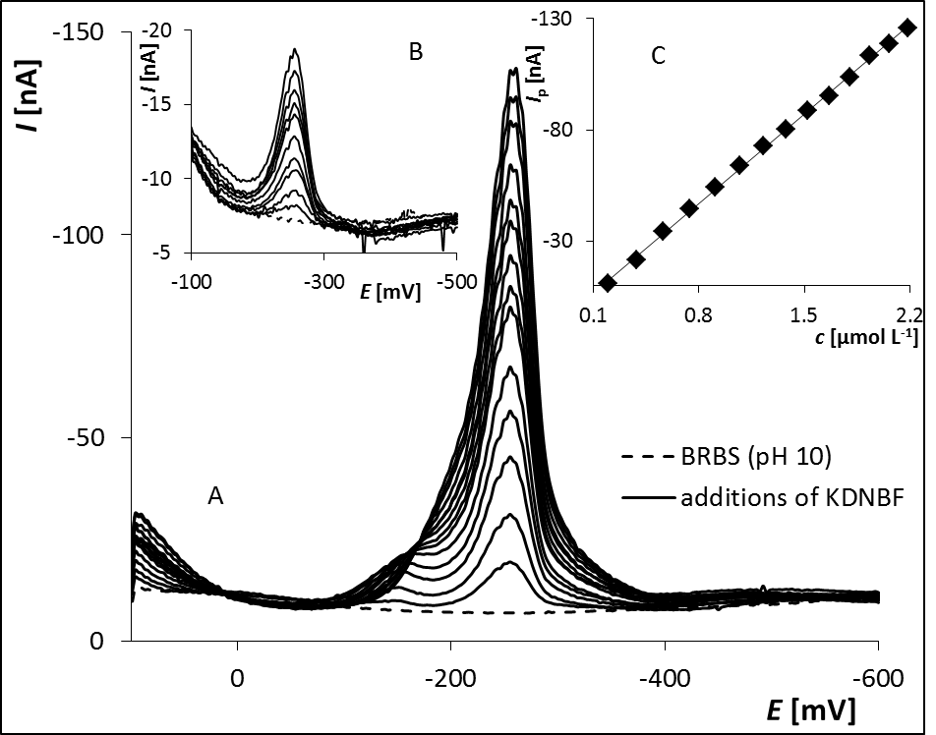
Fig. 3. DP voltammograms of KDNBF in dependence on concentration (1.96×10⁻⁷-2.188×10⁻⁶ mol L⁻¹) in BRBS (pH 10) obtained on HMDE (A); DP voltammograms of KDNBF in dependence on concentration (2×10⁻⁸-2×10⁻⁷ mol L⁻¹) (B); Dependence of peak height on KDNBF concentration (1.96×10⁻⁷-2.188×10⁻⁶ mol L⁻¹) (C).

Conclusion
Voltammetric behavior of KDNBF was studied using CV in connection with HMDE and the reduction of the present nitro groups was investigated. The sensitive voltammetric method for its determination using adsorptive stripping DPV was proposed applying HMDE and AgSAE, respectively.

Acknowledgment
Financial support of this work by the Technology Agency of the Czech Republic (project TA03010760) is gratefully acknowledged.

Reference
- Boulton A. J., Clifford D. P.: J. Chem. Soc., 5414 (1965).
- Norris W. P., Osmundsen J.: J. Org. Chem. 30, 2407 (1965).
- Meyer R., Köhler J., Homburg A.: Explosives. Wiley-VCH Verlag GmbH, Weinheim 2002.
- Norris W. P., Spear R. J., Read R. W.: Aust. J. Chem. 36, 297 (1983).
- Piechowicz T.: Procédé de préparation d'un explosif d'amorçage, FP 1519799, 1968.
- Piechowicz T. : Utilisation des éléments pyrotechniques et explosifs dans les systèmes spatiaux; Colloque International, Tarbes, France, Jul. 9th – 12th, 1968, Proceedings, p. 99-104.
- Matyáš R., Pachman J.: Primary explosives. Springer, in print 2013.
- Duguet J. R. and Pillaert J., Process for the preparation of an electropyrotechnic initiator by use of an aqueous adhesive, US 2003/0110971, 2003.
- Chatley G. R. C.: Power spot ignition droplet, US 6272992, 2001.
- Danilov J. N., Ilyusin M. A., Tselinsky I. V.: Promyshlennye vzryvchatye veshchestva; chast I. Iniciiruyushchie vzryvshchatye veshchestva, Sankt-Peterburgskii gosudarstvennyi tekhnologicheskii institut, Sankt-Peterburg 2001.
- Scott H. A.: Military-grade priming compositions based on potassium dinitrobenzofuroxan and tetrazene, WO 9914171, 1999.
- Pile D. A., John H. J.: Primers for enhanced ignition and actuation of ammunition, pyrotechnic devices, and explosive devices, US 20050189053, 2005.
- Khovonskov V. N., Kolesov V. I., Baskakov Y. M., Bibnev N. M., Korolev V. P.: Ammunition primer composition for small arms, US 20050098248, 2005.
- Mei G. C., Pickett J. W.: Dinitrobenzofuroxan-based lead-free, nontoxic priming compositions for ammunition, EP 1440958, 2004.
- Jung S. M., Lee H. S., Son J. W., Pak C. H.: Non-toxic primer powder compositions for small-caliber ammunition, US 20050224147, 2005.
- Bjerke R. K., Ward J. P., Ells D. O., Kees K. P.: Primer composition, US 4963201, 1990.
- Duguet J. R.: Priming charge with annular percussion and process for its manufacture, US 5353707, 1994.
- Mcgirr R.: Ignition composition for detonators and squibs, US 3135636, 1964.
- Koninck D. A., Briand D., Guillot L., Bley U., Gass V., Rooij N. F.: J. Microelectromech. Syst. 20, 1259 (2011).
- Kohler J.: Pyrotechnic body, US 2005/0178484, 2005.
- Tomlinson W. R., Sheffield O. E.: Engineering design handbook, Explosive series, Properties of explosives of military interest, Report AMCP 706-177, 1971.
- Schramm S., Léonço D., Hubers C., Tabet J. C., Bridoux M.: Talanta 143, 271 (2015).
- Lu T., Wen Z., Wang L., He X., Yuan Y., Wang M., Zhao Y., Li M., Pu X., Xu T.: Chemom. Intell. Lab. Syst. 147, 131 (2015).
- Üzer A., Erçağ E., Apak R.: Anal. Chim. Acta 534, 307 (2005).
- Gonzáles-Méndez R., Reich D. F., Mullock S. J., Corlett C. A., Mayhew Ch. A.: Int. J. Mass Spec. 385, 13 (2015).
- Gonzáles-Calabuig A., Cetó X., del Valle M.: Talanta 153, 340 (2016).
- Sağlam Ş., Üzer A., Tekdemir Y., Erçağ E., Apak R.: Talanta 139, 181 (2015).
- Saravanan N. P., Venugopalan S., Senthilkumar N., Santhosh P., Kavitha B., Prabu H. G.: Talanta 69, 656 (2006).
- Üzer A., Sağlam Ş., Tekdemir Y., Ustamehmetoğlu B., Sezer E., Erçağ E., Apak R.: Talanta 116, 768 (2013).
- Cetó X., O’Mahony A. M., Wang J., del Valle M.: Talanta 107, 270 (2013).
- Sivabalan R., Talawar M. B., Santhosh P., Senthilkumar N., Kavitha B., Gore G. M., Venugopalan S.: J Haz. Mat. 148, 573 (2007).
- Drost P.: Justus Liebigs Ann. Chem. 307, 49 (1899).
- Laviron E., Vallat A., Meunier-Prest R.: J. Electroanal. Chem. 379, 427 (1994).

