USING THE ACCELERATING RATE CALORIMETRY FOR DETERMINATION OF ENERGETIC MATERIALS THERMAL HAZARDS

Mašín J.¹, Šelešovský J .¹, Ferjenčík M.¹

¹University of Pardubice, Studentská 95, 532 10 Pardubice

Abstract
The thermal hazard is a cause of many serious industrial accidents, typically represented by runaway reactions. The key to prevention of these accidents is to comprehend a complex behaviour of substances with the runaway potential. Classic theories of thermal explosion are capable to describe the problem of thermal runaway reaction. However these theories are difficult to be daily used. For the practical purposes of the industrial safety a different approach is possible. For the safety of a process where thermal hazard could exert, four temperatures must be known: adiabatic temperature rise, decomposition temperature, standard temperature of a process and boiling point of a reaction mixture. From the relation among these parameters the processes can be then divided into several classes of hazard level. Standard temperature of the process is given by technology; the boiling point of the reaction mixture is given by its composition. The determination of decomposition temperature and adiabatic temperature rise is a complex problem. Usually thermoanalytical methods are used to obtain these parameters. One of the suitable methods is accelerating rate calorimetry (ARC). Using of ARC to determine the decomposition temperature and the adiabatic temperature rise is a main topic of this article. Compared to other thermoanalytical methods, ARC provides quite unique experimental conditions. The relatively large amount of the sample is used; pressure above the decomposing sample is monitored. The calorimeter simulates adiabatic decomposition of the sample. The decomposition of dibenzoyl peroxide solution and pentrite (pentaerythritol tetranitrate) was studied with ARC. The determination of the adiabatic temperature rise, the decomposition temperature and the influence of a sample and bomb masses and concentration on both parameters are discussed.

Introduction
The thermal hazard is a cause of many serious industrial accidents, typically represented by runaway reactions. The key to prevention of these accidents is to comprehend a complex behaviour of substances with the runaway potential.
One example for all is the accident at T2 Laboratories, where four people died and thirty two were injured, is good example which demonstrates, that full comprehension of thermokinetic behaviour of reactions is necessary if they are supposed to be run safely at industrial scale.¹ This accident could have been probably prevented if a proper thermometric measurement was performed before designing the process, because in this particular case the explosion of the reactor was caused by the undesired side reaction. This reaction could be detected by an appropriate calorimetric method.
Classic theories of thermal explosion are capable to describe the problem of thermal runaway reaction. However these theories are difficult to be daily used. First problem is a proper material description, mainly the decomposition kinetics. Second problem is solving of the resulting equations.
For the practical purposes of the industrial safety a different approach is possible.² For the safety of a process where thermal hazard could exert, four temperatures must be known: adiabatic temperature rise, decomposition temperature, standard temperature of a process and boiling point of a reaction mixture. From the relation among these parameters the processes can be then divided into several classes of hazard level.
Standard temperature of the process is given by technology; the boiling point of the reaction mixture is given by its composition. The determination of decomposition temperature and adiabatic temperature rise is a complex problem. Usually thermoanalytical methods are used to obtain these parameters. One of the suitable methods is accelerating rate calorimetry (ARC).³ Using of ARC to determine these two parameters is a main topic of this article.

Accelerating rate calorimetry
During the measurement the sample is enclosed in a small bomb enabling monitoring of temperature and pressure. Usually the sample is heated to certain temperature and it is maintained at this temperature for certain time (e.g. 15 min). If the decomposition does not occur, the temperature is elevated (e.g. by 5 °C), and the whole procedure is repeated until the decomposition starts. A typical stairs-like temperature profile is achieved in this “heat-wait-search” measuring mode. If the sample begins to decompose exothermically, the instrument is switched into adiabatic mode. The temperature around the bomb with the sample is maintained at the same temperature, which is measured on the surface of the bomb. The decomposition of the sample manifests itself as a temperature and pressure increase.
Compared to other thermoanalytical methods, ARC provides quite unique experimental conditions. The relatively large amount of the sample is used; pressure above the decomposing sample is monitored. The calorimeter simulates almost adiabatic decomposition of the sample. A measure of adiabacity can be expressed with so called Φ-factor which quantifies the relation between thermal masses of sample and its surroundings:

$$\text{Φ}\text{ = 1 + }\frac{m_{B}c_{B}}{m_{S}c_{S}}$$

Where m are masses, c are specific heats, indices S are for the sample and indices B are for the surroundings (bomb). The fully adiabatic process has the Φ-factor equal to 1. Otherwise, the surroundings can serve as a cooler, since a part of heat evolved from the decomposing sample is used for the heating of the surroundings. The results of measurements with a high Φ-factor should be corrected to achieve true adiabatic values.
This work consists of the two series of experiments. The first part of experiments was set to explore the dependence of the onset temperature and the adiabatic temperature rise on the concentration of toluene solutions of dibenzoyl peroxide. The second part of experiment is focused on the influence of bomb type on the measured results, because the thermal mass of the bomb (represented by Phi-factor) makes the difference between the experiment and fully adiabatic process.

Experimental part
The thermal decomposition of the samples was studied with the accelerating rate calorimetry. The calorimeter ARC-es, manufactured by THT, UK, was used. The experiments were carried out in heat-wait-search mode, with starting temperature 50 °C. The temperature steps with height 3 °C and length 15 minutes were applied, until the exothermic decomposition was detected. The temperature rate 0.02 °C/min was used as a limit to detect an exotherm.
Titanium bombs (8 g, 0.54 J/g°C) with the diameter 25.4 mm and the volume 9.8 ml were used for the first set of experiments. The 6 g of solution of dibenzoyl peroxide in toluene were used (concentrations 5, 10, 15 and 20 % w/w).
The second series of experiment was carried out with PETN (pentrite, pentaerythritol tetranitrate), one of the basic high explosives. Therefore only small amount of sample (80 mg) was used in all cases. The measurements started at the temperature 100 °C, other parameters (height and length of the step, temperature sensitivity for the exotherm detection) were the same as in the previous case. The standard titanium, stainless steel and hastelloy bombs were used. A special low mass titanium tube bomb was also used. The parameters of this series of measurements are stated in table 1.

Table 1.
Parameters of bombs used for PETN measurements.
 | Bomb type | SS-LNQ | HC-MBQ | Ti-LCQ | TiT
 | m [g] | 11,1 | 14,2 | 6,2 | 3,5
 | c_{p} [J/g°C] | 0,42 | 0,42 | 0,54 | 0,54
 | Φ [-] | 59,27 | 75,55 | 42,85 | 24,63

Results and Discussion
The recorded temperature and pressure rise of all four samples were put into the two separate graphs depicting temperature and pressure changes. The time axis does not correspond with the real time of measurement, but the position of the curves was shifted in time to clearly show their relative shapes. Figure 1 depicts temperature rise during the decomposition, figure 2 shows the pressure rise in the bomb.
Table 2 contains decomposition parameters of DBP calculated with the software calorimeter software, which takes into account non-ideal adiabatic environment of the calorimeter and recalculates recorded values with Φ-factor.
Table 2.
Decomposition parameters of DBP.
DBP concentration | Φ [-] | Tonset [°C] | Tadiab rise [°C] | Pmax [bar] | H [J]
5% | 1,42 | 77,6 | 8,0 | 4,736 | 116,464
10% | 1,42 | 71,6 | 20,0 | 8,907 | 291,414
15% | 1,42 | 67,6 | 44,1 | 15,214 | 641,620
20% | 1,42 | 62,3 | 65,5 | 21,068 | 951,585

The first set of experiments shows expected results. As the concentration of DBP in toluene rises, the onset temperature of decomposition (decomposition temperature) falls. The adiabatic temperature rise, maximum pressure and overall evolved enthalpy rise with the rising concentration; simply due to the fact that more of DBP is decomposed during the experiment.
Similarly, the pressure curves more or less copy the temperature rise, although the beginning of the decomposition is not so clear. However from the point where the DBP starts to decompose, it is clear that the higher concentration means faster decomposition leading to higher pressures.
The second part of experiment is focused on the influence of bomb type on the measured results. In this case, pentaerythritole tetranitrate (PETN) was selected as the testing compound. PETN is an explosive. To limit the damage to the apparatus, only a small amount of sample (80 mg) could be used. Therefore all the measurements from the second part were carried out with the relatively high Φ-factor. As a rule of thumb, the measurements should be carried out with as low Φ-factor as possible. However the decomposition of explosives is another issue and the safety is the most important in this case.
The figure 3 shows temperature profile caused by decomposition of PETN in each type of bomb, figure 4 depicts the pressure rise. Similarly to the previous experiment, the time axis does not correspond with the real time of measurement, but the position of the curves was shifted in time to clearly show their relative shapes. The basic parameters of the PETN decomposition are stated in table 3.

Table 3.
Decomposition parameters of PETN.
Bomb type | Φ [-] | Tonset [°C] | Tadiab. rise [°C] | Pmax [bar]
SS-LNQ | 59,27 | 153,7 | 24,1 | 9,420
HC-MBQ | 75,55 | 152,5 | 26,1 | 8,844
Ti-LCQ | 42,85 | 153,5 | 22,1 | 9,255
TiT | 24,63 | 146,6 | - | 34,000

The onset of the decomposition temperature was practically unaffected for all the standard bombs. The Φ-factor is so high, that a small difference of the thermal mass of the bombs does not influence the beginning of the onset of the decomposition temperature. The titanium tube bomb, used in the last case, has lower thermal mass and shows the decomposition temperature about 8 °C lower. However a sharp peak of the temperature record was observed in this case (figure 3). That means the sample was ignited during the decomposition and exploded. Therefore it is impossible to measure the end of decomposition correctly and the adiabatic temperature rise cannot be calculated in this case.
The maximum pressure is similar for all three standard bombs, because the same amount of the sample is decomposed in the same volume. In the case of titanium tube bomb, the volume is obviously lower and the pressure rises up to 34 bar.

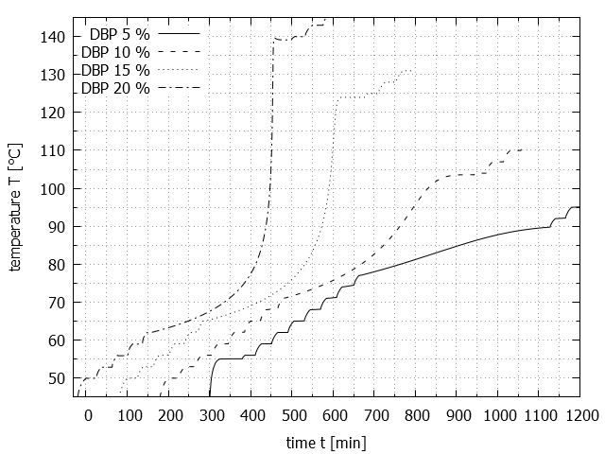Figure 1. Decomposition of DBP – temperature record.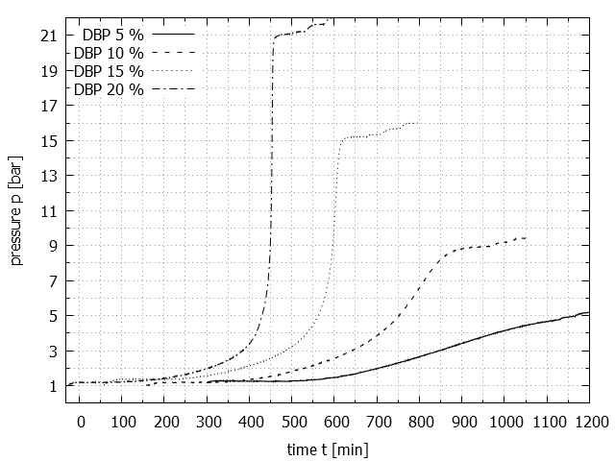 Figure 2. Decomposition of DBP – pressure record.
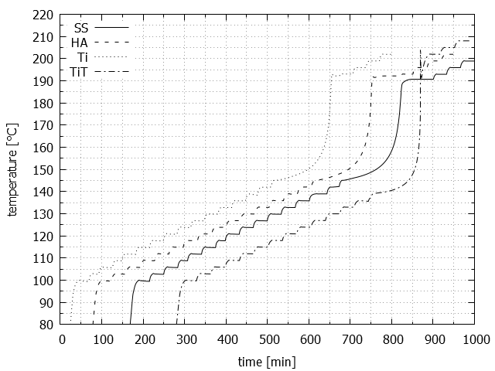
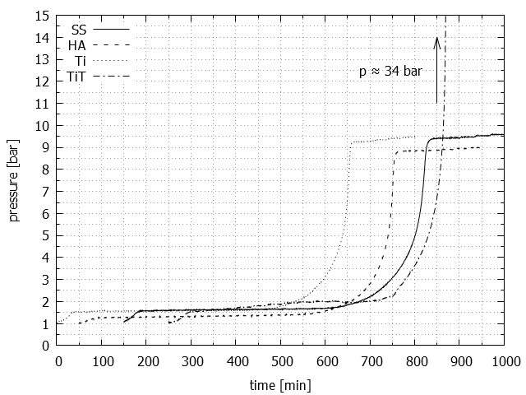
Figure 3. PETN decomposition – temperature record.
Figure 4. PETN decomposition – temperature record.

Conclusion
Using of ARC to determine the onset of decomposition temperature and the adiabatic temperature rise was demonstrated in case of two samples. The influence of the concentration was explored for the solutions of dibenzoyl peroxide in toluene. The influence of the material of the bomb (represented by Φ-factor) was demonstrated in the case of PETN decomposition.
The concentration of DBP influences both these parameters – the onset of decomposition temperature falls and the adiabatic temperature rise grows with the growing concentration. For such solutions, the best way is to test them in such concentration that corresponds to their real usage.
As a rule of thumb, the measurements should be carried out with as low Φ-factor as possible. However studying of the decomposition of explosives enables only small amounts of sample to be used in order to prevent the damage of the apparatus. Therefore all the measurements from the second part were carried out with the relatively high Φ-factor.
The onset of the decomposition temperature was practically unaffected for all the standard bombs. The Φ-factor is so high, that a small difference of the thermal mass of the bombs does not influence the beginning of the onset of the decomposition temperature. The titanium tube bomb, used in the last case, has lower thermal mass and shows the decomposition temperature about 8 °C lower. However a sharp peak of the temperature record was observed in this case (figure 3). That means the sample was ignited during the decomposition and it exploded. Therefore it was impossible to measure the end of decomposition and the adiabatic temperature rise could not be calculated in this case. The maximum pressure is similar for all three standard bombs, because the same amount of the sample is decomposed in the same volume. In the case of titanium tube bomb, the volume if obviously lower and the pressure rises up to 34 bar. Despite the titanium bomb has much lower mass (an therefore lower Φ-factor), its lower mass together with its lower internal volume forces one to used even smaller sample masses, what again leads to higher Φ-factor.

References
- Willey R. J.: Proc. Saf. Eng., 39-44, 30 (2011).
- Zemánek J.: ICCT 2015, First page (year).
- Townsend D. I., Tou J. C..: Thermochimica Acta, 1-30, 37 (1980).

