A perspective combination of quantum dots and silica nanoparticles for bioconjugation with antibodies used in immunosensors for detection of human alpha-fetoprotein

Aneta Kovářová ª, Jana Drbohlavová ^{b}, Zuzana Bílková ª, and Lucie Korecká ª

ª Department of Biological and Biochemical Sciences, Faculty of Chemical Technology, University of Pardubice, Studentská 573, 532 10 Pardubice, Czech Republic,
E-mail: aneta.kovarova@upce.cz
^{b} Central European Institute of Technology, Brno University of Technology, Purkyňova 123, 616 00 Brno Czech Republic, E-mail: jana.drbohlavova@ceitec.vutbr.cz

Abstract
The combination of quantum dots (QDs) with silica nanoparticles (SiNPs) as promising signal-generating label of antibodies used in electrochemical immunosensor is described. QDs-modified silica nanoparticles were conjugated with specific antibodies targeted to alpha-fetoprotein (AFP) to a creation of anti-AFP^{SiNPs-QDs} IgG conjugate for subsequent exploitation in quantum dot-linked immunosorbent assay (QLISA). Square wave anodic stripping voltammetry (SWASV) on mercury or bismuth film modified carbon screen-printed three-electrode sensors was used as a detection method. Insertion of nanoparticles to this system led to the achievement of higher current responses compare to results obtained with QDs only. Therefore, the sensitivity of complete immunoassay could be significantly improved.

Key-words: Quantum dots, Silica nanoparticles, Antibody label, Electrochemical immunosensors, SWASV.

Introduction
Immunoassays, widely used for detection of various important biomolecules associated with particular diseases, are analytical techniques based on highly specific recognition of antigen by an appropriate capture antibody. Thereafter, the measured signal, proportional to the amount of antigen present in the sample, is generated by secondary antibody, which is conjugated with an eligible label. In recent years, these assays have been used for detection of a wide range of diseases connected biomarkers in clinical diagnosis ^{1,2}. The assay sensitivity is the key parameter, especially for early stage disease detection. Immunosensors combine the specific assay with sensitive detection technique: optical, piezoelectric or electrochemical. Electrochemical immunosensors are specific, simple and affordable devices and offer a possibility of multitarget analysis and miniaturization. Currently, screen printed electrodes allow analysis in one droplet ^{3,4}.

Enzymes are habitually the first choice for antibody labeling in routine practice. Horse radish peroxidase, alkaline phosphatase or galactosidase are the most common, however the use of nanomaterials, such as gold nanoparticles, quantum dots (QDs) or metal ions begins to be in the forefront in this field due to the higher sensitivity of these systems. These tags could be easily detected electrochemically either by an addition of a suitable enzyme substrate or the labels are electroactive molecules directly detectable at the electrode ^{2,4}. QDs, semiconductor nanocrystals made of various heavy metals, are promising alternative to enzymes. The main advantage of their use in electrochemical detection is the possibility of simultaneous analysis of several types together based on difference in detection potentials of single elements forming the quantum dots. This feature can be used in immunosensors where the mixture of biomolecules is detectable in one run when the mixture of QDs-labeled antibodies differing in metal composition of used QDs. Also, higher sensitivity and stability is typical for QDs than for organic fluorophores or enzymes. The most common type of QDs are CdSe/ZnS QDs, but several companies produce PbS, CdS/ZnS, CdTe, ZnS/ZnS QDs. Based on the shown examples is evident, that there are two types of QDs: core and core-shell. The shell layer is nearly always composed of ZnS, which serves to protect the QDs core, reduce toxicity and increase photostability ^{5, 6}.

Rapidly emerging research of nanotechnology enabled wide spread of nanoparticles in immunosensors, therefore NPs are characterized by good compatibility and high surface. At present, mesoporous silica nanoparticles (SiNPs) are suitable for their chemical and thermal stability, good suspensibility in aqueous solution, nontoxicity and easy manipulation by centrifugation ^{7,8}. The most important characteristic of nanoparticles is their large surface that allows establishing of high amounts of molecules. In our work, we combined a high surface area of SiNPs for attachment of more QDs, which subsequently allows labeling antibodies more efficiently compare to common methods ⁹. The scheme of proposed arrangement is in Fig. 1.
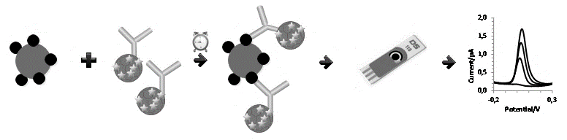
Fig. 1. Scheme of immunosensor, which is used to verify the functionality of conjugate anti-AFP^{SiNPs-QDs}.

Experimental part
PEG-COOH capped core-type PbS QDs were obtained by Mesoligth Inc. (USA). MPA capped CdTe QDs were created on CEITEC (Czech Republic) and chemicals for their synthesis were purchased from Sigma-Aldrich (USA), Merck (USA) or Penta (Czech Republic). Standard alpha-fetoprotein (AFP) and polyclonal rabbit anti-AFP IgG antibodies were from YO Proteins AB (Sweden). Mesoporous silica nanoparticles (SiNPs) with amino functional groups, 1-ethyl-3-(3-dimethylaminopropyl) carbodiimide (EDC) were supplied by Sigma-Aldrich (USA), SiMAG-carboxyl magnetic particles (1 μm I.D.) by Chemicell (Germany). All other chemicals were from Penta (Czech Republic) and were of reagent grade.

All electrochemical measurements were performed with portable electrochemical interface PalmSens (PalmSens, The Netherlands) controlled by software PSTrace 4.7 and connected with screen-printed three-electrode sensors with a carbon working, a carbon auxiliary and a silver pseudoreference electrode (DropSens, Spain) or mercury film-modified carbon working electrode (HgSPCE) with a carbon auxiliary, and a silver pseudo-reference electrode (IS-HM1, PalmSens).

Preparation of CdTe-MPA QDs
183.2 mg of cadmium chloride was dissolved in 90 ml of Millipore water. Then 400 mg of sodium citrate and 104 µl of mercaptopropionic acid were added. Subsequently, the pH was adjusted to 10 by an addition of 1M NaOH. Finally, 44 mg of sodium tellurite and 100 mg of sodium borohydride were added and the volume was completed to 100 ml. The solution was heated under continuous stirring in round bottom flask under reflux at 95 °C for 4 h. After cooling to room temperature, the solution was filtered and cleaned with isopropanol via centrifugation at 6 000 rpm for 30 min. The precipitated quantum dots were dissolved in Millipore water.

Labeling of polyclonal anti-AFP IgG antibodies with silica nanoparticles and quantum dots
Firstly, 4 µl of the 10 µM solution of carboxylated PbS QDs or 4 µl of the CdTe QDs (0,1 g/1 ml) was covalently linked to 1 mg of silica nanoparticles (SiNPs) with amino groups via standard one-step carbodiimide method with use of EDC linker at room temperature for 3 hours ¹⁰. Subsequently, QDs-modified SiNPs were washed by phosphate buffer pH 7.3 with 0.2M NaCl for removing nonspecific sorption of QDs. After washing steps, QDs-modified SiNPs were conjugated with 15 µg of polyclonal antibody anti-AFP IgG by oriented immobilization procedure based on oxidation of hydroxyl groups of antibodies with sodium periodate to form reactive aldehyde groups coupled with amino groups of SiNPs ¹⁰. After overnight incubation at 4 °C upon gentle mixing the creation of antibody conjugate (anti-AFP^{SiNPs-QDs} IgG) was confirmed by square wave anodic stripping voltammetry after release Pb(II), Cd(II) ions by 0.1M HCl (50 µl, 3 minutes). Screen-printed three-electrode sensor with mercury film-modified carbon working electrode (HgSPCE) was used. Parameters of the voltammetric technique were as follows: deposition potential -1.0 V for 120 s, potential range from -1.0 V to -0.15 V, step potential 0.003 V, amplitude 0.02805 V, and frequency 25 Hz. Purification of electrodes by using SWV was performed before sample measurement.

Verification of anti-AFP^{SiNPs-QDs} IgG conjugates capability to capture alpha-fetoprotein antigen
The ability of prepared antibody conjugates to formed immunocomplex with antigen and determination of its appropriate dilution for further applications was verified by use of magnetic microparticles modified with 1 µg of AFP antigen. The selected amount of anti-AFP^{SiNPs-QDs} IgG (ranged from 0,5 µg to 5 µg) was added in 0.1M phosphate buffer pH 7.3 containing 0.1% BSA and 0.05% Tween-20 and incubation for one hour at room temperature upon gentle mixing followed. After 5 washing steps with the same buffer and addition of 100 µl 0,1M HCl (3 minutes) current responses of released Pb(II) or Cd(II) ions were monitored by SWASV on screen-printed three-electrode sensor with carbon working electrode with in situ formed bismuth film (BiSPCE, 500 ppb of Bi(III)). The measurements proceeded under the above-mentioned conditions.

Results and Discussion
As already was stated, the QDs-modified silica nanoparticles were used for labeling the secondary anti-AFP IgG antibodies assuming an increase in sensitivity of detection of AFP by electrochemical immunosensor based on QLISA principle. Silica mesoporous nanoparticles with surface amino groups (Sigma-Aldrich, USA) were selected for conjugation with carboxyl CdTe or PbS QDs. The same type of SiNPs was already used for conjugation with enzymes, where the results confirmed the signal amplification ¹¹. The standard carbodiimide method was used for conjugation of SiNPs with CdTe and PbS QDs. Subsequent, labeling of anti-AFP IgG was proceeded via glycosidic part of IgG to maintain the binding sites free for antigen capture. The efficiency of antibody labeling was verified by SWASV of Cd(II) or Pb(II) ions released from appropriate QDs by an action of acidic medium. HgSPCE (PalmSens, The Netherland) enabled the droplet analysis were used and current response at potential -0.85 V for Cd(II) or -0.6 V for Pb(II) was recorded. Data obtained for comparisons of two types of conjugates prepared with and without insertion of SiNPs to labeling protocol are shown in Figure 2. Thus, significant increase (three times higher) of current response for anti-AFP^{SiNPs-QDs} compared to anti-AFP^{QDs} conjugates is confirmed.
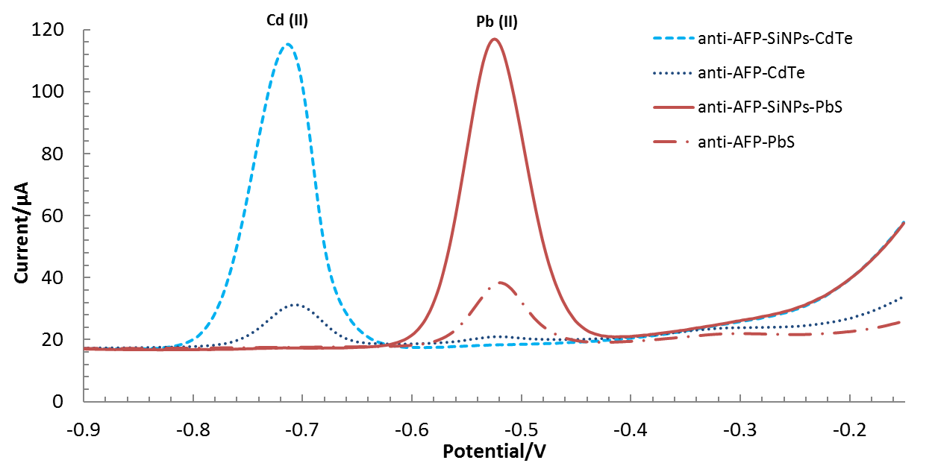
Fig. 2. Square wave voltammograms of Pb(II) or Cd(II) ions released from created conjugates anti-AFPSi^{NPs-QDs} and anti-AFP^{QDs} on HgSPCEs. Conditions of the electrochemical detection are specified in the experimental part.

The ability of prepared anti-AFP^{SiNPs-QDs} IgG antibodies to bind AFP antigen and therefore to be applicable as a signal-generating probe in immunosensor for AFP detection was verified with magnetic particles modified with 500 ng of AFP. The optimal dilution of the conjugate provided sufficient current response was set while lowest possible consumption of the conjugate (Fig. 3) was taken into account. The five times diluted conjugate (equivalent to 2 µg of anti-AFP^{SiNPs-QDs}) provided sufficient current response and therefore optimal for further use in the compiling the complete immunosensor. Finally, we performed a detection of the AFP antigen with the use of anti-AFP^{SiNPs-QDs} and those with enzyme alkaline phosphatase (anti-ApoE^{SiNPs-ALP}) where the final signals were more than five times higher for QDs modified SiNPs than for SiNPs modified with ALP. Moreover, CdTe and PbS quantum dots could be used for simultaneous detection due to difference in potentials of peak maximum.
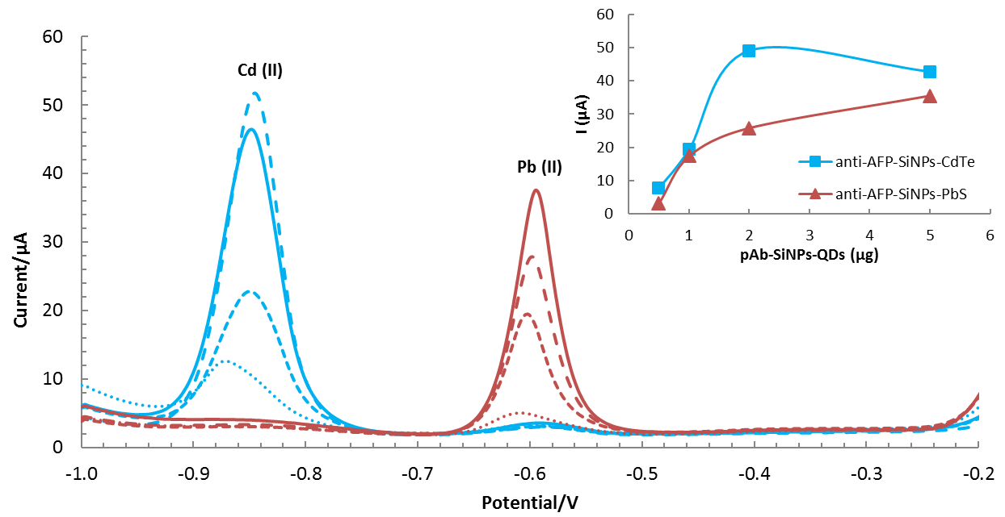
Fig. 3. Square wave voltammogram of Pb(II) or Cd(II) ions released from appropriate QDs for verification of the ability of prepared conjugates to bind antigen AFP on BiSPCE. Conditions of the electrochemical detection are specified in the experimental part.
Conclusions
A perspective combination of SiNPs and CdTe and PbS QDs used as sensitive signal-generating tags of antibodies is described. Created anti-AFP^{SiNPs-CdTe} and anti-AFP^{SiNPs-PbS} conjugates were used for detection of AFP antigen representing biomarker of ovarian carcinoma and then were compared with conjugates labeled only QDs (anti-AFP^{QDs}). A significantly higher current response was achieved by using QDs-modified SiNPs. The ability of conjugates to bind AFP and assumption of their use for simultaneous analysis of multiple biomarkers was confirmed.

Acknowledgements
Financial supports from projects of the University of Pardubice, Faculty of Chemical Technology (SGS-2017-004) and Czech Science Foundation No. 15-16549S are gratefully acknowledged.

References
1. Kokkinos Ch., Economou A., Prodromidis M. I.: Trends in Anal. Chem. 79, 88-105 (2016)
2. Pei X., Zhang B., Tang. J., Liu B., Lai W., Tang D.: Anal. Chim. Acta. 758, 1-18 (2013)
3. Bahadir E. B., Sezgintürk M. K.: Talanta. 132, 162-174 (2015)
4. Ricci F., Adornetto G., Palleschi G.: Electrochimica Acta. 84, 74-83 (2012)
5. Esteve-Turrillas F. A., Abad-Fuentes A.: Biosensors and Bioelectronics. 41, 12-29 (2013)
6. Mattoussi H., Mauro J. M., Goldman E. R., Anderson G. P., Sundar V. C., Mikulec F.V., Bawendi M. G.: J. Am. Chem. Soc. 122, 12142-12150 (2000)
7. Slowing I.I., Trewyn B. G., Giri S., Lin V. S.-Y.: Advanced Functional Mater. 17, 1225–1236 (2007)
8. Knopp D., Tang D., Niessner R.: Anal. Chim. Acta. 647, 14-30 (2009)
9. Dvořáková V., Čadková M., Datinská V., Klepárník K., Foret F., Bílková Z., Korecká L.: Anal. Methods. 9, 1991-1997 (2017)
10. Hermanson G.T.: Bioconjugate techniques, 2nd edn. Academic Press, New York (2008)
11. Kovářová A., Čadková M., Dvořáková V., Bílková Z., Korecká L.: XXXVI. Moderní elektrochemické metody. 109-112 (2016)

