This is the accepted version of the following article:

Machotová, J., Černošková, E., Honzíček, J., & Šňupárek, J. (2018). Water sensitivity of fluorine-containing polyacrylate latex coatings. Progress in Organic Coatings, 120, pp. 266-273. doi: 10.1016/j.porgcoat.2018.03.016

This postprint version is available from URI https://hdl.handle.net/10195/72636

Publisher’s version is available from
https://www.sciencedirect.com/science/article/pii/S0300944017311700?via%3Dihub

This postprint version is licenced under a Creative Commons Attribution-NonCommercial-NoDerivatives 4.0.International.

Water sensitivity of fluorine-containing polyacrylate latex coatings: Effects of crosslinking and ambient drying conditions

Jana Machotová ¹, Eva Černošková ², Jan Honzíček ¹, Jaromír Šňupárek ¹

¹ Institute of Chemistry and Technology of Macromolecular Materials, Faculty of Chemical Technology, University of Pardubice, Studentská 573, 532 10 Pardubice, Czech Republic
² Joint Laboratory of Solid State Chemistry, Faculty of Chemical Technology, University of Pardubice, Studentská 573, 532 10 Pardubice, Czech Republic
³ Institute of Environmental and Chemical Engineering, Faculty of Chemical Technology, University of Pardubice, Studentská 573, 532 10 Pardubice, Czech Republic

Correspondence to: Jana Machotova; e-mail address: jana.machotova@upce.cz,
tel.: +420 46 603 7194, fax: +420 46 603 7068.

Abstract In this study, fluorine-containing polyacrylate latexes comprising different levels of copolymerized perfluorethyl groups were prepared by the two-stage emulsion polymerization of 2,2,2-trifluoroethyl methacrylate, methyl methacrylate, butyl acrylate and methacrylic acid as main monomers, where the fluorine-containing monomer was copolymerized only into the second stage polymer. The effects of keto-hydrazide self-crosslinking and its combination with pre-coalescence and ionomeric crosslinking, respectively, on coating wettability, water absorption and water whitening were investigated. For the keto-hydrazide self-crosslinking, diacetone acrylamide was copolymerized into the second stage polymer to provide sites for the subsequent reaction with adipic acid dihydrazide. The pre-coalescence crosslinking of latex particles was introduced by copolymerizing allylmethacrylate during the synthesis and the ionomeric crosslinking was provided by the addition of a commercial zinc complexing agent. The influences of ambient conditions during the film-forming process in terms of temperature and relative humidity differences on coating wettability were evaluated. Further, changes of coating wettability as a function of water exposure duration were tested. The results showed that the highest level of hydrophobicity at the same amount of copolymerized 2,2,2-trifluoroethyl methacrylate could be achieved in the case of non-crosslinked latex films dried at elevated temperatures, whereas the highly crosslinked latexes combining pre-coalescence crosslinking and keto-hydrazide self-crosslinking provided the most water whitening-resistant coating films.

Keywords Latex, Fluoropolymer, Crosslinking, Coalescence, Water whitening, Wettability

Introduction
A common drawback of latex coatings is their water sensitivity, usually connected with water whitening, loss of adhesion and poor durability. Normally, when latex particles dry to form a continuous clear film, the liquid water evaporates while ionically-charged components such as surfactants, initiators and buffers remain trapped in interstitial areas of the film and become a driving force for the migration of water into interstitial areas. This migration results in increased water absorption and water whitening of coating films. Nevertheless, the hydrophilic components are usually the essential part of standard commercial products; therefore, the efforts to enhance water resistance of latex coatings by means of polymer structure changes are being highly encouraged. Among them, fluorination and crosslinking have been the traditionally used approaches.
Fluorinated polyacrylate latexes with special surface properties, such as low surface tension and related hydrophobicity, good adhesion to matrices and environmental protection value have attracted the attention of many investigators [1−4]. Up to date, fluorinated acrylate polymer emulsions with various structures, such as graft [5], random [6], and core−shell [7−11] have been synthesized by conventional emulsion polymerization, mini emulsion polymerization, seeded emulsion polymerization, and other synthetic polymerization techniques. However, the relatively high market price of fluorinated monomers limits their use and the challenge is how to minimize the amount of fluorinated monomers whereas the reasonable properties of the resulting products still can be maintained. One possible strategy to achieve cost-effectivity and increased coating hydrophobicity is to prepare latexes using a two-stage synthesis producing core−shell particles consisting of fluorine-free core and fluorine-rich shell [12−16]. The presented results reveal that while the weight fraction of fluorine-containing compounds in the polymer is decreased considerably, the physical and chemical properties still can be kept [17,18].
The fluorine-containing groups in fluorinated polymers have the tendency to orientate toward air-film interface during film formation to minimize the interfacial energy resulting in materials with increased hydrophobicity [19,20]. However, the fluorine groups can migrate to the inside of coating films when the environment surrounding the film changes, such as being immersed into water [21,22]. This phenomenon may lead to decrease in some properties of fluorinated latex films, such as water resistance [23]. If the fluorinated groups are fixed on the surface of latex particles, this problem might be resolved [9].
Besides fluorination, increasing crosslinking density is an effective tool to improve water resistance [24], solvent resistance [25] and mechanical properties [26,27] of water borne emulsions used as coatings and adhesives. Methods for increasing crosslinking density include pre-coalescence (intra-particle) crosslinking of latex particles achieved during polymerization and post-coalescence (inter-particle) crosslinking proceeding during latex film formation. Pre-coalescence crosslinking often results in rigid latex particles that may suffer from poor deformability and suppressed chain interpenetration during the coalescence stage. Post-crosslinking refers to a chemical reaction designed to occur during or shortly after latex film-formation. Among different post-crosslinking reactions, the keto-hydrazide self-crosslinking via the reaction between carbonyl groups in diacetone acrylamide (DAAM) repeat units and hydrazide groups from adipic acid dihydrazide (ADH) has been shown to be particularly effective [28−33]. The water soluble ADH is added to the latex after its preparation and as a result, the one-component self-crosslinking latex providing a long-term storage stability and a rapid crosslinking at ambient temperature is easily obtained. Therefore, these latexes are popular in a wide range of applications, starting from paints for the building industry through wood paints and varnishes to paints for metal protection and decorative systems.
The paper focuses on the combined effects of crosslinking and ambient conditions during the film-forming process on water sensitivity and wettability of fluorine-containing polyacrylate latex coating films. The presented work also aims to demonstrate the optimal composition based on the self-crosslinking latex system with the emphasis on sparing the fluorinated monomer consumption while maintaining the desired water-repellent properties.

Experimental
Materials
Latexes were synthesized of 2,2,2-trifluoroethyl methacrylate (TFEMA), methyl methacrylate (MMA), butyl acrylate (BA), methacrylic acid (MAA), allyl methacrylate (ALMA) and diacetone acrylamide (DAAM). All the monomers were purchased from Sigma-Aldrich (Czech Republic). Disponil FES 993 (BASF, Czech Republic) was used as the surfactant and ammonium persulfate (Penta, Czech Republic) was utilized as the initiator of the polymerization reaction. Adipic acid dihydrazide (ADH) was utilized as the crosslinker and was purchased from Sigma-Aldrich (Czech Republic). Aqueous suspension of ZnO nanoparticles (trade name nZ-BOCH 202) having the ZnO content of 40 wt. % was used as the ionomeric crosslinking agent and was kindly obtained from Bochemie (Czech Republic). All the chemicals were utilized as received without any further purification.

Preparation and characterization of latexes
Four series of polyacrylate latexes were synthesized by the semi-continuous two-stage emulsion polymerization comprising a variable content of acrylic monomers (see Table 1). The weight ratio of first stage/second stage polymer was 1/1, which means a thickness of the second stage polymer layer of about 20 % of the particle radius in the case of a full phase separation. The nature of acrylic monomers forming first stage and second stage polymers was chosen to achieve a calculated T_{g} (using the Fox equation [34]) of approximately 10 °C. In the case of all series, TFEMA was copolymerized with the monomers designed to form the second stage polymer and its concentration was gradually increased. In the series A, no crosslinking was introduced into latex films. In the series B, the latexes were designed to provide the keto-hydrazide self-crosslinking during the film-formation. The series C was represented by latexes that were able to produce highly crosslinked films by means of the combination of both the pre-coalescence crosslinking and the keto-hydrazide self-crosslinking. In the series D, the latexes were designed to provide both the keto-hydrazide self-crosslinking and the ionomeric crosslinking (complexing) during the film-formation. The pre-coalescence crosslinking of latex films was achieved by covalent intra-particle crosslinking of emulsion copolymers during their synthesis using ALMA. For the keto-hydrazide self-crosslinking, a constant amount of DAAM was copolymerized into the second stage polymer to provide sites for the subsequent interfacial covalent crosslinking by the reaction with ADH added during latex coating formulation. The ionomeric interfacial crosslinking was performed by the addition of a commercial zinc complexing agent in the amount of 3 wt. % (based on solids) to the latex after its neutralization and ADH addition. Carboxyl functionalities were introduced into the structure of first stage and second stage polymers by copolymerization with a constant amount of MAA for three reasons: firstly, to improve the colloidal stability of latexes; secondly, to ensure the acid catalysis of keto-hydrazide crosslinking; and thirdly, to enable the ionomeric crosslinking via zinc metal ions.
The latexes were produced in a 700 mL glass reactor by the semi-continuous two-stage emulsion polymerization under starved conditions in nitrogen atmosphere at 85 °C. This procedure ensured relatively homogeneous latex particles of statistical copolymers. The recipe of emulsion polymerization is shown in Table 2. The reactor charge was put into the reactor and heated to the polymerization temperature. Then the monomer emulsion was fed into the stirred reactor at feeding rate about 2 mL/min in two steps (1. first stage polymer preparation, 2. second stage polymer preparation). After that, during 2 hours of hold period at 85 °C the polymerization was completed. The pH was adjusted to 8.5 with ammonia solution. To ensure the keto-hydrazide self-crosslinking of latexes, a 10 wt.% aqueous solution of ADH in the amount corresponding to the molar ratio ADH:DAAM = 1:2, was added to the latex under agitation. The solids content of final latexes was about 35 wt.%.
The average particle sizes of latex particles in the water phase were determined by dynamic light scattering experiments performed using a Coulter N4 Plus instrument (Coulter, Corp., UK). All the DLS measurements were conducted at 25 °C. The structure of prepared polymers with the emphasis on the evidence of crosslinking reactions was investigated by means of a Fourier transform infrared (FT-IR) spectroscopy on a Nicolet iS50 instrument (Thermo Fisher Scientific, USA). The measurements were performed on a built-in all-reflective diamond ATR in the range from 4000 cm⁻¹ to 500 cm⁻¹ using the resolution of 2 cm^{–1} (64 scans per spectrum). The degree of crosslinking introduced into latex coating films was evaluated from the point of view of gel content changes. Specimens for the FT-IR spectroscopy and gel content measurements were prepared by pouring and drying the latexes on silicone substrates. The specimens were first air-dried at room temperature (RT, 23 ± 1 °C) for a month and then vacuum-dried at 30 °C for 2 weeks. The gel content was determined according to CSN EN ISO 6427 using a 24-hr extraction with THF in a Soxhlet extractor. Around 1 g of the dried latex sample was put into the thimble. After the extraction, the thimble was dried in an oven at 75 °C for 12 h, cooled in a desiccator overnight, and the gel content was calculated from the initial and final weights, assuming that the gelled material remained in the thimble.

Table 1
Composition and characteristics of emulsion copolymers differing in the way and the extent of crosslinking and TFEMA concentration in monomer feeds forming the second stage polymer
Sample | Composition of monomer feeds (wt. %)  TFEMA/MMA/BA/MAA/DAAM/ALMA |  | Particle size in the water phase (nm) |  | Gel content (wt. %)
 | First stage | Second stage | First stage | First stage + second stage
Series A: No crosslinking
A1 | 0/44/53/3/0/0 | 0/44/53/3/0/0 | 96.7 ± 0.9 | 121.0 ± 0.8 | 2.6
A2 | 0/44/53/3/0/0 | 15/31.5/50.5/3/0/0 | 98.2 ± 0.6 | 124.3 ± 1.0 | 2.3
A3 | 0/44/53/3/0/0 | 30/18.5/48.5/3/0/0 | 96.6 ± 0.4 | 123.3 ± 0.9 | 1.9
A4 | 0/44/53/3/0/0 | 45/5.5/46.5/3/0/0 | 80.1 ± 0.4 | 101.5 ± 0.5 | 3.4
Series B: Self-crosslinking
B1 | 0/44/53/3/0/0 | 0/39.5/52.5/3/5/0 | 80.2 ± 0.8 | 103.8 ± 0.6 | 77.8
B2 | 0/44/53/3/0/0 | 15/27/50/3/5/0 | 114.4 ± 0.6 | 143.1 ± 0.9 | 81.5
B3 | 0/44/53/3/0/0 | 30/14/48/3/5/0 | 126.4 ± 0.3 | 158.5 ± 1.1 | 79.1
B4 | 0/44/53/3/0/0 | 45/1/46/3/5/0 | 103.2 ± 0.6 | 128.1 ± 0.4 | 78.9
Series C: Self-crosslinking and pre-coalescence crosslinking
C1 | 0/43.4/52.6/3/0/1 | 0/39/52/3/5/1 | 80.0 ± 0.9 | 101.4 ± 0.5 | 98.6
C2 | 0/43.4/52.6/3/0/1 | 15/26/50/3/5/1 | 84.7 ± 0.7 | 102.2 ± 0.7 | 99.1
C3 | 0/43.4/52.6/3/0/1 | 30/13/48/3/5/1 | 88.5 ± 0.5 | 112.4 ± 0.6 | 98.2
C4 | 0/43.4/52.6/3/0/1 | 45/0.5/45.5/3/5/1 | 86.4 ± 0.4 | 110.9 ± 0.3 | 98.9
Series D: Self-crosslinking and ionomeric crosslinking
D1 | 0/44/53/3/0/0 | 0/39.5/52.5/3/5/0 | 80.2 ± 0.8 | 103.8 ± 0.6 | 91.2
D2 | 0/44/53/3/0/0 | 15/27/50/3/5/0 | 114.4 ± 0.6 | 143.1 ± 0.9 | 95.6
D3 | 0/44/53/3/0/0 | 30/14/48/3/5/0 | 126.4 ± 0.3 | 158.5 ± 1.1 | 94.4
D4 | 0/44/53/3/0/0 | 45/1/46/3/5/0 | 103.2 ± 0.6 | 128.1 ± 0.4 | 93.9

Table 2 Recipe of emulsion polymerization
 | Reactor charge | Monomer emulsion (First stage) | Monomer emulsion (Second stage)
Water (g) | 120 | 124 | 124
Disponil FES 993 (g) | 0.5 | 7.4 | 7.4
Ammonium persulfate (g) | 0.4 | 0.4 | 0.4
Monomers (g) | - | 100 | 100

Evaluation of wettability of latex coatings
Wettability studies involved the measurements of water contact angles using an optical tensiometer Attension Theta (Biolion Scientific, Finland) by the sessile drop method. An automatic micropipette was used to accurately dispense the volume (1 μL) of water. The time dependence of the water drop flowing (the change of contact angle) was recorded by a video camera and the steady-state contact angle value was subtracted in the time of 10 s. Measurements were made at 22 ° C and humidity of 45 ± 5 %. A software OneAttension (Biolion Scientific, Finland) was used for the image data recording and for the determination of water contact angles. Five measurements were performed for each sample and the accuracy of the constant angle measurement was estimated as ±1°.
For the wettability measurements, the coating films were draw-downed on glass panels using a blade applicator. Their wet thickness was 120 µm and no coalescing agents were used. To investigate the effect of ambient conditions during coating drying (temperature and relative humidity), coatings were dried at RT and 40 °C, respectively, in hermetic chambers with fixed humidity for two weeks. Two kinds of hermetic chambers were prepared with 33% and 84% relative humidity (RH), respectively, using saturated solutions of magnesium chloride and potassium chloride, respectively. The humidity in each chamber was checked by a thermohygrometer (T2041, Aldrich) and ranged ± 2 %.
To investigate the effect of the duration of water exposure on the change of coating wettability, coatings were dried at RT and 33% RH for two weeks at first, then they were immersed into distilled water at RT for 10, 20 min and 24 hours, respectively. After that, they were allowed to dry out at RT and 33% RH for two weeks again. Finally, water contact angles were determined.

Evaluation of water sensitivity of latex coatings
Water sensitivity of latex coating films from the point of view of their water absorption and water-whitening was evaluated. For evaluating the water absorption of latex coating films, specimens were prepared by pouring the latexes into a silicone mold. Films were allowed to dry out at RT for a month. The water absorption by latex films was measured by immersing samples of the approximate dimensions 20 × 20 × 1 mm³ in distilled water at RT. The water absorption, A is given by A = 100(w_{t} – w₀)/w₀, where w₀ is the sample weight before immersion and w_{t} is the sample weight after water immersion during a given time period. The swollen films were carefully removed from water, and water from the film surface was wiped by touching the polymer with a filter paper.
The water whitening of dried coating films (120 µm wet thickness) draw-downed on glass panels was evaluated objectively by measuring the change in transmittance at a fixed wavelength (500 nm, near the green light that is most sensitive to the human eye) using a ColorQuest XE Spectrometer (Hunterlab, USA). Before the measurement, coating films were allowed to dry out at RT and 33% RH for two weeks. After that, the films were immersed in distilled water at RT for 1 and 24 hours, respectively, followed by the immediate measurement of the transmittance of the exposed coating film area. The extent of water whitening W, is given by W = 100(T₀ – T_{t})/T₀, where T₀ is the sample transmittance before distilled water exposure and T_{t} is the sample transmittance after performing the immersion test.
Results and discussion
Characterization of latexes
Latexes with negligible amount of coagulum (0–0.2 %) were synthesized by the semi-continuous two-stage emulsion polymerization process with varying amount of TFEMA in second stage polymer compositions. All the prepared latexes (also after ADH addition in the case of series B, C and D) were stable for over 12 months. The average diameters of first stage polymer particles (samples taken after finishing the first polymerization step) and resulting latex particles (samples taken after finishing the two-stage polymerization procedure) were determined using DLS (see Table 1). When comparing the results between the sizes of first stage particles and resulting particles for individual samples, they were in a good accordance with the calculated growth of particle dimension, which means that no significant agglomeration nor secondary nucleation of new particles occurred during the second stage of polymerization.
The chemical structure of the prepared latex films was investigated by means of FT-IR spectroscopy. FT-IR spectra of the representatives A4, B4, C4 and D4 containing the same level of TFEMA are shown in Fig. 1. It is evident that the spectra show a typical pattern of acrylate/methacrylate copolymers with strong bands of C=O stretching at 1728 cm^{–1} assigned to carboxylic acid ester function. A broad band of O–H stretching observed at 3250 cm^{–1} is due to free carboxylic group (from MAA) and hydrogen bonded water. The region of C–H stretching bands shows an analogical pattern due to the similar content of main components in the copolymers (MMA and BA). The bands of medium intensity at 2959 and 2874 cm^{–1} were assigned to vibration modes of methyl group ν_{a}(C–H) and ν_{s}(C–H), respectively. The presence of CH₂ group is clear from a weak band of ν_{a}(C–H) and a shoulder of ν_{s}(C–H) at 2934 cm^{–1} and 2874 cm^{–1}, respectively. The copolymerization with TFEMA is evidenced by the appearance of characteristic bands at 1282 and 652 cm^{–1} that can be assigned to C–F stretching and C–F wagging, respectively. Intensity of these bands well correlates with the level of incorporated TFEMA as shown in Figure 2.
The absorption band at 1536 cm^{–1} appearing in all samples of the series B, C and D was assigned to bending of N–H bonds and indicates that DAAM was successfully copolymerized with acrylic monomers. These samples further show a weak band at 1652 cm^{–1} corresponding to N=C stretching, which confirms that the keto-hydrazide crosslinking reaction proceeded in all ADH-containing copolymers (see spectra b, c and d in Figure 1) [33,35]. In the spectra of the series D, stretching vibration of carboxylate anion ν_{a}(COO) appears at 1600 cm^{–1}, which proves ionomeric crosslinking between carboxylated emulsion copolymer and dissociated Zn²⁺ cations.
Fig.1. FT-IR spectra of emulsion copolymers containing 45 wt.% of TFEMA in second stage polymer compositions: (a) sample A4 without crosslinking; (b) sample B4 crosslinked by keto-hydrazide self-crosslinking; (c) sample C4 crosslinked using the combination of pre-coalescence crosslinking and keto-hydrazide self-crosslinking; (d) sample D4 crosslinked using the combination of keto-hydrazide self-crosslinking and ionomeric crosslinking.
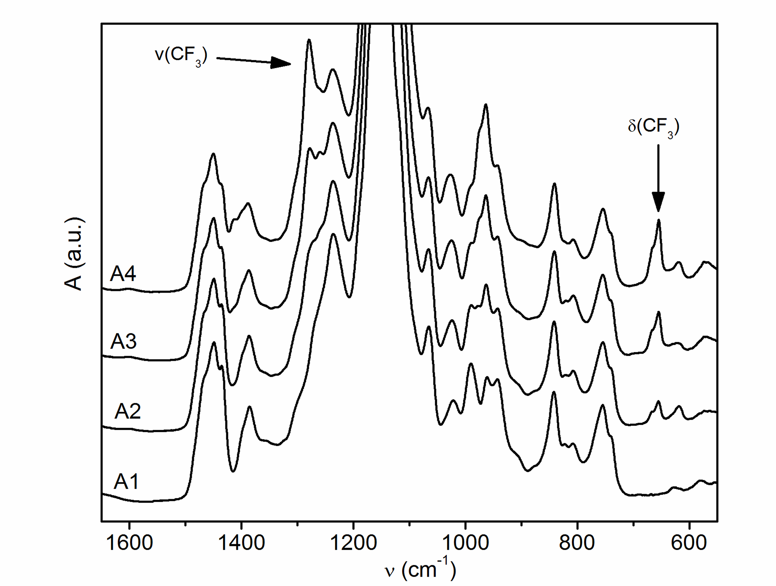
Fig.2. FT-IR spectra of emulsion copolymers of series A differing in the content of TFEMA in second stage polymer compositions: A1 - 0 wt.%, A2 - 15 wt.%, A3 - 30 wt.%, A4 - 45 wt.%.

The level of crosslinking introduced into latex particles and coating films was assessed to gel content values (see Table 1). When comparing the results for all series of latexes, it is evident that the self-crosslinking latexes of series B were found to produce polymer materials of high gel content (about 80 wt. %) owing to the keto-hydrazide crosslinking, whereas coatings made from latexes of the reference series A (designed to provide non-crosslinked coatings) contained a minor amount of gel, probably due to inter-molecular chain transfer to polymer as a result of BA copolymerization [36]. The self-crosslinking latexes of the series C and D provided almost completely crosslinked materials due to covalent pre-coalescence and self-crosslinking reactions in the case of the series C and due to covalent and ionomeric interfacial crosslinking in the case of the series D.

Wettability of latex coatings
The combined effects of crosslinking, TFEMA content and ambient conditions (temperature and RH) during the film-forming process on coating wettability were evaluated by drying out the coatings at the temperatures 23 and 40 °C, respectively, in hermetic chambers with 33% and 84% RH, respectively. The results of water contact angles measurements are presented in Fig. 3. It was confirmed that the wettability of coatings was decreased by increasing the content of TFEMA in latex particles and that this effect was shown to be affected by the level of crosslinking; the more the crosslinked latex film, the less significant the water-repellent role of fluorine. Therefore, the keto-hydrazide-crosslinked coatings of series B and particularly, the coatings of series C and D (combining self-crosslinking with pre-coalescence or ionomeric crosslinking) did not exhibit a considerable enhancement of water contact angles at the increased content of fluorine groups in the latex polymer. On the contrary, the non-crosslinked films of series A were found to provide water contact angles of about 100 ° at high concentrations of TFEMA units in the second stage polymer. This phenomenon can be attributed to the fixation of latex polymer by crosslinking, which hindered the orientation of higher amount of perflouroethyl groups towards the film-air interface during film-formation.
If the external conditions (in terms of temperature and RH) accompanying the drying out of latex films are concerned, it was clearly shown that the relative humidity was playing a crucial role, especially in the case of coatings based on particles comprising zero or low fluorine amount. These coating samples exhibited a pronounced difference in wettability depending on RH during film-formation; a significant drop in water contact angles was observed for the drying out at 84% RH. In this case, the polar environment (air saturated with water molecules) surrounding the film-forming coating probably supported the orientation of hydrophilic groups towards the film-air interface. Further, the reduction of the water evaporation rate may have facilitated the polar groups orientation due to prolonged hydroplasticization of latex polymer on one hand and delayed crosslinking (keto-hydrazide and/or ionomeric) on the other hand. It was also proved that the degree of crosslinking of these fluorine-low or fluorine-free coatings played a significant role. The increased level of polymer fixation resulted in coating systems being less prone to humidity changes during film-formation due to a suppressed orientation of polar groups towards film-air interface.
It can be summarized that introducing crosslinking into latexes limits achieving a maximal level of coating hydrophobicity at a given concentration of perflourethyl groups in the second stage polymer, on the other hand, crosslinking helps to maintain decreased wettability in the case of drying out of low-fluorine-containing acrylic latex films at elevated RH.
Further, the change of coating wettability after the contact with water was evaluated as well. For this purpose, at first the coatings were dried out at the ambient conditions (23 °C and 33% RH) which were shown favorable to provide low coating wettability. Then they were immersed into distilled water for a given period and after that they were dried out at the same conditions again. Finally, their water contact angle changes were measured. The results are listed in Table 3. It was demonstrated clearly that no obvious drop in coating wettability was determined in the case of all tested coating samples (the changes of contact angles were close to the standard deviation of tensiometric measurements) except the fluorine-rich non-crosslinked samples A3 and A4. In these cases, the absence of crosslinking apparently enabled the migration of a significant content of fluorine groups from the outer periphery to the inside of latex particles core when the latex film was immersed into water. This effect appeared already after 10-minutes-long immersion of coatings in water and was found not to be intensified significantly with the prolonged immersion. Taking into account the initial water contact angles, after immersion in water these samples were shown to exhibit the same level of wettability as the homologous crosslinked samples. In the case of the sample A4, the final wettability even decreased in comparison with the keto-hydrazide crosslinked sample B4. It can be stated that the undesirable loss of coating water-repellent properties induced by contact with water concerned particularly the fluorine-rich non-crosslinked latex coatings and that this problem can be solved successfully by introducing the keto-hydrazide self-crosslinking chemistry into emulsion polymers.
Fig. 3. Dependence of wettability of latex coatings on TFEMA content in latex particles and external conditions during film-formation: (a) series A (without crosslinking), (b) series B (keto-hydrazide crosslinking), (c) series C (pre-coalescence and keto-hydrazide crosslinking), (d) series D (keto-hydrazide and ionomeric crosslinking).

Table 3 Wettability changes of dried latex coatings after their water immersion for a given period
Sample | TFEMA content in second stage polymer (wt. %) | Initial water contact angle (°) | Water contact angle change (°)
 |  |  | 0 minª | 10 minª | 30 minª | 24 hª
Series A: No crosslinking
A 1 | 0 | 76.7 | 0 | 0.7 | 1.2 | -0.5
A 2 | 15 | 85.4 | 0 | 1.0 | 1.5 | 1.4
A 3 | 30 | 94.2 | 0 | -3.2 | -3.7 | -4.2
A 4 | 45 | 105.1 | 0 | -9.7 | -10.3 | -11.5
Series B: Self-crosslinking
B 1 | 0 | 79.0 | 0 | -1.4 | 0.9 | -0.4
B 2 | 15 | 86.3 | 0 | -0.6 | -1.5 | -2.0
B 3 | 30 | 91.6 | 0 | -1.5 | -1.1 | -1.2
B 4 | 45 | 98.2 | 0 | 0.3 | -1.3 | 0
Series C: Self-crosslinking and pre-coalescence crosslinking

C 1 | 0 | 78.0 | 0 | 1.5 | -1.2 | 1.1
C 2 | 15 | 85.2 | 0 | 1.5 | 1.5 | -1.3
C 3 | 30 | 88.9 | 0 | -1.7 | -2.8 | 0.2
C 4 | 45 | 90.5 | 0 | -0.9 | -0.1 | 0.5
Series D: Self-crosslinking and ionomeric crosslinking
D 1 | 0 | 80.3 | 0 | 1.5 | 1.0 | 0.9
D 2 | 15 | 86.1 | 0 | 0.8 | 1.6 | 1.2
D 3 | 30 | 92.1 | 0 | -0.7 | -2.0 | 0.6
D 4 | 45 | 94.5 | 0 | -0.4 | -0.2 | 0.7

ª Duration of water immersion of latex coatings

Water sensitivity of latex coatings
Water sensitivity of latex coating films was evaluated from the point of view of their water absorption and water whitening. The results of water absorption measurements are illustrated in Fig. 4. It is obvious that similar water absorption trends with respect to the fluorine groups content can be observed for all series of latex coatings; water uptake was found to be reduced with the increasing level of TFEMA units in latex particles in the case of performing long-term water absorption experiments. The results of 1-day-long water absorption revealed that fluorine-containing coatings of series B, C and D exhibited a greater water uptake in comparison with the fluorine-free samples. This finding may indicate a worse coalescence of the fluorine-containing latex particles, assuming that the increased hydrophobicity of particles´ surface could induce the formation of larger interstitial areas and/or channels filled with highly hydrophilic components (surfactant and initiator). Thus, a more porous film structure was probably formed and the initial speed of water absorption was facilitated.
It was shown as well that water absorption of latex films was affected most notably by the level of crosslinking; the more crosslinked film, the smaller water uptake. This phenomenon can be seen clearly especially in the case of long-term water absorption experiments. The explanation of suppressed water swelling in the case of crosslinked latex films was well described in literature. Kessel et al. [37] studied the competing effects of keto-hydrazide crosslinking and interdiffusion in waterborne systems finding that crosslinking inhibited particle flattening and retarded interdiffusion and entanglements formation. As the result, a porous film structure was formed and the extraction of ionically-charged components by water was facilitated, which lead to the reduction in osmotic pressure (as the main water absorption driving force). Moreover, the decreased water uptake of crosslinked latex coatings is also associated with the enhanced stiffness of crosslinked polymer, which restricts the influx of water and does not allow water domains to grow.
Further, water whitening of dried coating films was evaluated according to changes in transmittance (Fig. 5). The phenomenon of water whitening is believed to be caused by water entrapped inside the coating film. The opacity comes from water scattering centers of appropriate size within the film. It is well known that the size and number of the water domains are responsible for the water whitening effect and both can be restricted by the stiffness of the polymer. Therefore, films suffering from high water swelling are prone to enhanced water whitening as well.
Also in this case, the experiments confirmed that results of water whitening exhibited similar trends to water absorption results, i.e. water whitening was found to be reduced with the increasing level of TFEMA units in latex particles and primarily, by the level of crosslinking. Thus, latex compositions combining self-crosslinking and intra-particle covalent crosslinking (series C) provided the most water whitening resistant coatings, while the non-crosslinked films of series A were found to be the most sensitive to water whitening. The effect of fluorine content in the second stage polymer composition was shown to be minor in the case of all series. Nevertheless, it can be seen as well that the results of water whitening and water absorption after 1-day-long water contact don´t correlate well (compare white columns in Figs. 4 and 5). Namely, the coatings of series B absorbed higher amounts of water after 1-day-long immersion in comparison with coatings of series A, but they still water whitened significantly less. Similar results were obtained in the case of strongly crosslinked coatings of series C and D. This fact suggests that the amount of absorbed water is not necessarily the only indicator of water whitening, which was also evidenced in the literature [38]. Together the amount, size and location of water regions within the coating film determine the extent of water whitening. Jiang a Tsavalas [39] claim that only the water absorbed in the film as “clustered” is responsible for water whitening, whereas water absorbed in the interstices (nano-domains filled with surfactants and salts) between the coalesced particles should not scatter light enough to cause film whitening. They assume that the surfactant nano-domains serve as nanoscopic pathways for water to reach interior portions of the film more rapidly. The creation of water whitening domains (starting by solvation and plasticization of polymer by water) is responsible for film whitening. Hence, the quality of coalescence doesn´t probably affect the intensity of film whitening but only its rate.
Based on the above, the conflict between results of water absorption and water whitening can be explained simultaneously by the difference in coalescence quality and crosslinking density; the poorly coalesced films absorbed more water in the early stages of contact with water, because permeable pathways enabled a more rapid water transport into polymer. However, the density of polymer network controlled the size and growth rate of water domains. Taking into account that only water domains exceeding a certain size are needed to observe whitening effect (light of longer wavelengths becomes more strongly scattered as the domains grow larger), it is obvious that densely crosslinked polymers containing smaller water domains (in spite of more numerous) were observed less cloudy to the eye.

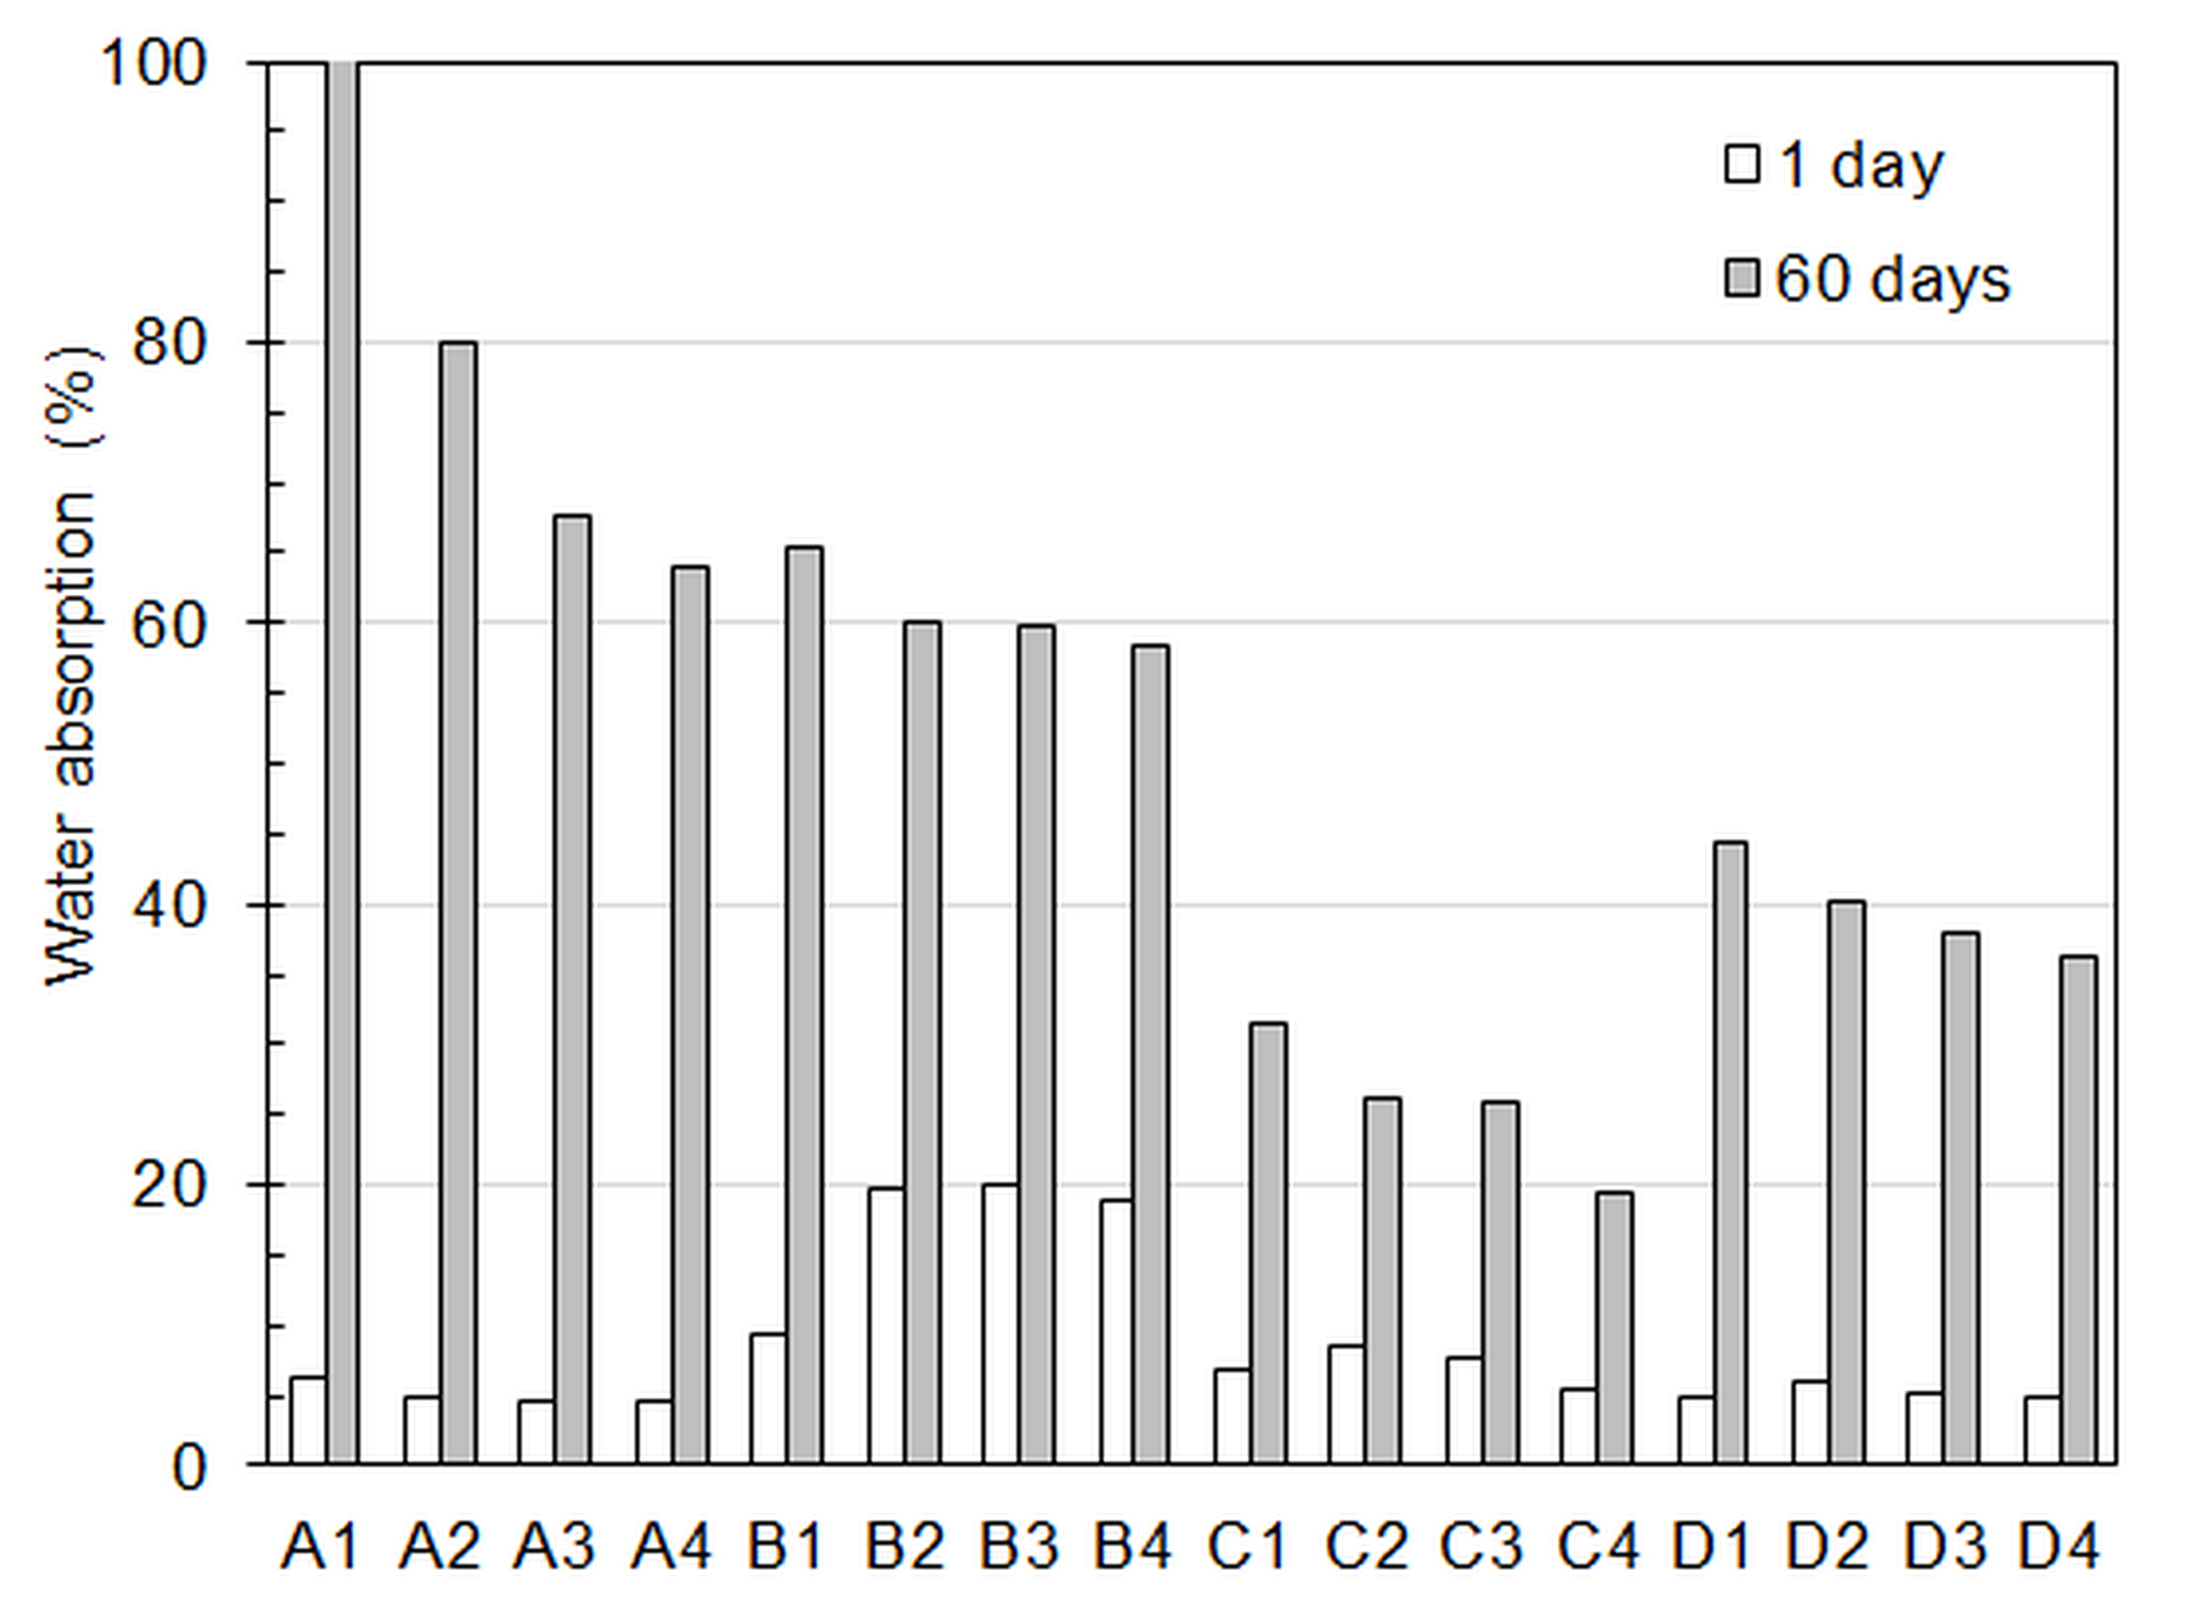
Fig. 4: Water absorption into latex coatings after their 1-day-long immersion (white columns) and 30-days-long immersion (grey columns) in distilled water at RT.
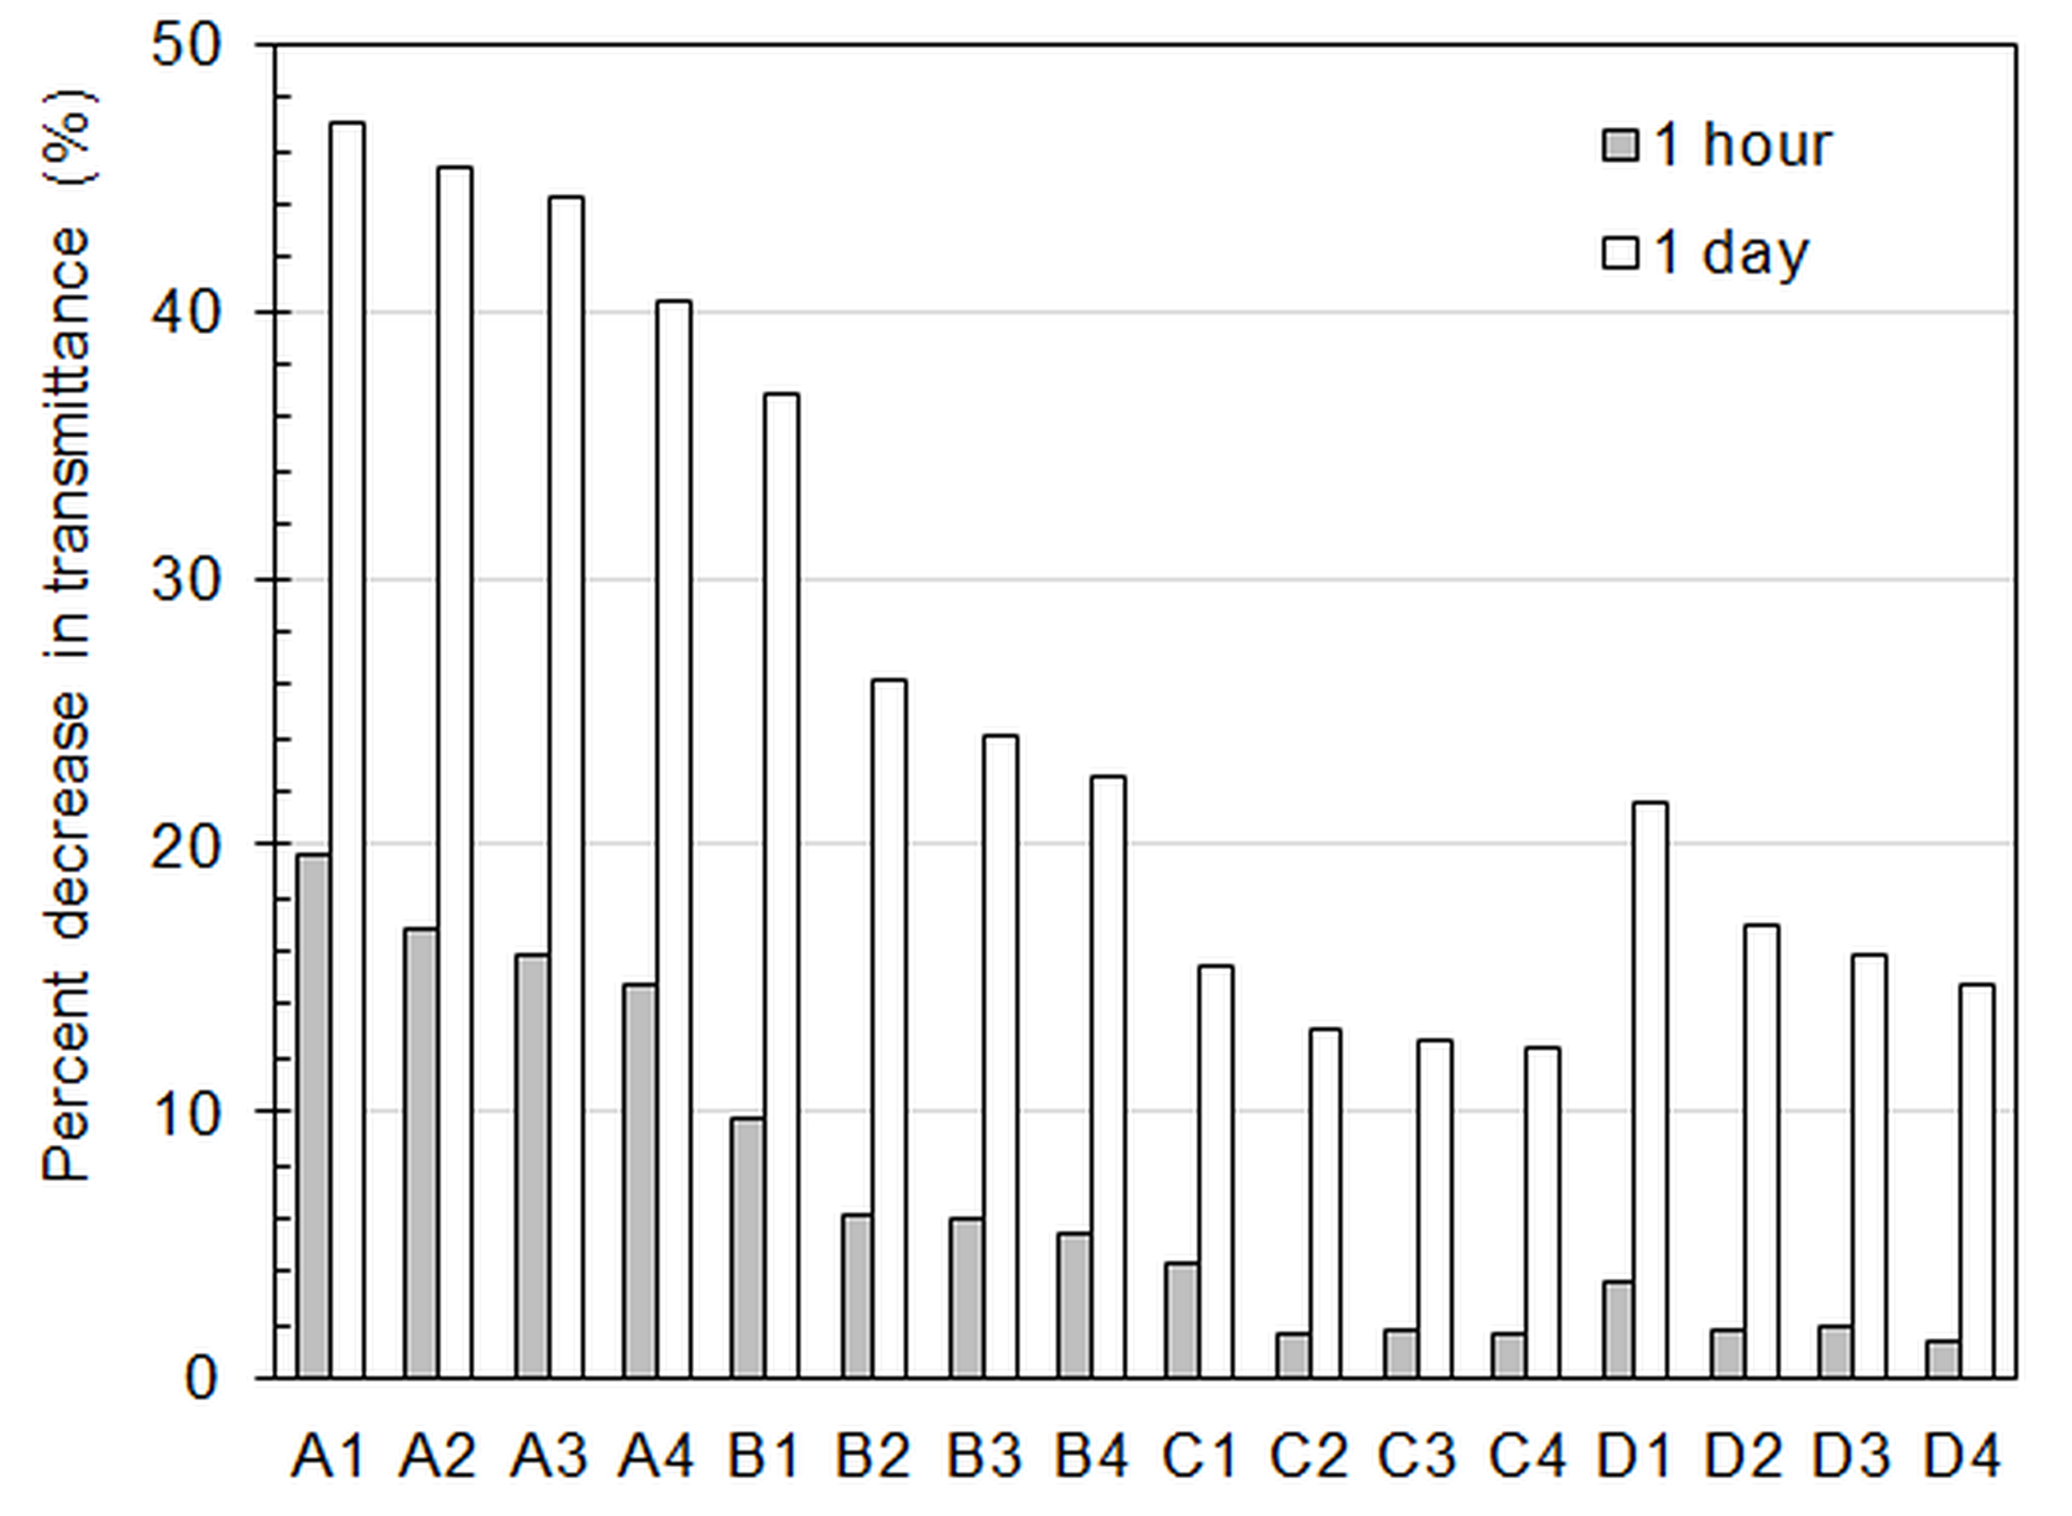
Fig. 5: Water whitening expressed in terms of transmittance decrease for coating films cast on glass panels after their immersion in distilled water at RT for 1 hour (grey columns) and 1 day (white columns). Transmittance values were measured at 500 nm.

Conclusions
The present study is related to water sensitivity of latex films originated from particles differing in perflourethyl group concentration in the second stage polymer. The combined effects of crosslinking and ambient conditions during the film-forming process were evaluated with the aim to spare the fluorinated monomer consumption while maintaining the desired water resistant properties. The results showed that introducing crosslinking into latexes limited achieving a maximal level of coating hydrophobicity at a given concentration of fluorine groups, on the other hand, a fixation of latex polymer by crosslinking resulted in decreased wettability in the case of drying out of low-fluorine-containing acrylic latex films at unfavorable conditions (elevated RH). Further, the undesirable loss of water-repellent properties after the contact with water was demonstrated in the case of fluorine-rich non-crosslinked coatings and this drawback was avoided completely by introducing the keto-hydrazide self-crosslinking chemistry. The results revealed as well that water sensitivity of coating films (manifested as water whitening) was reduced most notably by the level of crosslinking, while the effect of fluorine content was shown to be minor. Thus, latex compositions combining self-crosslinking with intra-particle covalent crosslinking or ionomeric crosslinking provided the most water whitening resistant coatings, while the non-crosslinked films were found to be the most sensitive to water whitening.
It can be concluded that it is advantageous to use an increased content of fluorine monomers in the case of non-crosslinked latex coating products. These materials will probably provide enhanced water-repellency but they will suffer from poor water resistance. On the contrary, saving of fluorine monomers is preferred when producing crosslinked latex coating compositions. In this case, the consumption of fluorine monomer can be minimized significantly (or omitted) providing that strongly crosslinked materials are prepared. The combination of keto-hydrazide self-crosslinking with pre-coalescence or ionomeric crosslinking was shown to be an effective tool to provide densely crosslinked coatings with enhanced resistance to water whitening.

Acknowledgements
The Technological Agency of the Czech Republic (TE02000011) is gratefully acknowledged for supporting this work. We would also like to acknowledge colleagues from the Institute of Optical Materials and Technologies Acad. Jordan Malinovsky, Bulgarian Academy of Sciences, Sofia, Bulgaria Assoc. Prof. Daniela Karashanova and Assoc. Prof. Rosen Todorov for fruitful discussions of results.

References
[1] M. Ma, R.M. Hill, Superhydrophobic Surfaces, Current Opinion in Colloid & Interface Science 11 (2006) 193−202.
[2] Y. Chen, Ch. Zhang, X. Chen, Emulsifier-free latex of fluorinated acrylate copolymer, Eur. Polym. J. 42 (2006) 694−701.
[3] X. Xiao, Y. Wang, Emulsion polymerization of fluorinated acrylate in the presence of a polymerizable emulsifier, Colloids and Surfaces A: Physicochem. Eng. Aspects 348 (2009) 151−156.
[4] L. He, J. Liang, X. Zhao, W. Li, H. Luo, Preparation and comparative evaluation of well-defined fluorinated acrylic latex copolymer latex and solution for ancient stone protection, Prog. Org. Coat. 69 (2010) 352−358.
[5] M. Yu, B. Zhang, B. Deng, X. Yang, K. Sheng, L. Xie, X. Lu, J. Li, Preirradiation-induced emulsion graft polymerization of glycidyl methacrylate onto poly(vinylidene fluoride) powder, J. Appl. Polym. Sci. 117 (2010) 3575−3581.
[6] T. Nishino, Y. Urushihara, M. Meguro, K. Nakamae, Surface properties and structures of diblock copolymer and homopolymer with perfluoroalkyl side chains, J. Colloid Interf. Sci. 283 (2005) 533−538.
[7] W. Zheng, L. He, J. Liang, G. Chang, N. Wang, Preparation and properties of core−shell nanosilica/poly(methyl methacrylate-butyl acrylate-2,2,2-trifluoroethyl methacrylate) latex, J. Appl. Polym. Sci. 120 (2011) 1152−1161.
[8] H. Ling, L. Junyan, Synthesis, modification and characterization of core−shell fluoroacrylate copolymer latexes, J. Fluorine Chem. 129 (2008) 590−597.
[9] X. Cui, S. Zhong, H. Wang, Emulsifier-free core−shell polyacrylate latex nanoparticles containing fluorine and silicon in shell, Polymer 48 (2007) 7241−7248.
[10] W. Xu, Q. An, L. Hao, L. Huang, Synthesis, film morphology, and performance of cationic fluorinated polyacrylate emulsion with core−shell structure, J. Appl. Polym. Sci. 125 (2012) 2376−2383.
[11] Q. An, W. Xu, L. Hao, L. Huang, Cationic fluorinated polyacrylate core−shell latex with pendant long chain alkyl: synthesis, film morphology, and its performance on cotton substrates, J. Appl. Polym. Sci. 127 (2013) 1519−1526.
[12] X. Xiao, R. Xu, Preparation and surface properties of core−shell polyacrylate latex containing fluorine and silicon in the shell, J. Appl. Polym. Sci. 119 (2011) 1576−1585.
[13] X. Cui, S. Zhong, Y. Gao, H. Wang, Preparation and characterization of emulsifier-free core−shell interpenetrating polymer network-fluorinated polyacrylate latex particles, Colloids and Surfaces A: Physicochem. Eng. Aspects 324 (2008) 14−21.
[14] K. Landfester, R. Rothe, M. Antoinetti, Convenient synthesis of fluorinated latexes and core−shell structures by miniemulsion polymerization, Macromolecules 35 (2002) 1658−1662.
[15] S.Y. Cheng, Y.J. Chen, Z.G. Chen, Core−shell latex fluorinated polymer rich in shell, J. Appl. Polym. Sci. 85 (2002) 1147−1153.
[16] J.W. Ha, I.J. Park, S.B. Lee, D.K. Kim, Preparation and characterization of core−shell particles containing perfluoralkyl acrylate in the shell, Macromolecules 35 (2002) 6811−6818.
[17] P. Marion, G. Beinert, D. Juhué, J. Lang, Core−shell latex particles containing a fluorinated polymer in the shell. I. Film formation studied by fluorescence nonradiative energy transfer, J. Appl. Polym. Sci. 64 (1997) 2409−2419.
[18] P. Marion, G. Beinert, D. Juhué, J. Lang, Core−shell latex particles containing a fluorinated polymer in the shell. 2. Internal structure studied by fluorescence nonradiative energy transfer, Macromolecules 30 (1997) 123−129.
[19] D. Anton, Surface-fluorinated coatings, Adv. Mater. 10 (1998) 1197−1205.
[20] R.R. Thomas, D.R. Anton, W.F. Graham, M.J. Darmon, K.M. Stika, Films containing reactive mixtures of perfluoroalkylethyl methacrylate copolymers and fluorinated isocyanates: Synthesis and surface properties, Macromolecules 31 (1998) 4595−4604.
[21] C. Zhang, Y. Chen, Investigation of fluorinated polyacrylate latex with core–shell structure, Polym. Int. 54 (2005) 1027−1033.
[22] M. Morita, H. Ogisu, M. Kubo, Surface properties of perfluoroalkylethyl acrylate/n-alkyl acrylate copolymers, J. Appl. Polym. Sci. 73 (1999) 1741−1749.
[23] D.L. Schmidt, R.F. Brady, K.J. Lam, D.C. Schmidt, M.K. Chaudhury, Contact angle hysteresis, adhesion, and marine biofouling, Langmuir 20 (2004) 2830−2836.
[24] G. Xu, L. Deng, X. Wen, P. Pi, D. Zheng, J. Cheng, Z. Yang, Synthesis and characterization of fluorine-containing poly-styrene-acrylate latex with core–shell structure using a reactive surfactant, J. Coat. Technol. Res. 8 (2011) 401−407.
[25] H. Bakhshi, M.J. Zohuriaan-Mehr, H. Bouhendi, K. Kabiri, Effect of functional monomer GMA on the physical-mechanical properties of coatings from poly(BA-MMA) latexes, J. Mater. Sci. 46 (2011) 2771−2777.
[26] P. Pinenq, M.A. Winnink, Polymer diffusion and mechanical properties of films prepared from crosslinked latex particles, J. Coat. Technol. 72 (2000) 45−61.
[27] M.A. Winnik, Interdiffusion and crosslinking in thermoset latex films, J. Coat. Technol. 74 (2002) 49−63.
[28] H. Li, Ch. Kan, Y. Du, D. Liu, Effects of the amount of diacetone acrylamide on the properties of styrene-acrylic copolymer latexes and their films, Polym. Prep. 43 (2002) 413−414.
[29] S.F. Zhang, F.R. Liu, Y.F. He, R.M. Wang, P.F. Song, Waterborne polyurethane-polyacrylic ester hybrid emulsion for humidity-controlling coatings, Arab. J. Sci. Eng. 39 (2014) 23−30.
[30] S.F. Zhang, Y.F. He, R.M. Wang, Z.M. Wu, P.F. Song, Preparation of emulsifier-free acrylate cross-linkable copolymer emulsion and application in coatings for controlling indoor, Iran Polym. J. 22 (2013) 447−456.
[31] Ch.G. Koukiotis, M.M. Karabela, I.D. Sideridou, Mechanical properties of ﬁlms of latexes based on copolymers BA/MMA/DAAM and BA/MMA/VEOVA-10/DAAM and the corresponding self-crosslinked copolymers using the adipic acid dihydrazide as crosslinking agent, Prog. Org. Coat. 75 (2012) 106−115.
[32] Ch. Koukiotis, I.D. Sideridou, Synthesis and characterization of latexes based on copolymers BA/MMA/DAAM and BA/MMA/VEOVA-10/DAAM and the corresponding 1K crosslinkable binder using the adipic acid dihydrazide as crosslinking agent, Prog. Org. Coat. 69 (2010) 504−509.
[33] X. Zhang, Y. Liu, H. Huang,; Y. Li, H. Chen, The diacetone acrylamide crosslinking reaction and its control of core−shell polyacrylate lattices at ambient temperature, J. Appl. Polym. Sci. 123 (2012) 1822−1832.
[34] T.G. Fox, P.J. Flory, 2nd-Order transition temperatures and related properties of polystyrene. 1. Influence of molecular weight, J. Appl. Phys. 21 (1950) 581−591.
[35] P. Pi, W. Wang, X. Wen, S. Xu, J. Cheng, Prog. Org. Coat. 81 (2015) 66−71.
[36] S. Podzimek, J. Machotova, J. Snuparek, M. Vecera, L. Prokupek, Characterization of molecular structure of acrylic copolymers prepared via emulsion polymerization using A4F-MALS technique, J. Appl. Polym. Sci. 131 (2014) 11178−11185.
[37] N. Kessel, D.R. Illsley, J.L. Keddie, The diacetone acrylamide crosslinking reaction and its influence on the film formation of an acrylic latex, J. Coat. Technol. Res. 5 (2008) 285−297.
[38] Y. Liu, A.M. Gajawicz, V. Rodin, W. Soer, J. Scheerder, G. Satgurunathan, P.J. McDonald, J.L. Keddie, Explanations for water whitening in secondary dispersion and emulsion polymer films, J. Polym. Sci. Part B: Polym. Phys. 54 (2016) 1658−1674.
[39] B. Jiang, J.G. Tsavalas, D.C. Sundberg, Water whitening of polymer films: Mechanistic studies and comparison between water and solvent borne films, Prog. Org. Coat. 105 (2017) 56−66.

