Components of Big Data Analytics for Strategic Management of Enterprise Architecture
Martin Lněnička, Renáta Máchová, Jitka Komárková, and Ivana Čermáková
Abstract. The concept of strategic management is currently being under pressure to adopt big data analytics as a tool for improving efficiency of decision-making and monitoring processes in organizations. This paper aims to provide a systematic approach to map the benefits driven by big data analytics in terms of enterprise architecture focusing on the importance for strategic management. The key components are identified and discussed in the context of TOGAF. The findings can be used as a guide to help developers and designers in reframing their enterprise architecture efforts.
Keywords: big data analytics, strategic management, enterprise architecture, design science research.
JEL Classification: L21, L25, M15, O32

Introduction
The global big data analytics market has seen a tremendous growth in the recent years that is helping businesses uncover more insights and making sense of their data in new ways. At the same time, they are exposed to continuously changing environments fueled by advancements in technologies, standards, regulations, and changing market requirements, which supposed to be solved at the level of Enterprise Architecture (EA). As recent contributions to EA theory suggest that Information Technology (IT) architecture should be agile enough to manage the large amounts of data, there is still a lack of research on components by which big data analytics supports the whole EA.
A key requirement to today’s changing environment is the ability of organizations to adapt dynamically in an effective and efficient manner. Information and Communication Technologies (ICT) play an important role in addressing such adaptation requirements. However, as complexity of organization and modern IT systems increases, the role of EA relates to evolving business trends and technology advancements (Ahlemann et al, 2012; Romero and Vernadat, 2016; Shah and El Kourdi, 2007). For example, Zimmermann et al (2014) reported that the technological and business architectural impact of new mobility solutions, social networks, case-based business process management and services computing with big data in cloud settings has multiple aspects, which directly affect EA. Since Lagerström et al (2011) confirmed that there are significant correlations between organizations’ success with IT and Enterprise Architecture Management (EAM) activities, the alignment of big data analytics with EA is solved in the context of strategic management. In that regard, EAM is no longer viewed as an IT department job but a strategic function that approaches enterprise related changes in a holistic and consistent way. It supports enterprise transformation in response to the increasingly dynamic enterprise environment (Ahlemann et al, 2012). Further, architecture is meaningful only in relation to other parts that together constitute the whole ecosystem (Tiwana, 2014). The main assumption that guides this paper is the need to map the benefits driven by big data analytics for stakeholders in terms of EA focusing on the importance for strategic management.

Research Methodology
We address this gap in the literature by exploring the relationship between big data analytics and EAM at the level of the individual components in the EA. These components were developed by: first, reviewing literature on big data analytics, EA and its management, and a set of EA frameworks to form a theoretical foundation; second, using the theoretical foundation to adapt requirements of big data analytics for strategic EAM; and third, consolidating these requirements into the existing EA framework in which benefits are highlighted. For this purpose, these basic architecture domains (layers) of The Open Group Architecture Framework (TOGAF) were used: business, data, application, and technology. TOGAF presents both the Architecture Development Method (ADM) and information model for architectural description. The cyclic ADM is designed as reference method for performing an architecture project, which in the sense of TOGAF is the way of performing EAM (The Open Group, 2009).
This paper employs a research method that follows the guidelines for Design Science Research (DSR) approach as described by Hevner et al (2004). DSR is a widely applied research approach and is concerned with developing useful artefacts. It is a problem-solving paradigm in which the boundaries of organizational capabilities to create new and innovative artefacts are extended together with the knowledge and understanding of a problem domain through the building and application of the design artefact (Hevner et al, 2004). In the context of EAM, it was previously applied by Aier, Gleichauf and Winter (2011). Aiming to provide a detailed overview to the issue of big data analytics for strategic management of EA, this paper is focused only on the first four steps of the DSR process while other steps will be described thoroughly in future research. In this regard, the objectives of this paper are: 1) discuss the preparedness of EA for big data analytics; 2) provide strategic alignment of big data analytics in the business ecosystem; 3) map these requirements on EA layers of TOGAF; and 4) propose a model containing components of big data analytics for strategic management of EA.

Theoretical Background

Importance of Enterprise Architecture and its Management
Architectures are largely technical decisions with enormous strategic consequences (Tiwana, 2014). EA frameworks identify the architecture’s scope and decompose its elements and relationships into structured layers and architectural dimensions. These are useful for defining and developing the detailed description of the architecture, the principles governing its development and the standards applied during the architecture’s development (Ahlemann et al, 2012; Shah and El Kourdi, 2007). While a wide range of these frameworks exists, a theme they have in common is layering. Layers comprise the basic structure of an EA model, representing distinct conceptual domains, which group together related elements (Simon et al, 2013). In this regard, Tiwana (2014) defined architecture as “a conceptual blueprint that describes how the ecosystem is partitioned into a relatively stable platform and a complementary set of applications that are encouraged to vary, and the design rules binding on both.” The architecture of a platform or an application is a high-level description of its building blocks and how they are related to each other, not a working implementation (Tiwana, 2014). According to TOGAF, apart from the holistic nature of EA, it can be represented with specific focus and is suitable as a framework for reflecting new requirements on architecture (The Open Group, 2009).
EAM is expected to provide business value by guiding the continuous development and transformation in an increasingly turbulent business environment (Ahlemann et al, 2012; Aier, Gleichauf and Winter, 2011). The EAM function has taken on a strategic role and presents a coherent set of guidelines, architecture principles and governance regimes that provide direction and practical help in the design and development of enterprise strategies and visions (Ahlemann et al, 2012). Both practitioners and researchers put forward EAM as a mean for achieving success with IT and a considerable amount of literature describes the components of successful EAM (Lagerström et al, 2011). The empirical analysis of Aier, Gleichauf and Winter (2011) revealed eight determining design factors of EAM, a delineation of three different types of EAM design in the form of clusters as well as insight about the successfulness of the different types.
Buckl et al (2010) presented building blocks for EAM solutions, which can be selected and configured based on the specificities of the organization, i.e. the organizational context and the goals pursued. These building blocks form the solution models to be combined to an organization-specific EAM function. Aier, Gleichauf and Winter (2011) identified these factors: IT operations support, enterprise focus and management, EAM governance, IT strategy and IT governance support, information supply, integrative role, design impact, and business strategy support. Zimmermann et al (2014) investigated mechanisms for adaptable EA that will support the development of service-oriented ecosystems with integrated technologies like semantic technologies, web services, cloud computing, and big data management.

Towards Requirements of Big Data Analytics in an Enterprise
Big data analytics has many perspectives. Arguably, the three most discussed are the business perspective, i.e. value and business outcomes, the technology perspective, i.e. computing resources and IT infrastructure management, and the social perspective, i.e. stakeholders and their knowledge, skills and abilities (Lake and Drake, 2014). These perspectives are usually comprised of components, which represent both functional and non-functional requirements (Pääkkönen and Pakkala, 2015). Big data impacts both the strategy development process and the actual strategies developed in a number of ways, often called the 6V’s (Demchenko, De Laat and Membrey, 2014; Lake and Drake, 2014). This concept is shown in Fig. 1. Variety allows greater visibility of business relationships and the business environment previously outside the scope of traditional management information systems. Volume allows more detailed analysis of strategic position, greater optimization of the supply chain and customer relationships. Velocity allows faster, more timely, feedback on experimental strategic initiatives, faster interactions with customers, suppliers, employees and other stakeholders. Other requirements have to be solved according to defined policies and procedures of an enterprise.
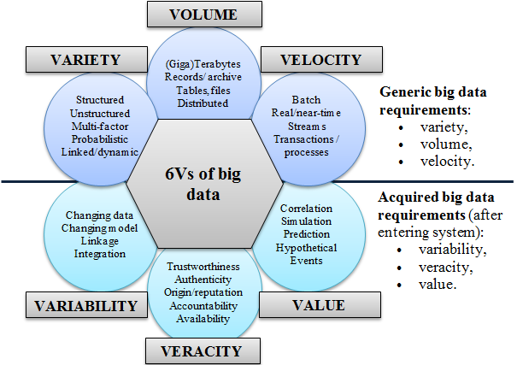
- 6Vs of big data [Demchenko, De Laat and Membrey, 2014]
Fig. 2 visualizes the importance of big data analytics for EA in the boundaries of the existing (as-is) architecture that provides the bases for planning the target (to-be) architecture. EAM includes the management tasks of planning and controlling business change from an architectural perspective. Among others, big data analytics should provide efficient resource allocation and use, efficient operating cost structure leading to savings, faster strategic change and delivery of results, support of decision-making on strategic level, etc.
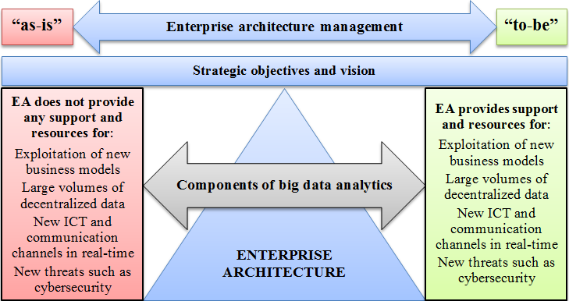
- Importance of big data analytics in the context of EA [authors]

Identifying Components of Big Data Analytics in Business Ecosystem
As defined by Hevner et al (2004), the first two steps in the DSR process require the creation of an innovative, purposeful artefact (Guideline 1) for a specified problem domain (Guideline 2). The artefact can be presented in the form of a construct, a model, a method, or an instantiation. Here, the components are formalized in the model for a specified domain of big data analytics in business ecosystem. Since thorough evaluation of the artefact is crucial (Guideline 3), the components were verified for relevance through semi-structured interviews with four interviewees consisting of practitioners and researchers. Finally, research contributions (Guideline 4) are discussed as follows.
Efficient collaboration between architects and EA stakeholders is one of the main critical success factors for EA. Van Der Raadt, Schouten and Van Vliet (2008) reported that the basis for efficient collaboration between architects and EA stakeholders is mutual understanding. As big data analytics requires specific skills of stakeholders, any change of EA has to begin with identification of these stakeholders. Among EA stakeholders that are described e.g. in Ahlemann et al (2012), big data analytics should involve service provider who establishes and maintains a computing framework in which certain applications will be executed, and application provider who is responsible for the big data analytics lifecycle management and the execution of related activities using platforms, tools and services. This stakeholder is important because of the big data analytics complexity and the required level of technical skills to work with these data. Strategic planning is an important component since it motivates EA choices (Lake and Drake, 2014; Romero and Vernadat, 2016). This process was explored by many practitioners and researchers who suggest that it should be constantly monitored and evaluated to ensure the agility and adaptability of EA. Big data analytics is always solved in the context of project management. There are also various roadmap alternatives that address the differences between implementation of selected components. The basic layers of EA defined by TOGAF are highlighted in Fig. 3. Furthermore, some interviewees were skeptical about the cost model. Especially the lack of knowledge and skills of employees and the need to recruit new employees may cause problems. On the other hand, the use of computing resources in the cloud is recognized as a way to store large amounts of data and decrease cost for a data center.
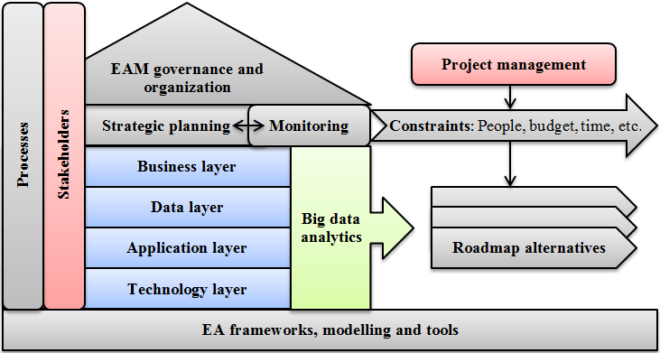
- Strategic alignment and relationships of big data analytics in business ecosystem [authors]
Fig. 4 shows the requirements of big data analytics for EA layers. The change in EA represented by big data analytics affects all the layers defined by TOGAF. For business architecture it means that the principles of agility and adaptability should be followed by EA. Since every organization has to face competition and a changing digital development landscape, these principles can ensure that the benefits of new ICT will be recognized. The data architecture requires new components that fulfil the characteristics of 6Vs. The application architecture needs to be prepared for specific platforms, tools and services, such as those listed in Lněnička and Komárková (2015) or Pääkkönen and Pakkala (2015). Technology architecture offers computing resources for both data and application architecture. It is recommended to use distributed and cloud computing resources (Lake and Drake, 2014). Infrastructure has to be managed and monitored with related tools. Interfaces and modules ensure that every module works the same way and data are accurately collected, transmitted and stored.
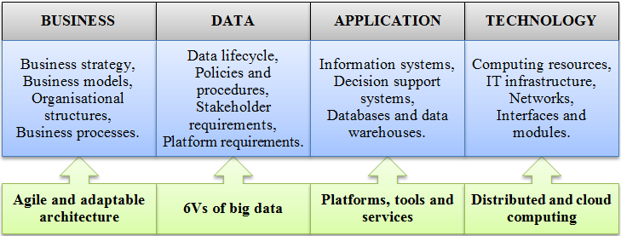
- Mapping requirements of big data analytics on EA layers of TOGAF [authors]
The identified components of big data analytics for strategic management of EA are shown in Fig. 5. Both strategic management of EA and big data analytics try to deliver value through the efficient work with business data. Components of business architecture are framed within the goals and skills of stakeholders, which result in a strategy. Big data business models then shape the requirements for other architectures. Big data analytics requires specific data lifecycle phases and activities. The basic of them are presented in this paper, while the others can be found in Demchenko, De Laat and Membrey (2014) or Lněnička and Komárková (2015). The most widely used batch processing framework is an open-source Apache Hadoop, which is based on MapReduce by Google. For real-time or stream processing, there is Apache Storm. Because of large amounts of data, new databases such as NoSQL or NewSQL, and distributed file systems have to be implemented. Their functions then affect the processes. Finally, technology architecture has to be secure, scalable, reliable and available to provide resources for applications and data. It should also help to eliminate possible threats such as cyberattacks.
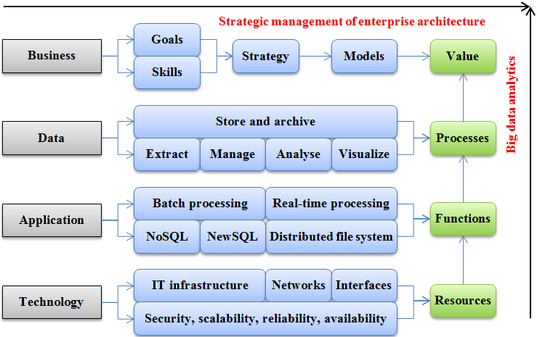
- Model containing components of big data analytics for strategic management of EA [authors]

Discussion and Limitations
Apart from big data analytics, there are also other technologies that may initiate the change of EA. Romero and Vernadat (2016) discussed the Internet-of-Things and its role in terms of creating new or extending the abilities of existing devices or business model innovations by enabling new forms of creating and capturing value. Integration of business data with open data is another emerging field of value creation (Lněnička and Komárková, 2015). In this regard, the importance of EA’s agility and adaptability has to be emphasized again. Further, when it comes to the manufacturing industry, the combination of industrial and digital technologies and business model innovations have created the Industry 4.0 vision, of a distributed global and virtual manufacturing factory of the future (Romero and Vernadat, 2016). On the other hand, not all organizations are prepared for the use of big data analytics as the maturity of their EA is low. Therefore, Lagerström et al (2011) provided a set of items (questions) to assess the maturity level of EA activities.
There are also some limitations in our work. First, the design components are most probably not stable over time but will change, either over the time of application within one organization or in dependency of some other aspect (Aier, Gleichauf and Winter, 2011). Moreover, it needs to be noted that the set of big data analytics components cannot be explained fully by our results. There is no information about how these components interact with each other in a specific business environment. This issue will be investigated in future research, according to the last three steps defined by Hevner et al (2004). Finally, since different EA stakeholder groups pursue different goals related to their specific role within the organization, it may be difficult to satisfy all stakeholders (Van Der Raadt, Schouten and Van Vliet, 2008).

Conclusion
Our principal contribution is a systematic approach dealing with the composition of architecture layers, components and relationships within agile and adaptable EA for big data analytics, by means of strategic management. In our paper, we applied the DSR approach to gain better understanding of EA’s strategic management through analysis of existing literature to build more agile and adaptable EA and identify components that capture the requirements of big data analytics. The novelty in our paper comprises new aspects for mapping benefits of big data analytics in the context of architecture layers of the existing EA framework TOGAF.
The results of this study showed that it is important for executive decision-makers as well as developers and designers to understand how the requirements of big data analytics influence the strategic management of EA. A subsequent deeper evaluation and extension of our approach is planned as future work.

Acknowledgements
This research is supported by University of Pardubice, SGS_2017_17 project.

References
Ahlemann, F., Stettiner, E., Messerschmidt, M. and Legner, C. (2012). Strategic Enterprise Architecture Management: Challenges, Best Practices, and Future Developments. Berlin Heidelberg: Springer-Verlag.
Aier, S., Gleichauf, B. and Winter, R. (2011). ‘Understanding Enterprise Architecture Management Design – An Empirical Analysis‘. Proceedings of the 10th International Conference on Wirtschaftsinformatik, Zurich, Switzerland, pp. 645-654.
Buckl, S., Dierl, T., Matthes, F. and Schweda, C. M. (2010). ‘Building Blocks for Enterprise Architecture Management Solutions‘. Proceedings of Second Working Conference, PRET 2010, Delft, The Netherlands, pp. 17-46.
Demchenko, Y., De Laat, C. and Membrey, P. (2014). ‘Defining architecture components of the Big Data Ecosystem‘. Proceedings of 2014 International Conference on Collaboration Technologies and Systems (CTS), Minneapolis, USA, pp. 104-112.
Hevner, A. R., March, S. T., Park, J. and Ram, S. (2004). ‘Design science in information systems research‘. MIS quarterly, 28 (1), pp. 75-105.
Lagerström, R., Sommestad, T., Buschle, M. and Ekstedt, M. (2011). ‘Enterprise Architecture Management’s Impact on Information Technology Success‘. Proceedings of the 44th Hawaii International Conference on System Sciences, Koloa, Hawaii, pp. 1-10.
Lake, P. and Drake, R. (2014). Information Systems Management in the Big Data Era. Cham: Springer International Publishing.
Lněnička, M. and Komárková, J. (2015). ‘The Impact of Cloud Computing and Open (Big) Data on the Enterprise Architecture Framework‘. Proceedings of the 26th International Business Information Management Association Conference, Madrid, Spain, pp. 1679-1683.
Pääkkönen, P. and Pakkala, D. (2015). ‘Reference Architecture and Classification of Technologies, Products and Services for Big Data Systems‘. Big Data Research, 2 (4), pp. 166-186.
Romero, D. and Vernadat, F. (2016). ‘Enterprise information systems state of the art: Past, present and future trends‘. Computers in Industry, 79, pp. 3-13.
Shah, H. and El Kourdi, M. (2007). ‘Frameworks for Enterprise Architecture‘. IT Professional, 9 (5), pp. 36-41.
Tiwana, A. (2014). Platform Ecosystems: Aligning Architecture, Governance, and Strategy. Waltham: Morgan Kaufmann.
The Open Group (2009). TOGAF Version 9: The Open Group Architecture Framework (TOGAF). The Open Group.
Van Der Raadt, B., Schouten, S. and Van Vliet, H. (2008). ‘Stakeholder Perception of Enterprise Architecture‘. Proceedings of Second European Conference, ECSA 2008, Paphos, Cyprus, pp. 19-34.
Zimmermann, A., et al. (2014). ‘Adaptable Enterprise Architectures for Software Evolution of SmartLife Ecosystems‘. Proceedings of the 2014 IEEE 18th International Enterprise Distributed Object Computing Conference Workshops and Demonstrations, Ulm, Germany, pp. 316-323.

martin.lnenicka@gmail.com
University of Pardubice, Faculty of Economics and Administration, Studentska 84, 53210 Pardubice, {renata.machova, jitka.komarkova, ivana.cermakova}@upce.cz

